ĐỀ 7 | ĐỀ ÔN THI HỌC KỲ II NĂM HỌC 2023-2024  MÔN: TIẾNG ANH 11

LISTENING
I. Kate is talking about her experience of moving out. Listen to her talk and mark the letter A, B, C or D to indicate the correct answer to each of the following questions. You will listen TWICE. (1 pt)
1. The main topic of Kate’s speech is ______.
A. “Money can buy happiness” B. “Love yourself”
C. “Live on your own” D. “Travel far from home”
2. Many people assume that the parents would not want their children to ______ them.
A. leave B. lend C. live D. lift
3. Kate’parents ______ her decision of moving out.
A. were tired and ignored B. respected and rejected
C. supported and respected D. got furious and rejected
4. The most important reason for independent living is to ______ travelling time to work.
A. erase B. increase C. reduce D. lengthen
5. The major challenge of independent living is ______.
A. electricity B. phone C. money D. rent
II. Listen to a music teacher talking to a potential donor and complete the summary. Write NO MORE THAN THREE WORDS in each blank. You will listen TWICE. (1 pt)
Ms Taylor is meeting Mr Robinson, a donator, to tell him about her plan for the (1) _______________. She wants to preserve folk music because it’s a representation of our (2) _______________ identity and past daily life. Thanks to crowdfunding, some traditional (3) ___________________ have been bought. With more donations from Mr Robinson, she can have a proper music classroom and (4) _______________ the class to students. Mr Robinson, who initially hesitated, is (5) _______________ to provide money to preserve folk music.
GRAMMAR AND VOCABULARY (3 pts)
I. Mark the letter A, B, C, or D on your answer sheet to indicate the word whose underlined part differs from the other three in pronunciation in each of the following questions.
1. A. looked B. laughed C. opened D. stepped
2. A. seat B. leave C. increase D. ready
II. Mark the letter A, B, C, or D on your answer sheet to indicate the word that differs from the other three in the position of primary stress in each of the following questions.
3. A. restore B. finish C. destroy D. preserve
4. A. historic B. imperial C. mechanic D. doctorate
III. Mark the letter A, B, C, or D on your answer sheet to indicate the correct answer to each of the following questions.
5. Many teenagers struggle ____________social issues such as bullying and poverty.
A. in B. about C. with D. over
6. Neil Armstrong was the first person ____________ foot on the moon
A. setting B. to set C. who sets D. set
7. People should stop smoking ____________ it is extremely detrimental to health.
A. although B. despite C. because D. because of
8. ____________education is a popular option for school-leavers who don’t go to university.
A. Vocational B. Academic C. Secondary D. Formal
9. ___________yesterday ___________she came here. I’m sure of that.
A. It was – that B. It is – when C. It was – when D. It is – who
10. Even when arrested, he denied ____________cut down that tree.
A. to have B. having C. have D. have had
11. Peer ___________can have positive or negative effects on teenagers.
A. pressure B. stress C. influence D. anxiety
12. John: “I’ve failed my final exam.”- Tom: “____________”
A. How disappointeD. B. I know how it feels.
C. I’m glad to hear that. D. So, good luck!
READING
II. Read the text and choose the best option. (1 point)
Becoming independent requires learning how to deal with various challenges and making important decisions. It involves (1) ______ tasks on one's own, while developing essential life skills. One crucial skill to acquire is responsibility in decision making. Understanding the consequences of choices becomes vital as individuals have to find their ways through different aspects of life. (2) ______, mastering time management becomes essential to find a balance between work and life. Becoming independent also requires self-study, where individuals take the initiative to expand their knowledge (3) ______ formal education. By developing effective study habits and seeking out information (4) ______, one can enhance their understanding and adaptability in a rapidly changing world. In summary, becoming independent demands acquiring the ability to deal with challenges, making (5) ______ decisions, effectively managing time, and embracing self-study as vital life skills.
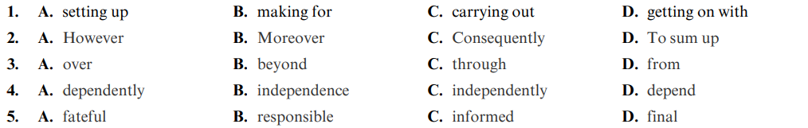
WRITING
I. Find a mistake in each of the following sentences and correct it. (1 point)
1. Having imported from America, the fruit was expensive.
2. It is his dishonesty what I dislike the most.
3. Although her poor health, she works twelve hours a day.
4. Verbal bullying happens when people keep telling lies or bad things about you behind your back.
II. Rewrite the following sentences using the given suggestions. (1 points)
1. They spent their holiday in Halong bay. (Cleft sentences)
=> It ___________________________________________________________
2. We had gone to Hoi An many times before. We knew exactly where to have a good dinner. (Having)
=> ____________________________________________________________
3. Although the picture was expensive, we bought it.
=> In spite of______________________________________________________
4. She doesn’t like any accademic subject. She may choose a vocational school. (Therefore)
=> ___________________________________________________________

THE END

