ĐỀ 1 | ĐỀ KIỂM TRA CUỐI HỌC KỲ I  MÔN: TIẾNG ANH 10
I. LISTENING: (2 pts)
PART 1: Listen to Helen talking to her friend, Sam, about being in a rock band. (1pt)
For questions 1-5, tick () A, B , C or D.You will hear the conversation twice.
Question 1: Sam agrees to play the guitar on______________.
A. Wednesday B. Friday C. Thursday D. Sunday
Question 2: Where does Nick’s band practise?
A. at Helen’s flat B. in a garage C. in Nick’s bedroom D. at a club
Question 3: Sam should bring____________.
A. sandwiches B. CDs C. a pullover D. a sweater
Question 4: The band will next play at_________________.
A. a party B. a club C. a college D. a school
Question 5: How much does Helen earn per night in the band?
A. £25 B. £20 C. £10 D. £110
PART 2 : Listen to the announcement by the director of Heart to Heart Charity and decide whether the following statements are true (T) or false (F). You will hear the conversation twice. (1pt)
Question 6: Heart to Heart Charity is a non –profit organisation.
A. True B. False
Question 7: Few children or adults in our community are hungry, cold, or sick nowadays.
A. True B. False
Question 8: You can donate food but not clothes.
A. True B. False
Question 9: You can’t donate money.
A. True B. False
Question 10: You can donate time and work in the office of this organisation.
A. True B. False

II. LANGUAGE: (2pts)
PART 1: Mark the letter A, B, C or D on your answer sheet to indicate the word that differs from the other three in the position of primary stress in each of the following questions.
Question 11: A. idol B. perform C. singer D. music
Question 12: A. invention B. emotion C. computer D. internet
PART 2: Mark the letter A, B,C or D on your answer sheet to indicate the correct answer to each of the following questions.
Question 13: Artificial Intelligence has been applied _______ various areas of life.
A. with B. to C. from D. of
Question 14: We _____________ in Ha Noi since 2000. We love living there.
A. lived B. live C. have lived D. are living
Question 15: Doing housework brings great ________ to children as it helps them develop necessary life skills.
A. benefits B. hardwork C. results D. practices
Question 16: The teacher encouraged her students_________ the music performance.
A. attend B. to attend C. attended D. attending
Question 17: The most obvious advantage of living green is that it helps reduce _____________.
A. pollute B. polluting C. polluted D. pollution
Question 18: A robot vacuum cleaner is a ________ device in your home. It makes housework less tiring.
A. helpful B. help C. helpless D. helpfully
Question 19: I think_______ volunteer works will help us develop life skills.
A. taking responsibility for B. taking care of C. taking part in D. getting access to
Question 20: Mark the letter A, B, C or D to indicate the word CLOSEST in meaning to the underlined word in the following question.
In spite of poverty, we manage to raise our children properly.
A. bring up B. give up C. look for D. make up
III. READING: (2pts)
PART 1: Read the following passage carefully and then choose the best option to fit each numbered blank (from 21 to 25).
E-readers
An e-reader is a small device on which you can store and read texts downloaded from the Internet. Compared with printed books, e-readers are often more convenient because an e-reader allows us (21) ___________ thousands of books while it is only as heavy as a single book. Besides, it has a lot of useful features that a (22) __________ does not have. The first e-reader was introduced by a small company in 1999. However, it was not until people became interested (23) _______ e-books that e-readers became popular around the world. In 2007, Amazon created Kindle, a famous e-reader (24) __________ has been widely used since then. (25) _________ e-readers have become less popular since tablets and smartphones were introduced, they are still used by many book lovers today.
Question 21. A. storing B. store C. to storing D. to store
Question 22. A. smartphone B. laptop C. computer D. printed book

Question 23. A. in B. on C. about D. of
Question 24. A. what B. which C. whom D. who
Question 25. A. Because B. When C. Although D. Until
PART 2: Read the following passage carefully and then choose the best option to fit each numbered blank (from 26 to 30).
A YEAR WITH OVERSEAS VOLUNTEERS

I was with Overseas Volunteers (OV) for a year after leaving university, and I was sent to an isolated village in Chad, about 500 km from the capital N'Djamena. Coming from' a rich country, I got quite a shock as conditions were much harder than I had expected. But after a few days I soon got used to living there. The people were always very friendly and helpful, and soon I began to appreciate how beautiful the countryside was.

One of my jobs was to supply the village with water. The well was a long walk away. And the women used to spend a long time every day carrying heavy pots backwards and forwards. So I contacted organization and arranged to have some pipes delivered. We built a simple pipeline and a pump, and it worked first time. It wasn't perfect - there were a few leaks, but it made a great difference to the villagers, who had never had running water before. And not only did we have running water, but in the evenings it was hot, because the pipe had been lying in the sun all day. All in all, I think my time with OV was a good experience. Although it was not well-paid, it was well worth doing, and I would recommend it to anyone who was considering working for a charity.
Question 26: The author____________________
A. has been working for OV for a year. B. is living in the capital N'Djamena.
C. was born in a rich family. D. used to be a volunnter working in a remote village.
Question 27: The word “it” in the second paragraph refers to?
A. running water B. the pump C. the pineline D. the supply of water
Question 28: How did the author feel when he arrived in the village?
A. surprised B. impressed C. disappointed D. depressed
Question 29: Which of the follwing is not true?
A. It took a lot of time to take home from the well.
B. The villagers used to live in conditions without running water.
C. A pipeline was built to carry cleam water to homes.
D. Solar energy was used to heat water.
Question 30: What does the author think about his time with OV?
A. It was paid a lot of money. C. It was not worth working
B. It wasted time. D. It provided good experience

IV. WRITING: (2pts)
PART 1: Choose the letter A, B, C or D to indicae the underlined part that needs correction (0,4 pt).
Question 31: While he walked home, it began raining heavily.
A B C D
Question 32: Many people enjoy to read the news on their smartphones.
A B C D
PART 2: Finish each of the following sentences in such a way that it means the same as the sentence printed before it. (0.6pt)
Question 33. I would like to listen to music in my free time.
I enjoy____________________________________________________.
Question 34. They look after their children properly.
Their children ______________________________________________.
Question 35. Mr Pike started working for this company ten years ago.
Mr Pike has________________________________________________.

PART 3: You saw this job advert for a volunteer at the Local Food Bank and want to apply. Write an application letter for this position (80- 100 words), following the guidelines below. (1pt)

Do you have a couple of hours to spare in the afternoon?
The Local Food Bank needs young and energetic volunteers to help give free food to the needy.

Volunteers Needed

Dear Sir or Madam,
I am writing to apply for a volunteer position………………………………………………………………
………………………………………………………………………………………………………………………………………………………………………………………………………………………………………………………………………………………………………………………………………………..
I am interested in…………………………………………………………………………………………....
………………………………………………………………………………………………………………………………………………………………………………………………………………………………………………………………………………………………………………………………………………………………………………………………………………………………………………………………………………………………………………………………………………………………………………
I am available for an interview………………………………………………………………………………
……………………………………………………………………………………………………………………………………………………………………………………………………………………………….
If my application is successful, I can start…………………………………………………………………...
………………………………………………………………………………………………………………..
I look forward to hearing from you.
Your faithfully,
………………………………

------ THE END -----
ĐÁP ÁN
SECTION I: MULTIPLE CHOICE QUESTION ( 32 x 0.2 pts. = 6.4 pts.)
1 | 2 | 3 | 4 | 5 | 6 | 7 | 8 | 9 | 10 | 11 | 12 | 13 | 14 | 15 | 16
C | B | D | C | A | A | B | B | B | A | B | D | B | C | A | B
17 | 18 | 19 | 20 | 21 | 22 | 23 | 24 | 25 | 26 | 27 | 28 | 29 | 30 | 31 | 32
D | A | C | A | D | D | A | B | C | D | C | A | D | D | B | B
SECTION II : WRITING
PART 2: Finish each of the following sentences in such a way that it means the same as the sentence printed before it. (0.6pt) ( 3 x 0.2 pt. = 0.6 pt.)
Question 33. People clean the street every two days.
The street is cleaned every two days.
Question 34. He started playing the guitar when he was ten.
He has been playing the guitar since he was ten.
He has played the guitar since he was ten.
Question 35. Why don’t we ask the teacher for help?
He suggests asking the teacher for help.
PART 2: Finish each of the following sentences in such a way that it means the same as the sentence printed before it. (0.6pt) ( 3 x 0.2 pt. = 0.6 pt.)
Question 33. They look after their children properly .
Their children are looked after properly.
Question 34. Mr Pike started working for this company ten years ago.
Mr Pike has been working for this company for ten years.
Mr Pike has worked for this company for ten years.
Question 35. I would like to listen to music in my free time.
I enjoy listening to music in my free time.
PART 3:
HƯỚNG DẪN CHẤM BÀI VIẾT THƯ (1,0 điểm)
Giáo viên cho điểm mỗi thành phần ứng với mức độ nhận thức học sinh đạt được.

Tổng: 1 điểm | Nhận biết | Thông hiểu | Vận dụng | Vận dụng cao
Nội dung  (0,4đ) | (0,1đ)  - Trả lời ở mức tối thiếu yêu cầu của bài. Bài viết có câu chủ đề và các thành phần cơ bản.  - Viết được một số ý chính nhưng có chỗ diễn đạt không rõ, bị lặp ý, không liên quan, gây khó hiểu cho người đọc. | (0,2đ)  - Trả lời được cơ bản yêu cầu của bài. Bài viết có câu chủ đề. Các thành phần cơ bản đều được phát triển, đôi khi có chỗ phát triển chưa cân xứng.  - Viết được cơ bản đủ ý chính. Có một vài ý không liên quan, gây khó hiểu cho người đọc.  - Có đôi chỗ dẫn chứng còn chưa phù hợp. | (0,3đ)  - Trả lời khá đầy đủ yêu cầu của bài. Bài viết có câu chủ đề. Các thành phần cơ bản được phát triển tương đối kỹ, logic và cân xứng.  - Viết đủ ý chính, các ý có liên quan đến chủ đề. - Dẫn chứng phù hợp, khá thuyết phục. | (0,4đ)  - Trả lời đầy đủ yêu cầu của bài. Bài viết có câu chủ đề. Các thành phần cơ bản được phát triển kỹ, logic, cân xứng.  - Đủ ý, các ý thống nhất, có liên quan chặt chẽ.  - Dẫn chứng hay và thuyết phục.
Tổ chức thông tin và tính liên kết (0,2đ) | (0,05đ)  - Thông tin bị lặp và ảnh hưởng đến diễn đạt.  - Sắp xếp ý thiếu logic, thiếu tính liên kết.  - Ít sử dụng hoặc sử dụng lặp các phương tiện kết nối, hoặc sử dụng các phương tiện kết nối chưa chính xác. | (0,1đ)  - Thông tin còn bị lặp. - Sắp xếp các ý có logic, có tính liên kết, mặc dù tính mạch lạc giữa các câu còn thấp hoặc máy móc.  - Sử dụng các phương tiện kết nối tuy còn đơn giản nhưng đúng nghĩa. | (0,15đ)  - Thông tin ít khi bị lặp.  - Sắp xếp ý logic, mạch lạc, dễ đọc, dễ hiểu.  - Sử dụng khá đa dạng và chính xác các phương tiên kết nối. | (0,2đ)  - Thông tin không bị lặp.  - Sắp xếp ý logic, mạch lạc cao. Bài viết có tổng thể hài hòa, trôi chảy, uyển chuyển, tự nhiên.  - Sử dụng đa dạng và chính xác các phương tiện kết nối.
Từ vựng (0,2đ) | (0,05đ)  - Từ vựng liên quan đến chủ đề hạn chế, lặp, hoặc không phù hợp.  - Dạng từ, chính tả còn viết sai, gây hiểu lầm hoặc khó chịu cho người đọc. | (0,1đ)  - Từ vựng tạm đủ để diễn đạt thông tin liên quan đến chủ đề. Một số chỗ dùng từ chưa phù hợp hoặc viết sai dạng từ.  - Còn mắc một số lỗi sai về dạng từ và chính tả gây khó khăn cho người đọc. | (0.15đ)  - Từ vựng đa dạng có liên quan đến chủ đề. Đôi chỗ còn mắc lỗi dùng từ chưa phù hợp hoặc sai dạng từ.  - Có sử dụng từ đồng nghĩa, trái nghĩa, kết hợp từ, thành ngữ...  - Ít lỗi sai về chính tả. | (0,2đ)  - Từ vựng phong phú liên quan đến chủ đề, diễn đạt tự nhiên. Dùng từ phù hợp, chính xác.  - Sử dụng đa dạng các từ đồng nghĩa, trái nghĩa, kết hợp từ, thành ngữ…  - Rất ít lỗi về dạng từ, và chính tả.
Ngữ pháp (0,2đ) | (0,05đ)  - Sử dụng cấu trúc câu đơn giản.  - Mắc nhiều lỗi sai về ngữ pháp và chấm câu, gây khó hiểu cho người đọc. | (0,1đ)  - Sử dụng các cấu trúc câu khác nhau.  - Có khá nhiều lỗi sai về ngữ pháp và chấm câu, đôi chỗ gây khó hiểu cho người đọc. | (0,15đ)  - Sử dụng đa dạng cấu trúc câu.  - Thi thoảng còn mắc lỗi về ngữ pháp và chấm câu, nhưng người đọc vẫn có thể hiểu. | (0,2đ)  - Sử dụng đa dạng, linh hoạt cấu trúc câu. - Còn một vài lỗi nhỏ về ngữ pháp và chấm cấu, người đọc vẫn thấy dễ hiểu.

* TAPESCRIPT:
PART 1: Listen to Helen talking to her friend, Sam, about being in a rock band.
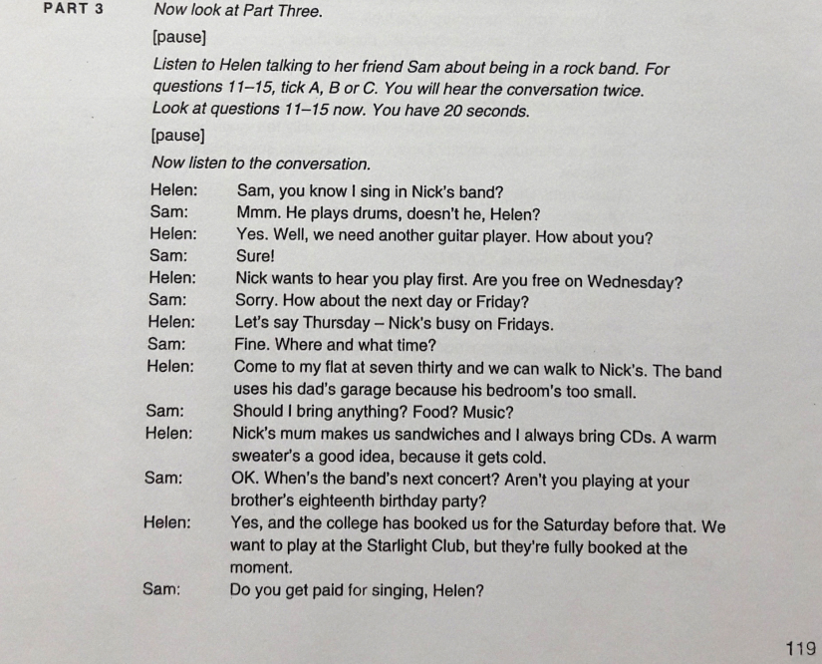
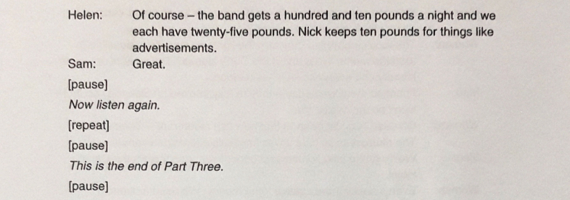
PART 2: Listen to some information about whales and decide whether the following statements are true(T) or false(F). You will listen twice.
This is a public service announcement for the Heart to Heart Charity.We are a non-profit organisation that helps people in need. As the Tet holiday approaches, we are asking you to think of those in our community who need help. Even today, we have unbelievable problems in our community. Many children and adults are hungry, cold and sick every day. Our goal here at Heart to Heart Charity is to help those people. To do this, we need your help. To help, you can do one of three easy things. First, you can donate food and clothes to our organisation. Your food and clothing will go straight to someone who needs it. Second, you can donate money to our organisation. We will only use your money to buy food, clothes, and medicine for the needy. Or last, you can donate your time and work in the office. We always need new volunteers. Your donation of any kind will always be welcome. So please contact us at 15 Ha Thanh Street. We are open from 8.30 a.m. to 10p.m. every day.

