ĐỀ 4 | ĐỀ KIỂM TRA CUỐI HỌC KỲ I  MÔN: TIẾNG ANH 10 CHUYÊN

SECTION 1: LISTENING (2PTS)
Part 1: You will hear a telephone conversation between the organizer of a short story competition and someone who wishes to take part in the competition. Write NO MORE THAN TWO WORDS AND/OR NUMBER for each answer. You will hear the conversation TWICE. (1pt)

SHORT STORY COMPETITION
Entry details
Cost of entry: ………… £5 ………….
Length of story: approximately ……………………. (1)
Story must include: a ……………………. (2)
Minimum age: …………………………. (3)
Last entry date: 1st………………………… (4)
Web address: www.…………………………..com (5)
Don’t: Post the story the organizers.

Part 2: You will hear an interview in which two people called Claire MacBride and Shaun Kale are talking about training to run in a charity marathon. Choose the answer (A, B, C or D) which fits best according to what you hear. You will hear the conversation TWICE. (1pt)
6. When Claire started her marathon training programme, she felt
A. encouraged by the reaction of others.
B. amazed at her own self-discipline.
C. determined to establish new habits.
D. aware of the size of the task ahead.
7. What mistake does Shaun believe he made in his marathon preparation?
A. not being sufficiently fit at the start
B. overtraining in the early days
C. not realising the importance of motivation
D. choosing an unsuitable training plan at first
8. Claire says that after she got injured she
A. considered the prospect of giving up her training.
B. accepted the necessity of getting plenty of rest.
C. paid attention to the recommendations of a trainer.
D. made the decision to modify her training plan.
9. What does Claire suggest about training on winter mornings?
A. It was helpful to pay attention to the sounds she heard.
B. It was hard without a running companion.
C. It was necessary to prepare herself mentally.
D. It was depressing to be running in the dark.
10. When asked about his running speed on the marathon, Shaun reveals his
A. lack of faith in technology.
B. desire to achieve a good race time.
C. worries about finishing the race.
D. pride in his increased fitness.

SECTION 2: USE OF LANGUAGE (2PTS)
Part 1: Mark the letter A, B, C, or D on your answer sheet to indicate the correct answer to each of the following questions. (1pt)
11. Many students find it hard to survive financially as they have ................. any money to live on each week.
A. almost B. quite C. hardly D. nearly
12. Mary decided to consider the proposal that was put ................. to her a few days ago.
A. front B. first C. forward D. ahead
13. She would prefer to go out ................. stay at home.
A. of B. from C. to D. rather than
14. ................. is the amount of carbon dioxide (CO2) produced by the activities of a person or an organization.
A. carbon fibre B. carbon level C. carbon footprint D. low-carbon
15. I had decided that a win in the local elections would provide a ................. to success.
A. springboard B. turning point C. highway D. milestone
16. Anne is seeing Mary off at the airport.
- Anne: "Don't fail to look after yourself, Mary!" - Marry: ".................................. "
A. Of course, you are an adult. B. Oh, I knew about that.
C. Thanks, I will. D. The same to you.
17. Please ................. me to cancel my dentist's appointment on Tuesday.
A. retain B. remind C. recall D. remember
18. The doctor may be able to help you, but don't expect him to ................. miracles.
A. develop B. turn C. work D. create
19. Peter was born and brought up in Hastings and know it like the.................
A. back of his hand B. tip of his tongue C. nose on his face D. hair on his head
20. I really object ................. by people who hardly even know me.
A. criticising B. to criticising C. to being criticised D. to criticise

Part 2: Read the text below and fill each gap with the correct form of the words in brackets. (0.5pt)
MAKING THE RIGHT CHOICE
The decision as to which university to apply to is often taken on the basis of a university's position on the world rankings table. Yet, other considerations, such as whether the course is (21.THEORY) ……………… or offers hands-on experience and the amount of time that students will need to work independently should be taken into account. The fact is that some undergraduates who express their (22. COMPLAIN) ……………… with their university experience base their (23. SATISFY) ……………… on poor organisation, the lack of support received and on having fewer contact hours than expected.
As higher education providers come under increasing pressure to meet established targets and to maintain or improve their status, course guidelines should (24. CLEAR) ………………… what participants can expect from the course and what the course expects from them. This should ensure a reduction in student drop-out rates. Inevitably, though, no matter how much the content and structure is spelt out, some students will turn up with (25. REAL) ………………… expectations that can never be met.

Part 3: Read the text below and think of the word which best fits each space. Use only ONE word in each space. (0.5pt)
CONFIDENCE TRICKS
Whether it is a job interview, a wedding speech or just asking someone out, there are times when we all want to appear confident, despite (26) ………………. feeling that way inside. Some people are more self-assured than others, it is true, but there are also a number of tricks that are worth remembering. The important thing, (27) ………………. all, is that you appear confident to others, and also that you do not allow a negative attitude to defeat you before the game has even begun.
Our bodies give us away most; a case of nerves produces adrenalin, which (28)………………. havoc with our systems, causing the shaky voice, the trembling hands and the sweaty forehead. So (29) ………………. from the mental preparation, there are a number of physical steps you can take.
The first is to stand straight, head up and shoulders back; a drooping posture immediately sends out a message of resignation. One way to quickly achieve this is to look up at the ceiling or sky for five seconds or (30) ……………….; this will have the added benefit of lifting your facial expression upwards, banishing the frown and the downturned mouth.

SECTION 3: READING (2PTS)
Part 1: Read the following passage and mark the letter A, B, C, or D on your answer sheet to indicate the correct answer to each of the questions. (1.5pts)
Each advance in microscopic technique has provided scientists with new perspective, on the function of living organisms and the nature of matter itself. The invention of the visible light microscope late in the sixteenth century introduced a previously unknown realm of single-celled plants and animals. In the twentieth century, electron microscopes have provided direct views of viruses and minuscule surface structures. Now another type of microscope, one that utilizes X rays rather than light or electrons, offers a different way of examining tiny details; it should extend human perception still farther into the natural world.
The dream of building an X-ray microscope dates to 1895; its development, however, was virtually halted in the 1940's because the development of the electron microscope was progressing rapidly. During the 1940's electron microscopes routinely achieved resolution better than that possible with a visible-light microscope, while the performance of X-ray microscopes resisted improvement. In recent years, however, interest in X-ray microscopes has revived, largely because of advances such as the development of new sources of X-ray illumination. As a result, the brightness available today is millions of times that of X-ray tubes, which, for most of the century, were the only available sources of soft X rays.
The new X-ray microscopes considerably improve on the resolution provided by optical microscopes. They can also be used to map the distribution of certain chemical elements. Some can form pictures in extremely short times; others hold the promise of special capabilities such as three-dimensional imaging. Unlike conventional electron microscopy, X ray microscopy enables specimens to be kept in air and in water, which means that biological samples can be studied under conditions similar to their natural state. The illumination used, so-called soft X rays in the wavelength range of twenty to forty angstroms (an angstrom is one ten-billionth of a. meter), is also sufficiently penetrating to image intact biological cells in many cases. Because of the wavelength of the X rays used, soft X-ray microscopes will never match the highest resolution possible with electron microscopes. Rather, their special properties will make possible investigations that will complement those performed with light- and electron-based instruments.
31. What does the passage mainly discuss?
A. The detail seen through a microscope B. Sources of illumination for microscope
C. A new kind of microscope D. Outdated microscopic techniques
32. According to the passage, the invention of the visible-light microscope allowed scientists to
A. see viruses directly
B. develop the electron microscope later on
C. understand more about the distribution of the chemical elements
D. discover single-celled plants and animals they had never seen before
33. The word "minuscule" in paragraph 1 is closest in meaning to
A. circular B. dangerous C. complex D. tiny
34. The word "it" paragraph 1 refers to
A. a type of microscope B. human perception C. the natural world D. light
35. Why does the author mention the visible-light microscope in the first paragraph?
A. To begin a discussion of sixteenth-century discoveries
B. To put the X-ray microscope in a historical perspective
C. To show how limited its uses are
D. To explain how it functioned
36. Why did it take so long to develop the X-ray microscope?
A. Funds for research were insufficient.
B. The source of illumination was not bright enough until recently.
C. Materials used to manufacture X-ray tubes were difficult to obtain.
D. X-ray microscopes were too complicated to operate.
37. The word "enables" in paragraph 3 is closest in meaning to
A. constitutes B. specifies C. expands D. allows
38. The word "rather" in paragraph 3 is closest in meaning to
A. significantly B. preferably C. somewhat D. instead
39. The word "those" in paragraph 3 refers to
A. properties B. investigations C. microscopes D. X rays
40. Based on the information in the passage, what can be inferred about X-ray microscopes in the future?
A. They will probably replace electron microscopes altogether.
B. They will eventually be much cheaper to produce than they are now.
C. They will provide information not available from other kinds of microscopes.
D. They will eventually chance the illumination range that they now use.

Part 2: Read the following passage and mark the letter A, B, C, or D on your answer sheet to indicate the correct word or phrase that best fits each of the numbered blanks. (0.5pt)
NEWS SHARING
The way we obtain our news coverage is always evolving. The public can gain information on current events from a wide variety of sources. Centuries ago, news was obtained either by word of mouth, with town criers (41) ……………..…. citizens of news and by-laws, or from print, with notices posted on doors of the local inn. With the (42) ……………..…. of radio, whole families could gather together in the living room to listen to the daily news bulletin. Even today, when TV sets occupy a prime (43) ……………..…. in the most used rooms in our house, some listeners remain faithful to their radio stations. Except, of course, for the fact that many will (44) ……………..…. in to them on their computer or tablet instead of turning their radio dial.
With the (45) ……………..…. use of social media, news travels faster than ever before. Minute-by-minute coverage of the news no longer relies on TV networks. Increased internet access enables individuals to share photos, opinions and even live videos with one sharp tap on the screen.
41 | A. explaining | B. informing | C. noting | D. communicating
42 | A. arrival | B. entrance | C. starting | D. approach
43 | A. area | B. site | C. position | D. point
44 | A. turn | B. switch | C. tune | D. start
45 | A. sweeping | B. absolute | C. large | D. widespread
SECTION 4: PARAGRAPH WRITING (2PTS)
Do you agree with the idea that “students should be allowed to use electronic devices in the class”? Write a paragraph (about 150-180 words), using reasons and specific examples to support your answer.
……………………………………………………………………………………………………………………..……………………………
……………………………………………………………………………………………………………………..……………………………
……………………………………………………………………………………………………………………..……………………………
SECTION 5: SPEAKING (2PTS)
----- The End -----

ĐÁP ÁN

1 | 2 | 3 | 4 | 5
3000/ three thousand words | surprising/ surprise | 16/ sixteen | August | Comp4ss/COMP4SS
6 | 7 | 8 | 9 | 10
B | C | D | A | B
11 | 12 | 13 | 14 | 15
C | C | D | C | A
16 | 17 | 18 | 19 | 20
C | B | C | A | C
21 | 22 | 23 | 24 | 25
THEORETICAL | COMPLAINTS | DISSATISFACTION | PROVIDERS  CLARIFY | UNREALISTIC/ UNREAL
26 | 27 | 28 | 29 | 30
Not | After | Play | Apart/ aside | so
31 | 32 | 33 | 34 | 35
C | D | D | A | B
36 | 37 | 38 | 39 | 40
B | D | D | B | B
41 | 42 | 43 | 44 | 45
B | A | C | C | D
TRANSCRIPT
Part 1
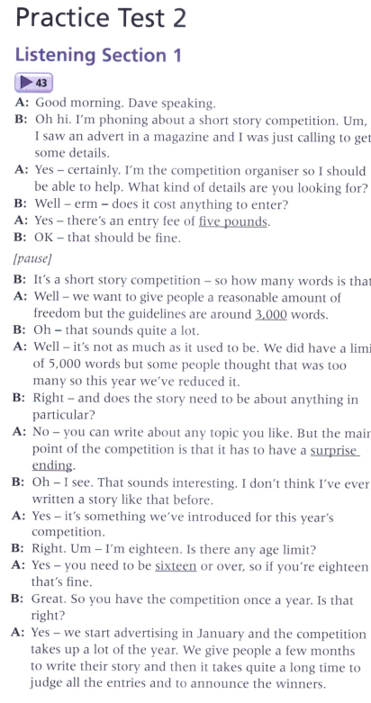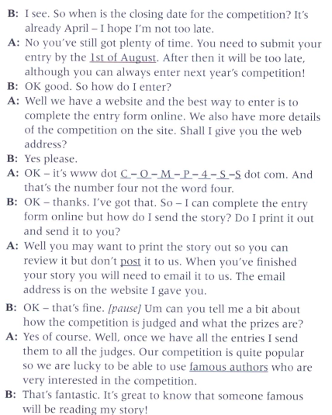

Part 2
