Date: September 4th , 2022

Period 1 INTRODUCING THE PROGRAMS OF ENGLISH 10
I. Objectives
1.Aims:

- Help Ss to know about the English book Global Success grade 10 in general.(Including themes, tests, lessons etc. )
- Introduce how to do an oral test, a fifteen - minute tests and a written test.
- Some requires of student to study well English.
- To help Ss have the opportunities to develop their oral fluency.
- To introduce the theme and units.
- By the end of the lesson, students will be able to:
+ Get to know the topic, the theme and units.
2. Skills : : Integrated, mainly communicative
3. Attitudes
- To help Ss have motivation in learning English
II. Teaching aids and materials.
- Teacher: Handouts, textbook, lesson plan, short videos, pictures, PowerPoint lesson,
- Students: Textbook, notebook, project plans.
III. Methods: - The whole lesson: Integrated, mainly communicative
IV. Teaching Procedure

Time/Stages | Activities | Interactions
1. Warm-up  8 minutes | * chatting  * Aim: get acquainted  * Content: ask ss some questions about their daily routine  * Products: answer the questions naturally  * Steps:  - introduce  - ask ss some questions  - ask ss to make friends by asking their partner some questions  Asks some students to introduce themselves:  What’s your name?  Do you like English?  Do you find English easy or difficult?  Which is the easiest, the most difficult? reading, speaking, listening, or writing?  Why do you learn English?  How long have you learned English?  Are you good or bad at English? | T <--> Ss  Individually
2. Presentation  30 minutes | 1. The text- Global Success 10  * Aim: help ss have general information about the book  * Content: introduce the Content, design, and  * Products: understand what they will learn in this book  * Steps:  - The 1st term  * Unit 1- Unit 5: 8 parts for each unit: getting started, language, reading, speaking, listening, writing, communication and culture and looking back & project  * Review 1, 2  * Written tests: 6: 15’(3) 45’(2) end- term (1)  - The 2nd term:  * Unit 6- Unit 10: 8 parts for each unit: getting started, language, reading, speaking, listening, writing, communication and culture and looking back & project  * Review 3, 4  * Written tests: 6: 15’(3) 45’(2) end- term (1)  2. Teacher’s demand:  - Read the lesson before studying in class.  - Do all exercises at home.  - It is good to find the meaning and the pronunciation of the new words in the dictionary at home.  -Listen to the teacher attentively and take part in the lesson actively and creatively.  - Take part in the activities that the teacher required such as pairs work, group work or individual  - Each S has a notebook and book (student book and work book)  Books  * Global Success Text - 10  * Work - book Global Success 10  At home:  * Prepare for the new lessons: Content, structures, words and phrases, pronunciation  * Revise the old lessons + do all the homework  At class:  * Participate in all activities  * Keep the discipline | T <--> Ss
3.  Consolidation  5 minutes | Students’ assessment  What do you find your English?  Very good/ excellent:  Good:  Average:  Bad:  Very bad:  - Give feedback. | T <--> Ss
4. Homework  2 minutes | - Prepare Unit 1: Family Life  Lesson1: Getting started | T <--> Ss

Date: September 4th , 2022
Period 2: UNIT 1: FAMILY LIFE
Lesson 1: Getting started – Household chores
I/ Learning outcomes:
By the end of this lesson, Ss will be able to:
- Knowledge:
- have an overview about the topic Family life;
- gain vocabulary to talk about household chores.
- Competences:
- develop communication skills;
- be collaborative and supportive in pair work and teamwork;
- actively join in class activities.
- Attributes:
- be aware of responsibilities towards family
II/ Teaching and learning resources:
Tape (CD), Tivi, speakers, textbook, teacher's book, copies of pictures, handouts, laptop, posters
III/ PROCEDURE:
Aims | Contents | Outcomes | Steps
ACTIVITY 1: INTRODUCTION & ENGAGE/ WARM UP (5’)
- Introduce the unit topic (Family life);  - Introduce some vocabulary to be learnt in the unit. | 1. Guessing picture(2’)  What is the picture about?  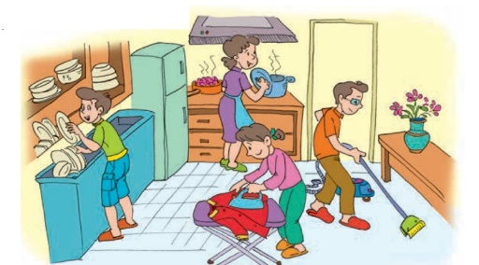 | Students’ oral prediction about the topic  Suggested answer:  Family life/ doing household chores | Elicit  Show the picture to elicit the topic
 | 2.Vocabulary: (3’)  List the household chores that you see in the picture (3’) | Lists of some household chores  Expected answers:  Clean the house  Wash the dishes  Iron clothes  Do the cooking | List  Work in groups of two to list the household chores on the board
ACTIVITY 2: STUDY/ PRESENTATION (15’)
- Understand the related words in the conversation  - Introduce the grammar points to be learnt in the unit. | 1. Vocabulary: (10’)  Look at the photos to guess the meaning of new words  - household (n) /ˈhaʊs.həʊld/  - chore (n) /tʃɔːr/  - breadwinner /ˈbredwɪnə(r)/ (n)  - heavy lifting /ˌhevi ˈlɪftɪŋ/ (np):  - homemaker /ˈhəʊmmeɪkə(r)/ (n):  - laundry /ˈlɔːndri/ (n): | A list of words in notebook | Elicit  Give synonym/ Vietnamese equivalent/ example to elicit vocabulary from Ss
 | * Check vocabulary: | The missing words on the board | Rub out and remember
 | 2. Listen & read (5’)  look at the picture (p.8 - 9) and answer the questions:  - Who are they?  - Where are they?  - What are they doing?  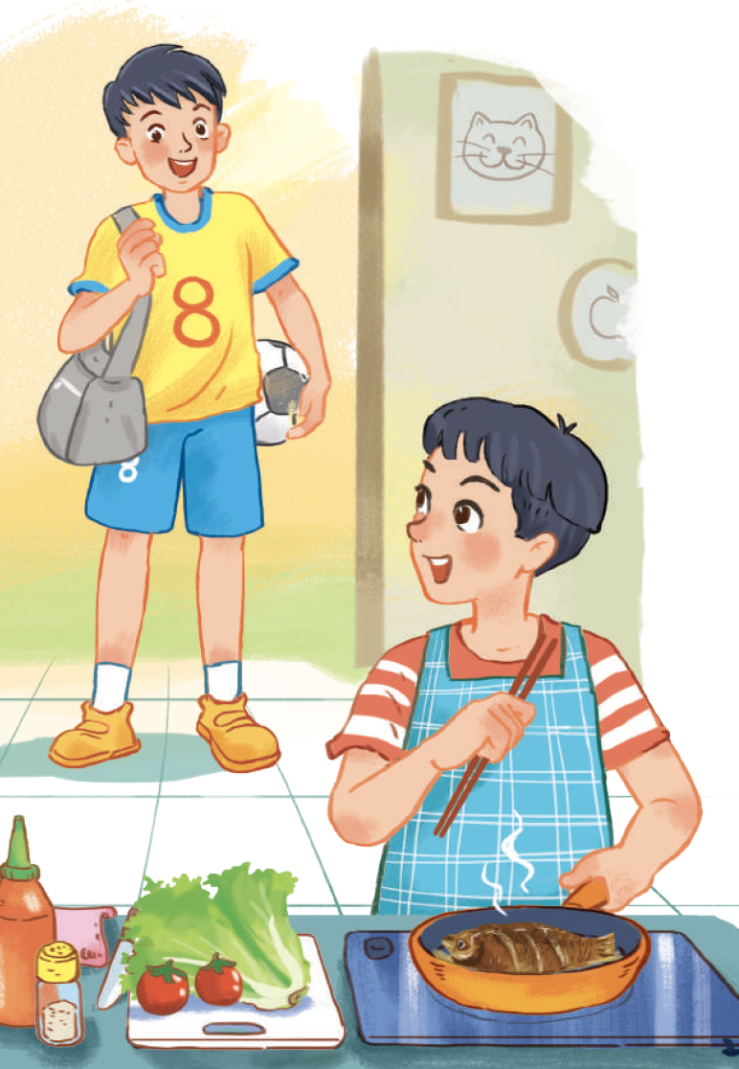 | Ss’prediction about the picture  Suggested answers: They are Nam and Minh. They are at Nam’s home. Nam is cooking. | Set the context for listening and reading the conversation
ACTIVITY 3: ACTIVATE/ PRACTICE (20’)
Practise reading for specific information | 1/ True/False (7’)  Read the conversation again and decide whether the following statements are true (T) or false (F). (p.9)  . | - Ss’ oral prediciton  - Statements identified as true or false  Key:  1.F → Nam is cooking now.  2.T 3.T | Predict then listen and read the conversation  - Work in pairs  - Peer correction  - Teacher’s feedback
- Practise scanning  - Develop students' knowledge of vocabulary for household chores | 2/ Fill in the table (7’)  Write the verbs/verb phrases that are used with the words or phrases in the conversation in 1. (p.9) | Some collocations for household chores  1.put out the rubbish  2.do the laundry  3.shop for groceries  4.do the heavy lifting  do the washing-up | Filling in the table  - Work in pairs  - Peer correction  -Teacher’s feedback
- Identify the present simple and the present continuous, and how they are used in sentences | 3/ Sentence completion (6’)  Complete the sentences from the conversation with the correct forms of the verbs in brackets. (p.9)  - I’d love to, but I’m afraid I can’t. I (prepare) ______ dinner.  - My mum usually (do) ________ the cooking, but she (work) _________ late today. | Completed verbs using th present simple or the present continuous  Answers:  1.‘m preparing  2. does – ‘s working | - Do the task individually  - share the answers with a peer.  - Teacher’s feedback
ACTIVITY 4: CONSOLIDATION/ PRODUCTION (5’)
Help students memorise the target language and skills that they have learned | 1. Wrap up (3’)  Watch the video clip and list all the household chores done in the video | - Ss’ list of household chores on the poster  Suggested answers:  - Clean the toilet  - Wash the clothes  - Vacuum the carpet  - Feed the chicken | Watching and listening  -Work in 4 groups  -Peer correction  - Teacher’s feedback
Inform students what the final product of the project should be and how students can prepare for it. | 2. Homework (2’)  a/ Exercises in the workbook  b/ Project preparation  - Tell Ss the project requirements: Do research on Family Day in Viet Nam or other countries in the world  (related information:time, place, history and reason to celebrate; food, activities)  - Ask Ss to present their plans in the last lesson of the unit. | Ss’ oral presentation of the research results | Groupwork

Date of preparation: September 4th, 2022
Date of teaching: September 7th, 2022
Period 3: UNIT 1: FAMILY LIFE
Lesson 2: Language
I/ Learning outcomes:
By the end of this lesson, Ss will be able to:
1. Knowledge:
- Pronounce the consonant blends /br/, /kr/, and /tr/ correctly in individual words and in sentences.
- Understand and use some lexical items about family life.
- Distinguish and use present simple and present continuous.
2. Competences:
- Be collaborative and supportive in pair work and team work.
- Access and consolidate information from a variety of sources.
- Actively join in class activities.
3. Attributes:
- Be aware of responsibilities towards family
II/ Teaching and learning resources:
Tape (CD), T.V, speakers, textbook, teacher's book, copies of pictures, handouts, laptop, posters…..
III/ PROCEDURE:
Aims | Content | Outcomes | Steps
ACTIVITY 1: PRONUNCIATION/ WARM UP (10’)
- To help students recognise and practise the consonant blends /br/, /kr/, and /tr/ in words. | 1. GAME: Guess the words  * T gives instructions:  - There are 3 pictures related to the consonant blends /br/, /kr/, and /tr/  - Ss have 5 seconds to think, then guess the word corresponding to the pictures.   | Students’ oral prediction about the pictures.  Suggested answers:  1. tree  2. bread  3. cream | Elicit  Show the pictures to elicit the three consonants.
 | 2. TASK 1: LISTEN AND REPEAT.  Pay attention to the consonant blends /br/, /kr/, and /tr/ (p.9)  * Teacher:  - plays the recording and asks Ss to listen to the words and repeat; tell them to pay attention to the consonant blends.  - makes sure Ss know the meaning of each word. | Repeated words with the consonant blends | Listen to the recording/  teacher & repeat in chorus then individually
 | TASK 2: LISTEN TO THE SENTENCES AND CIRCLE THE WORDS YOU HEAR. (p.9)  * Teacher gives the instruction clearly | Circled words.  Suggested answers:  1. b, 2. c , 3. a | Listen to the recording/  teacher and circle the correct words individually.
ACTIVITY 2: VOCABULARY (10’)
To make sure that students understand the meaning of some lexical items about household chores. | TASK 1: MATCH THE WORDS WITH THEIR MEANINGS. (p.10)  * T gives clear instructions. | Marched words with their meaning  Key:  1. b, 2. d, 3. e, 4. a, 5. c | - Work in pairs.  - Peer correction.  -Teacher’s feedback.
 | TASK 2: COMPLETE THE SENTENCES USING THE WORDS IN TASK 1. (p.10)  * T gives clear instructions. | Completed sentences with the words provided  Key:  1. homemaker  2. groceries  3. heavy lifting  4. housework  5. breadwinner | - Work in pairs.  - Peer correction.  -Teacher’s feedback.
ACTIVITY 3: GRAMMAR (12’)
To give students an opportunity to revise the use of present simple and present continuous | TASK 1: CHOOSE THE CORRECT FORM OF THE VERB IN EACH SENTENCE. (p.10)  * Teacher:  - tells Ss to read the sentences in 4 in Getting Started. T asks them what tense(s) is / are used in each of them. | Completed sentences using the correct form of the verbs  Key:  1. does  2.is putting out  3. cleans  4. is studying  5. does | - Work in pairs.  - Peer correction.  -Teacher’s feedback.
- Practise scanning  - Develop students' knowledge of vocabulary for household chores. | TASK 2: COMPLETE THE PARAGRAPH.  - T asks Ss to look at Remember! box again to master the differences  between Present simple and Present continuous.  - T asks Ss to work in pairs. | Completed paragraph using the simple present or present ontinuous  Key:  1. does  2. is not/isn’t doing  3. is watching  4. are doing  5. is tidying up  6. is trying | - Work in pairs.  - Peer correction.  -Teacher’s feedback.
ACTIVITY 4: EXTRA ACTIVITY (8’)
To help students further practise the present tenses forms. | Extra exercise : 10 questions  Put the verbs into the correct forms: present simple or present continuous.  1. Listen! My sister (sing)______a song.  2. Every night, we (go)___to bed at 11p.m.  3. Now, they (stay)______ in Ha Noi .  4. My grandfather often (read) ________ a newspaper in the morning.  5. Look! Hoa (run)____________.  6. Thuy usually (listen)_____ to the teacher in the class, but she (not listen) ____now.  7.Everyday, Mr. Hoang (not go) ______to work by car.  8. In the autumn, he rarely (go)_______ sailing and (go)________ to school.  9. I (write)____________ a letter to my best friend now.  10. At 11 a.m every day, I (have)_______ lunch and (go)________ to bed. | Completed sentences using the present simple or present continuous  * Key:  1. is singing 2. go  3. are staying 4. reads  5. is running  6. listens/ isn’t listening  7. doesn’t go  8. goes/ goes  9. am writing  10. have / go | - Give the handouts.  - Work in pairs.  - Peer correction.  -Teacher’s feedback.
ACTIVITY 5: CONSOLIDATION: (5’)
To help students memorize the target language and skills that they have learnt | WRAP-UP  - the consonant blends /br/, /kr/, and /tr/  - present simple or present continuous.  HOMEWORK:  - Exercises in the workbook.  - Prepare for lesson 3 Unit 1. | * Students’ list of what they have learnt.  - consonant blends /br/, /kr/, and /tr/.  - some lexical items about household chores.  - present simple vs. present continuous. | * Ss work individually.

Hand – out:
Language analysis
 | Present simple | Present continuous
1. Form | (+) S + V(s/es).  (-) S + do not/ does not (don't / doesn't) + V.  (?) Do/Does + S + V? | (+) S + am/is/are + Ving.  (-) S + am/is/ are + not (‘m not/ isn’t/ aren’t) + Ving.  (?) Am/ Is/ Are + S + Ving?
2. Uses | We use present simple to talk about habits or things we do regularly.  Example: My mother cooks every day. | We use present continuous to talk about things which are happening at the moment of speaking.  Example: My mother isn’t cooking now. She’s working in her office.
3. Time expressions | usually, always, every day, often, never, seldom…  🡪 adverbs of frequency | now, at the moment, at present, presently, …
Put the verbs into the correct forms: present simple or present continuous.
1. Listen! My sister (sing)______a song.
2. Every night, we (go)___to bed at 11p.m.
3. Now, they (stay)______ in Ha Noi .
4. My grandfather often (read) ________ a newspaper in the morning.
5. Look! Hoa (run)____________.
6. Thuy usually (listen)_____ to the teacher in the class, but she (not listen) ____now.
7.Everyday, Mr. Hoang (not go) ______to work by car.
8. In the autumn, he rarely (go)_______ sailing and (go)________ to school.
9. I (write)____________ a letter to my best friend now.
10. At 11 a.m every day, I (have)_______ lunch and (go)________ to bed.

Date: September 8th , 2022
Period 4- UNIT 1: FAMILY LIFE
Lesson 3: Reading – Benefits of doing housework
I/ Learning outcomes:
By the end of this lesson, Ss will be able to:
- Knowledge:
- have an overview about “Benefits of doing housework”
- gain vocabulary to talk about household chores
- Competences:
- develop reading skills for specific information
- provide Ss with more language and ideas about “Benefits of doing housework”
- Attributes:
- be aware of responsibilities towards household chore sharing in the family
II/ Teaching and learning resources:
Tape (CD), TV, speakers, textbook, teacher's book, copies of pictures, handouts, laptop, posters, Wifi connection
III/ PROCEDURE:

Aims | Content | Outcomes | Steps
ENGAGE/ WARM UP (5’)
- To create a friendly and lively atmosphere in the classroom | Introduction: (5’) | Ss’s chance to get to know each other | Introduce
- To familiarize Ss with the topic of the reading text  - To lead in the reading lesson | Asking questions using picture: (5’)  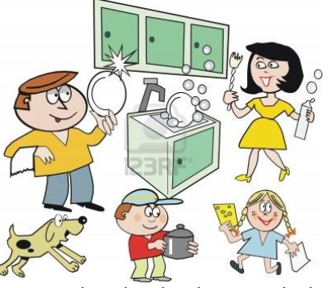  1. Who does the housework in your family?  2. How is the housework shared in your family?  3. What is your duty? | Ss’s oral prediction about the topic  Suggested answers:  1. Mother/ Father/ Children, etc.  2. Equally/ unequally  3. Clean the floor/ Wash the dishes/… | - T raises questions  - Sts answer
STUDY/ PRESENTATION (15’)
- To understand the new words in the reading. | Vocabulary:  + responsible /rɪˈspɒnsəbəl/ (adj): có trách nhiệm.  → (be) responsible for  → responsibility (n)  → take responsibility for  + gratitude /ˈɡrætɪtʃuːd/ (n): lòng biết ơn  → express one’s gratitude to SB  + strengthen /ˈstreŋθən/ (v): củng cố  + bond /bɒnd/ (n) = strong connection  + character /ˈkærəktər/ (n): tính cách | - A list of words in Ss’ notebook | Elicit  Give synonym/ Vietnamese equivalent/ example/pictures to elicit vocabulary from Ss
 | * Listen & repeat | Sts’ pronunciation of the words | Listen to the audio/teacher & repeat in chorus then individually
 | * Check vocabulary: | The missing words on the board | Rub out and remember
- To help Ss practise guessing the meanings of words in context. | Task 2: Read the text and tick (✔) the appropriate meaning of the highlighted words. (ex.2, p.11) (8’) | Some words or phrases ticked  Suggested answers:  1. a 2. b  3. a 4. a  5. b | Asks Ss to read and match the highlighted words and phrases in the text to their meanings.
ACTIVATE/ PRACTICE (20’)
- To practise reading for specific information | TASK 3: Read the text again and answer the answers. (Ex.3, p.12) (10’)  1. Most people think that housework is boring and the responsibility of wives and mothers only.  2. They want to give their children more time to play and study.  3. These are doing the laundry, cleaning the house, and taking care of others.  4. They learn that they have to try to finish their task even though they do not enjoy doing them.  5. Because children learn to appreciate all the hard work their parents do around the house for them. They also start treating doing household chores as special moments shared with their parents. | - Ss’ answers of the questions | - Work in pairs  - Read the text & questions then underline the key words.  - Find the answers.  - Peer correction  - Teacher’s feedback
To help Ss use the ideas and language in the reading or in their own ideas to talk about the benefits they can get from sharing housework | TASK 4: Work in groups. Discuss the question “What benefits do you think you can get from sharing housework?” (‘10’)  → Some hints:  - Learning to take responsibility  - Developing gratitude to their parents  - Strengthen family bonds  - Reduce family stress | Ss’ ideas and oral presentation about benefits of sharing household chores.  Suggested answers  → There are some huge benefits of sharing housework. Firstly,... | - Ss find out the benefits of sharing housework both in the passage and in their own ideas.  - Ss make a mindmap and present what they have discussed.  -Teacher’s feedback
CONSOLIDATION/ PRODUCTION (5’)
- To help students memorise the target language and skills that they have learned | 1.WRAP-UP (3’)  The teacher asks:  - What have you learnt today?  - What are the benefits of doing housework? | Ss’ reflection about the content of the lesson. | - Class work  - Teacher’s feedback
- To guide students to prepare for the next lesson. | 2. HOMEWORK (2’)  a/ Do exercises in the workbook.  b/ Learn the new words by heart.  c/ Ask sts to summarize the passage.  d/ Prepare for Speaking lesson. | Ss’ oral presentation of the research results. | Ss do individually

Date: September 10th , 2022

Period 5-UNIT 1: FAMILY LIFE
Lesson 4: SPEAKING
I/ Learning outcomes:
By the end of this lesson, Ss will be able to:
- Knowledge:
- Explain why children should or shouldn’t do housework;
- Discuss and express their opinions about why children should or shouldn’t do the housework.
- Competences:
- Be collaborative and supportive in pair work and team work;
- Develop presentation skills;
- Actively join in class activities;
- Be critical thinking.
- Attributes:
- Recognise the benefits of doing housework for children;
- Understand why children should or shouldn’t do housework;
- Sharing housework with their families.
II/ Teaching and learning resources:
Tape (CD), Tivi, speakers, textbook, teacher's book, handouts, laptop, posters
III/ PROCEDURE:
Aims | Content | Outcomes | Steps
ACTIVITY 1: WARM UP (5’)
- Create a friendly and lively atmosphere in the classroom  - Lead to the new lesson  - review some words & phrases related to household chores | 1. Game: Miming  - Clean the house  - Wash the dishes  - Water the plants  - Do the cooking  - Put out the rubbish  - Shop for groceries | Students’ oral prediction about the topic | Elicit  Give some phrases related to household chores
ACTIVITY 2: STUDY/ PRESENTATION (15’)
- Recall reasons from the reading text why people think children should or shouldn’t do housework and provide them with more ideas. | TASK 1: Below are reasons why children should or shouldn’t do housework. Put them in the correct column. Add some more if you can.  - Recall lexical items from previous lessons by asking Ss to call out the meaning of some words:  - develop life skills  - take responsibility  - break and damage things  - strengthen family bonds | Students’ oral presentation  KEY:  - phát triển kỹ năng mềm/ cuộc sống  - chịu trách nhiệm  - làm vỡ/ bể và làm hư hỏng đồ đạc  - thắt chặt sự gắn bó gia đình | Elicit  Give some phrases related to family life  Teacher’s feedback
 | - Ask Ss to read the reasons carefully and put them in the correct column  -Encourage Ss to raise their ideas | Students’ oral presentation  KEY:  List some more reasons  Expected answers:  - Chores teach time management.  - Completing chores can make children more confident.  - Most chores are not really for the children and can be dangerous  - Children won’t have time to take part in after-school activities | - Work in pairs  - Peer correction  - Teacher’s feedback  List  Work in pairs to list some more reasons  -Teacher’s feedback
  SHOULD | SHOULDN’T
  SHOULD
  1. Doing housework helps them develop life skills.
  2. Doing housework teaches them to take responsibility.
  5. Doing housework helps strengthen family bonds.
  SHOULDN’T
  3. Kids should be given plenty of playtime when they are young.
  4. They may break or damage things when doing housework.
  6. They need more time to study and do homework.
To provide students with an example conversation in which people express their opinions about whether children should or shouldn't do housework. | TASK 2: Complete & Listen the conversation  - Complete the conversation between Anna, Nam and Minh using some ideas from Task 1 (p.12) | - Completed conversation with the ideas provided  Key:  1.Doing housework helps them develop life skills.  2. They should be given plenty of playtime when they are young. | Listen the conversation & check  - Work in pairs  - Peer correction  - Teacher’s feedback
 | Practise the conversation | - Ss’ oral practice | - Work in groups of three  - Teacher’s feedback
ACTIVITY 3: ACTIVATE/ PRACTICE (20’)
To help students practise having conversations in which they can express their opinions about why children should or shouldn’t do housework. | MAKE CONVERSATIONS SIMILAR TO THE ONE IN TASK 2. (p.12)  - Remind Ss to swap roles and role-play their conversations | - Ss’ role-play/ conversation | - Work in groups of three  -Peer correction  - Teacher’s feedback
ACTIVITY 4: CONSOLIDATION/ PRODUCTION (5’)
- To consolidate what students have learnt in the lesson. | 1.WRAP-UP  Teacher asks: “ What are the benefits of doing household chores?” | Students’ oral presentation | -Work in groups of three  -Peer correction  - Teacher’s feedback
- To prepare for the next lesson. | 2. HOMEWORK  - Do exercises in the workbook  - Practice more conversation at home  -Prepare for the Listening lesson | Ss’ oral presentation | Groupwork

Date: September 15th , 2022

Period 6:UNIT 1: FAMILY LIFE
Lesson 1: Listening – Household chores
I/ Learning outcomes:
By the end of this lesson, Ss will be able to:
- Knowledge:
- Listen for details and specific information in a talk show about family life;
- Apply the language they have learnt in the listening in a speaking task about their own experiences.
- Competences:
- develop communication skills;
- be collaborative and supportive in pair work and teamwork;
- actively join in class activities.
- Attributes:
- Recognise how our families have helped us achieve success in our lives;
- Show gratitude towards our families.
II/ Teaching and learning resources:
Tape (CD), Tivi, speakers, textbook, teacher's book, copies of pictures, handouts, laptop, posters
III/ PROCEDURE:
Aims | Content | Outcomes | Steps
ACTIVITY 1: IN TRODUCTION & ENGAGE/ WARM UP (5’)
- To lead in the lesson | What are the roles of men and women in the family? (5)  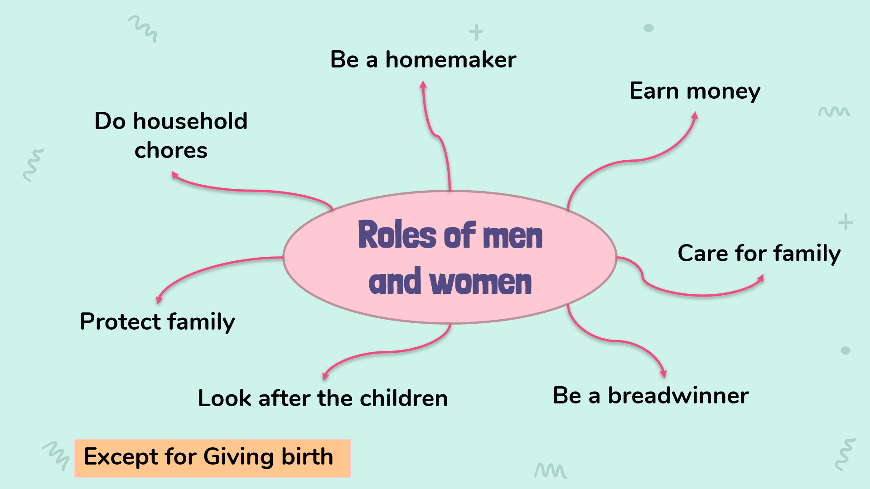 | Lists of the roles of men and women in the family  Suggested answer:  - doing household chores  -Earning money  - Protecting family | Elicit  Show the picture to elicit the topic
ACTIVITY 2: PRE-LISTENING {15’)
To introduce the topic of the listening extract and activate students’ prior knowledge. | 1. look at the photos to guess the meaning of new words (10’)  - Support (n):  - Cheer S.O up (v)  - Routine (n)  - Achievement (n): | A list of words in notebook | Elicit  Give synonym/ Vietnamese equivalent/ example to elicit vocabulary from Ss
 | * Listen & repeat | Sts’ pronunciation of the words | Listen to the audio/teacher & repeat in chorus then individually
 | * Check vocabulary: | The missing words on the board | Rub out and remember
 | 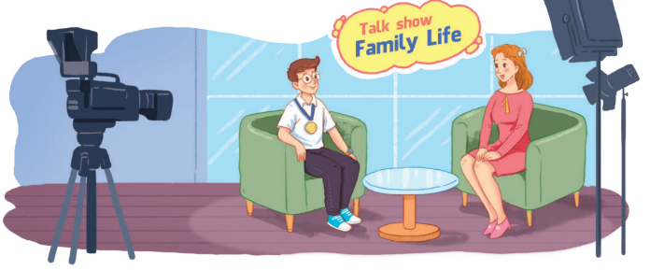  2 TASK 1: LOOK AT THE PICTURE AND ANSWER THE QUESTIONS.  (p. 13)  Suggested questions:  Who are the people?  Where are they?  What is in the background?  What are they doing?  What’s the boy wearing around his neck? | Ss’prediction about the picture  Suggested answers:  A student and the host of a talk show  In a studio  Name of the show: Family Life  Talking; The host is interviewing the student.  A gold medal | Set the context for listening.  - asks Ss to work in pairs, look at the picture and answer the questions.  - tells Ss that there are no right or wrong answers and they should feel free to make any guesses.  ** Ss answer the questions.  *** T confirms, shows the answers on the screen.
ACTIVITY 3: WHILE- LISTENING (20’)
To help students practise listening for specific information in an extract of a talk show and comparing their predictions with what they hear | TASK 2: LISTEN TO THE INTRODUCTION TO THE TALK SHOW AND CHECK WHETHER YOUR ANSWER TO QUESTION 2 ABOVE IS CORRECT OR NOT. (p.13)  * Teachers:  - tells Ss that they are going to listen to part of the talk show and decide whether their guesses are correct.  . | Ss’ prediction  T - S  T – S  S-T | Predict then listen and read the conversation  - Work in pairs  - Peer correction  - Teacher’s feedback  ** T plays the recording.  *** T confirms, shows the answers on the screen and asks Ss to make correction if they made a wrong answer.
To help students practise listening for details. | TASK 3: TRUE OR FALSE. (p.13)  .  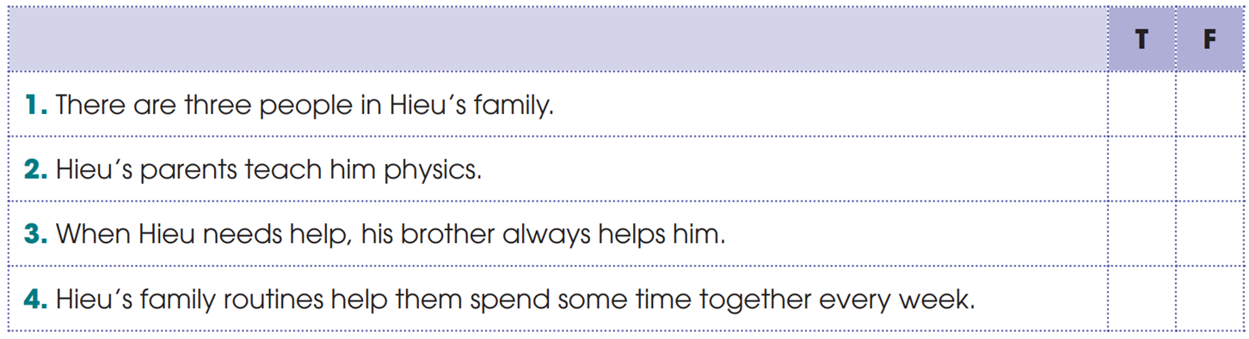 | Statements identified as true or false  Key: 1. F 2. F 3. T 4. T | Ss listen and check their answer.  - asks Ss to read through the statements once and underline the key words in them.  ** T plays the recording twice. Ss do the task and correct the false statements.  *** T checks answers
To help students practise listening for keywords. | 4 TASK 4: LISTEN AND COMPLETE THE SENTENCES. (p.13)  . | Completed sentences with the words provided  Key: 1. difficulties 2. love 3. sad | - Do the task individually  - share the answers with a peer.  - Teacher’s feedback
ACTIVITY 4: POST-LISTENING (10’)
To help students apply the language they have learnt in the listening in a speaking task about their own experiences. | TASK 5: DISCUSSION (p.13)  Work in groups. Discuss the following question.  “How can parents help their children achieve success in their studies?”  . | T - S  S - T - S  T - S | - having Ss work in groups of three and tells them to think about their own family to answer the question.  ** Ss prepare their presentation in groups. Each group chooses a representative to share the group’s ideas with the class.  *** T gives feedback
ACTIVITY 5: CONSOLIDATION/ PRODUCTION (5’)
- To consolidate what students have learnt in the lesson  - To prepare for the next lessons | 1.WRAP-UP (3’)  - How can parents help their children achieve success in their studies | - Ss’ list | -Peer correction  - Teacher’s feedback
- To prepare for the next lessons | 2. HOMEWORK (2’)  - Do the Listening exercises in the Workbook  - Prepare for the Writing lesson | Ss’ oral presentation of the research results | Groupwork

Date: September 17th , 2022
Period 7-UNIT 1: FAMILY LIFE
Lesson 6: Writing – Writing about family routines
I/ Learning outcomes:
By the end of this lesson, Ss will be able to:
- Knowledge:
- Use lexical items related to the topic “Family life”;
- Write an email to a friend about family routines.
- Competences:
- Develop communication skills;
- Be collaborative and supportive in pair work and teamwork;
- Actively join in class activities.
- Attributes:
- Be able and willing to share housework in the family.
II/ Teaching and learning resources:
- Grade 10 textbook, Unit 1, writing
- Computer connected to the Internet
- Projector/ TV/ pictures and cards
III/ PROCEDURE:
Aims | Content | Outcomes | Steps
ACTIVITY 1: WARM UP (7’)
- To introduce the concept of family routines and activities that can become part of them. | Which pictures can be family routines? (7’)  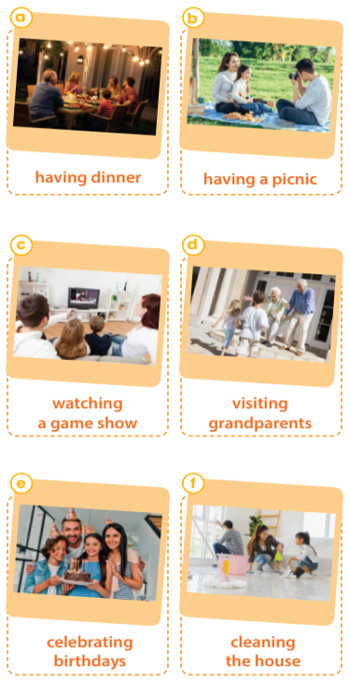 | - Ss’ ideas about family routines. | - To show the pictures and tell them to say what they depict.
ACTIVITY 2: STUDY/ PRESENTATION (15’)
-To provide an example email about family routines, which Ss can use as a model for their writing. | - Read Joey’s email about his family routines and complete the table with the information from it. (10’) | - Useful expressions of an email.  Suggested answers:  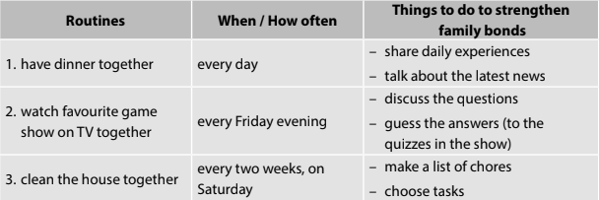 | - To explain the task  - To have Ss read the table headings.  - To read the email and underline the relevant information, then complete the table.
  Routines | When/ How often | Things to do to strengthen family bonds
  1. have dinner together
  2. | every Friday evening
  3. |  | - make a list of chores  - choose tasks
ACTIVITY 3: ACTIVATE/ PRACTICE (17’)
- To help students practise writing part of an email about family routines using given ideas. | 1. Instruct how to write the middle paragraph of the email.  + A paragraph is a group of sentences that develop ONE main idea.  + A paragraph usually consists of three parts: a topic sentence, supporting sentences and a concluding sentence.  + Two important qualities of a good paragraph are unity and coherence | - Some basic information about the structure of a paragraph  . | - To tell Ss that they are going to write a paragraph about family routines. They don’t have to write a whole email, and the opening and ending have been provided.  - To give Ss some basic information about the structure of a paragraph.
- To practise writing part of an email about family routines by using given ideas.  - To help students practise developing ideas and writing a paragraph. | 2. Complete the email about Dong’s family routines using the information in the box.  . | - Completion of the middle of an email.  Sample:  First, my family always have breakfast together. We often eat bread or noodles and share our plan for the day while eating. Second, we watch our favourite film on TV together every Saturday evening. We watch a film and share snacks. Then, we exchange opinions after the film. Third, on the second Sunday of the month, we visit our grandparents. When coming to our grandparents’ house, we usually do some housework for them and have lunch with them. They look really happy when talking and eating with us. | - To explain the task.  - To have Ss read the information in the table and check comprehension.  - To ask Ss to write the middle paragraph of the email.  - To offer support when necessary.
- To give students an opportunity to recognise the common mistakes so that they can avoid in writing | 3. Peer correction | - Ss’ sharing the writing and giving comments. | - To ask two Ss sitting next to each other to exchange their writing, read their partner’s writing and write the symbols next to their partner’s mistakes like the ones in the table above.  - To ask Ss to return their partner’s writing and lets them correct themselves.  - To remind them that they can ask for their partner’s help.
ACTIVITY 4: CONSOLIDATION/ PRODUCTION (6’)
- To help students memorise the target language and skills that they have learned. | 1. WRAP-UP  - We have practised writing a paragraph about family routines. | Ss’ oral presentation of writing an email about daily routines. | pairwork
- To help students memorise the content of the lesson and how students can prepare for new lesson. | 2. HOMEWORK  a/ Exercises in the workbook  b/ Prepare for Communication and Culture lesson |  | Groupwork

Date: September17th , 2022
Period 8-UNIT 1: FAMILY LIFE
Lesson 7: Communication and culture/ CLIL
I/ Learning outcomes:
By the end of this lesson, Ss will be able to:
- Knowledge:
- express their opinions in a conversation about whether family members should spend time together;
- understand British family values.
- Competences:
- be collaborative and supportive in pair work and team work;
- access and consolidate information from a variety of sources;
- actively join in class activities.
- Attributes:
- be more respectful of Vietnamese and British family values;
- be able and willing to embrace those family values.
II/ Teaching and learning resources:
- Grade 10 textbook, Unit 1, Communication and Culture/ CLIL
- Computer connected to the Internet
- Projector/ TV/ pictures and cards
III/ PROCEDURE:
Aims | Content | Outcomes | Steps
ACTIVITY 1: WARM UP (7’)
- To arouse the classroom atmosphere.  - To help students revise words/ phrases related to the topic. | List the advantages or disadvantages of sharing housework. | List of advantages or disadvantages of sharing housework | List  - Work in groups to list the advantages or disadvantages of sharing housework.
EVERYDAY ENGLISH - ACTIVITY 2: PRESENTATION (12’)
- To provide students with an example conversation in which people exchange opinions about  teenagers doing housework. | 1. Listen and complete the conversation with the expressions in the box. | Completed conversation with the expressions provided  Key:  1.A  2. C  3. B | - Listen to the audio/teacher & complete the conversation.
 | 2. Practise the conversation. | - Sts’ role play | - Work in groups of three to practise the conversation.
EVERYDAY ENGLISH - ACTIVITY 3: PRACTICE (6’)
- To help Ss practise expressing their opinions in a conversation about whether family members should spend time together. | - Have similar conversations exchanging opinions about whether family members should spend time together. | - Ss’ oral presentation of expressing opinions.  (e.g. Advantages: It strengthens family bonds; It makes children happy, develops their self-confidence; Children can learn life skills and how to behave from their parents.  Disadvantages: Children may become too dependent on their parents, do not have enough time for friends or other relationships, etc.) | Making a conversation  - Work in groups  - Peer correction  -Teacher’s feedback
CULTURE - ACTIVITY 4: STUDY/ PRESENTATION (12’)
- To pre-teach the meaning and pronunciation of some words/ phrases, so that students can use them in their presentation later and can understand the reading passage. | 1. Vocabulary  1. pass on sth (phr.v): give something to someone who lives after you die, usually a person in your family    2. truthful (a): honest and not containing or telling any lies    3. respectively (adv): with each relating to something previously mentioned, in the same order as first mentioned  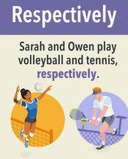 | List of words/ phrases in Ss’ notebook | Elicit  - Give synonym/ Vietnamese equivalent/ example to elicit vocabulary from Ss
- To help students learn about British family values and practise reading for specific information. | 2. Read the text and complete the table.  Read the text and list the five family values of British people in the 21st century in the table below. | - Table completion  Keys:  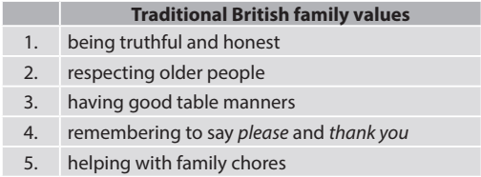 | Filling in the table  - Work in pairs  - Peer correction  -Teacher’s feedback
CULTURE - ACTIVITY 5: PRODUCTION (5’)
- To compare traditional British family values with traditional Vietnamese family values. | Discussion  Work in groups. Discuss whether Vietnamese people have similar family values.  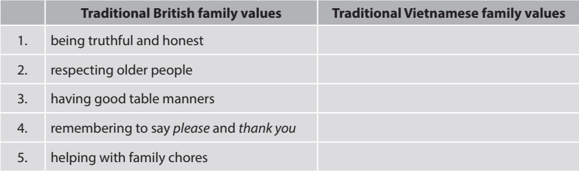 | - Ss’ oral presentation | Making a comparison  - Work in 4 groups  - Peer correction  - Teacher’s feedback
ACTIVITY 6: CONSOLIDATION (3’)
- To help students memorise the target language and skills that they have learned. | 1. WRAP-UP  - The ways to express opinions  - British and Vietnamese family values | - Ss’ oral presentation of expressing their opinions in a conversation about whether family members should spend time together and British and Vietnamese family values
 | 2. HOMEWORK  - Do exercises in the part Looking back  - Exercises in the workbook  - Prepare for Looking back and Project lesson |  | Groupwork

Date 19/09/2022
Period 9-UNIT 1: FAMILY LIFE
Lesson 8: Looking back & Project
I. OBJECTIVES
By the end of this lesson, Ss will be able to :
1. Knowledge
- review pronouncing consonant blends /br/, /kr/, /tr/
- review the vocabulary and grammar of Unit 1
- do research on Family Day in Viet Nam or other countries in the world and give a group presentation about it.
2. Core competence
- develop communication skills and creativity;
- develop presentation skills;
- develop critical thinking skills;
- be collaborative and supportive in pair work and team work;
- actively join in class activities.
3. Personal qualities
- be more creative when doing the project;
- develop self-study skills.

II/ TEACHING AND LEARNING RESOURCES:
- Textbook
- Laptop connected to the Internet
- TV/ pictures and cards
- Pictures, A0 paper
III/ PROCEDURE:
Aims | Content | Outcomes | Steps
ACTIVITY 1: WARM-UP (5mins)
- To arouse the classroom atmosphere.  - To help students revise words/ phrases related to the topic |       Brainstorming  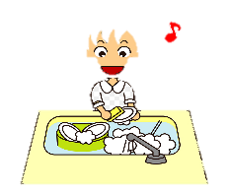  Household chores    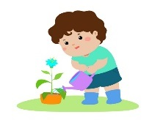     | List of words about the topic “Household chores” | List  Write down as many words as they can think of about the topic “Household chores”.
ACTIVITY 2: LOOKING BACK (17 mins)
To help students revise the consonant blends /br/, /kr/, and /tr/.  To help students revise words and phrases related to the topic of household chores, which they have learnt in the unit.  To help students revise the Present simple and Present continuous. | 1. PRONUNCIATION: LISTEN AND WRITE /BR/, /KR/ OR /TR/. (p.16)  6 mins  Listen and write /br/, /kr/, or /tr/ above the word that has the corresponding consonant blends. Then practise reading the sentences.  2. VOCABULARY: COMPLETE THE TEXT. (p.16) 5 mins  Complete the text. Use the correct form of the word and phrases in the box.  3. GRAMMAR: THERE IS A MISTAKE IN EACH SENTENCE BELOW. FIND THE MISTAKE AND CORRECT IT. (p.16) 6 mins | Ss’ practice reading the corresponding consonant blends  /kr/ /br/  1. I like ice cream, but my brother likes bread pudding.  /br/  /tr/ /kr/ /tr/  2. Tracy crashed her car into a tree and broke her leg.  /br/  /kr/ /br/  3. They often have crab soup for breakfast.  Completed text with words and phrases provided  1. does the cooking  2. does the heavy lifting  3. laundry  4. cleaning the house  5. does the washing-up  Corrected sentences  Key:  1. I’m wanting to see you. → want  2. I look after his dog. → ’m / am looking  3. Nam’s often looking untidy. → (often) looks  4. She cooks dinner. → ’s / is cooking  5. Excuse me, do you read the newspaper? Could I borrow it? → are you reading  6. What are your family doing in the evenings? → do / does ... do | - Do the task individually  - share the answers with a peer.  - Teacher’s feedback  - Do the task in groups of four.  - Write the missing words/ phrases on the board.  - Teacher’s feedback  - Do the task in pairs.  - Share the answers with another pair.  - Teacher’s feedback
ACTIVITY 3: PROJECT (21 mins)
To provide an opportunity for students to develop their research and collaboration skills and to practise giving an oral presentation. | Do research on Family Day in Viet Nam or other countries in the world    Present your findings to the class. Your presentation should include:  - Where it is celebrated  - When it is celebrated  - When it was first celebrated  - Why it is celebrated  - What people often do to celebrate the day | Ss’ oral presentation | * Teacher:  - Gives Ss a checklist for peer and self-assessment and explains that they will have to tick the appropriate items while listening to their classmates’ presentations and write comments if they have any. (The presenters should complete their self-assessment checklist after completing their presentation).  - Goes through the criteria for assessing their talk to make sure Ss are familiar with them.  - Invites two or three groups to give their presentations and encourages the rest of the class to ask questions at the end.  ** Ss do as instructed.  *** Ss make questions after each presentation.  **** Teacher:  - Gives praise and feedback after each presentation and gives marks for their presentation as part of their continuous assessment.  - Asks Ss to complete the self-assessment table, identifies any difficulties and weak areas and suggests further practice for individual Ss.
ACTIVITY 4: CONSOLIDATION (2 mins)
- To consolidate what students have learnt in the lesson.  - To prepare for the next lesson. | 1. WRAP-UP  - Revise the consonant blends /br/, /kr/, and /tr/.  - Revise words/ phrases related to the topic Household chores.  - Revise Present simple and Present continuous.  2. HOMEWORK  - Exercises in the workbook  - Prepare for Unit 2 lesson 1 |  | *T instructs  *Ss take notes

APPENDIXES
Suggested checklist for peer assessment:
 | Tick where appropriate | Comments (in English or Vietnamese)
DELIVERY
- The presenters greeted the audience.
- The presenters spoke clearly and naturally.
- The presenters cooperated when delivering their talk.
- The presenters interacted with the audience.
- The presenters used some photos /pictures to illustrate their ideas.
- The presenters concluded their talk appropriately
CONTENT: The presentation includes the following information about Family Day in Viet Nam or other countries.
- where it is celebrated
- when it is celebrated
- when it was first celebrated
- why it is celebrated
- what people often do to celebrate the day

Suggested checklist for self-assessment:
 | Tick where appropriate | Comments (in English or Vietnamese)
DELIVERY
- I greeted the audience.
- I spoke clearly and naturally.
- I cooperated with my group members when delivering the talk.
- I interacted with the audience.
- I used some photos / pictures to illustrate my ideas.
- I concluded my part of the talk appropriately.
CONTENT: The presentation includes the following information about Family Day in Viet Nam or other countries.
- where it is celebrated
- when it is celebrated
- when it was first celebrated
- why it is celebrated
- what people often do to celebrate the day

Date: September 24th , 2022
Period 10-UNIT 2: HUMANS AND THE ENVIRONMENT
Lesson 1: Getting started – Go Green Club
I/ Learning outcomes:
By the end of this lesson, Ss will be able to:
- Knowledge:
- Have an overview about the topic Human and the Environment.
- Gain vocabulary to talk about activities to adopt a greener lifestyle.
- Competences:
- Develop communication skills and environmental awareness.
- Be collaborative and supportive in pair work and teamwork.
- Actively join in class activities.
- Attributes:
- Develop a greener lifestyle and awareness of environmental issues;
- Be responsible to the environment.
II/ Teaching and learning resources:
- Tivi, speakers, textbook, teacher's book, copies of pictures, handouts, laptop, and posters

III/ PROCEDURE:
Aims | Content | Outcomes | Steps
ACTIVITY 1: IN TRODUCTION & ENGAGE/ WARM UP (5’)
- Introduce the unit topic ( Humans and the environment);  - Introduce some vocabulary to be learnt in the unit. | 1a. What are they doing?  1b. What for? (2’)  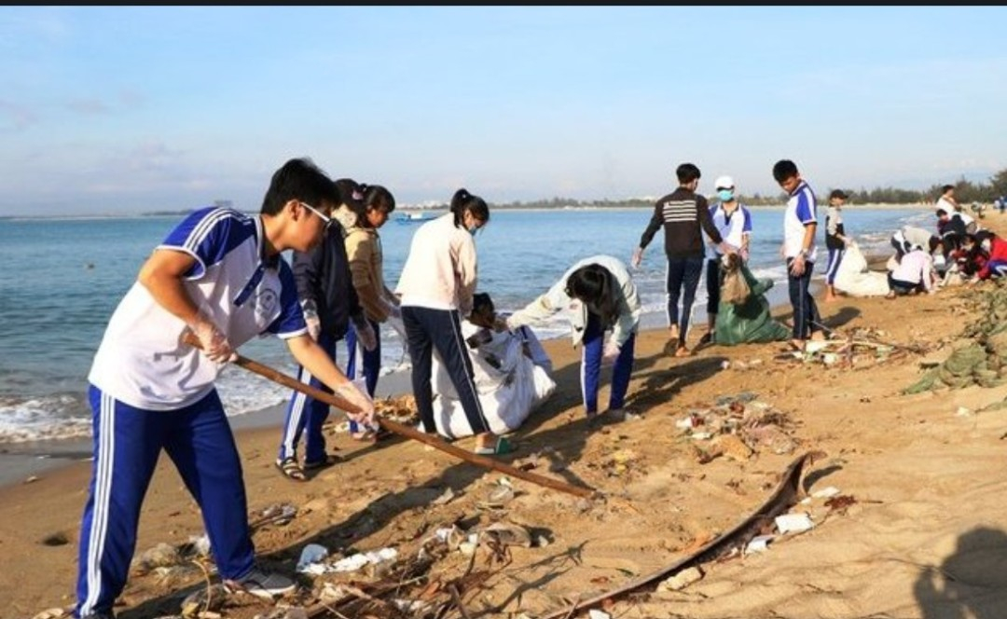 | Students’ oral prediction about the topic  Suggested answer:  2a. collecting garbage on the beach./ cleaning up the beach.  2b. to protect the environment. | Elicit  Show the picture to elicit the topic
 | 2. List the work that you do to protect the environment (3’)  T gives some cues to help students if they can’t do the task. | List of the work to protect the environment  Expected answers:  - planting trees.  - collecting garbage.  - sweeping school yard/ classrooms.  - Saving water, energy.  - watering flowers, plants  - taking out garbage.  - …………………. | Work in pairs to list some of the work that you do to protect the environment on the board
ACTIVITY 2: STUDY/ PRESENTATION (15’)
- Understand the related words in the environment.  - Introduce the grammar points to be learnt in the unit. | 1. Vocabulary  1. adopt (v) /əˈdɒpt/: start to use a particular method  2. awareness (of) (n) /əˈweənəs/: interest in and concern about a particular situation or area of interest    3. carbon footprint (n) /ˌkɑːbən ˈfʊtprɪnt/: a measure of the amount of carbon dioxide that is produced by the activities of a person or company  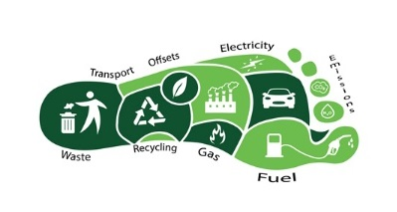  4. set up (v) /set ʌp/: = establish (synonym)  5. reduce (v) /rɪˈdʒuːs/ >< increase ( antonym) | A list of words in notebook | Elicit  Give synonym/ Vietnamese equivalent/ example to elicit vocabulary from Ss
 | * Listen & repeat | Sts’ pronunciation of the words | Listen to the audio/teacher & repeat in chorus then individually
 | * Check vocabulary:  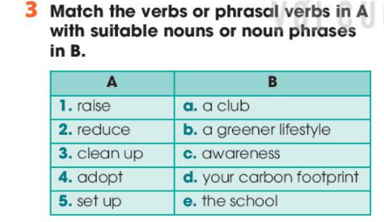 | - The missing words on the board.  - Do the task 3.  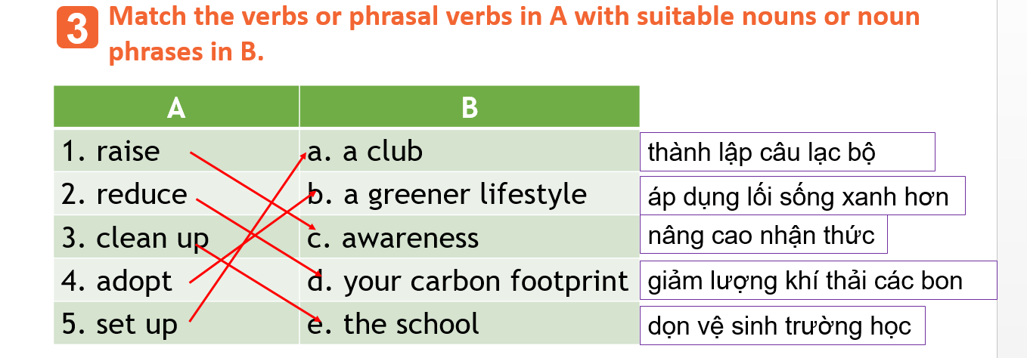 | Rub out and remember
 | 2. Listen & read (5’)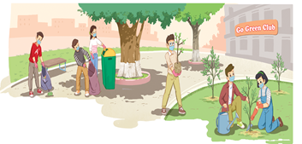  look at the picture (p.18 - 19) and answer the questions:  - Who are they?  - Where are they?  - What are they doing?  - Is cleaning up the school/ the street/ public places a way to adopt a green lifestyle?  * T leads to the new lesson.  * T plays the recording twice, has Ss listen to the conversation, read along and underline the activities in the conversation which are good for the environment.  ** Ss do the task individually.  *** Ss share their answers with a partner.  **** T checks their answers with the whole class.  * T has the Ss read the conversation in pairs.  ** Ss read the conversation.  *** One or two pairs read aloud. | Ss’prediction about the picture  Suggested answers:  - They are students.  - They are at school.  - They are cleaning up the school and planting trees.  - Yes, it is.  Suggested answers:  - adopting a greener lifestyle.  - raising local people’s awareness of environmental issues.  - reducing my carbon footprint | Set the context for listening and reading the conversation
ACTIVITY 3: ACTIVATE/ PRACTICE (15’)
Practise reading for specific information | TASK 2: READ AND ANSWER THE QUESTIONS. (p.19)  Read the conversation again and answer the following questions.  * T asks Ss to work individually to read the questions and underline the key words, then share their ideas with a partner who sits next to them.  ** Ss do Task 2 individually first.  *** Ss share and discuss with their partners about the key words.  **** T corrects their answers as a class.  - Who set up the Go Green Club?  - What does the club want to achieve?  - What does Nam think the club will do in the future?  - What is the first activity of the club?  - What is Mike keen to do?  - What do they decide at the end of the conversation?  * T asks Ss to scan the conversation, locate the key words to find the answer for each the question with the partner who sits behind them.  ** Ss do the task in pairs.  **** T divides the class into two big teams, and has Ss in each team take turns to choose a number in the game Lucky number to check the answers.  Nam will tell Mike the time and the place of the club meeting.  . | - Ss’ oral prediciton  - Ss’ answers  Key:  - The Youth Union in Nam’s school set it up.  - The club wants to improve the environment and encourage people to adopt a greener lifestyle.  - He thinks the club will organize more activities to raise people’s awareness of environmental issues.  - It is cleaning up the school right after the ceremony  - He is keen to reduce his carbon footprint. | Predict then listen and read the conversation  - Work in pairs  - Peer correction  - Teacher’s feedback
- Identify the present simple and the present continuous, and how they are used in sentences | TASK 4: COMPLETE THE FOLLOWING SENTENCES BASED ON THE CONVERSATION IN TASK 1. (p.19)  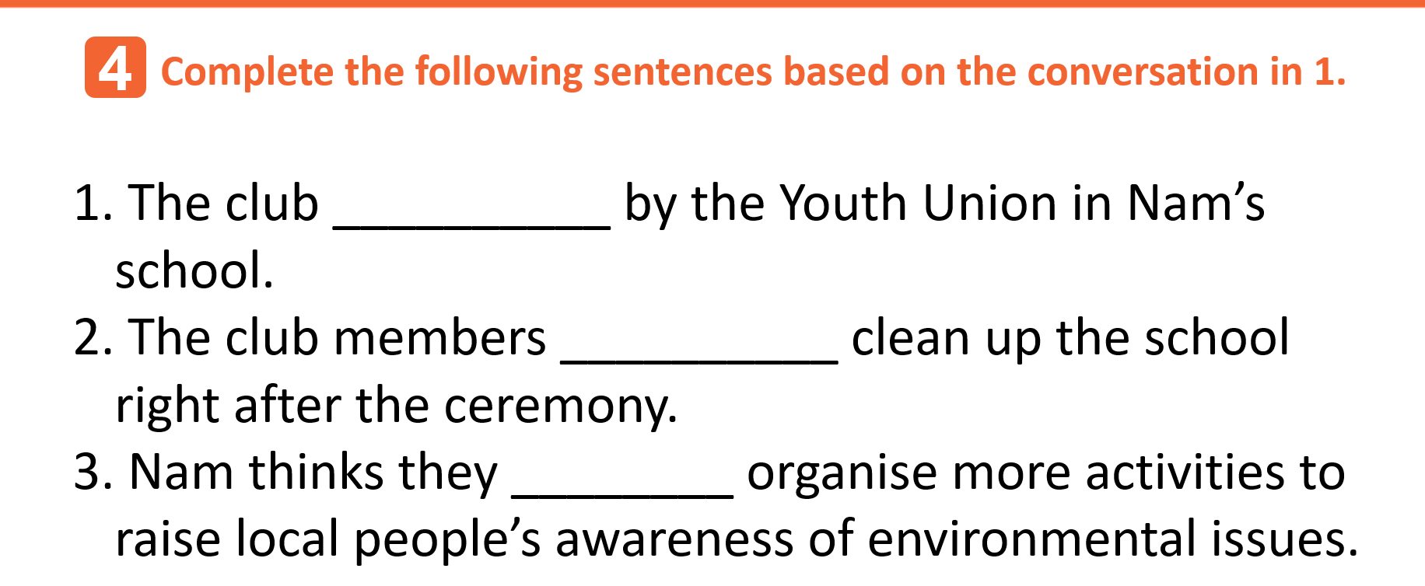  * T has Ss read each sentences, try to think of a verb or an auxiliary verb that will complete the gap.  ** Ss do the task individually.  *** Ss share the answers with a peer.  **** T asks the whole class to call out the verb forms first, then calls on individual Ss to read the complete sentences. | Completed sentences  using the present simple and the present continuous  Key:  1. was set up  2. are / ‘re going to  3. will / ‘ll | - Do the task individually  - share the answers with a peer.  - Teacher’s feedback
ACTIVITY 4: CONSOLIDATION/ PRODUCTION (5’)
Help students memorise the target language and skills that they have learned | 1.WRAP-UP (3’)  Watch the video clip and list all the work done to protect the environment in the video | - Ss’ list of household chores on the poster  Suggested answers:  - planting trees.  - collecting garbage.  - sweeping school yard/ classrooms.  - Saving water, energy.  - watering flowers, plants  - taking out garbage. | Watching and listening  -Work in 4 groups  -Peer correction  - Teacher’s feedback
Inform students what the final product of the project should be and how students can prepare for it. | 2. HOMEWORK (2’)  1. Exercises in the workbook  2. Project preparation  * Teacher:  - Has Ss look at the last page of Unit 2, the Project lesson and asks them what topic of the project is.  - Tells them the project requirements: Ss will have to make a plan for a Go Green Weekend in which they will:  + suggest activities for the event, provide the reasons and expected results of the activities;  + include information as stated in the table on page 27 in the Student’s Book.  + present their plans in the last lesson of the unit.  - Reminds Ss that beside brainstorming Go Green Weekend activities, they:  + can search for ideas on the Internet, in the newspapers, etc. for reference.  + should use photos/pictures to illustrate their ideas.  - Puts Ss into groups and has them choose their group leader; Asks them to assign tasks for each member, making sure that all group members contribute to the project work.  - Helps Ss set deadlines for each task. | Ss’ oral presentation of the research results | Groupwork

Date: September 25th , 2022
Period 11-UNIT 2: HUMANS AND THE ENVIRONMENT
Lesson 2: Language

I/ Learning outcomes:
By the end of this lesson, Ss will be able to :
1. Knowledge
- Pronounce the consonant blends /kl/, /pl/, /gr/, and /pr/ correctly in isolation and in sentences;
- Understand and use some lexical items about humans and the environment;
- Distinguish and use will and be going to to talk about the future;
- Use the passive voice correctly.
2. Competence
- Be collaborative and supportive in pair work and team work;
- Access and consolidate information from a variety of sources;
- Actively join in class activities.
3. Attributes:
- Adopt greener lifestyle and awareness of environmental issues;
- Be responsible for environment protection.

II/ Teaching and learning resources:
- Grade 10 textbook, Unit 2, Language
- Computer connected to the Internet
- Projector/ TV/ pictures and cards

III. PROCEDURES

Stage | Stage aim | Procedure | Interaction | Time
WARM-UP | - To arouse the classroom atmosphere.  - To lead in the lesson. | GUESSING GAME: WHAT AM I GOING TO DRAW?  -T shows the picture of dark clouds and asks ss “What’s going to happen ?”  -Ss answer.........................................................  - It is going to rain  - T gives comments ,asks some more questions to lead in the lesson.  + Is using these vehicles good for the environment?  + Why is using them not good for the environment? | T-S  S-S  T-S | 4 mins
PRONUNCIATION | To help students recognize and practise the consonant blends /kl/, /pl/, /gr/, and /pr/ in individual words. | TASK 1: LISTEN AND REPEAT.  Pay attention to the consonant blends /kl/, /pl/, /gr/, and /pr/. (p.19)  * T shows the following pictures, and asks Ss to describe each picture with a word.  v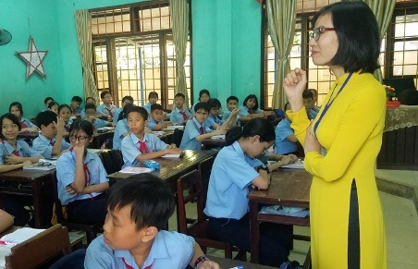  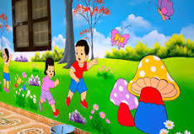  class ground play    gift green clean    place protect  - T has Ss work in pairs to categorize those pictures.  ** Ss do as instructed.  *** Ss share their ideas with a partner.  **** T confirms the correct answers and leads in the task.  * Teacher:  - plays the recording and asks Ss to listen to the words and repeat; tells them to pay attention to the consonant blends. (Teacher can play the recording as many times as necessary)  - makes sure Ss know the meaning of each word.  ** Ss do as instructed.  **** T checks whether Ss have improved their pronunciation by randomly calling on individual Ss to read the words aloud. | T-S  S-S  S-S  T-S  T-S  S-S  T-S | 6mins
PRONUNCIATION | To help students recognise the consonant blends /kl/, /pl/, /gr/, and /pr/ in sentences and pronounce them correctly. | TASK 2: LISTEN AND PRACTISE SAYING THE FOLLOWING SENTENCES. (p.19)  * Teacher:  - checks Ss’ comprehension of the sentences.  - plays the recording, has Ss focus on the words containing the consonant blends and asks them to circle these words.  - plays the recording again, pausing after each sentence, for Ss to repeat.  ** Ss do as instructed.  *** Ss practise reading the sentences in pairs.  **** T goes round to offer help and collects common mistakes to correct as a class. | T-S  S-S  S-S  T-S | 5 mins
VOCABULARY | To make sure that students understand the meaning of some lexical items about humans and the environment. | TASK 1: MATCH THE WORDS AND PHRASES TO THEIR MEANINGS. (p.20)  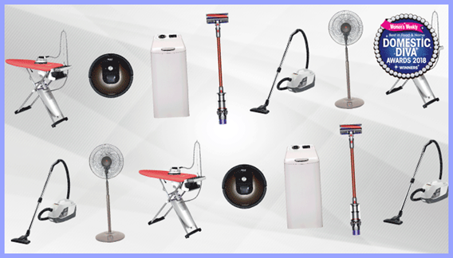  1. household appliances 2. energy 3. carbon footprint    4. litter 5. eco-friendly  * T gives clear instructions.  ** Ss work in pairs to discuss and do the matching.  *** Ss share the answers with the whole class.  **** T confirms the correct answer.  Key: 1. d - 2. e - 3. a - 4. b - 5. c | T-S  S-S  S-S  T-S | 4 mins
VOCABULARY | To give students practice in using the words/phrases in meaningful contexts. | TASK 2: COMPLETE THE SENTENCES USING THE WORDS OR PHRASES IN 1. (p.20)  * Teacher:  - has Ss read the sentences carefully to decide which word/phrase in 1 can be used to complete each of the sentences.  - explains that they should use the context clues to decide on the word/ phrase, e.g. in the first sentence, the gapped word is an adjective (eco-friendly)  ** Ss work in pairs to discuss and find the answers.  *** Ss share the answers with the whole class.  **** T confirms the correct answers and asks Ss to give the reasons why they have chosen the word/phrase for each sentence.  Key:  1. Eco-friendly  2. household appliances  3. carbon footprint  4. energy  5. litter | T-S  S-S  S-S  T-S | 4 mins
VOCABULARY | To help students memorize the words/phrases they have learnt. | TASK 3: MAKE SENTENCES, USING THE WORDS/PHRASES IN TASK 1.  * T divides the class into teams, asks Ss to write as many sentences as they can in 2 minutes, using the words/phrases in 1. T reminds them to make at least one sentence with each word/ phrase.  ** Ss works in small teams and do as instructed.  *** The teams with the most sentences take turns to read aloud their sentences.  **** T gives comments, collects common mistakes to correct. | T-S  S-S  S-S  T-S | 4 mins
GRAMMAR | - To give students an opportunity to revise the use of will and be going to to talk about future actions.  - To give students an opportunity to revise the passive voice. | THE FUTURE WITH WILL AND BE GOING TO  Complete the following sentences with will or the correct forms of be going to. (p.20)  * Teacher:  - tells Ss to read the explanations in the Remember! box on page 20 and asks Ss questions to elicit the differences between will and be going to, for example:  + Do both structures talk about the future?  + Which auxiliary do we use to talk about plans made at the moment of speaking / before the moment of speaking?  + Can we use both structures for predictions?  - in weaker classes, T gives more examples to make sure Ss understand the use of will and be going to; in stronger classes, has Ss come up with their own example sentences.  - asks Ss to work in pairs or individually to choose will or the correct form of be going to to complete each sentence.  - reminds them to use some clues in the sentence to decide on the correct tense form. e.g. 1: I don’t think; 2: have already made the decision; 3: I’m sure; 4: Look at; 5: I forgot to phone Dad.  ** Ss do as instructed.  *** Ss share their answers with a partner.  **** T check Ss’ answers and asks them to explain their choices (using the clues above).  Key:  1. will  2. are going to  3. will  4. is going to  5. will  PASSIVE VOICE  Rewrite the following sentences using the passive voice. Begin each sentence as shown.  * Teacher:  - asks Ss to read the explanation in the Remember! box on page 21 and asks Ss questions to check their understanding of the grammar point, for example:  + When do we use the passive voice?  + What do we focus on?  + How do we form the passive voice? (the verb be and the past participle of the main verb).  - in weaker classes, gives more examples to make sure Ss understand the use and forms of the passive voice in different tenses; in stronger classes, has Ss come up with their own example sentences in both passive and active structures.  - asks Ss to work independently and rewrite the sentences using the passive voice.  - reminds Ss of the correct verb forms in different tenses; of the use of the preposition by to mention the doer of the action.  - elicits that if the subject in the active voice is they or we, Ss don’t need to indicate the doer in the passive voice.  ** Ss do as instructed.  *** Ss work in pairs to compare their answers.  **** T checks the answers as a class by having individual Ss read out the sentences or write them on the board.  Key:  1. A green lifestyle is adopted by more and more people.  2. The rubbish was not put in the bins after the party yesterday by the students.  3. More trees will be planted in the neighbourhood.  4. A lot of clean-up activities are going to be organised by our club this weekend .  5. Important environmental issues were discussed at the meeting. | T-S  S-S  S-S  T-S  T-S  S-S  S-S  T-S | 6 mins  6 mins
CONSOLIDATION | To help students memorise the target language and skills that they have learned | WRAP-UP  * Teacher asks: What have you learnt today?  - Consonant blends /kl/, /pl/, /gr/, and /pr/  - Some lexical items about humans and the environment;  - Will and be going to to talk about the future;  - Passive voice.  HOMEWORK  - Exercises in the workbook.  - Prepare for Lesson 3, Unit 2. | T-S | 2 mins

Date: September27th , 2022
Period 12-UNIT 2: HUMANS AND THE ENVIRONMENT
Lesson 4: Reading

I/ Learning outcomes:
By the end of this lesson, Ss will be able to:
- Knowledge:
- have an overview about “Humans and the environment”
- gain vocabulary to talk about human and the environment.
- Competences:
- develop reading skills for specific information
- provide Ss with more language and ideas about “Humans and the environment”
II/ Teaching and learning resources:
Tape (CD), TV, speakers, textbook, teacher's book, copies of pictures, handouts, laptop, posters, Wifi connection
III/ PROCEDURE:

Aims | Content | Outcomes | Steps
ENGAGE/ WARM UP (5’)
- To create a friendly and lively atmosphere in the classroom | Introduction: (5’) | Ss’s chance to get to know each other | Introduce
- To familiarize Ss with the topic of the reading text  - To lead in the reading lesson | Play game: (5’)  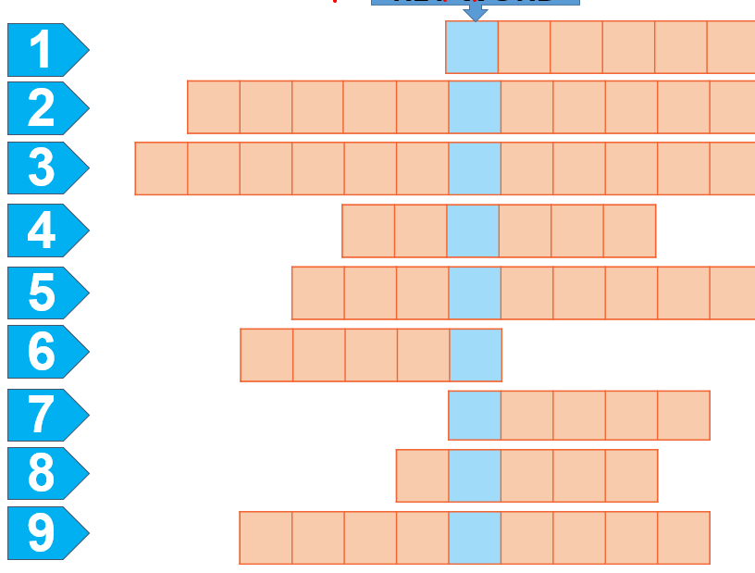 | Ss’s oral prediction about the topic  Suggested answers:  Life Style | - T raises questions  - Sts answer
STUDY/ PRESENTATION (15’)
- To understand the new words in the reading. | Vocabulary:  explosion (n)   method (n)  refillable (adj)  raw material (n.phr.)   sort (v)  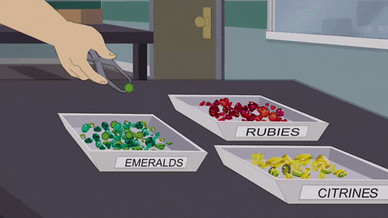 | - A list of words in Ss’ notebook | Elicit  Give synonym/ Vietnamese equivalent/ example/pictures to elicit vocabulary from Ss
 | * Listen & repeat | Sts’ pronunciation of the words | Listen to the audio/teacher & repeat in chorus then individually
 | * Check vocabulary: | The missing words on the board | Rub out and remember
- To help Ss practise guessing the meanings of words in context. | Task 1: Work in groups. Look at the pictures and answer the questions.  Task 2: Circle the correct meanings of the highlighted words and phrases in the text.  1. sustainable  - causing little or no damage to the environment  - bringing no benefits to the environment  2. organic  - without the use of animal organs  - without the use of chemicals | Some words or phrases ticked  Suggested answers:  In this picture, a man goes shopping with lots of plastic bags. It doesn’t show a green lifestyle. Plastic bags pollute the environment since they take time to decay. | Asks Ss to look at the pictures and answer the questions.
ACTIVATE/ PRACTICE (20’)
- To practise reading for specific information | TASK 3: Read the following text and choose the best title for it.  - Green living  - Green issues  - Green products  Task 4.Read the text again and decide whether the following statements are true (T) or false (F). | - Ss’ answers of the questions | - Work in pairs  - Read the text & questions then underline the key words.  - Find the answers.  - Peer correction  - Teacher’s feedback
To help Ss use the ideas and language in the reading or in their own ideas to talk about the benefits they can get from sharing housework | TASK 4: Work in groups. Discuss the question “In your opinion, which of the suggestions in the text is the easiest way to live green?  ?” (‘10’)  → Some hints: | Ss’ ideas and oral presentation about benefits of sharing household chores.  Suggested answers  In my/ our opinion, turning off household appliances when they are not in use is the easiest way to live green because we can do this right at home. We don’t need any equipment or training for this.  → Firstly,... | - Ss find out the benefits of sharing housework both in the passage and in their own ideas.  - Ss make a mindmap and present what they have discussed.  -Teacher’s feedback
CONSOLIDATION/ PRODUCTION (5’)
- To help students memorise the target language and skills that they have learned | 1.WRAP-UP (3’)  The teacher asks:  - What have you learnt today?  - The ways to live green. | Ss’ reflection about the content of the lesson. | - Class work  - Teacher’s feedback
- To guide students to prepare for the next lesson. | 2. HOMEWORK (2’)  a/ Do exercises in the workbook.  b/ Learn the new words by heart.  c/ Ask sts to summarize the passage.  d/ Prepare for Speaking lesson. | Ss’ oral presentation of the research results. | Ss do individually

Date: September 28th , 2022
Period 13-UNIT 2: HUMANS AND THE ENVIRONMENT
Lesson 4: Speaking
I/ Learning outcomes:
By the end of this lesson, Ss will be able to:
- Knowledge:
- gain vocabulary to talk about ways to live green
- Competences:
- develop communication skills;
- be collaborative and supportive in pair work and team work;
- actively join in class activities.
- Attributes:
- be aware of the importance of a green lifestyle.
II/ Teaching and learning resources:
Tape (CD), Tivi, speakers, textbook, teacher's book, copies of pictures, handouts, laptop, posters
III/ PROCEDURE:
Aims | Content | Outcomes | Steps
ACTIVITY 1: WARM UP (3’)
- Introduce the unit topic (Humans and the environment);  - Introduce some vocabulary to be learnt in the unit. | What are the pictures about?  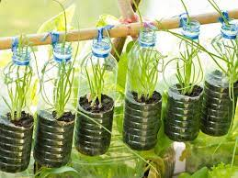 | Students’ oral prediction about the topic  Suggested answer:  Living green/ green lifestyle | Elicit  Show the pictures to elicit the topic
ACTIVITY 2: PRE-SPEAKING (20’)
To pre-teach some vocabulary so that students can understand the meanings and use them correctly in main speaking tasks. | VOCABULARY (6’)  * Teacher:  - shows the words one by one, models and has Ss repeat the words.  - has Ss guess the meanings of the words based on pictures, explanations or examples.  1. leave st on (idioms): choose to keep something operational or switched to an "on" position.  Ex: Someone left the lights on the whole time we were gone. Our electricity bill is going to be enormous.  2. chemical (n) /ˈkemɪkəl/: a substance obtained by or used in a chemical process    3. shade (n) /ʃeɪd/: slight darkness caused by something blocking the direct light from the sun  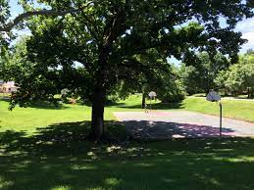  4. break down (phv) /breɪk daʊn/: to divide something into smaller parts  T confirms the meanings, calls on some individual Ss to make sentences with each word. | A list of words in notebook | Elicit  Give idiom, pictures definition, example to elicit vocabulary from Ss
To introduce more ideas for the main speaking tasks and get students involved in the lesson | TASK 1: WHICH OF THE FOLLOWING ACTIVITIES DO YOU THINK TEENAGERS SHOULD OR SHOULDN’T DO TO LIVE GREEN? PUT A TICK IN THE APPROPRIATE COLUMN. (p.23) (6’)  * T has Ss work in pairs, read the activities, discuss their meanings and decide which activities they should/ shouldn’t do to go green by putting a tick in the appropriate column.  ** Ss do as instructed.  *** Some individual Ss share their answers with the whole class.  **** T confirms the correct answers. | Ss’prediction about the activitives  Suggested answers:  1. shouldn’t  2. should  3. shouldn’t  4. should  5. shouldn’t  6. should | Set the context for speaking
  Activities | Should | Shouldn’t
  1. Leaving your appliances on when not in use |  | ✔
  2. Recycling your used items | ✔
  3. Using plastic bags when shopping |  | ✔
  4. Buying organic food | ✔
  5. Dropping litter in the street |  | ✔
  6. Planting trees | ✔
To introduce more ideas for the main speaking task and get students involved in the lesson | TASK 2: THE TABLE BELOW PRESENTS THE REASONS WHY TEENAGERS SHOULD OR SHOULDN’T DO THE ACTIVITIES IN 1. WORK IN PAIRS AND MATCH THEM WITH THE ACTIVITIES. (p.23) (8’)  * Teacher:  - has Ss read the reasons, and discuss with a peer to do the matching.  - reminds them that besides using because, they can use since/ as/ due to the fact that/ on the ground that to express reasons and encourages them to give more reasons and makes small exchanges after doing the matching, e.g.  Student A: Why shouldn’t you leave your appliances on when not in use?  Student B: Because this wastes electricity and creates dangerous situations. Why should you recycle your used items?  Student A: Since this protects natural resources.  ** Ss do as instructed.  *** Ss share the answers with the whole class.  **** Teacher confirms the correct answers and calls on some pairs to make small exchanges like the one above. | Matched reason with the activities  Suggested answers:  a - 5; b - 1; c - 3; d - 4; e - 2; f - 6 | Set the context for speaking
ACTIVITY 3: WHILE-SPEAKING (15’)
To give students an opportunity to discuss ideas in groups and share with the rest of the class. | TASK 3: WORK IN GROUPS. DISCUSS AND PRESENT YOUR IDEAS ABOUT WHAT YOU SHOULD OR SHOULDN'T DO TO LIVE GREEN. (p.23)  * T has Ss work in groups of 5, discuss what they should or shouldn’t do to live green.  - In weaker classes, T reminds them to use the ideas given in 1 and 2 in their discussion. In stronger classes, T encourages them to think of other activities and reasons.  ** Ss do as instructed.  *** T invites 3 groups to share their ideas with the rest of the class, other groups can put questions.  **** Teacher praises Ss for interesting and imaginative ideas, and for providing well-formulated reasons. | Ss’ oral presentation  Example: There are many things that we should or shouldn’t do to live green. We should recycle our used items so that we can protect natural resources. We shouldn’t drop litter in the street because this will make the street dirty and pollute the environment. | - Groupwork  - Teacher’s feedback
ACTIVITY 4: POST-SPEAKING (7’)
Help students memorise the target language and skills that they have learnt | 1.WRAP-UP (5’)  T asks Ss to close the books and answer the questions:  What should you do to live green?  What shouldn’t you do to live green? | Ss’ answers  Suggested answers:  - Use renewable energy  - Stop throwing out food  - Use compost  - Save water  - Use public transportation | - Pair work  -Peer correction  -Teacher’s feedback
2. HOMEWORK (2’)
- Learn the vocabulary by heart
- Prepare for the next lesson: Unit 2- Lesson 5: Listening

Date: October 1st , 2022
Period 14-UNIT 2: HUMANS AND THE ENVIRONMENT
Lesson 5: Listening
I/ Learning outcomes:
By the end of this lesson, Ss will be able to:
- Knowledge:
- Listen for specific information in a text about green living;
- Talk about a plan to organise a green event in their area.
- Competences:
- Be collaborative and supportive in pair work and team work;
- Actively join in class activities;
- Develop presentation skills.
- Attributes:
- Be more responsible for the environment and be able to propose plans to solve environmental issues in their residential areas;
- Be ready to make a plan to organize a green event in their area.
II/ Teaching and learning resources:
Tape (CD), Tivi, speakers, textbook, teacher's book, handouts, cell phones, pictures, laptop.
III/ PROCEDURE:
Aims | Content | Outcomes | Steps
ACTIVITY 1: WARM UP (5’)
- To arouse the classroom atmosphere.  - To get students be actively involved in the lesson. | Game: GUESSING WORDS | List of words related to the topic  Set 1: adopt, litter, eco-friendly  Set 2: sort, awareness, household appliances | - T divides class into 2 teams.  - T introduces the rule of game:  - T leads into the new lesson.
ACTIVITY 2: PRE-LISTENING (10’)
To pre-teach the pronunciation and the meaning of some vocabulary so that students can understand the content of the listening. | * Teaching Vocabulary  1. schedule (n): a plan that lists all the work that you have to do and when you must do each thing.  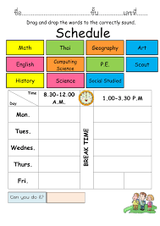  2. specific (adj): connected with one particular thing only.  E.g. The money was collected for a specific purpose.  3. donation (n): money or goods that are given to help a person or organization, or the act of giving them.  4. delivery (n): the act of taking goods, letters, parcels, etc. to people's houses or places of work.    * Checking Vocabulary: Slap the board | List of words in Ss’notebook | T uses some techniques in teaching Vocab: picture, example, explanation,
To introduce the topic of the listening and activate Ss’ prior knowledge | Task 1: Look at the picture and answer the question: What are they doing? Why?  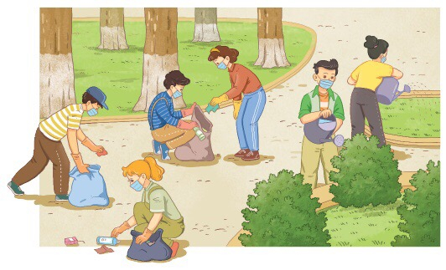 | Ss’ answers about the picture.  Suggested answer:  The students are picking up rubbish, bottles and plastic bags; They are watering plants and trees. | - T has Ss work in pairs and and tell their partner about what they see in the picture.  - Ss discuss with their friends.  - T invites some pairs to share their ideas.  - T gives feedback.
ACTIVITY 3: WHILE-LISTENING (15’)
- To help Ss practise listening for specific information. | Listen to an announcement about a Go Green Weekend event and do the following tasks.  Task 2: Multiple choice: Choose the best answer  1/ A Go Green Weekend event is being organized …………….  A. the upcoming Friday  B. the upcoming Saturday  C. the upcoming Sunday  D. the upcoming Thursday  2/ How many teams will be at a Go Green Weekend event?  A. 2 B. 3 C. 4 D. 5  3/ The Clean-up team will take the responsibility for cleaning …………….  A. the central park  B. the central museum  C. the central market  D. the central pub  4/ Items from local residents will be collected by …………….  A. the Donation Team  B. the Media Team  C. the Clean-up Team  D. None of the above Teams  5/ The Media Team will be responsible for …………….  A. picking up rubbish, bottles and plastic bags  B. sorting used items and putting them into the correct bags  C. watering small trees and flowers  D. posting pictures of the event on the club’s website  Task 3: Matching: Match the activities below with the corresponding team. | Completed sentences .  Suggested answer:  Task 2:  - C  - B  3 - A  4 - A  5 - D  Task 3:  1 - C  2 - A  3 – B  Matched activities with the corresponding team | - T gives handouts to Ss, asks them to work in groups of four, look at the handouts and have an overview of the two tasks.  - T asks Ss to listen to the recording 3 times and do two tasks.  - T lets Ss play the game on KAHOOT and has Ss check the answer by listening again.  - Teams having the highest marks will be the winner.  - T gives feedback.
  A | B
  1. The Media Team | A. Watering small trees and flowers
  - The Clean-up Team | - Putting used items into the correct bags
  - The Donation Team | - Making suggestions for the club’s future activities
ACTIVITY 4: POST-LISTENING (10’)
To give students an opportunity to personalise the language and ideas from the listening in a speaking task. | DISCUSSION:  “If you have to organize a green event in your area, what will you do?”  Cues:  + Have you ever taken part in an environmental activity or event?  + How many times have you participated in such activities or events?  + What did you do there?  + How did you feel? | Ss’ oral presentation. | - T asks Ss to work in groups of four and discuss the question.  - T gives Ss some cues/ questions to answer.  - T invites some Ss to present and lets other Ss give feedback.  - T comments.
ACTIVITY 5: CONSOLIDATION (3’)
To help students memorise the content of the lesson | WRAP UP: PICKING UP  What have just been mentioned in the lesson? Pick them up.  - 4 new words: schedule, specific, donation, delivery  - Green products  - Go Green Club  - Green living  - Holding a green event in the area. | 4 new words.  Suggested answer:  : schedule, specific, donation, delivery  - Green living  - Holding a green event in the area. | - T shows the screen about the content of the lesson and asks Ss to pick up the right content of the lesson.  - T invites some Ss to answer and lets the others give feedback.  - T comments.
HOMEWORK (2’)
Inform students what the final product of the speaking topic. | Work in individual to talk about the ways to hold a green event in your area. Then, post your video clip on the link: https://flip.com/e234a15f | Ss’ video clip on the link of Flipgrid | T gives Ss homework to do.

Date: October 4th , 2022
Period 15-UNIT 2: HUMAN AND THE ENVIRONMENT
Lesson 6: Writing
I/ Learning outcomes:
By the end of this lesson, Ss will be able to:
- Knowledge:
- Use lexical items related to the topic “Humans and the environment”;
- Write about ways to improve the environment.
- Competences:
- Be collaborative and supportive in pair work and team work;
- Actively join in class activities;
- Develop presentation skills.
- Attributes:
- Be more responsible for protecting the surrounding;
- Be able and willing to persuade other people to take actions to make a nice and clean environment.
II/ Teaching and learning resources:
- Grade 10 textbook, Unit 2, writing
- Computer connected to the Internet
- Projector/ TV/ sub-board
III/ PROCEDURE:
Aims | Content | Outcomes | Steps
ACTIVITY 1: WARM UP (6’)
- To arouse the classroom atmosphere.  - To get students be actively involved in the lesson. | GAME: RUNNING MAN (6’) | List of some ways to protect the environment  Expected answers:  Buying organic foods  Not using plastic bags  Planting trees | List  Work in groups to list the ways to protect the environment on the board
ACTIVITY 2: PRE - WRITING (6’)
- To help students recall some suggestions for improving the environment | MATCH (6’)  Match the suggestions for improving the environment with their expected results. (p.25) | Ss’ oral presentation  Key:  1.c  2.a  3.b | Match  Work in pairs to match the suggestions for improving the environment with expected results
ACTIVITY 3: WHILE-WRITING (18’)
To provide students with a model of a well-structured paragraph and practice in using connectors to link sentences. | 1/ FILL IN THE BLANKS (8’)  Read the incomplete paragraph about ways to improve the environment. Fill in the blanks with the words and phrases from the box. (p.25). | Completed paragraph with the words and phrases provided  Key:  1. First  2. For example  3. In conclusion | - be provided with an incomplete example as a model for their writing.  - recall the information about the structure of a paragraph  - Work in pairs  - Teacher’s feedback
To help students practise developing ideas and writing a paragraph | 2 COMPLETE THE PARAGRAPH (10’)  Add two more suggestions to improve the environment in your school to the paragraph in 2. Use the ideas in 1 to help you. (p.25) | A completed paragraph using more suggestions | - Work in groups of four
ACTIVITY 4: POST-WRITING (14’)
To give students an opportunity to recognize the common mistakes so that they can avoid in writing | 1. CORRECTION (12’)  a. PEER CORRECTION  - T explains the marking symbols in the following table.  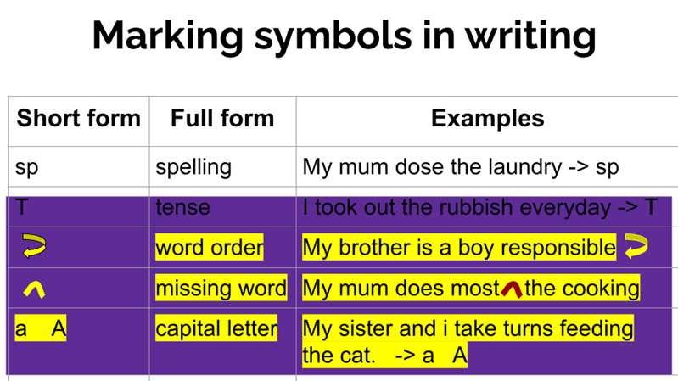  b. CLASS CORRECTION  - - T writes Ss’ common mistakes on the board, asks Ss to check whether they make the same mistakes in their writing. | Ss’ recognition of mistakes  Sample answer:  Another way would be to plant more trees. For example, we can plant more green trees around the school and in the schoolyard. It reduces CO2 and makes the air we breathe in cleaner. Finally, we can set up more rubbish bins. For instance, we can put more bins in public places such as parks or bus stations. This makes the waste collection easier. | - exchange their writing, read their partner’s writing and write the symbols next to mistakes that they can find like the ones (following the table provided).  - Correct those mistakes as a class.  - Teacher’s feedback
To help students memorise the content of the lesson | 2. WRAP-UP (1’)  We have practised writing a paragraph about suggestions to improve the environment.  3. HOMEWORK (1’)  - Exercises in the workbook  - Prepare for Communication and Culture lesson | Ss’ oral presentation | Individual

Date: October 7th, 2022
UNIT 2: HUMANS AND THE ENVIRONMENT
Lesson 7: Communication and Culture/ CLIL
I/ Learning outcomes:
By the end of this lesson, Ss will be able to:
- Knowledge:
- Ask for and give advice;
- Understand what a carbon footprint is.
- Competences:
- Be collaborative and supportive in pair work and team work;
- Access and consolidate information from a variety of sources;
- Actively join in class activities.
- Attributes:
- Be willing to take practical actions to help reduce their own carbon footprint and their family’s as well;
- Be responsible for environment protection.
II/ Teaching and learning resources:
Tivi, speakers, textbook, teacher's book, copies of pictures, handouts, laptop
III/ PROCEDURE:
Aims | Content | Outcomes | Steps
ACTIVITY 1: WARM UP (6’)
- To arouse the classroom atmosphere.  - To help students revise words/ phrases related to the topic | 1. Game: RUNNING MAN  - words / phrases related to the topic Humans and the Environment | List of words/ phrases related to the topic  Suggested answers:  - Green lifestyle  - Eco-friendly  - Plastic bags  - Zero waste  - Carbon footprint | - Team work  - Each team takes turns to run to the board and write a word/ phrase related to the topic Humans and the Environment  - confirms the correct word/ phrase
EVERYDAY ENGLISH - ACTIVITY 2: STUDY/ PRACTICE (8’)
- To provide Ss with an example conversation in which people ask for and give advice about ways to find information for the presentation. | Task 1:  Listen and complete the conversation with the expressions in the box. Then practise it in pairs. (p.25) | Completed conversation with the expressions provided  Suggested answers:  1. B  2. A  3. D  4. C | - asks Ss to read through the expressions in the box and the incomplete conversation  - plays the recording once or twice  - Ss do  - checks the answers
 | Practice | Ss’ practice | - asks Ss to practise the conversation in pairs then read aloud.
EVERYDAY ENGLISH - ACTIVITY 3: PRODUCTION (10’)
To help Ss practise ways of asking for and giving advice about green living | Task 2:  Work in pairs. Make a similar conversation asking for and giving advice about green living. Use the expressions below to help you. (p.25)  . | Ss’ conversation asking for and giving advice about green living. | - brainstorms green living ideas and writes them on the board  - revises common expressions used to ask for and give advice  - asks Ss to work in pairs  - gives them some minutes to think about specific green issues that they want to include in their conversation.  - act out their conversations  - Feedback
CLIL - ACTIVITY 4: PRACTICE (10’)
To help Ss to know the meanings and pronunciation of some words/ phrases, so that Ss can use them in their presentation later and can understand the reading passage. | Vocabulary  1. emission /ɪˈmɪʃn/ (n): khí thải  2. estimate /ˈestɪmeɪt/ (v): ước tính  3. average /ˈævərɪdʒ/ (adj): trung bình  4. atmosphere /ˈætməsfɪə(r)/ (n): bầu khí quyển | List of some words/ phrases in Ss; notebook | - shows the words one by one, plays the recording and has Ss repeat the sound of the words
To help students learn about carbon footprint and ways to reduce it (through CLIL) | Task 1:  Read the text and complete the table. (p.26) | Completed table  Suggested answers:  1. CO2  2. global temperatures  3. showers  4. public transport | - asks Ss read the text and complete the table.  - Ss do  - Ss share their answers with a partner.  - Feedback
CLIL - ACTIVITY 5: PRODUCTION (8’)
- To give students an opportunity to personalise the CLIL topic (ways to reduce their carbon footprint) | Task 2:  Work in pairs. Discuss things you can do to reduce your carbon footprint. (p.26) | - Students’ oral presentation  Suggested answers:  We thinks that our carbon footprint is not very big, but we’ll try to reduce it to further help the environment. First, we’ll start cycling to school instead of asking our parents to drive us. Second, we’ll stop using plastic bags for groceries. Finally, we'll start drinking filtered tap water instead of buying bottled water. | - work in pairs to discuss things they can do to reduce their carbon footprint.  - underline the ideas in the text so that Ss can use them in their discussion  - calls on some pairs to report their ideas to the class
ACTIVITY 6: CONSOLIDATION (3’)
To help students memorise the content of the lesson that they have learned  To inform what students do at home | Wrap-up  - The ways to ask for and give advice  - the ways to reduce carbon footprint in our lives | . | - Individual work
 | Homework  - Exercises in the workbook  - Prepare for Looking back and Project lesson | . | - Individual work

Date: October 8th, 2022
Period 17-UNIT 2: HUMANS AND THE ENVIRONMENT
Lesson 8: Looking back and project

I/ Learning outcomes:
By the end of this lesson, Ss will be able to:
- Knowledge:
- revise the consonant blends /kl/, /pl/, /gr/, /pr/ correctly;
- revise words and phrases related to humans and the environment learnt in the unit;
- revise how to use will and be going to, and passive voice correctly;
- plan activities for a Go Green Weekend and give a group presentation about the event.
2. Competences:
- develop communication skills and creativity;
- develop presentation skills;
- develop critical thinking skills;
- be collaborative and supportive in pair work and team work;
- actively join in class activities.
3. Attributes:
- be more creative when doing the project;
- develop self-study skills.
II/ Teaching and learning resources:
Tape (CD), Tivi, speakers, textbook, teacher's book, copies of pictures, handouts, laptop, posters

III/ PROCEDURE

Aims | Content | Outcomes | Steps
ACTIVITY 1: WARM-UP (5’)
- To arouse the classroom atmosphere.  - To help students revise words/ phrases related to the topic | WARM-UP  The last man standing | List of words/ phrases related to the topic | -T explains the game rules to Ss  - Ss do as instructed.
ACTIVITY 2: LOOKING BACK (20’)
To help students revise /kl/, /pl/, /gr/ and /pr/ | 1. PRONUNCIATION  Listen and underline the words with the consonant blends /kl/, /pl/, /gr/ or /pr/. Then practise reading the sentences. (p.26) | Pronounced words with the consonant blends /kl/, /pl/, /gr/ and /pr/  1. The professor is proud of the results of our project.  2. Grass is growing on the ground.  3. Those toy planes are made of plastic.  4. Click the button to become a member of the club. | *T asks Ss to listen to the recording and underline the words that have the consonant blends /kl/, /pl/, /gr/ or /pr/.  - T asks individual Ss to write the words with the consonant blends on the board and has them read those words several times.  - T plays the recording again, pausing after each sentence for Ss to repeat.  - T puts Ss in pairs and has them practise reading the sentences together.  *Ss do as instructed.
- To help students revise words and phrases related to human activities and the environment, which they have learnt in the unit. | 2. VOCABULARY  Complete the sentences. Use the words and phrases in the box. (p.26) | Completed sentences with the words and phrases provided  Key:  1. green lifestyle  2. carbon footprint  3. eco-friendly  4. appliances | * Teacher asks Ss to complete the sentences by using the words and phrases in the box individually.  *Ss do as instructed.
- To help Ss revise will and be going to and the passive voice | 3. GRAMMAR  Choose the best answers. (p.26) | Completed sentences using will and be going to and the passive voice. | *Teacher asks Ss to choose the answers that best complete the sentences individually.  *Ss do as instructed.
ACTIVITY 3: PROJECT (15’)
- To provide an opportunity for students to develop their research and collaboration skills, and to practise giving an oral presentation. | GO GREEN WEEKEND  Make a plan for a Go Green Weekend event. (P.27) | * Ss’ oral presentation about the research | * T gives Ss a checklist for peer and self-assessment.  - T goes through the criteria for assessing their talk.  - T invites two or three groups to give their presentations and encourages the rest of the class to ask questions at the end.  *Ss do as instructed.
ACTIVITY 4: CONSOLIDATION/ PRODUCTION (5’)
- To consolidate what students have learnt in the lesson. | 1.WRAP-UP (3’)  List of what Sts have learnt | - Ss’ list of what they have learnt today | *Teacher asks: What have you learnt today?  *Sts answer
-To prepare for the next lesson | 2. HOMEWORK (2’)  - Exercises in the workbook  - Preparation for Unit 3- lesson 1 |  | *T instructs  *Ss take notes

Date: October 10th, 2022
Period 18-UNIT 3: MUSIC
Lesson 1: Getting started – A talented artist

I. LEARNING OUTCOMES:
By the end of this lesson, Ss will be able to:
1. Knowledge
- gain an overview about the vocabulary related to the topic Music and main grammatical points taught in this unit;
- gain vocabulary to talk about their musical idols.
2. Core competence
- develop communication skills;
- be collaborative and supportive in pair work and teamwork;
- actively join in class activities.
3. Attributes
- develop a positive attitude towards music;
- be aware of the important role of music in our life.

II. MATERIALS
- Grade 10 textbook, Unit 3, Getting started
- Computer connected to the Internet
- Projector/ TV/ pictures and cards

III. PROCEDURES

Stage aim | Steps | Procedure | Outcomes
ACTIVITY 1: WARM-UP (5mins)
- To create a friendly and lively atmosphere in the classroom by listening some English song then guess these names.  - To lead into the new unit | Introduce | Listen to some pieces of music and guess the name of the songs.  - Divide class into 4 groups  Song 1: How long  Song 2: we don’t talk any more  Song 3: Attention  Song 4: Let her go  Song 5: See you again  - asks Ss some questions and leads in the lesson.  + Whose songs are these? (They are Charlie Puth .)  + What is his kind of music? (Pop music)  + Is he a talented singer? (Yes, he is) | - Ss’ prediction about the topic
ACTIVITY 2: PRESENTATION (15mins)
- Understand the related words in the conversation  - Introduce the grammar points to be learnt in the unit. | Elicit  Give pictures to elicit vocabulary from Ss | 2.1 Vocabulary  - talented (adj) /ˈtæləntɪd/: having a natural ability to do something well    2. musical instrument (n) /ˌmjuːzɪkl ˈɪnstrəmənt/: an object used for producing musical sounds, e.g. a piano or a drum 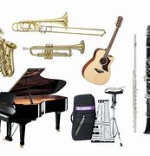  3. trumpet (n) /ˈtrʌmpɪt/: a brass musical instrument made of a curved metal tube that you blow into, with three valves for changing the note    4. perform (v) /pəˈfɔːm/: entertain an audience by playing a piece of music, acting in a play, etc.    - Shows the Vietnamese meaning, plays the recordings and asks Ss to repeat them.  - Checking vocabulary: Matching | - A list of words in notebook  - Ss’ pronunciation of the words  - The words related to the pictures
 | - Set the context for listening and reading the conversation | 2.2 LISTEN AND READ. (Ex.1, p.28)  - Sets the context for listening by having Ss look at the picture (p.28) and answer the questions    + Where are they? (at home/ in the living room)  + Who is the boy? (a singer)  + What are they doing? (The boy is singing on the stage. The girls are watching a live programme and cheering.) | - Ss’ prediction about the picture
ACTIVITY 3: PRACTICE (15mins)
- To practise reading for specific information  - To develop Ss' vocabulary of the topic Music  - To check Ss’ comprehension of the conversation | Reading for specific information  - Work individually | 3.1 READ THE CONVERSATION AGAIN AND ANSWER THE QUESTIONS. (Ex.2, p.29)  - Who are Ann and Mai talking about?  - What is he good at?  - What made him popular? | Questions answered  Key:  1. They are talking about a young pop singer.  2. He is good at writing music and playing many musical instruments.  3. His cover song videos made him popular.
 | Find out words and phrases related to music  Work in groups of four | 3.2 FIND WORDS OR PHRASES IN THE CONVERSATION WHICH REFERS TO... (Ex.3, p.29)  - Read the four categories and brainstorm words or phrases to check their prior knowledge, e.g. types of music: Rock and roll, Jazz, Pop, Classical.  - Read the conversation quickly again, and find the words or phrases that refer to the categories. | Words or phrases related to music  Key:  1. pop  2. Grammy, Billboard Music and Teen Choice Awards  3. piano, drums, guitar, and trumpet  4. social media
 | Matching  Work in pairs | 3.3 MATCH THE TWO PARTS TO MAKE COMPLETE SENTENCES.  (Ex. 4, p. 29)  -Read the two parts of each of the four sentences and checks comprehension.  - Elicits the target grammar point(s), e.g.  1. compound sentence, to-infinitive; 2. bare infinitive; 3. to-infinitive;  4. compound sentence. | Completed sentences  Key: 1. d; 2. c; 3. b; 4. a
ACTIVITY 4: PRODUCTION (5mins)
- To help Ss practise talking about their musical idol.  - To give students authentic practice in using target language. | Speaking  Work in pair | TALK ABOUT YOUR FAVOURITE SINGER OR MUSICAL BAND.  You should mention :  +Name: She/He is….  +Type of music: Her/His type of music is….  +Hobby: She/He likes…..  + Her/his famous song you like best: I like….. | Ss ‘ oral presentation
ACTIVITY 5: CONSODILATION (5mins)
- To help Ss memorize the target language and skills that they have learned.  - To inform Ss what the final product of the Project should be like and how Ss can prepare for it. | Group work | Wrap-up  - “ What have you learnt today?”  - Some lexical items about Music  - Talking about musical idols.  Homework  1. Exercises in the workbook  2. Project preparation  - Ask Ss to open their books at the last page of Unit 3, the Project section, look at the pictures and say what the topic of the Project is (a form of traditional music).  - Tell Ss about the Project requirements:  Ss will have to:  + do research on a form of traditional music in Viet Nam or another country  + include information related to the points stated on the Project page or prepare a poster (drawing, pictures) presenting the research results.  + give an oral presentation of the research results in the last lesson of the unit.  - how they can get the information (search the Internet, read newspapers, go to the library, talk to experts, etc.). | -Ss’ list of type of music/ musical instrument  -Ss’s oral presentation of musical idols  - Ss’ oral presentation of the research results

Date: October 14th, 2022
Period 19-UNIT 3: MUSIC
Lesson 2: Language
I/ Learning outcomes:
By the end of this lesson, Ss will be able to:
- Knowledge:
- pronounce two-syllable words with correct stress;
- understand and use words and phrases related to music;
- use conjunctions to make compound sentences;
- use to-infinitives and bare infinitives after some verbs.
- Competences:
- be collaborative and supportive in pair work and team work
- access and consolidate information from a variety of sources
- actively join in class activities
- Attributes:
- be willing to learn new language points
- be aware of the important role of music in life.
II/ Teaching and learning resources:
Tivi, speakers, textbook, teacher's book, handouts, laptop, sachmem.vn
III/ PROCEDURE:
Aims | Content | Outcomes | Steps
ACTIVITY 1: WARM UP (5’)
- To arouse the classroom atmosphere  - To lead in the lesson | 1. Board game: (5’) | Ss’s chance to get to know some two-syllable words related to the topic Music | Lead-in
   | S | I | N | G | E | R
  F | A | M | O | U | S
  A | T | T | R | A | C | T
   | A | R | T | I | S | T
  P | E | R | F | O | R | M
PRONUNCIATION
ACTIVITY 2: STUDY/ PRESENTATION (5’)
To give Ss practice in identifying the stressed syllables in two-syllable words and pronouncing these words. | 2. LISTEN AND REPEAT. PAY ATTENTION TO THE STRESSED SYLLABLE IN EACH WORD. (Ex.1, p.29) | Some pronounced two-syllable words  Rules:  - Most two-syllable nouns and adjectives have the stress on the first syllable.  - Most two-syllable verbs have the stress on the second syllable. | Elicit  Elicit the rule of the two-syllable words.
  Stress on the first syllable | Stress on the second syllable
  singer  programme  common  careful | relax  perform  attract  decide
ACTIVITY 3: PRACTICE (5’)
To help Ss identify stressed syllables in two-syllable words in sentences and pronounce these words correctly. | 1. LISTEN AND MARK THE STRESSED SYLLABLES IN THE WORDS IN BOLD. (Ex.2, p.29) | Stressed syllables in two-syllable words | Practice  - Do the task individually and work in pairs to compare the answers.  - Ask some students to read the sentences aloud and give feedback.
VOCABULARY
ACTIVITY 4: PRESENTATION (5’)
To make sure that sts understand the meaning of some lexical items about MUSIC. | 1/ MATCH THE WORDS WITH THEIR MEANINGS. (Ex.1, p.30). | Matched words with their meaning  Key:  1.c, 2d, 3e, 4a, 5b | Elicit  - Work in pairs  - Peer correction  - Teacher’s feedback
ACTIVITY 5: PRACTICE (5’)
To give Ss practice in using the words in meaningful contexts. | - COMPLETE THE SENTENCES USING THE WORDS IN 1. (Ex.2, p.30) | Completed the sentences with words provided  Keys: 1. Talented, 2. audience, 3. single, 4. judge, 5. perform | - Work in pairs  - Peer correction  -Teacher’s feedback
GRAMMAR
ACTIVITY 6: PRESENTATION 1 (COMPOUND SENTENCES)(5’)
- To give Ss the opportunity to revise how to form compound sentences. | - Revise the compound sentences  + A simple sentence consists of one independent clause.  Ex: The cat chased the mouse.  + A compound sentence consists of two or more independent clauses joined by a coordinating conjunction (e.g. for, and, nor, but, or, and yet, so). (Hint: The conjunctions spell FANBOYS.)  Ex: The cat chased the mouse, and the mouse ran into the hole. | Some notes on compound sentences | Elicit  - Answer teacher’s questions  - Give feedback
ACTIVITY 7: PRACTICE (5’)
_to give Ss chance to use conjunctions to make a compound sentence. | - Make compound sentences using the correct conjunctions in brackets. | Completed compound sentences  Key:  - I am a jazz fan, and my favourite style is from the late 1960s.  - Jackson wants to go to the music festival on Saturday, but he has a maths exam on that day.  - You can book the tickets online, or you can buy them at the stadium ticket office.  - The concert didn’t happen, so we stayed at home. | Practice  - work in pairs  - peer corrections  - Teacher’s feedback
ACTIVITY 8: PRESENTATION 2 (TO-INFINITIVES AND BARE INFINITIVES)(5’)
To give Ss the opportunity to revise  to-infinitives and bare infinitives | - Revise to-infinitives and bare infinitive  Some verbs are followed by to-infinitives: decide, expect, plan, want, promise, agree, hope, hesitate,…  - Some verbs are followed by bare infinitives: make, help, let,hear, notice ,…. | Some verbs followed To infinitive or bare infinitive usage | Elicit  Elicit some verbs followed by to-infinitive and some verbs followed by bare infinitive from students
ACTIVITY 9: PRACTICE (5’)
To give Ss chance to use  to-infinitives and bare infinitives in contexts. | - Complete the following sentences, using the to-infinitive or bare infinitive of the verbs in brackets. | Completed sentences  Key: 1. to send 2. fall 3. to delay 4. watch | Practice  - work in pairs  - peer corrections  -Teacher’s feedback
ACTIVITY 10: PRODUCTION (5’)
To use compound sentences, to-infinitive or bare infinitive to make a sentence. | - Make a sentence using compound sentences or to-infinitive or bare infinitive | Students’ sentences using compound sentences or to-infinitive or bare infinitive | Uncontrolled practice  - Work in groups  - Teacher’s feedback.
ACTIVITY 11: CONSOLIDATION (5’)
To help Ss memorise the target language that they have learned | 1.WRAP-UP | Suggested answers:  - stress in two-syllable words;  - words and phrases related to music;  - conjunctions to make compound sentences;  - to-infinitives and bare infinitives after some verbs. | Elicit  - Elicit the answers from students  - Teacher’s feedback
Inform students what they have to do at home | 2. HOMEWORK  - Exercises in the workbook  - Prepare for lesson 3 Unit 3.

Date: October16th, 2022

Period 20-UNIT 3: MUSIC
Lesson 3: Reading – American Idol
I/ Learning outcomes:
By the end of this lesson, Ss will be able to:
- Knowledge:
- read for specific information in a text about a famous TV music show;
- guess the meaning of words/phrases in context;
- talk about reasons why they want or don’t want to participate in a music competition.
- Competences:
- be collaborative and supportive in pair work and team work;
- access and consolidate information from a variety of sources;
- develop presentation skill;
- actively join in class activities.
- Attributes:
- recognise different musical shows;
- be eager to get more information about music shows.
II/ Teaching and learning resources:
Tape (CD), Tivi, speakers, textbook, teacher's book, copies of pictures, handouts, laptop, posters.
III/ PROCEDURE:
Aims | Content | Outcomes | Steps
ENGAGE/ WARM UP (5’)
- To create a friendly and lively atmosphere in the classroom;  - To introduce the unit topic (Music show);  - To lead in the lesson | 1. What is the picture about? (2’)   | Students’ oral prediction about the topic  Suggested answer:  Music show | Elicit  Show the picture to elicit the topic
 | 2. List more music shows you know (3’) | List of some music shows  Expected answers:  The voice kids  American idol  Rap Viet | List  Work in groups of two to list some music shows
STUDY/ PRESENTATION (15’)
- To understand the related words in the reading | 1. Vocabulary (7’)  - compete (v) = contest  competitive (a)  competitor(n)= contestant  competition (n)= contest    2. participate(v) in = take part in  participant (n)  3.audience (n) the group of people who have gathered to watch or listen to something (a play, concert, somebody speaking, etc.)    4. play a role in (idiom): be involved in or have an effect on  Ex: Water plays an important role in our life.  5. judge (n): someone who decides on the result of a competition | A list of words in Ss’ notebook | Elicit  Give synonym/ Vietnamese equivalent/ example/pictures to elicit vocabulary from Ss
 | * Listen & repeat | Sts’ pronunciation of the words | Listen to the audio/teacher & repeat in chorus then individually
 | * Check vocabulary: | The missing words on the board | Rub out and remember
- To help Ss practise guessing the meanings of words in context. | Task 2: Read a text about a famous music show. Match the highlighted words and phrases in the text to the meanings below. (ex.2, p.31) (8’) | Matched words and phrases with the meaning  Suggested answers:  1. b 2. a  3. d 4. c | Asks Ss to read and match the highlighted words and phrases in the text to the meanings.
ACTIVATE/ PRACTICE (20’)
- To practise reading for specific information | TASK 3: Read the text again and choose the best answers. (Ex.3, p.32) (10’) | Completed sentences  Key: 1. B 2. A  3. A 4. C  5. C | - Work in pairs  - Read the questions and underline the key words  - Choose the correct options  - Peer correction  - Teacher’s feedback
To help Ss use the ideas and language in the reading to talk about whether they want to take part in Vietnam Idol and give reasons. | TASK 4: Work in pairs. Discuss whether you want to participate in Vietnam idol. Give your reasons. (10’)    Model:  I like/dislike participating in Vietnam idol because I think………… | Ss’ ideas and oral presentation about the reasons Ss like or dislike Vietnam idol.  Suggested answers  Like: 1,3,5,6  Dislike:2,4, | - Ss work in pairs to make notes of things they like and dislike about the show to support their opinions  - T has Ss present a summary of their discussion  -Teacher’s feedback
  Reasons | like | dislike
  1.lifting your mood
  2.leading to stress and anxiety
  3.reducing stress
  4.be prepared for disappointment
  5.enhancing social and emotional learning
  6.creating sense of camaraderie and community
CONSOLIDATION/ PRODUCTION (5’)
- To help students memorise the target language and skills that they have learned | 1.WRAP-UP (3’)  List the content Ss have learnt | Ss’ reflection about the content of the lesson. | - Class work  - Teacher’s feedback
- To inform students what the final product of the project should be and how students can prepare for it. | 2. HOMEWORK (2’)  a/ Exercises in the workbook  b/ - Search for more music shows on the Internet, take note the regulations and the prizes and post them on the Facebook/Zalo group of your class  - Prepare for Speaking lesson | Ss’ oral presentation of the research results | Groupwork

Date: October 17th, 2022
Period 21-UNIT 3: MUSIC
Lesson 4: Speaking – Talking about a TV music show
I/ Learning outcomes:
By the end of this lesson, Ss will be able to:
- Knowledge:
- talk about a music show.
- Competences:
- be collaborative and supportive in pair work and team work;
- develop presentation skill;
- actively join in class activities;
- be creative;
- be critical in thinking.
- Attributes:
- be eager to create a new musical show;
- be ready to share their ideas with the whole class;
- be able to self-study.
II/ Teaching and learning resources:
Television, laptop, textbook, teacher's book, handouts.
III/ PROCEDURE:
Aims | Content | Outcomes | Steps
WARM UP (5’)
- To arouse the classroom atmosphere.  - To lead in the lesson. | Warm-up: (5’) Picture guessing     | Ss know the names of music shows.  Suggested answer:  - The voice kids  - RapViet  - Vietnam Idol Kids | Warm-up  - Ss look at the pictures and write down the names of the music shows.  - Ss share their answers with a partner.  - T checks by having some Ss to call out the answers.  - T leads in the new lesson.
PRESENTATION (10’)
- To pre-teach some vocabulary so that Ss can understand the meaning and use them correctly in main speaking tasks. | Activity 1. Vocabulary (5’)  - dress up (ph.v): /dres ʌp/ wear clothes that are more formal than those you usually wear    - runner-up (n): /ˌrʌnər ˈʌp/  a person or team that finishes second in a race or competition    - cash (n): /kæʃ/ money in the form of coins or notes    - come up with (ph.v): suggest or think of an idea or plan   | A list of words in ss’ notebook | Elicit  - T shows pictures/ gives explanations to elicit vocabulary from Ss.
 | * Listen & repeat | Sts’ pronunciation of the words | Listen to the audio/teacher & repeat in chorus then individually.
 | * Check vocabulary: | The missing words on the board | Rub out and remember
- To introduce more ideas for the main speaking tasks and get Ss involved in the lesson | 2. Task 1: Read about a TV music show and complete the notes below. (5’)  1. Name: I know your face  2. People who give their scores: …  3. Number of participants: …  4. What participants have to do: …  5. How participants win the show:  …  6. Prize(s): … | Ss’ complete notes about the TV music show.  Suggested answers:  2. two main judges and a guest artist  3. six  4. dress up and perform as famous international or local artists in a live show every week  5.  – 3 participants with the highest scores after 5 weeks go to the final night.  – TV audiences vote and decide on the winner and two runners-up.  6. cash | Individually  - Ss look at notes first and try to guess the information.  - T tells Ss to read the TV show description and complete the note.  - Ss compare their answers in pairs.  - T checks answers as a class.
PRACTICE (25’)
To help Ss brainstorm ideas for the speaking activity. | 1/ Match the information in column A with details in column B (3’)  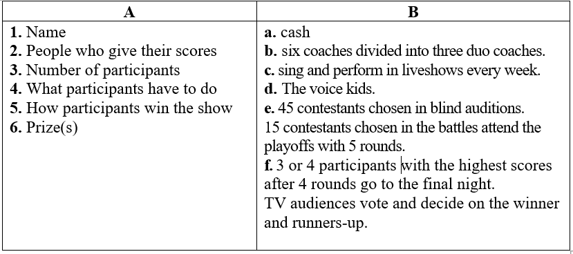 | - Ss’ complete notes about the TV music show.  Key:  1.d  2. b  3. e  4. c  5. f  6. a | - Ss work in groups of four to match the information in the handouts.  - Peer correction  - Teacher’s feedback
To help Ss brainstorm ideas for the speaking activity. | 2/ Task 2: Make up a new music show. Use the points in Task 1 and the activity Matching to organise your ideas. (7’) | Ss’ ideas about a TV music show.  Suggested answer:  - Your face sounds familiar  - Hidden voices  - X-factor  … | Brainstorming  - T asks Ss to refer back to their notes in Task 1 & Matching;  - T has Ss work in groups to brainstorm ideas for their new show and take notes.
To give Ss the opportunity to present their music shows to the class. | 3/ Present your show to the whole class. Use your ideas in Task 2 and the given expressions. Vote for the best show. (15’)  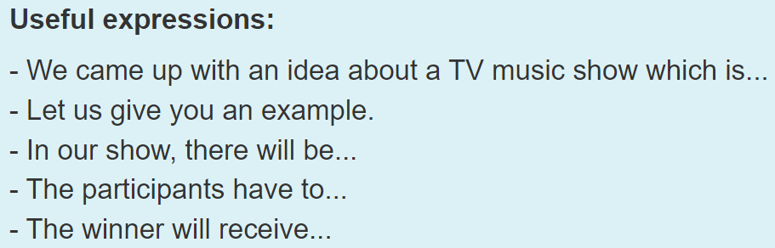 | Ss’ presentation about a TV music show. | - Ss work in groups to prepare for the presentation, using the given expressions.  - Some groups talk about their show.  - Class feedback  - T asks Ss to vote for the most interesting show.  - T gives feedback.
CONSOLIDATION/ PRODUCTION (5’)
To help Ss memorise the content of the lesson | 1.WRAP-UP (3’)  Teacher asks:  - What information should be included in a presentation about a TV music show?  - Can you talk something about your favourite TV music show? | - Ss’ reflection about the content of the lesson. | - T asks and Ss answer.
To help Ss prepare for the project | 2. HOMEWORK (2’)  a/ Exercises in the workbook  b/ Project preparation  - Search the Internet for some information about a form of traditional music in Vietnam or another country. | Ss’ report of information about a form of traditional music in Vietnam or another country. | Groupwork

Date: October 20th, 2022
Period 22-UNIT 3: MUSIC
Lesson 5: Listening

I/ Learning outcomes:
By the end of this lesson, Ss will be able to:
1. Knowledge.
- Listen for gist and specific information in an interview about a music festival;
- Talk about the reasons why they want/ don’t want to go to a music festival.
2. Competences.
- Be collaborative and supportive in pair work and team work;
- Actively join in class activities;
- Develop presentation skills;
- Be critical in thinking.
3. Attributes.
- Be more interested in music and music events.

II/ Teaching and learning resources:
- Grade 10 textbook, Unit 3, Listening
- Computer connected to the Internet
- Projector/ TV/ pictures and cards
- sachmem.vn

III/ PROCEDURE:

Aims | Content |  | Outcomes |  | Steps
WARM UP (6’)
- Arouse the classroom atmosphere.  - Get Ss be actively involved in the lesson | 1. Videos: (2’) | - Students’ oral prediction about the music festival |  | Watch videos
 | 2. Match the videos with their titles of the events (2’) | Suggested answer: music festival  1.Advertisment (Yamaha)  2. Football  3. Mid Autumn |  | Elicit  Stop the videos to elicit the titles
 | 3. Where do the events usually take place? (2’) | Expected answers:  On a farm/ at a stadium/ a park/ a beach |  | List  Work individually
ACTIVITY 1: PRESENTATION (6’)
- Understand and use the words related to the music events | New words  look at the photos to guess the meaning of new words  1. background (n): sounds that can be heard behind other sounds that are louder    2. stage (n): a raised area, usually in a theatre, etc. where actors, dancers, etc. perform    3. free of charge (adv): without having to pay    4. overcrowding (adj): the situation when there are too many people or things in one place    5. in advance (idiom): before the time that is expected; before something happens   | A list of words in Ss’notebook |  | Elicit  Give synonym/ Vietnamese equivalent/ example to elicit vocabulary from Ss
 | * Listen & repeat | Sts’ pronunciation of the words |  | Listen to the audio/teacher & repeat in chorus then individually
 | * Check vocabulary: | The missing words on the board |  | Rub out and remember
ACTIVITY 2: ACTIVATE/ PRACTICE (12’)
Practise listening for specific information | Today, we’ll listen to the music festival. Listen and do the tasks  TASK 2 (4’): Listen to an interview about preparations for an international youth music festival. Tick the information that you hear in the recording. (Ex.2, p.33)  TASK 3 (8’): Listen again and decide whether the following statements are true (T) or false (F). (Ex.3, p.33) | - Ss’ oral prediciton  - Ss’ answers  Key:A, D  Statements identified as true or false  Key: 1. F (first -> second); 2. F (They are still setting up the main stage and there’s still a lot to do.); 3. T; 4. F (They have sold the tickets in advance.); 5. T |  | Predict then listen and give answer  - Work individually  - Peer correction  - Teacher’s feedback  - Ss work in pairs or groups and compare answers
ACTIVITY 3: Production(10’)
Give Ss an opportunity to personalise the language and ideas from the listening in a speaking task. | Task 4 (10’)  Tell your friends about your experience on a music festival using the cues given:  - What is the name of the festival? - When did you attend?  - Where did the festival take place?  - Who did you go with?  - How do you feel about this festival? | - Ss’ oral presentation about the music festival |  | -SS talk about their music festival.  - T gives feedback
ACTIVITY 4: Consolidation (5’)
Help Ss memorise the content of the lesson | 1.Wrap-up  - We have listened to an interview about preparations for a music festival  2. Homework  - Exercises in the workbook  - Prepare for Writing lesson | - The vocabulary related to music festival and the content of the listening |  | - work individually

Date: October 23rd, 2022
Period 23-UNIT 3: MUSIC
Lesson 6: Writing
I. OBJECTIVES
By the end of this lesson, Ss will be able to:
- Knowledge:
- use lexical items related to the topic Music;
- write a blog about experiences at a music event.
- Core competence:
- be collaborative and supportive in pair work and team work;
- actively join in class activities;- be imaginative and creative ;- develop presentation skills.
- Personal qualities:
- be inspired to learn more about music and music events;
II/ Teaching and learning resources:
Tape (CD), Tivi, speakers, textbook, teacher's book, copies of pictures, handouts, laptop, posters
III/ PROCEDURE:
Aims | Content | Outcomes | Steps
ACTIVITY 1: WARM UP (8’)
-To arouse the classroom atmosphere  - To get Ss be actively involved in the lesson | 1.Introduction: (5’)  Game: Guess the mystery words.  : | Ss’s chance to know how to play the games | Introduce  The game
- Introduce some vocabulary to be learnt in the unit. | 2. What is the picture about? (2’) | Suggested answer:  Music | Elicit
- Introduce some vocabulary to be learnt in the unit. | Music event   blog writing   music website
ACTIVITY 2: STUDY/ PRESENTATION (15’)
- To pre-teach the pronunciation and the meaning of some vocabulary so that Ss can understand the content of the reading. | VOCABULARY:  1. hit (n): a song that is very popular  2. take place (phr.v): happen, especially after previously being arranged or planned  The music festival will take place on February 5th.  3.art exhibition (n): a collection of works of art, that are shown to the public | A list of words in notebook | Elicit  Give explanation/ Vietnamese equivalent/ example to elicit vocabulary from Ss
 | * Listen & repeat | Sts’ pronunciation of the words | Listen to the audio/teacher & repeat in chorus then individually
 | * Check vocabulary: | The missing words on the board | Rub out and remember
- To provide an example blog on a music website, which Ss can use as a model for their writing. | TASK 1: COMPLETE THE NOTES. (Ex.1, p.33)  Ann has just come back from a music event and shared her experience on a music website. Read her blog and complete the notes below.  e.g. Which event did Ann go to? | Notes completed  Key: Ann’s notes  Event: International Youth Music Festival  When: last Saturday  Where: in a big country park  Who with: some friends  Atmosphere: party  What we did:  saw favourite idols perform live on stage and listened to their greatest hits  – tasted yummy food from different countries  – made new friends  How we felt: excited | Work in pairs and note down  Copy in their notebooks
- To provide Ss with some useful words and phrases to describe experiences;  - To help Ss develop ideas for their writing in 3. | TASK 2: PUT THE WORDS & PHRASES INTO THE APPROPRIATE COLUMNS. (Ex.2, p.34)  Key: | Competed column with the words and phrases provided | Work in groups of 4
  _{Location} | _{Atmosphere} | _{Activities} | _{Feeling} |  | Feeling
  _{beach}  _{stadium} | _{amazing}  _{friendly}  _{relaxed}  _{wonderful}  _{fun} | _{watch fireworks}  _{play games}  _{take photos}  _{see art exhibitions}  _{play musical}  _{instruments} | _{amazing}  _{excited}  _{relaxed}  _{wonderful} |  | amazing  excited  relaxed  wonderful
ACTIVITY 3:
ACTIVATE\PRACTICE (17’)
- To help Ss practise developing ideas and an outline for their writing.  - To help Ss practise writing a blog about their personal experience at a music event. | TASK3: WRITE A BLOG. (Ex.3, p.34)  Imagine you went to a music event. Write a blog (about 120 words) to share  your experience. Use the notes in 1 and words and phrases in 2 to help you.  1. Instruct how to write the middle paragraph of the email.  2.Write a blog  3 Peer Correction  -Sample answer:  My sister and I attended the F5 tour at the National Stadium last night. I could sum up the concert in one word, INCREDIBLE. We found our way up to our seats after having a light meal and stood in a queue at the gate of the stadium for 45 minutes. When the curtain was raised to reveal the F5 band, the entire stadium went absolutely crazy. I was thrilled by every of their performances. There was so much emotion in many of their songs, and the way they performed was so terrific. This was such a wonderful experience, a night that I’ll never forget. I’m so grateful to have been able to have that experience. | Blog written | Work in teams
ACTIVITY 4: CONSOLIDATION/PRODUCTION (6’)
To help Ss memorise the content of the lesson | 1.WRAP-UP (3’)  - We have practised writing a blog about experiences at a music event.  2 Homework: - Search the Internet for music blogs, choose one that you like most and post it on your class’ Facebook or Zalo group, the blog which gets the most likes will be rewarded.  - prepare for Communication and Culture lesson. |  | Teacher’s feedback

Date: October 27th, 2022
Period 24-UNIT 3: MUSIC
Lesson 7: COMMUNICATION & CULTURE
I/ Learning outcomes:
By the end of this lesson, Ss will be able to:
- Knowledge:
- make and respond to suggestions
- identify chau van singing and other types of traditional music in Viet Nam.
- Competences:
- be collaborative and supportive in pair work and team work;
- access and consolidate information from a variety of sources;
- be creative and imaginative in making conversations
- actively join in class activities.
- Attributes:
- be willing to learn about national folk music;
- be responsible for maintaining national folk music and national culture.
II/ Teaching and learning resources:

Tape (CD), Tivi, textbook, teacher's book, Laptop,

III/ PROCEDURE:

Aims |  | Content |  | Outcomes |  |  | Steps
ACTIVITY 1:WARM UP (5’)
- To arouse the classroom atmosphere.  - To help Ss revise some types of traditional music in Viet Nam. |  | Video watching: Watch the video and say the names of some types of traditional music in Viet Nam. |  | * Ss’ individual presentation  Suggested answers: Tuong, Cai luong, Cheo, Ca tru, Xam, Quan ho, Chau van |  | * Teacher divides the class into two teams and plays the recording.  - asks Ss to give their answers.
EVERY DAY ENGLISH - ACTIVITY 2: (7’) ACTIVATE/PRACTISE
- To review expressions for making and responding to suggestions.  - To provide Ss with an example conversation in which people make and respond to suggestions about going to a music show. |  | Listen and complete the following conversation with the expressions from the box. then practise it in pairs. (ex.1, p.34) |  | Completed conversation  Key:  1. C  2. B  3. A  4. D |  | * Teacher:  - has Ss look at the four options A - D and checks if they understand their meanings and use: phrases to make suggestions  - asks Ss to read the conversation and find clues for the missing expressions, then has them complete the gaps.  - plays the recording for Ss to listen and complete the conversation  - puts Ss into pairs to practise the conversation.
EVERY DAY ENGLISH - ACTIVITY 3: (10’) PRODUCTION
-To help Ss practise making and responding to suggestions. |  | Have similar conversation making and responding to suggestions about going to a music show. |  | ** Ss’ making conversation  Expected answers:  + music shows:  a traditional music performance, a pop music show, …….  + locations:  Hanoi opera house, Thang Long art performance centre, ** conversations performed by Ss |  |  | * Teacher:  - has Ss brainstorm some ideas about what kind of music show they want to go to, where and when it happens and who performs;  - asks Ss to work in pairs to make similar conversations ,using the expressions for making and responding to suggestions
CULTURE : ACTIVITY 4:VOCABULARY PRETEACHING (5’)
- To pre-teach the meaning of some words/phrases, so that Ss can use them in their presentation later and can understand the reading passage. |  | Vocabulary  1. praise (v)   2. chanting (n):   3. psychic (n):   4. saint (n):  |  | A list of words in notebook |  |  | * Teacher:  - has Ss guess the meaning of the words based on pictures,
CULTURE – ACTIVITY 5 ( ACTIVATE) ( 10’)
- To introduce a type of traditional music in Viet Nam;  - To help Ss practise summarising the main points of a passage using a mind map. | Read a passage about chau van singing and complete the mind map below. (ex.1, p.35) |  | Completed mind map  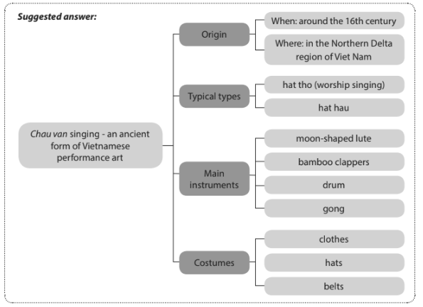 |  |  |  | * Teacher:  - asks Ss if they like traditional music and what types they are familiar with.  - has them look at the picture and describe it,  - introduces the type of music they are going to read about in this section.  - asks Ss to read the text and complete the mind map individually.
CULTURE – ACTIVITY 6 ( PRODUCTION) (5’)
To help Ss practise expressing opinions about a traditional type of music. |  | Tell your partner what you find most interesting about chau van singing. |  |  | ** Ss’ oral performance  Suggested answer: What I find most fantastic about chau van is that the psychic’s costumes are very colourful and the style of clothes, hats and belts depend on the rank of the gods or saints the performers worship. |  | * Teacher:  - asks Ss to work in pairs and share what they find most interesting about chau van singing.  *Teacher calls on some pairs to share their ideas with the whole class.
CONSOLIDATION & HOMEWORK (3’)
-To help Ss memorise the content of the lesson that they have learned |  | Wrap-up  Homework  - Exercises in the workbook  - Prepare for Looking back and Project lesson |  |  | Suggested answer:  -making and responding to suggestions;  -identifying chau van singing.

Date: October 28th, 2022
Period 25-ENGLISH 10- UNIT 3: MUSIC

Lesson 8: LOOKING BACK AND PROJECT

I/ Learning outcomes:
By the end of this lesson, Ss will be able to:
- Knowledge:
- pronounce two-syllable words with correct stress;
- understand and use words and phrases related to music;
- use conjunctions to make compound sentences correctly;
- use to-infinitives and bare infinitives after some verbs correctly;
- do research on traditional music in Viet Nam or another country and give a group presentation about it.
- Competences:
- develop communication skills and creativity;
- develop presentation skill;
- develop critical thinking skill;
- be collaborative and supportive in pair work and team work;
- actively join in class activities.
- Attributes:
- be more creative when doing the project;
- develop self-study skills.

II/ Teaching and learning resources:
Tape (CD), Tivi, speakers, textbook, teacher's book, copies of pictures, handouts, laptop, posters

III/ PROCEDURE:
Aims | Contents | Outcomes | Steps
ACTIVITY 1: WARM UP (5’)
- To arouse the classroom atmosphere.  - To help Ss revise words/ phrases related to the topic | 1. WARM-UP: (5’) | Lists of some words/ phrases related to the topic | Game  Game: The last man standing  Rules: Have ten Ss form a circle and stand at a center with a ball. Ss take turns to speak out a word related to the topic Music and pass the ball to one student. Let them toss it to another student as they name the word related to the theme. If they repeat a word or can’t say any more words, they need to sit down. The last student standing wins the game.  * Teacher: - invites ten Ss to form a circle and stand at a center with a ball.  - explains the game rules to Ss  ** Ss do as instructed  **** Teacher praises the Ss with the most words and the most interesting words/ phrases.
ACTIVITY 2: . LOOKING BACK (25’)
To help Ss revise stress in two-syllable words. | 1. PRONUNCIATION | A list of two-syllable words  Key + Audio script – Track 24:  per'form 'concert 'final 'singer 'famous en'joy | Listen and mark the stressed syllables in the following words. Then read them out.  * Teacher:  - has Ss do this activity individually, then compare their answers in pairs.  - plays the recording, pausing after each word for Ss to check their answers.  - writes the correct answers on the board if necessary.  - plays the recording again for Ss to repeat the words.  ** Ss do as instructed.  *** Ss compare their answers with a partner.  **** Teacher has Ss practise saying the words in pairs and checks their pronunciation.
- To help Ss revise vocabulary items they have learnt in the unit | 2. VOCABULARY | Completed text with words provided  Key:  1. music  2. fans  3. artists 4. instrument 5. Concerts | Complete the text using the words and phrases in the box.  * Teacher:  - asks Ss to read the paragraph quickly and check if they don’t know any words.  - has Ss do this activity individually and write their answers in their notebooks.  ** Ss do as instructed.  **** Teacher calls on individual Ss to write their answers on the board, and checks answers as a class.
- To help Ss revise compound sentences.  To help Ss revise verbs followed by to-infinitives and bare-infinitives. | 3. GRAMMAR | - Matched sentences  Key: 1.c 2. d 3. a 4. b  Corrected sentences using to infinitive or bare infinitive  Key:  1. attend -> to attend 2. to go -> go  3. buy -> to buy 4. to sing -> sing | GRAMMAR  1. Match the two parts to make complete sentences.  * Teacher asks Ss to read the two parts carefully and find out the clues to do the matching, e.g. He in 2 with his in d; We can in 3 and a…  ** Ss do the matching individually.  *** Ss compare their answers with a partner.  **** Teacher checks the answers as a class.  2. There is a mistake in each sentence below. Find the mistake and correct it.  * Teacher:  - asks Ss to read the sentences, then recall verbs that go with to-infinitives or bare infinitives.  - has them underline the mistakes in the sentences and correct them individually.  ** Ss do as instructed.  **** Teacher:  - calls on some Ss to read their answers.  - checks the answers as a class.
ACTIVITY 3: PROJECT (10’)
To provide an opportunity for Ss to develop their research and collaboration skills, and to practise giving an oral presentation. | PROJECT | Development of Ss’ research | * Teacher:  - gives Ss a checklist for peer and self-assessment and explains that they will have to tick the appropriate items while listening to their classmates’ presentations and write comments if they have any. (The presenters should complete their self-assessment checklist after completing their presentation).  - goes through the criteria for assessing their talk to make sure Ss are familiar with them.  - invites two or three groups to give their presentations and encourages the rest of the class to ask questions at the end.  ** Ss do as instructed.  *** Ss make questions after each presentation.  **** Teacher: gives praise and feedback after each presentation and gives marks for their presentation as part of their continuous assessment.  - asks Ss to complete the self-assessment table, identifies any difficulties and weak areas and suggests further practice for individual Ss.
ACTIVITY 4: CONSOLIDATION/ PRODUCTION (5’)
- To consolidate what students have learnt in the lesson.  - To prepare for the next lesson | CONSOLIDATION |  | Wrap-up  Teacher asks: What have you learnt today?  - revise how to pronounce stress in two-syllable words correctly;  - revise the use of words/ phrases related to the topic Music;  - revise how to use conjunctions to make compound sentences correctly;  - revise some verbs followed by to-infinitives and bare-infinitives.
Homework
- Exercises in the workbook
- prepare for Unit 4 lesson 1

Date: November 4th, 2022
PERIOR 26, 27, 28
REVIEW 1
PERIOR 26: Language

I. OBJECTIVES
By the end of this lesson, students will be able to:
1. Knowledge
- Review words related to family life, humans and environment, and music;
- Review the pronunciation of the consonant blends /br/, /kr/, /tr/, /gr/, /pr/;
- Apply the knowledge of grammar points learnt in the previous units to do the tasks;
(to-infinitive, bare infinitive, the present simple, the present continuous, the future with will and be going to)
- Use the passive voice;
- Use the coordinating conjunctions (and, or, but, so).
2. Core competence
- Develop communication skills and cultural awareness;
- Be collaborative and supportive in pair work and teamwork;
- Actively join in class activities.
3. Personal qualities
- Develop self-study skills;
II. Teaching and learning resources:
TV, speakers, textbook, teacher's book, handouts, laptop, sachmem.vn
III. PROCEDURES
Notes:
In each activity, each step will be represented as following:
* Deliver the task
** Implement the task
*** Discuss
**** Give comments or feedback

Stage aim | Procedure | Interaction | Time
WARM-UP  To lead in the lesson. | GAME: FINDING KEYWORDS  * Teacher shows 3 sets of pictures (taken from Project lessons of Unit 1-2-3) and asks students to find a keyword for each set of pictures.  ** Students raise hands to answer.  *** Teacher and students discuss the answers.  **** Teacher checks the answers as a class.  Set 1: Family life/family    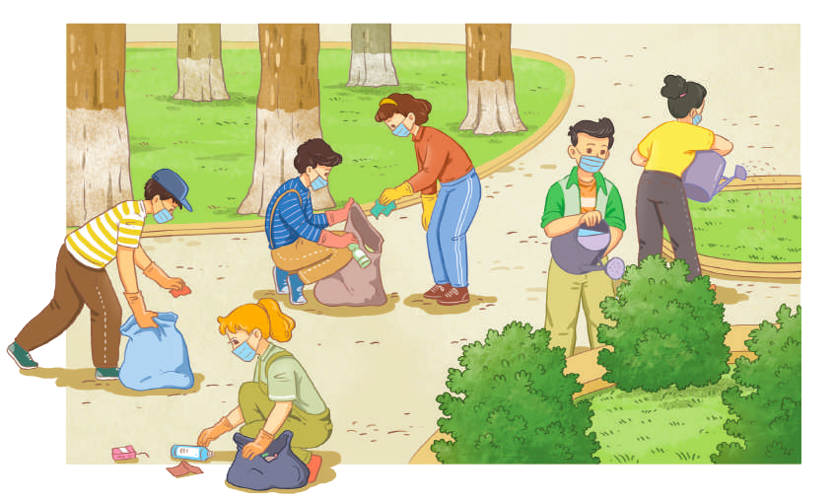 | T-S  S  T-S  T-S | 3 mins
  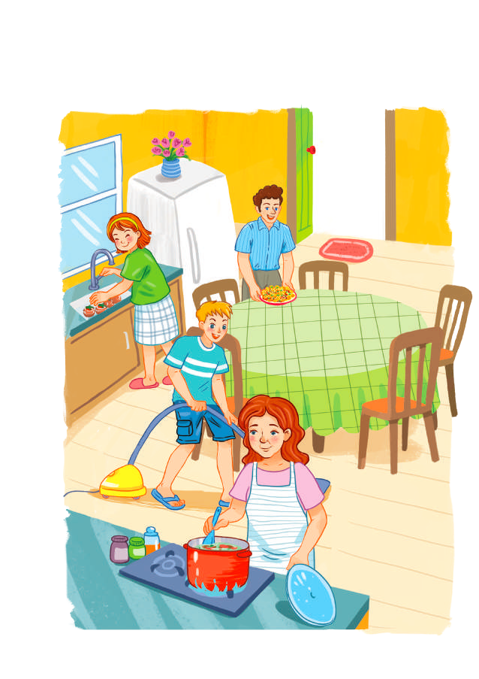 |  | 
  Set 2: Humans and the environment/ go green/ green lifestyle/ living green
  Set 3: Traditional music/music
   | 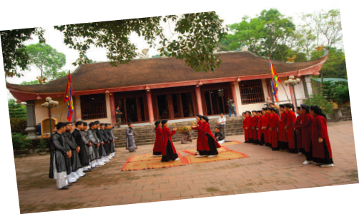
PRONUNCIATION  To check if students can identify consonant blends and provide further pronunciation practice. | TASK 1: LISTEN AND WRITE THE WORDS IN THE CORRECT COLUMNS. THEN PRACTISE SAYING THE WORDS. (p. 38)  * Teacher writes /br/, /gr/, /kr/, /pr/ and /tr/ on the board.  - Teacher writes one word containing the consonant blend below each of them.  - Teacher asks students to listen and write down the words containing the sound blends.  ** Students do the task by writing the words in a suitable column.  *** Teacher can invite some pairs of students to read aloud.  **** Teacher checks students’ pronunciation and gives feedback.  Key: | T-S  S  T-S  T-S | 5 mins
  /br/ | /gr/ | /kr/ | /pr/ | /tr/
  brain | green | crash | practise | train
  breakfast | grow | create | protect | treat
  breadwinner | great | cream | product | tree
VOCABULARY  To check if students remember collocations they have learnt in the previous units. | TASK 1: MATCH THE TWO PARTS TO MAKE COMPLETE SENTENCES. (p. 38)  * Teacher tells students to read the given parts of the sentences carefully and make sure they understand their meanings.  ** Students do this exercise individually by matching the halves to complete the sentences  *** Teacher allows students to share their answers before discussing as a class and encourages them to pronounce the sentences correctly.  **** Teacher checks the answers as a class and gives feedback.  Key:  1. e  2. d  3. a  4. b  5. c | T-S  Ss  Pair work  T-S | 5 mins
To check if students can use words they have learnt in the previous units. | TASK 2: COMPLETE THE FOLLOWING SENTENCES USING THE WORDS FROM THE BOX. (p. 38)  * Teacher asks students to work individually to complete the sentences with the given words and phrases.  ** Students work individually to complete the task.  *** Teacher allows students to share answers before discussing as a class.  **** Teacher asks students to say the sentences aloud and makes sure they pronounce the words and phrases correctly. Teacher can ask for translation to check their understanding.  Key:  1. laundry  2. groceries  3. perform  4. audience  5. eco-friendly | T-S  S  T-S  T-S | 7 mins
GRAMMAR  To check if students can use the grammar points learnt in the previous units in  sentences. | TASK 1: COMPLETE THE SENTENCES WITH THE CORRECT FORMS OF THE VERBS IN BRACKETS. (p. 39)  * Teacher asks students to work independently to fill in the blanks with the correct forms of the verbs in brackets.  ** Students read the sentences first and underline the clues that help them decide the correct forms of the verbs in brackets.  *** Teacher reminds students to use the correct forms of the verbs as requested in each sentence then allows them to share answers before discussing as a class.  **** Teacher can ask students to read aloud the full sentences and correct their pronunciation if needed.  Key:  1. cleans – is helping  2. to improve – take  3. practise – are practising  4. am going to watch – will win | T-S  S  T-S  T-S | 7 mins
To check if Ss can use the passive voice. | Task 2: Complete the sentences. Make sure they mean the same as the sentences above them. (p.39)  * Teacher asks students to read the sentences first.  ** Students do the task individually.  *** Teacher reminds students to pay attention to the passive and active forms of the sentences then allows them to share answers before discussing as a class.  **** Teacher can ask students to read aloud the full sentences and correct their pronunciation if needed.  Key:  1. The rubbish in the neighbourhood is collected three times a week.  2. All the electrical devices in the house were turned off.  3. His music videos will be watched online (by millions of people). | T-S  S  T-S  T-S | 8 mins
To check if Ss can use coordinating conjunctions (and, or, but, so) to make compound sentences. | TASK 3: MATCH THE TWO PARTS TO MAKE COMPLETE SENTENCES. (p. 39)  * Teacher asks students to read the two halves given of the sentence.  ** Students do the task individually.  *** Teacher reminds students to pay attention to the coordinating conjunctions (and, or, but, so) then allows them to share answers before discussing as a class.  **** Teacher can ask students to read aloud the full sentences and correct their pronunciation if needed.  Key:  1. b  2. c  3. d  4. a | T-S  S  T-S | 5 mins
CONSOLIDATION  - To consolidate what students have learnt in the lesson  - To prepare vocabulary for the next lesson | WRAP-UP  Teacher asks students to talk about what they have learnt in the lesson.  - Review on how to pronounce consonant blends, grammar points (to-infinitive, bare infinitive, the present simple, the present continuous, the future with will and be going to) and vocabulary of Unit 1, 2, and 3.  HOMEWORK  Prepare for Review 1 – Skills 1: Listening and speaking. | T-S | 2 mins

Date: November 4th, 2022

REVIEW 1
PERIOR 27: Skills (Listening & Speaking)
I. OBJECTIVES
By the end of this lesson, students will be able to:
1. Knowledge
- Practice listening for general and specific information about music;
- Practice talking about a favorite singer or musician.
2. Core competence
- Develop communication skills and cultural awareness;
- Be collaborative and supportive in pair work and teamwork;
- Actively join in class activities.
3. Personal qualities
- Develop self-study skills;

II. Teaching and learning resources:
TV, speakers, textbook, teacher's book, handouts, laptop, sachmem.vn

III. PROCEDURES
Notes:
In each activity, each step will be represented as following:
* Deliver the task
** Implement the task
*** Discuss
**** Give comments or feedback

Stage aim | Procedure | Interaction | Time
WARM-UP  To lead in the lesson. | NAME THE PICTURES: TRADITIONAL MUSIC  * T shows pictures and asks Ss to name the traditional music in the pictures.  ** Ss raise hands to answer.  *** T and Ss discuss the answers more.  **** T checks the answers as a class.  Key: | T-S  S  T-S  T-S | 5 mins
  Xoan singing | Chau van singing
  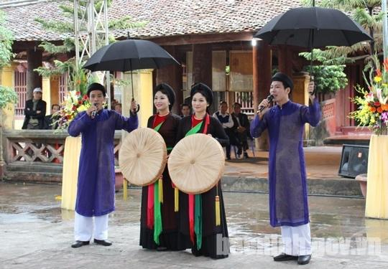
  Quan ho singing
LISTENING  To help students practise listening for main ideas. | TASK 1: LISTEN AND CHOOSE THE BEST TITLE FOR THE TALK. (p. 40)  * T focuses Ss’ attention on the three options and asks ‘What do you think the listening text will be about?’ to elicit Elvis Presley and check what Ss know about him.  ** Ss look at three options, read and underline key words.  *** T plays the recording once for Ss to listen and choose the best answer.  **** T confirms the answers as a class.  Key: C | T-S  S  T-S  T-S | 10 mins
To help students practise listening for specific information. | TASK 2: LISTEN AGAIN AND FILL IN EACH GAP IN THE QUICK FACTS WITH A NUMBER. (p. 40)  * T asks Ss to read through the Quick facts first, and elicit what the missing numbers refer to, e.g. year, age, how many awards.  - T plays the recording and has Ss fill in each gap with a number.  ** Ss listen and do the task individually.  *** T calls on some Ss to report their answers for the class.  **** T checks the answers and add more information if necessary.  Key:  1. 1935  2. 21  3. 3  4. 42  Audio script:  Elvis Presley was an American singer, musician and actor born in 1935. His single Heartbreak Hotel, released when he was 21, became a number-one hit in the United States. Starting with the film Love Me Tender, Presley also made 31 films. His single of the same name sold more than a million 67 copies even before the film was released. During his life, he received many awards, including three Grammys. Presley died of a heart attack at the age of 42. Many years after his death, Presley is still one of the best-selling singers of all time. | T-S  S  T-S  T-S | 10 mins
SPEAKING  To help students practise speaking about a favourite singer or musician. | WORK IN PAIRS. TALK ABOUT YOUR FAVOURITE SINGER OR MUSICIAN. USE THE EXPRESSIONS BELOW TO HELP YOU. (p. 40)  * T asks Ss to read through the expressions in the box.  ** Ss work in pairs to exchange their ideas about their favorite singer or musician.  *** T calls on some Ss to report their answers for the class.  **** T checks the answers and add more information if necessary.  Useful expressions:  - My favourite singer / musician is ...  - His / Her (most famous) single / song / album / work is ...  - His / Her single became a (number 1) hit in ...  - (During his / her life), he / she has received (many / some …) awards, including ... | T-S  Pair work  T-S | 15 mins
CONSOLIDATION To consolidate what students have learnt in the lesson. | WRAP-UP  T asks Ss to talk about what they have learnt in the lesson.  - Practice listening for general and specific information about music;  - Practice talking about a favourite singer or musician.  HOMEWORK  - Prepare for Review 1 – Skills 2 (Reading and Writing). | T-S | 5 mins

Date: November 4th, 2022
REVIEW 1
PERIOR 27: Skills (Reading & Writing)

I. OBJECTIVES
By the end of this lesson, students will be able to:
1. Knowledge
- Practise reading for general and specific information about how to live a green life;
- Practise writing a short paragraph about ways of living green.
2. Core competence
- Develop communication skills and cultural awareness;
- Be collaborative and supportive in pair work and teamwork;
- Actively join in class activities.
3. Personal qualities
- Develop self-study skills.

II. Teaching and learning resources:
TV, speakers, textbook, teacher's book, handouts, laptop, sachmem.vn

III. PROCEDURES
Notes:
In each activity, each step will be represented as following:
* Deliver the task
** Implement the task
*** Discuss
**** Give comments or feedback

Stage aim | Procedure | Interaction | Time
CHECK-UP  To check the knowledge in the previous lesson and give students more chance to practice speaking | TALK ABOUT YOUR FAVOURITE SINGER OR MUSICIAN  * T elicits the requirement of talking about Ss’ favourite singer or musician  ** Ss raise hands to answer.  *** T listens to Ss‘ answers and takes notes for comments.  **** T provides comments and feedback. | T-S  S  T-S  T-S | 5 mins
READING  To help students practise understanding word meanings in context. | TASK 1: READ THE TEXT BELOW. THEN WORK IN PAIRS TO COMPLETE THE CROSSWORD WITH FIVE WORDS FROM THE TEXT. (p. 40)  * T has Ss read through the text and the crossword clues. T focuses on the crossword grid and reminds them that the number of letters should match the number of squares.  ** Ss work individually to work out the words.  *** T puts them into pairs to compare their answers and asks individual Ss to write the words on the board.  **** T confirms the answers as a class.  Key:  1. environment  2. water  3. air  4. energy  5. green | T-S  S  T-S  T-S | 10 mins
To help students practise reading for specific information. | TASK 2: READ THE TEXT AGAIN AND GIVE SHORT ANSWERS TO THE FOLLOWING QUESTIONS. (p. 41)  * T asks Ss to read through the questions and check understanding of the vocabulary.  ** Ss read the text again and look for the answers to the questions.  *** T calls on some Ss to report their answers for the class.  **** T checks the answers and add more information if necessary.  Key:  1. The methods of collecting water (are).  2. Rainwater is collected from a roof and sent to a container.  3. Tiny drops of water in the air are turned into drinking water. | T-S  S  T-S  T-S | 10 mins
WRITING  To help students practise writing a short paragraph about ways of living green. | THINK ABOUT WAYS OF LIVING A GREEN LIFESTYLE. COMPLETE THE PARAGRAPH. USE WHAT YOU HAVE LEARNT AND THE IDEAS BELOW TO HELP YOU. (p. 41)  * T asks Ss to think about what they have learnt about different ways of living green.  ** Ss read through the ideas in the box, work in groups and brainstorm more ideas.  *** T gives Ss enough time to complete the paragraph. Set a time limit depending on the Ss’ ability level.  **** T asks individual Ss to read their paragraphs or collect them to check after class and provide written feedback.  Sample answer:  There are many ways you can make your life greener. First, make your area green by planting more trees and plants. Second, make your area clean by organising regular clean-up activities, collecting litter and setting up more recycling bins. Finally, turn off electrical devices when not in use and use energy from the sun, wind and water. Living a green lifestyle is not difficult, but these small changes will make a big difference. | T-S  S  Group work  T-S | 15 mins
CONSOLIDATION To consolidate what students have learnt in the lesson. | WRAP-UP  T asks Ss to talk about what they have learnt in the lesson.  - Practise reading for general and specific information about how to live a green life.  - Practise writing a short paragraph about ways of living green.  HOMEWORK  Prepare for Unit 4 – Getting started. | T-S | 5 mins

Date: November 5th, 2022
Period 29: MID-TERM TEST 1
TĐỀ CHÍNH THỨC  (Đề gồm có 03 trang) | KIỂM TRA GIỮA KỲ I NĂM HỌC 2022-2023  Môn: Tiếng Anh – Lớp: 10  Thời gian: 60 phút (không kể thời gian giao đề)
Họ và tên: .......................................................................... | Số báo danh: ........... | Mã đề 801
- LISTENING:
Task 1: Listen to the conservation between an officer and a student, then choose the best option for the questions.
Question 1. What does the student particularly like to eat?
A. seafood B. vegetable C. chicken D. meat
Question 2. what are the student’s hobbies?
A. reading and going to the movies. B. reading and going to the theater.
C. swimming and going to the movies. D. reading and dancing.
Question 3. What sport does the student play?
A. badminton B. volleyball C. tennis D. football
Question 4. What mode of transport does the student prefer?
A. taxi B. bus C. train D. car
Question 5. When will the student find out her homestay address?
A. this morning B. this afternoon C. this Friday D. this Monday
Task 2: Listen to the talk show and decide whether the statements are true (T)or false (F)
Question 6. There are four people in Hieu's family.
A. T B. F
Question 7. Hieu's parents teach him physics.
A. T B. F
Question 8. Hieu's brother only shares his happy moments with him
A. T B. F
Question 9. Hieiu’s parents’ love and trust give him strength to carry on.
A. F B. T
Question 10. Hieu's family routines help them spend some time together every year.
A. T B. F
B.LEXICO AND GRAMMAR
Mark the letter A, B, C, or D to indicate the word that differs from the other three in the position of the primary stress in each of the following questions.
Question 11. A. footprint B. issue C. admire D. plastic
Question 12. A. lifestyle B. maintain C. greenhouse D. nature
Mark the letter A, B, C or D on your answer sheet to indicate the correct answer to each of the following questions.
Question 13. Mark the letter A, B, C, or D on your answer sheet to indicate the underlined part that needs correction in the following question.
Doing housework teach children life skills and helps build their character.
A. life B. teach C. build D. their
Question 14. In the UK, poor air quality is responsible _____ some 40,000 deaths each year.
A. for B. in C. with D. to
Question 15. Hai is thanking Tom for his compliment.
-Hai: "Thank you for your kind words, Tom." -Tom: " _____________________”
A. You're welcome. B. That's not good. C. Good idea. D. Same to you.
Question 16. Mark the letter A, B, C, or D on your answer sheet to indicate the word CLOSEST in meaning to the underlined word in the following question.
To prevent pollution ,people should reduce the need to collect new raw materials and protect natural resources.
A. rise B. increase C. run out of D. cut down on

Question 17. Jim _____ a book at the moment.
A. had read B. reads C. is reading D. has read
Question 18. My responsibility is to wash the dishes and _____ the rubbish.
A. take up B. get out C. get up D. put out
Question 19. I'm lucky to have such a(n)_____ brother who always gives me help when I need it.
A. supported B. supports C. supportive D. support
Question 20. Peter is asking to borrow Nam's pen.
Peter: "Can I borrow your pen, Nam?"Nam: "_______________________”
A. Me too. B. Congratulations! C. Thanks a lot. D. Here you are.
Question 21. Remember to turn off your _____when they are not used.
A. household finance B. household appliances
C. household gods D. household chores
Question 22. Mark the letter A, B, C, or D on your answer sheet to indicate the word(s) OPPOSITE in meaning to the underlined word(s) in the following question.
We buy organic food at the farmers' market. It costs a little bit more, but we think it's better for our health.
A. Wealthy B. non-organic C. sustainable D. healthy
Question 23. When I lived in this city, I used to shop for_____at this supermarket.
A. heavy lifting B. laundry C. groceries D. housework
Question 24. I _____my parents at the weekend. I already bought a train ticket.
A. visited B. will visit C. visit D. am going to visit
C. READING: Task 1: Read the following passage and mark the letter A, B, C, or D on your answer sheet to indicate the correct word or phrase that best fits each of the numbered blanks .
Globally, the average carbon footprint per person is more (25) _____4 tons per year. Too much CO2 in the Earth's atmosphere can cause serious problems. It can lead(26) _____increasing global temperatures and air (27) _____, and destroy the natural world.
It's not difficult to reduce your carbon footprint. You can do it by making your daily activities eco-friendly. (28) _____, you can take shorter showers. The less hot water you use, the less energy is needed to heat the water. Instead of using your personal car or motorbike, you should use public transport, walk or cycle as much as possible.
Question 25. A. many B. much C. than D. as
Question 26. A. to B. with C. in D. for
Question 27. A. pollute B. pollution C. polluted D. polluting
Question 28. A. However B. Instead of C. For example D. Because
Task 2: Read the following passage and mark the letter A, B, C or D on your answer sheet to indicate the correct answer for each of the questions
PROUD OF THEIR DUSTBIN!
The dustbin is full to the top with crisp packets and coloured plastic. In fact, it’s so full that it’s difficult to put the lid on. But the Strauss family, who owns this dirty, old dustbin full of rubbish, are very proud of it. Why? Because it contains all the family’s rubbish for a whole year.
Two years ago, Richard and Rachelle Strauss and their daughter Verona read an article about plastic bags and how they cause pollution and harm sea creatures. They decided to stop using plastic bags completely. Now, when they buy food, they reuse their own bags each time. They recycle as much as they can - glass bottles, plastic bottles, paper, cardboard, cans - and they simply don’t buy things if they can’t recycle the packaging. (They buy their toothpaste in aluminium tubes just because aluminium can be recycled.) And they never throw food away - they eat their leftovers or use them to make compost.
At the moment, it’s impossible to recycle plastic crisp packets and sweet wrappers - and Verona loves crisps. If she bought a packet of crisps a day, she’d have to throw away lots of plastic. So she buys the biggest packets she can find - and each packet lasts for a week.
The family are keeping a record of their lifestyle on their website. They hope that other people will read it and reduce their waste. If everyone recycles a bit more, it will make a huge difference.
(Adapted from Solutions by Falla and Davies)

Question 29. What is the passage mainly about?
A. A lifestyle that is good for the environment
B. An old dustbin full of rubbish
C. A lifestyle that is harmful to the environment
D. An article about pollution
Question 30. The word contains in paragraph 1 is closest in meaning to _______.
A. uses B. throws C. keeps D. gives
Question 31. According to paragraph 2, the Strauss family read an article about _______.
A. plastic bags and how they harm the environment
B. plastic bags and how to produce them
C. plastic bags and how to make the environment clean
D. plastic bags and how they save sea animals
Question 32. According to paragraph 2, which of the following is NOT mentioned as the thing the Strauss family recycle?
A. cans B. food C. paper D. bottles
D. WRITING: (1PT)
Task 1: Rewrite the following sentences with the words given:
Question 33:Lan plans on buying a new car next weekend.
=>Lan is GOING TO BUY A NEW CAR NEXT WEEKEND.
Question 33: Peter has no intention of taking the trip with us tomorrow.
=>Peter is NOT GOING TO TAKE THE TRIP WITH US TOMORROW.
Question 35:People use wind energy to produce electricity.
=>Wind energy IS USED TO PRODUCE ELECTRICITY.
Question 36:The students put the rubbish in the bin after the party yesterday.
=>The rubbish WAS PUT IN THE BIN (BY THE STUDENTS) AFTER THE PARTY YESTERDAY.
Task 2: In about 80 - 100 words, write a paragraph about the reasons why children should do housework. (1PT)
Suggestions:- helping them develop life skills.
-teaching them to take responsibility,
- helping strengthen family bonds.
……………………………………………………………………………………………………………………………………………………………………………………
………………………………………………………………………………………………………………………………………………………………………………………………………………………………………………………………………………………………………………………………………………………………………………………………………………………………………………………………………………………………………………………………………………………………………………………………………………………………………………………………………………………………………………………………………………………………………………………………………………………………………………………………………………………………………………………………………………………………………

------ HẾT ------

Date: November 10th, 2022
Period 30: UNIT 4: FOR A BETTER COMMUNITY
Lesson 1: Getting started – Volunteering in the community
I/ Learning outcomes:
By the end of this lesson, Ss will be able to:
- Knowledge:
- Have an overview about the topic “ For a better community ”.
- Gain vocabulary to talk about activities to adopt volunteering in the community.
- understand meanings of the adjective suffixes: ful, less, ing and ed
- Competences:
- Develop communication skills and awareness of voluntary work.
- Be collaborative and supportive in pairwork and teamwork.
- Actively join in class activities.
- Attributes:
- Develop a sense of helping community and awareness of voluntary work.
- Be responsible to community.
II/ Teaching and learning resources:
- Tivi, speakers, textbook, teacher's book, copies of pictures, handouts, laptop, and posters
III/ PROCEDURE:
Aims | Content | Outcomes |  | Steps
ACTIVITY 1: INTRODUCTION & ENGAGE/ WARM UP (5’)
- create a friendly and lively atmosphere in the classroom  - Introduce the unit topic ( Humans and the environment);  - To lead into the new unit | 1. Introduction: (5’)  CLIP WATCHING  -T gives instructions (watch video and take notes individually)  Link: https://www.youtube.com/watch?v=Ho5b-CfKTpo  QUESTION  What volunteer activities do young people do in the video clip ?  - T divides the class into four groups. Four groups will take turns to write the their words/ phrases about the voluntary activities as much as possible on the board. If the group  write more words, they will be  winners.)  T leads into the lesson: Doing voluntary work to help the community is a way for you to contribute to make our community a better one. There are many activities you can do to help other people and in today’s lesson we will find out more about these activities. |  | Students’ oral prediction about the clip  List of volunteer activities  + Read books for children in orphanages  + Visit and play games with them or listen to their problems  + Work at home of sick and old people (clean up their houses, do their shopping or mow their law)  + Volunteer to work in remote or mountainous areas  + help disadvantaged or handicapped children  + help people who have suffered badly in the war or natural disaster | Elicit  Watch the clip to elicit the topic  Work in group
ACTIVITY 2: STUDY/ PRESENTATION (20’)
- Understand the words related to volunteer work Introduce the grammar points to be learnt in the unit. | 1. Vocabulary  1. volunteer (n/v) /ˌvɒlənˈtɪə(r)/: (picture)  2. advertisement (n) /ədˈvɜːtɪsmənt/:  (picture/ explanation)  3.community (n) /kəˈmjuːnəti/:  (explanation)  4. boost (v) /buːst/: (synonym)  5.orphanage (n) /ˈɔːfənɪdʒ/: (explanation) | List of vocabulary |  | Elicit  Give synonym/ Vietnamese equivalent/ example to elicit vocabulary from Ss
 | * Listen & repeat | Sts’ pronunciation of the words |  | Listen & repeat in chorus then individually
 | * Check vocabulary: | - The missing words on the board. |  | Rub out and remember
 | 2. Listen & read (5’)  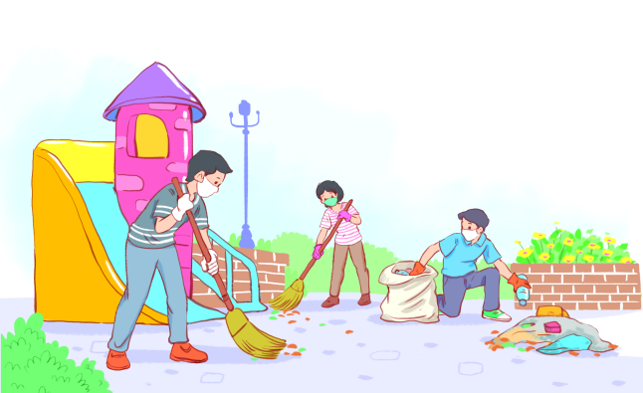  look at the picture (p.42) and answer the questions:  + Where are they?  + Who are they?  + What are they doing?  * T leads into the new lesson.  * T plays the recording twice, has Ss listen to the conversation, read along and underline the activities in the conversation which are good for the volunteering in the community  * One or two pairs read aloud. | Ss’ prediction about the picture  Suggested answers:  + They are at school/ in the park.  + They are students (They may be volunteers of the centre.).  - They are cleaning up the school and planting trees.  The activities in the conversation which are good for the volunteering in the community  -benefit the local area  -boost our confidence  -help us learn many useful skills  -join a local environmental group to clean up the park |  | Set the context for listening and reading the conversation  Answer the questions individulally  Work in individually and in pairs
ACTIVITY 3: ACTIVATE/ PRACTICE (15’)
Practise reading for specific information | TASK 2: READ AND ANSWER THE QUESTIONS. (p.43)  Read the conversation again and answer the following questions.  1. What was Tam doing when Kim went to her house?  2. What are some regular activities at the centre for community development?  3. How can Kim apply for volunteer work at the centre?  * T asks Ss to scan the conversation, locate the key words to find the answer for each question with the partner who sits behind them.  ** Ss do the task in pairs. | - Answered questions  Suggested answers  1. She was working as a volunteer at the local centre for community development.  2. Cleaning up the park or volunteering at the orphanage.  3. She needs to fill in the form, then send it in. |  | - read the conversation  - Work in pairs  - Peer correction  - Teacher’s feedback
- To help students revise adjectives ending in the suffixes -ed and  -ing; -ful and -less.  - To practise scanning | TASK 3: FIND ADJECTIVES WITH THE FOLLOWING SUFFIXES IN THE CONVERSATION AND WRITE THEM BELOW. (p.43)  * T has Ss scan the conversation and write down the adjectives ending with these suffixes : ed, ing, ful, less.  *Ss work individually.  *** Ss share their answers with a partner.  **** T checks and gives the correct answers with the whole class  -Have st them say the meaning of those adjective suffixes. | List of the adjectives ending with the suffixes  -ed: excited  -ing: interesting  -ful: useful, successful  -less: endless  Meaning of Adjective suffixes:  -Ful: full or having the qualities of  -Less: without or lacking  -Ed : describing how people are made to feel  -Ving: describing things or people causing the feeling
To help students identify the past simple and past continuous with when and while | TASK 4: FIND A VERB OR VERB PHRASE IN THE CONVERSATION TO COMPLETE EACH SENTENCE. (p.43)  * T has Ss say the usage of the past simple and past continuous with when and while  * T has Ss read each sentence, try to complete it with an appropriate  verb phrase without referring to the conversation.  ** Ss do the task individually.  *** Ss share the answers with a peer.  **** T asks the whole class the call out the verb forms first, then call on individual students to read the complete sentences. | The completed sentences with the verb or verb phrase  1. was working  2. saw |  | - Do the task individually  - share the answers with a peer.  - Teacher’s feedback
ACTIVITY 4: CONSOLIDATION/ PRODUCTION (5’)
To help students practising talking about activities which help protect the environment. | SELF-REFLECTION  Talk about activities you are going to do to make your community a better one (for a minute).  * Teacher:  - gives Ss clear instructions in order to make sure Ss can do effectively.  - encourages Ss to talk about some activities including following information:  + How many activities are you going to talk about?  + Where do you do those activities?  + Who do you do with?  + How often do you do those activities?  - observes Ss while they are talking, note their language errors. | - Ss’ list of voluntary activities  - place to do the activities  - Person they do with  - Always, usually, sometimes, never…. |  | -Work in 4 groups  -Peer correction  - Teacher’s feedback
To help students memorise the target language and skills that they have learnt  To inform Ss what the final product of the Project should be like and how students can prepare for it. | WRAP-UP  - Some lexical items about volunteering in the community  - Reading for specific information  - Scanning  HOMEWORK  - Exercises in the workbook  - Prepare for the next lesson  PROJECT PREPARATION  * T asks Ss open their books at page 51, look at the pictures and say what the topic of the Project is (A Volunteer Project).  Teacher:  - Tells Ss about the Project requirements:  + Ss will have to find information about a volunteer project in the community.  + Ss give an oral presentation about that volunteer project in the last lesson of the unit. Their presentation should include information related to the guiding questions.  + Ss can choose different ways to present their findings (PPT presentation, Poster presentation, recording a video about the project).  - Encourages Ss to use photos and / or pictures to illustrate their ideas.  - Explains to Ss how they can get the information, e.g: surf the Internet, read newspapers, go to their local community centre and talk to people there.  - Puts Ss into groups and have them choose their group leader. Then ask them to assign tasks (e.g. who will collect information, who will prepare the slides / record the video, who will write the report, and who will present) for each group member, making sure that all group members contribute to the group work.  ** Ss do as instructed.  **** T helps Ss set deadlines for each task and supports them throughout the process.  . | Ss’ oral presentation of the research results |  | Groupwork

Date: November 10th, 2022
Period 31: UNIT 4: FOR A BETTER COMMUNITY
Lesson 2: Language
I/ Learning outcomes:
By the end of this lesson, Ss will be able to:
- Knowledge:
- Use the lexical items related to the topic For a better community;
- Pronounce correctly stress in two-syllable words with the same spelling;
- Use the past simple vs. the past continuous.
- Competences:
- be collaborative and supportive in pair work and team work
- access and consolidate information from a variety of sources
- actively join in class activities
- Attributes:
- be willing to learn new language points
- develop a sense of helping the community and awareness of voluntary work
- be responsible to the community
II/ Teaching and learning resources:
TV, speakers, textbook, teacher's book, handouts, laptop, sachmem.vn
III/ PROCEDURE:
Aims |  | Content | Outcomes | Steps
WARM UP
- To arouse the classroom atmosphere  - To lead in the lesson |  | 1. Brain storming: (5’)  NAME SOME ACTIVITIES YOU CAN DO TO HELP THE COMMUNITY. | Ss’ oral answers about the activities Ss can do to help the community. | Lead-in
To help students recognize and understand the difference of stress in two-syllable words with the same spelling.  To help students practise saying sentences containing two-syllable words with the same spelling but different stress patterns.  To enrich students’ vocabulary.  To give students practice in using the words in meaningful contexts.  To give students practice in using adjectives ending in  -ed, -ing, -ful, and  -less.  - To have students revise the past simple and the past continuous.  - To help students understand the use of the past simple and the past continuous. | I. PRONUNCIATION  TASK 1: LISTEN TO THE SENTENCES AND CIRCLE THE WORD WITH THE STRESS YOU HEAR (p.43)  Rules:  - Most two-syllable nouns and adjectives have the stress on the first syllable.  - Most two-syllable verbs have the stress on the second syllable.  TASK 2: LISTEN AGAIN AND PRACTISE SAYING THE SENTENCES IN 1. (p.43)  II. VOCABULARY  TASK 1. MATCH THE WORDS WITH THEIR MEANINGS. (p.44)  TASK 2: COMPLETE THE FOLLOWING SENTENCES USING THE CORRECT FORMS OF THE WORDS IN 1. (p.44)  TASK 3: CHOOSE THE CORRECT WORD TO COMPLETE EACH OF THE FOLLOWING SENTENCES. (p.44)  III. GRAMMAR  Activity 1: PRESENTATION  The past simple  The past continuous  Past simple vs. past continuous with when and while |  | Ss’ pronunciation of the words.  + Marked stressed syllables in Ss’ book.  + Ss’ pronunciation of the sentences.  + Sts’ oral sentences  + Matched items in Ss’ books.  Key:  1. c 2. e 3. a 4. b 5. d  + A list of the missing words in the exercise 2 in Ss’ notebook.  Key:  1. generous  2. remote  3. donate  4. benefit  5. volunteers  Completed sentences with the correct adjectives  Key:  1. careful  2. interested  3. exciting  4. hopeless  Forms and usage of the past simple and the past continuous | Elicit  Elicit the rule of the two-syllable words.  - Pair work  - Peer correction  - Teacher’s feedback  Elicit  - Pair work  - Peer correction  - Teacher’s feedback  - Work in pairs  - Peer correction  - Teacher’s feedback  - T’s elicitation & explanation.  - Ss answer teacher’s questions  - Teacher’s feedback as a class.  - T’s elicitation & explanation.  - Ss answer teacher’s questions  - Teacher’s feedback as a class.  lets Ss recall the form of the present simple and the present continuous and elicits the rules of using these two verb forms from Ss.
  Positive
  S + V-ed + … .
  Negative
  S + didn’t + V-inf + … .
  Interrogative
  Did + S + V-inf + … ?
  Answer
  Yes, S + did.
  No, S + didn’t.
  Wh-questions
  Wh + did + S + V-inf + … ?
  Positive
  S + was/were + V-ing….
  Negative
  S + wasn’t/weren’t+ V-ing + …
  Interrogative
  Was/were + S + V-ing + …?
  Answer
  Yes, S + was/were.
  No, S + wasn’t/weren’t.
  Wh-questions
  Wh + was/were + S + V-ing + …?
To give students more practice in using the past simple and the past continuous with when and while. | Activity 2: PRACTISE  TASK 1: CHOOSE THE CORRECT VERB FORM IN EACH OF THE FOLLOWING SENTENCES. (p.44)  TASK 2: COMBINE THE TWO SENTENCES USING WHEN OR WHILE WHERE APPROPRIATE. (p.44) |  | + correct forms of words  + combined sentences | - T’s instruction  - Work in pairs or individually  - peer correction  - Teacher’s feedback  Pair work  - peer correction  - Teacher’s feedback
To give students a chance to apply what they have learnt | Activity 3 PRODUCTION  GAME: WHO IS FASTER?  * T divides Ss into groups of four, gives each group a piece of paper, and asks them to write sentences including 2 features:  + when/ while  + the past simple/ the past continuous  e.g. When I was wrapping the present, my mom knocked the door.  ** T asks each group to hand in their paper and checks. The group with more correct sentences is the winner.  *** T invites the winner to read aloud their sentences. |  | Students’ sentences on the verb tenses (past simple and past continuous tense) | - Groupwork  - Teacher’s feedback.
Inform students what they have to do at home | 2. HOMEWORK  - Exercises in the workbook  - Prepare for lesson 3 Unit 4

Date: November 10th, 2022
Period 32: UNIT 4: FOR A BETTER COMMUNITY
Lesson 3: Reading
I/ Learning outcomes:
By the end of this lesson, Ss will be able to:
- Knowledge:
- read for main ideas and specific information in a text about a volunteer club.
- gain vocabulary about voluntering activity.
- Competences:
- develop reading skills;
- be collaborative and supportive in pair work and teamwork;
- actively join in class activities.
- Attributes:
- be aware of responsibilities towards community.
II/ Teaching and learning resources:
Tape (CD), Tivi, speakers, textbook, teacher's book, copies of pictures, handouts, laptop, posters
III/ PROCEDURE:
Aims | Contents | Outcomes | Steps
ACTIVITY 1: INTRODUCTION & ENGAGE/ WARM UP (5’)
- get students to know the topic of the lesson through the pictures. | - List volunteering activities for teenagers, using the pictures on page 45 Textbook | Students’ oral prediction about the topic | Elicit  Show the picture to elicit the topic
 |  | Suggested answer:  - Helping at a footbank  - Selling handmade items  - Raising money for charity  - Helping old people  - Helping out at an animal shelter  - Cleaning up beaches  - Collecting litter  - ……. | List  Work in pairs to list volunteering activities for teenagers
 | Vocabulary:  - Set up = establish  - Hand-made (a)  - Hardship (n)  - Suffering (n) | A list of words | Elicit  Give synonym/ Vietnamese equivalent/ example to elicit vocabulary from Ss
ACTIVITY 2: STUDY/ PRESENTATION (15’)
- help students practice reading for main idea | Read the text and choose the main idea. | Chosen main idea of the text  Key: C | - Work individually and in pairs
ACTIVITY 3: ACTIVATE/ PRACTICE (15’)
Help Ss practice guessing the meaning of the words from context | 1/ Match the highlighted words in the text with their meanings.  . | - Ss’ oral guessing  - matched words with their meaning  Key:  1c 2d 3a 4e 5b | Have Ss read the text again, paying attention the context of each highlighted word, and looking for clues they can use to guess the meaning.  - Work in groups  - Teacher’s feedback
  A | B
  1.various | a.objects or things
  2.participate | b.takings things to s.o
  3.items | c.several different
  4.raised | d.to take part in an activity
  5.delivering | e.collected money
Practise reading for specific information | 2/ True/False  Read the text again and decide whether the following statements are true (T) or false (F). (p.46) | - statements identified as T/ F  KEY:  1F  2T  3F  4T | - Do the task individually  - share the answers with a peer.  - Teacher’s feedback
ACTIVITY 4: CONSOLIDATION/ PRODUCTION (10’)
Help Ss use the ideas and language in the reading to disuss a related question. | Discuss the question:  “If you were a member of the Volunteer Club, what would you do to help?” | - Sts’ oral presentation of volunteering activities  Suggested answers:  - Clean up the beaches  - Help the old and the homeless  - Direct traffic  - Donate blood  - Raise money for the poor  - Provide education for the people in remote and mountainous areas | -Work in groups of four  - Teacher’s feedback
Have Ss some volunteering activities | 2. Homework (2’)  a/ Review the Reading lesson  b/ Prepare for the Speaking lesson | Ss preparation for the Speaking lesson | Work individually

Date: November 10th, 2022
Period 33: CORRECTION-MID-TERM TEST 1
ĐỀ CHÍNH THỨC  (Đề gồm có 03 trang) | KIỂM TRA GIỮA KỲ I NĂM HỌC 2022-2023  Môn: Tiếng Anh – Lớp: 10  Thời gian: 60 phút (không kể thời gian giao đề)
Họ và tên: .......................................................................... | Số báo danh: ........... | Mã đề 801
- LISTENING:
Task 1: Listen to the conservation between an officer and a student, then choose the best option for the questions.
Question 1. What does the student particularly like to eat?
A. seafood B. vegetable C. chicken D. meat
Question 2. what are the student’s hobbies?
A. reading and going to the movies. B. reading and going to the theater.
C. swimming and going to the movies. D. reading and dancing.
Question 3. What sport does the student play?
A. badminton B. volleyball C. tennis D. football
Question 4. What mode of transport does the student prefer?
A. taxi B. bus C. train D. car
Question 5. When will the student find out her homestay address?
A. this morning B. this afternoon C. this Friday D. this Monday
Task 2: Listen to the talk show and decide whether the statements are true (T)or false (F)
Question 6. There are four people in Hieu's family.
A. T B. F
Question 7. Hieu's parents teach him physics.
A. T B. F
Question 8. Hieu's brother only shares his happy moments with him
A. T B. F
Question 9. Hieiu’s parents’ love and trust give him strength to carry on.
A. F B. T
Question 10. Hieu's family routines help them spend some time together every year.
A. T B. F
B.LEXICO AND GRAMMAR
Mark the letter A, B, C, or D to indicate the word that differs from the other three in the position of the primary stress in each of the following questions.
Question 11. A. footprint B. issue C. admire D. plastic
Question 12. A. lifestyle B. maintain C. greenhouse D. nature
Mark the letter A, B, C or D on your answer sheet to indicate the correct answer to each of the following questions.
Question 13. Mark the letter A, B, C, or D on your answer sheet to indicate the underlined part that needs correction in the following question.
Doing housework teach children life skills and helps build their character.
A. life B. teach C. build D. their
Question 14. In the UK, poor air quality is responsible _____ some 40,000 deaths each year.
A. for B. in C. with D. to
Question 15. Hai is thanking Tom for his compliment.
-Hai: "Thank you for your kind words, Tom." -Tom: " _____________________”
A. You're welcome. B. That's not good. C. Good idea. D. Same to you.
Question 16. Mark the letter A, B, C, or D on your answer sheet to indicate the word CLOSEST in meaning to the underlined word in the following question.
To prevent pollution ,people should reduce the need to collect new raw materials and protect natural resources.
A. rise B. increase C. run out of D. cut down on

Question 17. Jim _____ a book at the moment.
A. had read B. reads C. is reading D. has read
Question 18. My responsibility is to wash the dishes and _____ the rubbish.
A. take up B. get out C. get up D. put out
Question 19. I'm lucky to have such a(n)_____ brother who always gives me help when I need it.
A. supported B. supports C. supportive D. support
Question 20. Peter is asking to borrow Nam's pen.
Peter: "Can I borrow your pen, Nam?"Nam: "_______________________”
A. Me too. B. Congratulations! C. Thanks a lot. D. Here you are.
Question 21. Remember to turn off your _____when they are not used.
A. household finance B. household appliances
C. household gods D. household chores
Question 22. Mark the letter A, B, C, or D on your answer sheet to indicate the word(s) OPPOSITE in meaning to the underlined word(s) in the following question.
We buy organic food at the farmers' market. It costs a little bit more, but we think it's better for our health.
A. Wealthy B. non-organic C. sustainable D. healthy
Question 23. When I lived in this city, I used to shop for_____at this supermarket.
A. heavy lifting B. laundry C. groceries D. housework
Question 24. I _____my parents at the weekend. I already bought a train ticket.
A. visited B. will visit C. visit D. am going to visit
C. READING: Task 1: Read the following passage and mark the letter A, B, C, or D on your answer sheet to indicate the correct word or phrase that best fits each of the numbered blanks .
Globally, the average carbon footprint per person is more (25) _____4 tons per year. Too much CO2 in the Earth's atmosphere can cause serious problems. It can lead(26) _____increasing global temperatures and air (27) _____, and destroy the natural world.
It's not difficult to reduce your carbon footprint. You can do it by making your daily activities eco-friendly. (28) _____, you can take shorter showers. The less hot water you use, the less energy is needed to heat the water. Instead of using your personal car or motorbike, you should use public transport, walk or cycle as much as possible.
Question 25. A. many B. much C. than D. as
Question 26. A. to B. with C. in D. for
Question 27. A. pollute B. pollution C. polluted D. polluting
Question 28. A. However B. Instead of C. For example D. Because
Task 2: Read the following passage and mark the letter A, B, C or D on your answer sheet to indicate the correct answer for each of the questions
PROUD OF THEIR DUSTBIN!
The dustbin is full to the top with crisp packets and coloured plastic. In fact, it’s so full that it’s difficult to put the lid on. But the Strauss family, who owns this dirty, old dustbin full of rubbish, are very proud of it. Why? Because it contains all the family’s rubbish for a whole year.
Two years ago, Richard and Rachelle Strauss and their daughter Verona read an article about plastic bags and how they cause pollution and harm sea creatures. They decided to stop using plastic bags completely. Now, when they buy food, they reuse their own bags each time. They recycle as much as they can - glass bottles, plastic bottles, paper, cardboard, cans - and they simply don’t buy things if they can’t recycle the packaging. (They buy their toothpaste in aluminium tubes just because aluminium can be recycled.) And they never throw food away - they eat their leftovers or use them to make compost.
At the moment, it’s impossible to recycle plastic crisp packets and sweet wrappers - and Verona loves crisps. If she bought a packet of crisps a day, she’d have to throw away lots of plastic. So she buys the biggest packets she can find - and each packet lasts for a week.
The family are keeping a record of their lifestyle on their website. They hope that other people will read it and reduce their waste. If everyone recycles a bit more, it will make a huge difference.
(Adapted from Solutions by Falla and Davies)

Question 29. What is the passage mainly about?
A. A lifestyle that is good for the environment
B. An old dustbin full of rubbish
C. A lifestyle that is harmful to the environment
D. An article about pollution
Question 30. The word contains in paragraph 1 is closest in meaning to _______.
A. uses B. throws C. keeps D. gives
Question 31. According to paragraph 2, the Strauss family read an article about _______.
A. plastic bags and how they harm the environment
B. plastic bags and how to produce them
C. plastic bags and how to make the environment clean
D. plastic bags and how they save sea animals
Question 32. According to paragraph 2, which of the following is NOT mentioned as the thing the Strauss family recycle?
A. cans B. food C. paper D. bottles
D. WRITING: (1PT)
Task 1: Rewrite the following sentences with the words given:
Question 33:Lan plans on buying a new car next weekend.
=>Lan is GOING TO BUY A NEW CAR NEXT WEEKEND.
Question 33: Peter has no intention of taking the trip with us tomorrow.
=>Peter is NOT GOING TO TAKE THE TRIP WITH US TOMORROW.
Question 35:People use wind energy to produce electricity.
=>Wind energy IS USED TO PRODUCE ELECTRICITY.
Question 36:The students put the rubbish in the bin after the party yesterday.
=>The rubbish WAS PUT IN THE BIN (BY THE STUDENTS) AFTER THE PARTY YESTERDAY.
Task 2: In about 80 - 100 words, write a paragraph about the reasons why children should do housework. (1PT)
Suggestions:- helping them develop life skills.
-teaching them to take responsibility,
- helping strengthen family bonds.
……………………………………………………………………………………………………………………………………………………………………………………
………………………………………………………………………………………………………………………………………………………………………………………………………………………………………………………………………………………………………………………………………………………………………………………………………………………………………………………………………………………………………………………………………………………………………………………………………………………………………………………………………………………………………………………………………………………………………………………………………………………………………………………………………………………………………………………………………………………………………

------ HẾT ------

Date: November 17th, 2022
Period 34: UNIT 4: FOR A BETTER COMMUNITY
Lesson 4: Speaking
I/ OBJECTIVES
By the end of this lesson, Ss will be able to:
- Knowledge:
- Talk about the benefits of volunteering activities.
- Competences:
- Develop communication skills and creativity
- Be collaborative and supportive in pair work and team work
- Develop presentation skills
- Actively join in class activities
- Attributes:
- be aware of the benefits of volunteering activities and responsibilities towards community
- Develop self-study skills
II/ Teaching and learning resources:
Tivi, textbook, teacher's book, copies of pictures, handouts, laptop, posters
III/ PROCEDURE:
Aims | Contents | Outcomes | Steps
ACTIVITY 1: WARM UP (7’)
- To introduce the topic of reading.  - To enhance students’ skills of cooperating with teammates. | * GAME: JUMBLED WORDS --Divide class into 2 teams.  -The team that has the higher number of correct answers and is the faster will be the winner.  POSTER  1. anitondo  2. revloetun  3. dnuf  4. temero  5. tbosot | List of words relating to volunteering activities.  Suggested questions:  1. donation  2. volunteer  3. fund  4. remote  5. boost | - Teamwork.
ACTIVITY 2: PRE- SPEAKING (15’)
To introduce more ideas for the main speaking task and get students involved in the lesson. | TASK 1: LOOK AT THE FOLLOWING BENEFITS OF VOLUNTEERING ACTIVITIES. CHOOSE THE THREE MOST IMPORTANT BENEFITS. (p.46)  TASK 2: COMPLETE THE DIAGRAM WITH EXAMPLES AND DETAILS THAT EXPLAIN THE BENEFITS OF VOLUNTEERING ACTIVITIES. (p.46)  - Ask Ss to study examples in the diagram and see how each benefit of volunteering activities is explained with examples and details.  -Have Ss share the answer with the whole class. | A list the three most important benefits  Suggested questions: coming into contact, essential life skills, management skills, appreciate, be positive, a sense of purpose in life.  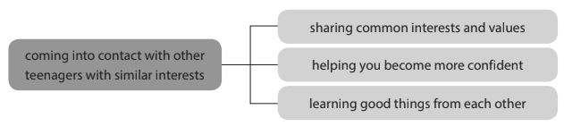  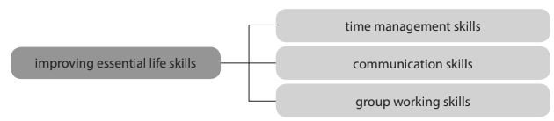  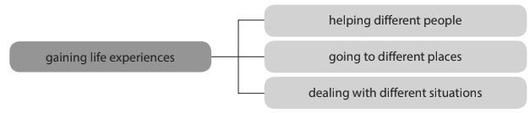 | - Read the list of benefits individually.  - work in pair  - share the answers with a peer.  - Teacher’s feedback  -work in pairs to complete their diagrams.  - Peer correction  -Teacher’s feedback
ACTIVITY 3: WHILE- SPEAKING (18’)
To help students enhance presentation skills | TASK 3: GIVE A PRESENTATION ABOUT THE BENEFITS OF VOLUNTEERING ACTIVITIES. (p.46)  We use the expressions on top to order points and the expressions on the bottom to give examples. | Ss’ oral presentation about the benefits of volunteering actitivites | -work in groups  -Teacher’s feedback
  Functions | Useful expressions
  Order points and expressions | First of all, …  Second, …  Third, …  Finally, …
  Giving examples | For example, …  For instance, …  …such as…
ACTIVITY 4: CONSOLIDATION/ PRODUCTION (5’)
Help students memorise the target language and skills that they have learned | 1. Wrap up (3’)  - Ask Ss to remember and list some lexical items about volunteering in the community | - Ss’ list of lexical items about volunteering in the community on the poster | -Work in 4 groups  -Peer correction  - Teacher’s feedback
Help Ss prepare for the next lesson and have further practice in the workbook. | 2. Homework (2’)  - Prepare for the next lesson, Listening  - Exercises in the workbook | - Answers in notebook | Whole class

Date: November 17th, 2022
Period 35: UNIT 4: FOR A BETTER COMMUNITY
Lesson 5: Listening

I. OBJECTIVES
By the end of this lesson, students will be able to:
1. Knowledge
- Use the lexical items related to the topic For a better community
- Listen for specific information about volunteering activities
2. Core competence
- Develop communication skills and creativity
- Be collaborative and supportive in pair work and team work
- Actively join in class activities
3. Attributes
- Develop a sense of helping the community and awareness of voluntary work
- Develop self-study skills
II. TEACHING AND LEARNING RESOURCES
- Grade 10 textbook, Unit 4, Listening
- Computer connected to the Internet
- Projector/ TV/ pictures and cards
- sachmem.vn
III. PROCEDURES
Aims | Contents | Outcomes | Steps
ACTIVITY 1: Warm-up (5’)
- To introduce the topic of reading.  - To enhance students’ skills of cooperating with teammates.  - To set the context of the listening text and activate students’ prior knowledge. | - Guessing pictures about volunteer work (2’)  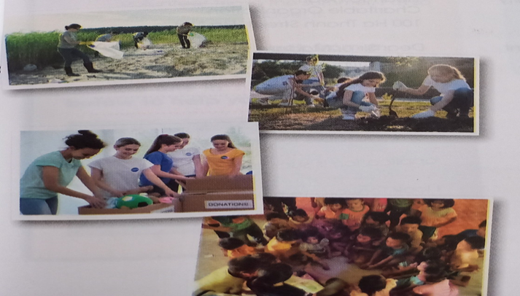  2. Read and answer the questions (3’)  - T asks Ss some questions about an announcement for volunteer positions.  a,Who needs volunteers?  b, Who can apply for the job?  - Ss spend some time thinking about the answers for the questions.  - Some Ss share the answers with the whole class.  - T confirms the answers and leads in the new lesson.  - T checks answers as a class. Then ask other questions. | Ss’s chance to get to know each other.  Suggested answers:  a, The City center for Community development.  b, People who are interested in community development projects and have a couple of hours to spare at the weekend. | Elicit  Show the pictures to elicit the topic  List  Work in pairs
ACTIVITY 2: Study (15’)
To help students practise listening for specific information. | LISTEN TO AN ANNOUNCEMENT AND CHOOSE THE BEST ANSWER TO COMPLETE EACH SENTENCE. (p.47)  - T asks Ss to look at the format of this activity and makes sure Ss know how they must answer the multiple choice questions. Then T has them read through the questions carefully and checks if they understand all the vocabulary.  - Ss listen and choose the best answer to complete each sentence.  - Some Ss compare their answers in pairs / groups.  - T checks answers by playing the recording again and pausing after the parts of the announcement containing the information. | Completed sentences with words listened.  Suggested answers:  1. B 2. B 3. C 4. A 5. C | List  -Work in pairs/ groups  -Share the answers with others.
ACTIVITY 3: Practices (15’)
To help students practise listening for specific information. | LISTEN AGAIN AND DECIDE WHETHER THE STATEMENTS ARE TRUE (T) OR FALSE (F). (p.47)  - T asks Ss to read through the statements carefully and checks if they understand all the vocabulary.  - Ss underline the key words / phrases in each statement, decide whether these statements are true or false.  Key words/ phrases:  1. helps people in the area;  2. Only poor people, get support;  3. looking for volunteers now;  4. new volunteers, only become members; local community development network;  5. deadline, application letter, 1st January.  - Some Ss compare their answers in pairs / groups.  - T checks answers as a class by playing the recording again and pausing after the parts of the announcement containing the information. | Statements identified as true or false  Suggested answers:  1. T  2. F (Teenagers, lonely old people and others also get support from this centre)  3. T  4. F (local and national)  5. T | List  -Work in pairs/ groups  -Teacher’s feedbacks
ACTIVITY 4: Production (5)
To give students an opportunity to personalise the language and ideas from the listening in a speaking task. | WORK IN GROUPS. DISCUSS THE FOLLOWING QUESTION. (p.47)  - T asks Ss to list the activities for community development mentioned in the recording  -- Ss work in groups and brainstorm other activities for community development.  --- Some groups discuss the question and take notes of their ideas.  -T invites some groups of Ss to give their presentations in front of the whole class. | Ss’s oral presentation  Suggested answers:  - building houses for poor people  - helping lonely old people  - creating facilities such as children’s playgrounds | List  Group work
To help students memorise the target language and skills that they have learned | WRAP-UP  - Some lexical items related to the topic For a better community  - Listen for specific information about volunteering activities  HOMEWORK  - Prepare for the next lesson, Writing  - Exercises in the workbook

Date: November 17th, 2022
Period 36: UNIT 4: FOR A BETTER COMMUNITY
Lesson 6: Writing
I. OBJECTIVES
By the end of this lesson, students will be able to:
1. Knowledge
- Use the lexical items related to the topic For a better community
- Write an application letter for volunteer work
- Competences:
- Develop communication skills and creativity
- Be collaborative and supportive in pair work and team work
- Actively join in class activities
- Attributes:
- Develop a sense of helping the community and awareness of voluntary work
- Develop self-study skills
II/ Teaching and learning resources:
Tape (CD), Tivi, speakers, textbook, teacher's book, copies of pictures, handouts, laptop, posters
III/ PROCEDURE:
Aims | Contents | Outcomes | Steps
- To introduce the topic of writing.  - To set the context for the writing part.  - To provide an example job application letter, which students can use as a model for their writing.  To introduce the context of the writing task and help students develop ideas for their writing. | WARM UP (3’)  GAME: HANGMAN  T gives suggestion:  - This is a kind of letter you need to write when you apply for a job.  PRE-WRITING (15’)  ACTIVITY 1 (8’)( READ THE APPLICATION LETTER FOR A VOLUNTEER POSITION. MATCH THE PARAGRAPHS WITH THEIR AIMS. (p.48)  -Ss study the three paragraphs of the letter and match each one with one of the aims and underline words and phrases that support the aims.  -Ss pay close attention to how the letter is organised (sender’s address, date, receiver's address, opening, closing).  A. Saying why you want to do the job.  B. Saying when you are available for an interview and can start work.  C. Mentioning the job you are applying for and where you got the information from.  ACTIVITY 2: (7’)  READ THE JOB ADVERT AND ANSWER THE QUESTIONS. (p.48)  -Read the job advertisement and underline important information  -Answer two questions:  1/ What qualities are needed for the job?  2/ What are the job duties? | Students’ oral prediction about the topic of writing  Suggested answer:  APPLICATION LETTER  Ss’ answers and explanation  Key:  Paragraph 1: C  Paragraph 2: A  Paragraph 3: B  T’s explanation of some new words  e.g. Heart to Heart, charitable, reliable, head office.  -Ss’ suggested answers.  Key:  1.Reliable and hardworking.  2. Welcoming guests and visitors, and receiving and sorting donations. | -Team work.  - Ss spend some time thinking about the answer.  -T draws Ss’ attention to the phrase APPLICATION LETTER and lets them know they are going to learn about.  -Ss work in pairs.  -Peer correction  -Share with other pairs.  -Teacher’s feedback  - Ss work in pairs  - T checks answers as a class.
To help students practise writing an application letter for a volunteer job. | WHILE-WRITING (15’)  ACTIVITY 3: COMPLETE THE APPLICATION LETTER FOR THE JOB. (p.48)  -Ss look at the outline of the application letter and identify the information they will need to complete it.  ……………. Street  ……………………….  1 January 20…  Heart to Heart Charitable Organisation  100 Ha Thanh Street, Ha Noi  Dear Sir or Madam,  I am writing to apply for a volunteer position ………….  I am interested in …………..  ………………………………  I am available for an interview………………………………… if my application is successful, I can start ………………………………………………………………  I look forward to hearing from you.  Yours faithfully,  Nguyen Ha Anh | Ss’s writing/ products | Work in group of 4  T goes around and offers help if needed.
To do a cross-check and final check on students’ writing. | POST-WRITING (10’) | Ss’s products (Their writing)  T collects Ss’ writings to hang on the board.  Sample answer:  877 Kim Ma Street  Ba Dinh, Ha Noi  12 March 2022  Heart to Heart Charitable Organisation  100 Ha Thanh Street, Ha Noi  Dear Sir or Madam,  I am writing to apply for a volunteer position at the head office of Heart to Heart Charitable Organisation. I saw the job advert on our school notice board.  I am interested in volunteer work and projects to help people in our community. I am polite, reliable and hardworking. I also have great people skills, which I believe are important for this position.  I am available for an interview on any weekday after 4.30 p.m. or at weekends. If my application is successful, I can start next month.  I look forward to hearing from you.  Yours faithfully,  Nguyen Ha Anh | -Peer correction.  -Exchange with other group to correct mistakes  -Give comments and correct them.  T then gives feedback on one writing as a model.  T also collects Ss’ other writings to mark at home and provides written feedback in the sheet paper of that group.
To help students memorize the target language and skills that they have learned. | CONSOLIDATION: (2)  - Some lexical items related to the topic For a better community  - Some structures used to write an application letter.  HOMEWORK:  -Do exercises in the workbook.  -Rewrite an application letter in the notebooks.  -Prepare for the next lesson. | Ss’ knowledge and understanding of the lesson. | -Work individually.

Date: November 25th, 2022
Period 37: UNIT 4: FOR A BETTER COMMUNITY
Lesson 7: Communication and Culture/CLIL
I/ Learning outcomes:
By the end of this lesson, Ss will be able to:
- Knowledge:
- Use the lexical items related to the topic For a better community
- Revise how to describe feelings
- Know more information about Save the Children and what it has contributed to the development of Viet Nam
- Competences:
- Be collaborative and supportive in pair work and teamwork
- Access and consolidate information from a variety of sources
- Actively join in class activities
- Attributes:
- Develop a sense of helping the community and awareness of voluntary work
- Understand more about Save the Children and what it has contributed to the development of Viet Nam
II/ Teaching and learning resources:
Tape (CD), Tivi, speakers, textbook, teacher's book, laptop, paper sheets, posters
III/ PROCEDURE:
Aims | Contents | Outcomes | Steps
WARM UP (7’)
- Introduce the topic for the better community | 1. GAME: WHO REMEMBERS MORE?  (Link: https://www.youtube.com/watch?v=tYmvsrkN8po) | Remembered information about principles of volunteering and places of volunteering. | Work in groups  - watch a video clip about volunteering  - write the answers on the given paper sheets.
EVERYDAY ENGLISH (15’)
Review expressions for describing feelings.  . | TASK 1: Listen and complete the conversation with the words from the box. Then practise it in pairs. (p.49) | Completed conversation with the words provided  Suggested answer:  1. C 2. D 3. B 4. A | - Do the task individually  - Share the answers with a peer.  - Teacher’s feedback
Help students practise expressing feelings in their own conversations about a volunteer trip. | TASK 2: Role-play. Imagine you are back from a volunteer trip. Work in pairs. Take on a role and act out a conversation like the one in 1. Use the expressions below to help you. | Made and practiced conversation | Work in pairs  - Peer correction  - Teacher’s feedback
CULTURE (15’)
Help students learn about Save the Children and what it has contributed to the development of Viet Nam. | TASK 1: Read the text below and complete the diagram about Save the children. | Completed diagram.  Suggested answer:  1. 120  2. improve (their) teaching skills and use digital technology  3. to go to school  4. life-saving skills | Pair work  - write their missing words  - Peer correction  Teacher’s feedback
Help students practise talking about Save the Children using the completed diagram. | TASK 2: Work in groups. Use the diagram to talk about Save the children. | Ss’ oral presentaion about Save the Children | Group work  Prepare and present in front of the whole class
CONSOLIDATION (8’)
Help students memorise what they have learned | 1. Wrap up (5’)  List  - some volunteer works to help the children. | - Ss’ list some volunteer works to help the children on the poster  Suggested answer:  -Help disabled/ street /disadvantaged… children  -teach poor children  … | -Work in 4 groups  -Peer correction  - Teacher’s feedback
Inform students what the final product of the project should be and how students can prepare for it. | 2. Homework (3’)  - Exercises in the workbook  - Prepare for the next lesson: Looking back and project | - Use the lexical items related to the topic For a better community  - Revise how to describe feelings  - Know more information about Save the Children and what it has contributed to the development of Viet Nam | Individually work

Date: November 25th, 2022
Period 38: UNIT 4: FOR A BETTER COMMUNITY
Lesson 8: Looking back and project

I/ Learning outcomes:
By the end of this lesson, Ss will be able to:
- Knowledge:
- Review the vocabulary , the stress pattern in two-syllable words and grammar of Unit 4
- Apply what they have learnt (vocabulary and grammar) into practice through a project
- Competences:
- Develop communication skills and creativity
- Develop presentation skills
- Be collaborative and supportive in pair work and team work
- Actively join in class activities
- Attributes:
- Be aware of responsibilities towards community.
II/ Teaching and learning resources:
Tape (CD), Tivi, speakers, textbook, teacher's book, laptop, posters
III/ PROCEDURE:
Aims | Contents | Outcomes | Steps
ACTIVITY 1: WARM UP (5’)
- Create a friendly and lively atmosphere in the classroom | BRAINSTORMING (5’)  - T divides the class into 2 teams.  - Members of each team take turns and write as many two-syllable words with the same spelling as possible in 2 minutes.  - The group having more correct answers is the winner. | - The two-syllable words with the same spelling.  Suggested answer:  increase  record  present  import… | - List  -Team work
ACTIVITY 2: PRONUNCIATION(5’)
-Help students revise the stress pattern in two-syllable words with the same spelling. | Listen and mark the stressed syllables in the words in bold. Then practise saying the sentences. (p.50)  -T asks Ss to listen and mark the stressed syllables in the words in bold in each sentence.  - Ss practise saying these sentences individually.  - Some Ss say these sentences out loud in front of the class.  - T corrects | Stressed syllable words  Key:  1. We hope that the number of volunteers will in'crease this year.  2. When will you pre'sent your report about the volunteer project?  3. I always keep a 'record of visitors’ donations.  4. We still im'port too many products that can be made in our country. | -Work  individually
ACTIVITY 3: VOCABULARY (5’)
- Help students revise word forms  - Use the adjectives ending in -ed, -ful, -less | Fill in the gaps with the correct forms of the words in brackets.  - Ss brainstorm words that can be formed from the words in brackets  - Ss study the context carefully and decide on the adjectives to fill in these gaps.  - T checks answers | -Correct forms of words provided.  e.g. ending, endless, excited, exciting, helpful, helpless, volunteer (v-n), voluntary, volunteering, donation, donors.  - Correct forms of the word.  Key:  1. endless  2. excited  3. helpful  4. volunteers  5. donations | - Work in pairs  - Teacher’s feedback
ACTIVITY 4: GRAMMAR (5’)
- Help students revise the use of the past simple and past continuous with when and while. | Complete the sentences using the correct forms of the verbs in brackets. Use the past simple or past continuous.  - Ss study the context carefully and decide which action is the longer one. Pay attention to the use of the connectives when and while.  - Ss check their answers in pairs  - T checks answers | Completed sentences with verbs using the past simple or past continuous  Key:  1. met, were working  2. were walking, saw  3. noticed, was delivering  4. arrived, was giving | - Work in pairs  - Teacher’s feedback
ACTIVITY 5: PROJECT (20’)
- Allow students to apply what they have learnt (vocabulary and grammar) into practice through  a project. | A VOLUNTEER PROJECT  - T has Ss work in their groups. Give them a few minutes to get ready for the presentation.  - Four groups give their presentations. T encourages the rest of the class to ask questions at the end.  -T gives praise and feedback. | - Presentation of their final product about a volunteer work. | - Work in groups.  - Presentation  - Peer correction  - Teacher’s feedback
ACTIVITY 6: CONSOLIDATION (5’)
- Help students memorize what they have learned | 1. WRAP-UP(3)  - - Review the vocabulary , the stress pattern in two-syllable words and grammar of Unit 4  - Apply what they have learnt (vocabulary and grammar) into practice through a project  2. HOMEWORK (2)  - Prepare for the next lesson: Unit 5 – Lesson: Getting started  - Exercises in the workbook | Ss’ oral presentation | - Work individually.

Date: November 25th, 2022
Period 39: UNIT 5: INVENTIONS
Lesson 1: Getting started –Inventions for Education
I/ Learning outcomes:
By the end of this lesson, Ss will be able to:
Knowledge:
- An overview about the topic inventions for education.
- Vocabulary to talk about inventions for education.
Competences:
- Develop communication skills and awareness of inventions for education.
- Be collaborative and supportive in pair work and teamwork.
- Actively join in class activities.
Attributes:
- Develop flexibility and creativity in learning.
- Be responsible for studying, using educational apps.
II/ Teaching and learning resources:
Tape (CD), Tivi, speakers, textbook, teacher's book, copies of pictures, handouts, laptop, posters
III/ PROCEDURE:
Aims | Contents | Outcomes | Steps
ACTIVITY 1: WARM UP (5’)
- Introduce the unit topic (inventions);  - Introduce some vocabulary to be learnt in the unit. | Game: Guessing  - Teacher brings 4-5 pictures of technological inventions made in the past few centuries such as computers, laptops, smartphones, and calculators.  - T leads in the lesson: Technological inventions have brought a lot of benefits to our lives. | Students’ oral prediction about the topic  -Suggested answer:  Computers, laptops, smartphones, and calculators. | -Students work in 4 groups  Elicit  Show the pictures to elicit the topic
 | Vocabulary:  List the modern inventions that you see in the picture | List of modern inventions Expected answers:  Computers, laptops, smartphones, and calculators. | Workin groups of two to list the modern inventions.  on the board
ACTIVITY 2: STUDY/ PRESENTATION (15’)
- Understand the related words in the conversation  - Introduce the grammar points to be learnt in the unit. | Vocabulary: (10’)  Look at the photos to guess the meaning of new words  1. invent (v) /in’vent/: phát minh, sáng chế  2. improve (v) /im’pruːv/: cảithiện, trởnêntốthơn  3. suitable (a) /ˈsuːtəbl/ or /ˈsjuːtəbl/: phù hợp  4. app (n) /æp/: ứng dụng  5. convenient (a) /kənˈviːniənt/: tiện lợi, thuận lợi | A list of words in Ss’ notebook | Elicit  Give synonym/ Vietnamese equivalent/ example to elicit vocabulary from Ss
 | * Check vocabulary: | The missing words on the board | Rub out and remember
 |  | Answered questions about the picture  Suggested answers:  Different answers: | Set the context for listening and reading the conversation  - Ss do the task individually  - Ss share their answers with a partner.  -T checks their answers with the whole class.
  Task 1. Listen and read (p.52).
  Teacher asks Ss to look at the picture (p.52
  -53) and answer the questions:
  
  + What’s the relationship between the speakers?
  + What do you think they are talking about?
  + How do we know?
  * T plays the recording twice, has Ss listen to the conversation, read along and underline the words and phrases describing inventions for education.
ACTIVITY 3: ACTIVATE/ PRACTICE (20’)
- To practice reading for specific information.  - To practice scanning  - To develop Ss' knowledge of inventions for education. | Task 2: Read the conversation again and answer the following questions.  What inventions are Phong and his dad talking about?  How useful are laptops?  Why is it fun and convenient to learn with educational apps on smartphones?  . | Answered questions  Key:  1.They are (talking about) laptops/ computers and smartphones.  2.(Since they were invented,) Laptops have allowed us to study better and work faster.  3.Because you can use educational apps that allow you to communicate and learn at the same time. | Read the  Conversation.  - Work in pairs  - Peer correction  - Teacher’s feedback
To help Ss revise some collocations for inventions so that they can use them in the following lessons.  - To practice scanning. | Task 3: (p.53). Find three nouns and three adjectives in the conversation in activity 1 to talk about inventions. Follow the example. | Keys:  useful (example)  smartphone  suitable  laptop  computer  valuable | - Finding words.  - Work in pairs  - Peer correction  -Teacher’s feedback
To help sts identify some future structures with the present perfect tense, gerunds, to-infinitives, and how they are used in sentences. | Task 4: (p. 53). Fill in the gap in the summary of the conversation with ONE word from activity 1. | Answers:  1.‘m preparing  2. does – ‘s working | - Do the task individually  - share the answers with a peer.  - Teacher’s feedback
ACTIVITY 4: CONSOLIDATION/ PRODUCTION (5’)
Help students memorize the target language and skills that they have learned | 1. Wrap up (3’)  Watch the video clip and list all the modern inventions in the video and their advantages. | - Ss’ list of new inventions on the poster  Suggested answers:  -smartphones, laptops, tablets: easy  communication, entertainment. | Watching and listening  -Work in 4 groups  -Peer correction  - Teacher’s feedback
Inform students what the final product of the project should be and how students can prepare for it. | 2. Homework (2’)  a/ Exercises in the workbook  b/ Project preparation  - Teacher asks Ss to open their books at the last page of Unit 5, the Project section, look at the picture and say what the topic of the Project is (Inventions for the classroom).  - Ask Ss to present their plans in the last lesson of the unit. |  | Groupwork

Date: December 3rd, 2022
Period 40: UNIT 5: INVENTIONS
Lesson 2: Language
I/ Learning outcomes:
By the end of this lesson, Ss will be able to gain:
1. Knowledge
- Use the lexical items related to the topic Inventions;
- Pronounce correctly stress in three-syllable nouns;
- Understand the present perfect, gerunds and to-infinitives.
2. Core competence
- Be collaborative and supportive in pair work and teamwork.
- Access and consolidate information from a variety of sources.
- Actively join in class activities.
3. Personal qualities
- Develop flexibility and creativity in learning.
- Be responsible for studying, using educational apps.
II/ Teaching and learning resources:
Tape (CD), Tivi, speakers, textbook, teacher's book, copies of pictures, handouts, laptop, posters
III/ PROCEDURE:
Aims | Contents | Outcomes | Steps
ACTIVITY 1: WARM UP - PRONUNCIATION (13’)
To help Ss recognize the stress patterns in some common three-syllable nouns. | - GAME: odd one out (3’)  1.1 A. poverty B. invention C. benefit  1.2 A.generous B. related C. chemical  1.3 A. century B. diagram C. advantage  2. Listen and repeat: (3’)  invention computer holiday century | List words with the stress pattern oOo  Suggested answer:  - invention  - related  - advantage  Ss’s attention to the big and small dots. | Pair work  Introduce
- To help Ss recognize the stress patterns in some common three-syllable nouns and pronounce them correctly. | 3. Game: Cross the river *(7’)  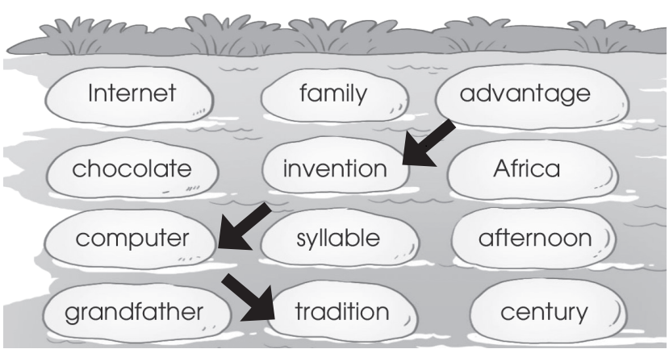 | List all the words with the stress pattern oOo  Suggested Answers:  - Advantage  - Invention  - Computer  - Tradition | Elicit  Show the picture to elicit the stress patterns
ACTIVITY 2: VOCABULARY/ PRESENTATION (15’)
To introduce more topic- related words. | 1. Vocabulary: (10’): Unscramble the underlined letters in the words.  Look at the photos to guess the meaning of new words  - household (n) /ˈhaʊs.həʊld/  - chore (n) /tʃɔːr/  - breadwinner /ˈbredwɪnə(r)/ (n)  - heavy lifting /ˌhevi ˈlɪftɪŋ/ (np):  - homemaker /ˈhəʊmmeɪkə(r)/ (n):  - laundry /ˈlɔːndri/ (n): | - A list of words in Ss’ notebook and their meaning. | - Look and guess  - Work in pairs.  - Listen and repeat
Ss remember the words and meaning | 2. Check vocabulary: (5’) | The correct words completed from the missing words. | Rub out and remember
ACTIVITY 3: GRAMMAR(15’)
To give Ss  the opportunity to practice using the present perfect. | A/ Present perfect (7’)  1 . Use:  Text book ( page 54)  2. Exercise: Circle the correct answer:  Exercise in text book (page 54) | - The usage of Present perfect.  - The form of present perfect  - Examples  - Answers | Elicit  - pair work
- To give Ss  the opportunity to revise verbs followed by gerunds and to – infinitives. | B. Gerund and to- infinitive (8’)  1. Remember:  Text book ( page 54)  2. Exercise: Complete the sentences using the gerund or the to – inf of the verbs in brackets | List some verbs followed by Gerund and to- Inf  - Ss’ correct answers | Elicit  Pair work
To revise what they have learnt and prepare for the next lesson: Reading | 2. Homework (2’)  - Exercises in the workbook  - Project preparation | Exercise completion | Individual work

Date: December 3rd, 2022
Period 41: UNIT 5: INVENTIONS
Lesson 1: Reading – Artificial Intelligence
I/ Learning outcomes:
By the end of this lesson, Ss will be able to:
- Knowledge:
- Develop reading skill for main ideas and specific information about artificial intelligence.
- Competences:
- Develop communication skills and creativity.
- Be collaborative and supportive in pair work and team work.
- Develop presentation skill.
- Actively join in class activities.
- Attributes:
- Develop flexibility and creativity in learning.
- Be responsible for studying, using educational apps.
II/ Teaching and learning resources:
- Grade 10 textbook, teacher's book , Unit 5, Reading
- Computer connected to the Internet
- Projector/ TV/ pictures
- sachmem.vn
III/ PROCEDURE:
Aims | Contents | Outcomes | Steps
ACTIVITY 1: IN TRODUCTION & ENGAGE/ WARM UP (5’)
- Introduce the topic of reading.  - Enhance Ss’ skills of cooperating with teammates. | 1. Answering the questions (3’)  Look at the pictures of Asimo and Sophia and discuss the questions below in pairs.  a. What are they?  b. What do you think they can do?   | Ss’ answers about the pictures.  Suggested answer:  - They are robots  - They can walk, they can talk….. | Elicit  Show the pictures.
 | 2.Vocabulary (2’)  List the activities that robots can do. | Ss’ list of the activities that robots can do.  Expected answers:  - Do the household chores(Clean the house, Wash the dishes ).  - Show emotions. | List  Work in groups of 4.
ACTIVITY 2: STUDY/ PRESENTATION (12’)
Provide students with some vocbularies before reading the text. | 1. Vocabulary (7’)  Guess the meaning of new words.  1. robot (n) /ˈrəʊbɒt/: rô bốt  2. communicate (v) /kəˈmjuːnɪkeɪt/: giao tiếp  3. emotion (n) /ɪˈməʊʃn/: cảm xúc  4. artificial intelligence (AI) (n)/ˌɑːtɪfɪʃl ɪnˈtelɪdʒəns/: trí tuệ nhân tạo  5. measure (v) /ˈmeʒə(r)/: đo lường | A list of words in Ss’ notebook. | Elicit  Give synonym/ Vietnamese equivalent/ example/ pictures .
 | 2. Checking vocabulary (3’) | The missing words on the board. | Rub out and remember .
Help Ss be more interested in reading passage. | - Prediction (2’)  Guess whether the following statements are true (T) or false (F) (p.55).  1. Sophia can show emotions when talking to humans.  2. AI helps to make machines that think and act like humans.  3. AI is one of the most important inventions of the 20th century. | Ss’ oral prediciton about the statements. | - Give statements for Ss to guess whether they are true or false.  - Work in individually.
ACTIVITY 3: ACTIVATE/ PRACTICE (17’)
Help Ss practise reading for specific information. | 1/ True/False (7’)  Read the text and decide whether the following statements are true (T) or false (F) (p.55).  . | Ss’ statements identified as true or false  Key:  1. T (Sophia can even communicate with people by using human language and expressing emotions.)  2. T (AI – the study and development of machines that can copy human intelligence.)  3. F (AI is one of the most important inventions of the 21st century.) | - Work in pairs.  - Peer correction.  - Teacher’s feedback.
Help Ss practise reading for specific information. | 2/ Matching (5’)  Read the text again and match the pictures with the uses of AI (p.55). | Matched pictures  Answers:  1. c 2. a 3. b | - Work in pairs.  - Peer correction.  -Teacher’s feedback.
Help Ss practise reading for the best title. | 3/ The best title (5’)  Read the text and choose the best title for it (p.55). | Ss’ answer about the best title of the text. | - Do the task in groups of 4.  - share the answers with other groups.  - Teacher’s feedback .
ACTIVITY 4: CONSOLIDATION/ PRODUCTION (11’)
- Help Ss use the ideas and language from the reading to talk about possible uses of AI in schools.  - Help some Ss enhance presentation skill learned. | - Dicussion (10’)  Work in groups and discuss how AI can be used in schools. Then share your ideas with the whole class (p.55). | - Ss’ ideas about how Al can be used in schools.  - Ss’ oral presentation of the discussion. | - Work in groups of 6.  - Share the answers with other groups.  - Teacher’s feedback.
Help Ss memorise the target language and skills that they have learned. | 2. Homework (1’)  - Exercises in the workbook.  - Ss’ preparation for the next lesson : Unit 5 ( Speaking). | Ss’ exercises and preparation. | Work in individually at home.

Date: December 3rd, 2022
Period 42: UNIT 5: INVENTIONS
Lesson 4: Speaking
I. Learning outcomes:
By the end of this lesson, Ss will be able to:
1. Knowledge
- An overview about the topic inventions for education.
- Vocabulary to talk about inventions for education.
2. Competence
- Develop communication skills and awareness of inventions for education.
- Be collaborative and supportive in pair work and teamwork.
- Actively join in class activities.
3. Attributes
- Develop flexibility and creativity in learning.
- Be responsible for studying, using educational apps.
II. Teaching and learning resources:
- Grade 10 textbook, Unit 5, Getting started
- Computer connected to the Internet
- Projector/ TV/ pictures and cards
- sachmem.vn
III/PROCEDURE:

Aims | Content | Outcomes | Steps
ACTIVITY 1: IN TRODUCTION & ENGAGE/ WARM UP (5’)
- To introduce the topic of speaking. | Game: Guessing names of 5 inventions  Example: This invention is a device which helps us to communicate over long distances. What is it? (answer: telephone) | List of names of 5 inventions (the internet, e-readers, robots, 3D printing, driverless cars) | Elicit  - Work in groups  -Guess its name.  - Teacher’s feedback
ACTIVITY 2: PRE-SPEAKING (15’)
- To equip Ss with useful expressions before speaking activities. |  | Useful expressions to talk about the uses of some modern inventions | -Teacher elicits some useful expressions to talk about the uses of inventions and asks Ss to give examples.
  Functions | Useful expressions
  Uses of inventions | - … help(s)/ allow(s) us to do st.  Example: The internet helps us to communicate over long distances.  - We/ People (can) use the internet to communicate over long distances.  - … is/ are used for ST/ doing ST.  Example: The internet is used for communication/communicating over long distances.
ACTIVITY 3: PRACTICE (20’)
-To help Ss practice useful expressions and structure their presentation. | Task 1: Work in pairs. Talk about the uses of these inventions(the internet, e-readers, robots, 3D printing, driverless cars). Use the expressions below to help you (p.56). | Ss’ talk about the uses of the internet, e-readers, robots, 3D printing, driverless cars respectively | Work in pairs and do as required.  - Feedback
- To help Ss practice useful expressions and structure their presentation. | Task 2: Work in groups. Talk more about one of the inventions in activity 1. Use the outline below to help you prepare a group presentation.  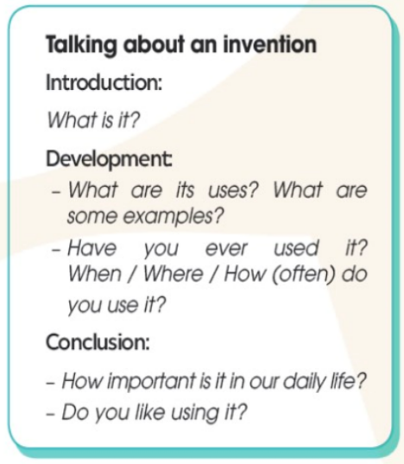 | Ss’s oral presentation about one of the inventions in activity | - Work in groups of three  - Peer correction  - Teacher’s feedback
ACTIVITY 4: PRODUCTION (5’)
-To help students enhance presentation skill | 1. Wrap up  Present your ideas to the whole class. Then vote for the most interesting group presentation.  - Some useful expressions about uses of inventions.  - Speaking about inventions and how they are used. | oral presentation | - Work in groups of three  - Peer correction  - Teacher’s feedback
- To help Ss memorise the target language and skills that they have learned. | 2. Homework  - Prepare for the next lesson: Unit 5: Listening.  - Exercises in the workbook . | Students’ oral presentation | Groupwork

Date: December 10th, 2022
Period 43: UNIT 5: INVENTIONS
Lesson 5: Listening – Robo Vacuum
I/ Learning outcomes:
By the end of this lesson, Ss will be able to:
1. Knowledge.
- Listen for specific information about how to use a robot vacuum.
- Talk about ss’ opinions and give reasons using the ideas and language in the listening
2. Competences.
- Develop communication skills and creativity.
- Be collaborative and supportive in pair work and team work.
- Actively join in class activities.
3. Attributes.
- Be more interested in inventions
II/ Teaching and learning resources:
- Grade 10 textbook, Unit 5, Listening
- Computer connected to the Internet
- Projector/ TV/ pictures and cards
- sachmem.vn
III/ PROCEDURE:

Aims | Content |  | Outcomes |  | Steps
WARM UP (6’)
- To introduce the topic of reading.  - To enhance students’ skills of guessing. | * Guessing game  It is a household appliance.  It has wheels.  It sucks up dirt and dust. | Guesses word Robo vacuum |  | * Guess the words  basing on 3 clues about the targeted words  ** lead in the new lesson.
ACTIVITY 1: NEW WORDS (6’)
- Understand and use the words related to robot vacuum. | New words  1. button (n) /ˈbʌtn/: cái nút    2. charge (v) /tʃɑːdʒ/: nạp, sạc (điện)  3. stain (n) /steɪn/: vết bẩn    Checking vocabulary  Complete the sentences with the words in the box. (p.57).  1. Press the _________ to start the device.  2. There is a dirty _________ on your smartphone. Wipe it away.  3. You need to _________ your mobile phone. The battery is very low.  Sts’ pronunciation of the words | A list of words in notebook  The missing words  1. button  2. stain  3. charge |  | Elicit  Picture  Real situation  Picture  Pairwork  * read and complete the sentences with the words in the box .  **share the answers with the whole class.  *** repeat in chorus then individually
ACTIVITY 2: ACTIVATE/ PRACTICE (14’)
Practise listening for specific information .  Practise listening for instructions. | TASK 2 (5’): Listen to a conversation about RoboVacuum. Fill in each gap in the diagram below with one word. (p.57.)  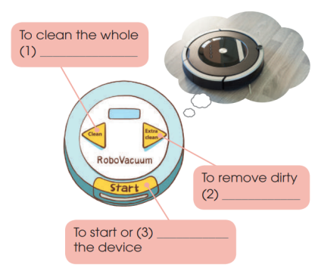  TASK 3 (9’): Listen again. Put a tick next to the correct way and a cross next to the wrong way to use RoboVacuum. (p.57). | Completed diagram  Key: 1. room 2. stains 3. stop  Statements identified as tick or cross  - X  - √  - √ |  | *predict information needed and if it is a noun, a verb or an adjective …  ** listen and fill in the gaps.  *** compare the answers in pairs.  **** check the answers  * listen to the conversation again and put a tick or a cross  ** study the pictures and describe the way to use RoboVacuum.  ** compare the answers in pairs.  ***check answers
ACTIVITY 3: Production(10’)
Give Ss an opportunity to personalise the language and ideas from the listening in a speaking task. | Task 4 (10’)  What other buttons do you want Robo Vacuum to have? Add them to the picture below and tell your friends about them. (p.57). | Expressed ideas about the added buttons a robovacuum should have. |  | Groupwork  * add to the picture other buttons  ** show the drawings and share their ideas.  *** T gives feedback
ACTIVITY 4: Consolidation (2’)
Help Ss memorise the content of the lesson | 1.Wrap-up  Teacher asks: What have you learnt today?  - We have listened to a conversation about robovacuum.  2. Homework  - Exercises in the workbook  - Prepare for Writing lesson |  | Some vocabulary and the content of the listening text |  | - Note down

Date: December 10th, 2022
Period 44: UNIT 5: INVENTIONS
Lesson 6: Writing
I/ Learning outcomes:
By the end of this lesson, Ss will be able to:
- Knowledge:
- Use the lexical items related to the topic Inventions.
- Write about the benefits of an invention.
- Competences:
- Develop communication skills and creativity.
- Be collaborative and supportive in pair work and team work.
- Actively join in class activities.
- Attributes:
- Develop flexibility and creativity in learning.
- Develop self-study skills.
II/ Teaching and learning resources:
- Grade 10 textbook, Unit 5, writing
- Computer connected to the Internet
- Projector/ TV/ sub-board
III/ PROCEDURE:
Aims | Content | Outcomes | Steps
ACTIVITY 1: WARM UP (6’)
- To arouse the classroom atmosphere.  - To get students actively involved in the topic Inventions. | GAME: Hot seat (6’) | List of some different types of inventions  Expected answers:  1. Electric light  2. Airplane  3. Automobile | -List the inventions  -Work in groups to list some different types of inventions  on the board
ACTIVITY 2: PRE - WRITING (6’)
- To provide Ss chances to list some benefits or uses of their invention. | Choose an invention in this unit. Draw a diagram to show how it is used. Then work in groups to guess one another's inventions. (p.58).  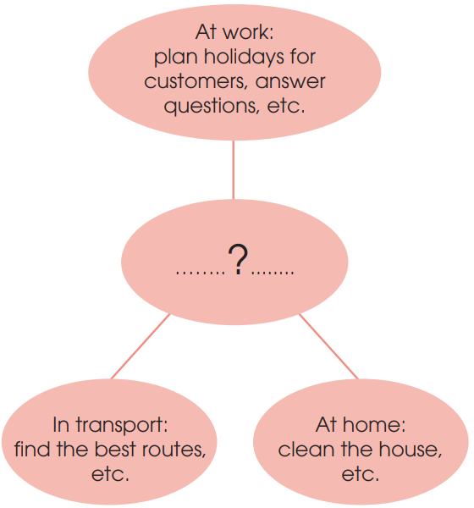 | Students’ oral answers. | - Choose an invention, draw a diagram  -Work in groups to guess one another's inventions
ACTIVITY 3: WHILE-WRITING (18’)
To help Ss revise useful expressions and structures which they can use in their writing task. | Rewrite the second sentence so that it has a similar meaning to the first. Use the expressions and the prompts below to help you. (p.58)  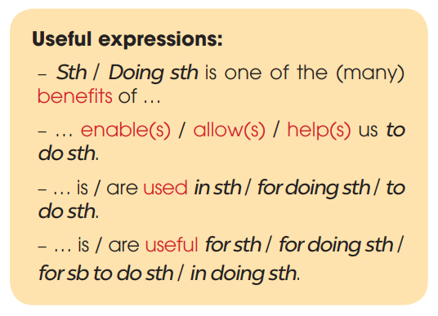 | Students’ complete sentences:  1. Helping drivers to find the best routes is one of the benefits of AI in transport.  2. Vacuum cleaners are useful for cleaning / in cleaning the house quickly.  3. Smartphones help us to learn languages.  4. Telephones are used to communicate / for communication / for communicating over long distances. | - Use the suggested words and useful expressions and structures to rewrite the sentences.  - work in pairs
To help students practise developing ideas and writing a paragraph | 2. WRITE A PARAGRAPH (10’)  Write a paragraph (120 - 150 words) to describe two or three benefits of the invention you chose in 1. Use the outline below to help you. (p.58.) | A complete paragraph using suggested outline | - Ss work individually to write a draft.  - T walks round the class to offer help if necessary.
ACTIVITY 4: POST-WRITING (15’)
- To do a cross-check and final check on students’ writing. | 1. CORRECTION (14’)  a. PEER CORRECTION  - T explains the marking symbols in the following table.  b. CLASS CORRECTION | A corrected paragraph  Sample answer:  Electricity is one of the great inventions of the past, because it has brought many benefits for people. First, electricity can be used to light our houses and streets. Without it, the world will be dark and dangerous. Second, electricity is also useful in heating. For example, in cold areas, electric heaters can keep us warm and healthy in long winters. Finally, the most important use of electricity is to run machines. Without electricity, factories, schools and hospitals cannot run normally. Everyone and everything will stop working. Other inventions, such as TVs, computers and robots will become useless without electricity. In conclusion, electricity plays a very important part in our life today and we cannot live without it. | -Peer correction  -Class correction  - Teacher’s feedback
To help students have a look on the next Lesson: Communication and Culture | 2. HOMEWORK (1’)  - Exercises in the workbook  - Prepare for Communication and Culture lesson |  | Individual

Date: December 10th, 2022
Period 45: UNIT 5: INVENTIONS
Lesson 7: COMMUNICATION & CULTURE
I/ Learning outcomes:
By the end of this lesson, Ss will be able to:
- Knowledge:
- Use the lexical items related to the topic Inventions;
- Revise how to make and respond to requests.
- Know more information about computer hardware.
- Competences:
- Be collaborative and supportive in pair work and teamwork.
- Access and consolidate information from a variety of sources.
- Actively join in class activities.
- Attributes:
- Develop a sense of problem-solving when deciding suitable computers.
- Understand more about computer hardware.
II/ Teaching and learning resources:
Tape (CD), Tivi, textbook, teacher's book, Laptop,
III/ PROCEDURE:
Aims |  | Content |  | Outcomes |  | Steps
ACTIVITY 1: WARM UP (5’)
- To introduce the topic Computer.  - To enhance students’ skills of cooperating with teammates. |  | Card game |  | -A list of words related to Computer  Suggested answers: Laptop/ Screen/  Hardware/ Software  Speed/ Document/  Display/ Battery/  Light/ Weight/  Size/ Brand/  Program/ Memory/  data |  | Ss work in groups to stick the word cards on the sheets.
EVERY DAY ENGLISH - ACTIVITY 2: (7’) ACTIVATE/PRACTISE
-To provide Ss with an example conversation in which people make and respond to requests.  - To review expressions for describing feelings. |  | Activity 1: Listen and complete a conversation at a computer store with the expressions in the box. Then practise it in pairs. (p. 58). |  | - A completed conversation  Suggested answers:  1. B 2. C 3. A 4. E 5. D |  | -Listen and complete the conversation with the expressions from the box individually.  -Practise the conversation in pairs.
EVERY DAY ENGLISH - ACTIVITY 3: (12’) PRODUCTION
-To help Ss practise making and responding to suggestions. |  | -Making requests:  +Could you tell me…?  +Please let me know…  +I want/ would like to know about….  ….  -Responding to requests:  +Sure, what can I do for you?  …….. |  | ** Ss’ performance  Expected answers:  A: Hello. I’m looking for a smartphone. Can you please recommend a good one to me?  B: Certainly, but can you let me know about your needs first?  A: Sure. I buy it for my mum. She needs a cheap and easy-to-use smartphone.  B: Then I think this one is the best one for you. You can take a look at it. Feel free to ask me if you need further information. |  | - Ss work in pairs (role- play)
CULTURE : ACTIVITY 4:VOCABULARY PRETEACHING (8’)
- To help Ss learn about computer hardware and learn some content vocabulary. |  | Activity 1: Read the text. Match the highlighted words and phrases with their meanings |  | -Ss’ matching  Suggested answers  1. c 2. d 3. a 4. e 5. b |  | Students work individually,
CULTURE – ACTIVITY 5 ( ACTIVATE) ( 10’)
- To help Ss relate what they have learnt to a problem-solving task and make connections. | Activity 2: Look at the advertisements. Decide which one is most suitable for each person below. (p.60).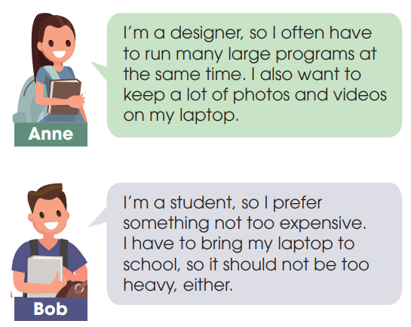 |  | ** Ss’ performance  Answers:  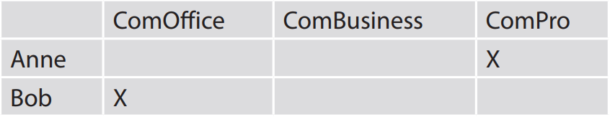 |  |  | - Ss work in groups
CONSOLIDATION & HOMEWORK (3’)
-To help Ss memorise the content of the lesson that they have learned |  | Wrap-up  - Revise how to make and respond to requests.  - Know more information about computer hardware.  Homework:  - Prepare for the next lesson: Unit 5 Looking back and project.  - Exercises in the workbook. |  |  | -List of useful language on making and responding to requests,  -some basic information about computer hardware, | -Individual or group work,

Date: December 17th, 2022
PERIOD 46: UNIT 5: : INVENTIONS
Lesson 8 Looking back and Project- Inventions

I/ Learning outcomes:
By the end of this lesson, Ss will be able to:
- Knowledge:
- Review the vocabulary and grammar of Unit 5.
- To revise stress placement on common three-syllable nouns.
- Apply what they have learnt (vocabulary and grammar) into practice through a project.
- Competences:
- Develop communication skills and creativity, presentation skills, and critical thinking skills.
- Be collaborative and supportive in pair work and teamwork.
- Actively join in class activities.
3. Attributes:
- Be more creative when doing the project.
- Develop self-study skills.
II/ Teaching and learning resources:
Tape (CD), Tivi, speakers, textbook, teacher's book, copies of pictures, handouts, laptop, posters
III/ PROCEDURE:
Aims | Contents | Outcomes | Steps
ACTIVITY 1: WARM UP (5’)
- To revise the three-syllable nouns and lead in the next part of the lesson.  - To enhance students’ skills of cooperating with teammates. | 1. BRAINSTORMING :  Write as many three-syllable nouns about topic Inventions as possible in 2 minutes. | Students’ lists of many three-syllable nouns about the topic of Inventions  Suggested answer:  Inventor  Invention  Computer  Telephone  Beverage  Camera  Submarine  Telegraph  Telescope  Typewriter | -Divide the class into 2 teams.  -Give instructions  -Sts play the game  give feedbacks
ACTIVITY 2: LOOKING BACK (12’)
- To revise words they have learnt in the unit.  - To revise stress placement on common three-syllable nouns. | PRONUNCIATION AND VOCABULARY (7’)  Solve the crossword. Use the three-syllable nouns in this unit. Read out the correct answers in pairs when you finish. (p. 60) | Sts’ solution of the crossword and correct pronunciation of the three-syllable nouns  Suggested answer:  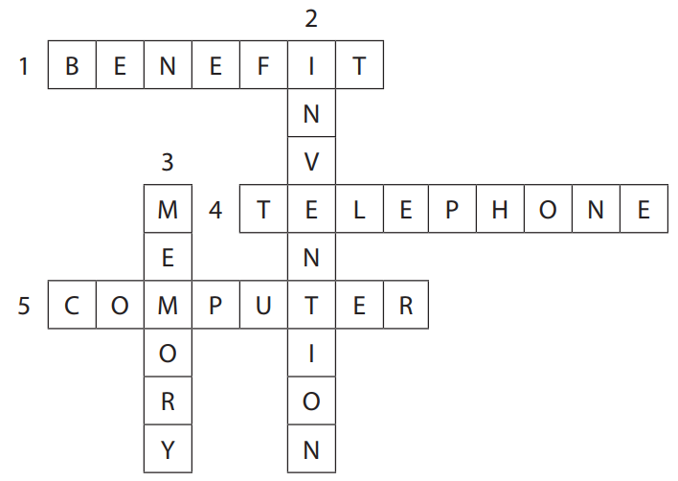 | - Give instructions  -Sts solve the crossword in pairs  - Give feedbacks  - Sts practise saying the words
To revise the present perfect, gerunds, and to-infinitives. | GRAMMAR (5’)  Circle the correct answers. (p. 60) | Completed sentences using correct tenses and verb forms  Suggested answers:  1. have just installed, using  2. to send, to learn  3. was invented, have changed | Choose the correct answers  -work in pairs  -peer correction  -teacher’s feedback
ACTIVITY 3: PROJECT (23’)
To allow students to apply what they have learnt into practice through a project.  - To provide an opportunity for students to develop their research and collaboration skills, and to practise giving an oral presentation. | INVENTIONS FOR THE CLASSROOM  - what the invention is  - what it looks like  - how it can be used in the classroom  - why the speaker thinks it will be a useful invention | - Sts’s oral presentations about an existing invention - Sts’peer and self-assessment | - Give Sts a checklist for peer and self-assessment  - Ss give presentations in groups  - T’s praise and feedback
ACTIVITY 4: CONSOLIDATION/ PRODUCTION (5’)
Help students memorize how to use present perfect and verb forms | 1. multiple choice exercise ( handouts) | - Ss’ handouts with their answer | Give handouts  -Sts work in 4 groups  -Peer correction  - Teacher’s feedback
Ss revise what they learned and prepare for the next lesson | 2. Homework (2’)  a/ Exercises in the workbook  b/ Prepare Unit 6-Getting started | Ss’ completion of the exercise and preparation | Individually at home

Date: December 17th, 2022

PERIOR 47, 48, 49 REVIEW 2

Period 47: Lesson 1: Language

I. OBJECTIVES
By the end of this lesson, Ss will be able to:
- Knowledge:
- Use the lexical items related to unit 4-5
- Pronounce correctly stress in two-syllable words with the same spelling;
- Use the past simple vs. the past continuous.
- Competences:
- be collaborative and supportive in pair work and team work
- access and consolidate information from a variety of sources
- actively join in class activities
- Attributes:
- be willing to learn new language points
- develop a sense of helping the community and awareness of voluntary work
- be responsible to the community
II/ Teaching and learning resources:
TV, speakers, textbook, teacher's book, handouts, laptop, sachmem.vn

III. PROCEDURES
Notes:
In each activity, each step will be represented as following:
* Deliver the task
** Implement the task
*** Discuss
**** Give comments or feedback

Stage aim | Procedure |  | Interaction | Time
WARM-UP  To revise the vocabulary related to the topic of Unit 4 and Unit 5. |  | MIMING GAME  * Teacher:  - lists out some key words of Unit 4 and Unit 5, e.g. generous, benefit, community, application, invention, laptop, smartphone, experiment, hardware, software, laboratory, equipment.  - has a volunteer come to the front then whispers one of the words into his/her ears.  ** Ss have to draw or mime the word. The rest of the class makes guesses. The first student who correctly calls out the word gets a point.  *** The class plays the game together.  **** T checks if the answers are correct or incorrect and leads in the lesson. | T-S  S  S-S  T-S | 5 mins
PRONUNCIATION  To check if students can identify the correct stress placement and provide further pronunciation practice. |  | TASK 1. ESCAPE THE MAZE (p.62)  Escape the maze by connecting all words with the stress on the first syllable. Follow the examples and then listen to check your answers. Practise saying the words.  * T explains the activity.  ** Ss try to escape the maze by connecting all words with the stress on the first syllable. T tells them to study the examples. T asks them to say these words aloud (increase, memory) with stress on the first syllable.  *** Ss work in pairs.  **** T gives feedback and discusses with the class. T plays the audio file for students to listen and repeat.  Key:  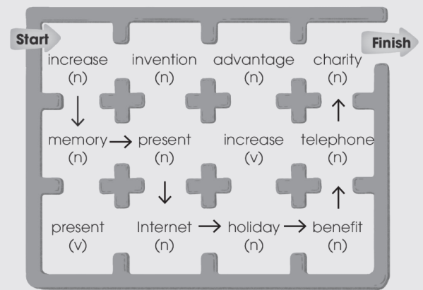 | T-S  S-S  T-S | 6 mins
To further practise putting stress on three-syllable words |  | TASK 2: PAIR THE CARDS.  * T explains the activity.  - Put Ss in pairs and give each pair 10 cards.  - Write 20 familiar three-syllable words on the board:  + 10 words with stress on the 1st syllable  + 10 words with stress on the 2nd syllable.  - Ask Ss to copy words on their cards then shuffle the cards and spread them in front of them.  ** Ss take turns to open any two cards. If the stress pattern of the words on the cards match, they read the words and keep both cards. If the stress patterns don’t match or they can’t pronounce correctly, put them face down in the same position. The winner is the player with the most cards.  *** Ss work in pairs.  **** T gives feedback and discusses with the class. | T-S  S-S  S-S  T-S | 6 mins
VOCABULARY To check if students can use words and phrases related to volunteering and inventions |  | TASK 1: FIND THE MISSING LETTER.  What are the missing letters? Complete the sentences using the pictures to help you. (p.62)  * T explains the activity. T demonstrates with the example by asking Ss to guess what the picture shows and elicits the answer from the Ss.  ** Ss work out the missing letters of the item by using the pictures. T reminds them that these are the words they learnt in Unit 4 and 5.  *** Ss work in pairs.  **** T gives feedback and discusses with the class.  Key:  1. devices, communicate  2. donate, volunteer | T-S  S-S  S-S  T-S | 6 mins
To check if students recognize the differences between -ing and -ed, -ful and -less adjectives |  | TASK 2. COMPLETE THE SENTENCES USING THESE WORDS. THERE ARE SOME EXTRA ONES. (p.63)  * T quickly reviews the differences between -ing and -ed, -ful and -less adjectives. Then T explains the activity. T asks Ss to fill in the gaps with words from the box and reminds them that there are some extra words that they might not need.  ** Ss do the task as required.  *** Ss exchange the answers.  **** T gives feedback and discusses with the class.  Key:  1. interesting / useful, careful  2. useless, interested | T-S  S  S-S  T-S | 6 mins
GRAMMAR  To check if students can use the past simple, past continuous, present perfect, gerunds, and to-infinitives. |  | TASK 1: READ THE TEXT AND CIRCLE THE CORRECT ANSWERS. (p.63)  * T explains the context of the text.  - T tells Ss that new ideas are usually the result of careful planning and analysis, but sometimes there are accidents which lead to useful inventions.  - T asks them to look at the pictures and guess what these inventions are.  ** Ss read the passage and choose the correct answers as they read.  *** Ss exchange the answers with their partner.  **** T gives feedback and discusses with the class.  Key:  1. find  2. Discovering  3. was sitting  4. fell  5. was cleaning  6. discovered  7. have used  8. to make  9. making | T-S  S  S-S  T-S | 6 mins
- To memorise information about the origin of some famous inventions.  - To practise the use of past tenses. |  | TASK 2: RECALL THE INFORMATION  * T divides the class into groups of three. T has each student in the groups choose a different invention from the text and pretend he/she is the person who has invented or discovered the thing.  ** Each student should try to explain how they did it using the information from the text. E.g. I’m Isaac Newton and I discovered the law of gravity. I was sitting under the apple tree when an apple fell on my head. I realized that something made apples fall straight to the ground. That’s how I discovered gravity.  *** Ss work in groups and then report to the whole class.  **** T gives feedback. | T-S  S-S  S-S  T-S | 7 mins
WRAP-UP  To consolidate what students have learnt in the lesson. |  | T asks Ss to talk about what they have learnt in the lesson. | T-S | 2 mins
HOMEWORK  To prepare for the next lesson. |  | Prepare for the next lesson: Review 2, Lesson 2 – Skills (1). | T-S | 1 min

Date: December 17th, 2022

REVIEW 2

Period 48: Skills (1) - Listening & Speaking

I. OBJECTIVES
By the end of this lesson, students will be able to:
1. Knowledge
- Review the Listening and Speaking skills they have learnt in Unit 4-5.
2. Core competence
- Develop critical thinking skill;
- Be collaborative and supportive in pair work and team work;
- Actively join in class activities.
3. Personal qualities
- Develop self-study skills.
II/ Teaching and learning resources:
TV, speakers, textbook, teacher's book, handouts, laptop, sachmem.vn

III. PROCEDURES
Notes:
In each activity, each step will be represented as following:
* Deliver the task
** Implement the task
*** Discuss
**** Give comments or feedback

Stage aim | Procedure | Interaction | Time
WARM-UP  To give excitement to students and lead in the lesson. | GAME: HANGMAN  * T writes 9 blank letters on the board.  _ _ _ _ _ _ _ _ _  ** Ss guess the letters in turn.  *** The class plays the game together. The first student to get the correct answer is the winner.  **** T checks if the answers are correct or incorrect and leads in the lesson. | T-S  S  S-S  T-S | 5 mins
LISTENING  To practise listening for main ideas | TASK 1. LISTEN AND CHOOSE THE BEST TITLE FOR THE TALK. (p.64)  * T explains the activity. T asks Ss if they know what a smart home is.  ** Ss read the titles, listen and choose the best one for the talk as they listen.  *** Ss work individually and then compare their answers with their friends.  **** T gives feedback and discusses with the class.  Key: A | T-S  S-S | 7 mins
To practise listening for specific information | TASK 2: LISTEN AGAIN AND FILL IN EACH BLANK WITH ONE WORD. (p.64)  * T explains the activity.  - T asks Ss to listen again. This time they are filling in notes, using one word for each blank.  - Before having Ss do the task, T reviews the techniques for this type of exercise, e.g. skimming through the note, predicting parts of speech and answers based on context clues.  - T gives Ss some time to skim through the note and try to work out the answers before they listen.  ** Ss do as instructions.  *** Ss work individually and then compare their answer with the friend’s.  **** T gives feedback and discusses with the class.  Key:  1. voice  2. Lights  3. alarm  4. devices | T-S  S-S  S-S  T-S | 7 mins
To further practise listening for specific information | TASK 3. WORK IN GROUPS. COMPLETE THE SENTENCES WITH AS MANY WORDS AS POSSIBLE.  * T puts Ss in groups and explains the task.  ** T gives each group a handout with 4 sentences. Each sentence has only 3 words given. T plays the audio (track 43). T can pause longer between sentences or play the audio several times if necessary.  *** Ss listen to the audio and complete each sentence with as many words as they can.  **** T gives feedback and discusses with the class.  1. ……………………………….. everything is controlled ………  2. ………….. turn on when ……………………………………….  3. ……………. your house temperature …………………….  4. …… that’s how technology …………………………………  Key:  1. Imagine living in a house where everything is controlled from a distance.  2. The lights turn on when you enter the room, and then turn off as you leave.  3. You can even control your house temperature, lights and devices from a mobile phone when you are far from home.  4. And that’s how technology can make your life more enjoyable and comfortable than ever. | T-S  S-S  S-S  T-S | 7 mins
SPEAKING  To practise speaking about smart homes | WORK IN GROUPS. WHAT OTHER FEATURES SHOULD A SMART HOME HAVE? HOW WILL THEY HELP US? USE THE EXPRESSIONS YOU LEARNT IN UNIT 5 TO HELP YOU. (p.64)  Task 1: Brainstorming and mind mapping  * T explains the activity. T tells Ss that now they will be talking about smart homes and suggesting new features. T gives each group a piece of A0 paper.  ** Ss work in groups, try to brainstorm and make a mind map on the paper given. Ss can draw and colour the mind map.  *** T walks round the class and gives support if necessary.  **** T gives feedback to each group before they present their work in front of theclass. | T-S  S-S  S-S  T-S | 7 mins
SPEAKING  To practise speaking about smart homes | Task 2: Presentation  * T asks Ss to look at the expressions in the box and reminds them to use them in their discussion.  ** Ss work in groups, use the mind map to prepare for a short presentation about smart homes and suggesting new features.  *** T walks round the class and gives support if necessary. T encourages them to use the expressions provided.  **** T asks some groups to share their ideas with the rest of the class. T gives feedback and discusses with the class. T praises for interesting ideas and good delivery. | T-S  S-S  S-S  T-S | 9 mins
WRAP-UP  To consolidate what students have learnt in the lesson. | T asks Ss to talk about what they have learnt in the lesson. | T-S | 2 mins
HOMEWORK  To prepare for the next lesson. | Prepare for the next lesson: Review 2 - Skills (2) - Reading and Writing. | T-S | 1 min

Date: December 17th, 2022

REVIEW 2

Period 49: Skills (2) - Reading and Writing

I. OBJECTIVES
By the end of this lesson, students will be able to:
1. Knowledge
- Review the Reading and Writing skills they have learnt in Unit 4-5.
2. Core competence
- Develop critical thinking skills;
- Be collaborative and supportive in pair work and team work;
- Actively join in class activities.
3. Personal qualities
- Develop self-study skills.
II/ Teaching and learning resources:
TV, speakers, textbook, teacher's book, handouts, laptop, sachmem.vn
III. PROCEDURES
Notes:
In each activity, each step will be represented as following:
* Deliver the task
** Implement the task
*** Discuss
**** Give comments or feedback

Stage aim | Procedure | Interaction | Time
WARM-UP  To give excitement to students and lead in the lesson. | GUESSING GAME  * T asks a student to come to the board. T shows him/her the key word community service and asks him/her to explain this word to the whole class.  ** This student can use any ways to describe the word, except for saying it directly.  *** The class plays the game together. The fastest student to guess the correct key word is the winner of the game.  **** T checks if the answers are correct or incorrect and leads in the lesson. | T-S  S-S  S-S  S-S | 5 mins
READING  To practice understanding words from context. | TASK 1. READ THE TEXT. MATCH THE HIGHLIGHTED WORDS WITH THEIR MEANINGS (p.64-65)  * T explains the context of the text.  - T writes down the words ‘community service’ and ‘volunteering’ on the board. - T asks if Ss know the difference between them and tells them that they will find the answer in the reading text.  ** Ss complete the matching exercise by focusing on the highlighted words in the text.  *** Ss check the answers as a class.  **** T gives feedback and discusses with the class and elicits the difference between ‘community service’ and ‘volunteering’, e.g. Community service can be either voluntary or compulsory, so volunteering is just one type of community service.  Key:  1. c  2. b  3. a | T-S  S  S-S  T-S | 5 mins
To practice reading for main ideas and specific information | TASK 2. READ THE TEXT AGAIN AND CHOOSE THE BEST ANSWERS. (p.65)  * T asks Ss to read the text again and complete the exercises.  ** Ss do the task as required.  *** T checks the answers as a class.  **** T gives feedback.  1. B  2. C (Clue: For example, they may volunteer to meet new people, to develop social skills, or to ‘find themselves’ (learn what they truly want in life)  3. A (Clue: In general, people may volunteer not just to have others, but to help themselves) | T-S  S  S-S  T-S | 6 mins
To further practice reading for main ideas and specific information | TASK 3. PLAY WITH CARDS.  * T puts Ss into pairs. Ask each pair to prepare two quiz questions based on the reading text and write them on cards or pieces of paper, e.g. How many types of community service are there? Why does the writer think volunteering isn’t always selfless?  ** T collects the cards, shuffles them and spreads them (face down), on a table in front of the class. Invite pairs to take turns to come to the table and turn over a card.  *** Ss read the question and answer it. Ss get one point for a correct answer. If the answer is wrong, they should put the card face down in the same position.  **** T checks the answers and gives feedback. | T-S  S-S  T-S | 6 mins
WRITING  To practice writing a job application letter | COMPLETE THIS APPLICATION LETTER FOR A VOLUNTEER JOB BY WRITING A SHORT PARAGRAPH. YOU MAY USE THE IDEAS BELOW TO HELP YOU. (p.65)  Task 1: Brainstorm  * T asks Ss to work in groups and brainstorm ideas to answer the question: Which skills and qualities are needed to be a volunteer for an organization collecting books for children?  ** T asks Ss to share their ideas and write them on the board. Ss can use the ideas in students’ book page 65.  *** Ss contribute to the discussion and note down the important points in their notebooks.  **** T checks the answers and gives feedback.  Suggested ideas:  - Fond of reading  - Love helping others  - Love meeting new people  - Good interpersonal skills  - Be enthusiastic and helpful  - Develop social skills | T-S  S  T-S | 10 mins
WRITING  To practice writing a job application letter | Task 2: Complete the application letter.  * T explains the task: Ss must finish an application letter for a volunteer job. Specifically, they need to write the reasons why they are interested in the job. They should write 50 - 70 words. T draws their attention to the suggested ideas and tells Ss they can incorporate them in their letters.  ** Ss complete the application letter.  *** T gives Ss enough time to write their letters. T walks round the class and offers help.  **** T collects some or all Ss’ writings to give written feedback.  Sample answer:  I am very interested in the job because I am very fond of reading and I can sort books very well. I also love helping others and meeting new people, especially children. In fact, reading books to children is my favourite hobby. I am also interested in this job because it will help me to develop my social skills, such as communication and teamwork skills. | T-S  S  T-S  T-S | 10 mins
WRAP-UP  To consolidate what students have learnt in the lesson. | T asks Ss to talk about what they have learnt in the lesson. | T-S | 2 mins
HOMEWORK  To prepare for the next lesson. | Prepare for the next lesson: Unit 6, Lesson 1 – Getting Started. | T-S | 1 min

Date: December 24th, 2022
Period 50, 51, 52 REVISION
Lesson: More exercises
Class level: Grade 10
Main language focus: Consolidation.
Integrated language skills: scanning, details
Main listening skills: Inferring cause and effect relationships.
Listening level: A2
Specific Objectives:
By the end of the lesson, Sts will be able to
- Review all the language skills and grammatical points and Listening which they have studied and used in the four units: 1, 2, 3, 4, 5 .
- Students can improve their techniques of doing the simple tests
Prior knowledge: Most students have known some vocabulary and grammar points in Unit 1,2,3 .
Teaching aids:
1. Textbooks
2. Pictures
3. Handouts

TRƯỜNG TRUNG HỌC PHỔ THÔNG | HƯỚNG DẪN ÔN TẬP CUỐI KÌ I, NĂM HỌC 2022-2023 MÔN: TIẾNG ANH 10
A. PHONETICS
Mark the letter A, B, C, or D to indicate the word that differs from the other three in the position of the primary stress in each of the following questions.
Question 1: A. become B. idol C. comment D. season
Question 2: A. perform B. release C. receive D. talent
Question 3: A. talent B. artist C. award D. famous
Question 4: A. theatre B. movie C. famous D. attend
Question 5: A. enjoy B. perform C. suffer D. agree
Question 6: A. weather B. birthday C. boring D. expect
Question 7: A. singer B. receive C. programme D. lyrics
Question 8: A. compose B. careful C. second D. album
Question 9: A. upload B. theatre C. receive D. guitar
Question 10: A. singer B. compose C. common D. programme
Question 11: A. favour B. enjoy C. reveal D. perform
Question 12: A. common B. music C. people D. perform
Question 13. A. quiet B. refer C. public D. honor
Question 14. A. release B. event C. single D. regard
Question 15. A. about B. award C. artist D. attend
Question 16. A. comment B. common C. channel D. compose
B. VOCABULARY AND GRAMMAR
Mark the letter A, B, C or D to indicate the correct answer to each of the following questions.
- Doing housework brings great _________to children as it helps them develop necessary life skills.
A. benefits B. hard work C. results D. practices
- She does two jobs at the same time as she is the main___________ of the family.
A. breadwinner B. homemaker C. housewife D. bread maker
- Kindness and responsibility are two___________ that many parents want to teach to their children.
A. family values B. customs C. cultures D. ideas
- ____ the rubbish in the early morning is a part of my daily routine.
A. Putting out B. Coming out C. Pulling out D. Bringing out
- ____ is a person who works at home and takes care of the house and family.
A. Breadwinner B. Homemaker C. Servant D. Houseman
- My mother ___the responsibility for running the household.
A. holds B. takes C. runs D. bears
- Doing chores as a family will help strengthen ____________.
A. family bonds B. generation gap C. family trees D. family values
- Linh can’t go out with us to see a movie now because she’s ____ dinner.
A. preparing B. making C. arranging D. keeping
- Sarah is a(n) ____________girl. She never cheats in exams.
A. generous B. sociable C. frank D. honest
- Instead of giving me answers to questions, my parents always ______________me to think for myself.
A. support B. encourage C. respect D. strengthen
- Ms. Mai asked me how she could ____ household chores equally in her family.
A. make B. divide C. give D. contribute
- She's such a good wife. She's __________her husband through difficult times.
A. taught B. leff C. supported D. provided
- Preparing and cooking meals are some of the essential __________for teens.
A. soft skills B. life skills C. table manners D. netiquette
- When I lived in this city, I used to shop for ____________at this supermarket.
A. heavy lifting B. groceries C. housework D. laundry
- The kids deeply___________ their grandfather for his great knowledge about the worlD.
A. create B. develop C. respect D. discuss
- I'm lucky to have such a(n)__________ brother who always gives me help when I need it.
A. support B. supporting C. supported D. supportive
- In my family, my father always takes charge of doing the ____ lifting.
A. strong B. hard C. heavy D. huge
- My mother told me to do the ___ yesterday but I forgot about it since I had much homework to finish.
A. wash-up B. laundry C. childcare D. exercises
- After eating dinner, I have to do the ____ and then do my homework every day.
A. washing-up B. wash-up C. washing-ups D. washings-up
- My responsibility is to wash the dishes and ______ the rubbish.
A. take up B. get out C. get up D. put out
- My mother is a ___________. She doesn't go to work, but stays at home to look after the family.
A. breadwinner B. homemaker C. housemaid D. solider
- He __________ to the cinema yesterday evening.
A. has gone B. goes C. went D. had gone
- Jim _________________ a book at the moment.
A. is reading B. had read C. reads D. has read
- I’m busy at the moment, _______on the computer
A. I work B. I’m worked C. I’m working D. I worked
- Don’t bother me while I _______________
A. am working B. was working C. will work D. will have completed
- My brother_______________out at weekend.
A. doesn’t usually go B. does usually not go C. doesn’t usually goes D. usually doesn’t goes.
- Every day, my sister _______________the floor.
A. usually clean B. cleans usually C. usually cleaned D. usually cleans
- Listen! Someone ______________.
A. is singing B. are singing C. sings D. sing
- First thing in the morning, I ____ a cup of milk te
A. has B. am having C. have D. will have
- Do you know the oldest type of ______ energy is the biomass that is derived from plant matter?
A. remarkable B. significant C. sustainable D. affordable
- We buy ___ food at the farmers' market. It costs a little bit more, but we think it's better for our health.
A. organic B. non-organic C. healthy D. wealthy
- In the UK, poor air quality is responsible ___________ some 40,000 deaths each year.
A. to B. for C. in D. with
- Sustainable energy is energy that __________ the needs of the present generations.
A. meets B. takes C. makes D. picks
- We can’t go along here because the road _______.
A. is repairing B. is repaired C. is being repaired D. repairs
- ___________car models always attract great attention at exhibitions.
A. Eco – friendly B. Wealthy C. Passionate D. Portable
- Remember to turn off your ___________when they are not useD.
A. household chores B. household appliances C. household finance D. invitations
- Small changes in your daily habits can help reduce the ___________you produce.
A. carbon footprint B. footsteps C. issues D. trouble
- One of the most important _____________of energy is the sun.
A. resources B. sources C. means D. kinds
- Students are reminded to _________ litter that they see on the grounD.
A. turn off B. put off C. pick up D. turn up
- Switching to ________ light bulb is one way to protect the environment.
A. energy-expending B. energy-wasting C. energy-saving D. energy-lacking
- More people _________ a green lifestyle because it is good for the environment.
A. adopt B. conclude C. compose D. create
- A modern hospital _________in this town soon.
A. will be built B. will build C. will built D. will be build
- You should cut down ________ electricity usage to reduce your carbon footprint.
A. in B. on C. to D. for
- Switching to ____ eco light bulb is one way to protect the environment.
A. energy-wasting B. energy-expending C. energy-lacking D. energy-saving
- Money ______ to the homeless shelter by Larry.
A. donated B. was donating C. was donated D. donates
- This house is going ______ by my mother
A. sold B. to be sold C. to sold D. to sell
- The ancient houses ______ by the fire. They are now under reconstruction.
A. were destroyed B. destroyed C. have destroyed D. were destroying
- Listen! There's someone at the door. I ____ the door for you.
A. am going to open B. am opening C. open D. will open
- “Look at those dark clouds!“ - “Yes, it ____ in some minutes.”
A. will rain B. is going to rain C. are going to rain D. is raining
- I ___________ a lot of presents on my birthday last week.
A. give B. was given C. was giving D. have given
- It‘s very hot. ____ the window. please?
A. Are you opening B. Are you going to open C. Will you open D. Won’t you open
- The boy _______ to the hospital immediately after the accident.
A. was taking B. took C. takes D. was taken
- My bike _______ brown and red by my father.
A. repaints B. repainted C. was repainting D. was repainted
- They _______ this story by their grandmother when they visited her last week.
A. were telling B. tell C. told D. were told
- More than 120,000 people ___ by the two atomic bombs in Hiroshima and Nagasaki in August, 1945.
A. were killing B. were killed C. killed D. kill
- Although I have taken some aspirin, the headache ________ away.
A. isn‘t going B. isn’t going to C. not go D. won’t go
- He ____ to the theatre tonight. He has got a free ticket.
A. goes B. is going C. went D. will go
- I ____ my parents at the weekenD. I already bought a train ticket.
A. visit B. am going to visit C. visited D. will visit
- Stephen William Hawking ____ on 8 January, 1942 in Oxford, EnglanD.
A. born B. has born C. is born D. was born
- ____ by your father?
A. Did that book write B. Did that book written C. Was that book writing D. Was that book written
- Nguyen Thuc Thuy Tien left a positive impression on both judges and __________ because of her friendliness and natural beauty.
A. spectators B. viewers C. audience D. passer-by
- When he was a teenager, he _____at the local theatre in his home town during the tourist season.
A. performed B. attracted C. decided D. relaxed
- She has joined the panel of _____________ the popular TV talent show.
A. audience B. judges C. viewers D. watchers
- I didn't enjoy the performance because I couldn't __________with any of the main characters.
A. identify B. deal C. cope D. cooperate
- Judges travel all round America __________search of the best singers and bring them to Hollywood.
A. on B. in C. at D. for
- Can you play any ____? - Yes. I can play the flute and the guitar.
A. musical tools B. pieces of music C. musical instruments D. musical devices
- Two of the four contestants will be ____ after tonight's show.
A. composed B. removed C. eliminated D. terminated
- Our music teacher has been invited to be a________ in many music competitions and talent shows.
A. singer B. competitor C. contestant D. judge
- The judges _________ an important role in the competition.
A. work B. play C. rest D. put
- The X-factor is a television singing competition_____________ in the United Kingdom.
A. originate B. originated C. originating D. origination
- But for your support, our band couldn’t have won the Grand Music ____________.
A. show B. quiz C. competition D. tour
- Our performance was ____ to be the best one in this competition last night.
A. cheered B. appeared C. judged D. seen
- In the last quarter of this year, our entertainment company had a big success in signing a lot of____________ with celebrities.
A. bargains B. contracts C. arrangements D. profits
- Chopin was considered to be one of the greatest Romantic piano ____ of the 19th century.
A. singers B. writers C. composers D. poets
- We’re seeking for the ___________musician to join our entertainment company.
A. good B. famous C. great D. talented
- These games are challenging, ____ it’s not easy to spend little time playing them.
A. so B. and C. for D. or
- I didn’t want to continue watching the show_________it was more and more boring later.
A. for B. or C. but D. and
- He can’t decide whether to buy the tickets for the music show online_________at the box office
A. and B. or C. yet D. so
- Smoking is extremely detrimental to health, ____ many people continue to smoke anyway.
A. nor B. so C. yet D. then
- Do you like singing_________dancing?
A. but B. yet C. so D. or
- I admire Celine Dion_________she has a nice voice.
A. so B. and C. but D. for
- He lost the key, ____ he couldn't get into the house.
A. yet B. or C. so D. for
- We were lost in the forest, ____ luckily my friend had a map in his backpack.
A. and B. so C. for D. but
- We_________old clothes and books to poor children.
A. interacted B. donated C. balanced D. applied
- We arrived at the hotel quite early, ____ in and had lunch.
A. checking B. checked C. was checking D. to check
- He is very ___________. He is always willing to give a lot of money to charity.
A. honest B. generous C. enthusiastic D. modest
- If you can do something to help others, you will find your life ____.
A. meaningful B. meaningless C. helpless D. interested
- The school is difficult to get to because it is located in a __________area.
A. remote B. cheerful C. confused D. practical
- If you don't have time to volunteer, you can__________ money and food.
A. participate B. boost C. donate D. deliver
- These ____ children encounter many problems and really need our help.
A. disadvantaged B. advantaged C. disadvantage D. advantage
- This clean water project will ______________the people in the village.
A. benefit B. donate C. raise D. volunteer
- Our club needs more_____________ to clean up the park at the weekend.
A. spectators B. assistants C. volunteers D. electrician
- We need to be _______________ when we record the donations.
A. careful B. careless C. carelessly D. carefully
- I am ___________________ in community development activities.
A. interested B. interesting C. excited D. exciting
- There are ________________ volunteering opportunities in our community.
A. excite B. excitedly C. excited D. exciting
- Last year, I was ________________at maths. I couldn't even do simple addition in my head.
A. hope B. hopeful C. hopefully D. hopeless
- Luckily, I got some ____ advice on how to make a presentation on ‘For a better community’ from my class teacher.
A. useless B. useful C. usefulness D. uselessness
- He spent his childhood in _______________ parts of Italy.
A. various B. vary C. variously D. variety
- They were so ____ about joining the local volunteer group that they couldn’t sleep last night.
A. excite B. excitement C. exciting D. excited
- Volunteers become well ____ of the problems facing the world.
A. aware B. concerned C. helpful D. interested
- Most of the students in that special school are making good progress, but Michael is a___ case.
A. hopefully B. hopeless C. hopeful D. hopelessly
- A lot of generous businessmen have ____ valuable contributions to helping needy people.
A. done B. taken C. made D. given
- It is ____ that all the students in class 1OA choose to do a project on ‘Helping the needy’.
A. surprising B. surprised C. surprise D. surprisingly
- They visit a retirement home and ____ time doing fun activities with the elderly who lack immediate family.
A. spend B. lose C. waste D. consume
- Fundraising for charity is a ____ thing for everyone to do to help the community.
A. meant B. meaningful C. meaningless D. meaning
- Every month, the volunteer group go to _________and mountainous areas to help those in need.
A. empty B. remote C. crowded D. poor
- Your music is very ____. Can't you just stop it?
A. annoying B. interesting C. annoyed D. bored
- Some of the students were ____ at English, so volunteer teachers had to try very harD.
A. hopeless B. hopeful C. endless D. excited
- She wishes she could do some _____ work this summer.
A. voluntarily B. volunteerism C. volunteer D. volunteering
- This charity provides financial support and mental comfort to ____ children.
A. advantaged B. disadvantaged C. advantageous D. disadvantageous
- You can ____ books, clothes, medicine and money to this charity.
A. donor B. donate C. devote D. dedicate
- While Tom and I ____, someone ____ at the door.
A. were talking - knocked B. were talking - was knocking C. talked - knocked D. talked - was knocking
- While the teacher was explaining to the whole class, she ____ carefully.
A. didn't listen B. wasn't listening C. had listened D. wasn't listened
- When we were on a voluntary tour, we ____ to public places to collect rubbish every day.
A. were going B. went C. have gone D. had gone
- They are going to treat drinking water and widen roads in_________areas.
A. private B. remote C. accessible D. secret
- The phone was engaged when I calleD. Who ____ to?
A. were you talking B. were you talked C. did you talk D. have you talked
- He feels_________about teaching English to children in remote areas.
A. excited B. hopeless C. helpful D. interested
- While Lan ____________ as a volunteer in the countryside, she met an old frienD.
A. was working B. worked C. had worked D. worked
D. READING Read the passage and choose the best answer to each of the following questions.
The three Rs
Rubbish, and how we choose to handle it, affects the environment and everything around us including the air, water, land, plants, and man-made things. We need a healthy environment for our well-being, (1)______ we can understand why effective management of rubbish is important. Everyone needs (2)_______ about and practise the three Rs - reduce, reuse, and recycle - to make our world safe and environmentally-friendly place. First, we must buy and use less and we should choose items with minimal packaging. Second, we should reuse things as much as possible and pass items on to others (3) _______ can use them when they are no longer of use to us. Finally, we should recycle everything once its usefulness is over so they can be made into new items. Making new items from recycled ones takes less energy and fewer resources than making products from brand-new materials. Just about anything that cannot be reused can be recycled into something more. You’d be (4) _______ what can be done with a recycled product! A recycled plastic bottle can be made into hundreds of other plastics goods that can be used for many years.
Question 1. A. so B. but C. or D. and
Question 2. A. to give B. to do C. to deliver D. to learn
Question 3. A. which B. who C. whom D. when
Question 4. A. amaze B. to amaze C. amazed D. amazing
Read the following passage and mark the option to indicate the correct answer to each of the following questions.
Street Children Volunteer Programme in Delhi
There are about 100 million street children in India who do not attend any school and spend most of their time on the streets. In Delhi, the capital city, it is estimated that there are about 175,000 street children of which 10% are runaways. In fact, there are more than 25,000 children who live in and around railway stations in Delhi. They can be seen searching the rubbish heap for a meal, sleeping between the tracks, often beaten and sexually abused.
Volunteer Work in the Street Children Programme in Delhi, India consists of taking informal education classes with the children, playing games with the children, and introducing them to different new activities. Volunteers can teach the children good habits such as cleanliness, hygiene, and greetings. On some of the days, volunteers can plan a trip with the children to a museum or zoo in Delhi. Such educational trips are very useful for the children where they love spending time and playing with the volunteers.
Volunteers work at the various contact points or shelter homes, being run by various organizations, which serve as day care centers for these street children. They can assist in providing love, care, basic literacy, recreation and most importantly spend time and shower affection on them.
Question 1. Street children in Delhi ______.
A. spend most of their time in and around railway stations B. live in very badly physical and mental conditions
C. account for 100 million from all parts of India D. can search heaps of food for meals
Question 2. Volunteers may do all of the following activities EXCEPT ______.
A. giving informal lessons to children B. playing games with children
C. teaching children good habits D. taking children to evening classes
Question 3. Educational trips are very useful for the children because ______.
A. there are many museums and zoos in Delhi
B. they can learn good habits such as cleanliness, hygiene and greetings
C. they have a good time and lots of fun with volunteers
D. they can play many educational games with volunteers there
Question 4. Day care centers for street children offer ______.
A. care, education, and recreation B. time, shower, and affection
C. supply of volunteers for various organizations D. contact points or shelter homes at railway stations
Question 5. The word “They” in the last paragraph refers to ______.
A. volunteers B. organizations C. day care centers D. street children

WRITING:I: Rewrite the following sentences, beginning as shown, without changing their meaning.
Question 1. John didn't understand the homework assignment. He asked the teacher for help. (SO)
John…………………………………………………………………………………………………….
Question 2. David invested a lot of money in the business. The business went bankrupt. (BUT)
David ………………………………………………………………………………………………….
Question 3. You can't remove any products from the nature. It is illegal. (TO V)
It is illegal for …………………………………………………………………………………………….
Question 4. The students didn’t put rubbish in the bins after the party yesterday. (PASSIVE VOICE)
The rubbish ………………………………………………………………………………………………
Question 5. They intend to organize an English club in our school.
They are …………………………………………………………………………………………………
Question 6. All the kids were doing their homework. The volunteer team arrived.
While ……………………………………………………………………………………………………
Question 7. When you phone me, it was my lunch time.
When you phoned me, I………………………………………………………………………………..
Question 8. I hope to see you at Christmas.
I’m looking forward …………………………………………………………………………………..
Question 9. My responsibility is to take out the garbage every day.
I am……………………………………………………………………………………………………
Question 10. His parents made him study hard for the exams.
He was…………………………………………………………………………………………………
Question 11. He likes tea. He will take a cup of coffee. (but)
………………………………………………………………………………………………………….
Question 12 I bought some books. I bought a school bag. (and)
………………………………………………………………………………………………………….
Question 13. The air in the city is highly polluted. We don’t like to live there. (so)
…………………………………………………………………………………………………………
Question 14. They are building a new hotel next to my house.
A new hotel………………………………………………………………………………………..
Question 15. They use boats as a means of transport in Mekong Delta.
…………………………………………………………………………………………………………
Question 16. Although most of us dislike Franky, we don’t dare to say so. (but)
………………………………………………………………………………………………………..
Topic writing:
I. Write a paragraph, using the following questions as cues for your writing.
Topic 3. You have an English friend and want to tell him / her about your favorite singer. Write an email (100 -120 words) to tell him / her about it.
You can use the following questions as cues:
1. What is his / her name? 2. What type of music does he/ she sing?
3. What type of people listen to his/ her songs? 4. Why do you admire him/ her?
To:________________
Subject:_____________
Dear______________,
_____________________________________________________________________________________
_____________________________________________________________________________________
_____________________________________________________________________________________
_____________________________________________________________________________________
_____________________________________________________________________________________
Best wishes,
(Signature)
II. Write a short paragraph (80 -100 words) about doing volunteer work.
You can use the following questions as cues:
1. Why do people do volunteer work? 2. Which volunteer activities do you like?
3. What situations need volunteer workers? 4. What benefits can you get from volunteer work?
……………………………………………………………………………………………………………………..
……………………………………………………………………………………………………………………..
……………………………………………………………………………………………………………………..
……………………………………………………………………………………………………………………..
……………………………………………………………………………………………………………………..
……………………………………………………………………………………………………………………..
……………………………………………………………………………………………………………………..
III: Write a paragraph (120 — 150 words) about one of your family routines. Use the following questions as cues for your writing.
1. What is the routine? 2. How often / When do you do it?
3. What are the activities? What does each family member do? 4. How do you feel about the routine?
……………………………………………………………………………………………………………………..
……………………………………………………………………………………………………………………..
……………………………………………………………………………………………………………………..
……………………………………………………………………………………………………………………..
……………………………………………………………………………………………………………………..
……………………………………………………………………………………………………………………..
……………………………………………………………………………………………………………………..
TOPICS FOR SPEAKING
UNIT 1 : FAMILY LIFE
Talk about your family routines. Use the following questions as cues
-What is the routine?
- How often / When do you do it?
- What are the activities? What does each family member do?
- How do you feel about the routine?
- Do you think that you should share the household chores with your parents? Why(not)?
- What are some important life skills you can learn when doing housework?

UNIT 2: HUMANS AND THE ENVIRONMENT
Talk about something you should or shouldn’t do to protect the environment
- How often do you do it? - Why shouldn’t you do it?
- Why should you do it? - Who can do it?
Useful languages:
Useful vocabulary | Useful structures
- littering, cutting down trees, using nylon bags, using private cars, reducing the amount of energy you use in home, using organic food, avoiding products that are made from plastic  - every day, once a week, three times a month, every week, ...  -friends, family members, relatives, colleagues,...  - damaging health, devastating ecosystems, causing flood, eroding solid, ... | • Avoiding ... is what I do to protect the environment.  • Saying no to ... is the way that I do to protect the environment.  • I do it every day/ once a week/ every time I go shopping, ...  • My family members don’t..., either.  • There are several reasons explaining for my decision.  • I don’t do it because of some reasons.

UNIT 3: MUSIC
Talk about a TV music show that you like.
You can use the following questions as cues:
• What is it?• How do you know it?
• What it is like?• Why do you like it?
Useful languages:
Useful vocabulary | Useful structures
• The Voice of Vietnam, Vietnam Idol, The X factor, The Remix  • through Internet, through TV, through friends, through magazines  • popular, new, interesting, celebrities’ appearance  • focusing on voice, relaxing, professional performances, | • Among many TV music shows ...  • I am a big fan of...  • One of my favourite TV music show is ...  • I like ... most.  • I know this program through ...  • I watched the show for the first time on ...  • In this program, ...  • There are some reasons why I like the show.  • Firstly, ... Secondly, ... In addition, ...

UNIT 4: FOR A BETTER COMMUNITY
- Talk about doing volunteer work.
You can use the following questions as cues: * Why do people do volunteer work?
* Which volunteer activities do you like?
* What benefits can you get from volunteer work?

LISTENING: PART 1. GAPFILL
PART 2. TRUE – FASLE ( UNIT 2,3,4)

