UNIT 10: ECOTOURISM
Lesson 1: Getting started – An eco-friendly fieldtrip to Phong Nha Cave

I. OBJECTIVES
By the end of this lesson, students will be able to gain:
1. Knowledge
- an overview about the topic ecotourism
- words and phrases related to ecotourism
2. Core competence
- Develop communication skills and awareness of tourism and their impact on the environment
- Be collaborative and supportive in pair work and teamwork
- Actively join in class activities
3. Personal qualities
- Develop a sense of being an ecotourist
- Be aware of tourism and their impact on the environment
II. MATERIALS
- Grade 10 textbook, Unit 10, Getting started
- Computer connected to the Internet
- Projector/ TV/ pictures and cards
- sachmem.vn

Language analysis
Form | Pronunciation | Meaning | Vietnamese equivalent
- stalactite (n) | /ˈstæləktaɪt/ | piece of rock hanging down from the roof of a cave | nhũ đá, thạch nhũ, vú đá
- fieldtrip (n) | /ˈfiːld ˌtrɪp/ | a visit made by students to study something away from their school or college | chuyến tham quan
- packaging (n) | /ˈpæk.ɪ.dʒɪŋ/ | the materials in which objects are wrapped before being sold | bao bì, giấy gói hàng

Assumptions
Anticipated difficulties | Solutions
- Students may not know some words in the conversation.  - Students may not know how to work in teams. | - Provide students with some lexical items before listening and reading the conversation.  - Give short, clear instructions and help if necessary.

Board Plan
Date of teaching
UNIT 10: ECOTOURISM
Lesson 1: Getting started – An eco-friendly fieldtrip to Phong Nha Cave

* Warm-up: Brainstorming
I. Vocabulary
1. stalactite (n)
2. fieldtrip (n)
3. packaging (n)
II. Practice
Task 1. Listen and read. (p. 110)
Task 2: Read the conversation again. Then find and correct a mistake in each sentence below. (p. 111)
Task 3: Put each phrase into the correct column. (p. 111)
Task 4: Complete these sentences from Task 1. (p. 111)
* Project preparation
* Homework
Choose a local tourist attraction and find information about it.

III. PROCEDURES
Notes:
In each activity, each step will be represented as following
* Deliver the task
** Implement the task
*** Discuss
**** Give comments or feedback

Stage | Stage aim | Procedure | Interaction | Time
WARM-UP | - To activate students’ knowledge on the topic of the unit.  - To create a lively atmosphere in the classroom  - To lead into the new unit | BRAINSTORMING: WHAT WOULD YOU LIKE TO DO THIS SUMMER VACATION?  * Teacher asks students to brainstorm answers for the question:  What would you like to do this summer vacation?  ** Students work in groups to do brainstorming.  *** Teacher and students discuss the answers.  **** Teacher provides suggested answers and focuses on the phrase “take part in an eco-tour” to lead in the topic of the unit.  Suggested answers:  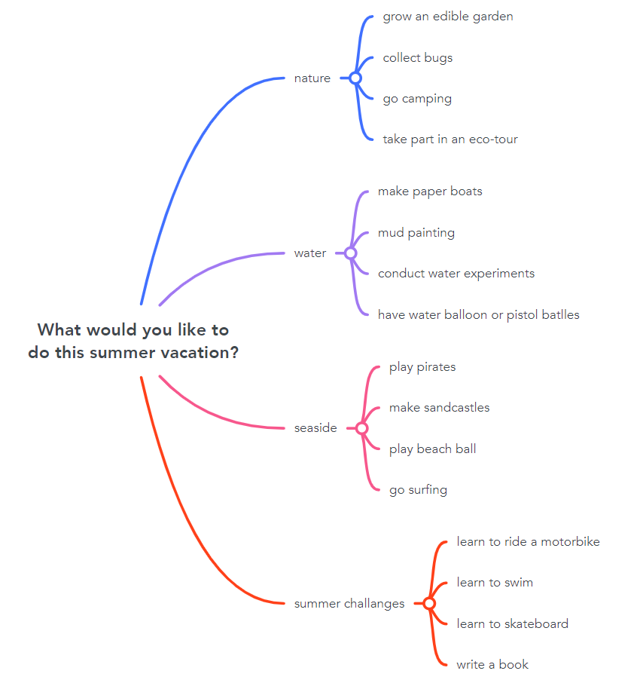 |  | 5 mins
VOCABULARY - PRE-TEACH | To help students use key language more appropriately before they read and listen | VOCABULARY  * Teacher asks students to look at the explanation and the photos to guess the meaning of new words.  ** Students say the Vietnamese meaning of the word.  *** Other students correct if the previous answers are incorrect.  **** Teacher shows the Vietnamese meaning, says the words aloud and asks students to repeat them. | T-S  S  S-S  T-S | 4 mins
  1. stalactite (n) | 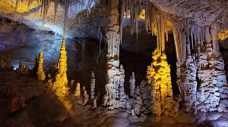
  2. fieldtrip (n) | 
  3. packaging (n) | 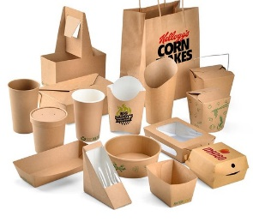
READ AND LISTEN | - To introduce the unit topic (Ecotourism);  - To introduce some vocabulary and the grammar points to be learnt in the unit. | TASK 1. LISTEN AND READ. (P. 110)  * Teacher asks students to look at the picture (p. 110), the heading of the conversation and answer the questions:  * Teacher then plays the recording twice, has students listen to the conversation, read along and underline words / phrases related to the environment in the conversation.  ** Ss do the task individually.  *** Teacher puts students in pairs and asks them to compare the words and phrases they have underlined and discuss their meaning.  **** Teacher checks check comprehension as a class.  Suggested answers: eco-friendly, damage the environment | T-S  T-S  S  Pair work  T-S | 7 mins
  What can you see?  (A cave / Phong Nha Cave) Who are the speakers?  (Nam, Mai, and their teacher) What do you think  they are discussing?  (A trip to the cave). | 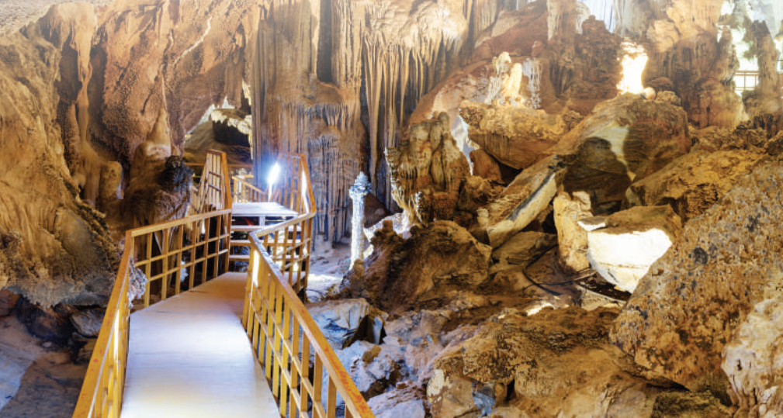
CONTROLLED PRACTICE | To check students’ comprehension of the conversation. | TASK 2: READ THE CONVERSATION AGAIN. THEN FIND AND CORRECT A MISTAKE IN EACH SENTENCE BELOW. (P. 111)  * Teacher asks students to find a mistake in each sentence and correct it:  - Ask them to identify and underline the key words in the sentences first. Then have them read the conversation again and locate the part that contains the information for each sentence.  - Have them compare the information in the conversation with each sentence to know which part of the sentence is incorrect, and how to correct it.  ** Students do the task individually.  *** Teacher has students work in pairs to discuss and compare their answers.  **** Teacher checks the answers as a class.  - Have them call out the part of the sentence which is incorrect first. Then ask them to give the corrections.  - Finally, have some students read the complete correct sentences.  Suggested answers:  1. On an eco-friendly fieldtrip, tourists enjoy, explore and damage the environment.  but not (OR: and protect / learn about)  2. Nam will take pieces of stalactites because they take a long time to form.  will not / won’t  3. Mai will bring snacks with a lot of packaging on the trip.  will not / won’t (OR: will bring … less …) | T-S  S  Pair work  T-S | 10 mins
CONTROLLED PRACTICE | To help students revise phrases related to ecotourism | TASK 3: PUT EACH PHRASE INTO THE CORRECT COLUMN. (P. 111)  * Teacher has students read the phrases in the box and explains that these are things that tourists should do or shouldn’t on an eco-friendly fieldtrip.  ** Teacher asks students to sort the phrases into the columns of Dos and Don’ts.  *** Teacher puts students in pairs and asks them to compare their answers.  ****Teacher checks answers as a class and elicit the meaning of any words students don’t know or find hard to understand.  Answers:  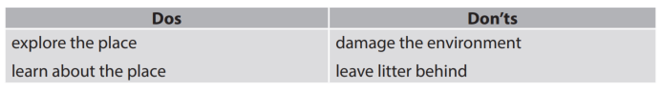 | T-S  S  Pair work  T-S | 4 mins
 | To help students identify conditional sentences Type 1 and Type 2. | TASK 4: COMPLETE THESE SENTENCES FROM TASK 1. (P. 111)  * Teacher asks students to read the two incomplete sentences and focus attention on the word ‘if’, elicits what kind of words are missing (verbs).  ** Teacher asks students to complete the sentences, using words from Task 1.  *** Teacher puts students in pairs and asks them to compare their answers.  **** Teacher checks the answers as a class.  Answers:  1. add, will be  2. were, wouldn’t | T-S  S  Pair work  T-S | 4 mins
LESS CONTROLLED PRACTICE | The aim of this activity is to inform students what the final product of the Project should be like and howSs can prepare for it. | Project preparation  * Teacher asks students open their books at the last page of Unit 10, the Project section, look at the picture and say what the topic of the Project is (Ecotours). Teacher then tells students about the Project requirements:  - Students will have to design an ecotour and then give an oral presentation of their ideas in the last lesson of the unit.  - Alternatively, ask students to prepare a poster presenting their ideas. In a poster presentation, students will display their inventions on posters and hang them around the classroom. One representative from each group will stand next to the poster. The rest will walk around, study the posters and talk to any representative of a group if they want to learn more about an invention.  - Then the class will sit down and vote for the best invention.  ** Teacher suggests the steps students should follow:  - Collect information (search the Internet, read newspapers, etc.);  - Illustrate their ecotours on computers or on posters, etc.  - Rehearse for the oral or poster presentation.  *** Teacher puts students into groups and have them choose their group leader. Then ask them to assign tasks for each group member, making sure that all group members contribute to the group work.  **** Teacher helps students set deadlines for each task and support them throughout the process | T-S  T-S  T-S  T-S | 10 mins
WRAP UP  HOMEWORK | To help students memorise the target language and skills that they have learned | WRAP-UP  - Some lexical items about ecotourism  - Reading for specific information  - Scanning  HOMEWORK  - Choose a local tourist attraction and find information about it.  - Exercises in the workbook | T-S | 1 min

UNIT 10: ECOTOURISM
Lesson 2: Language
I. OBJECTIVES
By the end of this lesson, students will be able to gain:
1. Knowledge
- Use the lexical items related to the topic ecotourism;
- Identify intonation patterns and use appropriate intonation (i.e. rising or falling tone);
- Use conditional sentences Type 1 and Type 2 correctly.
2. Core competence
- Be collaborative and supportive in pair work and teamwork;
- Access and consolidate information from a variety of sources;
- Actively join in class activities.
3. Personal qualities
- Develop a sense of an ecotourist;
- Be aware of tourism and their impact on the environment.
II. MATERIALS
- Grade 10 textbook, Unit 10, Language
- Computer connected to the Internet
- Projector/ TV/ pictures and cards
- sachmem.vn

Language analysis
Conditional sentences | Form | Use & Examples
Type 1 | If + present simple, … (will) … | Conditional sentences type 1 talk about real situations in the present or future that we believe are possible or likely to happen.  If you work hard, you will pass the exam.
Type 2 | If + past simple, … (would) … | Conditional sentences type 2 talk about imaginary situations that are impossible or unlikely to happen.  If I were a bird, I would fly

Assumptions
Anticipated difficulties | Solutions
- Students may be confused when using conditional sentences type 1 and type 2.  - Students may have underdeveloped speaking and co-operating skills. | - Give short and clear explanations with legible examples for each case.  - Give clear instructions, give examples before letting students work in groups.  - Provide feedback and help if necessary.

Board Plan
Date of teaching
UNIT 10: ECOTOURISM
Lesson 2: Language

* Warm-up
Matching: Caves in Phong Nha – Ke Bang National Park
I. Pronunciation
Task 1: Listen to these sentences. Pay attention to the intonation and repeat. (p. 111)
Task 2: Work in pairs and role-play this conversation. Pay attention to the intonation. Then listen and check. (p. 111)
II. Vocabulary
Task 1. Below is what ecotourists do. Match each sentence on the left with its explanation on the right. (p. 112)
Task 2: Complete these sentences with the highlighted words in Task 1. (p. 112)
III. Grammar
Task 1: Decide whether these statements can be real (R) or not (N). (p. 112)
Task 2: Put the verbs in brackets in the correct forms. (p. 112)
IV. Production
Game: Surprising matching!
* Homework

III. PROCEDURES
Notes:
In each activity, each step will be represented as following
* Deliver the task
** Implement the task
*** Discuss
**** Give comments or feedback

Stage | Stage aim | Procedure | Interaction | Time
WARM-UP | To activate students’ prior knowledge and introduce caves in Phong Nha – ke Bang National Park. | MATCHING: CAVES IN PHONG NHA – KE BANG NATIONAL PARK  * Teacher reveals that beside Phong Nha Cave, there are 9 other caves in Phong Nha – Ke Bang National Park and asks students to match the pictures with the correct names of the caves.  ** Students work in groups of four to do the matching task.  *** Teacher and students discuss the answers.  **** Teacher confirms the answers as a class.  Answers: | T-S  Group work  S-S  T-S | 5 mins
   | 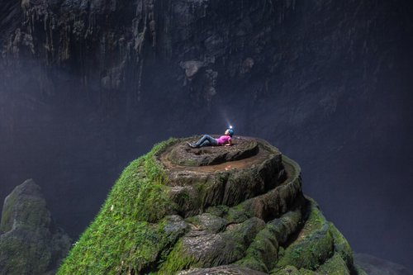
  Phong Nha Cave | Son Doong Cave
  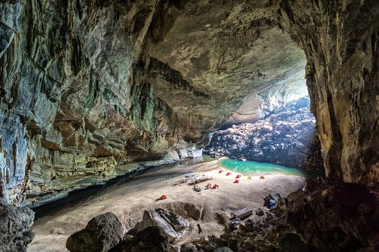 | 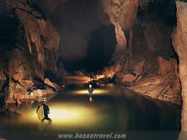
  Hang En Cave | Hang Toi Cave (Dark Cave)
  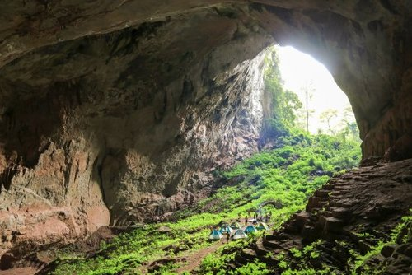 | 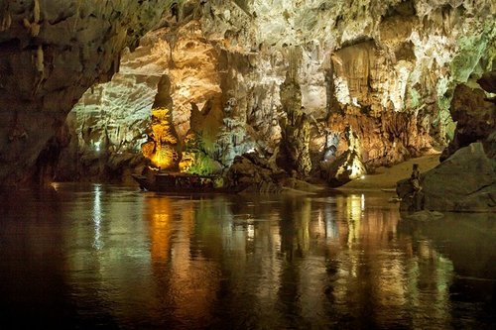
  Hang Voi Cave (Elephant Cave) | Thien Duong Cave (Paradise Cave)
  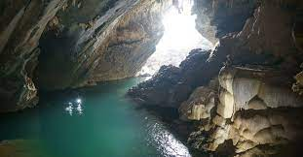 | 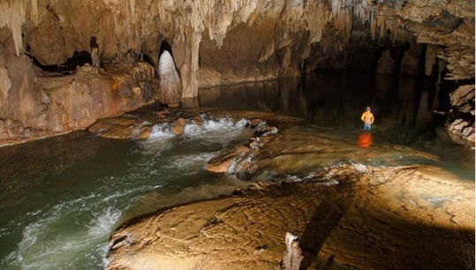
  Tra Ang Cave | Tu Lan Cave
  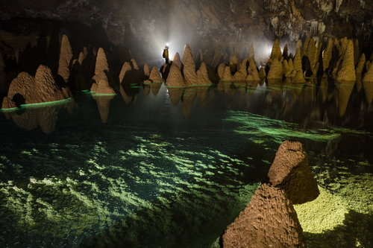 | 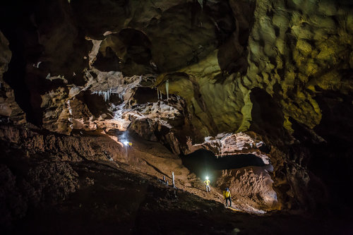
  Hang Va Cave | Hang Vom & Hang Gieng Vooc Cave
PRONUNCIATION | To help students recognise the intonation patterns in different types of sentences. | TASK 1: LISTEN TO THESE SENTENCES. PAY ATTENTION TO THE INTONATION AND REPEAT. (P. 111)  * Teacher asks students to listen to some sentences and has them pay attention to the arrows at the end.  ** Teacher asks students to listen to the sentences again, but this time have them use their hands to indicate the falling and rising tones at the end of each sentence. Teacher then asks students to read the notes in the Remember! Box and checks understanding by asking individual students to briefly explain the intonation patterns in the three types of sentences: statements, Wh-questions and Yes-No questions and provide an example for each kind.  ***Teacher plays the recording again, pausing after each sentence for students to repeat. Encourage them to use their hands to indicate the intonation pattern.  **** Teacher confirms the correct intonation.  Key:  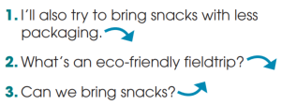 | T-S  T-S  T-S  T-S | 5 mins
PRONUNCIATION | To help students practise different intonation patterns in a conversation. | TASK 2: WORK IN PAIRS AND ROLE-PLAY THIS CONVERSATION. PAY ATTENTION TO THE INTONATION. THEN LISTEN AND CHECK. (P. 111)  * Teacher asks students to read quickly through the conversation and checks understanding.  ** Teacher has students work in pairs to role-play the conversation.  *** Teacher asks students to peer check and give comments to their partners.  **** Teacher asks students to pay attention to the three intonation patterns they have just learnt.  Audio script:  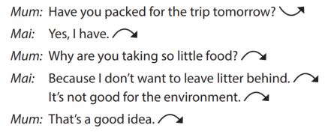 | T-S  Pair work  T-S | 5 mins
VOCABULARY | To help students understand the meanings of words / phrases related to ecotourism. | TASK 1. BELOW IS WHAT ECOTOURISTS DO. MATCH EACH SENTENCE ON THE LEFT WITH ITS EXPLANATION ON THE RIGHT. (P. 112)  * Teacher explains the context of the activity and tells students that the statements represent things that ecotourists do.  ** Students read the statements, focusing their attention on the key word highlighted in each sentence.  *** Teacher puts students in pairs and asks them to compare their answers.  **** Teacher checks answers as a class:  - Explain or elicit any new or difficult words  - Draw attention to the prepositions after some of the highlighted words  - Tell students they should try to memorise both the words and the prepositions that go with them.  Answers:  1. b  2. a  3. e  4. d  5. c | T-S  S  Pair work  T-S | 4 mins
VOCABULARY | To help students practise these words in meaningful contexts. | TASK 2: COMPLETE THESE SENTENCES WITH THE HIGHLIGHTED WORDS IN TASK 1. (P. 112)  * Teacher asks students to work in pairs and tells them to read the sentences carefully and decide which highlighted word in Task 1 can be used to complete each of the sentences.  ** Students work in pairs to complete the task.  *** Teacher asks students to peer check and give comments to their partners.  **** Teacher checks answers as a class:  - Have Ss call out the word they have used in each sentence first.  - Confirm the correct answers.  - Ask Ss to explain the meaning of each word using the definitions in Task 1.  - Ask some students to read the complete sentences.  Answers:  1. profit; crafts  2. aware; impact  3. responsible | T-S  Pair work  T-S | 10 mins
GRAMMAR | To help students recognise the differences between Types 1 and Type 2 conditional sentences. | TASK 1: DECIDE WHETHER THESE STATEMENTS CAN BE REAL (R) OR NOT (N). (P.112)  * Teacher asks students to study the sentences individually.  ** Students decide which statement is possible or likely to happen, and which one is imaginary or unlikely to happen.  *** Teacher asks students to peer check and give comments to their partners.  **** Teacher checks answers as a class:  - Tell students that all sentences that are ‘possible or likely to happen’ are conditional sentences Type 1, while sentences that are ‘imaginary or unlikely to happen’ are conditional sentences Type 2.  - Ask students to read the notes in the Remember! box. Check understanding by asking questions about each type.  Answers:  1. N  2. R  3. N  4. R | T-S  S  Pair work  T-S | 6 mins
GRAMMAR | To help students practise conditional sentences Types 1 and Type 2. | TASK 2: PUT THE VERBS IN BRACKETS IN THE CORRECT FORMS. (P. 112)  * Teacher asks students to put the verbs in brackets in the correct forms and tells them to pay attention to the meaning of each sentence, and whether the situation is possible (Conditional sentence Type 1) or not (Conditional sentence Type 2).  ** Students complete the task individually.  *** Teacher asks students to peer check and give comments to their partners.  **** Teacher checks answers as a class:  - Check answers as a class:  - Have individual students write the sentences on the board.  - Go through each sentence and ask Ss to explain why they have used that particular form.  Answers:  1. will stay  2. would grow  3. were / was. would be  4. give. will reduce | T-S  S  Pair work  T-S | 5 mins
EXTRA ACTIVITY | To give students a chance to apply what they have learnt. | GAME: SURPRISING MATCHING!  *Teacher divides the class into 4 groups.  - Group A will write If clause type 1. Group B will write Main clause type 1.  - Group C will write If clause type 2 Group D will write Main clause type 2.  ** Teacher then will match members of group A with ones of group B, and do the same with group C and D.  *** Teacher and students discuss and give comments to the surprising results.  **** Teacher confirms the possible answers and restates the use of Conditional sentences type 1 and type 2. | Group work | 4 mins
WRAP UP  HOMEWORK | To help Ss memorise what they have learned | WRAP-UP  - Use the lexical items related to the topic ecotourism;  - Identify intonation patterns and use appropriate intonation (i.e. rising or falling tone)  - Use conditional sentences Type 1 and Type 2 correctly.  HOMEWORK  - Prepare for the next lesson: Unit 10_Reading  - Exercises in the workbook | T-S | 1 min

UNIT 10: ECOTOURISM
LESSON 3: READING _ ECOTOUR BROCHURES

I. OBJECTIVES
By the end of this lesson, Ss will be able to gain:
1. Knowledge
- Develop reading skill for specific information in a brochure about ecotours.
2. Core competence
- Develop communication skills and creativity
- Be collaborative and supportive in pair work and team work
- Develop presentation skill
- Actively join in class activities
3. Personal qualities
- Develop a sense of an ecotourist
- Be aware of tourism and their impact on the environment
II. MATERIALS
- Grade 10 textbook, Unit 10, Reading
- Computer connected to the Internet
- Projector/ TV/ pictures and cards
- sachmem.vn

Language analysis
Form | Pronunciation | Meaning | Vietnamese equivalent
- protect (v) | /prəˈtekt/ | to keep someone or something safe from injury, damage, or loss | bảo vệ
- souvenir (n) | /ˌsuː.vənˈɪər/ | something you buy or keep to help you remember a holiday or special event | quà lưu niệm
- explore (v) | /ɪkˈsplɔːr/ | to search and discover (about something) | khám phá

Assumptions
Anticipated difficulties | Solutions
- Students may lack knowledge about some lexical items.  - Students may have underdeveloped reading, speaking and co-operating skills. | - Provide students with the meaning and pronunciation of words.  - Let students read the text again (if necessary).  - Create a comfortable and encouraging environment for students to speak.  - Encourage students to work in pairs, in groups so that they can help each other.  - Provide feedback and help if necessary.

Board Plan
Date of teaching
UNIT 10: ECOTOURISM
Lesson 3: Reading _ Ecotour brochures
* Warm-up
Name the tours
* Reading
Vocabulary
1. protect (v)
2. souvenir (n)
3. explore (v)
Task 1: Work in pairs. Answer these questions. (p. 113)
Task 2: Read the brochures below. Then work in pairs to solve the crossword using words from the brochures. (p. 113)
Task 3: Which tour does each statement below talk about? Write a, b, c or d. (p. 113)
Task 4: Work in groups. Think of new ideas for making one of the tours better for the environment. (p. 114)
* Homework

III. PROCEDURES
Notes:
In each activity, each step will be represented as following
* Deliver the task
** Implement the task
*** Discuss
**** Give comments or feedback

Stage | Stage aim | Procedure | Interaction | Time
WARM-UP | To introduce the topic of reading. | Name the tours  * Teacher shows the pictures and asks students to name the tours based in these pictures.  ** Students raise hands to provide the answers.  *** Teacher and students discuss the answers.  **** Teacher confirms the appropriate names of the tours and provides suggested answers.  Suggested answers: | T-S  S  T-S  T-S | 5 mins
  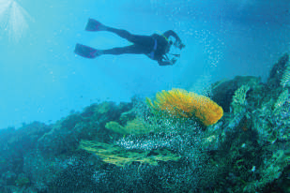 | 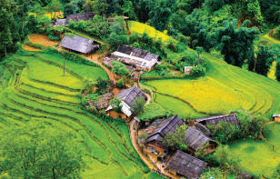
  Reef Tour | Trekking Tour
  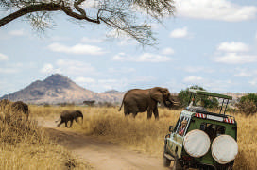 | 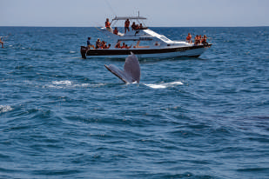
  National Park Tour | Whale-watching Tour
PRE-READING | To provide students with some lexical items before reading the text.  To introduce the topic of the reading and get students involved in the lesson. | VOCABULARY  * Teacher asks students to look at the explanation and the photos to guess the meaning of new words.  1. protect (v)  2. souvenir (n)  3. explore (v)  ** Students say the Vietnamese meaning of the word.  *** Other students correct if the previous answers are incorrect.  **** Teacher shows the Vietnamese meaning, says the words aloud and asks students to repeat them.  TASK 1: WORK IN PAIRS. ANSWER THESE QUESTIONS. (P. 113)  * Teacher puts students in pairs to ask and answer the questions.  **Teacher explains that each photo is part of a brochure advertising a tour in four different places: Australia, Viet Nam, Zimbabwe, Hawaii and asks them to discuss what tourists can do on the tours without reading the texts.  *** Teacher has some students share their answers with the whole class.  **** Teacher gives comments and checks students’ pronunciation if necessary. | T-S  S  S-S  T-S  T-S  T-S  S  T-S | 7 mins
WHILE-READING | To help students practise guessing the meaning of words from context. | TASK 2: READ THE BROCHURES BELOW. THEN WORK IN PAIRS TO SOLVE THE CROSSWORD USING WORDS FROM THE BROCHURES. (P. 113)  * Teacher points out that the part of speech (v, n, adj) as well as the brochure where they can find the words are provided in brackets.  ** Teacher asks students to work in pairs to solve the crossword using words from the brochures.  *** Teacher walks round the class and provide help if necessary.  **** Teacher checks the answers as a class.  - Have individual Ss write the words on the board.  - In weaker classes, check understanding of the words by asking students to make sentences with them.  Answers:  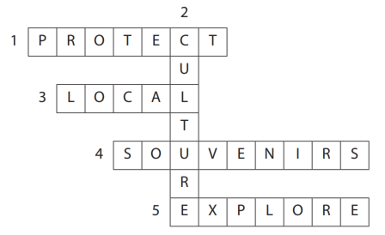 | T-S  Pair work  T-S  T-S | 20 mins
WHILE-READING | To help students practise reading for specific information. | Task 3: Which tour does each statement below talk about? Write a, b, c or d. (p. 113)  * Teacher reminds students of the scanning skill:  - Ask Ss to read the four statements and underline the key words in each of them.  - Check the key words students have underlined  - Remind Ss that the statements may include paraphrased information. Tell them to read through the brochures again looking for the key words they underlined in the statements or words with the same or similar meaning  ** Teacher asks students to match each statement with the correct brochure.  *** Teacher asks students to peer check and give comments to their partners.  **** Teacher checks answers as a class:  Answers:  1. d (Clue: Buy local souvenirs to help the local Whale Protection Program)  2. c (Clue: Learn how you can help save wild animals in the local research centre)  3. b (Clue: Children not allowed)  4. a (Clue: Watch 3D documentaries to learn about sea animals and the coral reef, and what you can do to protect it) | T-S  T-S  Pair work  T-S | 20 mins
POST-READING | To help students use the language and ideas from the unit to make suggestions for more eco-friendly tours. | TASK 4: WORK IN GROUPS. THINK OF NEW IDEAS FOR MAKING ONE OF THE TOURS BETTER FOR THE ENVIRONMENT. (P. 114)  * Teacher asks students if they think the four tours in Task 2 are friendly to the environment and has students read the brochures again and underline things that make them eco-friendly.  ** Teacher puts students into groups. Each group should choose a tour and brainstorm ideas for making it more eco-friendly. Students read the example, then elicit which brochure it refers to (c) and how it will help the environment  *** Teacher asks students some groups to present a summary of their ideas or just the most useful ones in front of the class.  **** Teacher encourages the rest of the class to give comments and praises for good effort and interesting ideas.  Suggested answers:  A. If they ban swimming with fish, the Great Barrier Reef will be better protected. Tourists should not be allowed to dive very close to the coral reefs.  B. Tourists should always follow the walking paths and trails on the Sa Pa Trekking Tour. The local people with whom the tourists stay should only use local ingredients. If they only use local ingredients, their carbon footprint will be lower.  D. The boats on the Whale-watching Tour should not get too close to the whales or make too much noise. If the boats are environmentally friendly, they will not harm the whales or their habitats. This is because environmentally-friendly boats use less fuel and oil, make small waves and are quiet. | T-Ss  Group work  S  S-S | 10 mins
WRAP UP  HOMEWORK | To help Ss memorise the target language and skills that they have learned | WRAP-UP  - Some lexical items about ecotourism.  - Reading for general and specific information in a brochure about ecotours..  HOMEWORK  - Prepare for the next lesson: Unit 10: Speaking  - Exercises in the workbook | T-S | 3 mins

UNIT 10: ECOTOURISM
LESSON 4: SPEAKING – HOW TO BECOME AN ECOTOURIST
I. OBJECTIVES
By the end of this lesson, Ss will be able to gain:
1. Knowledge
- Talk about how to become an ecotourist.
2. Core competence
- Develop communication skills and creativity;
- Be collaborative and supportive in pair work and team work;
- Develop presentation skills;
- Actively join in class activities.
3. Personal qualities
- Develop a sense of being an ecotourist;
- Be aware of tourism and their impact on the environment.
II. MATERIALS
- Grade 10 textbook, Unit 10, Speaking
- Computer connected to the Internet
- Projector/ TV/ pictures and cards
- sachmem.vn

Language analysis
Functions | Useful expressions | Examples
Giving suggestions | … should (not) / ought (not) to / do sth. | We should not litter on the beach or the street.
Giving suggestions | One of the things … can / should (not) do / is (to) do sth. | One of the things we should not do is to litter on the beach or the street.
Giving suggestions | I suggest that … (should / should not) do sth. | I suggest that we should not litter on the beach or the street.
Giving suggestions | It will (be better / good …) if …/ do / avoid doing sth. | It will be better for the environment if we avoid littering on the beach or the street.

Assumptions
Anticipated difficulties | Solutions
Students may lack knowledge about some useful structures. | Provide students with the form and use of some useful structures in their talk.
Students may have underdeveloped speaking and co-operating skills. | - Create a comfortable and encouraging environment for students to speak.  - Encourage students to work in pairs, in groups so that they can help each other.  - Provide feedback and help if necessary.
Some students will excessively talk in the class. | - Explain expectations for each task in detail.  - Have excessive talking students practise.  - Continue to clarify task expectations in small chunks (before every activity).

Board Plan
Date of teaching
UNIT 10: ECOTOURISM
Lesson 4: Speaking _ How to become an ecotourist

* Warm-up: Matching game
Task 1: Match each verb on the left with a phrase on the right. (p. 114)
* Speaking: Benefits of volunteering activities
Task 2: Discuss which of the things in Task 1 we should or should not do to become ecotourists. (p. 115)
Task 3: Talk about what tourists should or should not do if they are on an ecotour to a tourist attraction in your local area. (p. 115)
Task 4: Share your ideas with the whole class. Vote for the best ideas. (p. 115)
* Homework

III. PROCEDURES
Notes:
In each activity, each step will be represented as following
* Deliver the task
** Implement the task
*** Discuss
**** Give comments or feedback

Stage | Stage aim | Procedure | Interaction | Time
WARM-UP | - To introduce the topic of reading.  - To enhance students’ skills of cooperating with teammates. | MATCHING GAME  Task 1: Match each verb on the left with a phrase on the right. use the pictures to help you. (p. 114)  * Teacher puts students work in groups of four. Each group will have to match a verb with the appropriate phrase. The fastest groups with the correct answers will be the winner.  ** Students work in groups.  *** Students give comments to other groups.  **** Teacher confirms the answers.  Key:  1. c (on the beach or the street)  2. d (crowded places)  3. a (walking paths and trails)  4. b (wild animals)  5. f (water and electricity)  6. e (locally made souvenirs) | Group work  T-Ss | 5 mins
  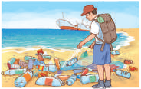 | 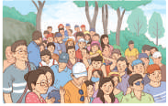 | 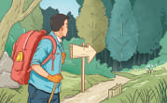
  1. litter | 2. avoid | 3. follow
  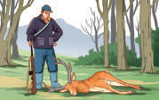 | 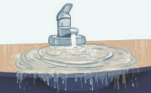 | 
  4. hunt | 5. waste | 6. buy
PRE-SPEAKING | To help students brainstorm more ideas for the main speaking task. | TASK 2: WORK IN PAIRS. DISCUSS WHICH OF THE THINGS IN TASK 1 WE SHOULD OR SHOULD NOT DO TO BECOME ECOTOURISTS. USE THE EXPRESSIONS BELOW TO HELP YOU. (P. 115)  * Teacher asks students to read the useful expressions and the examples in the box.  ** Teacher asks students to work in pairs and discuss which of the activities in Task 1 they should do, and which they should not do to become ecotourists.  *** Teacher walks round the class and provide help and encourages pairs to try to use the structures in the box.  **** Teacher asks some pairs to present their ideas in front of the whole class and praises for interesting suggestions and fluent delivery. | T-S  Pair work  T-S  S-S | 10 mins
WHILE-SPEAKING | To give students an opportunity to discuss in groups and give suggestions to ecotourists. | TASK 3: WORK IN GROUPS. TALK ABOUT WHAT TOURISTS SHOULD OR SHOULD NOT DO IF THEY ARE ON AN ECOTOUR TO A TOURIST ATTRACTION IN YOUR LOCAL AREA. USE THE DISCUSSION QUESTIONS BELOW TO HELP YOU. (P. 115)  * Teacher asks students to study the discussion questions first and checks understanding by eliciting some responses from the whole class.  ** Teacher puts students into groups and ask each group to choose a tourist attraction in their local area.  - Tell them to talk about what tourists should or should not do if they are on an ecotour to that tourist attraction.  - Remind them that they are going to share their ideas with the whole class later.  - Give sheets of paper form them to take notes of their ideas.  *** Teacher walks round the class and provide help when necessary. | T-S  Group work  T-S | 10 mins
POST-SPEAKING | To help students present their ideas in front of the class. | TASK 4: SHARE YOUR IDEAS WITH THE WHOLE CLASS. VOTE FOR THE BEST IDEAS. (P. 115)  * Teacher has each group prepare a brief presentation of their ideas.  ** Teacher allows a time limit of 3 - 4 minutes for students to practise their presentations in their group.  *** Teacher invites some groups to present in front of the class while the rest of the class give feedback and say what they like about it. When students finish their presentations, let them reflect on their performance  **** Teacher then asks other students to give further comments. Teacher then praises for good effort, highlight the presenters’ strong points and makes suggestions for better organisation and presentation of their ideas. | T-S  Group work  S-S | 17 mins
WRAP UP  HOMEWORK | To help students memorise the target language and skills that they have learned | WRAP-UP  Talk about how to become an ecotourist  HOMEWORK  - Prepare for the next lesson: Unit 10: Listening  - Exercises in the workbook | T-S | 3 mins

UNIT 10: ECOTOURISM
LESSON 5: AN ECOTOUR IN THE MEKONG DELTA
I. Objectives
By the end of this lesson, Ss will be able to gain:
1. Knowledge
- Use the lexical items related to the topic ecotourism;
- Listen for specific information in a tour guide speech welcoming ecotourists in the Mekong Delta.
2. Core competence
- Develop communication skills and creativity;
- Be collaborative and supportive in pair work and team work;
- Actively join in class activities.
3. Personal qualities
- Develop a sense of an ecotourist;
- Be aware of tourism and their impact on the environment.
II. Materials
- Grade 10 textbook, Unit 10, Listening
- Computer connected to the Internet
- Projector/ TV/ pictures and cards
- sachmem.vn

Assumptions
Anticipated difficulties | Solutions
Students may have underdeveloped listening skills. | - Play the recording many times if necessary.  - Encourage students to work in pairs, in groups so that they can help each other.  - Provide feedback and help if necessary.
Some students will excessively talk in the class. | - Explain expectations for each task in detail. Have excessive talking students practice.  - Continue to explain task expectations in small chunks (before every activity).

Board Plan
Date of teaching
UNIT 10: ECOTOURISM
Lesson 5: An ecotour in the Mekong Delta
* Warm-up
Answer the questions.
* Listening
Task 1: Work in pairs. Look at the photos from an ecotour in the Mekong Delta. What do you think ecotourists can do there? (p. 115)
Task 2: Listen to a tour guide introducing the tour. Number the pictures in Task 1 in the order you hear them. (p. 115)
Task 3: Listen again. Fill in each gap in the brochure below with one word. (p. 115)
Task 4: Work in groups and discuss the question. (p. 115)
* Homework

III. PROCEDURES
Notes:
In each activity, each step will be represented as following
* Deliver the task
** Implement the task
*** Discuss
**** Give comments or feedback

Stage | Stage aim | Procedure | Interaction | Time
WARM-UP | - To introduce the topic of reading.  - To set the context of the listening text and activate students’ prior knowledge. | ANSWER THE QUESTIONS  *Teacher asks Ss some questions about river deltas.  - How many river deltas are there in Viet Nam?  - Do you know the names of the 2 river deltas in Viet Nam?  - Do you know another name for Cuu Long River Delta?  **Students spend some time thinking about the answers for the questions.  ***Some students share the answers with the whole class.  ****Teacher confirms the answers and leads in the new lesson.  Suggested answers:  1. There are 2.  2. Red River Delta and Cuu Long River Delta.  3. Mekong Delta | T-S  S  S-S  T-S | 5 mins
PRE-LISTENING | To introduce more topic-related vocabulary and activate students’ prior knowledge. | TASK 1: WORK IN PAIRS. LOOK AT THE PHOTOS FROM AN ECOTOUR IN THE MEKONG DELTA. WHAT DO YOU THINK ECOTOURISTS CAN DO THERE? (P. 115)  * Teacher sets the context:  - Ask students to imagine they are ‘travelling’ to Mekong Delta today.  - Describe or show it on the map. (It is in the far south of Viet Nam, covering 13 cities and provinces such as Can Tho, Long An, Tien Giang, Ben Tre, Vinh Long, Tra Vinh, Hau Giang, Soc Trang, Dong Thap, An Giang, Kien Giang, Bac Lieu and Ca Mau.)  - Introduce or pre-teach some words or phrases to help students describe the pictures, e.g. floating market, host family, weaving (village).  ** Teacher puts students in pairs and ask them to study the pictures and describe what they see in each one. Teacher encourages students to think what ecotourists can do there based on the pictures.  *** Teacher asks some students to share their ideas with the whole class.  **** Teacher and students discuss the ideas.  Suggested answers:  - Visit a floating market, and buying fruits there  - Visit a weaving village, buying traditional arts and crafts  - Have a traditional meal / food (with a host family or at a local restaurant) | T-S  Pair work  S-S  T-S | 7 mins
  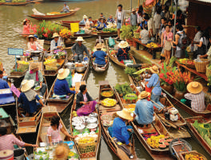 |  | 
WHILE-LISTENING | To help students practise listening for specific information to order pictures. | TASK 2: LISTEN TO A TOUR GUIDE INTRODUCING THE TOUR. NUMBER THE PICTURES IN TASK 1 IN THE ORDER YOU HEAR THEM. (P. 115)  * Teacher tells students to listen to a tour guide introducing an eco-friendly tour in the Mekong Delta.  ** Teacher asks students to order the pictures while they are listening to the recording.  *** Teacher has students to swap their textbook for peer checking.  **** Teacher checks the answers as a class.  Key:  1. a  2. b  3. c | T-S  S  Pair work  T-S | 10 mins
WHILE-LISTENING | To help students practise listening for specific information. | TASK 3: LISTEN AGAIN. FILL IN EACH GAP IN THE BROCHURE BELOW WITH ONE WORD. (P. 115)  * Teacher tells students that they are going to listen to the recording again.  ** Students have some time to study the brochure first then fill in the gaps in a brochure.  *** Teacher asks students to discuss their answers in pairs when they finish.  **** Teacher checks the answers as a class, plays the recording again, pausing after each answer.  Key:  1. eco-friendly  2. local  3. souvenirs  4. traditional | T-Ss  Ss  Pair work  T-Ss | 10 mins
POST-LISTENING | To give students the opportunity to use the ideas and language in the listening to talk about their opinions and give reasons. | TASK 4: WORK IN GROUPS AND DISCUSS THE QUESTION. (P. 115)  * Teacher has students look at the brochure in 3 again and underline the activity they find most interesting.  ** Teacher puts students in pairs to discuss their choices  *** Teacher invites some groups to share their ideas in front of the class.  **** Other groups discuss the questions, take notes of the ideas and give feedback to their friends. | T-S  Group work | 10 mins
WRAP UP  HOMEWORK | To help Ss memorise the target language and skills that they have learned | WRAP-UP  - Some lexical items related to the topic Ecotourism  - Listen for specific information in a tour guide speech welcoming ecotourists in the Mekong Delta  HOMEWORK  - Prepare for the next lesson: Unit 10: Writing  - Exercises in the workbook | T-S | 3 mins

UNIT 10: ECOTOURISM
Lesson 6: Writing – Writing a website advertisement for an ecotour
I. OBJECTIVES
By the end of this lesson, Ss will be able to gain:
1. Knowledge
- Use the lexical items related to the topic Ecotourism
- Write a website advertisement for an ecotour
2. Core competence
- Develop communication skills and creativity
- Be collaborative and supportive in pair work and team work
- Actively join in class activities
3. Personal qualities
- Develop a sense of an ecotourist
- Be aware of tourism and their impact on the environment
II. MATERIALS
- Grade 10 textbook, Unit 10, Writing
- Computer connected to the Internet
- Projector/ TV/ pictures and cards
- sachmem.vn

Assumptions
Anticipated difficulties | Solutions
Students may have underdeveloped writing skills. | - Encourage students to work in pairs and in groups so that they can help each other.  - Provide feedback and help if necessary.

Board Plan
Date of teaching
UNIT 10: ECOTOURISM
Lesson 6: Writing – Writing a website advertisement for an ecotour
* Warm-up
Watch a video and guess the place: Hoi An Ancient Town
* Writing
Task 1: Look at the photos of an ecotour to Hoi an villages (Da Nang, Viet Nam), and complete the notes below. Then discuss your ideas in pairs. (p. 116)
Task 2: Rewrite these sentences about Hoi an villages. Use the expressions below to help you. (p. 116)
Task 3: Write a website advertisement (120 – 150 words) for an ecotour to Hoi An villages. Use what you have learnt in Task 1 and Task 2 and the suggested outline below to help you. (p. 116)
* Homework

III. PROCEDURES
Notes:
In each activity, each step will be represented as following
* Deliver the task
** Implement the task
*** Discuss
**** Give comments or feedback

Stage | Stage aim | Procedure | Interaction | Time
WARM-UP | - To introduce the topic of writing.  - To set the context for the writing part. | Watch a video and guess the place  * Teacher plays a video and ask students to guess the place in the video.  ** Students raise hands to provide the name of the place.  *** Students discuss their friends’ answers.  **** Teacher confirms the answer as a class.  Video link: https://www.youtube.com/watch?v=ZSyoQflfkyU  Answers: Hoi An Ancient Town | T-S  S  S-S  T-S | 5 mins
PRE-WRITING | To brainstorm ideas for their writing task | Task 1: Look at the photos of an ecotour to Hoi an villages (Da Nang, Viet Nam), and complete the notes below. Then discuss your ideas in pairs. (p. 116)  * Teacher tells students that they are going to write about an ecotour in Hoi An.  ** Teacher puts students in pairs to work on the notes together:  - Ask Ss to focus attention on the pictures on page 54 and study them.  - Ask each question and have students read the examples.  *** Students discuss their answers.  **** Teacher checks the answers as a class.  Suggested answers:  What do you think is special about Hoi An villages?  - coconut palms near Thu Bon River  - traditional crafts such as colourful paper lanterns  What do you think tourists can do there?  - do the gardening at a local farm  - ride bicycles through the villages  - travel on basket boats  - visit craft villages  What can tourists do to make their trip more eco-friendly?  - use eco-friendly transport such as bicycles  - buy traditional crafts to help local people | T-S  Pair work  S-S  T-S | 7 mins
   | 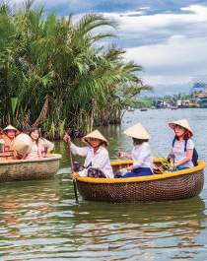
  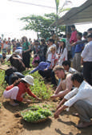 | 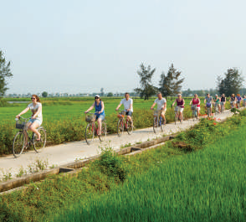
PRE-WRITING | To help students revise expressions and structures to use in their writing task. | TASK 2: REWRITE THESE SENTENCES ABOUT HOI AN VILLAGES. USE THE EXPRESSIONS BELOW TO HELP YOU. (P. 116)  * Teacher asks students to study the useful expressions in the box, then focuses attention on the sentences and checks comprehension.  ** Teacher asks students to rewrite them, using the suggested words and the structures in the box.  *** Teacher asks students to swap their textbook for peer checking  **** Teacher checks answers as a class.  Suggested answers:  1. Hoi An villages are well-known for their beautiful vegetable and herb gardens.  2. Tourists can spend the morning working on a local farm.  3. Tourists are recommended to buy handmade products to help local businesses | T-Ss  Ss  Pair work  T-Ss | 8 mins
WHILE-WRITING | To help students practise writing a website advertisement for an ecotour to Hoi An villages. | TASK 3: WRITE A WEBSITE ADVERTISEMENT (120 – 150 WORDS) FOR AN ECOTOUR TO HOI AN VILLAGES. USE WHAT YOU HAVE LEARNT IN TASK 1 AND TASK 2 AND THE SUGGESTED OUTLINE BELOW TO HELP YOU. (P. 116)  * Teacher asks students to study the suggested outline in their Student’s Book.  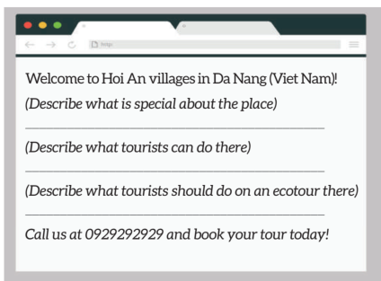  ** Teacher gives students a time limit to do the writing task.  *** Teacher walks round the class to provide help when necessary. | T-S  S  T-S | 15 mins
POST-WRITING | To do a cross-check and final check on students’ writing. | PEER CHECK  * Teacher has the groups swap and give feedback on each other’s writing.  ** Students work in pairs and swap their draft letters for peer review.  *** Teacher then gives feedback on one writing as a model.  ****Teacher collects Ss’ writings to mark and provide written feedback in the next lesson. | T-S  Pair work  T-S  T-S | 7 mins
WRAP UP  HOMEWORK | To help Ss memorise the target language and skills that they have learned | WRAP-UP  - Some lexical items related to the topic Ecotourism  - Write a website advertisement for an ecotour  HOMEWORK  - Rewrite the paragraph in the notebooks.  - Prepare for the next lesson: Unit 10: Communication and culture/ CLIL  - Exercises in the workbook | T-S | 3 mins

UNIT 10: ECOTOURISM
Lesson 7: Communication and Culture/ CLIL
I. OBJECTIVES
By the end of this lesson, Ss will be able to gain:
1. Knowledge
- Use the lexical items related to the topic Ecotourism;
- Ask for and give advice
- Know more information about tourism impact on the environment.
2. Core competence
- Be collaborative and supportive in pair work and teamwork
- Access and consolidate information from a variety of sources
- Actively join in class activities
3. Personal qualities
- Develop a sense of an ecotourist
- Be aware of tourism and their impact on the environment
II. MATERIALS
- Grade 10 textbook, Unit 10, Communication and culture/ CLIL
- Computer connected to the Internet
- Projector/ TV/ pictures and cards
- sachmem.vn

Language analysis
Useful expressions
Asking for advice | Giving advice
- Can you help me with (sth)?  - I have a problem and I need your help / advice.  - Should I (do sth)?  - What do you think I should (do / bring…)? | - You should / ought to / had better (do sth).  - It’s / It'll be a good idea (to do sth).  - If I were you, I would (do sth).  - What about / How about (doing sth)?  - Why don’t you (do sth)?  - I’d recommend (doing sth).

Assumptions
Anticipated difficulties | Solutions
Students may have underdeveloped speaking and co-operating skills. | - Encourage students to work in pairs and in groups so that they can help each other.  - Provide feedback and help if necessary.
Some students will excessively talk in the class. | - Explain expectations for each task in detail.  - Have excessive talking students practise.  - Continue to explain task expectations in small chunks (before every activity).

Board Plan
Date of teaching
UNIT 10: ECOTOURISM
Lesson 7: Communication and Culture/ CLIL
* Warm-up
Brainstorming
I. Everyday English
Task 1: Listen to a conversation between a woman and a tour guide. Fill in each gap with one word you hear. Then practise it with your partner. (p. 117)
Task 2: Work in pairs. Make similar conversations asking for and giving advice about trips. Use the expressions below to help you. (p. 117)
II. Culture
Task 1: Read the text below and fill in each gap in the table below with one of the highlighted words from the text. (p. 117)
Task 2: Which kind of tourism does each description below fit best? Tick the appropriate column. (p. 118)
* Homework

III. PROCEDURES
Notes:
In each activity, each step will be represented as following
* Deliver the task
** Implement the task
*** Discuss
**** Give comments or feedback

Stage | Stage aim | Procedure | Interaction | Time
Warm-up | To introduce the topic. | Brainstorming:  * Teacher asks students to answer the question:  “What kind of advice do you need before a tour/trip?”  ** Students raise hands to do brainstorming.  *** Teacher and students discuss the answers.  **** Teacher provides the suggested answers and introduce the topic of the listening task.  Suggested answers:  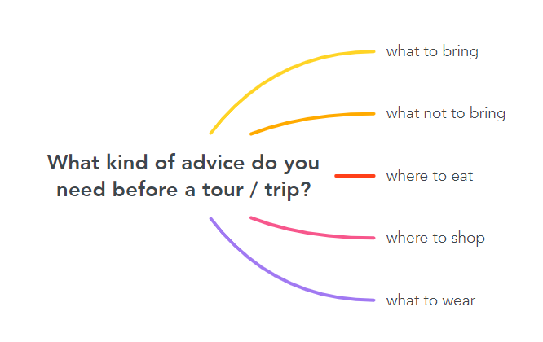 | T-S  S  T-S  T-S | 5 mins
EVERYDAY ENGLISH | To introduce and help students remember different structures to ask for and give advice. | Asking for and giving advice  Task 1: Listen to a conversation between a woman and a tour guide. Fill in each gap with one word you hear. Then practise it with your partner. (p. 117)  * Teacher tells students that they are going to listen to a conversation between a woman and a tour guide:  - While listening, they should complete the conversation with the words they hear.  - Give them some time to skim through the conversation. Check understanding of the words such as surfing, surfboard and wetsuit.  - Encourage them to guess the answers before listening.  ** Students listen to the conversation and complete the listening task.  *** Teacher asks students to swap their textbooks for peer checking.  **** Teacher checks the answers as a class:  - Play the recording again, pausing after each word to confirm the correct answers.  - Put students into pairs and have them practise the conversation  Answers:  1. should  2. were  3. Should  4. recommend | T-S  S  Pair work  T-S | 7 mins
 | To help students practise asking for and giving advice about a trip. | TASK 2: WORK IN PAIRS. MAKE SIMILAR CONVERSATIONS ASKING FOR AND GIVING ADVICE ABOUT TRIPS. USE THE EXPRESSIONS BELOW TO HELP YOU. (P. 117)  * Teacher gives the instruction of the task:  - Tell Ss that the words they used to fill in the gaps in 1 are part of expressions for asking for and giving advice.  - Ask Ss to read the list of expressions and check understanding.  ** Students work in pair to complete the task:  - Students role-play conversations similar to the one in Task 1.  - Ss should pretend that one of them is a tourist and the other is the tour guide.  - Students have a few minutes to plan their conversations before they role-play them.  - Students should decide on the type of tour, the place, the activities and what advice to ask for and give.  - Students then swap roles.  *** Teacher walks round the class and provides help when necessary.  **** Teacher asks some pairs to role-play their conversations in front of the whole class, praises for good effort, clear pronunciation and fluent delivery. | T-S  Pair work  T-S  S-S | 10 mins
CULTURE | To help students learn about types of tourism through CLIL (Environmental studies) and learn some content vocabulary. | TASK 1: READ THE TEXT BELOW AND FILL IN EACH GAP IN THE TABLE BELOW WITH ONE OF THE HIGHLIGHTED WORDS FROM THE TEXT. (P. 117)  * Teacher sets the context:  - Ask Ss some questions to find out what they already know about the topic:  - What kinds of impact does tourism have on the environment?  - Name different kinds of tourism which are good / bad for the environment that you know?  - Ask Ss what they want to know about the topic. Write their questions on the board:  - How much damage will tourism do to the environment in the future? (CO2-emissions from tourism will increase by 25% in the next 15 years);  - What are the main ways for tourism to damage the environment?  (direct and indirect: When tourists are littering on the street, they are damaging the environment directly. When tourists are travelling by plane and vehicles which emit CO2, they are damaging the environment indirectly).  - Ask Ss to look at the two pictures and think of to opposite adjectives to describe each, e.g. crowded vs. private, noisy vs. quiet, polluted vs. eco-friendly.  ** Teacher tells students that they are going to read about four popular types of tourism and put them into categories in the table according to their negative or positive impact on the environment.  *** Teacher and students elicit any new or difficult words, e.g. Why is tourism is called ‘the smokeless industry’? (Because it is an industry without chimneys and is considered environmentally friendly).  **** Teacher confirms the answers as a class.  Key:  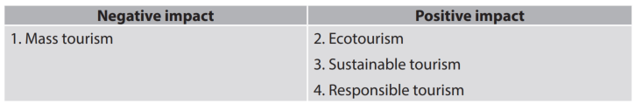 | T-S  S  S-S  T-S | 10 mins
CULTURE | To help students understand differences between four main types of tourism. | TASK 2: WHICH KIND OF TOURISM DOES EACH DESCRIPTION BELOW FIT BEST? TICK THE APPROPRIATE COLUMN. (P. 118)  * Teacher tells students to read the text again to decide which statement fits which type of tourism.  ** Students do the task in groups.  *** Teacher lets students discuss their answers.  **** Teacher checks answers as a class:  - Have Ss call out their answers first.  - Then provide, or ask some Ss to provide the clue for the answers in the text  Key:  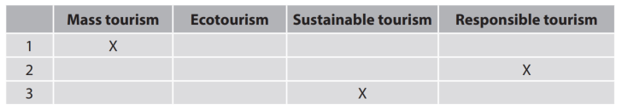 | T-S  Group work  S-S  T-S | 10 mins
WRAP UP  HOMEWORK | To help Ss memorise what they have learned | WRAP-UP  - Use the lexical items related to the topic Ecotourism;  - Ask for and give advice  - Know more information about tourism impact on the environment.  HOMEWORK  - Prepare for the next lesson: Unit 10 – Looking back and project  - Exercises in the workbook | T-S | 3 min

UNIT 10: ECOTOURISM
Lesson 8: Looking back and project
I. OBJECTIVES
By the end of this lesson, Ss will be able to gain:
1. Knowledge
- Review the vocabulary and grammar of Unit 10
- Apply what they have learnt (vocabulary and grammar) into practice through a project
2. Core competence
- Develop communication skills and creativity
- Develop presentation skill
- Develop critical thinking skill
- Be collaborative and supportive in pair work and team work
- Actively join in class activities
3. Personal qualities
- Be more creative when doing the project
- Develop self-study skills
II. MATERIALS
- Grade 10 textbook, Unit 10, Looking back and project
- Computer connected to the Internet
- Projector/ TV/ pictures and cards
- sachmem.vn

Assumptions
Anticipated difficulties | Solutions
Students may have underdeveloped speaking and co-operating skills. | - Encourage students to work in pairs and in groups so that they can help each other.  - Provide feedback and help if necessary.
Some students will excessively talk in the class. | - Explain expectations for each task in detail.  - Have excessive talking students practise.  - Continue to explain task expectations in small chunks (before every activity).

Board Plan
Date of teaching
UNIT 10: ECOTOURISM
Lesson 8: Looking back and project
* Warm-up
Watch the video and guess the name of the place.
I. Looking back
Vocabulary
Choose the correct words to complete the conversation. (p. 118)
Pronunciation
Work in pairs. Role-play the conversation above. Try to use appropriate intonation. (p. 118)
Grammar
Put the verbs in brackets in the correct forms. (p. 118)
II. Project
Design an ecotour
* Homework

III. PROCEDURES
Notes:
In each activity, each step will be represented as following
* Deliver the task
** Implement the task
*** Discuss
**** Give comments or feedback

Stage | Stage aim | Procedure | Interaction | Time
WARM-UP | - To introduce an ecotourism complex and lead in the next part of the lesson. | Watch the video and guess the name of the place.  * Teacher plays the video and asks students to guess the name of the place.  ** Students watch the video and try to find out the name of the place based on the sights in the video as soon as possible.  *** Teacher and students discuss the answers.  **** Teacher confirms the answers as a class.  Link video: https://www.youtube.com/watch?v=iCspAti-0T8&t=18s  Key:  Trang An Ecotourism Complex  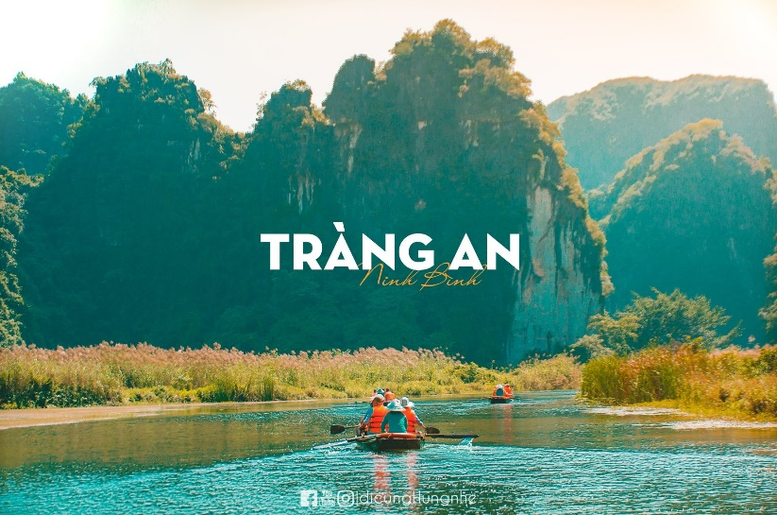 | T-Ss  Ss  T-Ss  T-Ss | 5 mins
VOCABULARY | To revise words students have learnt in this unit | CHOOSE THE CORRECT WORDS TO COMPLETE THE CONVERSATION. (P.118)  * Teacher asks students to read each sentence and check comprehension and asks students study the context carefully and decide on the correct words to complete the conversation.  ** Students complete the task individually.  *** Teacher asks students to exchange their textbooks for peer checking..  **** Teacher checks answers as a class by asking individual student to read the sentences.  Key:  1. sustainable  2. protect  3. profits  4. litter  5. aware  6. ecotourism  7. impact | T-S  S  Pair work  T-S | 5 mins
PRONUNCIATION | To practise different intonation patterns | WORK IN PAIRS. ROLE-PLAY THE CONVERSATION ABOVE. TRY TO USE APPROPRIATE INTONATION. (P. 118)  * Teacher asks students to work in pairs to role-play the conversation in Vocabulary.  ** Students role-play the conversation, using the appropriate intonation.  *** Teacher asks some pairs to role-play or read out loud the conversation in front of the class.  **** Teacher praises for good effort and natural delivery. | T-S  Pair work  T-S | 5 mins
GRAMMAR | To revise conditional sentences Type 1 and Type 2. | PUT THE VERBS IN BRACKETS IN THE CORRECT FORMS. (P. 118)  * Teacher explains to students that they are going to review the use of conditional sentences Type 1 and Type 2, gives students some time to review the grammar rules in the Language lesson before doing the activity.  ** Students complete the task individually.  *** Teacher asks students to swap their textbooks for peer checking.  **** Teacher corrects the answers as a class by asking individual student to read the sentences and explain why they used conditional sentences Type 1 or Type 2.  Key:  1. were / was; would live  2. work; will be  3. allow; will have  4. had; would go | T-Ss  Ss  Pair work  T-Ss | 7 mins
PROJECT | To provide an opportunity for students to develop their research and collaboration skills, and to practise giving an oral presentation. | DESIGN AN ECOTOUR  * As students have prepared for the project throughout the unit, the focus of this lesson should be on the final product, which is an oral presentation.  ** Teacher has students work in their groups.  - Give them a few minutes to get ready for the presentation.  - Give Ss a checklist for peer and self-assessment. Explain that they will have to tick appropriate items while listening to their classmates’ presentations and write comments if they have any.  - The presenters should complete their self-assessment checklist after completing their presentation.  - If necessary, go through the assessment criteria to make sure Ss are familiar with them.  *** Teacher invites two or three groups to give their presentations, encourages the rest of the class to ask questions at the end.  **** Teacher gives praise and feedback after each presentation. | T-S  Group work  S-S  T-S | 20 mins
WRAP UP  HOMEWORK | To help students memorise what they have learned | WRAP-UP  - Review the vocabulary and grammar of Unit 10  - Apply what they have learnt (vocabulary and grammar) into practice through a project  HOMEWORK  - Exercises in the workbook | T-S | 3 mins

