ĐỀ 5 | ĐỀ ÔN THI HỌC SINH GIỎI  TIẾNG ANH 9
SECTION I: LISTENING (3.0 points) (You will hear twice for each part)
SECTION I. LISTENING. A - LISTENING COMPREHENSION (2pts)
PART 1. (0,5pt) You will hear five short conversations.
You will hear each conversation twice.
There is one question for each conversation.
For questions 1-5, put a tick under the right answer.
1. What is John going to do tonight?
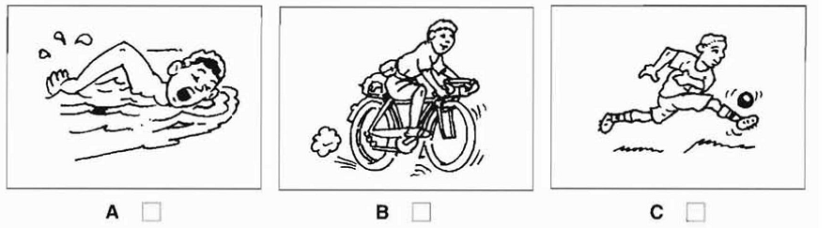
2. Which is Ben’s family?
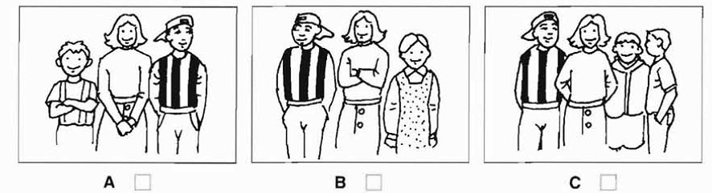
3. Which bag does the woman buy?
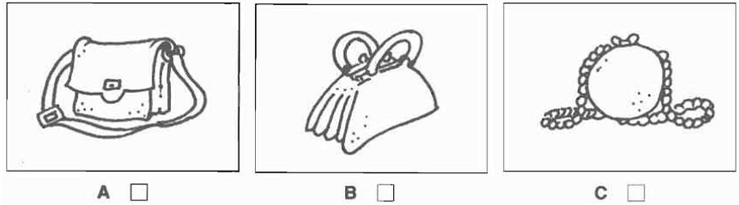
4. How much did the woman pay foe the apples?
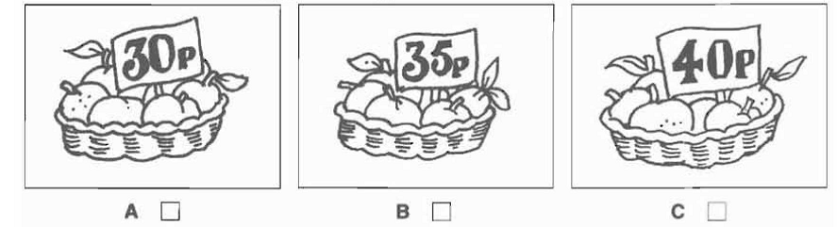
5. What time does the film start?
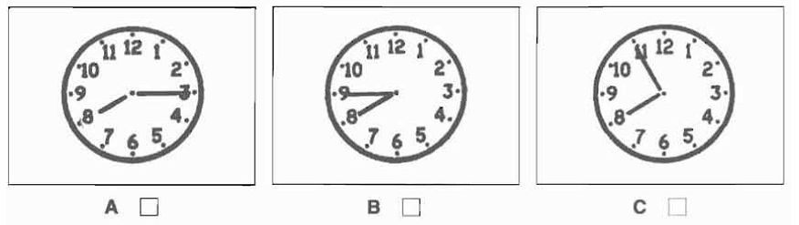

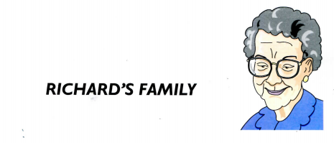
PART 2(0. 5pt). Listen and write.

Oldest person: grandmother
1. Name: …………………………
2. Age: …………………………
3. Lives with: …………………………
4. Job: …………………………
5. Favourite hobby: …………………………

PART 3(1,0pt):Listen to Amanda talking to a friend about a birthday party. Tick A,B or C.
You will hear the conversation twice.
1. Which ice cream will they have at the party?
A. coffee B. Lemon C. apple
2. Which is broken?
A. the CD player B. the cassette recorder C. the guitar
3. Whose birthday is it?
A. Emma’s B. Joan’s C. Amanda’s sister’s
4. What present has Amanda bought?
A. a camera B. a video C. a football
5. What time should people arrive at the party?
A. 8 p. m B. 8. 30 p. m C. 9. 30 p. m
SECTION II: LEXICO – GRAMMAR (7.0 points)
Part 1: Questions from 16 to 36. (3.0 points - 0.15/ each)
Choose the best answer to each question.
16. I haven’t ________ decided where to go on holiday this year.
A. still B. yet C. already D. then
17. How do you speak this fraction: 3/5?
A. Three over fifth B. Three-fifth C. Three-fifths D. Three-fives
18. The number of cars on the roads ________ increasing, so we need to build more roads.
A. is B. was C. were D. are
19. There is no ________ explanation for what happened.
A. scientifically B. scientist C. science D. scientific
20. I can ________ what he’s doing; it’s so dark down there.
A. see through B. make out C. look into D. show up
21. Could you be more specific about what is ________ in this particular job?
A. enclosed B. concentrated C. presented D. involved
22. He retired early ________ ill – health.
A. on behalf of B. on account of C. believe D. imagine
23. The person who writes symphonies or concertos is a ________.
A. composer B. conductor C. pianist D. playwright
24. There is no reason to______ his honesty; he is absolutely sincere.
A. search B. doubt C. inquire D. ask
25. His personal problems seem to have been ______him from his work lately.
A. disrupting B. disturbing C. distracting D. dispersing
26. The job of student lodgings officer________ many visits to landladies.
A. concerns B. offers C. asks D. involves
27. It is________ knowledge in the village that Mr. and Mrs. Thorne quarrel violently several times a week.
A. common B. complete C. normal D. usual
28. “Which one do you want?” “I’m not sure I can ________a choice. I like all of them.”
A. do B. choose C. make D. take
29. The volcano had been _________ for hundreds of years before the eruption last month.
A. dying B. fixed C. asleep D. dormant
30. You have to ________the person with the ball until you catch them.
A. chase B. rush C. jump D. drop
31. The fans climbed over the fence to ________paying.
A. avoid B. prevent C. abandon D. refuse
32. I had no ________that the divorce rate was so high in this country.
A. knowledge B. idea C. doubt D. understanding
33. A railway bridge is already ________over the river.
A. been erected C. in construction B. erecting D. being built
34. It was very difficult for the inspector to________ what recommendations he should make.
A. realize B. settle C. solve D. decide
35. This is not the right________ to ask for my help; I am far too busy even to listen!
A. moment B. situation C. opportunity D. circumstance
Part 2: Questions from 36 to 45. (2 points - 0.2/ each)
Use the correct form of the word in brackets to complete the following sentences.
36. There's a post office a bit …………………………. down the road. | FAR
37. Six months after the accident, he still has …………………………. walking. | DIFFICULT
38. I can't play tennis that well because I'm a ………………………….. | BEGIN
39. Don't go there. It's ………………………….. | DANGER
40. Read this. It'll be very …………………………. for your trip to Australia. | USE
41. I didn't find him that …………………………., but my friend did. | ATTRACT
42. The school has a …………………………. for being very up-to-date with technology. | REPUTE
43. These are …………………………. clothes and that's why they are very expensive. | DESIGN
44. I left the party because it was …………………………. noisy in there. | EXTREME
45. I had no …………………………. but to tell him. | CHOOSE
Part 3: Questions from 46 to 50.(1 point - 0.2/ each)
Each of the following sentences has an error. Find the errors and correct them.
46. The novel writing by Charles Dickens attracts a lot of children.
47. Thank you very much for your letter, who came yesterday.
48. He experimented with ways of transmitting speech over a long distant with his assistant.
49. Each of the students in the accounting class has to type their own research.
50. Janet is finally used to cook on an electric stove after having a gas one for so long.
Part 4: Questions from 51 to 55.(1 point - 0.2/ each)
Fill in each of the sentences with correct prepositions.
51. In most countries, children start the primary school ………………. the age of six.
52. Since Jennifer was a year younger than her friends, she had a hard time keeping ………………. with them.
53. There are different sets of language learning sets available ………………. all age groups.
54. I'll try to figure ………………. what's wrong with the computer tomorrow.
55. It took 10 firefighters to put ………………. the fire at the school.
SECTION III: READING (6.0 points)
Part 1. Questions 56 – 65 (2 points - 0.2/ each)
Read the passage below and choose the best answer to each question.
TRAFFIC IN OUR CITIES
The volume of traffic in many cities in the world today continues to expand. This causes many problems, including serious air pollution, lengthy delays, and the greater risk (56) _________ accidents. Clearly, something must be done, but it is difficult to (57) _________ people to change their habits and leave their cars at home.
One possible (58) _________ is to make it more expensive for people to use their cars by (59) _________charges for parking and bringing in tougher fines for anyone who (60) _________ the law. In addition, drivers could be required to pay for using particular routes at different times of the day. This system, (61) _________ as “road pricing”, is already being introduced in a number of cities, using a special electronic card (62) ______ to windscreen of the car.
Another way of dealing with the problem is to provide cheap parking on the (63) _______ of the city, and strictly control the number of vehicles allowed in to the centre. Drivers and their passengers then use a special bus service for the (64) _______ stage of their journey.
Of course, the most important thing is to provide good public transport. However, to get people to give up the comfort of their cars, public transport must be felt to be reliable, convenient and comfortable, with fares (65) __________ at an acceptable level.
56. A. of B. for C. about D. by
57. A. make B. arrange C. suggest D. persuade
58. A. approach B. manner C. custom D. style
59. A. enlarging B. increasing C. growing D. developing
60. A. crosses B. refuses C. breaks D. cracks
61. A. named B. seen C. called D. known
62. A. fixed B. joined C. built D. placed
63. A. outskirts B. border C. outside D. limit
64. A. late B. end C. complete D. final
65. A. taken B. kept C. given D. stood
Part 2. Questions 66 – 75 (2.0 points - 0.2/ each)
Read the passage below and choose the best answer to each question
Although they are an inexpensive supplier of vitamins, minerals, and high-quality protein, eggs also contain a high level of blood cholesterol, one of the major causes of heart diseases. One egg yolk, in fact, contains a little more than two-thirds of the suggested daily cholesterol limit. This knowledge has caused egg sales to plummet in recent years, which in turn has brought about the development of several alternatives to eating regular eggs. One alternative is to eat substitute eggs. These egg substitutes are not really eggs, but they look somewhat like eggs when they are cooked. They have the advantage of having low cholesterol rates, and they can be scrambled or used in baking. One disadvantage, however, is that they are not good for frying, poaching, or boiling. A second alternative to regular eggs is a new type of egg, sometimes called 'designer' eggs. These eggs are produced by hens that are fed low-fat diets consisting of ingredients such as canola oil, flax, and rice bran. In spite of their diets, however, these hens produce eggs that contain the same amount of cholesterol as regular eggs. Yet, the producers of these eggs claim that eating their eggs will not raise the blood cholesterol in humans.
Egg producers claim that their product has been portrayed unfairly. They cite scientific studies to back up their claim. And, in fact, studies on the relationship between eggs and human cholesterol levels have brought mixed results. It may be that it is not the type of egg that is the main determinant of cholesterol but the person who is eating the eggs. Some people may be more sensitive to cholesterol derived from food than other people. In fact, there is evidence that certain dietary fats stimulate the body's production of blood cholesterol. Consequently, while it still makes sense to limit one's intake of eggs, even designer eggs, it seems that doing this without regulating dietary fat will probably not help reduce the blood cholesterol level.
66. What is the main purpose of the passage?
A. To introduce the idea that dietary fat increases the blood cholesterol level.
B. To inform people about the relationship between eggs and cholesterol.
C. To persuade people that eggs are unhealthy and should not be eaten
D. To convince people to eat 'designer' eggs and egg substitutes.
67. According to the passage, which of the following is a cause of heart diseases?
A. minerals B. cholesterol C. canola oil D. vitamins
68. Which of the following could best replace the word 'somewhat'?
A. in fact B. a little C. indefinitely D. a lot
69. What has been the cause for changes in the sale of eggs?
A. increasing price B. decreased production
C. dietary changes in hens D. concerns about cholesterol
70. According to the passage, one yolk contains approximately what fraction of the suggested daily limit for human consumption of cholesterol?
A. 3/4 B. 2/3 C. 1/2 D. 1/3
71. The word 'portrayed' could best be replaced by which of the following?
A. studied B. destroyed C. tested D. described
72. What is the meaning of 'back up'?
A. reverse B. advance C. block D. support
73. What is meant by the phrase 'mixed results'?
A. The results are blended. B. The results are a composite of things.
C. The results are inconclusive. D. The results are mingled together.
74. According to the passage, egg substitutes cannot be used to make any of following types of eggs EXCEPT?
A. boiled B. poached C. scrambled D. fried
75. According to the author, which of the following may reduce blood cholesterol?
A. reducing egg intake but not fat intake B. increasing egg intake and fat intake
C. decreasing egg intake and fat intake D. increasing egg intake but not fat intake
Part 3: Questions 76 – 85 (2.0 points - 0.2/ each)
Read the text and fill in one word which best fits each gap.
All men should (76) ……………….………….. We study to (77) ……………….…………. our knowledge and develop our intelligence. Education (78) ……………….…………. an important role in our life. First of all, we have to learn (79) ……………….…………. to observe accurately, to think truthfully, to speak correctly and to write clearly. Education gives us (80) ……………….…………. of things around us and it preserves the national noble traditions and customs from generation to generation. Education makes a person perfect. An (81) ……………….…………. man is both talented and virtuous. In every country, the government consider education (82) ……………….…………. the most important policy. Some (83) ……………….…………. us sometimes think that we have finished our education when we left school or (84) ……………….…………. from a university. Actually, real education should (85) ……………….…………. finish.
SECTION IV: WRITING (4.0 points)
Part 1: Questions from 86 to 90.(2 point- 0.4/ each)
Finish each of the following sentences in such a way that it means the same as the sentence printed before it.
86. The phone stopped ringing the moment I got down stairs.
No sooner
87. He is determined to carry on working when he is 65.
He has no
88. He was very sorry that he didn’t see Audrey on her trip to London.
He greatly
89. She agreed to go out to dinner with him because she assumed he was not married.
Had she
90. Everyone was surprised that the singer had very little money when he died.
The singer had
Part 2: Questions from 91 to 92.(2 points - 0.4/ each)
Complete the second sentence so that it has a similar meaning to the first sentence, using the word given. Do not change the word given.
91. Clara said that she had not seen the missing letter. having
Clara ……………….………….……………….…………. the missing letter.
92. It's important to consider everyone's opinion before a final decision is made. account
Everyone's opinion must ……………….………….……………….…………. before a final decision is made.
93. My passport needs renewing because I´m going abroad this summer. get
I need ……………….………….……………….…………. because I´m going abroad this summer.
94. My boss doesn't mind what time I start or finish work. difference
It ……………….………….…………………………….…………. what time I start or finish work.
95. Many people believe that Edison has the ability to become world judo champion. capable
Many people believe that Edison ……………….………….……………….……the world championship in judo.

……………………THE END ……………………...
ĐÁP ÁN
SECTION I: LISTENING (3.0 points) (You will hear twice for each part)
Part 1: A. Part 1
1. C 2. A 3. C 4. A 5. A

2. A. Part 2
1. Beulah
2. 91/ninety-one (years old)
3. brother
4. (a) photographer
5. computer game(s)

3. A. Part 3
1. C. apple
2. A. the CD player
3. A. Emma’s
4. B. a video
5. B. 8. 30 p. m

SECTION II: LEXICO – GRAMMAR (7.0 points)
Part 1: Questions from 16 to 36. (3.0 points - 0.15/ each)
Choose the best answer to each question.
16. I haven’t ________ decided where to go on holiday this year.
A. still B. yet C. already D. then
17. How do you speak this fraction: 3/5?
A. Three over fifth B. Three-fifth C. Three-fifths D. Three-fives
18. The number of cars on the roads ________ increasing, so we need to build more roads.
A. is B. was C. were D. are
19. There is no ________ explanation for what happened.
A. scientifically B. scientist C. science D. scientific
20. I can ________ what he’s doing; it’s so dark down there.
A. see through B. make out C. look into D. show up
21. Could you be more specific about what is ________ in this particular job?
A. enclosed B. concentrated C. presented D. involved
22. He retired early ________ ill – health.
A. on behalf of B. on account of C. believe D. imagine
23. The person who writes symphonies or concertos is a ________.
A. composer B. conductor C. pianist D. playwright
24. There is no reason to______ his honesty; he is absolutely sincere.
A. search B. doubt C. inquire D. ask
25. His personal problems seem to have been ______him from his work lately.
A. disrupting B. disturbing C. distracting D. dispersing
26. The job of student lodgings officer________ many visits to landladies.
A. concerns B. offers C. asks D. involves
involve (v.) sth = cần phải kéo theo, đòi hỏi
27. It is________ knowledge in the village that Mr. and Mrs. Thorne quarrel violently several times a week.
A. common B. complete C. normal D. usual
be common/ public knowledge s ai cũng biết
28. “Which one do you want?” “I’m not sure I can ________a choice. I like all of them.”
A. do B. choose C. make D. take
make a choice = chọn lựa
29. The volcano had been _________ for hundreds of years before the eruption last month.
A. dying B. fixed C. asleep D. dormant
dormant (adj.) = nằm im; a dormant volcano = một núi lửa đang nằm im (nghĩa là không tắt hẳn, mà cũng không phun lửa)
30. You have to ________the person with the ball until you catch them.
A. chase B. rush C. jump D. drop
chase (v.) sb = đuổi theo ai; rush (v.) sb into doing sth = làm cho
ai hành động vội vã, hấp tấp; jump (v.) = nhảy; drop (v.) = để rơi
31. The fans climbed over the fence to ________paying.
A. avoid B. prevent C. abandon D. refuse
avoid (v.) doing sth = tránh làm gì; prevent (v.) sb from doing sth
= ngăn cản không cho ai làm gì; abandon (v.) sth = bỏ rơi cái gì;
refuse (v.) sth = khưốc từ, từ chối cái gì
32. I had no ________that the divorce rate was so high in this country.
A. knowledge B. idea C. doubt D. understanding
have no idea = không biết
33. A railway bridge is already ________over the river.
A. been erected C. in construction B. erecting D. being built
build (v.) sth = xây dựng, thiết lập cái gì; be + being + pp = đang
được làm gì (bị động), be under construction = đang được xây dựng
34. It was very difficult for the inspector to________ what recommendations he should make.
A. realize B. settle C. solve D. decide
decide (v.) sth = quyết định cái gì
35. This is not the right________ to ask for my help; I am far too busy even to listen!
A. moment B. situation C. opportunity D. circumstance
moment (n.) = lúc; circumstance (n.) = tình huông, hoàn cảnh;
situation (n.) = 'tình hình, hoàn cảnh; opportunity (n.) = cơ.hội
Part 2: Questions from 36 to 45. (2 points - 0.2/ each)
Use the correct form of the word in brackets to complete the following sentences.
36. There's a post office a bit further/farther down the road. | FAR
37. Six months after the accident, he still has difficulty walking. | DIFFICULT
38. I can't play tennis that well because I'm a beginner. | BEGIN
39. Don't go there. It's dangerous. | DANGER
40. Read this. It'll be very useful for your trip to Australia. | USE
41. I didn't find him that attractive, but my friend did. | ATTRACT
42. The school has a reputation for being very up-to-date with technology. | REPUTE
43. These are designer clothes and that's why they are very expensive. | DESIGN
44. I left the party because it was extremely noisy in there. | EXTREME
45. I had no choice but to tell him. | CHOOSE
Part 3: Questions from 46 to 50.(1 point - 0.2/ each)
Each of the following sentences has an error. Find the errors and correct them.
46. The novel writing by Charles Dickens attracts a lot of children. written
47. Thank you very much for your letter, who came yesterday. which
48. He experimented with ways of transmitting speech over a long distant with his assistant. distance
49. Each of the students in the accounting class has to type their own research. its
50. Janet is finally used to cook on an electric stove after having a gas one for so long. cooking
Part 4: Questions from 51 to 55.(1 point - 0.2/ each)
Fill in each of the sentences with correct prepositions.
51. In most countries, children start the primary school at the age of six.
52. Since Jennifer was a year younger than her friends, she had a hard time keeping up with them.
53. There are different sets of language learning sets available for all age groups.
54. I'll try to figure out what's wrong with the computer tomorrow.
55. It took 10 firefighters to put out the fire at the school.
SECTION III: READING (6.0 points)
Part 1. Questions 56 – 65 (2 points - 0.2/ each)
Read the passage below and choose the best answer to each question.
TRAFFIC IN OUR CITIES
The volume of traffic in many cities in the world today continues to expand. This causes many problems, including serious air pollution, lengthy delays, and the greater risk (56) _________ accidents. Clearly, something must be done, but it is difficult to (57) _________ people to change their habits and leave their cars at home.
One possible (58) _________ is to make it more expensive for people to use their cars by (59) _________charges for parking and bringing in tougher fines for anyone who (60) _________ the law. In addition, drivers could be required to pay for using particular routes at different times of the day. This system, (61) _________ as “road pricing”, is already being introduced in a number of cities, using a special electronic card (62) ______ to windscreen of the car.
Another way of dealing with the problem is to provide cheap parking on the (63) _______ of the city, and strictly control the number of vehicles allowed in to the centre. Drivers and their passengers then use a special bus service for the (64) _______ stage of their journey.
Of course, the most important thing is to provide good public transport. However, to get people to give up the comfort of their cars, public transport must be felt to be reliable, convenient and comfortable, with fares (65) __________ at an acceptable level.
56. A. of B. for C. about D. by
57. A. make B. arrange C. suggest D. persuade
58. A. approach B. manner C. custom D. style
59. A. enlarging B. increasing C. growing D. developing
60. A. crosses B. refuses C. breaks D. cracks
61. A. named B. seen C. called D. known
62. A. fixed B. joined C. built D. placed
63. A. outskirts B. border C. outside D. limit
64. A. late B. end C. complete D. final
65. A. taken B. kept C. given D. stood
Part 2. Questions 66 – 75 (2.0 points - 0.2/ each)
Read the passage below and choose the best answer to each question
Although they are an inexpensive supplier of vitamins, minerals, and high-quality protein, eggs also contain a high level of blood cholesterol, one of the major causes of heart diseases. One egg yolk, in fact, contains a little more than two-thirds of the suggested daily cholesterol limit. This knowledge has caused egg sales to plummet in recent years, which in turn has brought about the development of several alternatives to eating regular eggs. One alternative is to eat substitute eggs. These egg substitutes are not really eggs, but they look somewhat like eggs when they are cooked. They have the advantage of having low cholesterol rates, and they can be scrambled or used in baking. One disadvantage, however, is that they are not good for frying, poaching, or boiling. A second alternative to regular eggs is a new type of egg, sometimes called 'designer' eggs. These eggs are produced by hens that are fed low-fat diets consisting of ingredients such as canola oil, flax, and rice bran. In spite of their diets, however, these hens produce eggs that contain the same amount of cholesterol as regular eggs. Yet, the producers of these eggs claim that eating their eggs will not raise the blood cholesterol in humans.
Egg producers claim that their product has been portrayed unfairly. They cite scientific studies to back up their claim. And, in fact, studies on the relationship between eggs and human cholesterol levels have brought mixed results. It may be that it is not the type of egg that is the main determinant of cholesterol but the person who is eating the eggs. Some people may be more sensitive to cholesterol derived from food than other people. In fact, there is evidence that certain dietary fats stimulate the body's production of blood cholesterol. Consequently, while it still makes sense to limit one's intake of eggs, even designer eggs, it seems that doing this without regulating dietary fat will probably not help reduce the blood cholesterol level.
66. What is the main purpose of the passage?
A. To introduce the idea that dietary fat increases the blood cholesterol level.
B. To inform people about the relationship between eggs and cholesterol.
C. To persuade people that eggs are unhealthy and should not be eaten
D. To convince people to eat 'designer' eggs and egg substitutes.
67. According to the passage, which of the following is a cause of heart diseases?
A. minerals B. cholesterol C. canola oil D. vitamins
68. Which of the following could best replace the word 'somewhat'?
A. in fact B. a little C. indefinitely D. a lot
69. What has been the cause for changes in the sale of eggs?
A. increasing price B. decreased production
C. dietary changes in hens D. concerns about cholesterol
70. According to the passage, one yolk contains approximately what fraction of the suggested daily limit for human consumption of cholesterol?
A. 3/4 B. 2/3 C. 1/2 D. 1/3
71. The word 'portrayed' could best be replaced by which of the following?
A. studied B. destroyed C. tested D. described
72. What is the meaning of 'back up'?
A. reverse B. advance C. block D. support
73. What is meant by the phrase 'mixed results'?
A. The results are blended. B. The results are a composite of things.
C. The results are inconclusive. D. The results are mingled together.
74. According to the passage, egg substitutes cannot be used to make any of following types of eggs EXCEPT?
A. boiled B. poached C. scrambled D. fried
75. According to the author, which of the following may reduce blood cholesterol?
A. reducing egg intake but not fat intake B. increasing egg intake and fat intake
C. decreasing egg intake and fat intake D. increasing egg intake but not fat intake
Part 3: Questions 76 – 85 (2.0 points - 0.2/ each)
Read the text and fill in one word which best fits each gap.
All men should (76) study. We study to (77) improve/ enrich our knowledge and develop our intelligence. Education (78) plays an important role in our life. First of all, we have to learn (79) how to observe accurately, to think truthfully, to speak correctly and to write clearly. Education gives us (80) lots of things around us and it preserves the national noble traditions and customs from generation to generation. Education makes a person perfect. An (81) educated man is both talented and virtuous. In every country, the government consider education (82) as the most important policy. Some (83) of us sometimes think that we have finished our education when we left school or (84) graduate from a university. Actually, real education should (85) never/ not finish.
SECTION IV: WRITING (4.0 points)
Part 1: Questions from 86 to 90.(2 point- 0.4/ each)
Finish each of the following sentences in such a way that it means the same as the sentence printed before it.
86. The phone stopped ringing the moment I got down stairs.
No sooner had I got downstairs than the phone stopped ringing.
87. He is determined to carry on working when he is 65.
He has no intention of giving up working/ retiring when he is 65.
88. He was very sorry that he didn’t see Audrey on her trip to London.
He greatly regretted not seeing Audrey on her trip to London.
89. She agreed to go out to dinner with him because she assumed he was not married.
Had she known that he was married, she would not have agreed to go out to dinner with him.
90. Everyone was surprised that the singer had very little money when he died.
The singer had very little money (left) when he died, which surprised everybody.
Part 2: Questions from 91 to 92.(2 points - 0.4/ each)
Complete the second sentence so that it has a similar meaning to the first sentence, using the word given. Do not change the word given.
91. Clara said that she had not seen the missing letter. having
Clara denied having seen the missing letter.
92. It's important to consider everyone's opinion before a final decision is made. account
Everyone's opinion must be taken into account before a final decision is made.
93. My passport needs renewing because I´m going abroad this summer. get
I need to get my passport renewed because I´m going abroad this summer.
94. My boss doesn't mind what time I start or finish work. difference
It makes no difference to my boss what time I start or finish work.
95. Many people believe that Edison has the ability to become world judo champion. capable
Many people believe that Edison is capable of winning the world championship in judo.

……………………THE END ……………………...

