KIỂM TRA GIỮA KỲ I – NĂM HỌC 2022 – 2023 (ĐỀ 1)
MÔN TIẾNG ANH- LỚP 9

A. LISTENING
I. Listen and answer the question by choosing the correct picture A, B or C (1.0 pt)
1. What does Oliver hope to do?
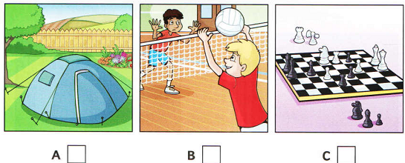

2. What has Oliver not found yet?

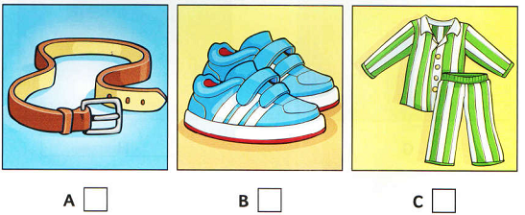
3. Which homework will Oliver take?

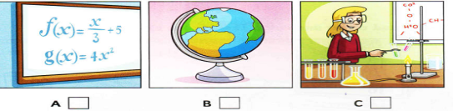
4. What must Oliver remember to take?

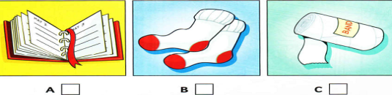

5. Who must Oliver send a message to?


II. Listen twice and fill in each gap ONE correct word/ number to complete the table. (1.0 pt)
My favourite pop star!
Age at first singing lesson: 10
1. Favourite song: ……………………………….
2. Where she enjoys singing most: at……………………………..
3. Manager’s name: Michael ………………….…..
4. Before going on stage, has: some ……………………..…..
5. Favourite things she wears: her…….………………….…

B. VOCABULARY-GRAMMAR- LANGUAGE FUNCTION
Choose the best answer by circling A, B or C . ( 2.0 pts)
1. My grandparents __________this workshop 30 years ago.
A. set up | B. passed down | C. faced up to
2. Bat Trang is famous for its __________products.
A. pottery | B. conical hat | C. silk
3. I was born in Scotland but I ________ in Northern Ireland.
A. grew up B. raised C. brought up
4. Air pollution is the__________problem in Beijing.
A. more serious B. most serious C. most seriously
5. Mr. Long said that he________in Ho Chi Minh City.
A. has lived B. is living C. lived
6. Some people think that schools put too much ____________ on students nowadays.
A. interest B. emotion C. pressure
7. Overcoming negative feelings is a/ an ___________ control skill.
A. cognitive B. emotion C. house- keeping
8. It was very dark,_________ we decided to come home.
A. because | B. if | C. so
9. Peter: I’m tired! I have lots of work to do. I don’t know where to start
– Lan: .............................................................
A. How about going to the cinema?
B. If I were you, I would buy something to eat.
C. I think that you should break a large task into smaller tasks.

10. Man: Congratulations! Boy: _____________
A. I’m sorry. B. Thank you. C. What a pity!

C. READING
I. Which notice (A — H) says this (1 — 5)? Match one Notice to one statements (1,5 pts)
1. If you come early, you can sit here.  2. You cannot go here on Sunday.  3. You will need to have cash here.  4. You won’t need to pay for small kids.  5. You get more for your money. | 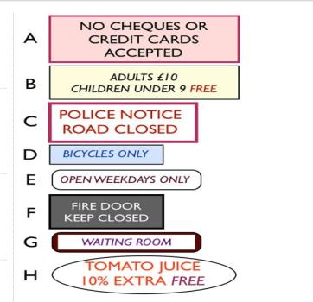

II. Read the following passage and choose the item ( A, B, or C ) that best answers each of the questions about it. ( 1.5 pts)
BAT TRANG VILLAGE
Bat Trang is an interesting attraction in Hanoi that tourists should not ignore. Bat Trang belongs to Gia Lam district of Ha Noi. You can catch the bus 47 (Long Bien- Bat Trang) that stops just a few steps from Dong Xuan market with the end terminal in Bat Trang. You can also ride a motorbike from the center of Hanoi to Bat Trang. Bat Trang ceramics are produced for daily household use (bowls, cups, plates, pots, bottles…), worshipping, or decoration purposes. Visiting Bat Trang, tourists can take a walk or join a buffalo tour for sightseeing and shopping. Besides many ceramic stores along the road in the village, tourists should visit Bat Trang Porcelain and Pottery Market where they can directly make pottery products by themselves. Many youngsters and foreign tourists are interested in in this activity, and spend a whole day in the market to make a gift for family or friends.
1. How can visitors get to Bat Trang?
A. By bus | B. By motorbike | C. By bus or motorbike
2. Where does the bus 47 stop?
A. just a few steps from Dong Xuan market
B. At Dong Xuan market
C. In Gia Lam district
3. What are Bat Trang ceramics not produced for?
A. Household use | B. Garden tools | C. Decoration
4. What are tourists interested in doing in Bat Trang?
A. Making pottery by themselves. | B. Eating local food | C. Talking to craftsman
5. What is the passage probably for?
A. Farmers | B. Teachers | C. Tourists
D. WRITING
I. Rewrite the following sentences as directed. ( 1.5 pts)
1. . “How can I open that door?” She wondered.
→She wondered how……………………………………………………………
2. No one in my class is more intelligent than Lan.
→ Lan is .........................................................................................................
3. Nam started playing the guitar two months ago.
→ Nam has …………………………………………………………………
4. David has good relationship with most of his colleagues.
→David gets ………………………………………………………………
5. Lan was ill, so she did not go to Dong Ho village with her friends
→Because …………………………………………………………………
II. Write a passage in 60 to 80 words to share your idea about “ Living in a city has a number of advantages” . Use the given suggestions (1.5pts)
- Public Transportation
- Shopping
- Jobs
- Services
………………………………………………………………………………………………….
………………………………………………………………………………………………….
.................. The end .....................
ĐÁP ÁN
Question | Answer keys | Marks
Listening I | Tổng 1 điểm. Mỗi đáp án đúng 0.2 đ  1. B 2. A 3. A 4. C 5. B | 1 điểm  0.2x5
Listening II | Tổng 1 điểm. Mỗi câu đúng 0.2 đ  1. winter 2. festival 3. Sparks  4. honey 5. necklace | 1 điểm  0.2x5
Grammar and vocabulary | Tổng 2 điểm. Mỗi câu đúng 0.2 đ  1. A 2. A 3. A 4. B 5. C  6. C 7. B 8. C 9. C 10. B | 2 điểm  0.2x10
Reading I | Tổng 1.5 điểm. Mỗi câu đúng 0.3 đ  1 – G 2 – E 3 – A 4 – B 5 - H | 1.5 điểm  0.3x5
Reading II | Tổng 1.5 điểm. Mỗi câu đúng 0.3 đ  1. C 2. A 3. B 4. A 5. C | 1.5 điểm  0.3x5

