ĐỀ ÔN TẬP GIỮA HỌC KỲ I –ĐỀ 4
NĂM HỌC 2024-2025
Môn thi: TIẾNG ANH 8
Thời gian: 60 phút

A. LISTENING. ( 2.0 pts)
I. Listen and circle the correct answer. (1.0 pt)
1. What sport does Ben’s brother do?  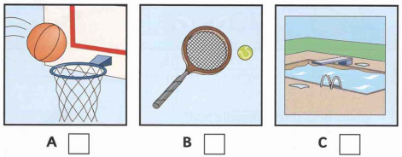  2. Where does Ben’s brother work?  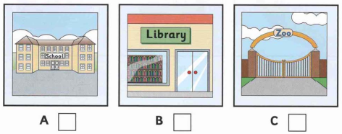  3. How did Ben go to his grandparents’ house?  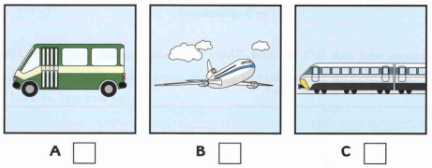 | 4. What can Ben give his sister for her birthday?  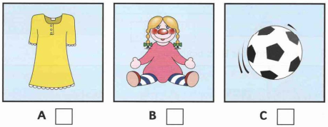  5. What is Ben’s mum cook for supper? (NB)  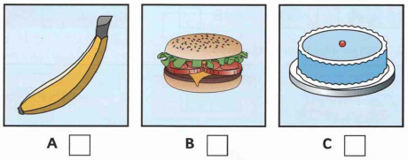  II. Listen and fill in the missing information. (1.0 pt)  - Name: …………Tom Hill….………  - Lives at: 15…………………....street  - How old: ……………………………  - Father’s name: ……………………...  - Mother’s name: …………………….  - What hurts: …………………………
B. GRAMMAR, VOCABULARY AND LANGUAGE FUNCTIONS. (3.0 pts)
I. Choose the word whose underlined part pronounced differently from that of the others.
1. A. soup B. move C. June D. sugar
2. A. villa B. hospitable C. village D. pasta
II. Mark the letter A, B, C or D to indicate the correct option.
3. Sitting too close in front of the television makes your eyes ______________.
A. strong B. hurt C. exciting D. relax
4. People in the countryside live _____________ than those in the city.
A. happy B. more happily C. happily D. less happy
5. Country children play _____________ on streets than city children.
A. more free B. freelier C. freer D. more freely
6. Peter enjoys _____________ origami with his friends at recess.
A. make B. to make C. making D. makes
7. We are all hooked ____________ making star lanterns.
A. in B. on C. off D. to
8. Nomads are often on the move for a new _____________ for their cattle.
A. pasture B. field C. land D. area
9. Daisy is addicted _____________ social media. She spends lots of time on Facebook and Instagram.
A. of B. with C. to D. about
10. In ______________ time, farmers use buffalo-drawn cart to take food home.
A. harvest B. collect C. relax D. countryside
11. I think country life is so boring and ____________ because you're not close to shops and services.
A. unhealthy B. inconvenient C. comfortable D. peaceful
IV. Mark the letter A, B, c or D to indicate the most suitable response to complete each of the following conversations.
12. Bob: “I’m sure you will love this new cartoon.” - Lily: “_____________”
A. Yes, it’s right up my street. B. How nice of you to say so!
C. Yes. That’s alright. D. You’re welcome.
13. “How often do you take part in Huong pagoda festival?” – “_____________”
A. In the early morning. B. It’s very far.
C. I like going to the pagoda. D. Once a year.

V. Mark the letter A, B, C or D to indicate the word(s) CLOSEST in meaning to the underlined words in each of the following questions.
14. This is one of most well-known heritage sites in Vietnam.
A. famous B. normal C. unknown D. favorite
15. There are certainly many disadvantages to living in the country.
A. good points B. positive things C. drawbacks D. benefits

C. READING. (3.0 pts)
I. Read and circle the correct answer (A, B, C, or D) to complete the following paragraph. (1.5 pts)
They widen the roads so cars and lorries can get to the village easily. They build a medical centre so people’s health can be looked (1) …………… at any time. They build a new school so their (2) ………… have better learning conditions. They build a bridge (3) ……………. the river so villagers have a shorter way to town. They also build a football ground so their children can (4) ………………sports. In addition, they grew cash crops so people can export the crops and have more money. I would like to become an agricultural engineer in the future so I can apply new technology to our farming and do more for the village (5)……………….. our parents did.
1. A. on B. for C. into D. after
2. A. adults B. children C. parents D. husbands
3. A. on B. by C. over D. to
4. A. do B. play C. get D. have
5. A. as B. like C. so D. similar
II. Read the passage and choose the correct answer for each question. (1.5 pts)
Living in the country is something that people from the city often dream about. However, it has both advantages and disadvantages.
There are certainly many advantages of living in the country. First, you can enjoy peace and quietness. Moreover, people tend to be friendlier. A further advantage is that there is less traffic, so it is safer for young children.
However, there are certain drawbacks to life outside the city. First, because there are fewer people, you are likely to have few friends. In addition, entertainment is difficult to find, particularly in the evening. Furthermore, there are fewer shops and services so it is quite hard to find jobs. As a result, you may have to travel a long way to work, which can be extremely expensive.
In conclusion, it can be seen that the country is often the best place for those who are retired or who have young children. In contrast, young or single people who have a career are better provided for in the city.
1. Which of the following statements is NOT true according to the passage?
A. There are fewer shops and services in the country.
B. It’s hard to find entertainment in the country.
C. People in the country tend to be friendlier than people in the city.
D. The country is only suitable for retired people.
2. How many advantages does living in the country have?
A. Three B. Two C. Four D. No
3. Having few friends is ______________.
A. one of the drawbacks to life in the country
B. one of the certain drawbacks to life outside the city
C. the only disadvantage of living in the country
D. one of the certain advantages to life outside the city
4. Living in the country is safer for young children because ______________.
A. there are few shops B. there are few services
C. there is less traffic D. there are fewer people
5. According to the passage, living in the country has ______________.
A. only bad points B. both good and bad points
C. only good points D. no disadvantages

D. WRITING. (2.0 pts)
I. Rewrite the following sentences, using the given words and beginnings. (1.0 pt)
1. I love listening to music.
I like___________________________________________________________________
2. I spend two hours drawing this picture.
It______________________________________________________________________
3. Living in the city is more interesting than living in the country.
Living in the country is_____________________________________________________
4. I am interested in hanging out with friends on Saturday evening.
I enjoy__________________________________________________________________
5. I can't cook as well as my mother. (better)
My mother can __________________________________________________________
II. Write a paragraph (80-100 words) about the cause(s) of teen stress and offer solutions. (1.0 pt) (VDC)
Some suggestions:
Causes of teen stress: peer pressure, too much schoolwork, spending too much time on social media, bullying,…
Possible solutions: avoiding bullies wherever possible, staying calm and relaxed, turning off smartphones, talking to teachers,…
……………………………………………………………………………………………………..
……………………………………………………………………………………………………..
……………………………………………………………………………………………………..
……………………………………………………………………………………………………..
……………………………………………………………………………………………………..
……………………………………………………………………………………………………..
……………………………………………………………………………………………………..
……………………………………………………………………………………………………..
……………………………………………………………………………………………………..
……………………………………………………………………………………………………..
……………………………………………………………………………………………………..
……………………………………………………………………………………………………..
……………………………………………………………………………………………………..
HƯỚNG DẪN CHẤM
A. LISTENING. (2.0 pts)
I. Listen and tick the box. (0.2 X 5= 1.0 pt)
1A 2C 3B 4C 5A
II. Listen and write. (0.2 X 5= 1.0 pt)
1. High 2. Ten/10 3. John 4. Clare 5. neck
B. Grammar, vocabulary and language functions. (0.2 X 15= 3.0 pts)
I. Choose the word whose underlined part pronounced differently from that of the others by circling A, B, C or D.
1. D
2. C
II. Mark the letter A, B, C or D to indicate the correct option.
3. B  4. B  5. D  6. C  7. B | 8. A  9. C  10. A  11. B  12. A | 13. D  14. A  15. C
C. READING. (3.0 pts)
I. Read and circle the correct answer to complete the following paragraph. (0.3 X 5= 1.5 pts)
1. D
2. B
3. C
4. B
5. A
II. Read the passage and choose the correct answer for each question (0.3 X 5= 1.5 pts)
1. D
2. A
3. A
4. C
5. D
D. WRITING. (2.0 pts)
I. Rewrite the following sentences, using the given words and beginnings. (0.2 X 5= 1.0 pt)
1. I like listening to music
2. It takes me two hours to draw this picture.
3. Living in the country is less interesting than living in the city.
Or: Living in the country is not as interesting as living in the city.
Or: Living in the country is more boring than living in the city.
4. I enjoy hanging out with friends on Saturday evening.
5. My mother can cook better than me/I (can).
II. Write a paragraph (80-100 words) about the cause(s) of teen stress and offer solutions. (1.0 pt) (VDC). (1.0 pt)
* Form: (0,1 point)
- Correct form of paragraph.
* Task fulfillment: (0,6 point)
- Give the choice with all detailed explanation
- Well – organized.
* Language:
- accurate grammar. (0,1 point)
- appropriate vocabulary. (0,1 point)
- correct spelling and punctuation (0,1 point)

