UNIT 9: NATURAL DISASTERS
Lesson 1: Getting started – We are all safe!

I. OBJECTIVES
By the end of this lesson, Ss will be able to:
1. Knowledge
- Gain an overview about the topic Natural disasters.
- Gain vocabulary to talk about Natural disasters.
2. Competences
- Develop communication skills and creativity
- Be collaborative and supportive in pair work and teamwork
- Actively join in class activities
3. Personal qualities
- Develop awareness of natural disasters.
- Be concerned and know what to prepare when natural disasters happen.

II. MATERIALS
- Grade 8 textbook, Unit 9 - Getting started
- Computer connected to the Internet
- Projector / TV
- hoclieu.vn

Language analysis
Form | Pronunciation | Meaning | Vietnamese equivalent
1. damage (n,v) | /ˈdæmɪdʒ/ | to harm or spoil something | thiệt hại, gây tổn hại
2. funnel (n) | /ˈfʌnl/ | an object that has a wide  round opening at the top | cái phễu
3. tornado (n) | /tɔːˈneɪdəʊ/ | a dangerous storm which is a spinning cone of wind that destroys anything in its path as it moves across the  ground | lốc xoáy
4. eruption (n) | /ɪˈrʌpʃn/ | an occasion when a volcano  explodes, and flames and  rocks come out of it | sự phun trào
5. pull up | /pʊl ʌp/ | to move something towards yourself | kéo lên, nhổ lên, lôi lên
6. landslide (n) | /ˈlændslaɪd/ | a mass of rock and earth  moving suddenly and  quickly down a steep slope | vụ sạt lở
Assumption
Anticipated difficulties | Solutions
Ss may lack experience of group work. | - Encourage Ss to work in groups so that they can help one another.  - Give short, clear instructions, and help if necessary.

III. PROCEDURES
1. WARM-UP (5 mins)
a. Objectives:
- To create an active atmosphere in the class before the lesson
- To lead into the new unit.
b. Content:
- Questions & answers about natural disasters
c. Expected outcomes:
- Ss have general ideas about the topic: Natural disasters.
d. Organisation

TEACHER AND STUDENTS’ ACTIVITIES | CONTENTS
Asking questions:  - T asks Ss some questions about natural disasters in Viet Nam.  - Ss answer the question individually.  - T draws a mind map on the board to summarise Ss’ ideas. Write the title on the board Natural disasters.  - T asks Ss to guess what the conversation might be about. | Questions:  1. Can you name some natural disasters in Viet Nam?  2. Are there often natural disasters in Viet Nam?  3. How can you know when there is an incoming natural disaster?  4. What would you do if you were notified of an incoming earthquake?

e. Assessment
- Teacher’s feedback.

2. ACTIVITY 1: PRESENTATION (8 mins)
a. Objectives:
- To introduce some vocabulary related to the topic.
- To get Ss ready for the dialogue of the lesson.
b. Content:
- Vocabulary pre-teaching
c. Expected outcomes:
- Ss know how to pronounce the new words correctly and use them in appropriate situations.
d. Organisation

TEACHER AND STUDENTS’ ACTIVITIES | CONTENTS
Vocabulary pre-teaching  - Teacher introduces the vocabulary.  - Teacher explains the meaning of the new vocabulary, using pictures, explanation and translation.  - Teacher checks students’ understanding with the “Matching” technique.  - Teacher reveals that these words will appear in the reading text and asks students to open their textbook to discover further. | New words:  1. damage (v,n)  2. funnel (n)  3. tornado (n)  4. eruption (n)  5. pull up  6. landslide (n)
e. Assessment
- Teacher checks students’ pronunciation and gives feedback.

3. ACTIVITY 2: PRACTICE (22 mins)
a. Objectives:
- To set the context for the introductory dialogue
- To develop students’ reading skills.
b. Content:
- Task 1: Listen and read.
- Task 2: Read the conversation again. Complete each sentence with no more than TWO words from it.
- Task 3: Write the natural disasters from the box under the pictures. Then listen, check, and repeat.
- Task 4: Choose the correct option to complete each sentence.
c. Expected outcomes:
- Students can read and understand general and specific information about Natural disasters.
d. Organisation

TEACHER AND STUDENTS’ ACTIVITIES | CONTENTS
Task 1: Listen and read. (7 mins)
- Teacher asks Ss to look at the picture on pages 92, 93 and answer the questions  - Teacher elicits answers from Ss.  - Teacher introduces the two characters: Tom and Mi and explains that they are friends and they are talking about natural disasters.  - Teacher plays the recording twice for Ss to listen and read along.  - Teacher asks some pairs of students to read the conversation aloud. | Questions:  1. What can you see in the picture?  2. What natural disaster is it?
Task 2: Read the conversation again. Complete each sentence with no more than TWO words from it. (5 mins)
- Teacher tells Ss to read the conversation again and work independently to find the answers.  - Ss work independently to find the best answers.  - Teacher has Ss compare the answers in pairs before checking with the whole class.  - Teacher checks the answers as a class and gives feedback. | Answer key:  1. flood  2. second floor  3. natural disaster  4. was having  5. pulled
Task 3: Write the natural disasters from the box under the pictures. Then listen, check, and repeat. (5 mins)
- Teacher asks Ss to look at the pictures and say if they know the natural disaster shown in each picture.  - Ss work individually to write the natural disasters in the box under the pictures.  - Ss compare their answers with a partner.  - Teacher invites some Ss to go to the board and write their answers.  - Teacher confirms the correct answer.  - Teacher has some Ss practice saying the natural disasters words again. | Answer key:  1. flood  2. tornado  3. volcanic eruption  4. storm  5. landslide  6. earthquake
Task 4: Choose the correct option to complete each sentence. (5 mins)
- Teacher asks Ss to work in pairs, read the sentences and choose the correct answers.  - Teacher asks for Ss’ answers and confirms the correct ones.  - For a more able class, teacher has Ss work in pairs to do the activity and explain why the other word is not the correct answer. | Answer key:  1. volcanic eruption  2. earthquake  3. landslide  4. storms  5. tornado
e. Assessment
- T’s observation and feedback

4. ACTIVITY 3: PRODUCTION (7 mins)
a. Objectives:
- Ss can revise the words and phrases indicating natural disasters.
b. Content:
- Task 5: Word web
c. Expected outcomes:
- Ss can write the names of natural disasters they know.
d. Organisation
TEACHER AND STUDENTS’ ACTIVITIES | CONTENTS
Task 5: Word web: Work in groups. Complete the web with all of the words and phrases related to natural disasters you know. (7 mins)
- Work in groups. Complete the web with all of the words and phrases related to natural disasters you know.  - Teacher asks Ss to work in groups.  - Teacher asks Ss to include the words and phrases learnt in this lesson or other words.  - Teacher invites some Ss to share their groups’s answers with the class. | 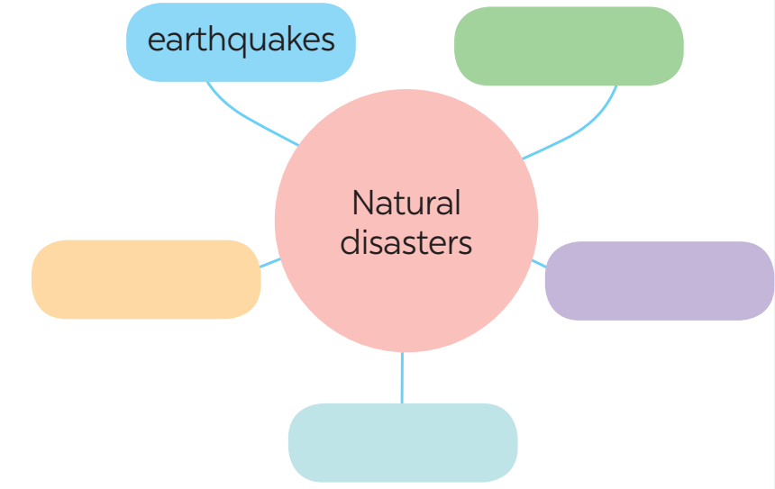
e. Assessment
- T’s feedback.

4. CONSOLIDATION (3 mins)
a. Wrap-up
- Teacher asks one or two Ss to tell the class what they have learnt. Teacher shows them the slide with the objectives. Teacher ticks the objectives that have been learnt.
- Teacher asks Ss to say aloud some words and phrases they remember from the lesson.
b. Homework
- Learn by heart all the words that they have just learnt.
- Do exercises in the workbook.
- Start preparing for the Project of the unit:
Teacher randomly puts Ss in groups of 4 or 5 and asks them to choose a natural disaster they want to learn more about and make a poster about it (suggested information in Project lesson). Students will show and present their posters in Lesson 7 – Looking back and Project. (Teacher should check the progress of students’ preparation after each lesson.)

Board Plan

Date of teaching ……..
UNIT 9: NATURAL DISASTERS
Lesson 1: Getting started – We are all safe!

*Warm-up

* Vocabulary
1. damage (v,n)
2. funnel (n)
3. tornado (n)
4. eruption (n)
5. pull up
6. landslide (n)

Task 1: Listen and read.
Task 2: Read and complete each sentence.
Task 3: Write the name of natural disasters.
Task 4: Choose the correct answer.
Task 5: Complete the web.

*Homework

UNIT 9: NATURAL DISASTERS
Lesson 2: A closer look 1

I. OBJECTIVES
By the end of this lesson, students will be able to gain:
1. Knowledge:
- Vocabulary: The lexical items related to natural disasters.
- Pronunciation: Stress in words ending in -al and -ous
2. Core competence:
- Develop communication skills and creativity
- Be collaborative and supportive in pair work and teamwork
- Actively join in class activities
3. Personal qualities
- Develop awareness of Natural disasters.
- Be concerned and know what to prepare when natural disasters happen.

II. MATERIALS
- Grade 8 textbook, Unit 9 - A closer look 1
- Computer connected to the Internet
- Projector / TV
- hoclieu.vn

Language analysis
Form | Pronunciation | Meaning | Vietnamese equivalent
1. destroy (v) | /dɪˈstrɔɪ/ | to damage something so  badly that it cannot be used | phá hủy
2. erupt (v) | /ɪˈrʌpt/ | start to burn or burst into flames | phun trào
3. predict (v) | /prɪˈdɪkt/ | to say that an event or action  will happen in the future | dự đoán
4. emergency kit | /ɪˈmɜːdʒənsikit/ | a set of things used for a first-aid | bộ dụng cụ dùng trong trường hợp khẩn cấp
5. property (n) | /ˈprɒpəti/ | a building or area of land, or both together | của cải, nhà cửa
6. rescue worker | /ˈreskjuːˈwɜːkə/ | a person who helps  someone or something out of a dangerous, harmful, or unpleasant situation | nhân viên cứu hộ
7. victim (n) | /ˈvɪktɪm/ | a person who has suffered  the effects of violence or  illness or bad luck | nạn nhân

Assumption
Anticipated difficulties | Solutions
1. Students may lack experience of group/ teamwork. | - Encourage students to work in groups so that they can help each other.
2. Students may have underdeveloped co-operating skills. | - Encourage students to work in pairs, in groups so that they can help each other.

III. PROCEDURES
1. WARM-UP (5 mins)
a. Objectives:
- To create an active atmosphere in the class before the lesson.
- To lead into the new lesson.
b. Content:
- Kim’s game.
c. Expected outcomes:
- Ss review words about Natural disasters.
d. Organisation
TEACHER AND STUDENTS’ ACTIVITIES | CONTENTS
- Teacher asks Ss to work in 2 groups.  - Teacher shows some pictures related to Natural disasters in 2 minutes.  - Ss look at the pictures and remember (no writing).  - As soon as teacher stops showing the pictures, Ss work in groups and write the words for the pictures they have seen.  - The group with more correct words becomes the winner. | Kim’s game:
  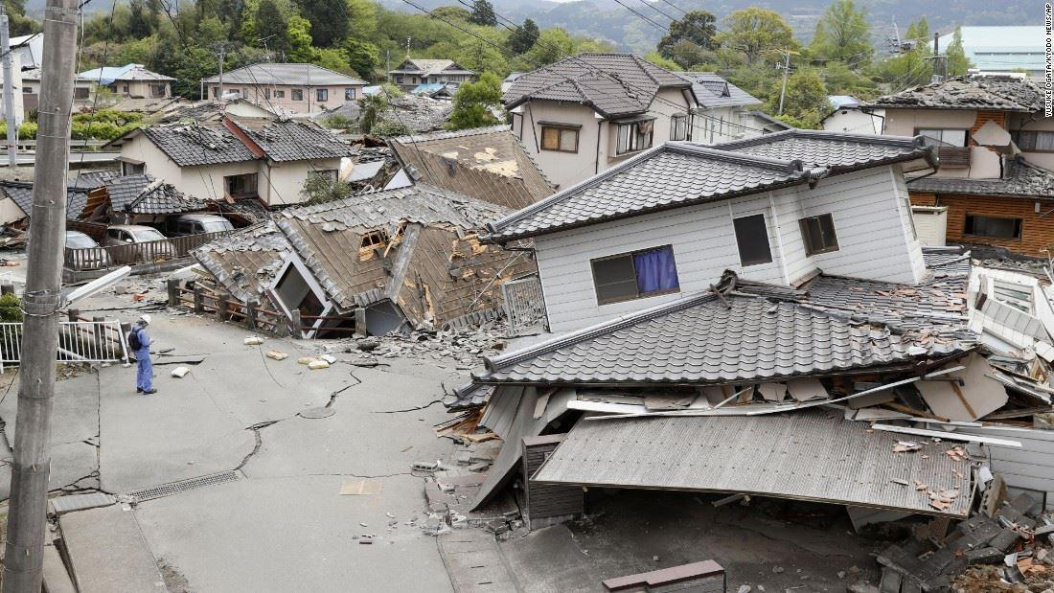  earthquake | 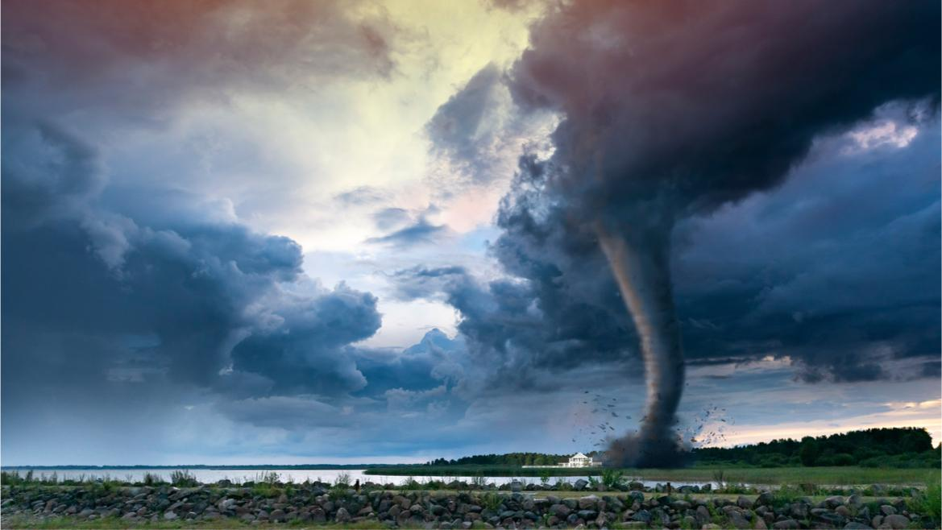  tornado
  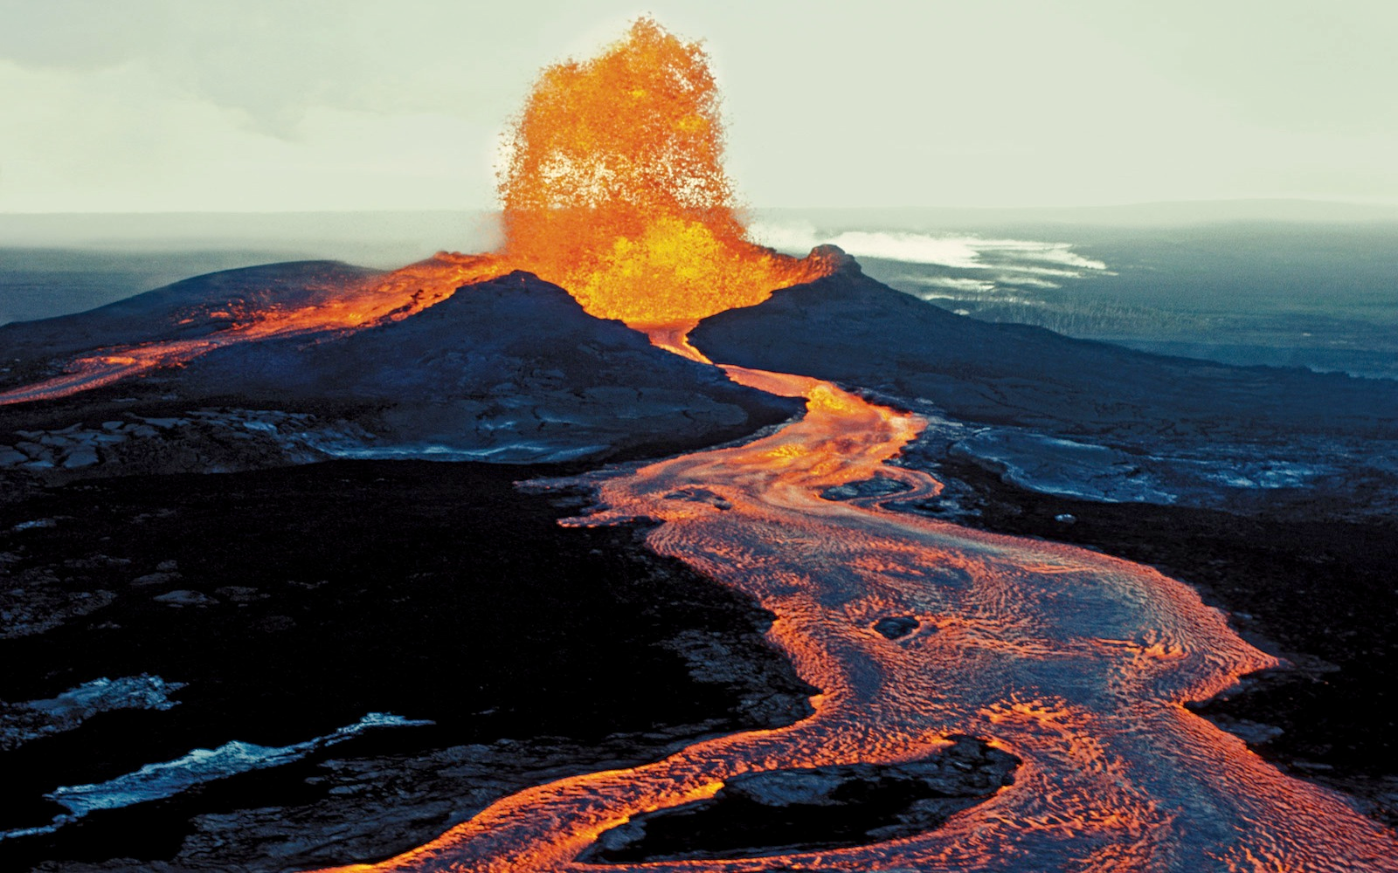  volcanic eruption | 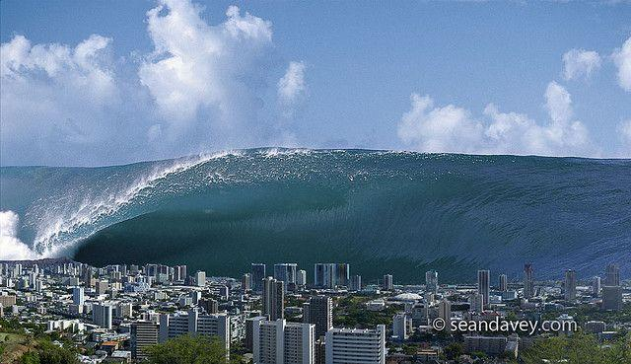  tidal wave/ tsunami
  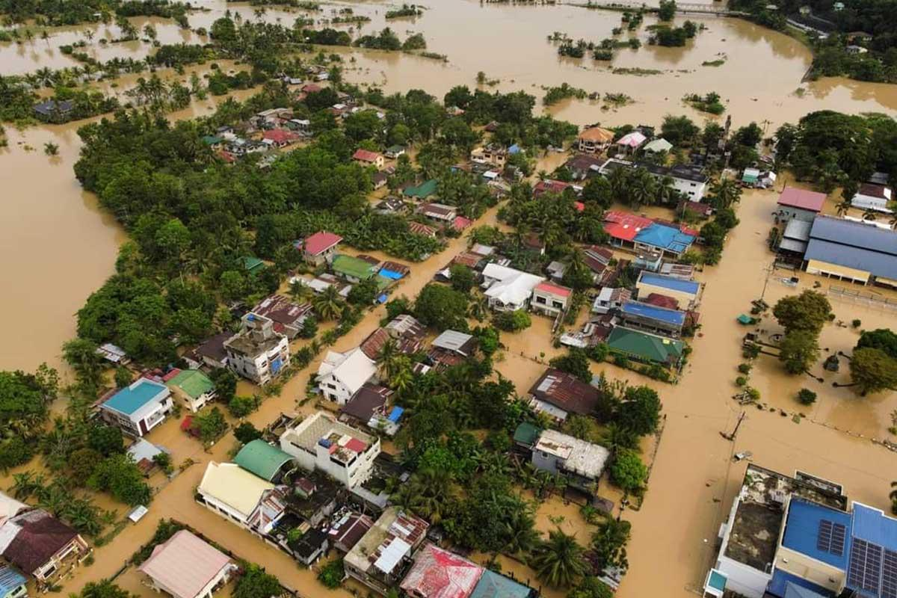  flood | 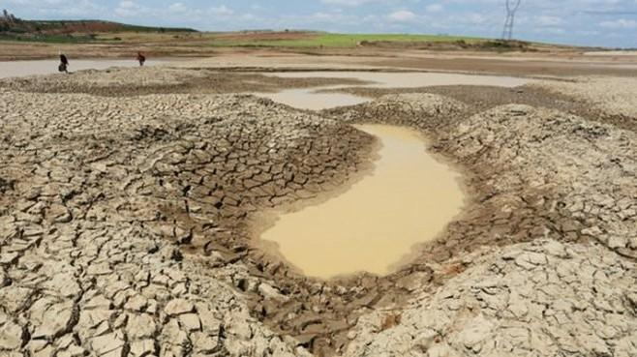  drought
e. Assessment
- Teacher’s feedback.

2. ACTIVITY 1: VOCABULARY (22 mins)
a. Objectives:
- To present some words and phrases related to natural disasters.
- To give Ss further practice with words and phrases related to natural disasters.
b. Content:
- Vocabulary pre-teaching
- Task 1: In column B, write the noun forms of the verbs in column A.
- Task 2: Write a word or phrase from the box under the correct picture.
- Task 3: Fill in each blank with a word or phrase from the box.
c. Expected outcomes:
- Ss know how to pronounce the new words correctly and use them in appropriate situations.
d. Organisation

TEACHER AND STUDENTS’ ACTIVITIES | CONTENTS
Vocabulary pre-teaching (7 mins)
- Teacher introduces the words.  - Teacher explains the meaning of the new vocabulary, using pictures and translation.  - Teacher checks students’ understanding with the “Rub out and remember” technique. | New words:  1. destroy (v)  2. erupt (v)  3. predict (v)  4. emergency kit  5. property (n)  6. rescue worker  7. victim (n)
Task 1: In column B, write the noun forms of the verbs in column A. (5 mins)
- Teacher asks Ss to read the verbs in column A and try to give the noun forms of these verbs.  - Teacher asks Ss to work in pairs to compare their answers.  - Teacher has some Ss write their answers on the board.  - Teacher checks and confirms the correct answers. |  | Answer key:  1. destruction  2. eruption  3. warning  4. prediction  5. damage
Task 2: Write a word or phrase from the box under the correct picture. (5 mins)
- Teacher asks Ss to work individually.  - Ss look at the pictures and choose a suitable word/ phrase for each picture.  - Ss compare answers in pairs.  - Teacher invites some Ss to give their answers.  - Teacher confirms the correct answers. |  | Answer key:  1. whistle  2. property  3. emergency kit  4. victim  5. rescue worker
Task 3: Fill in each blank with a word or phrase from the box. (5 mins)
- Teacher asks Ss to work individually.  - Ss read all the sentences carefully to make sure they understand the sentences and fill in the blanks with the words and phrases in the box.  - Teacher lets Ss share their answers in pairs.  - Teacher invites some Ss to give the answers.  - Teacher confirms the correct answers. |  | Answer key:  1. damage  2. warning  3. emergency kit  4. predict  5. property
e. Assessment
- Teacher’s observation and feedback.

3. ACTIVITY 2: PRONUNCIATION (13 mins)
a. Objectives:
- To help students identify the stress in words ending in -al and -ous
- To help students stress the words ending in -al and -ous correctly and read the sentences including these words with correct stress.
b. Content:
- Listen and repeat the words. Pay attention to the word stress.
- Listen and repeat the sentences. Mark the stress in the underlined words.
c. Expected outcomes:
- Ss distinguish and pronounce the words ending -al and -ous with correct stress.
d. Organisation

TEACHER AND STUDENTS’ ACTIVITIES | CONTENTS
Task 4: Listen and repeat the words. Pay attention to the word stress. (6 mins)
- Teacher asks Ss to read out the words.  - Teacher plays the recording for them to listen and repeat the words they hear. Teacher plays the recording as many times as necessary.  - Teacher explains that these words have the stress on the first syllable and tells them that the endings –al and –ous do not change the stress pattern of the original words.  - Teacher asks Ss to work in pairs to practise saying the words.  - Teacher invites some Ss to say the words aloud. | 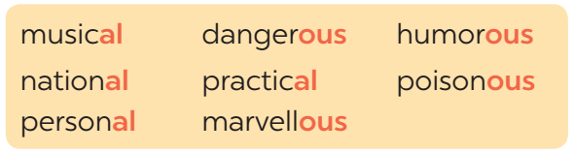
Task 5: Listen and repeat the sentences. Mark the stress in the underlined words. (7 mins)
- Teacher has Ss read the sentences quickly.  - Teacher plays the recording for Ss to listen to the sentences.  - Teacher asks Ss to pay attention to the underlined words and put stress on the correct syllable in each word.  - Teacher invites some Ss to share their answers, teacher confirms the correct ones.  - Teacher plays the recording again for Ss to repeat the sentences.  - Teacher has Ss practise the sentences in pairs and invites some pairs to read the sentences aloud. | Answer key:  1. The flood victims are collecting their ‘personal property.  2. Avoid ‘dangerous places, such as windows or bookcases, during an earthquake.  3. There are ‘numerous ‘tropical storms in this area every year.  4. Some ‘natural disasters, such as landslides, usually happen in ‘mountainous areas.  5. She gave us ‘practical tips about treating ‘poisonous wastes.
e. Assessment
- Teacher’s observation and feedback

4. CONSOLIDATION(5 mins)
a. Wrap-up
- Teacher asks Ss to retell the main points of the lesson.
b. Homework
- Learn by heart all the words that they have just learnt.
- Do exercises in the workbook.
- Prepare for Lesson 3 - A closer look 2

Board Plan

Date of teaching ……..

UNIT 9: NATURAL DISASTERS
Lesson 2: A closer look 1

*Warm-up

* Vocabulary
1. destroy (v)
2. erupt (v)
3. predict (v)
4. emergency kit
5. property (n)
6. rescue worker
7. victim (n)

Task 1: Write the noun forms of the verbs.
Task 2: Write a word or phrase.
Task 3: Fill in each blank.
Task 4: Listen and repeat the words.
Task 5: Listen and repeat the sentences. Mark the stress.

*Homework

UNIT 9: NATURAL DISASTERS
Lesson 3: A closer look 2

I. OBJECTIVES
By the end of this lesson, students will be able to gain:
1. Knowledge:
- Grammar: How to use “The past continuous”
2. Core competence:
- Develop communication skills and creativity
- Be collaborative and supportive in pair work and teamwork
- Actively join in class activities
3. Personal qualities
- Develop awareness of Natural disasters.
- Be concerned and know what to prepare when natural disasters happen.

II. MATERIALS
- Grade 8 textbook, Unit 9 - A closer look 2
- Computer connected to the Internet
- Projector / TV/ pictures and cards
- Phần mềm tương tác hoclieu.vn

Language analysis
Structure | Examples
Affirmative sentences: S + was/ were + V_ing | She was doing her homework at 8 o’clock last night.
Negative sentences: S + was/ were not + V_ing | She was not doing her homework at 8 o’clock last night.
Questions: Was/ were + S + V_ing? | Was she doing her homework at 8 o’clock last night?

Assumption
Anticipated difficulties | Solutions
Students may not know how to work in teams or fully understand the exercises and tasks. | Give short, clear instructions and help if necessary.

III. PROCEDURES
1. WARM-UP (5 mins)
a. Objectives:
- To create an active atmosphere in the class before the lesson.
- To lead into the new lesson.
b. Content:
- Questions and answers.
c. Expected outcomes:
- Ss can use suitable answers to teacher’s questions.
d. Organisation
TEACHER AND STUDENTS’ ACTIVITIES | CONTENTS
- Teacher says one sentence about himself, using the past continuous.  - Teacher invites some Ss to answer the question.  (teacher writes the question and Ss’ answers on the board. If Ss don’t use the past continuous, still accept their answers).  - Teacher underlines the form of the past continuous in the sentence, and then corrects Ss’s answers if they don’t include the past continuous in their answers.  - Teacher tells them that they are going to learn the past continuous and leads to the lesson. | Question:  What were you doing?
e. Assessment
- Teacher’s feedback.

2. ACTIVITY 1: PRESENTATION (8 mins)
a. Objectives:
- To introduce the form and use of the past continuous.
b. Content:
- Introduce the past continuous.
c. Expected outcomes:
- Ss know the form and how to use the past continuous.
d. Organisation
TEACHER AND STUDENTS’ ACTIVITIES | CONTENTS
- Teacher draws Ss’s attention to the sentences on the board and asks “What is the form of the past continuous?”  - Teacher invites some Ss to answer the questions, then writes their answers on the board.  - Teacher confirms the correct answer. | - Form of the past continuous:  (+): S + was/ were + V_ing.  (-): S + was/ were not + V_ing.  (?): Was/ were + S + V_ing?  - The use of the past continuous:  We use the past continuous to describe:  + an action that was happening at a particular time in the past.  + a past action that was happening when another action interrupted it. We use the past simple for the action that interrupted it.  - Notes:  + We can use when or while before the past continuous.  + We can only use when before the past simple.
e. Assessment
- Teacher’s observation and feedback
3. ACTIVITY 2: PRACTICE (23 mins)
a. Objectives:
- To help Ss practise the form of the past continuous.
- To help Ss distinguish the past simple and the past continuous.
- To give further practice with the past continuous.
b. Content:
- Task 1: Complete the sentences by putting the verbs in brackets into the past continuous.
- Task 2: Circle the correct answer to complete each sentence.
- Task 3: Look at the picture and write what each person in Lan’s family was doing when the earthquake happened. Use the given word and phrases from the box.
- Task 4: Form questions using the past continuous. Then in pairs, ask and answer the questions.
c. Expected outcomes:
- Ss know how to use the past continuous.
- Ss can distinguish the past simple and the past continuous.
d. Organisation

TEACHER AND STUDENTS’ ACTIVITIES | CONTENTS
Task 1: Complete the sentences by putting the verbs in brackets into the past continuous. (6 mins)
- Teacher asks Ss to work in pairs and do the exercise.  - Ss do the exercise, then compare their answers with other pairs.  - Teacher invites some Ss to share their answers.  - Teacher confirms the correct answers. |  | Answer key:  1. were helping  2. was not / wasn’t snowing  3. was working  4. were … doing; was watching  5. Were … crying
Task 2: Circle the correct answer to complete each sentence. (5 mins)
- Teacher asks Ss to work individually and do the exercise.  - Teacher asks Ss to compare their answers with a partner.  - Ss discuss with their friends if there are any differences between their answers.  - Teacher checks students’ answers as a class.  - Teacher confirms the correct answers. |  | Answer key:  1. donated  2. were you doing; was sleeping  3. were camping; came  4. ran; moved  5. wasn’t reading; was watching
Task 3: Look at the picture and write what each person in Lan’s family was doing when the earthquake happened. Use the given word and phrases from the box. (6 mins)
- Teacher asks Ss who they can see in the picture and what they are doing.  - Teacher describes the situation to Ss and asks them to describe the actions of the people in the picture, using the past continuous and the words/ phrases given in the box.  - Teacher has Ss do this exercise individually and then compare their answers with another classmate’s.  - Teacher invites some Ss to write their answers on the board.  - Teacher checks the answers with the whole class and confirms the correct answers. |  | 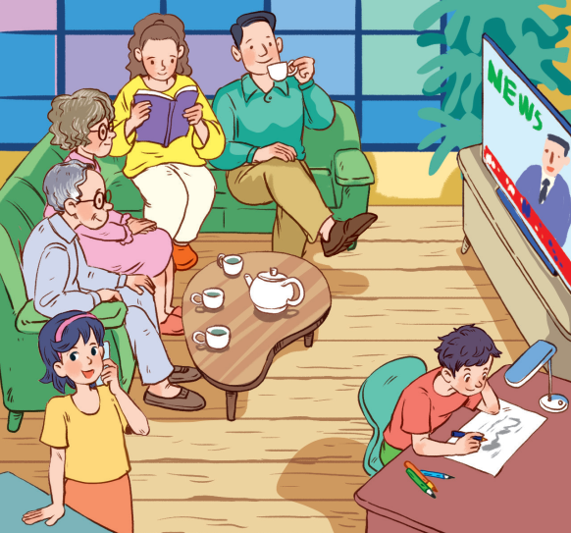  Answer key:  1. Lan’s grandparents were watching TV.  2. Lan’s/ Her mother was reading a book.  3. Lan’s/ Her father was drinking tea.  4. Lan was talking on the phone.  5. Lan’s/ Her brother was drawing.
Task 4: Form questions using the past continuous. Then in pairs, ask and answer the questions. (5 mins)
- Teacher asks Ss to read the example carefully and explains what they have to do.  - Teacher asks Ss to work in pairs to do this activity. They make questions and then practise asking and answering.  - Teacher invites some pairs to ask and answer the question in front of the class.  - Teacher comments on their answers and accepts different answers provided that they are correct and logical. |  | Answer key:  1. Were you having dinner at 7 o’clock yesterday evening?  2. Were you doing your homework at 8 o’clock yesterday evening?  3. Were you watching a film at 9 o’clock yesterday evening?
e. Assessment
- Teacher’s observation and feedback

4. ACTIVITY 3: PRODUCTION (7 mins)
a. Objectives:
- To help students practise the past continuous via a game.
b. Content:
- Task 5: Work in groups. Take turns to say a sentence that describes what each person in the picture was doing.
c. Expected outcomes:
- Ss can say sentences to describe what each person in the picture was doing.
d. Organisation

TEACHER AND STUDENTS’ ACTIVITIES | CONTENTS
Task 5: Work in groups. Take turns to say a sentence that describes what each person in the picture was doing. (7 mins)
- Teacher divides Ss into groups and assigns a group leader to keep watch of the game.  - Teacher explains the rule of the game:  The picture shows a class at break time. Now work in groups. Look at the picture for one minute. Take turns to say a sentence that describes what each person in the picture was doing. You score one point for every correct sentence. The student with the highest score in each group wins.  - Teacher has groups play the game in about 3-5 minutes.  - Teacher invites some groups to perform the game in front of the whole class and comments on their performance. |  | Suggested answers:  - Mai was reading.  - Phong and Nick were playing chess.  - Lan and Ann were singing.  - Nam was cleaning the board.  - Mi and Ha were talking.
e. Assessment
- Teacher’s observation and feedback.

4. CONSOLIDATION (3 mins)
a. Wrap-up
- Teacher asks Ss to summarise the main points of the lesson.
b. Homework
- Remember the form and use of the past continuous.
- Do exercises in the workbook.
- Prepare for Lesson 4 - Communication

Board Plan
Date of teaching ……..

UNIT 9: NATURAL DISASTERS
Lesson 3: A closer look 2

*Warm-up

* Presentation: The past continuous
- Form:
(+): S + was/ were + V_ing.
(-): S + was/ were not + V_ing.
(?): Was/ were + S + V_ing?
- Use:

* Practice:
Task 1: Complete the sentences.
Task 2: Circle the correct answer.
Task 3: Look at the picture and write.
Task 4: Form questions using the past continuous.
Task 5: Say a sentence.

*Homework

UNIT 9: NATURAL DISASTERS
Lesson 4: Communication

I. OBJECTIVES
By the end of this lesson, students will be able to:
1. Knowledge:
- Use lexical items related to natural disasters.
- Practise giving and responding to bad news.
- Get some information about natural disasters.
2. Core competence:
- Develop communication skills and creativity
- Be collaborative and supportive in pair work and teamwork.
- Actively join in class activities
3. Personal qualities
- Develop awareness of Natural disasters.
- Be concerned and know what to prepare when natural disasters happen.

II. MATERIALS
- Grade 8 textbook, Unit 9 - Communication
- Computer connected to the Internet
- Projector / TV
- hoclieu.vn

Language analysis
Form | Pronunciation | Meaning | Vietnamese equivalent
1. shake (v) | /ʃeɪk/ | to move backwards and forwards or up and down in quick, short movements | rung, lắc
2. Fahrenheit (n) | /ˈfærənhaɪt/ | a measurement of temperature on a standard in which 32° is the temperature at which  water freezes and 212° that at which it boils | độ F (đo nhiệt độ)
3. Richter scale (n) | /ˈrɪktə skeɪl/ | a system used to measure the  strength of an earthquake | độ rích te (đo độ mạnh của động đất)

Assumption
Anticipated difficulties | Solutions
Ss may not have sufficient listening skills. | - Play the recording many times if necessary.  - Pick some Ss to ask and answer the questions.  - Have Ss practise the dialogue in pairs.

III. PROCEDURES
1. WARM-UP (5 mins)
a. Objectives:
- To create an active atmosphere in the class before the lesson.
- To lead into the new lesson.
b. Content:
- Ask and answer
c. Expected outcomes:
- Ss get some general ideas and get ready for the new lesson.
d. Organisation
TEACHER AND STUDENTS’ ACTIVITIES | CONTENTS
- Teacher shows a picture about one disaster.  - Teacher asks Ss to work individually and answer the questions.  - Teacher invites some Ss to talk in front of the class.  - Teacher comments on their answers and leads to the new lesson. | Answering the questions:  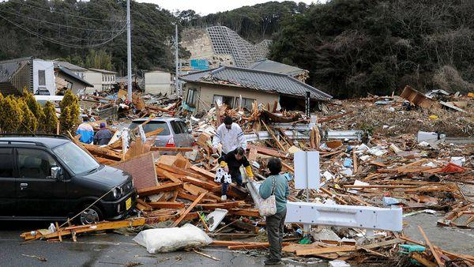  1. What do you see in the picture?  2. How do you feel?
e. Assessment
- Teacher’s feedback.

2. ACTIVITY 1: EVERYDAY ENGLISH (20 mins)
a. Objectives:
- To introduce ways of giving and responding to bad news.
- To help Ss practise giving and responding to bad news.
b. Content:
- Vocabulary pre-tech
- Task 1: Listen and read the dialogue below. Pay attention to the highlighted sentences.
- Task 2: Work in pairs. Practise giving and responding to bad news in the following situations.
c. Expected outcomes:
- Ss know how to give and respond to bad news.
- Students can make dialogue using the structures of giving and responding to bad news.
d. Organisation
TEACHER AND STUDENTS’ ACTIVITIES | CONTENTS
Vocabulary pre-teach (5 mins)
- Teacher introduces the vocabulary.  - Teacher explains the meaning of the new vocabulary, using pictures and translation.  - Teacher checks students’ understanding with the “What and where?” technique. | New words:  1. shake (v)  2. Fahrenheit (n)  3. Richter scale (n)
Task 1: Listen and read the dialogue below. Pay attention to the highlighted sentences.
(6 mins)
- Teacher plays the recording for Ss to listen and read the dialogue between Mark and Phong.  - Teacher asks Ss to pay attention to the highlighted sentences and tells them that these are two ways to give and respond to bad news.  - Teacher has Ss practise the dialogue in pairs.  - Teacher calls on some Ss to practise the dialogue in front of the class. | 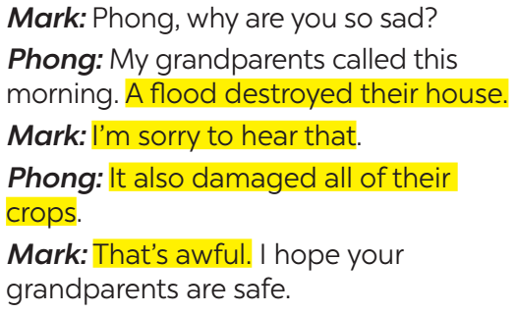
Task 2: Work in pairs. Practise giving and responding to bad news in the following situations. (9 mins)
- Teacher asks Ss to work in pairs to read the given situations and make similar dialogues, using the language they have learnt.  - Ss use the language and make similar dialogues.  - Teacher moves around to observe and provides help.  - Teacher calls on some pairs to practise in front of the class.  - Teacher comments on their performance. | Situations:  – You have a friend in a mountainous area. A landslide destroyed his family’s garden yesterday. You share this news with your classmate.  – You hear that a big earthquake hit a city. You share this news with your classmate.
e. Assessment
- Teacher’s observation and feedback.

3. ACTIVITY 2: KNOWLEDGE OF NATURAL DISASTERS (18 mins)
a. Objectives:
- To provide Ss with knowledge of different natural disasters.
- To provide Ss with a chance to communicate with each other and confirm their knowledge of natural disasters.
b. Content:
- Task 3: Read the short passages below. Decide which natural disaster each person below is talking about.
- Task 4: Choose the correct answer to each question to see how much you know about natural disasters.
- Task 5: Work in pairs. Compare your answers. Then check your answers with the key on page 101. How many points did each of you get?
c. Expected outcomes:
- Ss know more about natural disasters.
d. Organisation

TEACHER AND STUDENTS’ ACTIVITIES | CONTENTS
Task 3: Read the short passages below. Decide which natural disaster each person below is talking about. (6 mins)
- Teacher asks Ss to work in pairs to read the three short texts and decide what natural disaster each person is talking about.  - Teacher asks Ss to prepare an explanation for their answers.  - Teacher elicits answers from Ss.  - Teacher confirms the correct answers. |  | Answer key:  Nam: landslide  Ann: tornado  Tom: earthquake
Task 4: Choose the correct answer to each question to see how much you know about natural disasters. (7 mins)
- Teacher tells Ss that they are going to answer a questionnaire to see how much they know about natural disasters.  - Teacher has Ss read through the questionnaire quickly and explain any new words.  - Teacher asks Ss to answer the questions individually. |  | Answer key:  1. A  2. B  3. C  4. B  5. C  6. A
Task 5: Work in pairs. Compare your answers. Then check your answers with the key on page 101. How many points did each of you get? (5 mins)
- Teacher asks Ss to work in pairs to compare their answers.
- Teacher asks Ss to note down the answers and then check them with the key on page 101.
- Teacher has Ss calculate the points each of them earns.
- Teacher asks some Ss to report their answers and points to the class.
e. Assessment
- Teacher’s observation and feedback.

4. CONSOLIDATION (4 mins)
a. Wrap-up
- Teacher asks Ss to summarise the main points of the lesson.
b. Homework
- Learn by heart all the words that they have just learnt.
- Do exercises in the workbook.
- Prepare for Lesson 5 – Skills 1

Board Plan
Date of teaching ……..

UNIT 9: NATURAL DISASTERS
Lesson 4: Communication

*Warm-up

* Everyday English
Vocabulary
1. shake (v)
2. Fahrenheit (n)
3. Richter scale (n)

Task 1: Listen and read.
Task 2: Practise in the following situations.
Task 3: Read and decide which natural disaster each person below is talking about.
Task 4: Choose the correct answer.
Task 5: Work in pairs. Compare your answers.

*Homework

UNIT 9: NATURAL DISASTERS
Lesson 5: Skills 1

I. OBJECTIVES
By the end of this lesson, students will be able to:
1. Knowledge:
- Read for specific information about natural disasters
- Talk about a natural disaster.
2. Core competence:
- Develop communication skills and creativity.
- Be collaborative and supportive in pair work and teamwork.
- Actively join in class activities.
3. Personal qualities:
- Develop awareness of Natural disasters.
- Be concerned and know what to prepare when natural disasters happen.

II. MATERIALS
- Grade 8 textbook, Unit 9- Skills 1.
- Computer connected to the Internet.
- Projector / TV
- hoclieu.vn

Language analysis
Form | Pronunciation | Meaning | Vietnamese equivalent
1. ash (n) | /æʃ/ | the soft, grey or black, powdery substance left after something has burned. | tro
2. tsunami (n) | /tsuːˈnɑːmi/ | an extremely large wave caused by a violent movement of the  earth under the sea | trận sóng thần
3. tremble (v) | /ˈtrembl/ | to shake slightly in a way that you cannot control | rung lắc

Assumption
Anticipated difficulties | Solutions
1. Students may lack knowledge about some lexical items. | Provide students with the meaning and pronunciation of words.
2. Students may not have sufficient reading, speaking and co-operating skills. | - Let students read the text again (if necessary).  - Create a comfortable and encouraging environment for students to speak.  - Encourage students to work in pairs, in groups so that they can help each other.  - Provide feedback and help if necessary.

III. PROCEDURES
1. WARM-UP (5 mins)
a. Objectives:
- To create an active atmosphere in the class before the lesson.
- To lead into the new lesson.
b. Content:
- Who’s faster?
c. Expected outcomes:
- Ss review words related to natural disasters.
d. Organisation
TEACHER AND STUDENTS’ ACTIVITIES | CONTENTS
- Teacher divides Ss into groups.  - Teacher gives each group a piece of paper.  - Teacher asks them to list all the words about natural disasters they have learnt.  - Ss work in their group and list all the words about natural disasters in 2 minutes.  - Teacher asks 4 groups to tick their posters on the board.  - Teacher checks and gives comments.  - The group with most correct words is the winner. | erupt  Natural disasters
e. Assessment
- Teacher’s feedback.

2. ACTIVITY 1: READING (24 mins)
a. Objectives:
- To introduce some vocabulary
- To activate Ss’ knowledge of the topic of the reading text.
- To help Ss develop the skill of reading for the main idea (skimming), specific information (scanning) and guessing word meaning in context.
b. Content:
- Vocabulary pre-teach
- Task 1: Match the headlines with the natural disasters.
- Task 2: Read the two news articles. Match the highlighted words with their meanings.
- Task 3: Read the articles again and answer the questions.
c. Expected outcomes:
- Ss understand new vocabulary
- Students can understand the text and choose the right answers.
d. Organisation
TEACHER AND STUDENTS’ ACTIVITIES | CONTENTS
Vocabulary:  - Teacher introduces the vocabulary.  - Teacher explains the meaning of the new vocabulary, using pictures and translation.  - Teacher checks students’ understanding with the “Matching” technique. | New words:  1. ash (n)  2. tsunami (n)  3. tremble (v)
Task 1: Match the headlines (1 – 2) with the natural disasters (A – B). (5 mins)
- Teacher asks Ss to read the headlines carefully and match them with the disasters.  - Ss work individually and do the task.  - Teacher elicits and confirms the correct answers.  - Teacher tell Ss something about Tonga which is a country in the South-western Pacific Ocean. It consists of about 170 islands.  - Teacher tells them that they are going to read news articles about two natural disasters. | Answer key:  1. B  2. A
Task 2: Read the two news articles. Match the highlighted words with their meanings.
(7 mins)
- Teacher asks Ss to read through the two articles individually.  - Ss read the articles carefully and match the words with their meanings.  - Teacher asks Ss to compare answers in pairs.  - Teacher confirms the answers as a class and explains if needed. | Answer key:  1. d  2. e  3. a  4. b  5. c
Task 3: Read the articles again and answer the questions. (7 mins)
- Teacher asks Ss to work individually.  - Ss read the articles again and answer 5 questions.  - Teacher asks Ss to compare their answers with a partner.  - Teacher confirms the correct answer as a class. | Answer key:  1. In the South Pacific last Saturday.  2. A tsunami.  3. It destroyed hundreds of homes on some small islands, and more than twenty people on these islands are missing.  4. For about 30 seconds.  5. A strong earthquake in China.
e. Assessment
- Teacher’s observation and feedback.

3. ACTIVITY 2: SPEAKING (13 mins)
a. Objectives:
- To help Ss generate ideas for talking about a natural disaster.
- To give Ss a chance to give a short piece of news about a natural disaster.
b. Content:
- Task 4: Work in pairs. Match the questions with the answers.
- Task 5: Work in groups. Prepare a short piece of news about the natural disaster in 4 or one you know of. Report the news to the class.
c. Expected outcomes:
- Ss can talk and prepare a short piece of news about natural disasters.
d. Organisation
TEACHER AND STUDENTS’ ACTIVITIES | CONTENTS
Task 4: Work in pairs. Match the questions with the answers. (6 mins)
- Teacher asks Ss to work in pairs.  - Ss read all the sentences carefully then match the questions with suitable answers.  - Teacher moves around to observe and offer help if needed.  - Teacher invites some pairs to practise in front of the class. |  | Answer key:  1. c  2. e  3. a  4. b  5. d
Task 5: Work in groups. Prepare a short piece of news about the natural disaster in 4 or one you know of. Report the news to the class. (7 mins)
- Teacher divides Ss into groups.  - Ss prepare a short piece of news about natural disasters.  - Teacher asks them to read the news in the reading part again to imitate the way it is written.  - Teacher asks them to read the example. Teacher tells them that they only need to organise the answers to the questions in 4 in a logical order to create a piece of news.  - Teacher moves around to give support if needed.  - Teacher invites some groups to report the news to the class.  - Teacher asks other groups to listen and give comments.  - Teacher comments on Ss’ answers. |  | Example:  Five days of heavy rain caused a serious flood in a village in Phu Yen. The flood happened last week. …
e. Assessment
- Teacher’s observation and feedback.

4. CONSOLIDATION (3 mins)
a. Wrap-up:
- Teacher asks Ss to summarise the main points of the lesson.
b. Homework:
- Learn by heart all the words that they have just learnt.
- Do exercises in the workbook.
- Prepare for Lesson 6 – Skills 2.

Board Plan
Date of teaching ……..

UNIT 9: NATURAL DISASTERS
Lesson 5: Skills 1

*Warm-up

* Reading
Vocabulary
1. ash (n)
2. tsunami (n)
3. tremble (v)

Task 1: Match.
Task 2: Read and match.
Task 3: Read and answer the questions.

* Speaking
Task 4: Match the questions with the answers.
Task 5: Prepare a short piece of news. Report to the class.

*Homework

UNIT 9: NATURAL DISASTERS
Lesson 6: Skills 2

I. OBJECTIVES
By the end of this lesson, students will be able to:
1. Knowledge:
- Listen and get general and specific about things to do before, during, and after a natural disaster;
- Write instructions about things to do before, during, and after a natural disaster.
2. Core competence:
- Develop communication skills and creativity.
- Be collaborative and supportive in pairwork.
- Actively join in class activities.
3. Personal qualities
- Develop awareness of Natural disasters.
- Be concerned and know what to prepare when natural disasters happen.

II. MATERIALS
- Grade 8 textbook, Unit 9 Skills 2.
- Computer connected to the Internet.
- Projector / TV
- hoclieu.vn

Language analysis
Form | Pronunciation | Meaning | Vietnamese equivalent
1. authority (n) | /ɔːˈθɒrəti/ | a group of people with official responsibility for a particular  area of activity | chính quyền
2. warn (v) | /wɔːn/ | to make someone realise a  possible danger or problem | cảnh báo
3. avoid (v) | /əˈvɔɪd/ | to stay away from someone or something | tránh, tránh xa

Assumption
Anticipated difficulties | Solutions
Students may not have sufficient listening, writing and co-operating skills. | - Play the recording, replay depends on students’ needs.  - Encourage students to work in pairs, in groups so that they can help each other.  - Provide feedback and help if necessary.

III. PROCEDURES
1. WARM-UP (5 mins)
a. Objectives:
- To create an active atmosphere in the class before the lesson.
- To lead into the new lesson.
b. Content:
- Chatting
c. Expected outcomes:
- Ss can talk about what people should do before, during and after a storm.
d. Organisation
TEACHER AND STUDENTS’ ACTIVITIES | CONTENTS
- Teacher shows a picture of a storm and asks Ss what people should do before, during and after a storm.  - Teacher asks Ss to work individually and think of the answers.  - Teacher invites some Ss to share their ideas.  - Teacher gives comments and leads to the new lesson. | 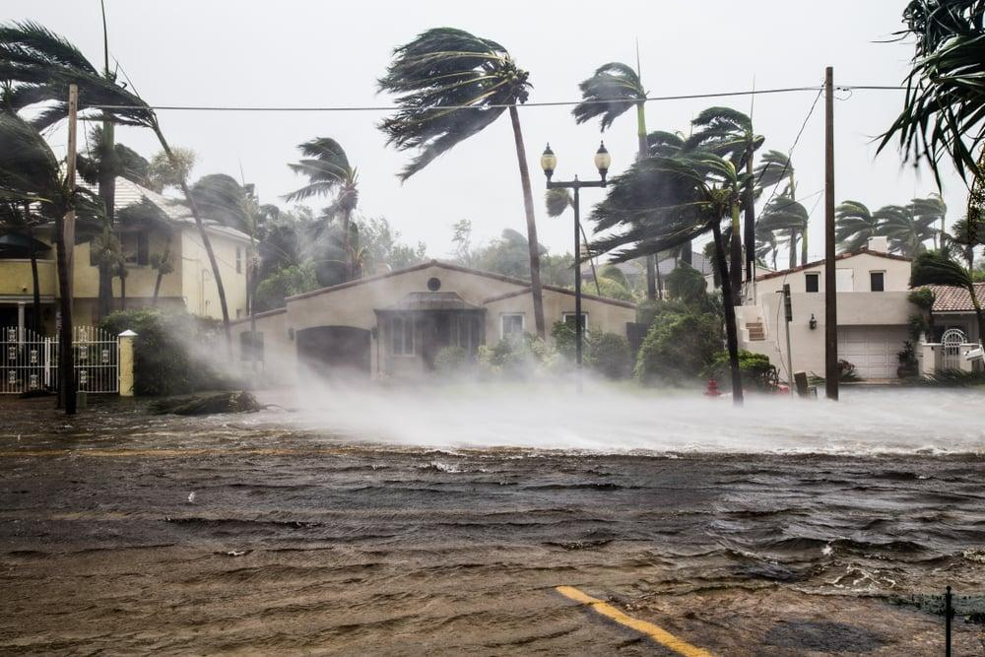
e. Assessment
- Teacher’s feedback.

2. ACTIVITY 1: VOCABULARY (4 mins)
a. Objectives:
- To introduce new words related to natural disasters.
- To help Ss develop the skill of listening for specific information.
- To help Ss further develop the skill of listening for specific information.
b. Content:
- Vocabulary pre-teach
- Task 1: Work in pairs. Look at the picture and answer the questions.
- Task 2: Listen to a broadcast. Put the activities in the correct column.
- Task 3: Listen again and tick T (True) or F (False) for each sentence.
c. Expected outcomes:
- Ss can answer the questions correctly.
- Ss can listen for specific information and do the learning tasks
d. Organisation
TEACHER AND STUDENTS’ ACTIVITIES | CONTENTS
Vocabulary pre-teaching
- Teacher introduces the vocabulary.  - Teacher explains the meaning of the new vocabulary, using pictures and translation.  - Teacher checks students’ understanding with the “Matching” technique. | New words:  1. authority (n)  2. warn (v)  3. avoid (v)
Task 1: Work in pairs. Look at the picture and answer the questions. (4 mins)
- Teacher asks Ss to work in pairs and look at the pictures carefully.  - Ss look at the pictures and answer the two questions.  - Teacher elicits the answers from Ss.  - Teacher invites some Ss to answer in front of the class. | Suggested answer:  A torch, a mask, a lamp, a whistle, a bottle of water, some medicine, matches, a radio, some plasters, a candle, a multi-purpose knife, some batteries, a blanket.
Task 2: Listen to a broadcast. Put the activities (1 – 6) in the correct column. (7 mins)
- Teacher tells Ss that they are going to listen to a broadcast in which instructions to prepare for a natural disaster are given.  - Teacher has them read the activities 1-6 and try to guess which activities go into which column.  - Teacher invites some Ss to share their answers and write them on the board.  - Teacher has Ss read the activities again and underline the key words.  - Teacher plays the recording and asks Ss to listen and put the activities in the correct columns.  - Ss work in pairs to compare their answers.  - Teacher asks Ss to compare their answers with the ones on the board.  - Teacher confirms whether they are right or wrong, playing the audio again if necessary. | Answer key:  - Before a storm: 2,6  - During a storm: 3,5  - After a storm: 1,4
Task 3. Listen again and tick T (True) or F (False) for each sentence. (7 mins)
- Teacher tells Ss that they are going to listen to the broadcast again and decide if the statements are true or false.  - Without playing the recording again, teacher has Ss read the statements and decide if they are true or false.  - Teacher plays the recording and asks Ss to listen again to check their answers.  - Teacher asks Ss to work in pairs to compare their answers.  - Teacher asks for Ss’ answers and confirms the correct ones. | Answer key:  1. F  2. T  3. F  4. T
e. Assessment
- Teacher’s observation and feedback

3. ACTIVITY 2: WRITING (15 mins)
a. Objectives:
- To brainstorm ideas and make an outline for Ss’ writing.
- To help Ss practise writing instructions about things to do before, during and after a flood.
b. Content:
- Task 4: Work in pairs. Discuss what you should do before, during, and after a flood. Write your ideas in the columns.
- Write instructions (80 - 100 words) about things to do before, during, and after a flood.
c. Expected outcomes:
- Ss can write instructions about things to do before, during, and after a flood.
d. Organisation
TEACHER AND STUDENTS’ ACTIVITIES | CONTENTS
Task 4: Work in pairs. Discuss what you should do before, during, and after a flood. Write your ideas in the columns. (5 mins)
- Teacher asks Ss to work in pairs.  - Ss discuss what they should do before, during and after a flood.  - Ss write their ideas in the columns.  - Teacher has some Ss present their ideas.  - Teacher comments on their answers. |  | 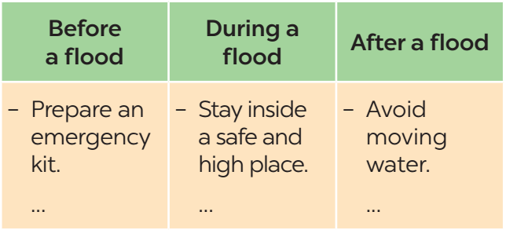
Task 5: Write instructions (80 - 100 words) about things to do before, during, and after a flood. (10 mins)
- Teacher asks Ss to work individually and write their instructions based on their answers in task 4.  - Teacher asks one student to write his/ her answer on the board. Other Ss and teacher comment on the writing on the board. |  | Suggested answer:  Here are the things you should do before, during, and after a ﬂood.  Before:  – Prepare an emergency kit with necessary things.  – Build barriers to stop ﬂoodwater from entering the house.  – Move to a higher place if necessary.  During:  – Listen to the radio or television for warnings and information.  – Be careful with ﬂash ﬂooding.  After:  – Avoid moving water.  – Stay away from damaged areas unless the local authority needs your help.  – Listen for local warnings of ﬂash ﬂoods.
e. Assessment
- Teacher’s observation and feedback.

4. CONSOLIDATION (3 mins)
a. Wrap-up
- Teacher asks Ss to summarise the main points of the lesson.
b. Homework
- Learn by heart all the words that they have just learnt.
- Rewrite the instructions.
- Do exercises in the workbook.
- Prepare for Lesson 7 – Looking back + Project.

Board Plan
Date of teaching ……..

UNIT 9: NATURAL DISASTERS
Lesson 6: Skills 2

*Warm-up

* Listening
Vocabulary
1. authority (n)
2. warn (v)
3. avoid (v)

Task 1: Look at the picture and answer the questions.
Task 2: Listen and put the activities in the correct column.
Task 3: Listen and tick.

* Speaking
Task 4: Discuss and write your ideas.
Task 5: Write instructions.

*Homework

UNIT 9: NATURAL DISASTERS
Lesson 7: Looking back & Project

I. OBJECTIVES
By the end of this lesson, students will be able to:
1. Knowledge:
- Revise more vocabulary items they have learnt in the unit.
- Revise the differences between the past simple and past continuous.
- Revise the past continuous.
- Have an opportunity to research more deeply into a natural disaster.
2. Core competence:
- Develop communication skills and creativity.
- Be collaborative and supportive in pair work.
- Actively join in class activities
3. Personal qualities
- Develop awareness of Natural disasters.
- Be concerned and know what to prepare when natural disasters happen.

II. MATERIALS
- Grade 8 textbook, Unit 9- Looking back & Project
- Computer connected to the Internet
- Projector / TV
- hoclieu.vn

Assumption
Anticipated difficulties | Solutions
Students may not have sufficient speaking, writing and co-operating skills when doing project. | - Encourage students to work in pairs, in groups so that they can help each other.  - Provide feedback and help if necessary.

III. PROCEDURES
1. WARM-UP (5 mins)
a. Objectives:
- To create an active atmosphere in the class before the lesson.
- To lead into the new lesson.
b. Content:
- Mind map
c. Expected outcomes:
- Ss can tell the teacher what they have learnt in unit 9.
d. Organisation
TEACHER AND STUDENTS’ ACTIVITIES | CONTENTS
- Teacher writes on the board “Unit 9” and asks students to think of what they have already learnt in this unit.  - Students work in groups to do the task.  - Teacher calls some students to retell.  - Teacher confirms and leads them to do all the exercises in books. | Suggested answer:  - Vocabulary: about the natural disasters  - Pronunciation: stress in words ending in -al and -ous  - Grammar: The past continuous
e. Assessment
- Teacher’s feedback.

2. ACTIVITY 1: VOCABULARY (10 mins)
a. Objectives:
- To help Ss revise the vocabulary they have learnt in the unit through pictures.
- To help Ss revise more vocabulary items they have learnt in the unit in different contexts.
b. Content:
- Task 1: Write the name of a natural disaster in each blank.
- Task 2: Fill in each blank with the correct form of the word in brackets.
c. Expected outcomes:
- Ss can use the words they have learnt in different contexts.
d. Organisation
TEACHER AND STUDENTS’ ACTIVITIES | CONTENTS
Task 1: Write the name of a natural disaster in each blank. (5 mins)
- Teacher asks Ss to work individually, read the sentences and look at the pictures.  - Ss write the name of a natural disaster in each blank.  - Teacher asks Ss to compare their answers with a partner.  - Teacher calls some Ss to share their answers.  - Teacher confirms the correct answers as a class. |  | Answer key:  1. flood  2. storm  3. earthquake  4. volcanic eruption  5. landslide
Task 2. Fill in each blank with the correct form of the word in brackets. (5 mins)
- Teacher asks Ss to work individually and read 5 sentences carefully.  - Ss complete the sentences using the correct form of the words given.  - Teacher asks Ss to share their answers with a partner.  - Teacher invites some Ss to write their answers on the board.  - Teacher confirms the correct answers. |  | Answer key:  1. destruction  2. predictions  3. victims  4. warned  5. workers
e. Assessment
- Teacher’s observation and feedback

3. ACTIVITY 2: GRAMMAR (10 mins)
a. Objectives:
- To help Ss revise the differences between the past simple and past continuous.
- To help Ss revise the past continuous by completing the sentences about them and their family members.
b. Content:
- Task 3: Put the verbs into the correct tense: the past simple or past continuous.
- Task 4: Complete the sentences about you and your family members.
c. Expected outcomes:
Students can differentiate between the past simple and past continuous.
d. Organisation
TEACHER AND STUDENTS’ ACTIVITIES | CONTENTS
Task 3: Put the verbs into the correct tense: the past simple or past continuous. (5 mins)
- Teacher asks Ss to work individually and read the sentences carefully.  - Ss give the correct form of the verbs (the simple past or past continuous).  - Teacher asks them to compare their answers with a partner.  - Teacher confirms the correct answers as a class. |  | Answer key:  1. were … doing  2. destroyed  3. was watering; came  4. were calling; appeared  5. Were … listening
Task 4: Complete the sentences about you and your family members. (5 mins)
- Teacher asks Ss to work individually and write sentences about their family members, using the past continuous.
- Teacher asks Ss to compare their sentences with a partner.
- Teacher invites some Ss to write their sentences on the board.
- Teacher comments on their answers.
e. Assessment
- Teacher’s observation and feedback

4. ACTIVITY 3: PROJECT (15 mins)
a. Objectives:
- To provide Ss with an opportunity to research more deeply into a natural disaster.
b. Content:
- Present the poster to the class.
c. Expected outcomes:
- Ss can research more deeply into a natural disaster.
d. Organisation
TEACHER AND STUDENTS’ ACTIVITIES | CONTENTS
What do we know about it?  - Ask Ss to read the instructions again (T has already assigned the project since the first lesson of the Unit and checked their progress after each lesson).  - Let students have some time to check their posters for the final time and make any adjustments if necessary.  - T has groups show their posters and present them to the class. | 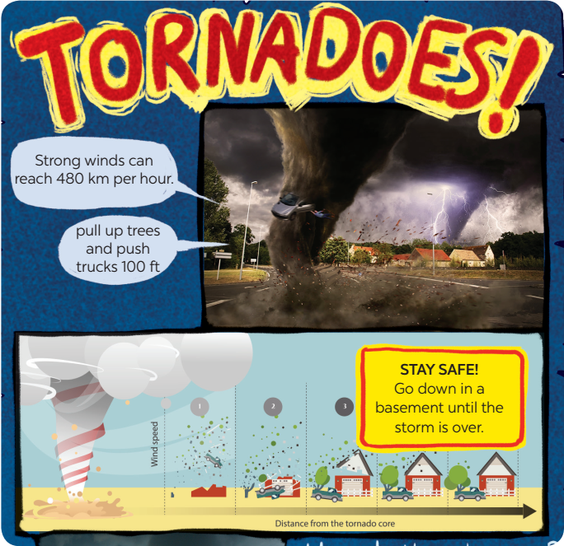
e. Assessment
- T checks ss’ grammatical and spelling mistakes on their poster, listens to their presentation, and gives feedback.

5. CONSOLIDATION (3 mins)
a. Wrap-up
- Teacher asks Ss to summarise the main points of the lesson.
b. Homework
- Do exercises in the workbook.
- Prepare for Unit 10 – Getting started

Board Plan
Date of teaching ……..

UNIT 9: NATURAL DISASTERS
Lesson 7: Looking back & Project

*Warm-up

* Vocabulary
Task 1: Write the name of a natural disaster.
Task 2: Fill in each blank.

* Grammar
Task 3: Put the verbs into the correct tense.
Task 4: Complete the sentences.

* Project

*Homework

