UNIT 4: ETHNIC GROUPS OF VIET NAM
Lesson 1: Getting started – I’m from the Tay ethnic group

I. OBJECTIVES
By the end of this lesson, Ss will be able to:
1. Knowledge
- Gain an overview about the topic Ethnic groups of Viet Nam
- Gain vocabulary to talk about Ethnic groups of Viet Nam
2. Competences
- Develop communication skills and creativity
- Be collaborative and supportive in pair work and teamwork
- Actively join in class activities
3. Personal qualities
- Love our country and people, respect the diversity of our culture through knowledge and understanding about ethnic groups of Viet Nam

II. MATERIALS
- Grade 8 textbook, Unit 4: Getting started
- Computer connected to the Internet
- Projector / TV
- hoclieu.vn

Language analysis
Form | Pronunciation | Meaning | Vietnamese equivalent
1. ethnic (adj) (group) | /ˈeθnɪk / (/gru:p/) | relating or belonging to a group of people who can be seen as different. | (nhóm) dân tộc
2. post (n) | /pəʊst/ | a vertical stick or pole stuck into the ground | cột
3. overlook (v) | /ˌəʊ.vəˈlʊk/ | provide a view of something | nhìn ra
4. stilt house (n) | /stilt haus/ | ​a house with a set of long pieces of wood or metal used to support it | nhà sàn
5. costume (n) | /'kɔstju:m/ | the set of clothes typical of a particular country | trang phục
6. terraced field (n) | /ˈterəst fiːld / | a row of fields like steps on a slope | ruộng bậc thang

Assumption
Anticipated difficulties | Solutions
Ss may lack experience of group work. | - Encourage Ss to work in groups so that they can help one another.  - Give short, clear instructions, and help if necessary.
Students may lack vocabulary to deliver a speech. | - Explain expectations for each task in detail.  - Continue to explain task expectations in small chunks (before every activity).  - Provide vocabulary and useful language before assigning tasks.  - Encourage students to work in groups so that they can help each other.

III. PROCEDURES
1. WARM-UP (5 mins)
a. Objectives:
- Introduce the new lesson and set the scene for Ss to acquire new language;
- Get students' attention at the beginning of the class by enjoyable and short activities as well as to engage them in the follow-up steps.
b. Content:
- Introduce the names of some ethnic groups
c. Expected outcomes:
- Ss have general ideas about the topic Ethnic groups of Viet Nam.
d. Organisation
TEACHER’S AND STUDENTS’ ACTIVITIES | CONTENTS
- Teacher asks Ss to work in 2 groups and think of some ethnic groups in Viet Nam.  - Teacher writes the name of one ethnic group as a modelling activity.  - Ss (one by one) go to the board and write the names of ethnic groups in Viet Nam that they know.  - Teacher checks Ss’ results.  - The group with more correct names of ethnic groups in Viet Nam becomes the winner. | Network:  Tay  Ethnic groups  Suggested answers:  Tay, Nung, Dao, Kinh, Brau, Hani, Hmong, Bahnar, Bru, Muong, Koho, Giay, …
e. Assessment
- Teacher’s feedback.

2. ACTIVITY 1: PRESENTATION (7 mins)
a. Objectives:
- Ss know words about ethnic groups of Viet Nam.
b. Content:
- Vocabulary pre-teaching
c. Expected outcomes:
- Ss know how to pronounce the new words correctly and use them in appropriate situations.
d. Organisation
TEACHER’S AND STUDENTS’ ACTIVITIES | CONTENTS
Vocabulary pre-teaching  - Teacher introduces the vocabulary.  - Teacher explains the meaning of the new vocabulary, using pictures and translation.  - Teacher checks students’ understanding with the “Matching” technique.  - Teacher reveals that these words will appear in the reading text and asks students to open their textbook to discover further. | New words:  1. ethnic (adj) (group)  2. post (n)  3. overlook (v)  4. stilt house (n)  5. costume (n)  6. terraced field (n)
e. Assessment
- Teacher checks students’ pronunciation and gives feedback.

3. ACTIVITY 2: PRACTICE
a. Objectives:
- To have Ss get specific information from the text.
- Students can develop their reading and listening skills.
- To develop Ss’ vocabulary related to the topic.
b. Content:
- Task 1: Listen and read.
- Task 2: Read the conversation again and circle the correct answers.
- Task 3: Match the pictures with the word and phrases from the conversation.
- Task 4: Complete the sentences with the words and phrases from the box.
c. Expected outcomes:
- Students can read and get general and specific information about the Tay ethnic group to complete the tasks.
d. Organisation
TEACHER AND STUDENTS’ ACTIVITIES | CONTENTS
Task 1: Listen and read. (8 mins)
- Teacher asks Ss to look at the title and the picture in the book then answer the questions.  - Ss answer the questions in pairs.  - Teacher plays the recording twice. Ss listen and read.  - Teacher asks some pairs of students to read the conversation aloud.  - Teacher asks Ss if they would like to change or add anything to their previous answers. | Questions:  - What do you think Lai and Tom are talking about?  - Do you know anything about the Tay ethnic group?  Suggested answers:  - They are talking about the Tay ethnic group/ an ethnic group/…
Task 2: Read the conversation again and circle the correct answers. (5 mins)
- Teacher tells Ss to read the conversation again and work independently to find the answers.  - Ss work independently to find the best answers.  - Teacher has Ss compare the answers in pairs before checking with the whole class.  - Teacher checks the answers as a class and gives feedback. | Answer key:  1. C  2. B  3. A
Task 3: Match the pictures with the word and phrases from the conversation. (5 mins)
- Teacher asks Ss to look at the pictures and read the word and phrases.  - Ss work individually to match the word and phrases with the pictures.  - Ss compare their answers with a partner.  - Teacher checks the answers as a class and gives feedback. | Answer key:  1. c  2. a  3. d  4. b
Task 4. Complete the sentences with the words and phrases from the box. (5 mins)
- Teacher asks Ss to read 5 sentences (with gaps) carefully.  - Ss work independently to fill in each blank with a suitable word or phrase from the box.  - Teacher checks the answers as a class and gives feedback. | Answer key:  1. folk dance  2. overlooks  3. musical instrument  4. traditional  5. ethnic groups
e. Assessment
- T’s observation and feedback.

4. ACTIVITY 3: FURTHER PRACTICE (7 mins)
a. Objectives:
- Ss can locate the living places of some large ethnic groups in Viet Nam
b. Content:
- Task 5: Game: Where are they?
c. Expected outcomes:
- Ss have a better understanding of ethnic groups in Viet Nam and can locate some of their living places
d. Organisation

TEACHER’S AND STUDENTS’ ACTIVITIES | CONTENTS
Task 5: Game “Where are they?”
Work in groups. Discuss and label the map with the names of the ethnic groups from the box. The first team to get all the correct answers win.
- Teacher asks Ss to work individually, look at the map and read the words carefully.  - Teacher divides the class into 2 teams.  - Teacher asks Ss to play the game in 2 minutes.  - Ss from 2 teams (one by one) go to the board and write one name for each number.  - The team with more correct answers wins. | Answer key:  1. Hmong  2. Nung  3. Ede  4. Bahnar  5. Khmer  6. Cham
e. Assessment
- T’s feedback.

4. CONSOLIDATION: (3 mins)
a. Wrap-up
- Teacher shows some ethnic groups on the projector.
- Teacher asks Ss to say the words related to ethnic groups from the lesson that they can remember.
b. Homework
- Learn by heart all the words that they have just learnt
- Do exercises in the workbook.
- Start preparing for the Project of the unit:
Teacher randomly puts Ss in groups of 4 or 5 and asks them to choose an ethnic group in Viet Nam that they are most interested in and make a poster about it (suggested information in Project lesson). Students will show and present their posters in Lesson 7 – Looking back and Project. (Teacher should check the progress of students’ preparation after each lesson.)

Board Plan

Date of teaching ……..
Unit 4: Ethnic groups of Viet Nam
Lesson 1: Getting started

*Warm-up

* Vocabulary
1. ethnic (adj) (group)
2. post (n)
3. overlook (v)
4. stilt house (n)
5. costume (n)
6. terraced field (n)

Task 1: Listen and read.
Task 2: Read the conversation again and circle the correct answers.
Task 3: Match the pictures with the word and phrases from the conversation.
Task 4: Complete the sentences with the words and phrases from the box.
Task 5: Game: Where are they?

*Homework

UNIT 4: ETHNIC GROUPS OF VIET NAM
Lesson 2: A closer look 1

I. OBJECTIVES
By the end of this lesson, students will be able to gain:
1. Knowledge:
- Vocabulary: The lexical items related to the life of the ethnic people.
- Pronunciation: Correctly pronounce words that contain the sounds /k/ and /g/
2. Core competence:
- Develop communication skills and creativity
- Be collaborative and supportive in pair work and teamwork
- Actively join in class activities
3. Personal qualities
- Respect ethnic groups of Viet Nam and their culture
- Develop self-study skills.

II. MATERIALS
- Grade 8 textbook, A closer look 1
- Computer connected to the Internet
- Projector / TV
- hoclieu.vn

Language analysis
Form | Pronunciation | Meaning | Vietnamese equivalent
1. communal house (n) | /kəˈmjuːnəl haʊs/ | a house for community meetings and events. | nhà rông, nhà sinh hoạt cộng đồng.
2. minority (n) | /maɪˈnɔːrəti gru:p/ | the smaller part of a group; less than half of the people or things in a large group | dân tộc thiểu số
3. livestock (n) | /ˈlaɪvstɒk/ | animals and birds that are kept on a farm, such as cows, sheep, or chickens | gia súc
4. raise (v) | /reiz/ | to take care of a person, or an animal or plant, until they are completely grown | chăn nuôi
5. gong (n) | /ɡɒŋ/ | a round piece of metal that is hung in a frame and hit  with a stick to produce a  sound as a signal | cái cồng, cái chiêng

Assumption
Anticipated difficulties | Solutions
1. Students may lack experience of group/ teamwork. | Encourage students to work in groups so that they can help each other.
2. Students may not have sufficient listening, speaking and co-operating skills. | - Play the recording, the replay depends on the students’ need and level.  - Encourage students to work in pairs, in groups so that they can help each other.  - Teacher gives feedback and help if necessary.

III. PROCEDURES
1. WARM-UP (5 mins)
a. Objectives:
- To create an active atmosphere in the class before the lesson.
- To lead into the new lesson.
b. Content:
- Kim’s game.
c. Expected outcomes:
- Ss review words about ethnic groups in Viet Nam.
d. Organisation

TEACHER AND STUDENTS’ ACTIVITIES | CONTENTS
- Teacher asks Ss to work in 2 groups.  - Teacher shows some pictures related to ethnic groups in 2 minutes.  - Ss look at the pictures and remember (no writing)  - As soon as teacher stops showing the pictures, Ss work in groups and write the words for the pictures they have seen  - The group with more correct answers becomes the winner. | Kim’s game:  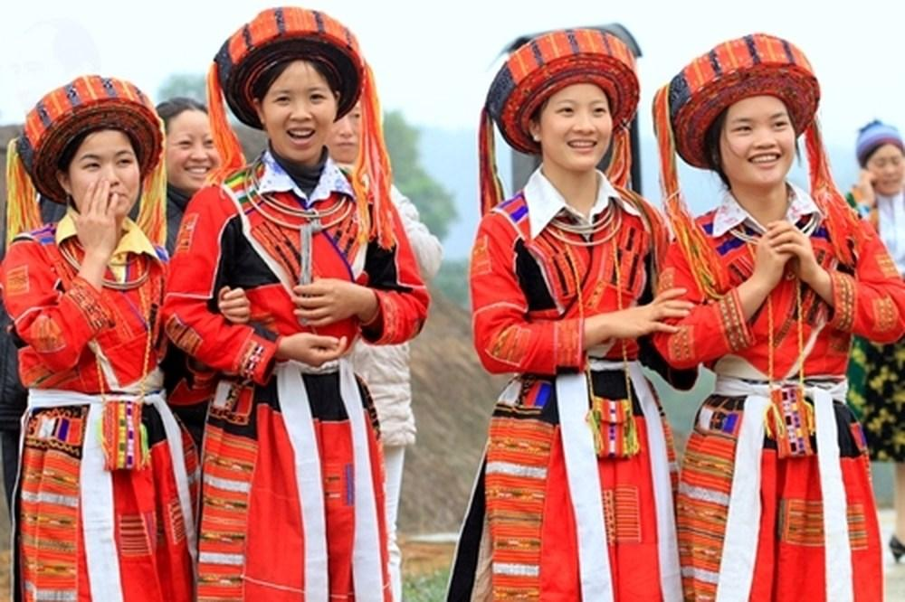  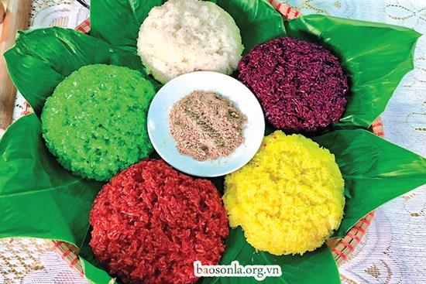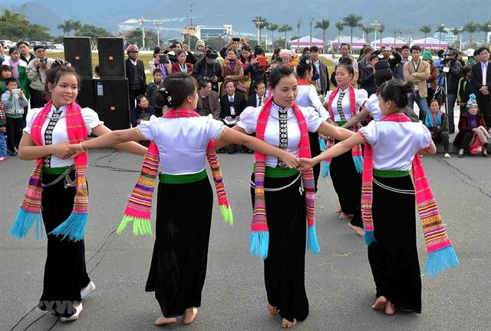  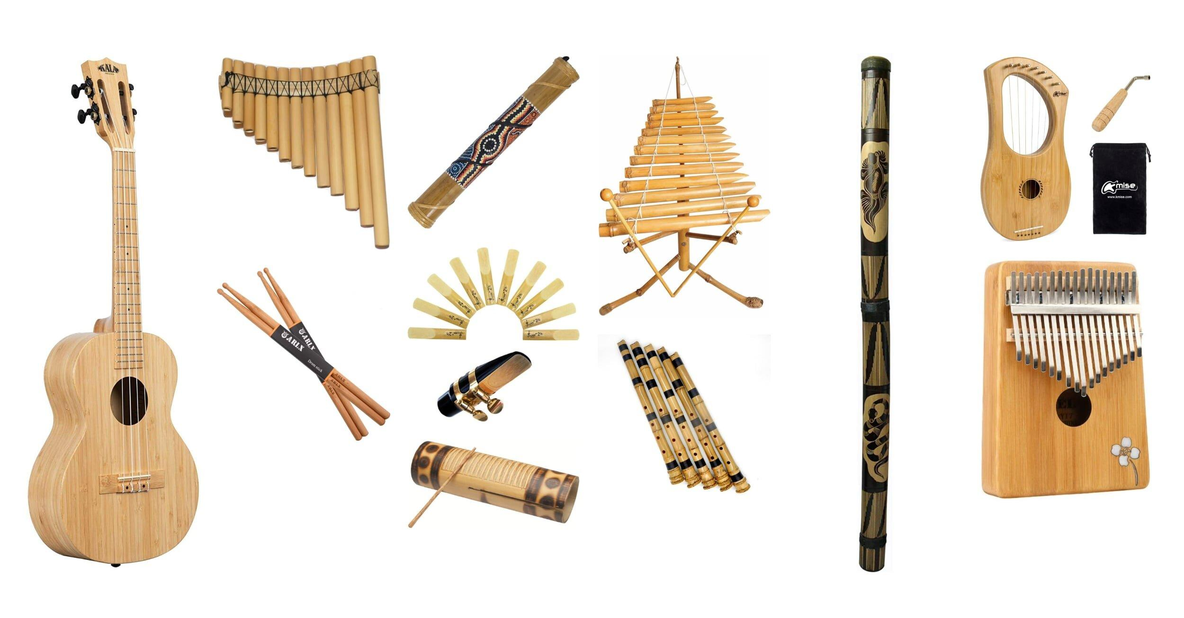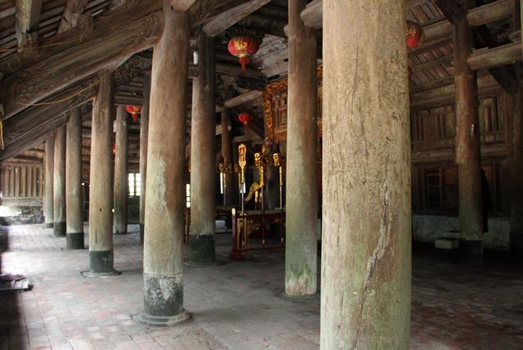    Suggested answers:  (a) bamboo house, costume(s), five-colour sticky rice, folk dance, musical instrument(s), post(s), stilt house, terraced field(s)
e. Assessment
- Teacher’s feedback.

2. ACTIVITY 1: VOCABULARY (23 mins)
a. Objectives:
- To introduce new words related to the life of the ethnic people.
- To help Ss understand more clearly the meaning of some words and phrases.
- To help Ss use the words in specific contexts.
b. Content:
- Task 1: Write a word or phrase from the box under each picture.
- Task 2: Match the words and phrases with their meanings.
- Task 3: Complete the sentences with the words and phrases from the box.
c. Expected outcomes:
- Ss can pronounce the new words correctly and use them in appropriate situations.
- Ss understand more clearly the meaning of some words and phrases.
- Ss use the words in specific contexts.
d. Organisation

TEACHER’S AND STUDENTS’ ACTIVITIES | CONTENTS
Vocabulary pre-teaching (6 mins)
- Teacher introduces the vocabulary.  - Teacher explains the meaning of the new vocabulary, using pictures and translation.  - Teacher checks students’ understanding with the “What and where?” technique. | New words:  1. communal house (n)  2. minority (n)  3. livestock (n)  4. raise (v)  5. gong (n)
Task 1: Write a word or phrase from the box under each picture. (5 mins)
- Teacher asks Ss to look at each picture and say the word or phrase describing it if they know.  - Teacher asks Ss to read the phrases and do the matching.  - Ss work individually, choose the suitable word/ phrase and write it under each picture.  - Teacher checks the answers as a class. |  | Answer key:  1. wooden statue  2. Rong house  3. weaving  4. bamboo flute  5. gong  6. terraced fields
Task 2: Match the words and phrases with their meanings. (5 mins)
- Teacher asks Ss to read the words and phrases that have been provided.  - Teacher guides Ss if needed.  - Ss work individually, match suitable words/ phrases with their meanings.  - Teacher checks the answers as a class. |  | Answer key:  1. c  2. a  3. e  4. d  5. b
Task 3: Complete the sentences with the words and phrases from the box. (7 mins)
- Teacher asks Ss to read the words/ phrases and the sentences carefully.  - Teacher asks Ss to work in pairs, discuss and choose suitable words/ phrases to fill in the gaps.  - Ss do the task in pairs.  - Ss go to the board and write their answers.  - Teacher checks the answers as a class. |  | Answer key:  1. unique features  2. weave  3. raise  4. communal house  5. minority group  6. livestock
e. Assessment
- Teacher’s observation and feedback.

3. ACTIVITY 2: PRONUNCIATION (12 mins)
a. Objectives:
- To help students identify how to pronounce the sounds /k/ and /g/.
- To help students practise pronouncing these sounds correctly in words and in sentences.
b. Content:
- Task 4: Listen and repeat the words. Pay attention to the sounds /k/ and /g/.
- Task 5: Listen and repeat the sentences. Pay attention to the underlined words.
c. Expected outcomes:
- Ss can distinguish and pronounce the sound /k/ and /g/correctly in their speaking.
d. Organisation

TEACHER AND STUDENTS’ ACTIVITIES | CONTENTS
Task 4: Listen and repeat the words. Pay attention to the sounds /k/ and /g/. (7 mins)
- Teacher plays the recording (Track 21).  - Teacher asks Ss to listen and pay attention to the sounds /k/ and /g/.  - Ss repeat the words as a class, in groups and individually.  - Teacher plays the recording as many times as necessary. | 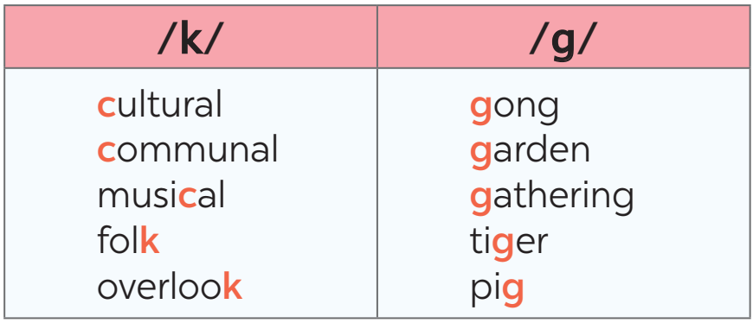
Task 5: Listen and repeat the sentences. Pay attention to the underlined words. (5 mins)
- Teacher plays the recording (Track 22).  - Teacher asks Ss to listen and pay attention to the underlined words with the sounds /k/ and /g/.  - Ss repeat the sentences as a class, in groups and individually.  - Teacher plays the recording as many times as necessary.  - Teacher asks some students to read the sentences individually. | 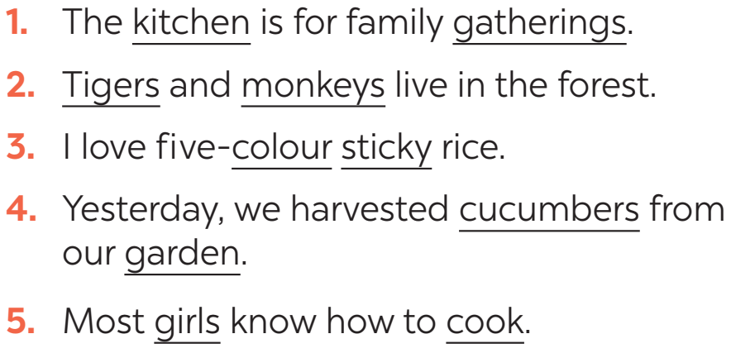
e. Assessment
- Teacher’s observation and feedback.

4. CONSOLIDATION (5 mins)
a. Wrap-up
- Teacher asks Ss to retell the main points of the lesson.
b. Homework
- Learn by heart all the words that they have just learnt.
- Do exercises in the workbook.
- Prepare for Lesson 3 - A closer look 2

Board Plan

Date of teaching
Unit 4: Ethnic groups of Viet Nam
Lesson 2: A closer look 1

*Warm-up

* Vocabulary
1. communal house (n)
2. minority group (n)
3. livestock (n)
4. raise (v)
5. gong (n)
Task 1: Write a word or phrase from the box under each picture.
Task 2: Match the words and phrases with their meanings.
Task 3: Complete the sentences with the words and phrases from the box.

* Pronunciation
Task 4: Listen and repeat the words. Pay attention to the sounds /k/ and /g/.
Task 5: Listen and repeat the sentences. Pay attention to the underlined words.

*Homework

UNIT 4: ETHNIC GROUPS OF VIET NAM
Lesson 3: A closer look 2

I. OBJECTIVES
By the end of this lesson, students will be able to gain:
1. Knowledge:
- Vocabulary:
The lexical items related to the life of the ethnic people.
- Grammar:
+ Yes / No and WH-questions.
+ Countable and uncountable nouns.
2. Core competence:
- Develop communication skills and creativity
- Be collaborative and supportive in pair work and teamwork
- Actively join in class activities
3. Personal qualities
- Respect ethnic groups of Viet Nam and their culture
- Develop self-study skills

II. MATERIALS
- Grade 8 textbook, Unit 4: A closer look 2
- Computer connected to the Internet
- Projector / TV
- hoclieu.vn

Language analysis
Form | Pronunciation | Meaning | Vietnamese equivalent
1. harvest (v) | /ˈhɑːvɪst/ | to pick and collect crops | gặt hái, thu hoạch
2. crop (n) | /krɒp/ | a plant that is grown in large  quantities | vụ mùa, vụ trồng trọt
3. waterwheel (n) | /ˈwɔːtəwiːl/ | a wheel with buckets attached to its rim; raises water from a stream or pond | bánh xe nước

Assumption
Anticipated difficulties | Solutions
1. Some Ss may not remember how to change sentences into Yes / No and Wh-questions. | Remind them quickly how to change sentences into Yes / No and Wh-questions.
2. Ss may not have sufficient co-operating skills. | - Give clear instructions, give examples before letting Ss work in groups.  - Provide feedback and help if necessary.

III. PROCEDURES
1. WARM-UP (5 mins)
a. Objectives:
- To create an active atmosphere in the class before the lesson.
- To lead into the new lesson.
b. Content:
- Game: Who is faster?
c. Expected outcomes:
- Ss can recall words related to ethnic groups in Viet Nam.
d. Organisation
TEACHER AND STUDENTS’ ACTIVITIES | CONTENTS
- Teacher divides Ss into 4 groups.  - Teacher gives each group a piece of paper.  - Teacher asks them to write as many words (nouns) related to ethnic groups of Viet Nam as possible.  - Each group chooses one secretary to write the words that other members tell him/ her.  - Ss play the game in 3 minutes.  - Teacher asks each group to hand in their papers and checks, the group with the most correct words is the winner. Teacher invites the winner to read aloud their words.  - Teacher gives feedback. | Who is faster?  Suggested answers:  gong, communal house, wooden statue, folk dance, musical instrument, bamboo house, costume, five-colour sticky rice, stilt house, terraced field,...
e. Assessment
- Teacher’s feedback.

2. ACTIVITY 1: YES / NO AND WH-QUESTION (12 mins)
a. Objectives:
- To introduce new words related to the life of the ethnic people
- To help students revise the form of Yes / No questions and the use of Wh-question words.
b. Content:
- Vocabulary
- Task 1: Change the sentences into Yes / No questions.
- Task 2: Choose the correct question word for each question below.
c. Expected outcomes:
- Ss know how to form Yes / No questions and the use of Wh-question words.
d. Organisation
TEACHER AND STUDENTS’ ACTIVITIES | CONTENTS
Vocabulary pre-teach
Vocabulary:  - Teacher introduces the vocabulary.  - Teacher explains the meaning of the new vocabulary, using pictures and translation.  - Teacher checks students’ understanding with the “Rub out and remember” technique. |  | New words:  1. harvest (v)  2. crop (n)  3. waterwheel (n)
Task 1: Change the sentences into Yes / No questions. (7 mins)
- Teacher asks Ss to work individually and do the exercise.  - Teacher asks Ss to compare their answers with their friends.  - Ss discuss with their friends if there are any differences between their answers.  - Teacher checks students’ answers as a class.  - Teacher asks some Ss to read their answers. |  | Answer key:  1. Do women play an important role in a Jrai family?  2. Is mua sap a popular folk dance of the Thai people?  3. Did you have boarding schools for minority students in 1950?  4. Did you attend the Ban Flower Festival in Dien Bien last year?  5. Will you watch a documentary about the Khmer?
Task 2: Choose the correct question word for each question below. (5 mins)
- Teacher asks Ss to work individually.  - Teacher asks them to read the sentences carefully and decide which question word correctly fits in.  - Teacher calls on some Ss to give and explain their answers.  - Teacher checks and confirms the correct answers. |  | Answer key:  1. B  2. B  3. A  4. A  5. B
e. Assessment
- Teacher’s observation and feedback.

3. ACTIVITY 2: COUNTABLE AND UNCOUNTABLE NOUNS (13 mins)
a. Objectives:
- To help students identify countable and uncountable nouns and revise how to use a quantifier with a countable or uncountable noun.
b. Content:
- Task 3: Write C (countable) or U (uncountable) for the underlined words.
- Task 4: Fill in each blank with a, much, many, a little, or a few.
- Task 5: Work in groups. Think of six nouns related to each of the topics below, in which three nouns are countable and three nouns are uncountable.
c. Expected outcomes:
- Ss can identify countable and uncountable nouns and how to use a quantifier with a countable or uncountable noun.
d. Organisation

TEACHER’S AND STUDENTS’ ACTIVITIES | CONTENTS
Task 3: Write C (countable) or U (uncountable) for the underlined words. (7 mins)
- Teacher has a small revision of countable and uncountable nouns (what they are and how to identify them).  - Teacher gives some examples like cooking oil, road, ball, air,… and asks Ss which one they can count and which one they cannot.  - Teacher refers to the use of quantifiers that a countable or uncountable noun can go with through examples.  Eg: This is a ball.  There is a little cooking oil in the bottle.  - Teacher asks Ss to work individually and do the exercise.  - Teacher asks Ss to compare their answers in pairs.  - Ss discuss their answers if there are any differences.  - Teacher gets feedback and confirms the correct answers. |  | Answer key:  - Countable nouns: 1,3,4,6  - Uncountable nouns: 2,5
Task 4: Fill in each blank with a, much, many, a little, or a few. (6 mins)
- Teacher asks Ss to work individually.  - Ss read each sentence carefully and decide if the noun after the quantifier is countable or uncountable and if the sentence is affirmative, negative or interrogative. Then choose a suitable quantifier a, much, many, a little, or a few for each sentence.  - Teacher asks Ss to compare their answers with their partner.  - Teacher asks Ss to read their answers.  - Teacher confirms and checks answers. |  | Answer key:  1. a  2. many  3. a few  4. a little  5. much
Task 5: Work in groups. Think of six nouns related to each of the topics below, in which three nouns are countable and three nouns are uncountable. (5 mins)
- Teacher asks Ss to work in groups and choose one topic.  - Teacher allows Ss a certain amount of time to discuss and come up with the six words as required.  - Ss think of six nouns to the topic they choose in which three nouns are countable and three nouns are uncountable.  - Teacher calls on three quickest groups to read aloud their answers.  Topics:  + Leisure time  + Living in the mountains |  | Suggest words:  * Leisure time:  + Countable nouns: film, game, sport,…  + Uncountable nouns: music, gardening, reading,…  * Living in the mountains:  + Countable nouns: terraced field, stilt house, communal house,….  + Uncountable noun: five-colour sticky rice, nature, …
e. Assessment
- Teacher’s observation and feedback.

4. CONSOLIDATION (5 mins)
a. Wrap-up
- Teacher asks Ss to summarise the main points of the lesson.
b. Homework
- Learn by heart all the words that they have just learnt.
- Do exercises in the workbook.
- Prepare for Lesson 4 - Communication.

Board Plan

Date of teaching ……..

Unit 4: Ethnic groups of Viet Nam
Lesson 3: A closer look 2

*Warm-up

* Yes / No and Wh-questions
Vocabulary
1. harvest (v)
2. crop (n)
3. waterwheel (n)
Task 1: Change the sentences into Yes/ No questions.
Task 2: Choose the correct question word for each question below.

* Countable and uncountable nouns
Task 3: Write C or U for the underlined words.
Task 4: Fill in each blank with “a/ much/ many/ a little or a few”.
Task 5: Word games
*Homework

UNIT 4: ETHNIC GROUPS OF VIET NAM
Lesson 4: Communication

I. OBJECTIVES
By the end of this lesson, students will be able to gain:
1. Knowledge:
- Use the lexical items related to the life of the ethnic people.
- Give opinions about the lifestyle of ethnic minority groups.
- Ask and answer about the Jrai people.
2. Core competence:
- Develop communication skills and creativity
- Be collaborative and supportive in pair work and teamwork
- Actively join in class activities
3. Personal qualities
- Respect ethnic groups of Viet Nam and their culture
- Develop self-study skills

II. MATERIALS
- Grade 8 textbook, Unit 4: Communication
- Computer connected to the Internet
- Projector / TV
- hoclieu.vn

Language analysis
Form | Pronunciation | Meaning | Vietnamese equivalent
1. weave (v) | /wiːv/ | create a piece of cloth by interlacing strands of fabric, such as wool or cotton | dệt, đan
2. hunt (v) | /hʌnt/ | chase and try to catch and kill an animal or bird for food | săn, săn đuổi
3. role (n) | /rəʊl/ | the position that someone has in a situation, organisation, society or relationship. | vai trò
4. statue (n) | /ˈstætʃuː/ | an object made from a hard material, especially stone or metal, to look like a person or animal | tượng

Assumption
Anticipated difficulties | Solutions
Students may lack experience of group and pair work | - Encourage Ss to work in groups, in pairs so that they can help one another.  - Give short, clear instructions and help if necessary.

III. PROCEDURES
1. WARM-UP (5 mins)
a. Objectives:
- To create an active atmosphere in the class before the lesson.
- To lead into the new lesson.
b. Content:
- Kim’s game.
c. Expected outcomes:
- Ss can recall words related to ethnic groups in Viet Nam
d. Organisation

TEACHER’S AND STUDENTS’ ACTIVITIES | CONTENTS
- Teacher divides Ss into 4 groups.  - Teacher gives each group a piece of paper.  - Teacher shows 8 pictures about ethnic groups of Viet Nam in 2 minutes.  - Ss look at the pictures, guess the names of ethnic groups (without writing).  - Ss work in their group and write the names of ethnic groups in 2 minutes.  - Teacher asks 4 groups to exchange the posters.  - Teacher shows the answers and asks them to check.  - The group with the most correct words is the winner. | Kim’s game
  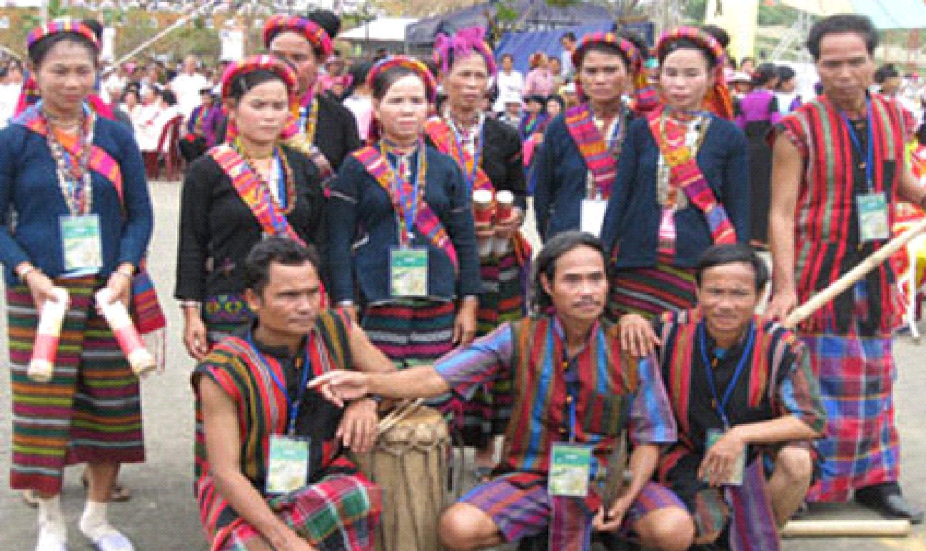  Brau | 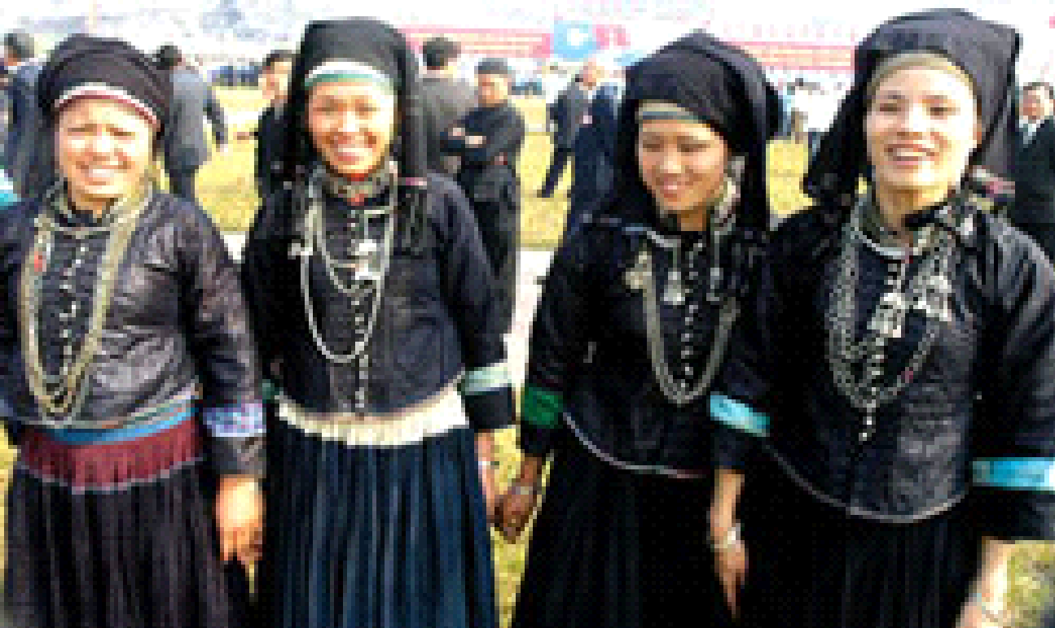  Nung
  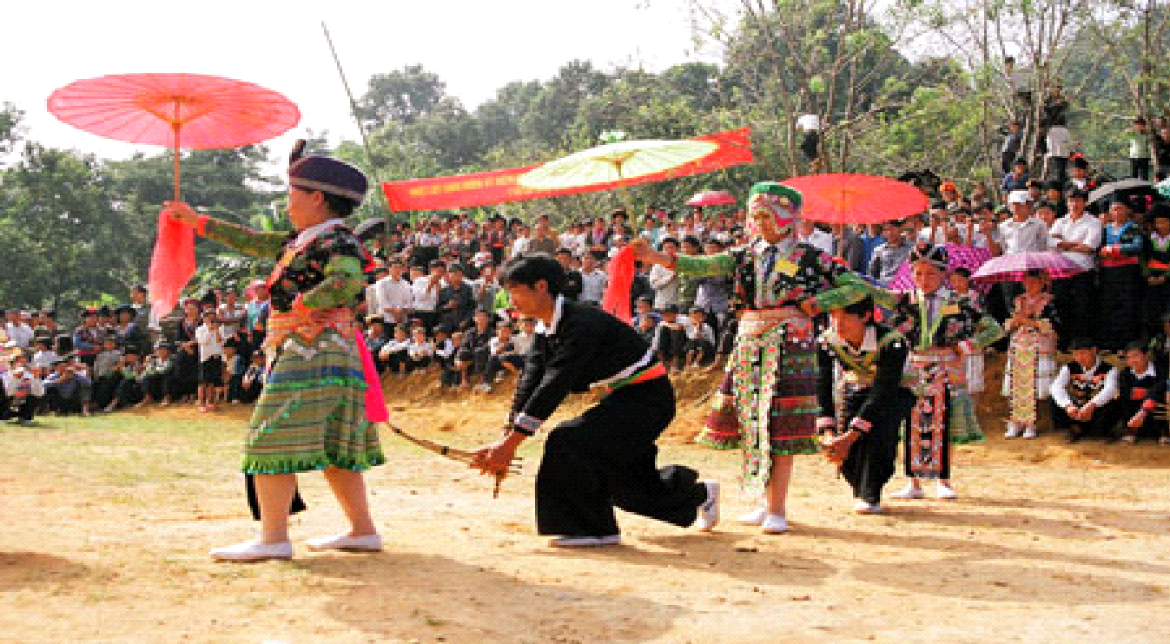  Hmong | 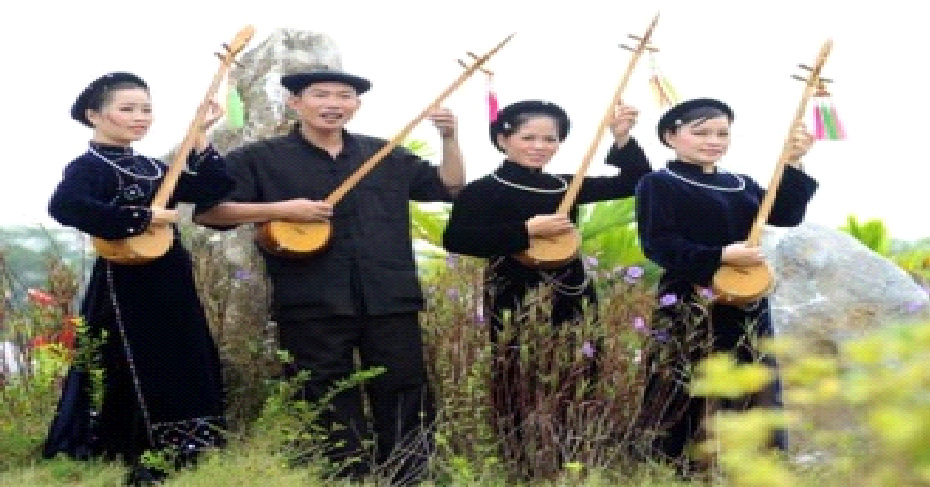  Tay
    Khmer | 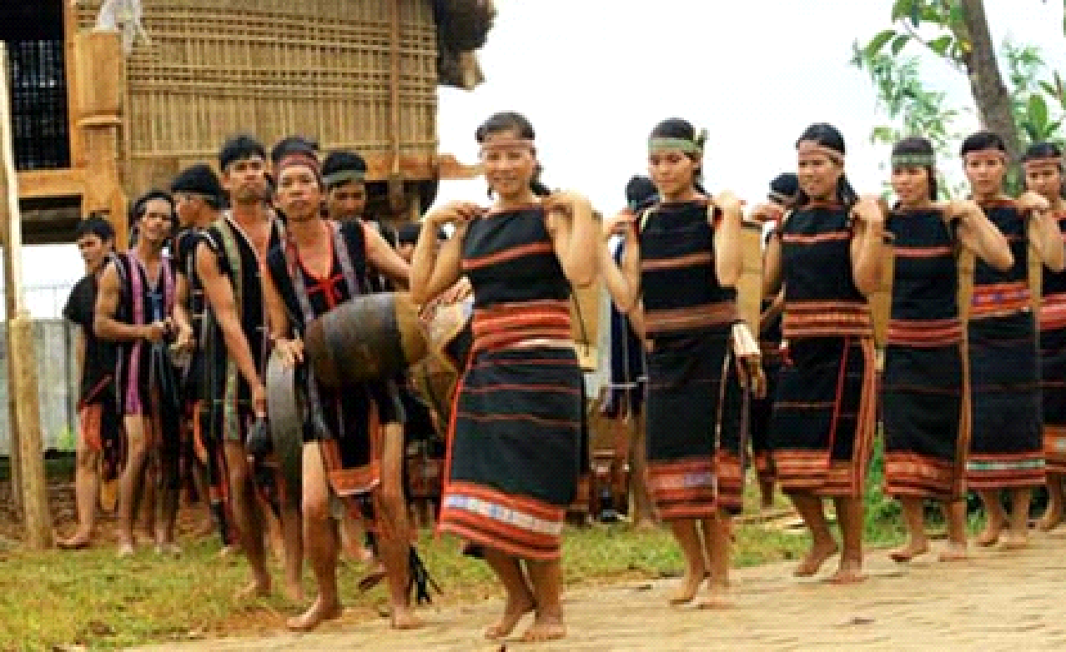  Ede
  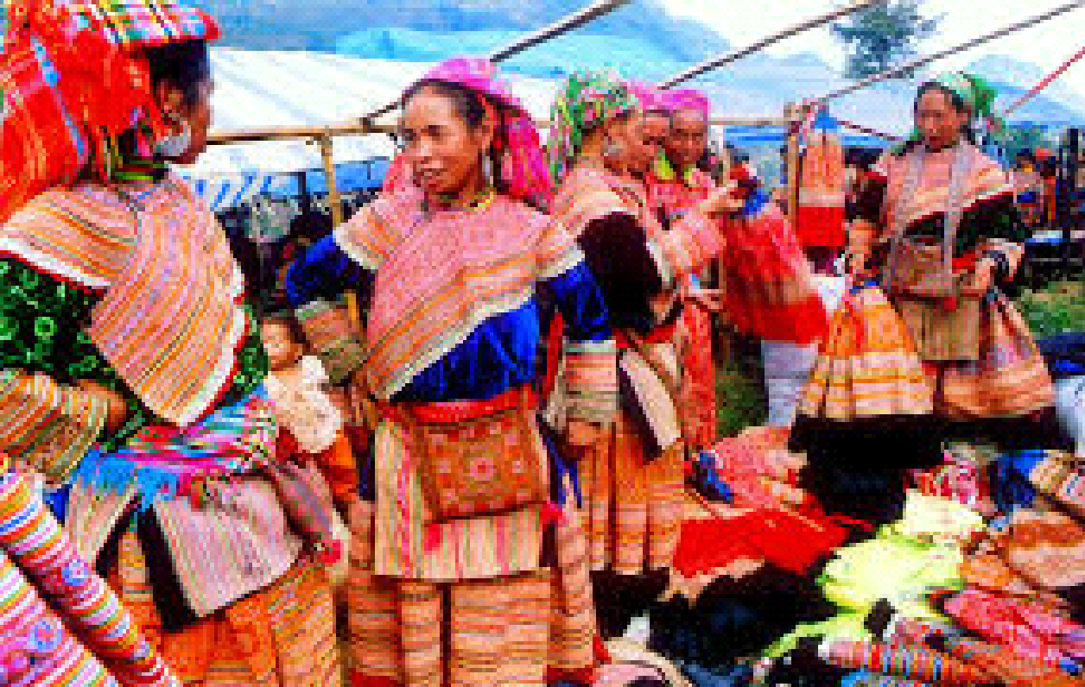  Hoa | 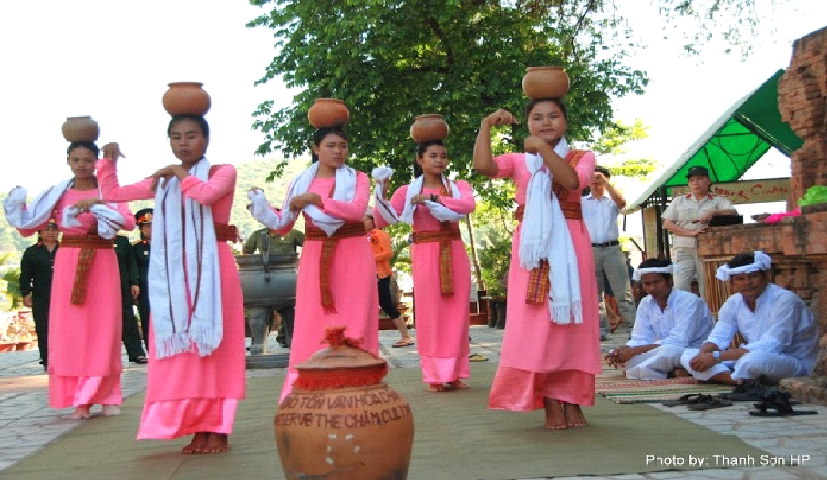  Cham
e. Assessment
- Teacher’s feedback.

2. ACTIVITY 1: EVERYDAY ENGLISH (18 mins)
a. Objectives:
- To introduce new words related to the life of the ethnic people.
- To introduce some ways to give opinions and allow Ss to practise.
b. Content:
- Vocabulary
- Task 1: Listen and read the conversation. Pay attention to the highlighted parts.
- Task 2: Work in pairs. Make a similar conversation to ask and give opinions about these topics.
c. Expected outcomes:
- Ss can use phrases/structures to give opinions in English.
d. Organisation

TEACHER’S AND STUDENTS’ ACTIVITIES | CONTENTS
Vocabulary (5 mins)
- Teacher introduces the vocabulary.  - Teacher explains the meaning of the new vocabulary, using pictures and translation.  - Teacher checks students’ understanding with the “What and where?” technique. | New words:  1. weave (v)  2. hunt (v)  3. role (n)  4. statue (n)
Task 1: Listen and read the conversation. Pay attention to the highlighted parts. (6 mins)
- Teacher asks Ss to listen and read along with the conversation. Teacher asks Ss to pay attention to the highlighted parts.  - Ss work individually, listen to the audio file and read along with the conversation.  - Teacher elicits the structures giving opinions.  - Teacher asks Ss to practise the conversation in pairs. | Structures to give opinions:  - I think …  - To my way of thinking …
Task 2. Work in pairs. Make a similar conversation to ask and give opinions about these topics. (7 mins)
- Teacher asks Ss to work in pairs to make conversations, using structures for giving opinions.  - Ss use the structures given and make similar conversations about the following topics:  + Playing traditional games.  + Living close to nature.  - Teacher asks some pairs to perform their conversations.  - Teacher comments on their performance. | Suggested conversation:  A: What do you think about playing traditional games?  B: I think/ To my way of thinking it’s …
e. Assessment
- Teacher’s observation and feedback

3. ACTIVITY 3: LIFESTYLE OF THE ETHNIC MINORITY GROUPS (18 mins)
a. Objectives:
- To provide students with more knowledge about the lifestyle of ethnic minority groups through a quiz.
- To give students some practice asking and answering about some information in the notes of Jrai people.
b. Content:
- Task 3: GAME: How much do you know about ethnic groups in Viet Nam?
- Task 4: Work in pairs. Read the notes below about the Jrai. Take turns to ask and answer about the information.
- Task 5: Work in groups. Share with your group the information about the Jrai people you find interesting.
c. Expected outcomes:
- Ss can identify the lifestyle of some ethnic minority groups.
- Ss can ask and answer about Jrai people based on an information note.
- Ss can share their opinions about the Jrai people’s lifestyle
d. Organisation

TEACHER’S AND STUDENTS’ ACTIVITIES | CONTENTS
Task 3: How much do you know about ethnic groups in Viet Nam? (6 mins)
- Teacher asks Ss to work individually, read the sentences carefully and choose the correct answers.  - Ss play the game in 3 minutes. (PPT slides)  Game “Who’s the millionaire?  - Teacher divides the class into 2 teams, explains the rules and lets them play the game.  - Each team has to answer the questions by choosing the best answer. The team with more points is the winner. |  | 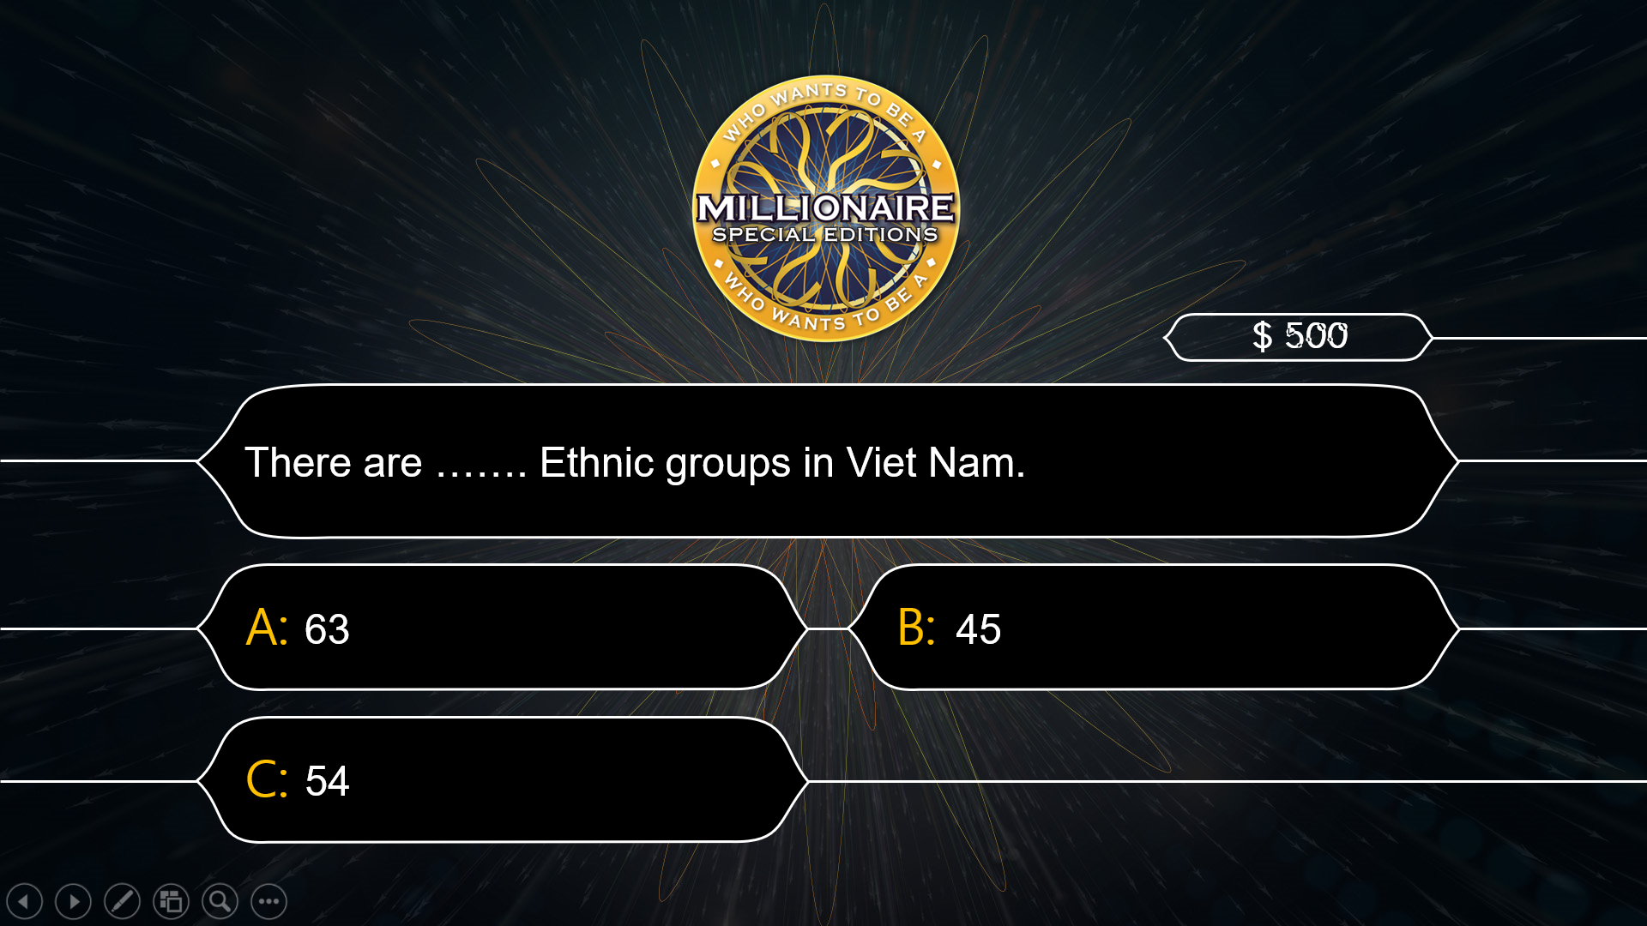  Answer key:  1. C  2. B  3. B  4. A  5. C  6. C
Task 4: Work in pairs. Read the notes below about the Jrai. Take turns to ask and answer about the information. (7 mins)
- Teacher asks Ss to work in pairs.  - Ss read each piece of information carefully and decide on the question they want to ask and the answer they would give.  - Teacher asks Ss to swap their roles of asking and answering.  - Teacher calls on 2-3 pairs to share their questions and answers.  - Teacher corrects them if needed. |  | Suggested questions and answers:  1. What is the population of the Jrai?  => It is about 513,930.  2. Where do they live?  => They live mainly in Gia Lai.  3. What type of house do they live in?  => They live in stilt houses.  4. What do they do for their living?  => They grow crops, weave, …
Task 5. Work in groups. Share with your group the information about the Jrai people you find interesting. (5 mins)
- Teacher asks Ss to work in groups.  - Teacher allows Ss some time to refer to the notes in 4 and choose the features they are interested in.  - Ss give their opinions on certain features of the Jrai people, using the suggested structures.  - Teacher calls on some groups to share their opinions with the class. |  | Students may start sharing their opinions with:  - I like … because …  - I think that …
e. Assessment
- Teacher’s observation and feedback.

5. CONSOLIDATION (4 mins)
a. Wrap-up
- Teacher asks Ss to summarise the main points of the lesson.
b. Homework
- Learn by heart all the words that they have just learnt.
- Do exercises in the workbook.
- Prepare for Lesson 5 – Skills 1.

Board Plan

Date of teaching ……..
Unit 4: Ethnic groups of Viet Nam
Lesson 4: Communication

*Warm-up

* Everyday English
Vocabulary
1. weave (v)
2. hunt (v)
3. role (n)
4. statue (n)
Task 1: Listen and read the conversation.
Task 2: Asks the questions and give opinions about these topics.

* Lifestyle of the ethnic minority groups
Task 3: How much do you know about ethnic groups in Viet Nam?
Task 4: Read the notes. Then ask and answer about the information.
Task 5: Group work: Opinion sharing.

*Homework
UNIT 4: ETHNIC GROUPS OF VIET NAM
Lesson 5: Skills 1

I. OBJECTIVES
By the end of this lesson, students will be able to gain:
1. Knowledge:
- Use the lexical items related to a stilt house.
- Give opinions about the features of a stilt house.
- Ask and answer about the type of house they live in.
2. Core competence:
- Develop communication skills and creativity
- Be collaborative and supportive in pair work and teamwork
- Actively join in class activities
3. Personal qualities
- Respect ethnic groups of Viet Nam and their culture
- Develop self-study skills

II. MATERIALS
- Grade 8 textbook, Unit 4: Skills 1
- Computer connected to the Internet
- Projector / TV
- hoclieu.vn

Language analysis
Form | Pronunciation | Meaning | Vietnamese equivalent
1. staircase (n) | /ˈsteəkeɪs/ | a set of stairs inside a building | cầu thang bộ
2. material (n) | /məˈtɪəriəl/ | a physical substance that things can be made from | vật liệu
3. open fire (n) | /ˌəʊpən ˈfaɪə/ | a place in a house in which a fire can be lit. | lò sưởi/ bếp lửa
4. owner (n) | /ˈəʊnə/ | someone who owns something | người sở hữu/ chủ

Assumption
Anticipated difficulties | Solutions
1. Students may lack knowledge about some lexical items. | Provide students with the meaning and pronunciation of words.
2. Students may not have sufficient reading, speaking and co-operating skills. | - Let students read the text again (if necessary).  - Create a comfortable and encouraging environment for students to speak.  - Encourage students to work in pairs, in groups so that they can help each other.  - Provide feedback and help if necessary.

III. PROCEDURES
1. WARM-UP (5 mins)
a. Objectives:
- To create an active atmosphere in the class before the lesson.
- To lead into the new lesson.
b. Content:
- Game: Who’s faster?: Type of houses
c. Expected outcomes:
- Ss review words related to type of houses.
d. Organisation
TEACHER’S AND STUDENTS’ ACTIVITIES | CONTENTS
- Teacher divides Ss into 4 groups.  - Teacher gives each group a piece of paper.  - Teacher asks them to write the names of houses they know in 2 minutes.  - Ss work in their group and write the name of houses in 2 minutes.  - Teacher asks 4 groups to exchange the posters.  - Teacher shows the answers and asks them to check.  - The group with the most correct words is the winner. | Suggested answers:  Villa, apartment, flat, country house, town house, building, stilt house, rong house, cottage, farmhouse, tree house, houseboat, detached house,…
e. Assessment
- Teacher’s feedback.

2. ACTIVITY 1: READING (24 mins)
a. Objectives:
- To help Ss develop their reading skill for general and specific information.
b. Content:
- Vocabulary
- Task 1: Write the words and phrase from the box under the correct pictures.
- Task 2: Read the passage and tick T (True) or F (False).
- Task 3: Read the passage again and fill in each blank with one word.
c. Expected outcomes:
- Ss can pronounce the new words correctly and use them in appropriate situations.
- Ss know more about stilt houses.
d. Organisation

TEACHER’S AND STUDENTS’ ACTIVITIES | CONTENTS
Vocabulary pre-teaching (5 mins)
- Teacher introduces the vocabulary.  - Teacher explains the meaning of the new vocabulary, using pictures and translation.  - Teacher checks students’ understanding with the “Matching” technique. | New words:  1. staircase (n)  2. material (n)  3. open fire (n)  4. owner (n)
Task 1: Write the words and phrase from the box under the correct pictures. (5 mins)
- Teacher asks Ss to look at each picture first and ask if they know the word or phrase describing the thing shown in it.  - Ss match the word with the correct picture.  - Teacher gets feedback  - Teacher confirms the correct answer as a class. | Answer key:  1. staircase  2. open fire  3. posts
Task 2: Read the passage and tick T (True) or F (False). (7 mins)
- Teacher asks Ss to read through the text individually.  - Ss read each statement in the table, locate it in the text and decide if it is true (T) or false (F).  - Teacher asks Ss to double-check their answers with their partners.  - Teacher confirms the answers as a class and explains if needed. | Answer key:  1. F  2. F  3. T  4. T
Task 3: Read the passage again and fill in each blank with one word. (7 mins)
- Teacher asks Ss to work individually.  - Ss read each incomplete sentence, locate where it appears in the text, and choose the correct word from the text to complete the sentence.  - Teacher asks Ss to compare their answers with a partner.  - Teacher gets feedback.  - Teacher confirms the correct answer as a class. | Answer key:  1. traditional  2. field  3. forest - mountains  4. Rong
e. Assessment
- Teacher’s observation and feedback.

3. ACTIVITY 2: SPEAKING (13 mins)
a. Objectives:
- To help Ss talk about houses, using the ideas and vocabulary they have learnt in the reading.
b. Content:
- Task 4: Work in pairs. Discuss and tick the features of a stilt house from the list below. Share your opinions with the class.
- Task 5: Work in pairs. Ask and answer about the type of home each of you lives in. Take notes of your partner’s answers and report what you find to the class.
c. Expected outcomes:
- Ss can talk about stilt houses and the type of home they live in.
d. Organisation
TEACHER’S AND STUDENTS’ ACTIVITIES | CONTENTS
Task 4: Work in pairs. Discuss and tick the features of a stilt house from the list below. Share your opinions with the class. (6 mins)
- Teacher asks Ss to work in pairs.  - Ss discuss the features provided and decide if they are about stilt houses or not.  - Teacher encourages them to give further information to support their answers.  - Teacher calls on some Ss to share their answers with the class. |  | Suggested answer:  A stilt house…  - stands on big posts.  - is made from natural materials.  - is close to nature.
Task 5: Work in pairs. Ask and answer about the type of home each of you lives in. Take notes of your partner’s answer and report what you find to the class. (7 mins)
- Teacher asks Ss to read the questions provided so that they know what to include in their description.  - Teacher asks Ss to work in pairs, taking turns to ask and answer about their house.  - Teacher asks them to take notes of their partner’s answers.  - Teacher goes around and listens. Teacher gives help if needed.  - Teacher calls on some pairs to share their answers with the class. |  | Suggested questions:  - What type of house do you live in?  (a flat, a house, a detached house, a stilt house, a farmhouse, a cottage, a tree house,…)  - What materials is it made from?  - What is the most popular part of your house?  - What do you do there?
e. Assessment
- Teacher’s observation and feedback.

4. CONSOLIDATION (3 mins)
a. Wrap-up
- Teacher asks Ss to summarise the main points of the lesson.
b. Homework
- Learn by heart all the words that they have just learnt.
- Do exercises in the workbook.
- Prepare for Lesson 6: Skills 2.

Board Plan
Date of teaching ……..
Unit 4: Ethnic groups of Viet Nam
Lesson 5: Skills 1

*Warm-up

* Reading
Vocabulary:
1. staircase (n)
2. material (n)
3. open fire (n)
4. owner (n)
Task 1: Write the words/ phrase under the correct pictures.
Task 2: True or False
Task 3: Read & fill the blanks.

* Speaking
Task 4: Discussion
Task 5: Ask and answer. Report to the class.

*Homework

UNIT 4: ETHNIC GROUPS OF VIET NAM
Lesson 6: Skills 2

I. OBJECTIVES
By the end of this lesson, students will be able to:
1. Knowledge:
- Use the lexical items related to the topic of the listening text.
- Develop the skill of listening for specific information.
- Write a paragraph about the things they do to help their family.
2. Core competence:
- Develop communication skills and creativity.
- Be collaborative and supportive in pair work.
- Actively join in class activities
3. Personal qualities
- Respect ethnic groups of Viet Nam and their culture
- Develop self-study skills

II. MATERIALS
- Grade 8 textbook, Unit 4: Skills 2
- Computer connected to the Internet
- Projector / TV
- hoclieu.vn

Language analysis
Form | Pronunciation | Meaning | Vietnamese equivalent
1. gather (v) | /ˈɡæðər/ | to come together in a group | tụ họp
2. pass on (v) | /pɑːs ɒn/ | to give someone something that another person has given you | để lại/ truyền lại
3. legend (n) | /ˈledʒənd/ | a very old story or set of stories from ancient times | truyền thuyết

Assumption
Anticipated difficulties | Solutions
1. Students may lack knowledge and experiences about the topic. | Prepare some hand-outs.
2. Students may not have sufficient listening, writing and co-operating skills. | - Play the recording, replay depends on students’ needs.  - Encourage students to work in pairs, in groups so that they can help each other.  - Provide feedback and help if necessary.
III. PROCEDURES
1. WARM-UP (5 mins)
a. Objectives:
- To create an active atmosphere in the class before the lesson.
- To lead into the new lesson.
b. Content:
- Chatting: What do you do to help your parents?
c. Expected outcomes:
- Ss talk about what they can do to help their parents.
d. Organisation
TEACHER’S AND STUDENTS’ ACTIVITIES | CONTENTS
- Teacher writes the question: What do you do to help your parents?  - Teacher asks Ss to work individually in two minutes to prepare the answers.  - Teacher asks some Ss to talk before class.  - Teacher listens and gives comments. | Suggested answers:  - Clean the floor  - Cook meals  - Feed the chicken  - Collect the eggs  - Look after the house  …
e. Assessment
- Teacher’s feedback.

2. ACTIVITY 1: LISTENING (22 mins)
a. Objectives:
- To introduce new words related to the life of the ethnic people.
- To help Ss focus on some key words related to the topic of the listening text.
- To prepare Ss with the topic of the listening and focus on some phrases describing the activities.
b. Content:
- Vocabulary
- Task 1: Match the phrases with the correct pictures.
- Task 2: Listen and tick the activities that minority children do to help their families.
- Task 3: Listen again and circle the correct answer A, B, or C.
c. Expected outcomes:
- Ss can pronounce the new words correctly and use them in appropriate situations.
- Students can identify specific information about activities that minority children do through listening.
d. Organisation
TEACHER’S AND STUDENTS’ ACTIVITIES | CONTENTS
Vocabulary pre-teach (5 mins)
- Teacher introduces the vocabulary.  - Teacher explains the meaning of the new vocabulary, using pictures and translation.  - Teacher checks students’ understanding with the “Matching” technique. | New words:  1. gather (v)  2. legend (n)  3. (to) pass on (v)
Task 1: Match the phrases with the correct pictures. (4 mins)
- Teacher asks Ss to work individually and read the phrases carefully.  - Ss match the phrases with suitable pictures.  - Teacher calls some Ss to share their answers and read the phrases aloud.  - Teacher confirms their answers as a class. | Answer key:  1. c  2. a  3. b
Task 2: Listen and tick the activities that minority children do to help their families. (7 mins)
- Teacher asks Ss to read the phrases quickly to have some ideas of what information they need to answer the question.  - Teacher plays the recording.  - Ss listen and tick the phrases.  - Teacher asks Ss to share their answers with a partner.  - Teacher confirms the correct answers as a class. | Answer key: 1 - 2 - 3 - 5 - 6
Task 3: Listen again and circle the correct answer A, B, or C. (7 mins)
- Teacher asks Ss to read the questions so that they know what information they should focus on for the answers.  - Teacher encourages more advanced Ss to do the exercise without listening to the text again.  - Teacher replays the recording for Ss to do exercise 3.  - Ss compare their answers in pairs.  - Teacher invites some pairs to give their answers and confirms the correct ones as a class.  - Teacher plays the recording again if needed, stopping at the place where Ss have difficulties. | Answer key:  1. C  2. A  3. B  4. C  5. A
e. Assessment
- Teacher’s observation and feedback

3. ACTIVITY 2: WRITING (15 mins)
a. Objectives:
- To help Ss prepare both ideas and vocabulary about what they do to help their family.
- To help Ss practise writing a paragraph about the things they do to help their family.
b. Content:
- Task 4: Note five things you do to help your family.
- Task 5: Write a paragraph (80 - 100 words) about the things you do to help your family. Use the ideas in 4.
c. Expected outcomes:
- Ss can write a paragraph about the things they do to help their family.
d. Organisation
TEACHER’S AND STUDENTS’ ACTIVITIES | CONTENTS
Task 4: Note five things you do to help your family. (5 mins)
- Teacher asks Ss to work individually.  - Ss note five things they do to help their family.  - Teacher moves around to offer help.  - Teacher invites some Ss to share their answers to the class. | Suggested answer:  - Cook meals.  - Clean the floor.  - Sweep the floor.  - Feed the animals.  - Water the flowers.  - Wash the dishes  …
Task 5: Write a paragraph (80 - 100 words) about the things you do to help your family. Use the ideas in 4. (10 mins)
- Teacher asks Ss to look at the notes they have made in task 4.  - Ss work individually, use the notes to write out a paragraph.  - Teacher goes around and offers help if needed, especially with connectors.  - Teacher calls on some Ss to read aloud their writing.  - Teacher corrects if they make any mistakes. | Suggested answer:  I learnt to share housework with other members of the family when I was seven or eight. I always start the day by tidying up my bed. Then I prepare breakfast for me and my brother. I usually help prepare dinner or do the washing afterwards. At the weekend, I usually spend an hour cleaning and tidying up my room and collecting dirty clothes of the whole family for washing. I sometimes do other work like planting vegetables or ﬂowers on the top open ﬂoor of our house with my mother, repairing our bikes with my father, or repainting the gate. I think doing housework together connects our family’s members.
e. Assessment
- Teacher’s observation and feedback.

4. CONSOLIDATION (3 mins)
a. Wrap-up
- Teacher asks Ss to summarise the main points of the lesson.
b. Homework
- Learn by heart all the words that they have just learnt.
- Do exercises in the workbook.
- Prepare for Lesson 7: Looking back & Project.

Board Plan

Date of teaching ……..
UNIT 4: Ethnic groups of Viet Nam
Lesson 6: Skills 2

*Warm-up

* Listening
Vocabulary
1. gather (v)
2. legend (n)
3. (to) pass on
Task 1: Match the phrases with the correct pictures.
Task 2: Listen and tick the activities.
Task 3: Listen again and circle the correct answer.
* Writing
Task 4: Note five things you do to help your family.
Task 5: Write about the things you do to help your family.

*Homework

UNIT 4: ETHNIC GROUPS OF VIET NAM
Lesson 7: Looking back & Project

I. OBJECTIVES
By the end of this lesson, students will be able to:
1. Knowledge:
- Revise more vocabulary items they have learnt in the unit in different contexts.
- Revise Yes/ No questions and Wh-questions.
- Revise the use of countable and uncountable nouns.
- Have an opportunity to research more deeply into an ethnic group they are interested in.
2. Core competence:
- Develop communication skills and creativity.
- Be collaborative and supportive in pair work.
- Actively join in class activities
3. Personal qualities
- Respect ethnic groups of Viet Nam and their culture
- Develop self-study skills

II. MATERIALS
- Grade 8 textbook, Unit 4: Looking back & Project
- Computer connected to the Internet
- Projector / TV
- hoclieu.vn

Assumption
Anticipated difficulties | Solutions
1. Students may not have sufficient speaking, writing and co-operating skills when doing project. | - Encourage students to work in pairs, in groups so that they can help each other.  - Provide feedback and help if necessary.
2. Some students may excessively talk in the class. | - Define expectation in explicit detail.  - Have excessive-talking students practise.  - Continue to define expectations in small chunks (before every activity).

III. PROCEDURES
1. WARM-UP (5 mins)
a. Objectives:
- To create an active atmosphere in the class before the lesson.
- To lead into the new lesson.
b. Content:
- Mind map
c. Expected outcomes:
- Ss can tell the teacher what they have learnt in unit 4.
d. Organisation
TEACHER AND STUDENTS’ ACTIVITIES | CONTENTS
Mind map  - Teacher writes on the board “Unit 4” and asks students to think of what they have learnt already in this unit.  - Students work in groups to do the task.  - Teacher calls some students to retell.  - Teacher confirms and leads them to do all the exercises in books. | Suggested answer:  - Vocabulary: about the lifestyle of ethnic groups  - Pronunciation: /k/ and /g/  - Grammar: Yes / No and Wh-questions, countable and uncountable nouns
e. Assessment
- Teacher’s feedback.

2. ACTIVITY 1: VOCABULARY (10 mins)
a. Objectives:
- To help Ss revise the vocabulary they have learnt in the unit through pictures.
- To help Ss revise more vocabulary items they have learnt in the unit in different contexts.
b. Content:
- Task 1: Match the words and phrases with the pictures.
- Task 2: Complete the sentences with the word and phrases from the box.
c. Expected outcomes:
- Ss can use the words they have learnt in different contexts.
d. Organisation
TEACHER’S AND STUDENTS’ ACTIVITIES | CONTENTS
Task 1: Match the words and phrases with the pictures. (5 mins)
- Teacher asks Ss to work individually and read the words/ phrases carefully.  - Ss match the phrases with suitable pictures.  - Teacher calls some Ss to share their answers.  - Teacher confirms the correct answers as a class. |  | Answer key:  1. c  2. a  3. e  4. b  5. d
Task 2: Complete the sentences with the word and phrases from the box. (5 mins)
- Teacher asks Ss to read the word and phrases in the box and see if they still remember their meanings.  - Ss read each sentence and choose the correct answer from the box to complete it.  - Teacher asks Ss to double-check their answers with their partners.  - Teacher confirms the correct answers as a class. |  | Answer key:  1. musical instruments  2. sticky rice  3. communal house  4. folk songs  5. staircase
e. Assessment
- Teacher’s observation and feedback

3. ACTIVITY 2: GRAMMAR (10 mins)
a. Objectives:
- To help Ss revise Yes / No questions and Wh-questions.
- To help Ss revise the use of countable and uncountable nouns.
b. Content:
- Task 3: Write questions from the clues.
- Task 4: There is one incorrect underlined word in each sentence. Circle and correct it.
c. Expected outcomes:
- Students can make Yes / No and Wh-questions using the clues.
- Students can identify mistakes when using countable and uncountable noun and correct them.
d. Organisation
TEACHER’S AND STUDENTS’ ACTIVITIES | CONTENTS
Task 3: Write questions from the clues. (5 mins)
- Teacher asks Ss to work individually and read the clues carefully.  - Ss use the clues given to make Yes / No and Wh-questions.  - Teacher asks them to compare their answers with a partner.  - Teacher confirms the correct answers as a class. |  | Answer key:  1. Did you attend the Khmer’s Moon Worship Festival last year?  2. How many ethnic minority groups are there in Viet Nam?  3. Where do the Hmong live?  4. What did you do at the Ede’s Harvest Festival last October?  5. How old are the minority children when they start helping the family?
Task 4: There is one incorrect underlined word in each sentence. Circle and correct it. (5 mins)
- Teacher asks Ss to read each sentence and decide which underlined word is incorrect.  - Teacher asks Ss to do this exercise individually.  - Teacher calls on 2-3 Ss to give their answers and asks them to explain their answers.  - Teacher confirms the correct answers as a class. |  | Answer key:  1. houses → house  2. leave → leaves  3. Much → Many  4. houseworks → housework  5. many → much
e. Assessment
- Teacher’s observation and feedback

4. ACTIVITY 3: PROJECT (15 mins)
a. Objectives:
- To provide Ss with an opportunity to research more deeply into an ethnic group they are interested in.
b. Content:
- Present the poster to the class.
c. Expected outcomes:
- Ss can research more deeply and talk about an ethnic group they are interested in.
d. Organisation

TEACHER’S AND STUDENTS’ ACTIVITIES | CONTENTS
Our ethnic groups  - Ask Ss to read the instructions again (T has already assigned the project since the first lesson of the Unit and checked their progress after each lesson).  - Let students have some time to check their posters for the final time and make any adjustments if necessary.  - T has groups show their posters and present them to the class. | 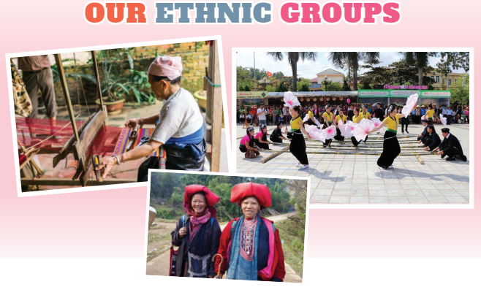
e. Assessment
- T checks ss’ grammatical and spelling mistakes on their poster, listens to their presentation, and gives feedback.

5. CONSOLIDATION (3 mins)
a. Wrap-up
- Teacher asks Ss to summarise the main points of the lesson.
b. Homework
- Do exercises in the workbook.
- Prepare for Unit 5: Getting started.

Board Plan

Date of teaching ……..
UNIT 4: Ethnic groups of Viet Nam
Lesson 7: Looking back & Project

*Warm-up

* Vocabulary review
Task 1: Match the words and phrases with the pictures.
Task 2: Complete the sentences.
* Grammar review
Task 3: Write questions from the clues.
Task 4: Circle the mistakes and correct.
* Project

*Homework

