ĐỀ 13 | ĐỀ ÔN TẬP GIỮA HỌC KỲ II  NĂM HỌC 2025-2026  MÔN: TIẾNG ANH 7

I. LISTENING:
Listen to the recording/ the conversation... and choose/ circle the letter A, B, C, or D to indicate the correct answer to each of the following questions. (You will hear the recording TWICE.) (1.0 pt)
1. What’s the matter with Jill? She has a/ an _________.
A. earache B. stomachache C. temperature
2. Which costume is Ben wearing?
A. the bat B. the rabbit C. the clown
3. What does John want for lunch?
A. soup B. pizza C. burger and French fries
4. What does Jane want to take to Jim’s house?
A. school things B. new CDs C. new video
Listen to the recording/ the conversation... and state whether the statements below are true (T) or false (F). (You will hear the recording TWICE.) (1.0 pt)
5. Sue is twelve years old.
6. Sue lives in Hil Street.
7. She goes to school twice a week.
8. She reads seven books a week.
II. PRONUNCIATION
Choose the letter A, B, C, or D to indicate the word whose underlined part differs from the other three in pronunciation in each of the following questions. (0.5 pt)
9. A. are B. square C. care D. share
10. A. obey B. survey C. key D. grey
III. GRAMMAR AND VOCABULARY
Choose the letter A, B, C, or D to indicate the correct answer to each of the following questions. (2.25 pts)
11. A film that is based only on real facts or events, is a ____________
A. cartoon B. fantasy C. comedy D. documentary
12. _______ is not very far from here to the city center.
A. That B. This C. It D. It’s
13. You should look right and left when you go _________ the road.
A. down B. along C. up D. across
14. Did you __________ to the cinema last night?
A. goes B. went C. going D. go
15. The film received positive ___________. Most critics say it’s a must-see.
A. reports B. reviews C. summaries D. actors
16. The film was so ________ that she cried at the end.
A. moving B. confusing C. funny D. hilarious
17. It’s raining heavily. _________, my father still has to go out.
A. Because B. Although C. However D. Despite
18. The “ao dai” is the most traditional _____________ of Viet Nam.
A. cloth B. wear C. costume D. clothing
19. ___________they often play all sorts of music in the festival?
A. Does B. Are C. Do D. Did
II. Read the following advertisement / school announcement and choose the letter A, B, C, or D to indicate the correct option that best fits each of the numbered blanks from 20 to 22. (0.75 pt)
Join us for a fantastic music festival!
- Enjoy live (20) _________ by local bands.
- Sing-along songs performed by talented singers.
- Drumming workshops will be offered.
- Artistic activities will be organized all day and night.
The music festival is going to take place (21) _________ August 30 to September 2 at My Dinh National stadium. Don't miss out on the fun! Let's (22) _________ music together!
20. A. exhibitions B. performances C. highlights D. parades
21. A. to B. on C. from D. in
22.A. enjoy B. to enjoy C. enjoying D. enjoyed
D. READING
I. Read the following passage and choose the letter A, B, C, or D to indicate the correct option that best fits each of the numbered blanks from 23 to 27. (1.25 pts)
When you are in Hong Kong, you can go about by taxi, by train, by tram, by bus, or by underground. I prefer the underground because it is fast, easy and cheap. There are many trams and buses in Hong Kong, and one cannot drive on the road quickly and without stopping many times. The underground is therefore usually quicker than taxis or buses. If you do not know Hong Kong very well, it is very difficult to find the bus you want. You can take a taxi, but it is more expensive than the underground or a bus. At the underground you can find good maps that tell you the station names and show you how to get to them, so that it is easy to find your way.
23. The writer (tác giả) prefer the underground because it is______________
A. fast and cheap B. cheap and easy
C. fast, easy and cheap D. fast and easy
24. Is the underground usually quicker than taxis or buses?
A. Yes, it is B. No, it isn’t
C. Yes, it does D. No, it doesn’t
25. ____________ tell you the station names and show you how to find the way.
A. good maps B. underground C. police D. drivers
26. What does the word “it” in line 6 refer to? (refer to = ám chỉ, nói đến)
A. a bus B. a taxi C. the underground D. the train
27. What is the passage mainly about?
A. Life in Hong Kong. B. Means of transport in Hong Kong.
C. People in Hong Kong. D. The underground in Hong Kong.
II. Read the following passage and choose the letter A, B, C, or D to indicate the correct answer to each of the questions from 28 to 32. (1.25 pts)
Rio de Janeiro
The carnival in Rio is the biggest (28) ________ the world. (29) ____________ lasts for about five days. The Rio Carnival is famous for its samba music. People dress up in special (30) _________ and dance on floats. At the Rio Carnival, (31) __________ enjoy the parades and competitions between samba “schools” or groups. These schools can (32) _________ millions of dollars preparing every year.
28. A. on B. in C. at D. all
29. A. They B. It C. He D. She
30. A. costumes B. dress C. T-shirt D. skirts
31. A. teachers B. students C. tourists D. dancers
32. A. spending B. spend C. to spend D. spends
E. WRITING
I. Choose the letter A, B, C, or D to indicate the sentence that has the same meaning as the given sentence. (0.5 pt)
33. She is so young, but she always gives an excellent performance.
A. Despite she is so young, she always gives an excellent performance.
B. Although she is so young, she always gives an excellent performance.
C. Although she is so young, but she always gives an excellent performance.
D. She is so young although she always gives an excellent performance.
34. What’s the distance between Ho Chi Minh City and Phu Quoc Island?
A. How far is it from Ho Chi Minh City to Phu Quoc Island?
B. How far it is from Ho Chi Minh City to Phu Quoc Island?
C. How far is it from Ho Chi Minh City and Phu Quoc Island?
D. How far is it between Ho Chi Minh City to Phu Quoc Island?
II. Write about your favourite film. You can use these cues below. (1.5 pts)
- What is the name of the film?
- What is the type of the film?
- Who are the main characters?
- What is the film about?
- Why do you like the film?

ĐÁP ÁN
A. LISTENING
I. Listen and choose the best answer. (0.25*4=1.0 pt)
1. A 2. C 3. B 4. C
II. Listen and decide if the statement is true (T) or false (F). (0.25*4=1.0 pt)
5. T 6. F 7. F 8. T
B. PRONUNCIATION
Choose the word which has the underlined part pronounced differently from that of the rest. (0.25*2=0.5 pt)
9. A 10. C
C. VOCABULARY – GRAMMAR
I/ Choose the best option marked A, B or C to complete each sentence.
(0.25*9=2.25 pts)
11. D 12. C 13. D
14. D 15. B 16. A
17. C 18. C 19. C
II. Read the following advertisement / school announcement and choose the letter A, B, C, or D to indicate the correct option that best fits each of the numbered blanks from 20 to 22. (0.25*3=0.75 pt)
20. B 21. C 22. A
D. READING
I. Read the following passage and choose the letter A, B, C, or D to indicate the correct option that best fits each of the numbered blanks from 23 to 27. (0.25*5=1.25 pts)
23. C 24. A 25. A 26. B 27. B
II. Read the following passage and choose the letter A, B, C, or D to indicate the correct answer to each of the questions from 28 to 32. (0.25*5=1.25 pts)
28. B 29. B 30. A 31. C 32. B
E. WRITING
I. Choose the letter A, B, C, or D to indicate the sentence that has the same meaning as the given sentence. (0.25*2=0.5 pt)
33. B 34. A
II. Write about your favourite film. You can use these cues below. (1.5 pts)
- correct form: 0.2 p - reasonable ideas: 0.5 p
- accurate grammar: 0.3 p - appropriate vocabulary: 0.3 p
- good linking of sentences: 0.2 p

TAPESCRIPS
1.
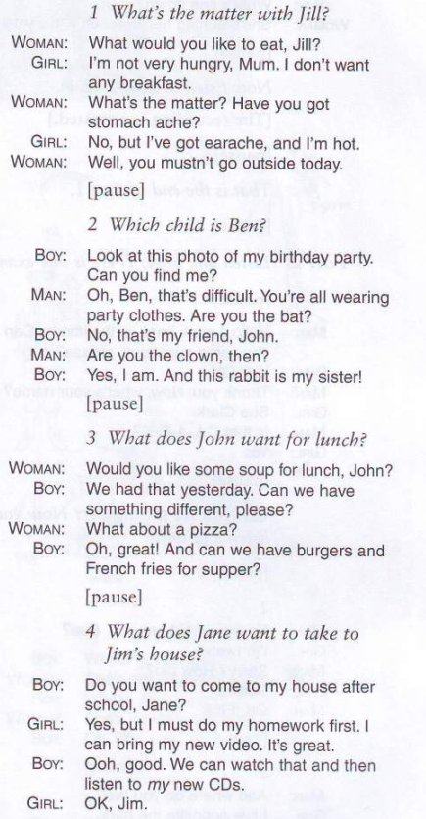
2.
