ĐỀ 5 | ĐỀ ÔN TẬP GIỮA HỌC KỲ II  NĂM HỌC 2025-2026  MÔN: TIẾNG ANH 7

SECTION A. LISTENING (2.0 pts)
Task 1: Listen and circle the correct answer.
1. What music will they have at the party? (NB)
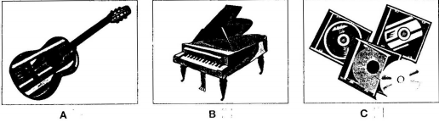

2. When will the man go on holiday? (TH)
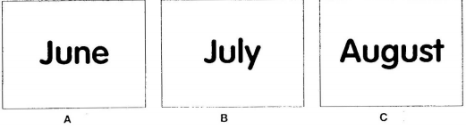

3. What will the weather be like tomorrow? (NB)
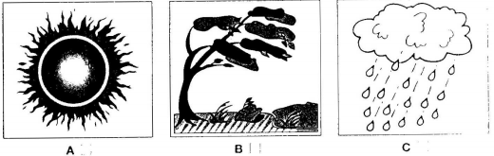

4. What color is Mary’s coat? (NB)
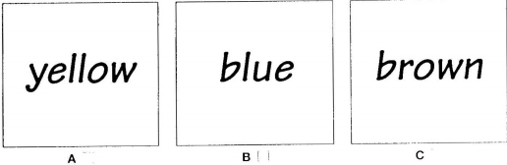

5. What did the woman repair? (TH)
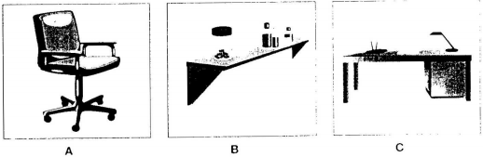
Task 2. Listen to a man making a telephone call and complete the questions from 6 – 10.

MESSAGE
To: Diana
From: Ian
Name of hotel: (6) ___________________________(NB)
Address: (7) ________________________________ (NB)
Meeting starts at: (8) _________________________(NB)
Bring: (9) ___________________________________(NB)
Visit factory on: (10) __________________________(TH)

SECTION B. VOCABULARY, GRAMMAR AND LANGUAGE FUNCTION (3.0 pts).
Task 1. Find the word which has a different sound in the parts underlined.
11. A. snail B. sign C. station D. pavement (NB)
12. A. share B. nightmare C. fear D. bear (NB)

Task 2. Choose the best answer to fill in the blanks by circling A, B, C or D.
13. The Samba Parade in Rio Carnival has thousands of samba _______ from various samba schools. (TH)
A. performance B. perform C. performer D. performers
14. Tung used _________ a horse when he was a child. (NB)
A. ride B. to ride C. riding D. was ride
15. It is a horror film. _______________, it is a good film. (NB)
A. Although B. However C. And D. So
16. You should notice ____________ when you are on the road. They help you go on the right way. (TH)
A. bus B. motorbike C. road signs D. trees
17. She likes this film because it is __________ (TH)
A. entertaining B. entertain C. entertainment D. entertained
18. On Thanksgiving, families and friends _____________ to have a feast. (TH)
A. meet B. arrive C. gather D. appear
19. We should wait for the traffic lights before we cross the street. (TH)
A. turn green B. to turn green C. turn yellow D. to turn yellow
20. The end of the film was so that many people cried.(TH)
A. shocking B. moving C. exciting D. boring
21. ………….. does it take you to get to Ho Chi Minh City by plane? - About 2 hours. (NB)
A. How far B. How much C. How long D. How many
22. Mr. Beans Holiday is a film - I was laughing from beginning to end. (TH)
A. hilarious B. violent C. scary D. moving
23. The atmosphere is felt around all the village. (VD)
A. festive B. festival C. air D. tradition
24. – “Do you feel like seeing a film?” – “___________” (VD)
A. No, I don’t like it at all. B. Sure. What film shall we see?
C. Who is in it? D. Let’s meet at 8.00
25. “How often is Bikaner Camel Festival celebrated?” – “____________________”. (NB)
A. In a city in northern India B. Every year
C. In January D. To show off the camels

SECTION C. READING (2.0 pts)
Task 1: Read the passage and choose the correct answer to each question (26 – 30) (1 pts)
Yesterday, on the way home from school, I saw an accident. A boy was run over by a taxi when he was riding his bicycle. The boy’s leg was broken and it was bleeding badly. Someone there tried to stop the bleeding. They put pressure on it and held it tight. A man used his mobile phone to call the emergency service. Some minutes later, an ambulance arrived and sent the boy to the hospital. Two policemen came to the scene immediately. Some people told the police that the taxi driver was driving at a very high speed when the accident happened. Some others began talking about the traffic accidents these days and blamed the increasing number of accidents on the roads for careless driving and drunk drivers.
26. What did the writer see yesterday? (NB)
A. a fire B. an accident C. a fighting D. a crash
27. The accident happened between a taxi and…………….(TH)
A. a bus B. a car C. a bicycle D. a motorbike
28. The boy was sent to the hospital by…………….(TH)
A. a police B. a car C. an ambulance D. a passenger
29. What part of his body was hurt? – His……………….. (NB)
A. arm B. leg C. head D. shoulder
30. How was the driver driving when the accident happened? – Very…………….(TH)
A. slowly B. fast C. carefully D. well

Task 2: Choose the best answers to complete the passage.
William Shakespeare was the (31) _____ writer in the English language. He was born in 1564 in Stratford- upon- Avon. At the age of eighteen he married Anne Hathaway, who was eight years (32) _____ than himself. A few years later he moved to London, where he worked as an actor and a playwright. Shakespeare wrote thirty seven plays and 154 sonnets (a kind of poem). His most famous plays are the four great tragedies - Othelo, Macbeth, Hamlet, and King Lear. Shakespeare died in Stratford on 23 April 1616, but his plays are still very popular today. They have been translated into different languages, and many of them have been (33) _____ into films, both in English and other languages. Shakespeare's plays are about the great issues of life - love, hatred, jealousy, power, ambition, (34) _____ and so on. So, his plays are just (35)___________ today as they were in the sixteenth century.
31. A. great | B. greater | C. greatest | D. old (NB)
32. A. old | B. older | C. later | D. elder (NB)
33. A. did | B. done | C. made | D. had (TH)
34. A. death | B. died | C. die | D. dead (VD)
35. A. different | B. relevant | C. same | D. modern (TH)

SECTION D. WRITING (3.0 pts)
Task 1. Underline the mistakes in the following sentences. (1pt)
36. The children are very boring with the film and want to go home. (NB)
A B C D
37. When I was on holiday last summer, I was going to the beach every day. (TH)
A B C D
38. Tom used to going to school by bus. Now he goes by bike. (NB)
A B C D
39. Though the traffic was heavy yesterday morning, but we still got to the meeting on time. (NB)
A B C D
40. You should drive fast because this street is very crowded in the morning. (TH)
A B C D
Task 2. Complete the second sentences in each pair so that it means the same as the sentence before it (1.0pt).
41. Tom was a poor student. However, he studied very well. (VD)
- Although _______________________________________________________________
42. The distance from Ho Chi Minh City to Phu Quoc Island is about 300 km. (VD)
It is______________________________________________________________________
43. It is a good idea for us to go to see the dentist once every six months. (VD)
- We should________________________________________________________________
44. Eating fastfood is not advisable because it can be bad for your health. (VD)
- You shouldn’t____________________________________________________________
45. My father is very busy, but he always spends time playing with us at the weekend.(VD)
- Though _________________________________________________________________
Task 3. Write a paragraph of 80-100 words about your favourite festival using the given clues. (1.0pt) (VDC)
- What is the name of the festival?
- Where and when does it take place?
- What activities are there in the festival?
- Why do you like it the most?
…………………………………………………………………………………………………………………………………………………………………………………………………………………………………………………………………………………………………………………………………………………………………………………………………………………………………………
………………………………………………………………………………………………………………………………………………………………………………………………………………………………………………………………………………………………………………………………………………………………………………………………………………………………………..
……………………………………………………………………………………………………………………………………………………………………………………………………………………………………

KEY
SECTION A: LISTENING (2 pts)
Task 1: Listen to the conversations and circle the correct answer.
1. C 2. B 3. B 4. A 5. B
Task 2: Listen to a man making a telephone call. Fill in the blanks with the correct information.
6. (the) April (Hotel)
7. Leith
8. 10.20/ ten twenty
9. (the/a/an/Ian’s) book
10. Tuesday
SECTION B. VOCABULARY, GRAMMAR AND LANGUAGE FUNCTION (3.0 pts).

Task 1. Find the word which has a different sound in the parts underlined.
11. B 12. C

Task 2. Choose the best answer to fill in the blanks by circling A, B, C or D.

13. D 14. D 15. B

16. C 17. A 18. C 19. B 20. B

21. C 22. A 23. A 24. B 25. B

SECTION C. READING (2.0 pts)
Task 1: Read the passage and choose the correct answer to each question (26 – 30) (1 pts)
26. B 27. C 28. C 29. C 30. A

Task 2: Choose the best answers to complete the passage.
31. C 32. B 33. C 34. A 35. B

SECTION D: WRITING (3 pts)
Task 1. Underline the mistakes in the following sentences. (1pt)
36. B 37. C 38. A 39. C 40. A
Task 2. Complete the second sentences in each pair so that it means the same as the sentence before it 1.
41. Tom was a poor student, he studied very well.
42. about 300 km from Ho Chi Minh city to Phu Quoc Island.
43. go to see the dentist once every 6 months.
44. eat fastfood because it can be bad for your health.
45. my father is very busy, he always spends time with us at the weekend.

Task 3. Write a paragraph of 80-100 words about your favourite festival using the given clues. (1.0pt) (VDC)
* Paragraph writing
- Ngữ pháp: Chia đúng thì động từ, sử dụng từ nối hợp lí, câu đúng cấu trúc ….
- Nội dung: Viết đúng nội dung, đủ ý.
- Từ vựng: Sử dụng từ phù hợp

