ĐỀ 2 | ĐỀ ÔN TẬP GIỮA HỌC KỲ II  NĂM HỌC 2025-2026  MÔN: TIẾNG ANH 7

- Listening: (2pts)
- Listen and draw lines. There is one example (1 point)
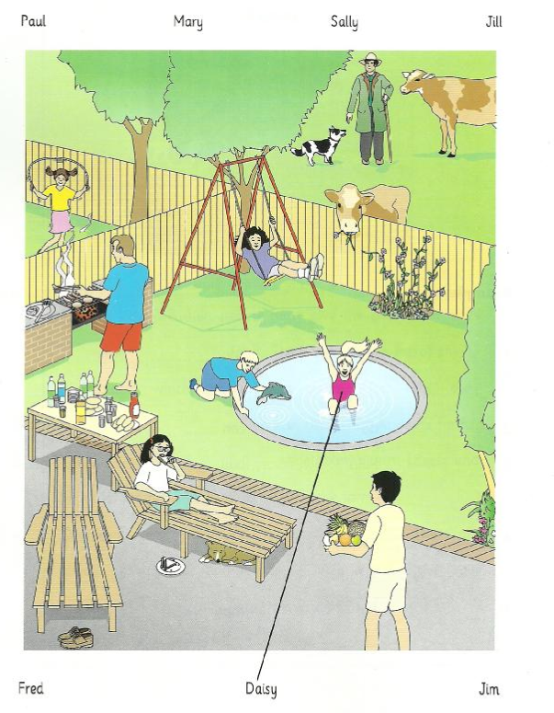

2. Listen and write. There is one example (1 point)
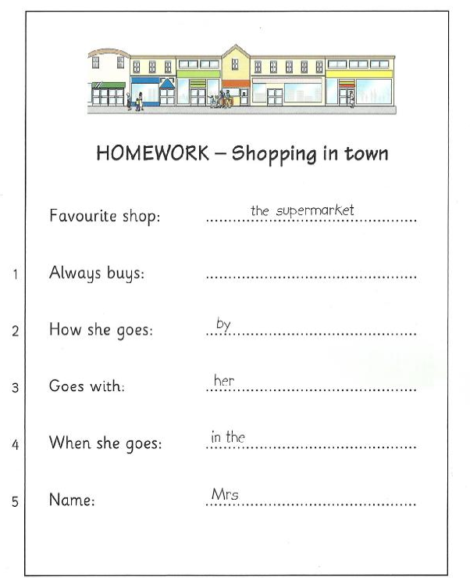

II. Language: Choose the word or phrase that best completes each sentence or do as direct. (2,5pts)
11.Choose the word whose underlined part is pronounced differently:
NB a. year b. near c. chair
12. Choose the word which has a different stress pattern:
NB a. concert b. discuss c. ticket
13. Watching too much television is not _____ you or your eyes.
VD a. good for b.experience c. harmful
14. . Nick “ My teeth are hurting me!” Bill: “…………………………………”.
NB a. You should go to the dentist b. Really? c. Thank you!
15. Lan: “How about your exam?” Hoa: “………………………………………”
TH a. No, thanks! b. It’s a piece of cake c. You’re welcome

16. Taking the bus is very __________because it stops everywhere I need to go.
TH a. convenient b. quick c. modern
17. A subway ticket isn’t__________as a train ticket.
NB a. more expensive b.as expensive c. expensive
18. She is disappointed__________she got a F on her math exam.
TH a. although b. however c. because
19. How __________ junk food do you eat every week?
TH a. many b. much c. any
20. Some cities have ________ buses to reduce air pollution.
NB a. eco- friendly b. comfortable c. reliable

Answers | 11. | 12. | 13. | 14. | 15.
Answers | 16. | 17. | 18. | 19. | 20.

III. Reading. (2,5pts)
- Read the following passage and choose the correct answer A, B, C, or D (1,25 pts)
Two of the most important holidays in the United State are Independence Day and Thanksgiving Day. The fourth of July marks the American declaration of Independence from Britain. Most towns, big or small, celebrate the fourth of July with parades andfireworks. Families (21) ……………. with barbecues or picnics. Thanksgiving Day is celebrated in Fall, on the fourth Thursday in November. It is a day (22) ………….. people give thanks to the harvest. Most families (23) ……………. a large dinner with roast turkey. (24) ……………. Independence Day and Thanks giving are national(25)…………….
TH 21. A. celebrating B. celebration C. celebrate D. celebrated
NB 22. A. where B. when C. which D. what
TH 23. A. have B. buy C. help D. take
NB 24. A. Besides B. Both C. Either D. Nor
TH 25. A.chances B. months C. holidays D. times
- Read the passage. Decide whether the statements are True (T) or False (F) then answer the questions. (1,25 pts)
My favorite movie is cartoon “Tom and Jerry”. Tom is a cat with blue and white color. He keeps the house for a normal family and has a very free life. His job is chasing Jerry day by day. Jerry is a brown house mouse. He usually lives in the deep cave behind the wall. Although they hate each other so much and always find ways to hurt the opponent but when Tom or Jerry falls into really dangerous situations, then both become another savior. The film is an endless confrontation between Tom and Jerry, bring plenty of laughter for the audiences. I love this film because when I watch it I feel very glad, feeling like returned to my childhood.
A. True/ False statements
TH 26.Jerry is very scare of Tom.
TH 27.They sometimes help each other in a hard situation.
NB 28.Tom is a black and white cat.
TH 29.Tom and Jerry is a moving one.
NB 30.People often laugh when they watch this cartoon.
IV. Writing: (3 pts)
1. Write a new sentence as similar as possible in meaning to the original sentence or do as directed. (1,8pts)
NB31. Choose the incorrect part indicated by A, B, C or D in the following sentence:
He was not very happy so he passed his test.
A B C D
TH32.Her/ big/ is/ backpack/ blue/ new.(Put the words/ phrases in the correct order to form a meaningful sentence.)
______________________________________________________________________________
VD33.Halloween in Mexico is not the same as Halloween in the US. (Rewrite the sentence, using the given word “different”)
Halloween in Mexico____________________________________________________________
VD34.My sister has to write a book report.(Rewrite the sentence, using the given word “should”)
My sister ______________________________________________________________________
VD35.Do you want to buy that computer very much?(Rewrite the sentence, using the given word “really”)
Do you _______________________________________________________________________
VD36. I missed the bus although I woke up early. (Rewrite the sentence, using the given word “however”)
_____________________________________________________________________________
2. Write sentences using the prompts (1,2 pt)
VD37. I/ be/ so upset/ because/ I/ fail/ English test/ yesterday.
______________________________________________________________________________
VD38.you/ have to/ practice/ presentation/ later?
______________________________________________________________________________
VD39.The train/ be not/ fast/ as/ the plane.
______________________________________________________________________________
VD40. How / far/ be/it/ your/ school/ nearest/ bus- stopt ?
______________________________________________________________________________

--- The End ---
ĐÁP ÁN

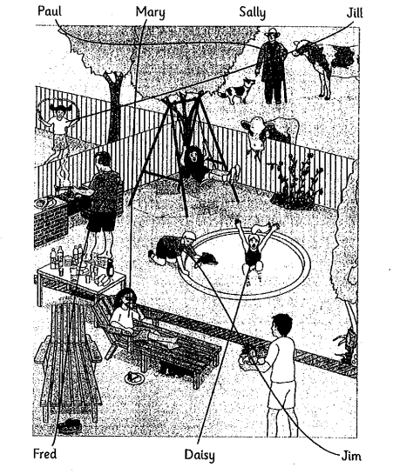

Question |  | Answer | Mark
I. LISTENING |  | I. Listen and draw lines (1 point).  Lines should be drawn between  1. Fred and the man cooking, with no shoes.  2. Mary and the girl on the sun chair, eating a sandwich.  3. Jim and the blond boy with a dolphin.  4. Jill and the girl skipping in the garden next door.  5. Paul and the man with the cows and the dog.  II. Listen and write (1 point).  1. vegetables  2. bus  3. daughter  4. afternoon  5. Rich | 1pt = 0.2 x 5  1pt = 0.2 x 5
II. VOCABULARY – GRAMMAR – LANGUAGE FUNCTION |  | I.  11. c 12. B 13.a 14.a 15.b  16.a 17.b 18.c 19.b 20.a | . 0.25 x 10 = 2,5
III.READING |  | 1. Choose the correct answer A, B, c or D to fill each blank in the following passage.(1,5p)  21. C 22.B 23.A 24.B 25.C  2.Read the passage. Decide whether the statements are True (T) or False (F) then answer the questions. (1,25 pts)  26.F 27.T 28.F 29.F 30.T | 0.25 x 5 = 1,25  0.25 x 5 = 1,25
IV.  WRITING |  | 1. Write a new sentence as similar as possible in meaning to the original sentence or do as directed. (1,8pts)  31. B ( although)  32. Her backpack is big new blue.  33. Halloween in Mexico is different from Halloween in the US  34.My sister should write a book report.  35. Do you really want to buy that computer ?  36. I woke up early however I missed the bus  2. Write sentences using the prompts (1,2 pt)  37. I was so upset because I failed my English test yesterday.  38. Do you have to practice the presentation later ?  39.The train is not as fast as the plane.  40. How far is it from your school to the nearest bus- stop ? | 0.3 x 6 = 1,8  0.3 x 4 = 1,2

--- The End ---

