ĐỀ 9 | ĐỀ ÔN TẬP CUỐI HỌC KỲ I NĂM HỌC 2025-2026  MÔN: TIẾNG ANH 7

PART 1: LISTENING
I. Listen to a conversation and decide if the statements are true (T) or false (F).(1,0pt)
1. _______Megan always has milk and bread for breakfast.
2. _______ She has a cheese sandwich, a yogurt and orange juice for lunch.
3. _______ She usually has a snack at school.
4. _______ Megan has a steak and chips with her parents when they eat out.
II. Listen to the passage about Community Service. Then circle the best answer A, B, or C. You will listen TWICE. (1,0pt)
5. Heart to Heart Charity mainly helps _____ in Viet Nam.
A. orphan B. poor children C. homeless children D. elderly people
6. Last _____, they had a lot of volunteer activities in Cao Bang and Ha Giang.
A. June B. week C. July D. month.
7. _____ people donated money to the charity.
A. 50 B. 43 C. 134 D. 15
8. All the money was spent on buying food, _____ and medicine for the children.
A. clothes B. books C. toys D. souvenirs
PART 2: VOCABULARY- GRAMMAR- PRONUNCIATION
I. Choose the word which has the underlined part pronounced differently from the rest (0,5pt)
9. A. watched B. phoned C. preferred D. followed
10. A. midterm B. pepper C. prefer D. preserve
II. Choose the best option A, B, C, or D to complete the following sentence(s) (1.5pts)
11. My younger brother likes _____________ computer games.
A. play B. playing C. plays D. played
12. Would you like to have ________________ orange juice?
A. some B. lots C. a lot D. many
13. Ha_____ to the birthday party last night.
A. doesn’t come B. won’t come C. isn’t coming D. didn’t come
14. This shirt is not as expensive __________________ I thought at first.
A. as B. like C. from D. than
15.___________________ are not good for your health.
A. fish B. meat C. vegetables D. soft drinks
16.___________ her children watch cartoons before he goes to school?
A. Is B. Are C. Do D. Does
PART 3: READING
I. Choose the correct word for each blank in the following passage. (1,0pt)
A recent report showed which countries were the healthiest to live in. It included things like how long people live and what kind (17)_____________ health problems they have. Some of the countries on the list were Australia, Italy and France ; and Japan was at (18)_____________ top. In Japan, more people live to be over eighty years old than in any other countries. Part of the reason is that people have a very (19)_____________ diet. They eat a lot of fish and vegetables. They don’t eat much red meat and cheese . We don’t all have to (20)_____________ in Japan to be healthier, but we should definitely all eat more fish and do more exercise , too.
17. A. of B. with C. on D. from
18. A. a B. an C. the D. no article
19. A. healthy B. awful C. exciting D. bad
20. A. living B. lived C. live D. to live
II. Read the passage carefully and answer the questions by choosing the correct answer A, B, C or D. (1,0pt)

Jenny and Sarah are practising singing a Vietnamese folk song to take part in a singing contest only for foreign students who are studying in schools in Ho Chi Minh City. Their song is Hoa thom buom luon. It has a beautiful melody, but they find it challenging because the lyrics are difficult for them to pronounce. With the help of Miss Thanh, their Vietnamese tutor, their performance is improving significantly. Besides singing, they also have to practise a traditional dance in order to impress the judges and the audience. Although the dance is not as difficult as the song, they still rehearse very hard. With a lot of efforts, both girls hope they will have a great performance and win the contest.
21. Who can compete in the singing contest?
A. Vietnamese students. B. International students.
C. Vietnamese tutors. D. Vietnamese teachers.
22. What do Jenny and Sarah think about the song they chose?
A. The melody is challenging but the lyrics are easy.
B. The melody is hard but the lyrics are lovely.
C. The melody is beautiful but the lyrics are difficult.
D. The melody is challenging but the lyrics are difficult.
23. What does the word their in line 4 mean?
A. Foreign students’. B. Miss Thanh’s. C. Jenny and Sarah’s. D. Jenny’s.
24. Why do they practise a traditional dance?
A. To show off their dancing talent.
B. To make an impression on the judges and the audience.
C. To make their performance more beautifully.
D. To make them happy.
PART 4: WRITING
I. Rewrite the following sentences so that the second sentence means exactly the same as the sentence before it.(1.0pt)
25. Her bike is not the same as mine.
→ Her bike is ____________________________________________.
26. Tom enjoys reading comic books. Tom enjoys listening to music.
→ Tom enjoys____________________________________________.
27. My sister hates cooking meals.
→ My sister doesn’t ____________________________________________.
28. What is the price of the bicycle?
→ How much ____________________________________________?

II. Write complete sentences to make a short paragraph about your hobby.(1,0pt)
EX: My hobby/ be/ do/ the gardening/.
My hobby is doing the gardening.
29. I/ start/ my hobby/ 2/ year/ ago.
…………………………………………………………………………….……..….
30. I/ share/ hobby/ my father/.
…………………………………………………………………………….……..….
31. I need/ some plant/, gloves,/ pots and soil to/ my hobby.
…………………………………………………………………………….……..….
32. Gardening/ help/ us to / protect/ environment.
…………………………………………………………………………….……..….

--- THE END ---

HƯỚNG DẪN CHẤM KIỂM TRA CUỐI HKI
PART 1: LISTENING
I.Listen to a conversation and decide if the statements are true (T) or false (F).(1,0pt)
1F, 2T, 3F, 4F
II. Listen to the passage and circle the best answer A, B, or C. You will listen TWICE. (1,0pt)
5B, 6C, 7B, 8A
PART 2: VOCABULARY- GRAMMAR- PRONUNCIATION
I. Choose the word which has the underlined part pronounced differently from the rest (0,5pt)
9A, 10B
II. Choose the best option A, B, C, or D to complete the following sentence(s) (1,0pt)
11B, 12A, 13D, 14A, 15D,16C,
PART 3: READING
I. Choose the correct word for each blank in the following passage. (1,0pt)
17A, 18C, 19A, 20C
II. Read the passage. Circle the best answer A, B, C or D to each of the questions. (1,0pt)
21B, 22C, 23C, 24B
PART 4: WRITING
I. Rewrite the following sentences so that the second sentence means exactly the same as the sentence before it.(1.0pt)
29. Her bike is different from mine .
30. Tom enjoys reading comic books and listening to music.
31. My sister’s doesn’t like cooking meals.
32. How much is the bicycle?.
II. Write complete sentences to make a passage describing best friend. (1m)
( Each correct answer gives 0.25 point)
29. I started my hobby 2 years ago.
30. I share my/this hobby with my father.
31. I need some plants, gloves, pots and soil to do my hobby.
32. Gardening helps/can help us to protect our environment.
--- THE END ---

Tape script 1
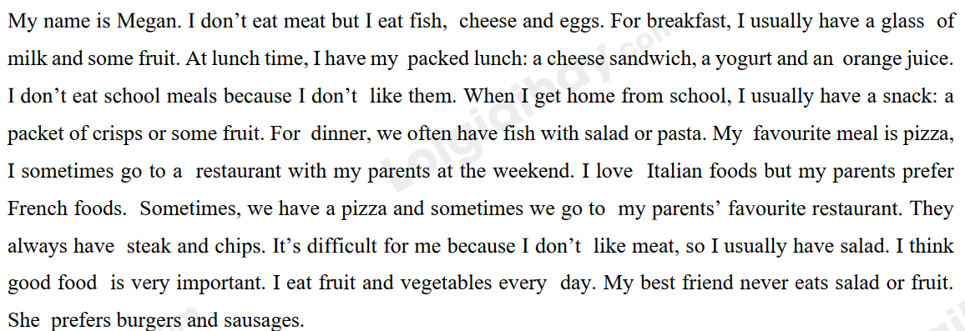

A: Were you sporty as a child?
.
Tape script 2
Hello, I’m Minh Quang. This is July report of the Heart to Heart charity. We are a non-profit that helps poor children in Vietnam. Last July, we had a lot of volunteer activities in Cao Bang and Ha Giang. We highly appreciate your support and donation. All the books and clothes were sent to 850 poor children in the two provinces. We have received 62 million VND from 43 donors. All the money was then spent on buying food, clothes and medicines for the children. We would like to thank 50 volunteers for your time, efforts and endless love for the children. We had a meaningful trip with lots of useful and exciting activities for the children such as teaching them Vietnamese and English and telling stories to them. We always need new volunteers. Your donation of any kind will always be welcomed. So please don’t hesitate to contact us via: …

