ĐỀ 18 | ĐỀ ÔN TẬP GIỮA HỌC KỲ II  NĂM HỌC 2025-2026  MÔN: TIẾNG ANH 6
I. I. LISTENING:
Part 1 : listen and tick (V) the box. There is one example. (1.0 point)
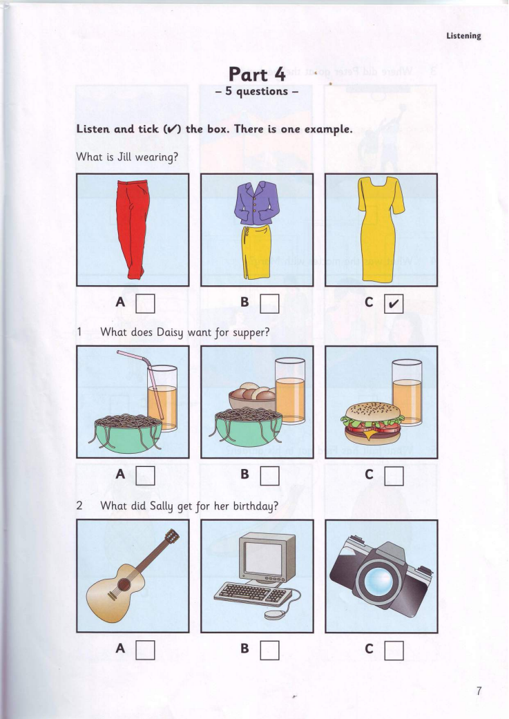
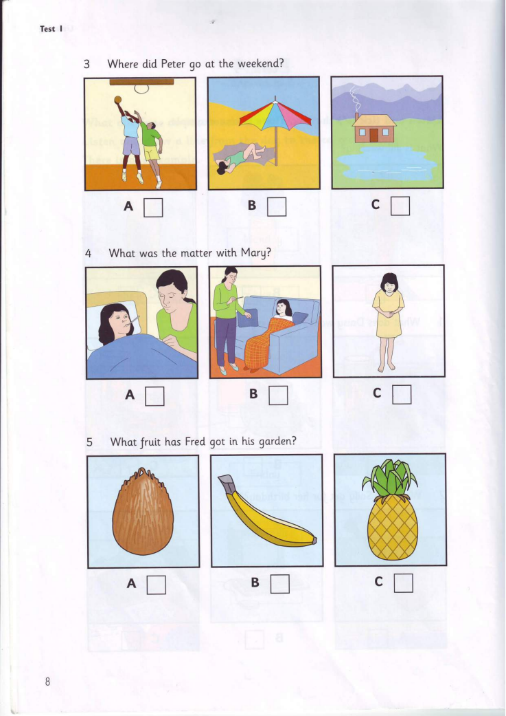
Part 2 . Listen to Tracy talking about her house. Tick True (T) or False (F) (1point)
You will listen TWICE.
Statements | True | False
5. There are three people in Tracy's family
6. Tracy’s family goes to the department store on Monday
7. There isn't a Television in her room.
8. Tracy enjoys living in her lovely house
II. PRONUNCIATION
Choose the letter A, B, C, or D to indicate the word whose underlined part differs from the other three in pronunciation in the following questions from 9 to 10. (0.5 point)
9. A. borrow B. close C. work D. cold
10. A. man B. bad C. sad D. village
III. GRAMMAR AND VOCABULARY
Choose the letter A, B, C, or D to indicate the correct answer to the following questions from 11 to 19. (2.25) points)
11. He...................out with his friends last week.
A. go B. goes C. went D. going
12. I love Children are always right, a .................... for kids.
A. story B. interesting C. game show D. film
13. My brother often watches ..................... . They are so funny.
A. sports B. comedies C. football D. progamme
14. Jonh and Liz are very rich. …………house is big.
A. Their B. They C. Theirs D. Them
15……………sleep well last night?
A. Do you B. Were you C. Did you D. Are you
16. Big Ben is the most famous tower in.......................
A. England B. America C. Australia D. Japan
17.Why do you often forget to................ the light when you go out of the classroom ?
A. turn on B. turn off C. close D. open
18. ‘Let’s learn’ teaches children to study Maths. It’s an ...................... program.
A. educational B. popular C. entertaining D. interested
19. .................... does Mark wash his car? - Every Sunday afternoon.
A. What B. When C. What time D. How often
Read the following school announcement and mark the letter A, B, C, or D on your answer sheet to indicate the correct option that best fits each of the numbered blanks from 20 to 22. (0.75 point)
School Announcement: Field Trip to Cuc Phuong National Park
We are (20) _____ to announce a field trip to Cuc Phuong National Park. Please note the following
details:
- Date: Next Friday, February 12th
- Departure: School bus (21) _______ at 8:00 AM
- Bring: Packed lunch, water bottle, and comfortable shoes.
- Explore: Nature trails, wildlife, and learn (22) _____ conservation efforts.
Don't miss out on this educational adventure!
20. A. excite B. excited C. excitement D. excitingly
21. A. left B. has left C. had left D. leaves
22. A. with B. to C. about D. at

IV. READING
Read the following passage and choose the letter A, B, C, or D to indicate the correct option that best fits each of the numbered blanks from 23 to 27. (1.25 points)
Hoi An is one of the (23) ................. towns in Viet Nam. It (24) ................. on the lower section of the Thu Bon river. It is a very beautiful town with a s lot of colour (25)................. which are hung around the town. Hoi An is famous for one -(26) ................. tailoring. Customers order clothes in the morning and get them in the evening. The price is not really expensive . If you want to find the place of the (27) ................. time, Hoi An is a good choice.
23. A. newer B. newest C. oldest D.older
24. A. are B. is C. are being D.am
25. A. lanterns B. stars C. balloons D.pens
26. A. month B. week C. day D. year
27. A. modern B. newer C. new D. old
Read the following passage and choose the letter A, B, C, or D to indicate the correct answer to each question from 28 to 32. (1.25 points)
Every year, thousands of people come to Edinburgh, the capital of Scotland, to be part of the Edinburgh Festival. For three weeks every August and September the city is filled with actors and artists from all over the world. They come to Edinburgh for the biggest art festival in Britain. During this time the streets of the city are alive with music and dance from early morning until late at night. You can even see artists painting pictures on the streets. One of the best parts of the Festival is “Fringe” where students do comedy shows in small halls and cafes.
Thousands of tourists come to the festival to see new films and plays and hear music played by famous musicians. This year you can see over five hundred performances with actors from forty countries.
The tickets for these performances are quite cheap and it is usually easier to see your star in Edinburgh than it is in London. So come to Edinburgh next summer.
28. Edinburgh is a __________.
A. capital B. country C. continent
29. How long does Edinburgh Festival last?
A. 2 weeks B. 3 weeks C. 4 weeks
30. What does they refer to?
A. actors B. artists C. actors and artists
31. What is one of the most interesting parts of the Festival?
A. music and dance B. Fringe C. new films
32. Which statement is NOT TRUE ?
A. Tourists can see new films and plays.
B. Tourists can enjoy performances with actors from 14 countries.
C. The tickets for these performances are not expensive.

V. WRITING
I. Choose the best sentence that has the closest meaning to the one provided.(0,5pt)
33. I have a lot of homework tonight. I can’t watch The voice kids show
A. I have a lot of homework tonight, but I can’t watch The voice kids show
B. I have a lot of homework tonight and I can’t watch The voice kids show
C. I have a lot of homework tonight, so I can’t watch The voice kids show
D. I have a lots of homework tonight, so I can’t watch The voice kids show

34. Helen's favorite sport is table tennis.
A. Helen likes playing table tennis.
B. Helen like play sports table tennis.
C. Helen likes to playing table tennis.
D. Helen like playing sports table tennis
II. In about 50 - 60 words . Write a paragraph about the sport / game that you usually play.(1,5 pts).
.......................................................................................................................................................................................................................................................................................................................
........................................................................................................................................................................................................................................................................................................................
......................................................................................................................................................................................................................................................................................................................
.......................................................................................................................................................................................................................................................................................................................
_______________________________________

ĐÁP ÁN

Phần trắc nghiệm: mỗi đáp án đúng được 0.25 điểm
I. LISTENING
Part 1. Listen to 5 short conversations TWICE then choose the correct answer for each question. (1.0 point) (audio Flyers 5 – test 2 – part 4)
1. A | 2.C | 3.C | 4.B
Part 2. Listen to the conversation twice then decide whether the statements are True (T) or False (F). (1.0 point) (audio Flyers 5 – test 2 – part 2)
5.F | 6.F | 7.T | 8.T
II. PRONUNCIATION
Choose the letter A, B, C, or D to indicate the word whose underlined part differs from the other three in pronunciation in the following questions from 9 to 10. (0.5 point)
9.C | 10.D
III. GRAMMAR AND VOCABULARY
Choose the letter A, B, C, or D to indicate the correct answer to each of the following questions from 11 to 19. (2.25) points)
11.C | 12.C | 13.B | 14.A | 15.C | 16.A | 17.B | 18.A | 19.D
Read the following advertisement and choose the letter A, B, C, or D to indicate the correct option that best fits each of the numbered blanks from 20 to 22. (0.75 point)
20.B | 21.D | 22.C
III. READING
Read the following passage and choose the letter A, B, C, or D to indicate the correct option that best fits each of the numbered blanks from 23 to 27. (1.25 points)
23.C | 24.B | 25.A | 26.C | 27.D
Read the following passage and choose the letter A, B, C, or D to indicate the correct answer to each of the questions from 28 to 32. (1.25 points)
28.A | 29.B | 30.C | 31.B | 32.B
V. WRTING
Choose the best sentence that has the closest meaning to the one provided.(0,5pt)
33.C | 34.A
In about 50-60 words, write a paragraph about the sport / game that you usually play (1.5 points)
- correct form: 0.5 p - reasonable ideas: 0.25 p
- accurate grammar: 0.25 p - appropriate vocabulary: 0.25 p
- good linking of sentences: 0.25 p
__________________________________________

