ĐỀ 15 | ĐỀ ÔN TẬP GIỮA HỌC KỲ II  NĂM HỌC 2025-2026  MÔN: TIẾNG ANH 6

I. LISTENING:
Part 1: Listen to conversations TWICE then choose the correct answer for each question. (1.0 point).
Question 1. What’s the name of Anna’s school?
A.She goes to Pear Tree school B.She goes to Apple school C. She goes to Pink school
Question 2. How many children are in Anna’s class ?
A. There are ten. B. There are nine. C. There are thirteen.
Question 3. Who sits next to Anna at school ?
A. Her friend,Sam B. Her friend,Tom C. Her friend,Mary
Question 4. What’s the name of Anna’s English teacher?
A. His name,David. B. His name,Tom C. His name,Tony
Part 2: Listen to the conversation and state whether the statements below are true (T) or false (F). (You will hear the conversation TWICE.) (1.0 point)
Statements | T/F
Question 5. He lives in a house in Water street.
Question 6. The number of his house is ten.
Question 7. His favourite toy is ugly monster.
Question 8. His monster has got five red feet.
II. PRONUNCIATION
Choose the letter A, B, C, or D to indicate the word whose underlined part differs from the other three in pronunciation in each of the following questions. (0.5 point)
Question 9. A. chess B. tennis C. contest D. match
Question 10. A. town B. postcard C. house D. around
III. GRAMMAR AND VOCABULARY
Choose the letter A, B, C, or D to indicate the correct answer to each of the following questions. (2.25 points)
Question 11.She _________________Ha Noi last week
A. visits | B. visiting | C. visited | D. visit
Question 12. The food is very _______________
A. long | B. delicious | C. noisy | D. crowded
Question 13. Where do you often ______________ swimming?
A. play | B. do | C.go | D. have
Question 14. ______________ is a famous landmark in New York.
A. Merlion | B. The Statue of Liberty | C. Sydney Opera House | D. The Eiffel Tower
Question 15. He was lazy, ______________ he failed the exam.
A. so | B. but | C. or | D. because
Question 16. ________is it from here to the TV station? - Three kilometres.
A. How long | B. How much | C. How far | D. How often
Question 17. Big Ben is the most famous tower in _________________
A. Tokyo | B. London | C. New York | D. Paris
Question 18. Her school is bigger than ________ school.
A. I | B. me | C. my | D. mine
Question 19. I like playing football, ______ my brother doesn’t like.
A. and | B. so | C. but | D. because
Read the following school announcement and choose the letter A, B, C, or D to indicate the correct option that best fits each of the numbered blanks from 20 to 22. (0.75 point)

AUTUMN BREAK
Dear parents,
Please note that school will be closed (20) _____ Monday 23rd October to Sunday 29th October for the Mid Term Autumn break.
Students should (21)_____ to school on Monday 30th October, 2023 wearing winter (22)_____.
Regards
Penguin Lower school
Question 20. A. from B. on C. between D. in
Question 21. A. be return B. return C. returns D. returned
Question 22. A. clothes B. coat C. uniform D. dress

IV. READING:
Read the following passage and choose the letter A, B, C, or D to indicate the correct option that best fits each of the numbered blanks from 23 to 27. (1.25 points)
Nha Trang (23) _____ a famous seaside city in central Viet Nam. It (24)_______ a lot of tourists from many countries because it has beautiful beaches and an exciting atmosphere of a young, growing city. Coming to Nha Trang from January (25) _____ August, you can enjoy wonderful weather: warm and sunny. It is so good for swimming and sunbathing. Visitors can rent (26) _______ bike and cycle around the city. Nha Trang is also famous for its delicious (27) _________.

Question 23. A. are | B. is | C. were | D. was
Question 24. A. attract | B. attracting | C. attracts | D. attracted
Question 25. A. at | B. in | C. on | D. to
Question 26. A. an | B. a | C. the | D.
Question 27. A. seafood | B. beaches | C. people | D. weather

Read the following passage and choose the letter A, B, C, or D to indicate the correct answer to each of the questions from 28 to 32. (1.25 points)
Hoa likes sports very much. She does morning exercises every morning. In the afternoon, she often plays volleyball with some friends. They often play it in the stadium near Hoa’s house. They have never played volleyball in the street. On the weekend, she and her friends sometimes go picnicking in the countryside. They always take food and water. They feel happy after going picnicking.
Question 28. What does Hoa do every morning?
A. plays volleyball B. does morning exercises
C. plays badminton D. does karate
Question 29. Who does she often play volleyball with?
A. her friends B. her neighbors C. her parents D. her brother
Question 30. Where does she often play volleyball?
A. in her house B. in the street C. in the stadium D. in the school yard
Question 31. What have she and her friends never done?
A. take food and water B. go picnicking
C. play volleyball in the street D. play volleyball.
Question 32. How do they feel after going picnicking?
A. happy B. sad C. tired D. bored

V. WRITING
Choose the letter A, B, C, or D to indicate correct sentence written from the words given. (0.5 point)
Question 33. Many girls/aerobics/keep/fit
A. My girls do aerobics to keep fit B. My girls go aerobics to keep fit
C. My girls play aerobics to keep fit D. My girls does aerobics to keep fit
Question 34. They/ happy/ last holiday?
A Was they happy last holiday? B. Were they happy last holiday?
C. Did they happy last holiday? D. Did they be happy last holiday?
Question 35. Write a paragraph of 50 - 60 words about your favourite TV programme. You can use the following questions as suggestions. (1.5 points)
- What is the name of the programme?
- What time is it on?
- What is it about?
- What do you like most about the programme?

----- The end ----
ĐÁP ÁN
I. LISTENING:
Part 1: Listen to 4 short conversations TWICE then choose the correct answer for each question. (0.25 each question)
- A 2. C 3. A 4. C
Part 2: Listen to the conversation and state whether the statements below are true (T) or false (F). (You will hear the conversation TWICE.) (0.25 each question)
1.T 2. F 3.T 4.T
II. PRONUNCIATION
Choose the letter A, B, C, or D to indicate the word whose underlined part differs from the other three in pronunciation in each of the following questions. (0.25 each question)
9. D 10. B
III. GRAMMAR AND VOCABULARY
Choose the letter A, B, C, or D to indicate the correct answer to each of the following questions. (0.25 each question)
11. C 12. B 13. C 14. B 15. A
16. C 17. B 18. C 19. C
Read the following school announcement and choose the letter A, B, C, or D to indicate the correct option that best fits each of the numbered blanks from 20 to 22. (0.25 each question)
20. A 21. B 22. C

IV. READING:
Read the following passage and choose the letter A, B, C, or D to indicate the correct option that best fits each of the numbered blanks from 23 to 27. (0.25 each question)
23. B 24.C 25.D 26. B 27. A
Read the following passage and choose the letter A, B, C, or D to indicate the correct answer to each of the questions from 28 to 32. (0.25 each question)
28. B 29. A 30. C 31. C 32. A

V. WRTING
Choose the letter A, B, C, or D to indicate correct sentence written from the words given. (0.25 each question)
33. A 34. B
Question 35. Write a short paragraph (about 80 words) about your hobby. (1.5 points)
- correct form: 0,25 p - reasonable ideas: 0,6 p
- accurate grammar: 0,25 p - appropriate vocabulary: 0,2 p
- good linking of sentences: 0,2 p
Part 1 | Part 2
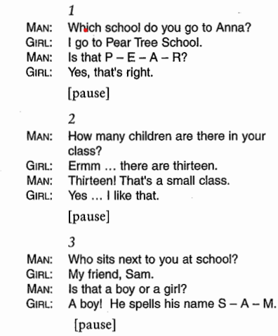  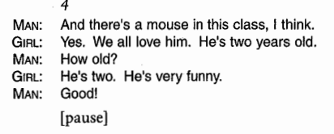 | 