ĐỀ 13 | ĐỀ ÔN TẬP GIỮA HỌC KỲ II  NĂM HỌC 2025-2026  MÔN: TIẾNG ANH 6

SECTION A: LISTENING (2 point)
Task1: You will hear five short conversations. For each question, put a √ under the right answer. You will hear each conversation TWICE (1pt)
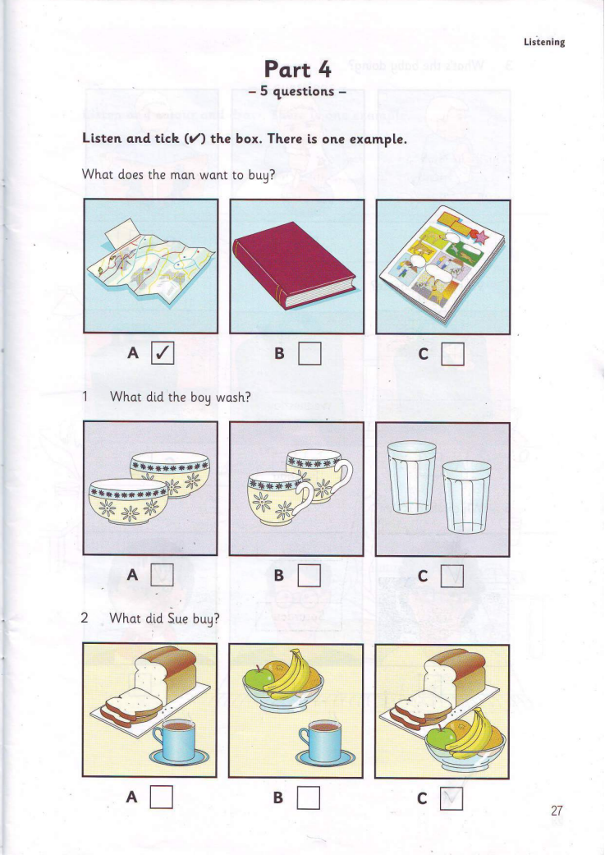
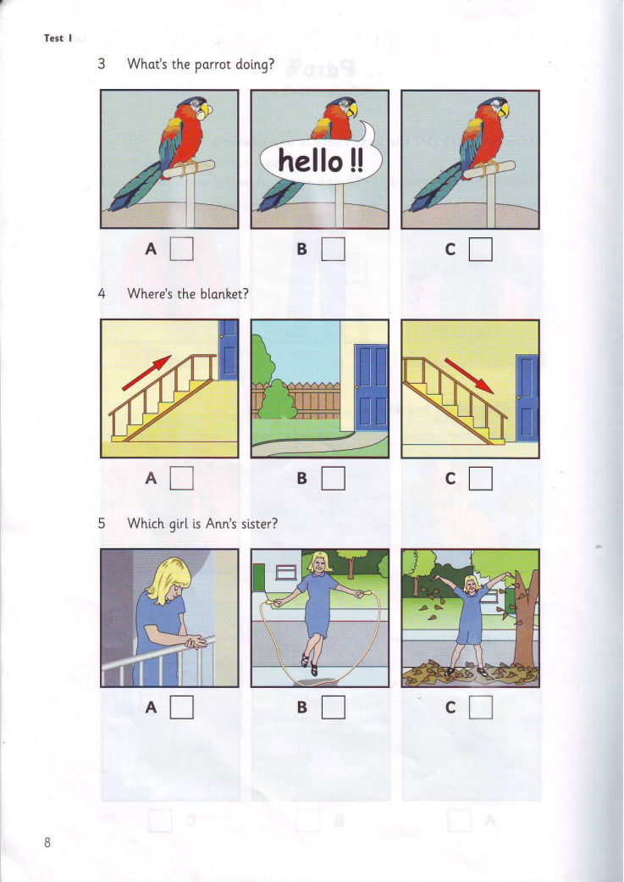
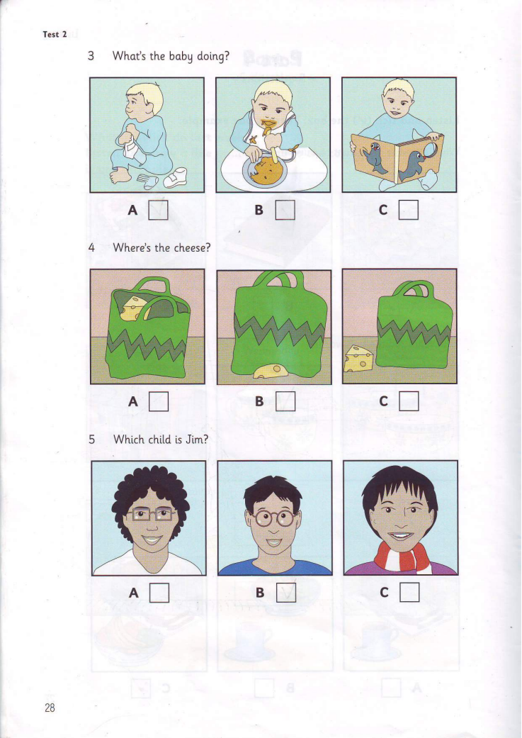
Task 2: Listen to a friend talking about his sports activities every week. Tick T (True) or F (False). You will listen twice (1 point)
1. He goes swimming at 6 o’clock on Monday.
2. He plays basketball between 7a.m. and 9 a.m. on Tuesday.
3. He can’t do any sports on Thursday.
4. On Friday morning, he join a chess club at his school.
5. His football team often loses the matches.
SECTION B: LANGUAGE (3 POINTS)
I. Choose the word whose underlined part pronounced differently from that of the others by circling A, B, C or D (0.4 point)
1. A. thanks B. thick C. though D. thought NB
2. A. slow B. phone C. post D. count NB
II. Choose the best option (A, B, C or D) to complete these sentences. (2.6 points)
3. “Who is the millionaire” is the __________that I like best.
A. cartoon B. game show C. channel
4. Nam: Last week, I played tennis with Jane and I won for the first time.
Peter:____________
A.Thank you B. Congratulation! C. That’s a good idea.
5. Tom: “Let’s play a game of badminton.” – Peter: “___________.”
A. Good idea B. No, I won’t. C. Good job!
6.__________do you go to the gym? - Once a day.
A. What B. Where C. How often
7. The first modem Olympic Games took _________ in Athens in 1896.
A. site B. location C. place
8. I often _____ fishing with my father at the weekend.
A. do B. go C. play
9. _______ rubbish on the street, please !
A. Don’t throw B. don’t throwing C. not throw
10. Last year, my brother ________ a new car.
A. buy B. bought C. is buy
11. My pen is red and _______ is green
A. yours B. your C. you
12.My brother likes watching TV, ________ I like going out with my friends.
A. and B. but C. or
13. _________ do you take morning exercises ?- Because it is good for my health.
A. What B. When C. Why
14. Where are the children now? They __________ in the yard.
A. play B. are playing C. is playing
15. ‘Let’s learn’ teaches children to study Maths. It’s an __________ program.
A. educational B. popular C. entertaining
SECTION C: READING (2.5 POINTS)
I. Read the passage and then choose the correct answer to each question. (1 point)
There are many TV channels for children. They offer interesting (1)_________for fun and learning. When children (2)________ watching the programmes, they can visit far-away lands, meet interesting people , learn about the (3)________ around them, laugh with the comedians, and enjoy the funny (4) _________ colourful cartoon characters. They can also (5)________ guests at the studio of a programme.
1. A. television B. programmes C. animals
2. A. are B. was C. is
3. A. home B. school C.world
4. A. because B. and C. but
5. A. met B. become C. read
II. Read the passage and choose the correct answer for each question (1.5 points)
Every year, thousands of people come to Edinburgh, the capital of Scotland, to be part of the Edinburgh Festival. For three weeks every August and September the city is filled with actors and artists from all over the world. They come to Edinburgh for the biggest art festival in Britain. During this time the streets of the city are alive with music and dance from early morning until late at night. You can even see artists painting pictures on the streets. One of the best parts of the Festival is “Fringe” where students do comedy shows in small halls and cafes.
Thousands of tourists come to the festival to see new films and plays and hear music played by famous musicians. This year you can see over five hundred performances with actors from forty countries.
The tickets for these performances are quite cheap and it is usually easier to see your star in Edinburgh than it is in London. So come to Edinburgh next summer.
1. Edinburgh is a __________.
A. capital B. country C. continent
2. How long does Edinburgh Festival last?
A. 2 weeks B. 3 weeks C. 4 weeks
3. What does they refer to?
A. actors B. artists C. actors and artists
4. What is one of the most interesting parts of the Festival?
A. music and dance B. Fringe C. new films
5. Which statement is NOT TRUE ?
A. Tourists can see new films and plays.
B. Tourists can enjoy performances with actors from 14 countries.
C. The tickets for these performances are not expensive.
SECTION D: WRITING (2.5 POINTS)
I. Find out the mistake in each following sentence. (0.5 point)
1. Merlion is a creature with the head of a lion or the body of a fish.
A. is B. with C. head D. or
2. Phong goes to a book exhibition with his parents last Friday.
A. goes B. a C. with D. last
II. Rewrite the following sentences as directed ( using the suggested words) so that the meanings stay the same. (1 pt)
1. It’s rainy today. I can’t go jogging. (so)
=> It’s ……………………………………………………………………………………………………………………………………………………………………………...
2. I like cartoon. I don’t watch it much
=> Although ……………………………………………………………………………………………………………………………………………………………………………...
3. She went to Da Nang last Sunday. (When)
=> When ……………………………………………………………………………………………………………………………………………………………………………...
4. It is my bag. It is red.
=> The red bag ……………………………………………………………………………………………………………………………………………………………………………...
5. You shouldn’t spend a lot of time watching TV.
=> You……………………………………………………………………………………………………………………………………………………………………………...
III. Quynh Anh is writing a postcard to her English friend to tell her about Hue city. Use the given words to make complete sentences about it. (1 pt)
Hi Jane,
Hue is a great city!
1. The weather/be/ fine/ sunny/ all the time.
__________________________________________________________.
2. The food / be/ cheap/ delicious.
__________________________________________________________.
3. The people/be/ friendly and hospitable.
__________________________________________________________.
4. We/ visit/ the hitoric monuments / Huong River / now.
__________________________________________________________.
5. I / buy/ a nice present/ you/ yesterday.
__________________________________________________________.
You must visit this city someday. You’ll love it.
Bye for now!
Cheer,
Quynh Anh
ĐÁP ÁN
Mục chấm | Đáp án | Điểm
SECTION A. LISTENING | I. You will hear five short conversations. For each question, put a √ under the right answer (1pt) M5-2- 4
SECTION A. LISTENING | 1.C 2.C 3.A 4.B 5.B | Each correct answer 0.2 pt
SECTION A. LISTENING | II. Listen to a friend talking about his sports activities every week. Tick T (True) or F (False). You will listen twice (1 point)
SECTION A. LISTENING | 1.F 2.T 3.T 4.T 5. F | Each correct answer 0.2 pt
SECTION B. LANGUAGE FOCUS | I. Choose the word whose underlined part pronounced differently from that of the others by circling A, B, C or D (0.4 point)  II. Choose the best answer A, B, or C to complete the sentence. (2.6 pts)
SECTION B. LANGUAGE FOCUS |  | Each correct answer 0.2 pt
  1. C | 2.D |  | 3.B | 4.B | 5.A | 6.C | 7.C
  8.B | 9.A | 10.B | 11.A | 12.B | 13.C | 14.B | 15.A
SECTION C. READING | I. Read the passage and then choose the correct answer to each question. (1 point)
SECTION C. READING | 1- B 2- A 3- C 4-B 5-B | Each correct answer 0.2 pt
SECTION C. READING | II. Read the passage then choose the best answer for each question/ sentence. (1.5pts)
SECTION C. READING | 1.A 2. B 3. C 4. B 5. B | Each correct answer 0.3 pt
SECTION D. WRITING | I. Find out the mistake in each following sentence. (0.5 point)
SECTION D. WRITING | 1. D 2. A | Each correct answer 0.25 pt
SECTION D. WRITING | II. Rewrite the following sentence so that it has similar meaning to the first one. (1 point)
SECTION D. WRITING | 1. It’s rainy today so I can’t go jogging.  2. Although I like cartoon, I don’t watch it much.  3. When did she go to Da Nang?  4. The red bag is mine.  5. Don’t spend a lot of time watching TV | Each correct answer 0.2 pt
SECTION D. WRITING | III. Quynh Anh is writing a postcard to her English friend to tell her about Hue city. Use the given words to make complete sentences about it. (1 pt)
SECTION D. WRITING | Hi Jane,  Hue is a great city. (1)The weather is fine and sunny all the time. (2)The food is cheap and delicious. (3)The people here are friendly and hospitable. (4) We are visiting the historic monumenst and Huong River now. (5) I bought a small present for you yesterday. You must visit this city someday. You’ll love it.  Bye for now!  Cheer,  Quynh Anh | Each correct answer 0.2 pt

