ĐỀ 11 | ĐỀ ÔN TẬP CUỐI HỌC KỲ II  NĂM HỌC 2025-2026  MÔN: TIẾNG ANH LỚP 2

Part 1
4 questions

Listen and match. There is one example.
5
4
3
2
1

b
c
e
d
a

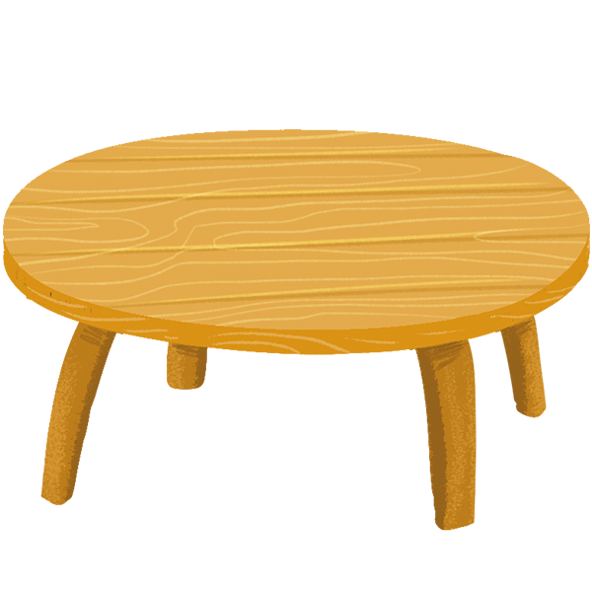
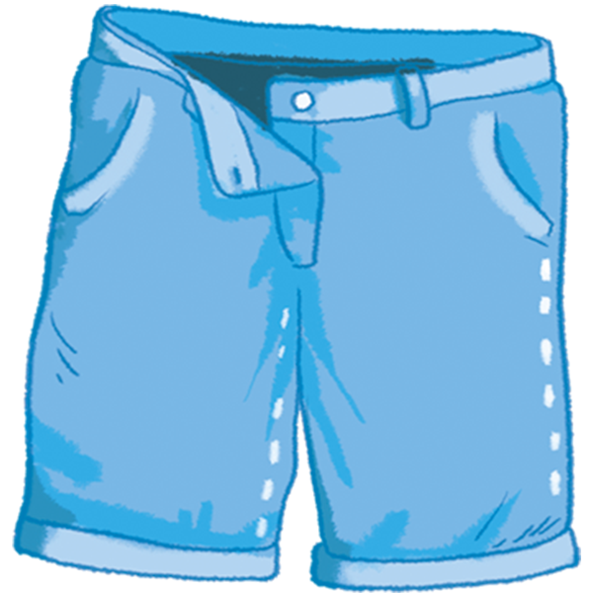
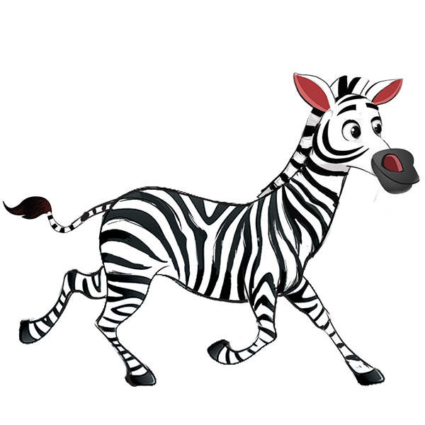

Part 2
4 questions

Listen and circle. There is one example.
3
2
1

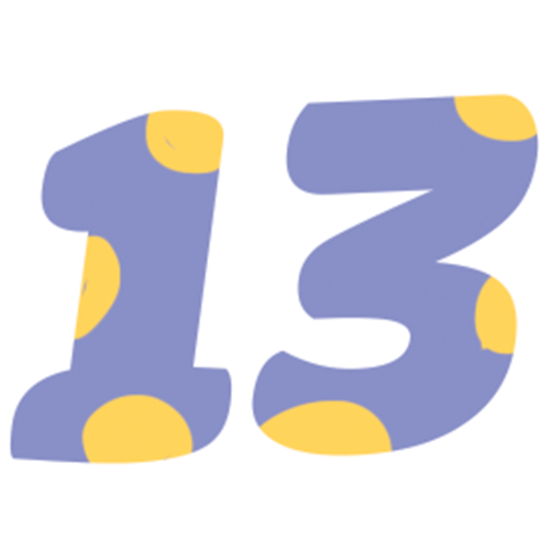

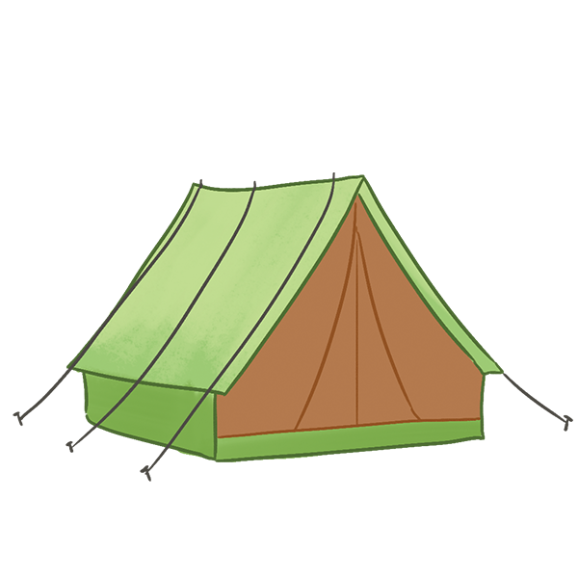
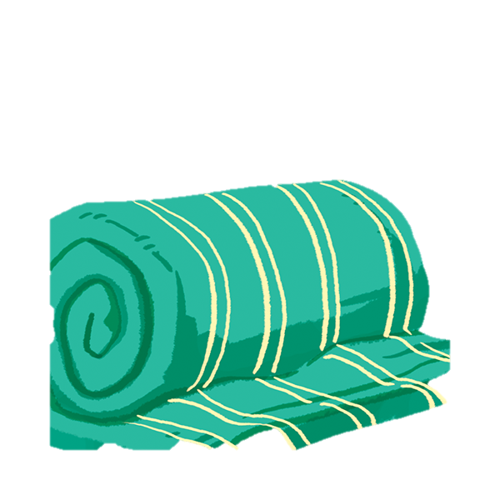

5
4


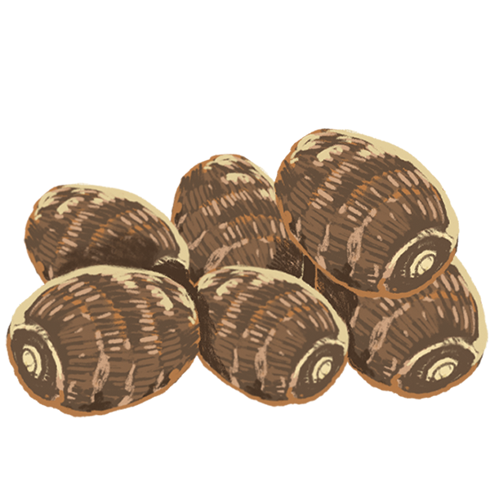



Part 1
4 questions

Look and read. Then match. There is one example.
1. What number is it? | 1.c | a. Seventeen squares.
2. How many squares? | 2…… | b. She’s having grapes.
3. Do you like the tiger? | 3…… | c. It’s fifteen.
4. How old is your sister? | 4…… | d. No, I don’t.
5. What is Mai having ? | 5…… | e. She’s twenty.
Part 2
4 questions

Look and read. Put a tick in the box. There is one example.
1.I want some yo-yos.
a. b. c.


2. Where’re the shirts?
a. b. c.


3.He’s drawing.
a. b. c.




4. I like the turtle.
a. b. c.
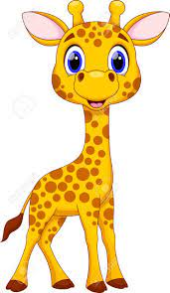



5. What number is it? It’s thirteen.
a. b. c.


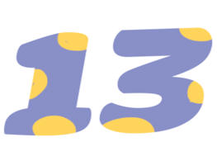

Part 3
4 questions

Look at the pictures. Look at the letters. Complete the words. There is one example.
s t z w p
g

teapot

4
3
2
1
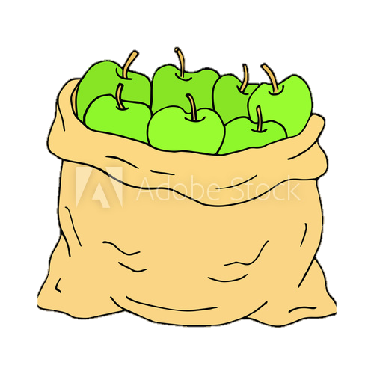
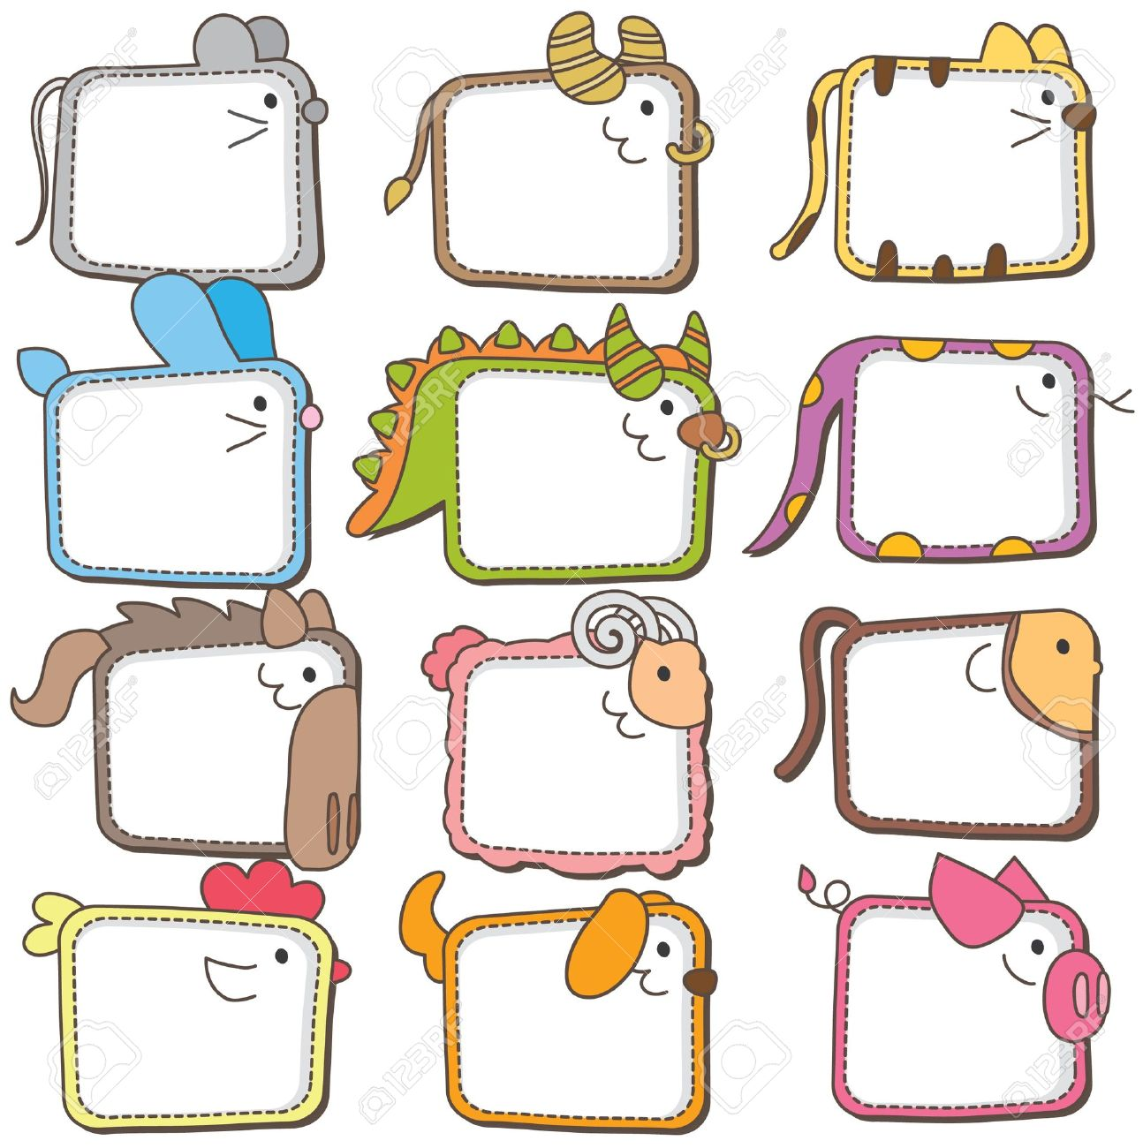

…..bra

….horts
T….elve

A….ples

Part 4
4 questions

Look at the pictures. Look at the words. Put them in order. There is one example.
Grandmother?
your
How old
is
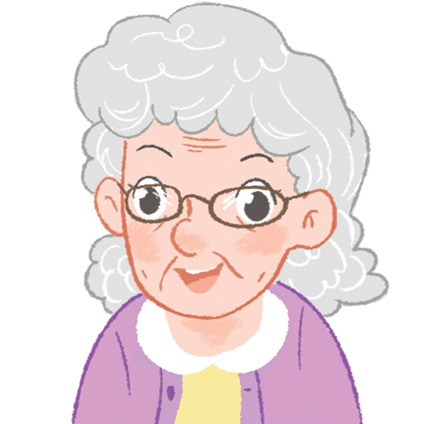
- How old is your grandmother?

the
are
Shoes?
Where

many
yams
?
How

?
doing
he
What’s

She’s eighteen.
sister?
is your?
How old

