ĐỀ 9 | ĐỀ ÔN TẬP CUỐI HỌC KỲ II  NĂM HỌC 2025-2026  MÔN: TIẾNG ANH LỚP 2
Part 1
4 questions

Listen and draw lines .There is one example.
5
4
3
2
1



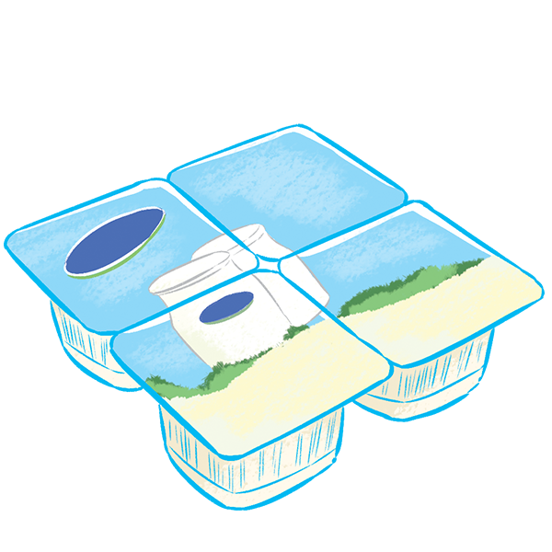



Part 3
4 questions

Listen and tick (v) or cross(x). There is one example.
5
4
3
2
1


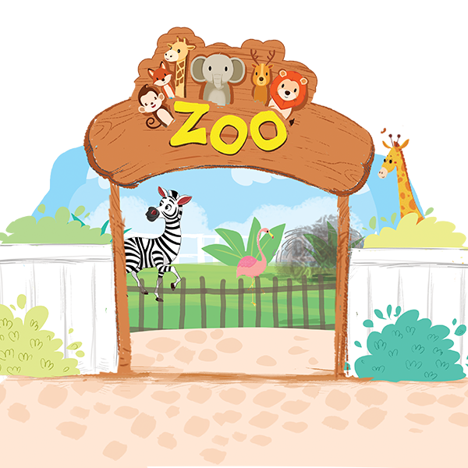
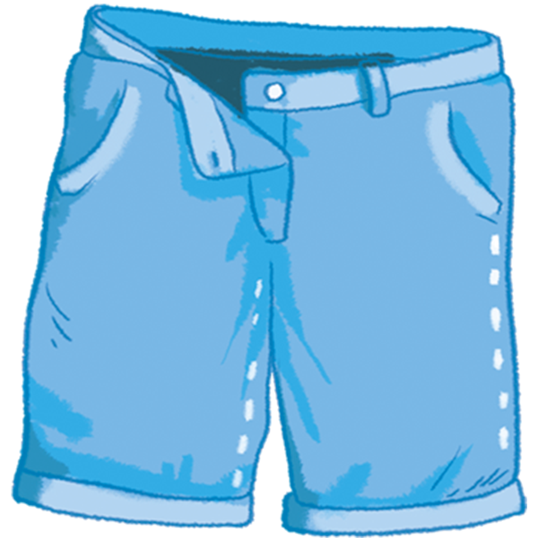

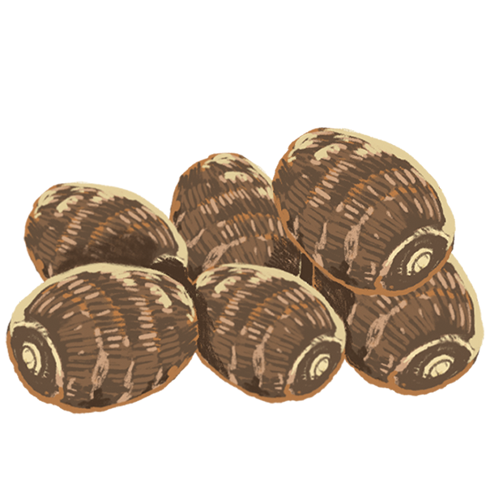

Part 1
4 questions

Look and read. Draw lines. There is one example.
  a | 1. I like the shirt.  2. They’re sliding.  3. How many yo-yos? Nine  4. What number is it? It’s fouteen.  1.d 2…… 3….. 4….. | 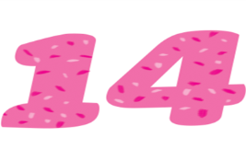  c
  b |  |   d
Part 2
4 questions

Look and read . Circle the pictures. There is one example.
  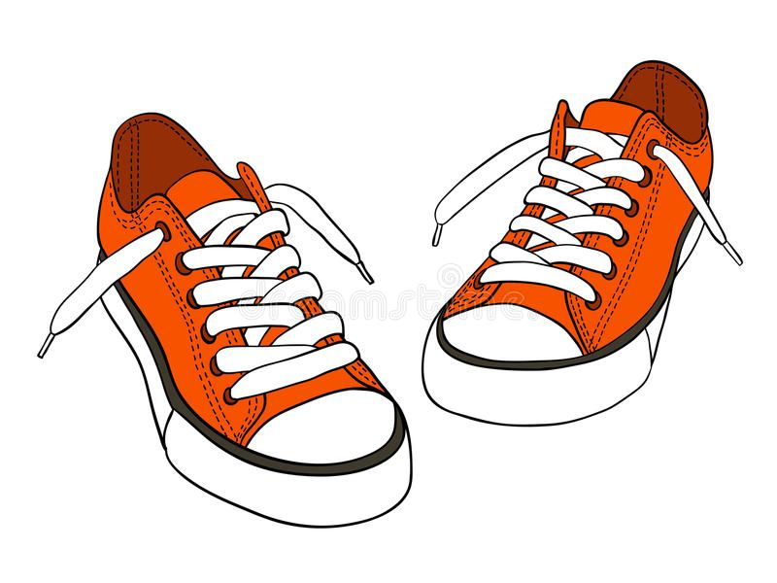  1. Shorts in the shop. |       2. The tent is over there.
    3. My grandmother is seventy. |   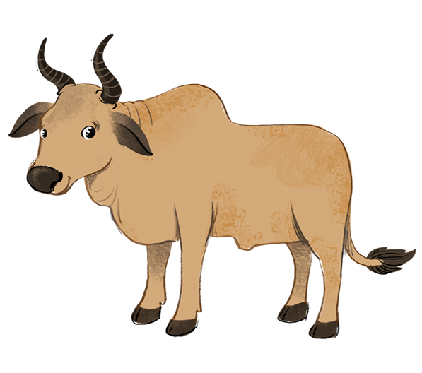    4.I like the tiger.
Part 3
4 questions

Look at the pictures. Look at the letters. Complete the words. There is one example.
a b v b
1
4
2
3
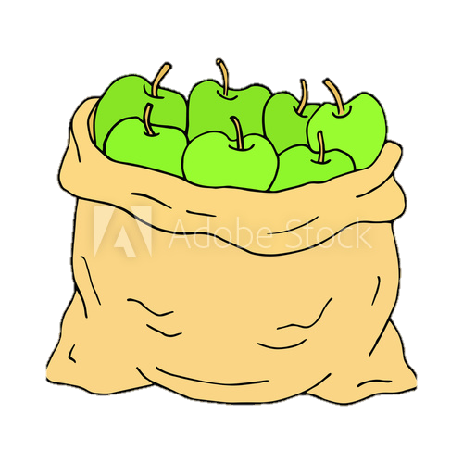

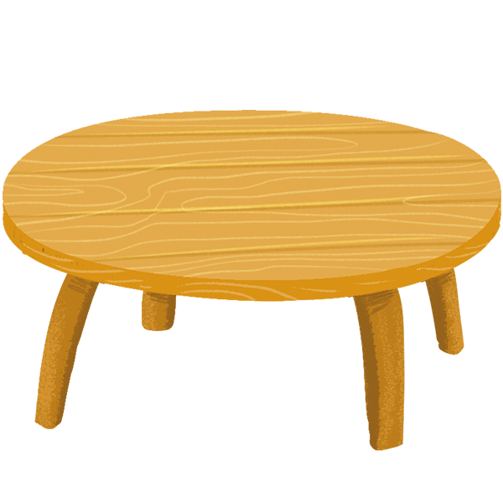

….lanket

Table
Se….enteen

Ap….les

Part 4
4 questions

Look at the pictures. Look at the words. Put them in order. There is one example.
yams.
- I want some yams.
some
I
want


a bike.
is
riding
He

shops.
are
Shirts
in the

your
is
brother?
How old

