ĐỀ 8 | ĐỀ ÔN TẬP CUỐI HỌC KỲ II  NĂM HỌC 2025-2026  MÔN: TIẾNG ANH LỚP 2
Part 1
4 questions

Listen and number . There is one example.
a
e
d
c
b



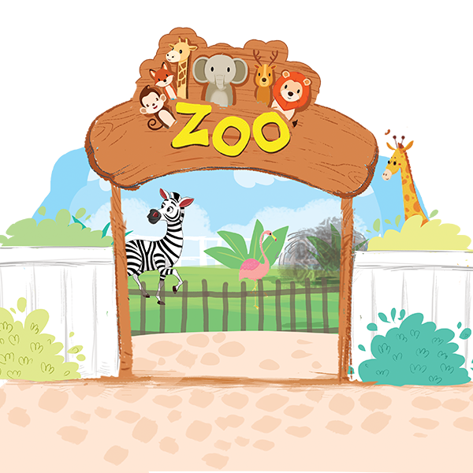
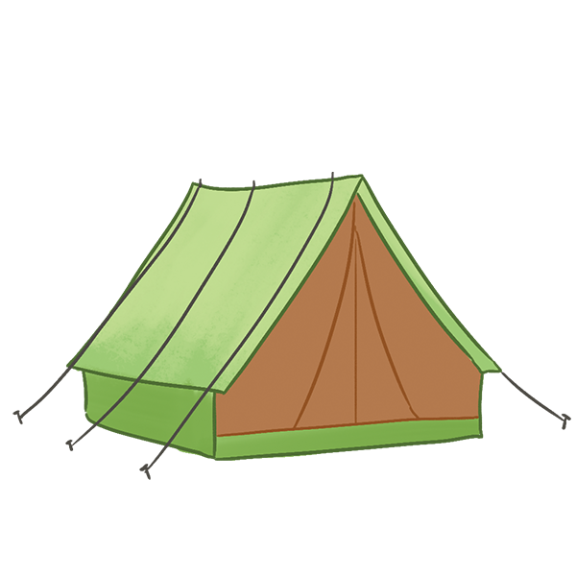
1

Part 1
4 questions

Listen and circle. There is one example.



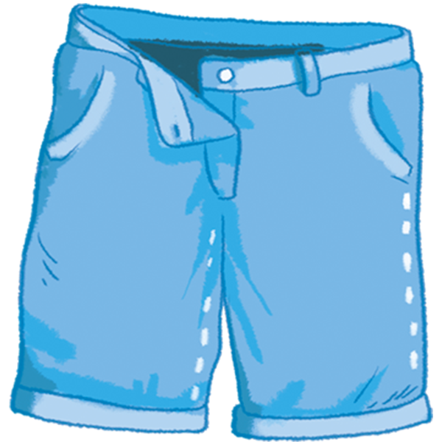
1




3
2



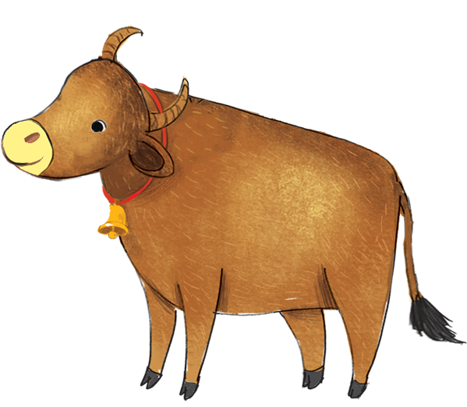
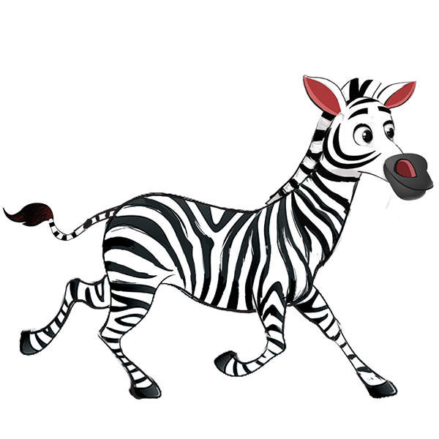
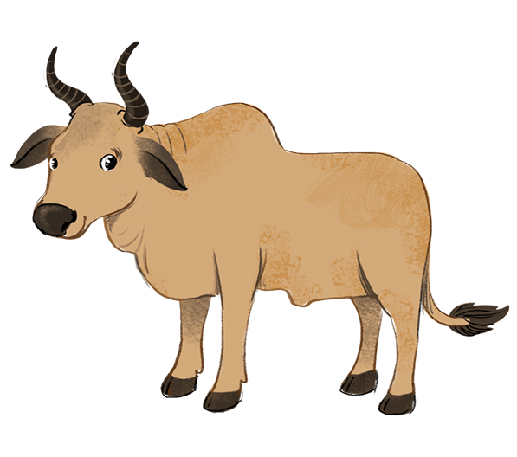
4
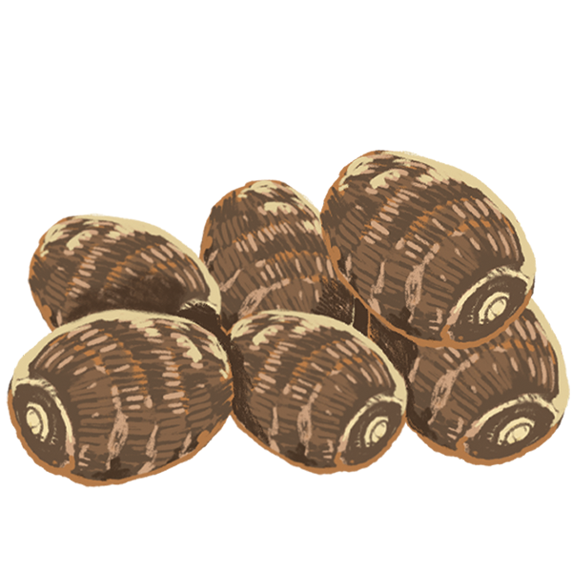

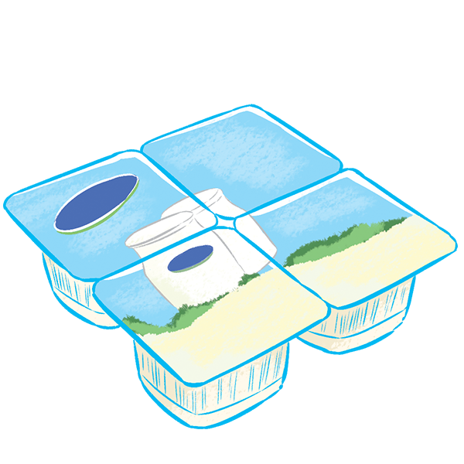
5

Part 1
4 questions

Look and read. Draw lines. There is one example.
  a | 1. She’s my sister.  2. Shorts are in the shop.  3. Is the teapot in the tent?  4. It’s thirteen.  1.d 2…… 3….. 4….. | 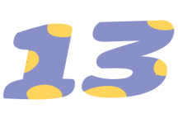  c
  b |  |   d
Part 2
4 questions

Look and read . Put a tick in the box. There is one example.
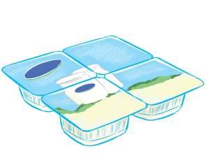  1.a. I want some yogurt.  b. I want some yams. | 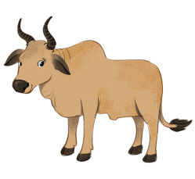  2.a. Do you like the zebu?  b. Do you like the zebra?
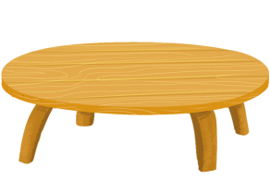  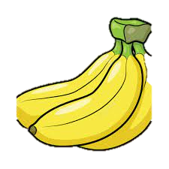  3.a. The grapes are on the table.  b. The bananas are on the table. |   4.a. He’s flying a kite.  b. He’s riding a bike.

Part 3
4 questions

Look at the pictures. Look at the letters. Complete the words. There is one example.
s i d n

4
1
2
3

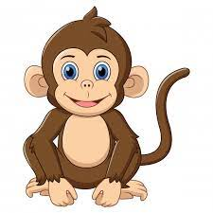

Mo….key

Yams
….riving

F….fteen

Part 4
4 questions

Look at the pictures. Look at the words. Put them in order. There is one example.
cars.
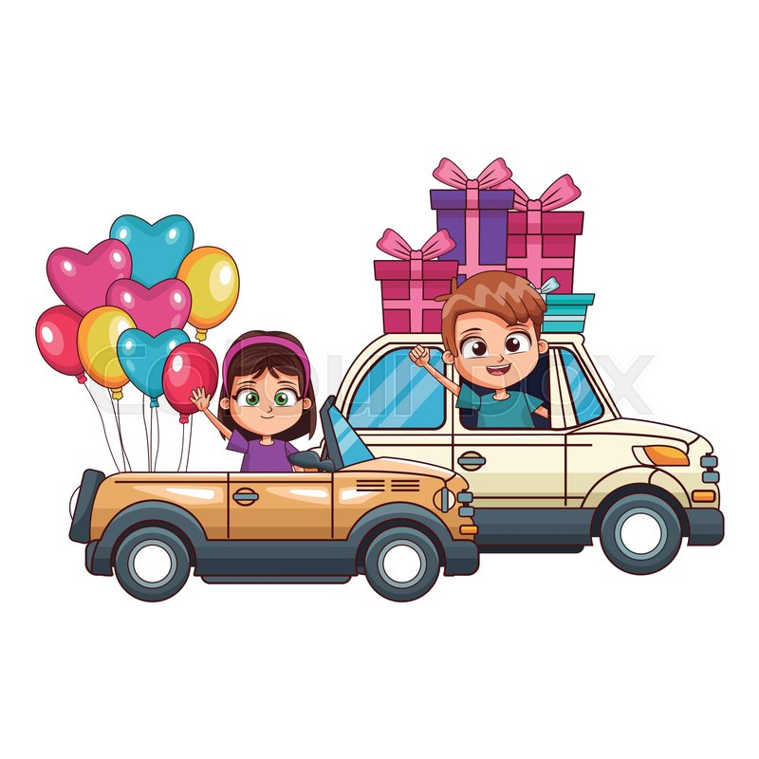
- They are driving cars.
driving
They
are


a cake.
is
having
He

are
the shop.
Shoes
in

triangles?
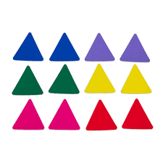
triangles.
How many
twelve

