ĐỀ 5 | ĐỀ ÔN TẬP CUỐI HỌC KỲ II  NĂM HỌC 2025-2026  MÔN: TIẾNG ANH LỚP 2
PART I. LISTENING
 |  |  |  |  | Listen and circle (1 point)
 |  |  |  |  |  | y |  | z
 |  |  |  |  |  | n |  | l |  |  |  |  |  | sh |  | t
 |  |  |  |  |  | y |  | z |  |  |  |  |  | i |  | a
 |  |  |  |  | Listen and tick (1 point)
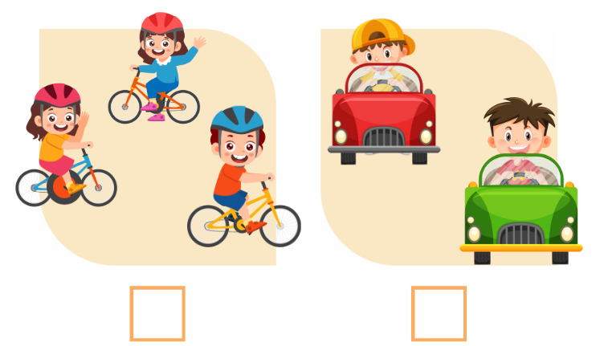

✓

 |  |  | 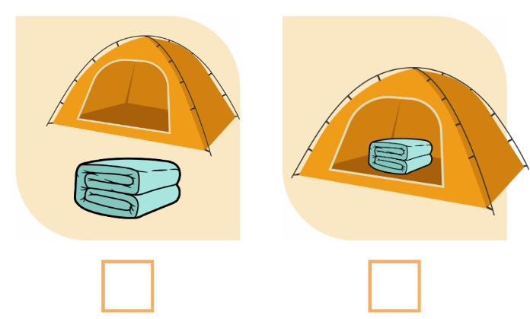 |  |  |  |  |  |  |  |  | 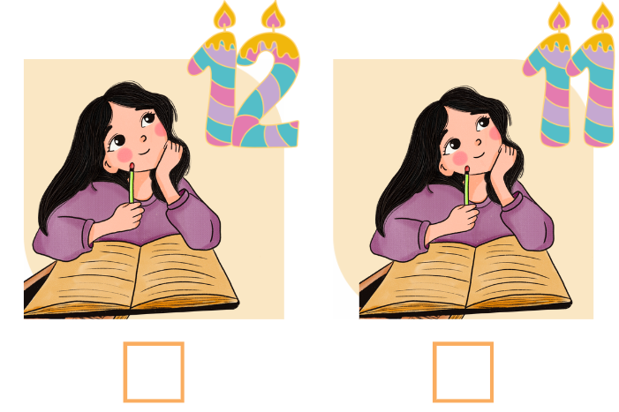
 |  |  | 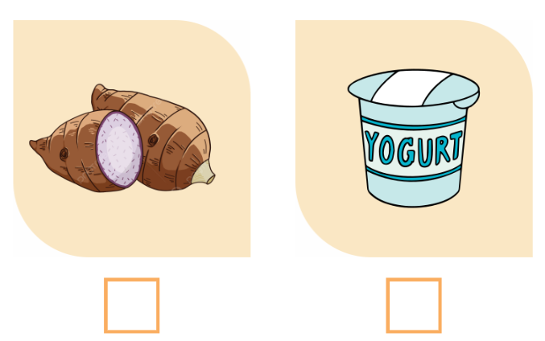 |  |  |  |  |  |  |  |  | 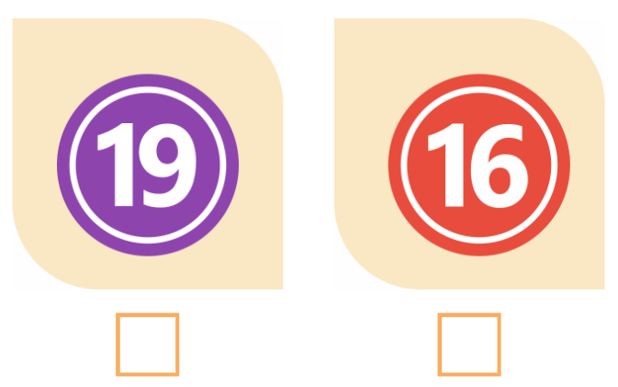
 |  |  |  |  | Listen and tick or cross (1 point)

 |   ✓ | The cake is on the table.
- What number is it?
- It’s nineteen.
- Do you like the zebu?
- Yes, I do.
- What do you want?
- I want some yo-yos.
- Where are the shoes?
- Over there.
PART II. READING
 |  | Read and tick (0.75 points)
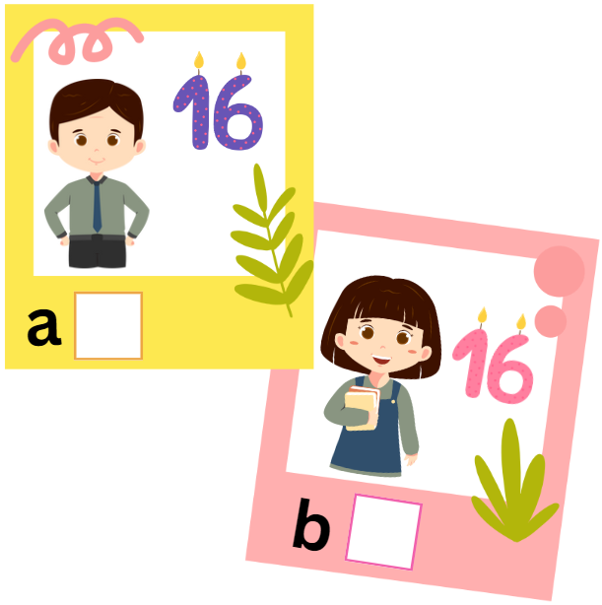  ✓ |  |  |  | 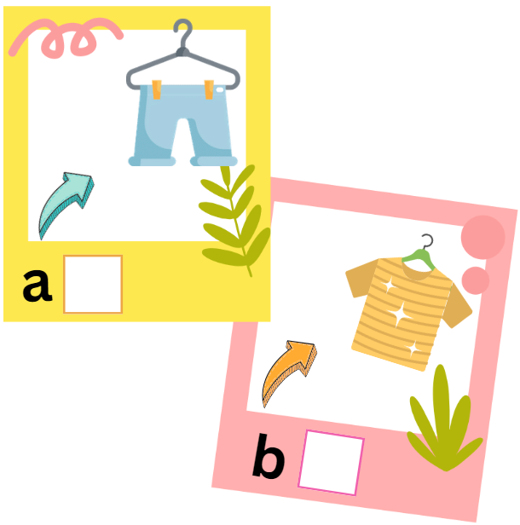
- My sister is sixteen. |  |  |  | - The shorts are over there.
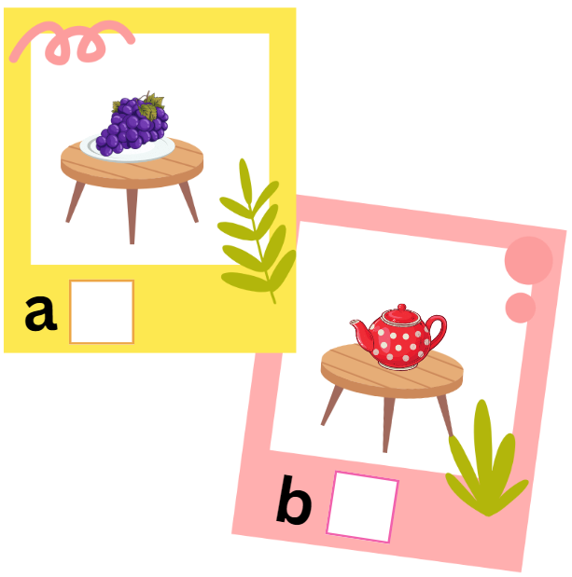 |  |  |  | 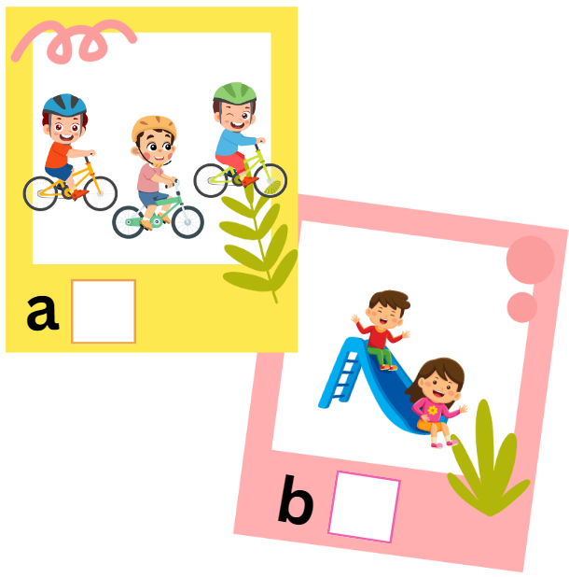
- The grapes are on the table. |  |  |  | - They are riding.
 |  | Read and tick (✓) or cross (x) (0.75 points)
 | 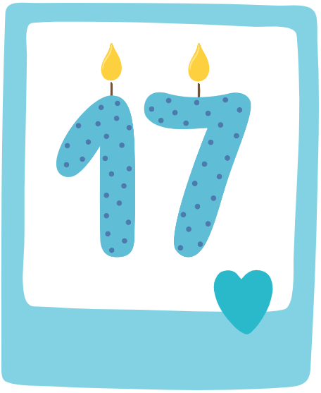 |  |  |  | 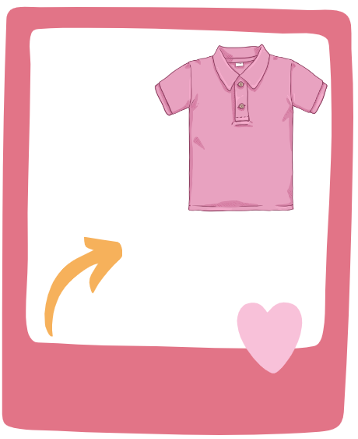
  ✓ | It’s seventeen. |  |  |  | The shirt is over there.
 |  |  |  |  | 
 | Do you like the zebu? |  |  |  | The teapot is in the tent.
PART III. WRITING
 | Reorder the letters to make a word (1.5 points)

- 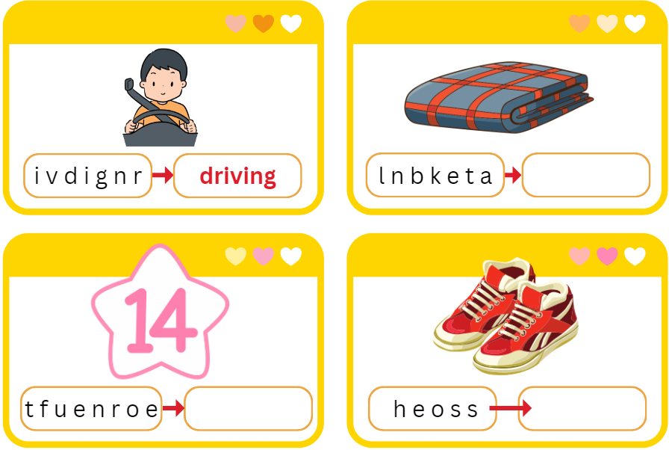

 | Reorder the words to make complete sentences (1.5 points)
- twelve./ It/ is
It is twelve.
- bikes./ are/ They/ riding
_________________________________________________
- the/ The/ is/ on/ table./ cake
_________________________________________________
- you/ Do/ zoo?/ the/ like
_________________________________________________
PART IV. SPEAKING
 | Introduction (0.5 points)
Teacher asks students to answer questions:
- Hello, what’s your name? How old are you?
- How are you today?
 | Let’s talk (2 points)
Teacher shows the pictures and asks students to answer questions:

Q1: How old is your sister?  A: ________________________________________ |  | 
Q2: What do you want?  A: ________________________________________ |  | 
Q3: Is the blanket in the tent?  A: ________________________________________ |  | 
Q4: How many mangos can you see?  A: ________________________________________ |  | 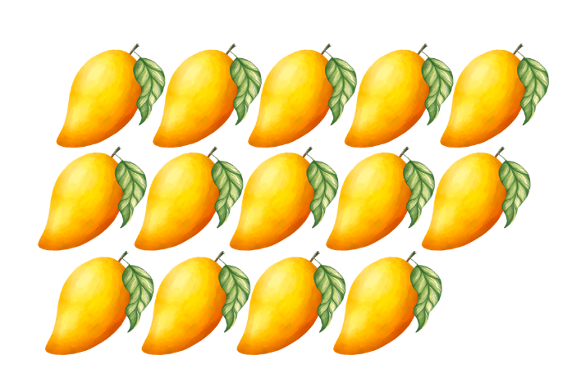
ĐÁP ÁN
PART I. LISTENING (3 points)
QUESTION 1: Listen and circle (1 point)
Mỗi câu đúng 0.25 điểm (0.25x4)
- n | - sh | - z | - a
QUESTION 2: Listen and tick (1 point)
Mỗi câu đúng 0.25 điểm (0.25x4)
QUESTION 3: Listen and tick or cross (1 point)
Mỗi câu đúng 0.25 điểm (0.25x4)
- x | - x | - ✓ | - x
PART II. READING (1.5 points)
QUESTION 4: Read and tick (0.75 points)
Mỗi câu đúng 0.25 điểm (0.25x3)
- a | - a | - a
QUESTION 5: Read and tick (✓) or cross (x) (0.75 points)
Mỗi câu đúng 0.25 điểm (0.25x3)
- ✓ | - x | - x
PART III. WRITING (3 points)
QUESTION 6: Reorder the letters to make a word (1.5 points)
Mỗi câu đúng 0.5 điểm (0.5x4)
- blanket | - fourteen | - shoes
QUESTION 7: Reorder the words to make complete sentences (1.5 points)
Mỗi câu đúng 0.5 điểm (0.5x2)
- They are riding bikes..
- The cake is on the table.
- Do you like the zoo?
PART IV. SPEAKING (2.5 points)
QUESTION 8: Introduction (0.5 points)
Mỗi câu trả lời 0.25 điểm (0.25x2)
QUESTION 9: Let’s talk (2 points)
Mỗi câu trả lời 0.5 điểm (0.5x4)
- She is fifteen.
- I want some yo-yos.
- No, it isn’t. It is near the tent.
- Fourteen mangos./ I can see fourteen mangos./ There are fourteen mangos.

