ĐỀ 4 | ĐỀ ÔN TẬP CUỐI HỌC KỲ II  NĂM HỌC 2025-2026  MÔN: TIẾNG ANH LỚP 2
PART I. LISTENING
 | Listen and tick (1 point)

✓

 |  | n |  | l
 |  | sh |  | t |  |  |  | sh |  | s
 |  | er |  | a |  |  |  | i |  | y

 | Listen and circle (1 point)

 | 
 | 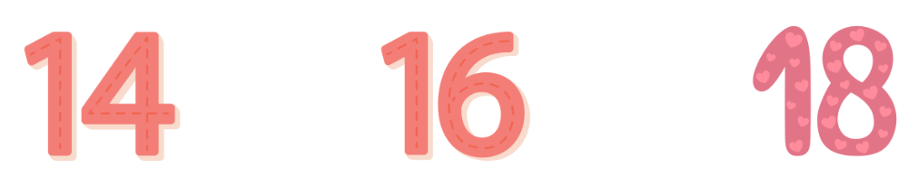
 | 
 | 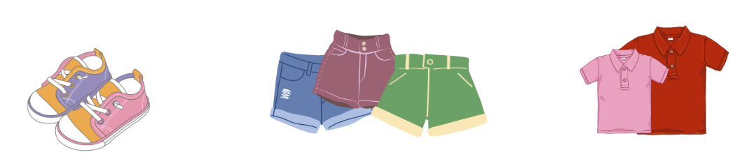
 | 
 |  | Listen and complete (1 point)
- The blanket is in the tent.
- - How old is your _____________________?
- He’s seventeen.
- - Is the _____________________ on the table?
- Yes, it is.
- They are _____________________.
- - Do you like the _____________________?
- Yes, I do.
PART II. READING
 |  | Read and match (0.75 points)
  0. shirts |  |  | 1. thirteen |  | 2. table | 3. sliding
  A |  |  |   B |  |   C |   D
 | Read and circle A, B or C (0.75 points)
- I want a cake.
- 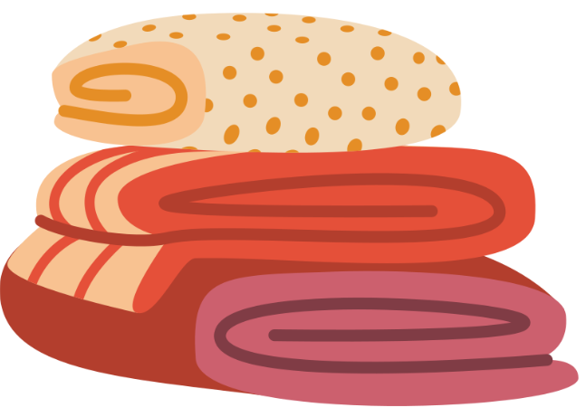 |  |  |  | -  |  |  | - 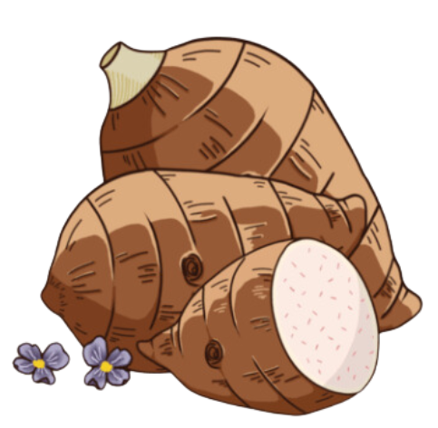
- They’re driving.
-  |  |  |  | -  |  |  | - 
- Do you like the zebu?
-  |  |  |  | -  |  |  | - 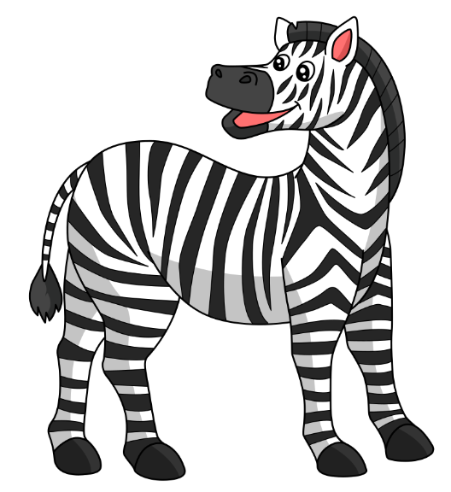
- Where are the shorts?
-  |  |  |  | -  |  |  | - 
PART III. WRITING
 | Write the missing letters (1.5 points)

A
B
Z
R
E
0
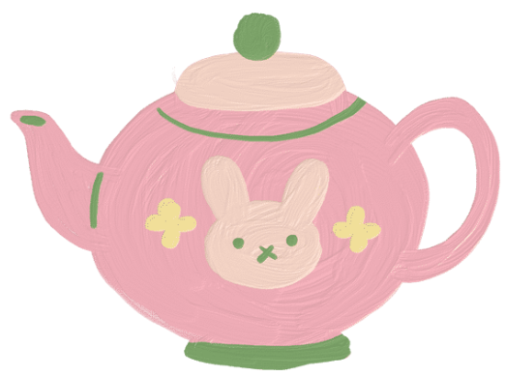
P
T
1


R
O
2
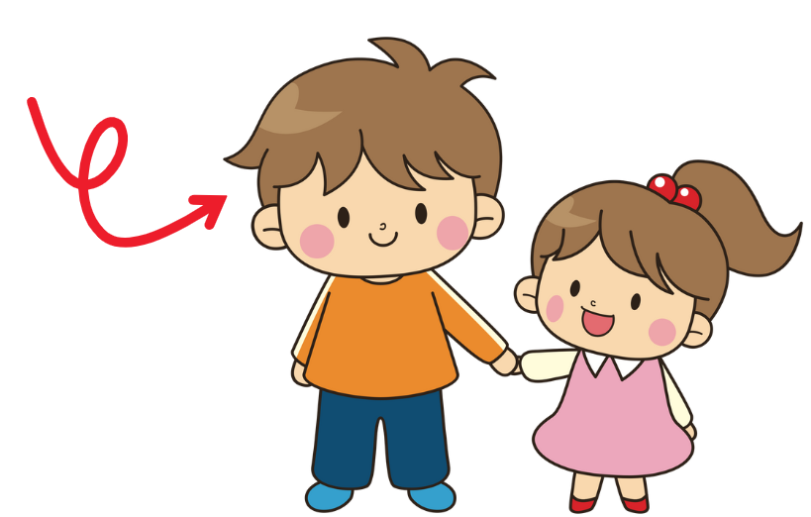
B
E
H
3
 | Write the missing words (1.5 points)
 |  | 
- Do you like zebu? |  | - The _______________ are on the table.
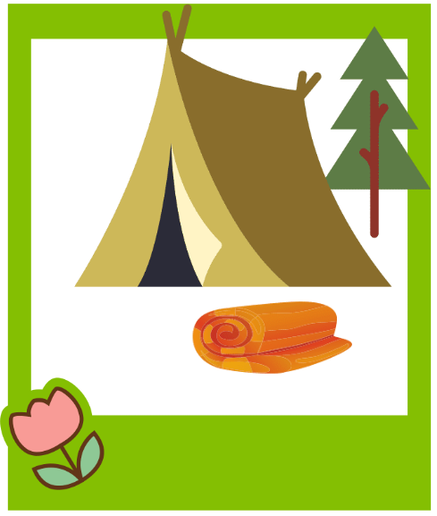 |  | 
- The blanket is near the _______________. |  | - My sister is _______________.
PART IV. SPEAKING
 | Introduction (0.5 points)
Teacher asks students to answer questions:
- Hello, what’s your name? How old are you?
- How are you today?
 | Let’s talk (2 points)
Teacher shows the pictures and asks students to answer questions:
Q1: How old is Huy?  Q2: How old is Nam?  Q3: How many apples can you see?  Q4: How many cakes can you see? | 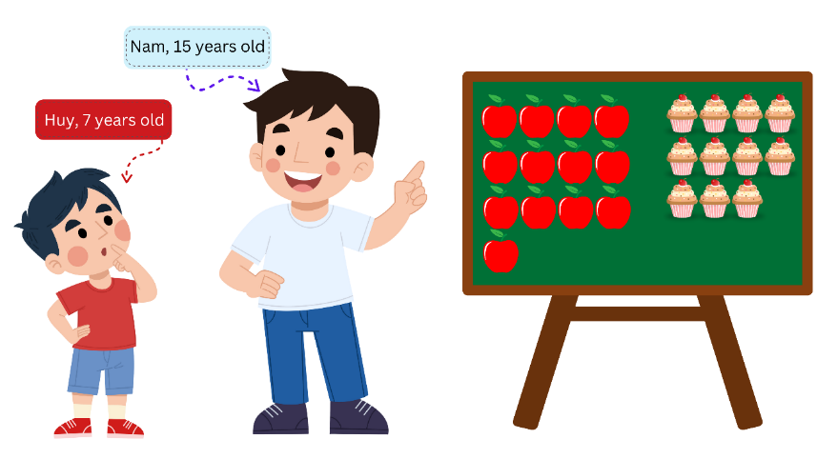
ĐÁP ÁN
PART I. LISTENING (3 points)
QUESTION 1: Listen and tick (1 point)
Mỗi câu đúng 0.25 điểm (0.25x4)
- t | - sh | - er | - i
QUESTION 2: Listen and circle (1 point)
Mỗi câu đúng 0.25 điểm (0.25x4)
QUESTION 3: Listen and complete (1 point)
Mỗi câu đúng 0.25 điểm (0.25x4)
- brother | - teapot | - sliding | - zoo
PART II. READING (1.5 points)
QUESTION 4: Read and match (0.75 points)
Mỗi câu đúng 0.25 điểm (0.25x3)
- B | - D | - A
QUESTION 5: Read and circle A, B or C (0.75 points)
Mỗi câu đúng 0.25 điểm (0.25x3)
- C | - B | - C
PART III. WRITING (3 points)
QUESTION 6: Write the missing letters (1.5 points)
Mỗi câu đúng 0.5 điểm (0.5x3)
- teapot | - yogurt | - brother
QUESTION 7: Write the missing words (1.5 points)
Mỗi câu đúng 0.5 điểm (0.5x3)
- grapes | - tent | - fifteen
PART IV. SPEAKING (2.5 points)
QUESTION 8: Introduction (0.5 points)
Mỗi câu trả lời 0.25 điểm (0.25x2)
QUESTION 9: Let’s talk (2 points)
Mỗi câu trả lời 0.5 điểm (0.5x4)
- He’s seven.
- He’s fifteen.
- Thirteen apples/ I can see thirteen apples.
- Eleven cakes/ I can see eleven cakes.

