ĐỀ 3 | ĐỀ ÔN TẬP CUỐI HỌC KỲ II  NĂM HỌC 2025-2026  MÔN: TIẾNG ANH LỚP 2
PART I. LISTENING
 |  | Listen and tick or cross (1 point)
 |  |  |   x | a
 |  |  |  | a |  |  |  | i
 |  |  |  | l |  |  |  | y
 |  | Listen and match (1 point)

C
  A |  |  |   B |  | 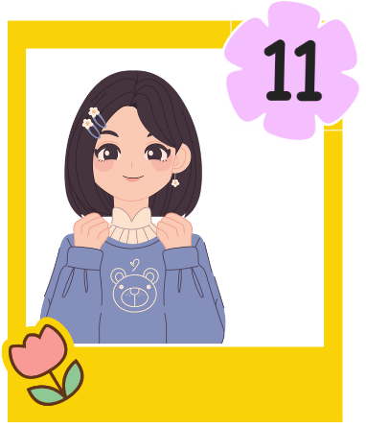 |  | 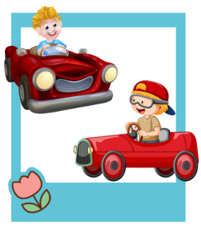  D |  |   E
 |  | Listen and choose A, B or C (1 point)
 | - The ____________ are on the table.
 |  |  |  | - grapes |  | - cake |  | - banana
- - What number is it?
- It’s ____________.
 |  |  |  | - fifteen |  | - sixteen |  | - fourteen
- - Is the blanket near the ____________?
- Yes, it is.
 |  |  |  | - water |  | - tent |  | - window
 | - They are ____________.
 |  |  |  | - riding |  | - sliding |  | - driving
- - What do you want?
- I want some ____________.
 |  |  |  | - yo-yos |  | - yams |  | - yogurt
PART II. READING
 | Read and match (0.75 points)
 |  |  |  |  |  |   The grapes are on the table.
 | 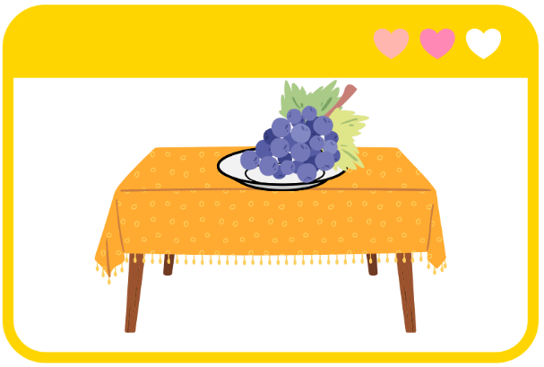 |  |  |  |  | - Where are the shirts?  - Over there.
 | 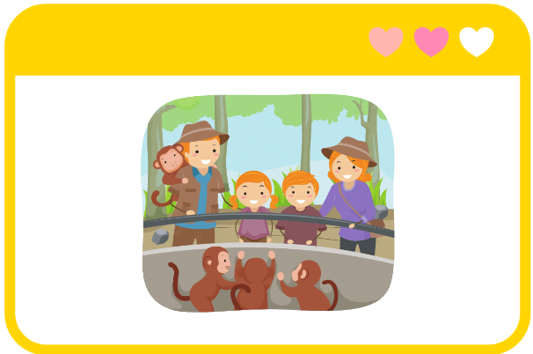 |  |  |  |  | I want some yams.
 | 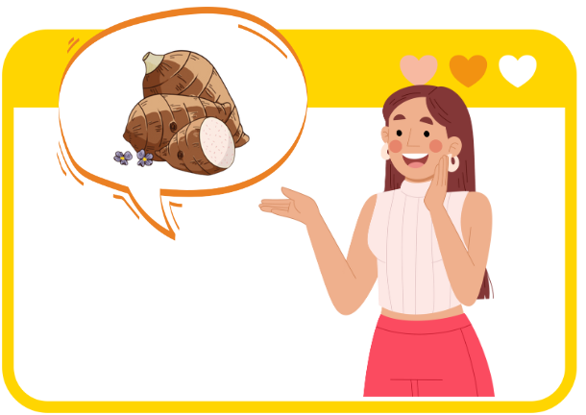 |  |  |  |  | - Do you like the zoo?  - Yes, I do.
 |  | Look and tick A or B (0.75 points)
✓ |  |  |  |  | 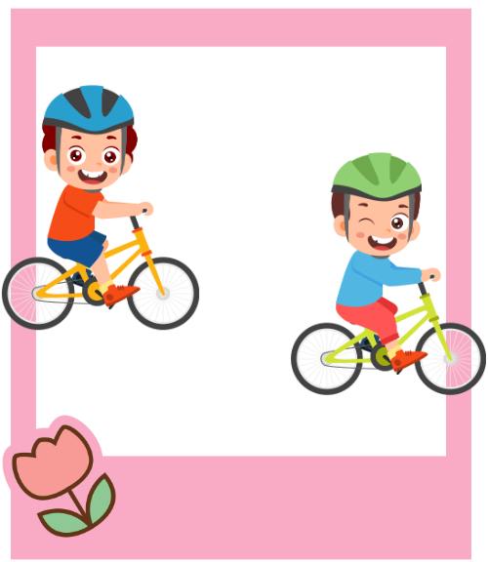
 |  | - I want some yo-yos. |  |  | - They’re sliding.
 |  | - I want some yogurt. |  |  | - They’re riding bikes.
 |  | 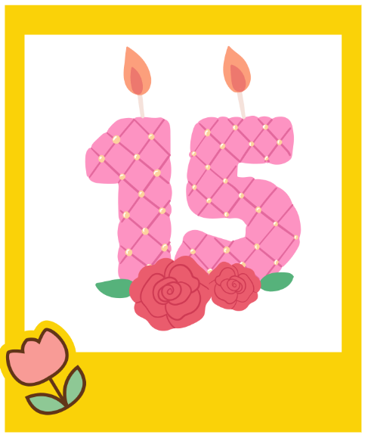 |  |  | 
 |  | - It’s fifteen. |  |  | - The blanket is in the tent.
 |  | - It’s fourteen. |  |  | - The blanket is near the tent.
PART III. WRITING
 | Write the missing letters (2 points)
- How old is your  sister?
- Do you like  z___________?
- The c___________ is on the table.
- He’s  d___________ a car.
- The s___________ are over there.

 | Reorder the words to make complete sentences (1 point)
- are/ sliding./ They
They are sliding.
- old/ is/ How/ brother?/ your
_________________________________________________
- yogurt./ I/ some/ want
_________________________________________________
PART IV. SPEAKING
 | Introduction (0.5 points)
Teacher asks students to answer questions:
- Hello, what’s your name? How old are you?
- How are you today?
 | Let’s talk (2 points)
Teacher shows the picture and asks students to answer questions:
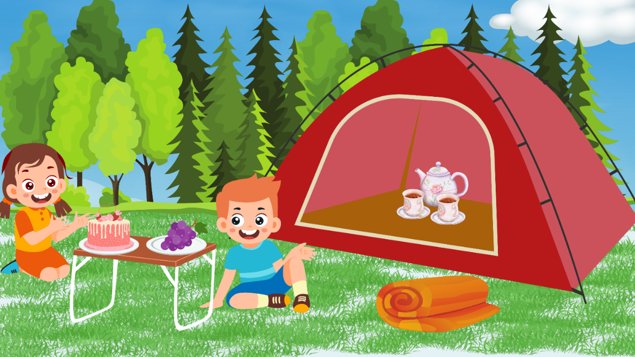
Q1: Is the cake near the table?
A: _________________________________________________.
Q2: Are the grapes on the table?
A: _________________________________________________.
Q3: Is the blanket in the tent?
A: _________________________________________________.
Q4: Is the teapot near the tent?
A: _________________________________________________.
ĐÁP ÁN
PART I. LISTENING (3 points)
QUESTION 1: Listen tick or cross (1 point)
Mỗi câu đúng 0.25 điểm (0.25x4)
- ✓ | - ✓ | - x | - x
QUESTION 2: Listen and match (1 point)
Mỗi câu đúng 0.25 điểm (0.25x4)
- E | - B | - D | - A
QUESTION 3: Listen and choose A, B or C (1 point)
Mỗi câu đúng 0.25 điểm (0.25x4)
- C | - B | - A | - C
PART II. READING (1.5 points)
QUESTION 4: Read and match (0.75 points)
Mỗi câu đúng 0.25 điểm (0.25x3)
- The grapes are on the table. | - Do you like the zoo?  Yes, I do. | - I want some yams.
QUESTION 5: Look and tick A or B (0.75 points)
Mỗi câu đúng 0.25 điểm (0.25x3)
- B | - A | - B
PART III. WRITING (3 points)
QUESTION 6: Write the missing letters (2 points)
Mỗi câu đúng 0.5 điểm (0.5x4)
- zebra | - cake | - driving | - shoes
QUESTION 7: Reorder the words to make complete sentences (1 point)
Mỗi câu đúng 0.5 điểm (0.5x2)
- How old is your brother?
- I want some yogurt.
PART IV. SPEAKING (2.5 points)
QUESTION 8: Introduction (0.5 points)
Mỗi câu trả lời 0.25 điểm (0.25x2)
QUESTION 9: Let’s talk (2 points)
Mỗi câu trả lời 0.5 điểm (0.5x4)

