ĐỀ 2 | ĐỀ ÔN TẬP CUỐI HỌC KỲ II  NĂM HỌC 2025-2026  MÔN: TIẾNG ANH LỚP 2
PART I. LISTENING
 |  |  |  | Listen and tick (1 point)  ✓
 |  |  |  |  |  | a |  | i
 |  |  |  |  |  | l |  | n |  |  |  | t |  | z
 |  |  |  |  |  | er |  | m |  |  |  | i |  | y
 |  |  | Listen and number (1 point)
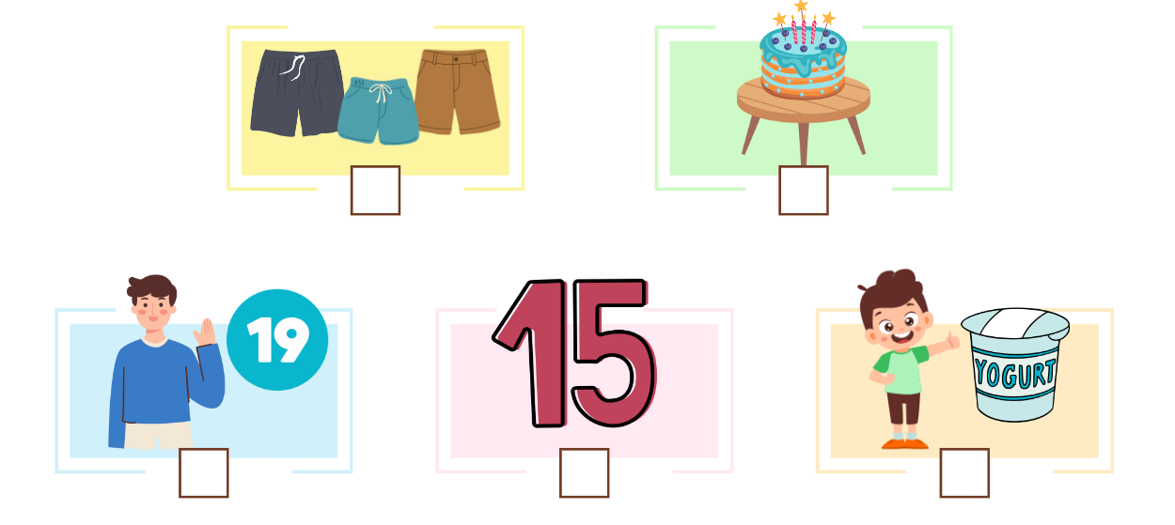
0
 |  | Listen and complete (1 point)
- The blanket is near the tent.
- - Is the teapot on the __________________?
- Yes, it is.

- - What number is it?
- It’s __________________.
- - What do you want?
- I want some __________________.
- - How old is your sister?
- She’s __________________.
PART II. READING
 | Read and tick (0.75 points)
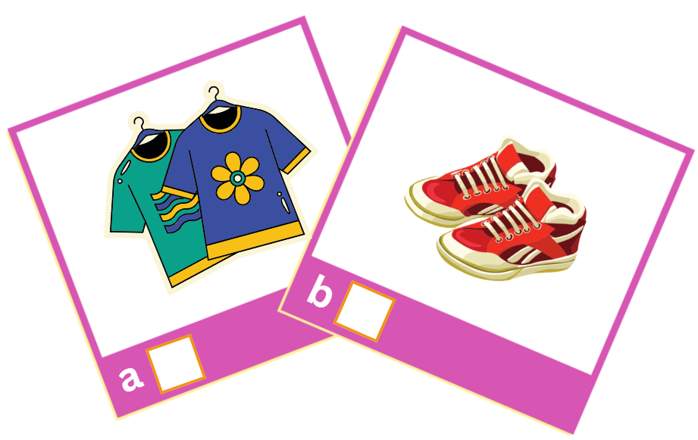  ✓ |  | 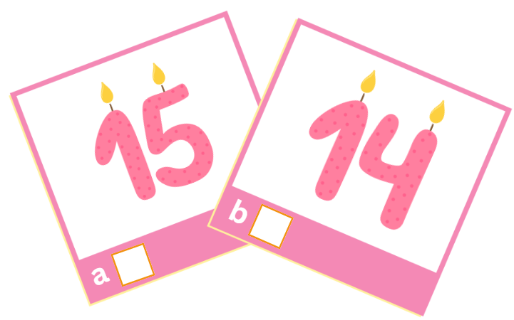
- shirts |  | - fourteen
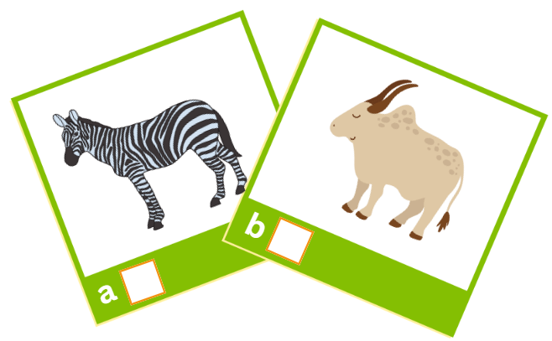 |  | 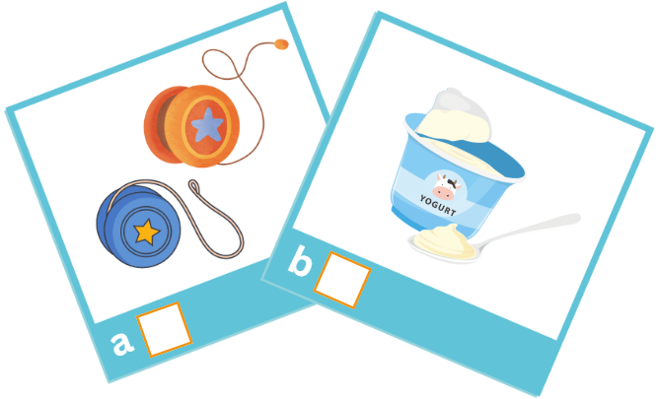
- zebra |  | - yo-yos

 |  | Read and tick (✓) or cross (x) (0.75 points)
 |  |  |  | 
  ✓ | The cake is on the table. |  |  | My brother is thirteen.
 |  |  |  | 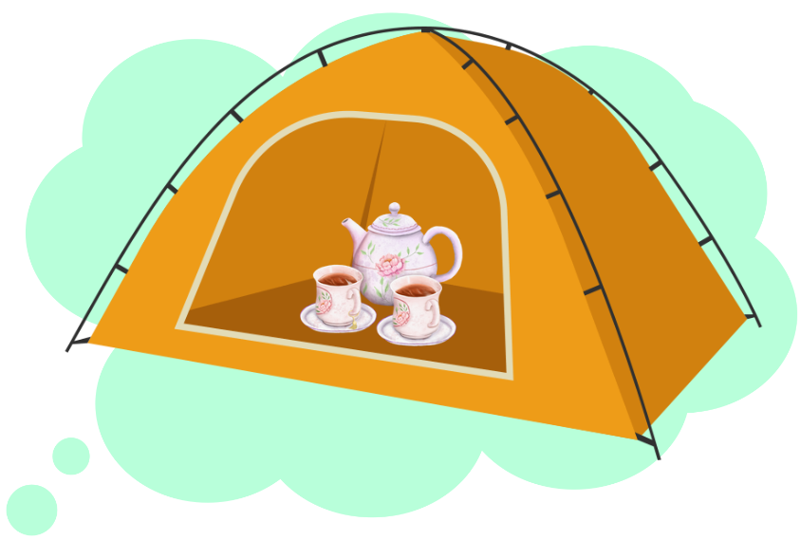
 | She’s riding. |  |  | The teapot is in the tent.
PART III. WRITING
 | Write the missing letters (1.5 points)

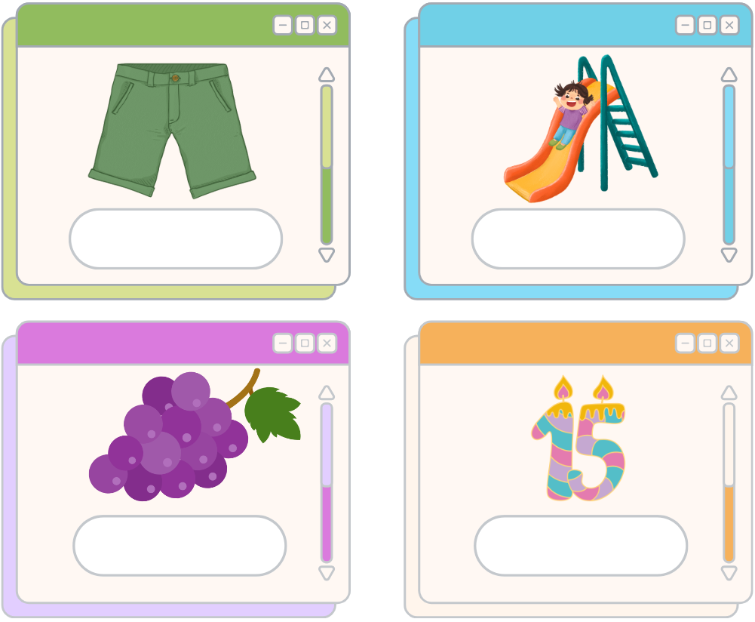
1. _ l_ _ i _ g
0. s h o r t s
3. f_ _ t_ _ n
2. _ r _ p_ _

 |  | Write the missing words (1.5 points)
 |  |  | 
 | - Where are the shirts? |  | - Is the ___________ near the tent?
 |  |  | 
 | - Do you like the ___________? |  | - I ___________ some grapes.
PART IV. SPEAKING
 | Introduction (0.5 points)
Teacher asks students to answer questions:
- Hello, what’s your name? How old are you?
- How are you today?
 |  | Describe the pictures by answering the following questions (2 points)
Teacher shows the pictures and asks students to answer questions:

 | 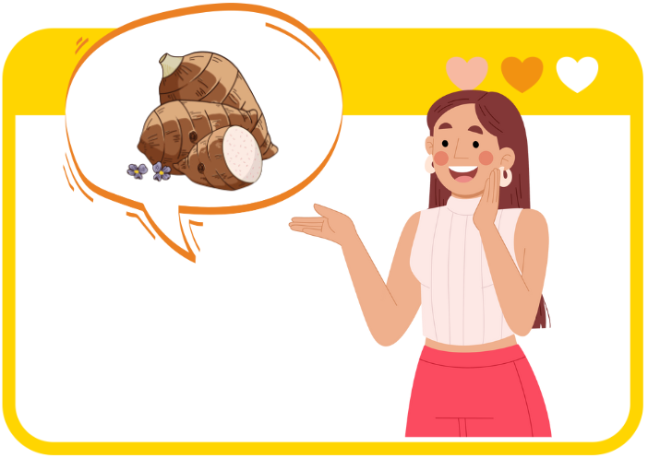 |  |  | 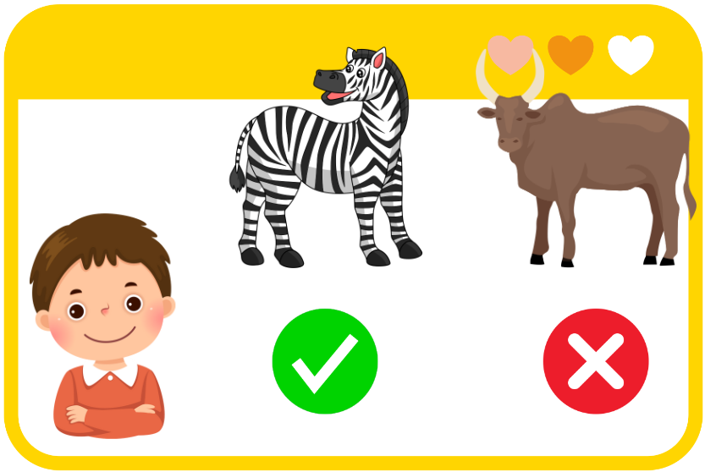
 | Q: What do you want?  A: __________________________ |  |  | Q: Do you like zebu?  A: ________________________
 | 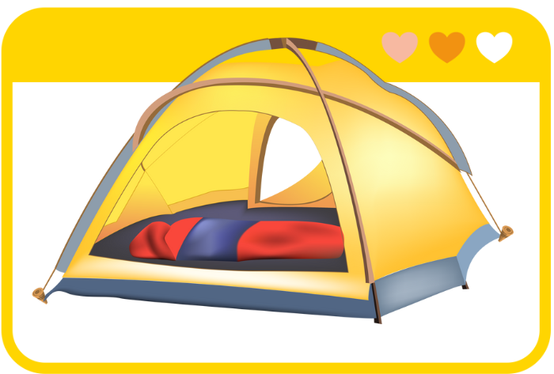 |  |  | 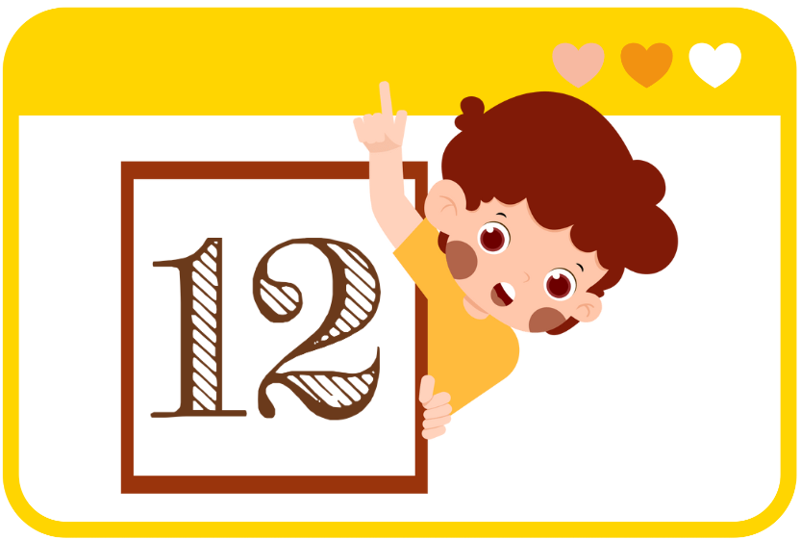
 | Q: Where is the blanket?  A: __________________________ |  |  | Q: What number is it?  A: ________________________

ĐÁP ÁN
PART I. LISTENING (3 points)
QUESTION 1: Listen and tick (1 point)
Mỗi câu đúng 0.25 điểm (0.25x4)
- n | - t | - er | - y
QUESTION 2: Listen and number (1 point)
Mỗi câu đúng 0.25 điểm (0.25x4)
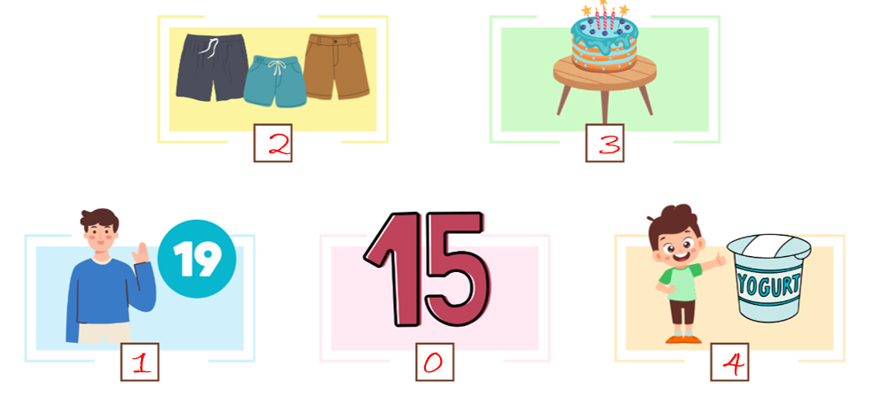
QUESTION 3: Listen and complete (1 point)
Mỗi câu đúng 0.25 điểm (0.25x4)
- table | - eleven | - yo-yos | - thirteen
PART II. READING (1.5 points)
QUESTION 4: Read and tick (0.75 points)
Mỗi câu đúng 0.25 điểm (0.25x3)
- b | - a | - a
QUESTION 5: Read and tick (✓) or cross (x) (0.75 points)
Mỗi câu đúng 0.25 điểm (0.25x3)
- x | - x | - ✓
PART III. WRITING (3 points)
QUESTION 6: Write the missing letters (1.5 points)
Mỗi câu đúng 0.5 điểm (0.5x3)
- sliding | - grapes | - fifteen
QUESTION 7: Write the missing words (1.5 points)
Mỗi câu đúng 0.5 điểm (0.5x3)
- blanket | - zoo | - want
PART IV. SPEAKING (2.5 points)
QUESTION 8: Introduction (0.5 points)
Mỗi câu trả lời 0.25 điểm (0.25x2)
QUESTION 9: Let’s talk (2 points)
Mỗi câu trả lời 0.5 điểm (0.5x4)
- I want some yams.
- No, I don’t. I like zebra.
- It’s in the tent.
- It’s twelve.

