ĐỀ 1 | ĐỀ ÔN TẬP CUỐI HỌC KỲ II  NĂM HỌC 2025-2026  MÔN: TIẾNG ANH LỚP 2
PART I. LISTENING
 |  |  | Listen and circle (1 point)
 |  |  |  | y |  | z
 |  |  |  | a |  | i |  |  |  | er |  | a
 |  |  |  | s |  | sh |  |  |  | v |  | t
 |  |  | Listen and tick (1 point)

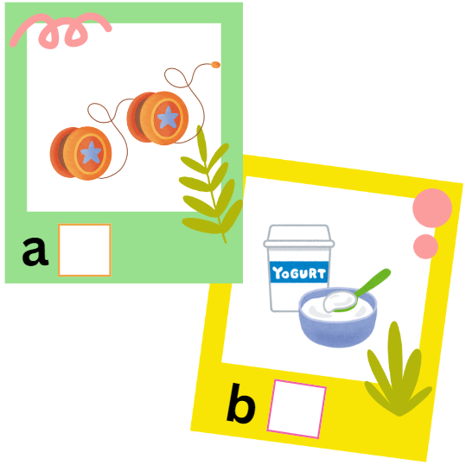

✓

 | 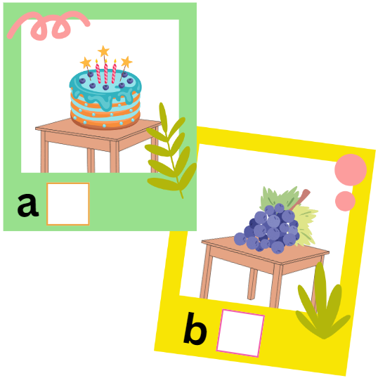 |  | 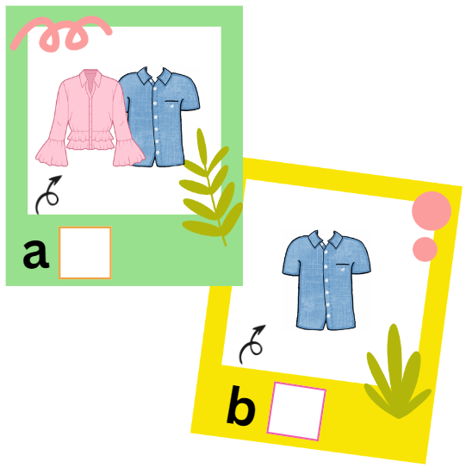
 | 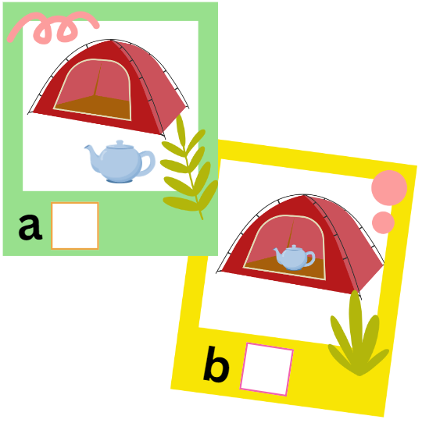 |  | 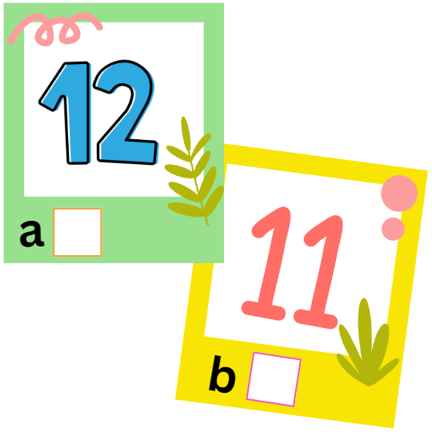
 | Listen and tick (✓) or cross (x) (1 point)

 |   ✓ |  | 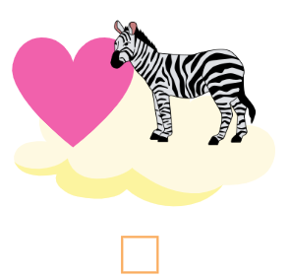 |  | 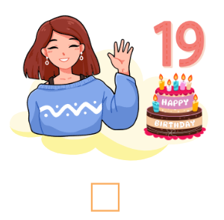
 |  |  | 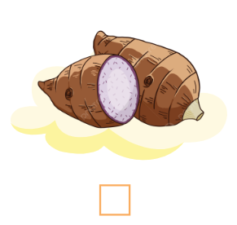 |  | 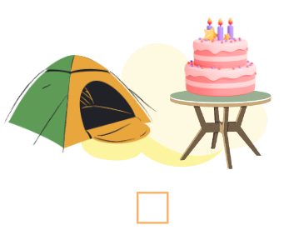
PART II. READING
 | Read and match (0.75 points)
 |  |  |  | 
  A. a zebu |  | B. grapes | C. shoes | D. a teapot

 |  | Read and choose A, B or C (0.75 points)
 | 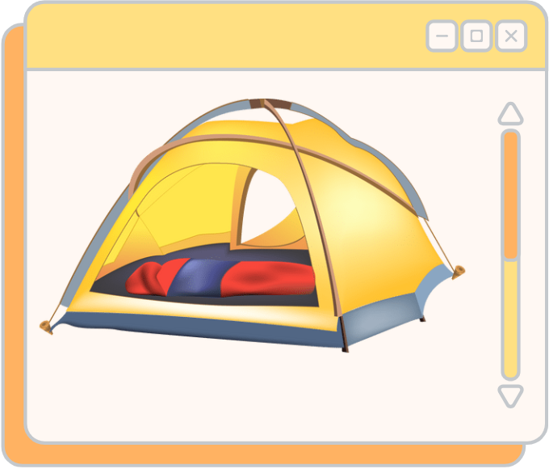 |  | - Is the blanket near the tent?  - No, it isn’t. It’s __________ the tent.  - on  - in  - under
 |  |  | - What do you want?  - I want some __________.  - yam  - yogurt  - milk
 |  |  | - Where is the cake?  - It is on the __________.  - tent  - fence  - table
 |  |  | - What are they doing?  - They’re __________.  - driving  - sliding  - riding
PART III. WRITING
 |  | Reorder the letters to make a word (2 points)
 | 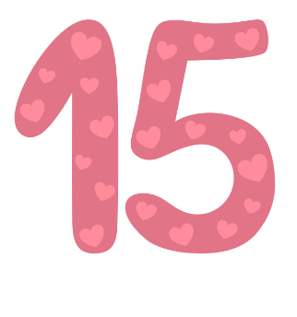
fifteen
efitenf

 | 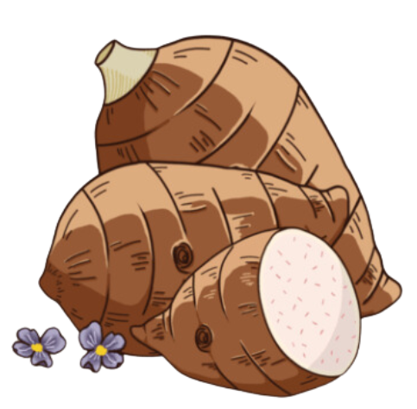 |  |  |  | 
 | syma |  |  |  | 1.  razbe
 | 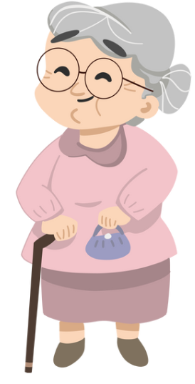 |  |  |  | 
 | thegromdran |  |  |  | irthss
 |  |  | Reorder the words to make complete sentences (1 point)
- some/ want/ yo-yos./ I
I want some yo-yos.
- like/ you/ the/ zoo?/ Do
________________________________________________
- are/ driving/ They/ cars.
________________________________________________
PART IV. SPEAKING
 | Introduction (0.5 points)
Teacher asks students to answer questions:
- Hello, what’s your name? How old are you?
- How are you today?
 |  | Describe the pictures by answering the following questions (2 points)
Teacher shows the pictures and asks students to answer questions:

 | 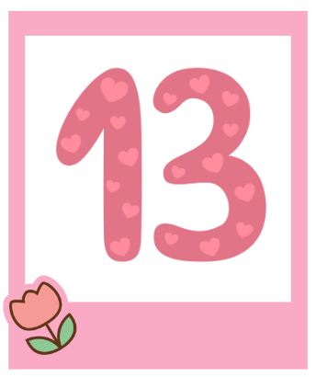 |  |  | 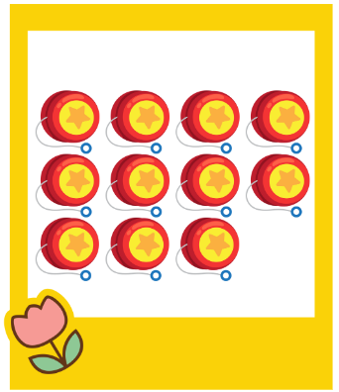
 | Q: What number is it?  A: __________________________. |  |  | Q: How many yo-yos can you see?  A: __________________________.
 |  |  |  | 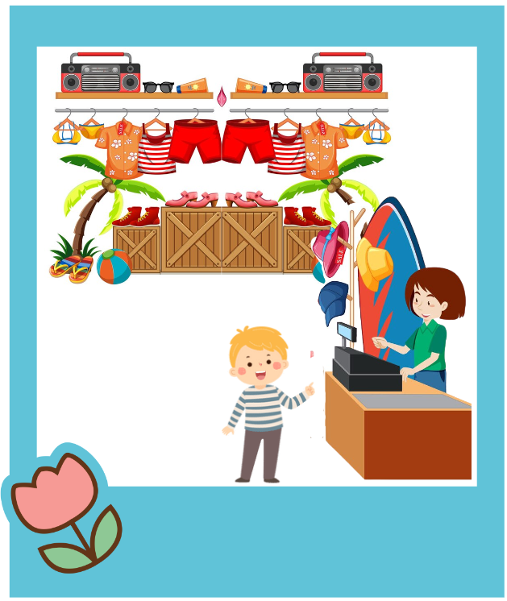
 | Q: How old is your sister?  A: __________________________. |  |  | Q: Where are the shorts?  A: __________________________.

ĐÁP ÁN
PART I. LISTENING (3 points)
QUESTION 1: Listen and circle (1 point)
Mỗi câu đúng 0.25 điểm (0.25x4)
- a | - er | - sh | - t
QUESTION 2: Listen and tick (1 point)
Mỗi câu đúng 0.25 điểm (0.25x4)
- b | - a | - b | - a
QUESTION 3: Listen and tick (✓) or cross (x) (1 point)
Mỗi câu đúng 0.25 điểm (0.25x4)
- x | - x | - ✓ | - ✓
PART II. READING (1.5 points)
QUESTION 4: Read and match (0.75 points)
Mỗi câu đúng 0.25 điểm (0.25x3)
- C | - B | - A
QUESTION 5: Read and choose A, B or C (0.75 points)
Mỗi câu đúng 0.25 điểm (0.25x3)
- B | - C | - B
PART III. WRITING (3 points)
QUESTION 6: Reorder the letters to make a word (2 points)
Mỗi câu đúng 0.5 điểm (0.5x4)
- yams | - zebra | - grandmother | - shirts
QUESTION 7: Reorder the words to make complete sentences (1 point)
Mỗi câu đúng 0.5 điểm (0.5x2)
- Do you like the zoo?
- They are driving cars.
PART IV. SPEAKING (2.5 points)
QUESTION 8: Introduction (0.5 points)
Mỗi câu trả lời 0.25 điểm (0.25x2)
QUESTION 9: Let’s talk (2 points)
Mỗi câu trả lời 0.5 điểm (0.5x4)

