ĐỀ 22 | ĐỀ ÔN TẬP CUỐI HỌC KỲ II  NĂM HỌC 2025-2026  MÔN: TIẾNG ANH LỚP 3
PART I. LISTENING
Question 1: Listen and match. There is one example. (1 point)
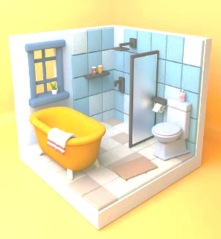 |   20 |  |  | 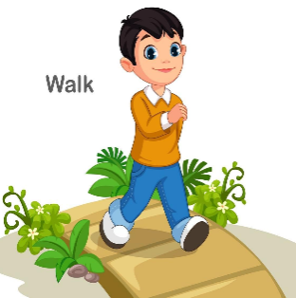
 |  |  |  | 
Question 2: Listen and tick Right or Wrong. There is one example. (1 point)
Sentences | Right (✓) | Wrong (☓)
- This is a cook. | ✓
- My father is twenty-five years old.
- There is a bed and a window in my bedroom.
- I would like to drink some juice.
- She has a train, and he has a bus.

Question 3: Listen and tick the picture which describes the sentences you hear. There is one example. (1 point)
✓ | -  | - 
 | -  | - 
 | -  | - 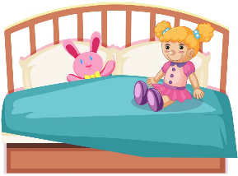
 | -  | - 
 | -  | - 

Question 4: Listen and write the correct answer in the gap. There is one example. (1 point)
- It is ………my father…………
- They are in…………………………………………………………..
- No,……………………………………………………………………
- I……………………………………………………………………….
- They can see………………………………………………………….
PART II. READING
Question 5. Circle the odd one out. There is one example. (0.75 points)
 | bus | pet | plane | ship
 | cycling | painting | peacock | skipping
 | bird | cook | doctor | driver
 | bedroom | desk | living room | kitchen
Question 6. Fill in each blank with one word. There is one example. (0.75 points)
I and my brother are at the (0) zoo. We can see many animals. I can see a tiger. It is (1) ____________ a tree. There is an elephant. It is drawing. Look! A (2) ____________ is swinging in the tree. I can see a (3) ____________. It is dancing. We really like the animals at the zoo. | zoo climbing  monkey peacock  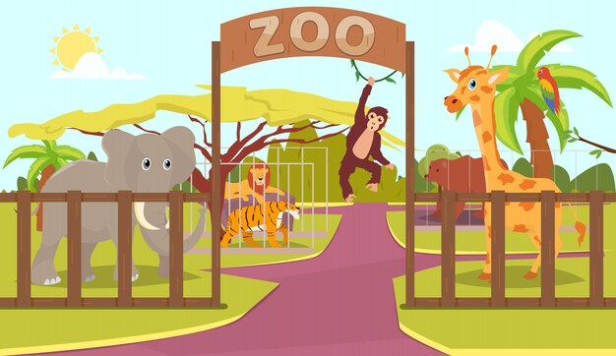
Question 7. Read and choose A, B or C. There is one example. (0.5 points)
Good morning! I am Henry. I am in the library now. I am reading a book. This is my hobby. | 
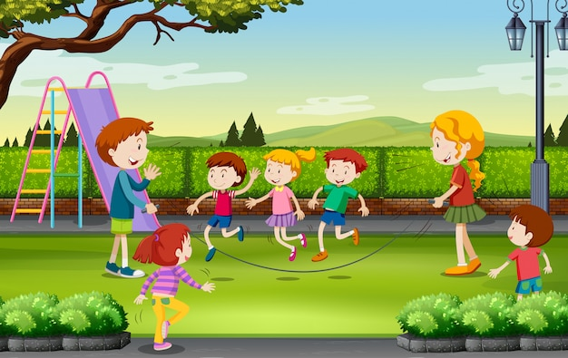 | Hi there! I’m Linda. I like playing in the playground at break time. I am skipping with my classmates now.
- Where is Henry?
- He is in the music room.
- He is in the library.
- He is in the playground.
- Does Henry like reading a book? | - Who is Linda skipping with?
- Yes, he does.  - No, he doesn’t.  - No information is given. | - Her friends  - Her father  - Her sister
PART III. WRITING
Question 8. Fill in each blank with one word. There is one example. (0.75 points)
 |  |  | 
 | - Would you like some chicken?  - Yes, please. |  | The lamp is on the ____________.
 |  |  | 
 | My sister is a ____________. |  | I have a ____________.
Question 9. Use the given words to make sentences. There is one example. (0.75 points)
- My father/ farmer
My father is a farmer.
- He/ a bus/ two kites/ a train/ three trucks
___________________________________________________________
- Bed/ small
___________________________________________________________
- Would/ you/ like/ juice?
___________________________________________________________
Question 10. Answer the questions with the given words. There is one example. (0.5 points)
- What’s she doing? (cycling)
She’s cycling.
- Do you have any goldfish? (three/ in the tank)
___________________________________________________________
- Where’s the table? (in the living room)
___________________________________________________________
PART IV. SPEAKING
Question 11. Introduction. (0.5 points)
- What’s your name? How old are you?
- What’s your hobby? What do you do at break time?
Question 12. Describe the pictures by answering the following questions. (0.75 points)
1. |  | Q: What’s she doing?  A: ____________________________________  Q: Where is she now?  A: ____________________________________
2. |    | Q: How old is he?  A: ____________________________________
3. |  | Q: Does he have any cats?  A: _______________________________________
Question 13. Let’s talk. (0.75 points)
- How many bedrooms are there in your house?
- Do you have any teddy bears?
- How many dogs do you have? Do you like them?
ĐÁP ÁN
PART I. LISTENING (4 points)
QUESTION 1: Listen and match (1 point)
Mỗi câu đúng 0.25 điểm (0.25x4)
- D | - A | - E | - C
QUESTION 2: Listen and tick Right or Wrong (1 point)
Mỗi câu đúng 0.25 điểm (0.25x4)


QUESTION 3: Listen and tick or cross (1 point)
Mỗi câu đúng 0.25 điểm (0.25x4)
 | B |  | B |  | A |  | B
QUESTION 4: Listen and write the correct answer in the gap (1 point)
Mỗi câu đúng 0.25 điểm (0.25x4)
 | the living room | 2. | I don’t | 3. | am singing | 4. | a parrot

PART II. READING (2 points)
QUESTION 5: Circle the odd one out (0.75 points)
Mỗi câu đúng 0.25 điểm (0.25x3)
- 1. | peacock | - 2. | bird | - 3. | desk
QUESTION 6: Fill in each blank with one word (0.75 points)
Mỗi câu đúng 0.25 điểm (0.25x3)
- 1. | climbing | - 2. | monkey | - 3. | peacock

QUESTION 7: Read and choose A, B or C (0.5 points)
Mỗi câu đúng 0.25 điểm (0.25x2)
- A | - A

PART III. WRITING (2 points)
QUESTION 8: Fill in each blank with one word (0.75 points)
Mỗi câu đúng 0.25 điểm (0.25x3)
- table | - teacher | - parrot
QUESTION 9. Use the given words to make sentences (0.75 points)
Mỗi câu đúng 0.25 điểm (0.25x3)
1. He has a bus, two kites, a train, and three trucks.
2. The bed is small.
3. Would you like some juice?
QUESTION 10. Answer the questions with the given words. (0.5 points)
Mỗi câu đúng 0.25 điểm (0.25x2)
1. I have three goldfish in the tank.
2. The table is in the living room.
PART IV. SPEAKING (2 points)
QUESTION 11: Introduction (0.5 points)
Mỗi câu trả lời 0.25 điểm (0.25x2)
QUESTION 12. Describe the pictures by answering the following questions. (0.75 points)
Mỗi câu trả lời 0.25 điểm (0.25x3)
1. Q: What’s she doing?
A: She is painting.
Q: Where is she now?
A: She is in the art room.
2. Q: How old is he?
A: He is eighteen years old.
3. Q: Does he have any cats?
A: No, he doesn’t. He has a dog.
QUESTION 13: Let’s talk (0.75 points)
Mỗi câu trả lời 0.25 điểm (0.25x3)
Student’s answer.

