ĐỀ 21 | ĐỀ ÔN TẬP CUỐI HỌC KỲ II  NĂM HỌC 2025-2026  MÔN: TIẾNG ANH LỚP 3

PART I. LISTENING
Question 1: Listen and number. There is one example. (1 point)
C
D
E
A
0
11
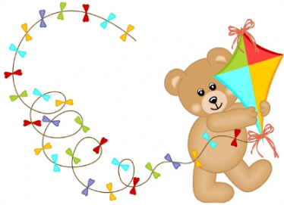 |   B |  |  | 

Question 2: Listen and choose the correct answer. There is one example. (1 point)
- He is my _____________. | A. father | B. brother | C. uncle
- Her job is ____________. | A. a father | B. a doctor | C. a farmer
- The table is___________ and  the chairs are_________. | A. big / small | B. big / brown | C. small / new
- I don’t have any__________. | A. fish | B. goldfish | C. rabbits
- I am _____________. | A. listening to music | B. singing a song | C. writing a letter
Question 3: Listen and tick or cross. There is one example. (1 point)
0.   | 1. | 2.  | 3.   | 4.  


Question 4: Listen and choose the answer for the question. (1 point)
 | 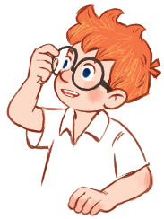  ……………? | - It’s my father.  - My father is a doctor.
 |   ……………? | - I’d like some orange juice.  - I’d like some fish and water.
 |   ……………? | - Yes, I do.  - I have two.
 | 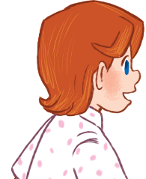  ……………? | - They are skating.  - They play badminton.
4. | 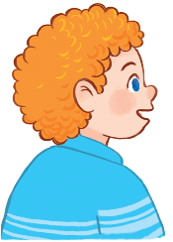  ……………? | - It is grey.  - It is drawing.

PART II. READING
Question 5. Read and match. There is one example. (0.75 points)
 | - What’s her job?  - She’s a nurse. |  | 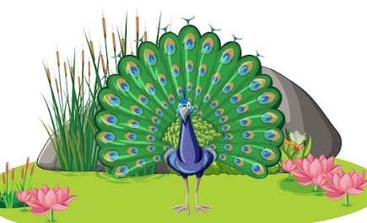
 | - Would you like some rice?  - Yes, please. |  | 
 | - What can you see?  - I can see a peacock. |  | 
 | - Do you have any dogs?  - No, I don’t. I have a cat. |  | 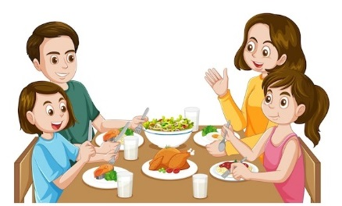
Question 6. Read and choose A, B or C. There is one example. (0.75 points)
- How _____ is your brother?
- He is twenty years old.
 | - young | - old | - tall
 | How many _____ do you have?
 | - goldfish | - parrot | - dog
- What are you doing?
- I am_____ in my room.
 | - sing | - dance | - dancing
- What’s she _____?
- She’s playing badminton?
 | - does | - do | - doing

Question 7. Read and tick True or False. There is one example. (0.5 points)
Hi, everyone. My name is Thuy Duong. Welcome to my house! This is the living room and that is the kitchen. There are some bedrooms in my house for my grandmother, my parents, my brother, and me. Let’s go to my bedroom. It is a small room, but I love it so much! | 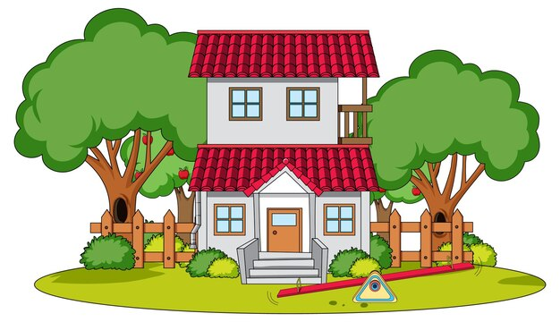
 |  | True | False
- There are a living room and a kitchen in Thuy Duong’s house. |  | ✓
- There are three bedrooms in her house.
- Thuy Duong doesn’t like her room because it is small.
PART III. WRITING
Question 8. Reorder the letters to make a word. There is one example. (0.75 points)
 | 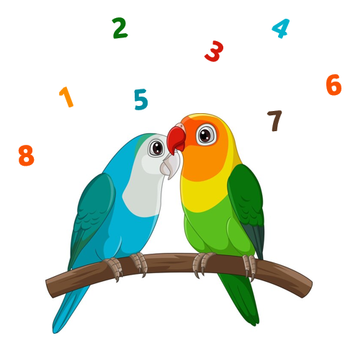
0. erdivr → driver | 1. tociungn → ______________
 | 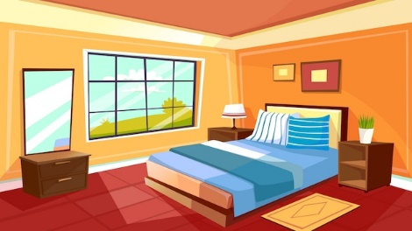
2. nsakgti → ______________ | 3. rebodom → ______________
Question 9. Reorder the words to make complete sentences. There is one example. (0.75 points)
- eighteen/ sister/ My/ is/ old./ years
My sister is eighteen years old.
- many/ How/ have?/ do/ you/ rabbits
_______________________________________________________________
- listening/ am/ to/ music./ I
_______________________________________________________________
- would/ What/ eat? / like/ you/ to
_______________________________________________________________
Question 10. Answer the questions with the given words. There is one example. (0.5 points)
- What’s the elephant doing? (dancing)
It’s dancing. /The elephant is dancing.
- What would you like to drink? (water)
_______________________________________________________________
- How many cats do you have? (no cat, three dogs)
______________________________________________________________
PART IV. SPEAKING
Question 11. Introduction. (0.5 points)
- What’s your name? How old are you?
- What’s your hobby? What do you do at break time?
Question 12. Describe the pictures by answering the following questions. (0.75 points)
1. |  | Q: What’s his job?  A: ______________________________________
2. |  | Q: What’s this?  A: ______________________________________  Q: How many windows are there in the bedroom?  A: _____________________________________
3. |  | Q: What can you see?  A: ______________________________________  Q: What’s the monkey doing?  A: ______________________________________
Question 13. Let’s talk. (0.75 points)
- What’s your mother’s job?
- Do you have any brothers or sisters? How old is he/she?
- Do you have any pets? What are they?
ĐÁP ÁN
PART I. LISTENING (4 points)
QUESTION 1: Listen and number (1 point)
Mỗi câu đúng 0.25 điểm (0.25x4)
- E | - B | - D | - A
QUESTION 2: Listen and choose the correct answer (1 point)
Mỗi câu đúng 0.25 điểm (0.25x4)
- C | - A | - B | - A

QUESTION 3: Listen and tick or cross (1 point)
Mỗi câu đúng 0.25 điểm (0.25x4)

QUESTION 4: : Listen and choose the answer for the question (1 point)
Mỗi câu đúng 0.25 điểm (0.25x4)
- B | - B | - A | - B

PART II. READING (2 points)
QUESTION 5: Read and match (0.75 points)
Mỗi câu đúng 0.25 điểm (0.25x3)
- 1. | D | - 2. | A | - 3. | C
QUESTION 6: Read and choose A, B or C (0.75 points)
Mỗi câu đúng 0.25 điểm (0.25x3)
- A | - C | - C
QUESTION 7: Read and tick True or False (0.5 points)
Mỗi câu đúng 0.25 điểm (0.25x2)
- false | - false
PART III. WRITING (2 points)
QUESTION 8: Reorder the letters to make a word (0.75 points)
Mỗi câu đúng 0.25 điểm (0.25x3)
- counting | - skating | - bedroom
QUESTION 9. Reorder the words to make complete sentences (0.75 points)
Mỗi câu đúng 0.25 điểm (0.25x3)
1. How many rabbits do you have?
2. I am listening to music.
3. What would you like to eat?
QUESTION 10. Answer the questions with the given words. (0.5 points)
Mỗi câu đúng 0.25 điểm (0.25x2)
1. I’d like some water, please.
2. I do not have a cat. I have three dogs. / I have no cat. I have three dogs.
PART IV. SPEAKING (2 points)
QUESTION 11: Introduction (0.5 points)
Mỗi câu trả lời 0.25 điểm (0.25x2)
QUESTION 12. Describe the pictures by answering the following questions. (0.75 points)
Mỗi câu trả lời 0.25 điểm (0.25x3)
1. Q: What’s his job?
A: He’s a doctor.
Q: What’s this?
2. A: It’s a bedroom.
Q: How many windows are there in the bedroom?
A: There are two windows in the bedroom.
3. Q: What can you see?
A: I can see a monkey.
Q: What’s the monkey doing?
A: It is climbing.
QUESTION 13: Let’s talk (0.75 points)
Mỗi câu trả lời 0.25 điểm (0.25x3)
Student’s answer.

