ĐỀ 10 | ĐỀ ÔN TẬP CUỐI HỌC KỲ I  NĂM HỌC 2025-2026  MÔN: TIẾNG ANH 3

- Listen and tick (

PART A: LISTENING


. There is 1 example .(1 point)
)




0. 



A B C

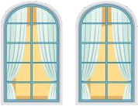
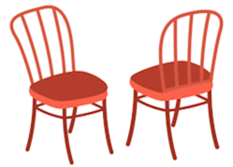


1.

A
2.



C A B C
B

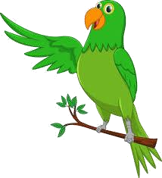

3.

A B C
4.
A B C

Listen and number . There is 1 example .(1 point)





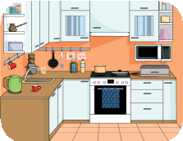
0
A B C D E



Listen and write T (True) os F (False) . There are examples .(1 point)

0. a. b. F
T

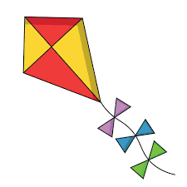

1.  2.  3.  4.

Listen and write . There is 1 example .(1 point)

0. Open
your books, please.

- A : What would you like to eat ?
B: I’d like some , please.
3. A: What are you doing ?
B: I’m .
2. A: How many dogs do you have ?
B: I have .
4. A: What’s he doing ?
B: He’s .

PART B: READING




II. Read and tick ( or cross ( ) . There are examples. ( 1 points)
)


- I’m nine years old.

- A: Where’s the table ?
B: It’s in the bedroom.

- My friends are playing badminton.

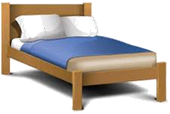

- A: What does your uncle do ?
B: He’s a teacher.
- A: What’s the elephant doing ?
B: It’s dancing.



II. Look, read and complete. There are examples. ( 1 point)
juice
skipping
nurse
windows
nine

0. A: How old are you ?

B: I ‘m (0)
nine .

- A: What does your mother do ?
B: She’s a .

3. A: What’s he doing ? B: He’s .
- This is my bedroom. The are big.
- A: What would you like to drink ?
B: I’d like some .

PART C: WRITING


Write the words. There are examples. (1 point)

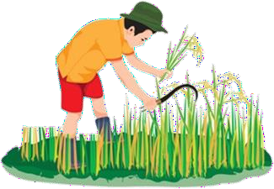

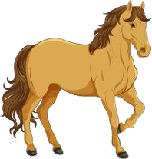

0. _nine
1. 2. 3. 4.


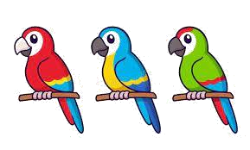
Look and write. There are examples. ( 1 point)


0. A: How old are you ?

B: I’m _e_ig_ht .

- A: What’s your sister doing ? B: He’s _ _ _ _ _ _ _.
1. My brother is years
old.

- He has three _.


- A: Would you like some ?
B: Yes, please.

Reorder the words. There are examples. ( 0.5 point)

0.
you ?
are
How
How a_r_e_you? .

1.
is
kitchen.
The
in
table
the
.

2.
music.
My
is
to
listening
brother
.

Interview. ( 0.5 point)
  - What’s your name ?

PART D: SPEAKING

  - Do you have any dogs ?

. .

Look at the pictures and answer the question ( 1 point) .



  - What’s he doing ?
.
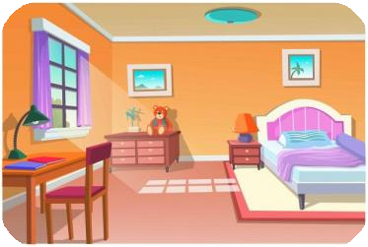
3. Where is the lamp ?
.
2. What can you see ?

.

4. What would you like to eat ?
.

The end

ĐÁP ÁN
KEYS
PART A: LISTENING
I. Listen and tick
1. C | 2. A | 3. C | 4.
II. Listen and number.
1. B | 2. C | 3. D | 4. A
III. Listen and T or F
1. F 2. T 3. T 4. F
IV. Listen and write
1. chicken 2. some 3. Playing basketball 4. cycling
PART B: READING
I. Read and tick or cross
1. X | 2.X | 3. V | 4. V
II. Look, read and complete.
1. NURSE | 2. WINDOWS | 3. SKIPPING | 4. JUICE
PART C: WRITING
I. Reorder the letters
1. farmer | 2.living room | 3. horse | 4. writing/ write
II. Look and write
1. twelve | 2. cycling | 3. parrots | 4. bread
III. Reorder the words
1. The table is in the kitchen.
2. My brother is listening to music.
PART D: SPEAKING
I. Interview
II. Answer the questions
1. listening to music./ He’s listening to music.
2. a peacock/ peacock./ I can see a peacock.
3. It’s in the bedroom./ in the bedroom.
4. beans, please./ I’d like some beans, please.

