ĐỀ 8 | ĐỀ ÔN TẬP CUỐI HỌC KỲ I  NĂM HỌC 2025-2026  MÔN: TIẾNG ANH 3

Listen and tick (
PART A: LISTENING

. There is 1 example .(1 point)
)


0.
A B C


1. 2.
A B C A B C




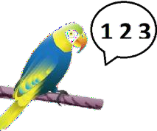3.
A B C
4.
A B C

Listen and number . There is 1 example .(1 point)

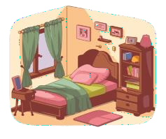0
A B C D E


Listen and write T (True) os F (False) . There are examples .(1 point)
T

  - a.
b. F



3.
1.

2.
4.

Listen and write . There is 1 example .(1 point)

0.
  - A : What are you doing ?
B: I’m

Open

.
your books, please.
  - A: Do you have any cats ?
B: No, I don’t. I have .

  - A: Would you like some
B: Yes, please.
? 4. A: Is she a ?
B: Yes, she is.

PART B: READING


- Read and tick ( or cross ( ) . There are examples. ( 1 points)
)

  - I’m nine years old. 

  - A: Do you have any birds ?
B: Yes, I do.

  - There’s big bed in the room.

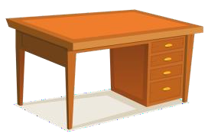

  - A: What would you like to eat ?
B: I’d like some eggs.
  - A: Where’s the living room ?
B: It’s there.



II. Look, read and complete. There are examples. ( 1 point)
juice
skipping
nurse
windows
nine

    - A: How old are you ?

B: I ‘m (0)
n_ine .

    - A: What does your mother do ?
B: She’s a .

3. A: What’s he doing ? B: He’s .

2. This is my bedroom. The are big.
- A: What would you like to drink ?
B: I’d like some .

PART C: WRITING


  - Write the words. There are examples. (1 point)





0. _nine
1.
2.
3.
4.


Look and write. There are examples. ( 1 point)


0. A: How old are you ?
B: I’m _e_ig_ht .


    - A: What’s the monkey doing ? B: It’s _.
- A: What’s his job ?

B: He’s a _ .

  - He has three _ .


  - A: Would you like some ?
B: Yes, please.

Reorder the words. There are examples. ( 0.5 point)

0.
you ?
are
How
How a_r_e_you? .

1.
is
nurse.
My
a
sister
.

2.
kite.
My
is
a
flying
friend
.

Interview. ( 0.5 point)

      - What’s your name ?

PART D: SPEAKING

      - Do you have any dogs ?

. .


Look at the pictures and answer the question ( 1 point) .


      - What’s he doing ?
      - What can you see ?

. .

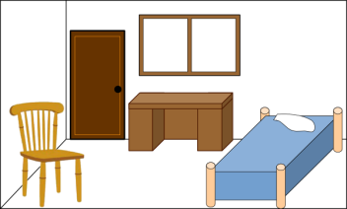

      - Where are the chairs ?
.
      - What would you like to drink ?
.

The end

KEYS
PART A: LISTENING
I. Listen and tick
1. C | 2. B | 3. C | 4. A
II. Listen and number.
1. D | 2. A | 3. C | 4. B
III. Listen and T or F
1. T 2. F 3. F 4. T
IV. Listen and write
1. watching TV 2. a dog 3. rice 4. worker
PART B: READING
I. Read and tick or cross
1. V | 2.X | 3. X | 4. V
II. Look, read and complete.
1. NURSE | 2. WINDOWS | 3. SKIPPING | 4. JUICE
PART C: WRITING
I. Reorder the letters
1. BEANS/BEAN | 2.SINGER | 3. ELEPHANT | 4. FLY AKITE/  FLYING A KITE
II. Look and write
1. farmer | 2. swinging | 3. trucks | 4. water
III. Reorder the words
1. My sister is a nurse.
2. My friend is flying a kite.
PART D: SPEAKING
I. Interview
II. Answer the questions
1. playing badminton./ He’s playing badminton.
2. an elephant./ I can see an elephant.
3. They’s in the bedroom./ in the bedroom.
4. juice, please./ I’d like some juice, please.

