ĐỀ 7 | ĐỀ ÔN TẬP CUỐI HỌC KỲ I  NĂM HỌC 2025-2026  MÔN: TIẾNG ANH 3

Listen and tick (
)

0.

1.
A B

PART A: LISTENING
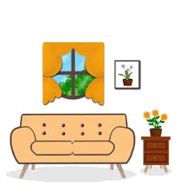. There is 1 example .(1 point)
B
2.
A


A

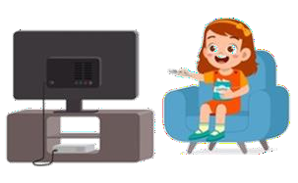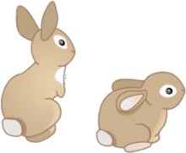3. 4.
B
A B A B

Listen and number . There is 1 example .(1 point)

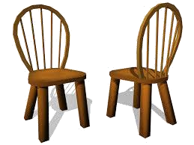0
A B C D E


Listen and write T (True) os F (False) . There are examples .(1 point)
T

0. a.
b. F

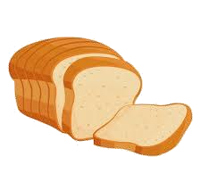
1.
2.
3.
4.

Listen and write . There is 1 example .(1 point)

Open
your books, please.

  - A : How old is your ?
B: He’s twenty years old.
- A: What are you doing ?
B: I’m a picture.
2. A: What can you see ?
B: I can see a .
- I have three .

PART B: READING


II. Read and tick ( or cross ( ) . There are examples. ( 1 points)
)

  - I’m nine years old.

  - A: What’s he doing ?
B: He’s writing.



  - She has three cars.

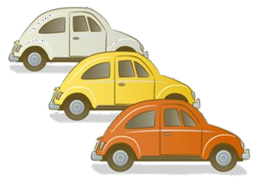

  - A: What would you like to drink ?
B: I’d like some milk.
  - A: Where’s the bedroom ?
B: It’s there.

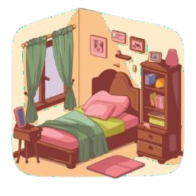

II. Look, read and complete. There are examples. ( 1 point)
chicken
cycling
sister
chairs
nine

    - A: How old are you ?

B: I ‘m (0)
n_ine .

    - A: How old is your ?
B: She’s ten years old.

3. A: What’s she doing ? B: She’s .

2. There are two in the bedroom.

- A: Would you like some ?
B: Yes, please.

PART C: WRITING



  - 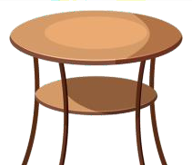Reorder the letters. There are examples. (1
point)



- inen
- kapecoc
- marefr
- balet
- tame

→ n_ine →
→ → →


Look and write. There are examples. ( 1 point)


- A: How old are you ?

B: I’m _e_ig_ht .

2. A: What is he doing ? B: He’s _ .
- A: What’s her job ?
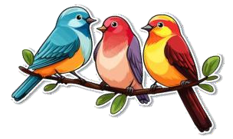B: She’s a _ _ _ _ _ .
.

  - He has three _ _ _ _ _


  - A: Would you like some ?
B: Yes, please.

Reorder the words. There are examples. ( 0.5 point)

0.
you ?
are
How
How a_r_e_you? .

1.
desk
room.
There’s
in
a
the
.

2.
goldfish ?
Do
you
any
have
.

Interview. ( 0.5 point)

      - What’s your name ?

PART D: SPEAKING

      - How many teddy bears do you have ?

. .

Look at the pictures and answer the question ( 1 point) .



      - What’s the monkey doing ?
      - What would you like to drink ?

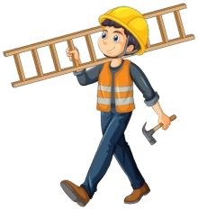
. .
      - What’s his job ? 4. What’s he doing ?

. .

The end
KEYS
PART A: LISTENING
I. Listen and tick
1. A | 2. B | 3. B | 4. A
II. Listen and number.
1. D | 2. C | 3. A | 4. B
III. Listen and T or F
1. T 2. F 3. F 4. T
IV. Listen and write
1. peacock 2. dolls 3. milk 4. bedroom
PART B: READING
I. Read and tick or cross
1. X | 2.V | 3. X | 4. V
II. Look, read and complete.
1. sister | 2. chair | 3. cycling | 4. chicken
PART C: WRITING
I. Reorder the letters
1. cooking | 2.library | 3. basketball | 4. notebook
II. Look and write
1. nurse | 2. running | 3. birds | 4. chicken
III. Reorder the words
1. There’s a desk in the room.
2. Do you have any goldfish?
PART D: SPEAKING
I. Interview
II. Answer the questions
1. swinging/ It’s swinging.
2. Milk./ I’d like sime milk.
3. Worker/ He’s a worker.
4. playing basketball./ He’s playing basketball.

