ĐỀ 6 | ĐỀ ÔN TẬP CUỐI HỌC KỲ I  NĂM HỌC 2025-2026  MÔN: TIẾNG ANH 3

Listen and tick (
PART A: LISTENING

. There is 1 example .(1 point)
)


0.
A B

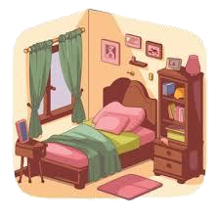1.
B
2.
A
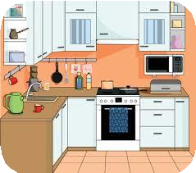A B

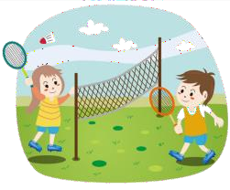3. 4.
A B A B

Listen and number . There is 1 example .(1 point)

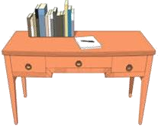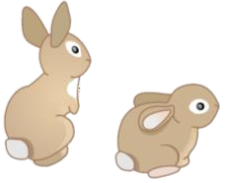0
A B C D E


Listen and write T (True) os F (False) . There are examples .(1 point)
T

  - a.
b. F

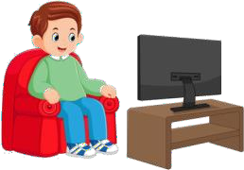

1. 2. 3.
4.

Listen and write . There is 1 example .(1 point)

0.

  - A : What can you see ?
Op_en

your books, please.
  - My sister has two .

B: I can see a .

  - A : What would you like to drink?
B: I’d like some .
  - This is my . The door is big.

PART B: READING


    - Read and tick ( or cross ( ) . There are examples. ( 1 points)
)

      - I’m nine years old.

      - A: What’s she doing?
B: She’s skating.



      - A: What’s his job ?
B: He’s a teacher.

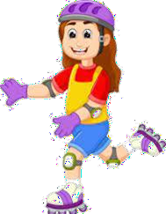

      - A: Where are the books?
B: They’re on the table.
      - A: What’s the monkey doing ?
B: It’s swinging.

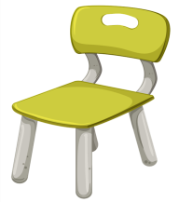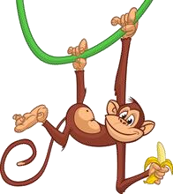

Look, read and complete. There are examples. ( 1 point)
toys
bread
table
cats
nine

      - A: How old are you ?

B: I ‘m (0)
      - A: Do you have any ?
B: Yes, I do.

3. They have many .
n_ine

.
      - A: What would you like to eat ?
B: I’d like some .

- There’s a in the living room.

PART C: WRITING

  - Reorder the letters. There are examples. (1 point)

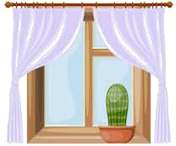

- inen
→ _nine
- foshigld
→
- kgiwanl
→
- rsitse
→
- widnow
→


Look and write. There are examples. ( 1 point)


- A: How old are you?

B: I’m _e_ig_ht .

2. A: What are you doing ? B: I’m _ .
- A: What’s his job?
B: He’s _ _ _ _ _ _ .

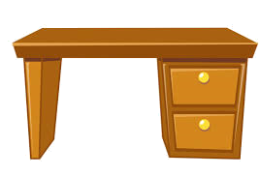
  - There is a in the room.


  - A: Would you like some ?
B: Yes, please.

Reorder the words. There are examples. ( 0.5 point)

0.
you ?
are
How
How a_r_e_you? .

1.
chess
time.
I
at
play
break
.

2.
eraser ?
Do
you
an
have
.

Interview. ( 0.5 point)

  - What’s your name ?

PART D: SPEAKING

  - How old are you ?

. .

Look at the pictures and answer the question ( 1 point) .



- How many rabbits do you have ?
.

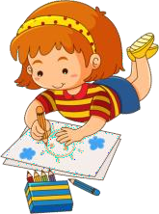
  - What’s she doing ?
2. What would you like to eat ?

.

  - Where’s the table ?

. .

The end

ĐÁP ÁN
KEYS
PART A: LISTENING
I. Listen and tick
1. A | 2. B | 3. B | 4. A
II. Listen and number.
1. D | 2. C | 3. A | 4. B
III. Listen and write T or F
1. T 2. F 3. F 4. T
IV. Listen and write
1. peacock 2. dolls 3. milk 4. bedroom
PART B: READING
I. Read and tick or cross
1. V | 2.X | 3. X | 4. V
III. Look, read and complete.
1. cats/ toys | 2.bread | 3. toys/ cats | 4. table
PART C: WRITING
I. Reorder the letters
1. goldfish | 2. walking | 3. sister | 4. window
II. Look and write
1. driver | 2. dancing | 3. desk | 4. juice
III. Reorder the words
1. I play chess at break time.
2. Do you have an eraser?
PART D: SPEAKING
I. Interview
II. Look and answer
1. I have some.
2. I’d like some eggs/ an egg.
3. He’s drawing.
4. In the living room./ It’s in the living room.

