ĐỀ 5 | ĐỀ ÔN TẬP CUỐI HỌC KỲ I  NĂM HỌC 2025-2026  MÔN: TIẾNG ANH 3



PARTA: LISTENING
I. Listen and tick ( ) . There is 1 example .(1 point)



0.




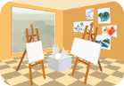
A B

1. 2. A B



3. 4. A B


A B

A B

II. Listen and number . There is 1 example .(1 point)






0 A B C D E
III. Listen and write . There is 1 example .(1 point)

0. ________ your books, please.
Open

1. A: What’s your hobby? B: It’s __________.

3. A: Is this our __________? B: Yes, it is.

2. A : May I ________ Vietnamese? B : No, you can’t.

4. A: What do you do at break time? B: I play ____________.



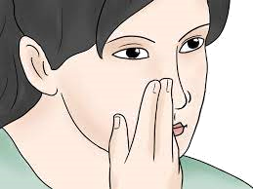

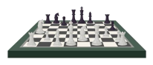
PART B: READING


I. Look, read and tick ( ) or cross ( ). There is one example. (1pt)

0. pencil 1. goodbye 2. open 3. library 4. puzzle


II. Look, read and match. There are examples. ( 1 points)

0. I’m five years old.
a.

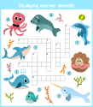
1. – Is this your gym? Yes, it is.
b.


2. – Do you have a notebook? No, I don’t.
c.


3. – What’s your hobby? It’s walking.
d.



4. – What do you do at break time?
I play word puzzles. e.
III. Look, read and complete. There are examples. ( 1 point)

art dancing open chess nine

0. A: How old are you ?

B: I ‘m (0) ________ .
nine

1. A: What do you do at break time?

B: I play ______________.

3. A: I like painting.

B: Let’s go to the _______ room.

2. A: What’s your hobby?

B: I like ____________.

4. ________ your mouth, please.

PART C: WRITING



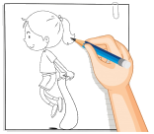

I. Look and write. There are examples. ( 1 point)


0. A: How old are you?
I’m eight years old
B: ________________ .

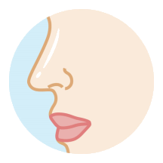
2. A: What’s this?

B: _________________.
1. A: Do you have an eraser?

B: _________________.

3. A: What’s your hobby?

B: ___________________.

4. A: What do you do at break time? B: ________________________.

III. Reorder the words. There are examples. ( 1 point)

0. you? are How

__________________________________ .
How are you?

1. swimming. like I

__________________________________ .

2. chess. I play break at time

_________________________________ .

PART D: SPEAKING

I. Interview. ( 0.5 point)

1. What’s your name ? ____________________ .
2. Do you have any dogs ? ____________________ .

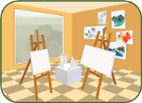

II. Look at the pictures and answer the question ( 1 point) .

1. Is this the art room ? ____________________ .

2. Is that your teacher ? ____________________ .

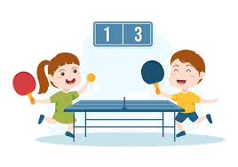
3. What do you do at break time ? ____________________ .

______ The end ______

KEYS
PART A: LISTENING
I. Listen and tick
1. a | 2. a | 3. b | 4. b
II. Listen and number.
1. c | 2. a | 3. d | 4. b
III. Listen and write
1. running 2. speak 3. playground 4. badminton
PART B: READING
I. Read and tick or cross
1.V | 2. X | 3. V | 4. X
II. Read and and match
1. d | 2. e | 3. a | 4. b
III. Look, read and complete.
1. chess | 2. dancing | 3. art | 4. Open
PART C: WRITING
I. Write the words
1. white | 2. pencil case | 3. classroom | 4. break time
II. Look and write
1. Yes, I do. | 2. It’s a nose. | 3. I like drawing./  It’s drawing. | 4. I chat with friends.
III. Reorder the words
1. I like swimming.
2. I play chess at break time.
PART D: SPEAKING
I. Interview
II. Answer the question.
1. Yes, it is./ Yes. 2. No, he isn’t./ No.
3. I play table tennis.

