
ĐỀ 4 | ĐỀ ÔN TẬP CUỐI HỌC KỲ I  NĂM HỌC 2025-2026  MÔN: TIẾNG ANH 3


PARTA: LISTENING
I. Listen and tick ( ) . There is 1 example .(1 point)



0.

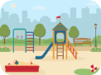

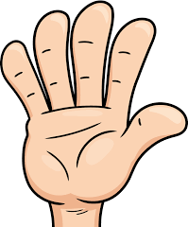
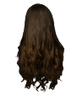
A B

1. 2. A B

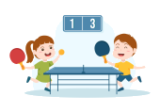


3. 4. A B

A B

A B

II. Listen and number . There is 1 example .(1 point)



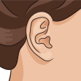
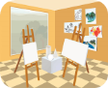

0 A B C D E
III. Listen and write . There is 1 example .(1 point)

0. ________ your books, please.
Open

1. I have a __________.

3. A: What colour is it?
B: My eraser is _________.

2. A : Let’s go to the ________ room. B : OK. Let’s go!

4. A: What do you do at ___________? B: I play volleyball.

PART B: READING


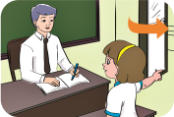
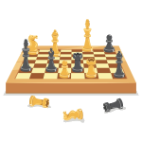


I. Look, read and circle a or b. There is one example. (1pt)

0. a. pencil

b. pen

1. a. come in

b. go out
2. a. chess

b. puzzle word

3. a. running

b. walking

4. a. ears

b. eyes


II. Look, read and choose the correct word. There are examples. ( 1 points)

0. I’m five / nine years old.

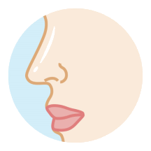
1. – What’s this?
It’s a mouth / nose.



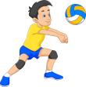
2. – What colour is it? It’s orange / yellow.

3. – What’s your hobby? It’s dancing / painting.

4. – What do you do at break time? I play volleyball / football.

III. Look, read and complete. There are examples. ( 1 point)

swimming music room word puzzles playground nine

0. A: How old are you ?

B: I ‘m (0) ________ .
nine


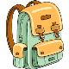
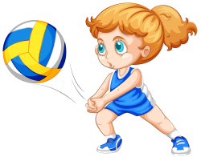

1. A: What do you do at break time?

B: I play ______________.

3. A: Is this our____________?

B: Yes, it is.

2. A: What’s your hobby?

B: I like ____________.

4. A: I like singing.

B: Let’s go to the ____________.

PART C: WRITING

I. Write the words. There are examples. (1 point)

0. nine 1. _________ 2. __________ 3. ___________ 4. ___________

II. Reorder the words. There are examples. ( 1 point)

0. you? are How

__________________________________ .
How are you?

1. gym. Let’s the to go

__________________________________ .

2. break time? do What at do you

__________________________________ .

PART D: SPEAKING

I. Interview. ( 0.5 point)

1. What’s your name ? ____________________ .
2. How old are you ? ____________________ .

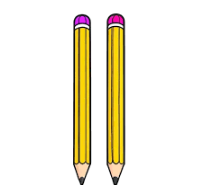

II. Look and answer the questions. ( 1.5 point)

1. What’s your hobby ? ____________________ .
2. What colour are they ? ____________________ .


3. A: What do you do at break time? B: ________________________.

______ The end ______

KEYS
PART A: LISTENING
I. Listen and tick
1. a | 2. a | 3. a | 4. b
II. Listen and number.
1. B | 2. C | 3. D | 4. A
III. Listen and write
1. school bag 2. music 3. yellow 4. break time
PART B: READING
I. Look, read and circle a or b.
1.b | 2. a | 3. a | 4. b
II. Read and choose the correct word
1. nose | 2. orange | 3. painting | 4. volleyball
III. Look, read and complete.
1. word puzzles | 2. sswimming | 3. playground | 4. music room
PART C: WRITING
I. Write the words
1. mouth | 2. school bag | 3. volleyball | 4. colour
II. Reorder the words
1. Let’s go to the gym.
2. What do you do at break time?
PART D: SPEAKING
I. Interview
II. Answer the questions
1. It’s cooking./ I like cooking./ cooking.
2. They’re yellow./ Yellow.
3. I play badminton./ Play badminton.

