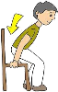
ĐỀ 3 | ĐỀ ÔN TẬP CUỐI HỌC KỲ I  NĂM HỌC 2025-2026  MÔN: TIẾNG ANH 3


PARTA: LISTENING
I. Listen and tick ( ) . There is 1 example .(1 point)




0.

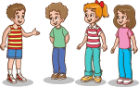
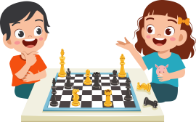
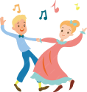
A B

1. 2. A B

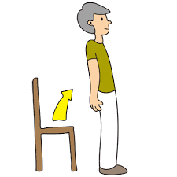
3. 4. A B

A B



A B


II. Listen and number . There is 1 example .(1 point)


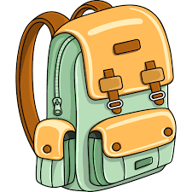

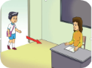
0 A B C D E
III. Listen and write . There is 1 example .(1 point)

0. ________ your books, please.
Open

1. A : What’s your hobby? B: I like ____________.

3. Hi, I’m Ben. I play __________ at break time.

2. A : What colour are they? B : They’re __________.

4. Let’s go to the ____________.

1

PART B: READING

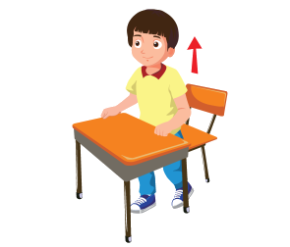
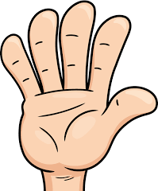

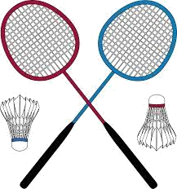
I. Look, read and circle a or b. There is one example. (1pt)

0. a. Pencil

b. Pen

1. a. Sit down

b. Stand up
2. a. Hand

b. Hair

3. a. Dancing

b. Singing

4. a. Table tennis

b. Badminton

II. Look, read and match. There are examples. ( 1 points)

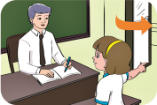
0. I’m five years old.
a.



1. – What’s this?
It’s an ear. b.

2. – May I go out?
Yes, you can. c.


3. – Is this our classroom?
Yes, it is. d.

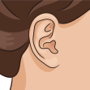
4. I play basketball at break
time. e.

III. Look, read and complete. There are examples. ( 1 point)

hobby nose eraser black nine

0. A: How old are you ?

B: I ‘m (0) ________ . 2
nine

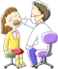
1. A: Do you have an _________?

B: Yes, I do.

3. A: What colour are they?

B: They’re ___________.

2. A: What’s your __________?

B: I like singing.

4. A: What’s this?

B: It’s a ____________.

PART C: WRITING

II. Look and write. There are examples. ( 1 point)


0. A: How old are you?

B: I’m _______ .
eight

2. Open your _______, please.
1. A: Do you have a pen?

B: No, I don’t. I have a ________.


3. I like _____________.

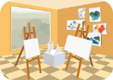
4. A: I like drawing?

B: Oh, let’s go to the ______ room.

II. Reorder the words. There are examples. ( 1 point)

0. you? are How

__________________________________ .
How are you?

1. pen blue. The is

__________________________________ .

2. notebook? Do have a you

__________________________________ .

3

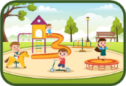
PART D: SPEAKING

I. Interview. ( 0.5 point)

1. What’s your name ? ____________________ .
2. Do you have a pencil case ? ____________________ .

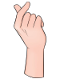

II. Answer the questions ( 1.5 point)

1. What’s this?

_________________.

2. What’s your hobby ?

_________________.

3. Is this the gym ?

_________________.

______ The end ______

KEYS
PART A: LISTENING
I. Listen and tick
1. B | 2. A | 3. A | 4. B
II. Listen and number.
1. B | 2. C | 3. D | 4. A
III. Listen and write
1. Painting 2. green 3. basketball 4. classroom
PART B: READING
I. Look, read and circle a or b.
1.b | 2. a | 3. a | 4. b
II. Read and match
1. e | 2.a | 3. b | 4. c
III. Look, read and complete.
1. eraser | 2. hobby | 3. black | 4. nose
PART C: WRITING
I. Look and write
1. pencil | 2. mouth | 3. walking | 4. art
II. Reorder the words
1. The pen is blue.
2. Do you have a notebook?
PART D: SPEAKING
I. Interview\
II. Answer the questions
1. a hand/ It’s a hand. 2. I like swimming./ Swimming.
3. No, it isn’t. / No.

