ĐỀ 2 | ĐỀ ÔN TẬP CUỐI HỌC KỲ I  NĂM HỌC 2025-2026  MÔN: TIẾNG ANH 3

PARTA: LISTENING
I. Listen and tick ( ) . There is 1 example .(1 point)



0.


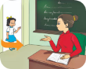
A B

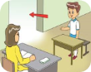

1. 2.

A B A B


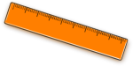

3. 4.
A B A B
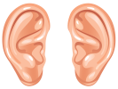
II. Listen and number . There is 1 example .(1 point)


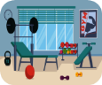


00 A B C D E
III. Listen and write . There is 1 example .(1 point)

0. ________ your books, please.
Open

1. A : What’s your hobby? B: I like ____________ .

2. A : Do you have a ____________ ? B : Yes, I do.

3. A : What do you do at break time? B : I play _________ .
4. A: What colour is it?
B: It’s ___________ . 1

PART B: READING
I. Look, read and draw the lines. There is one example. (1pt)


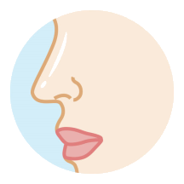


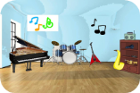
0. 1. 2. 3. 4.


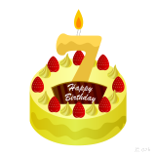


a. drawing b. Music room c. pencil d. nose e. Good bye II. Read and circle a or b . There are examples. ( 2 points)

0. I’m five years old.

1. I play table tennis at break time .

2. A: Do you have a ruler ?
B: No, I don’t. I have a pen .

3. A: Is it our classroom ? B: Yes, it is .

4. A: What’s your hobby ? B: I like running .

a. b.

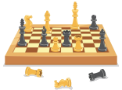

a. b.

a. b.



a. b.



a. b.

III. Look, read and complete. There are examples. ( 1 point)

School bag playground that Sit down nine

0. A: How old are you ?

B: I ‘m (0) ________ . 2
nine

1. A: Is this the __________?

B: Yes, it is .

3. I have a ____________ .

2. A: May I ___________ ?

B: Yes, you can .

4. A: Is _______ Minh ?

B: No, it isn’t . It’s Nam .

PART C: WRITING

I. Look and write. There are examples. ( 1 point)

0. A: How old are you?



B: I’m _______ .
eight

2. _ _ _ _ _ your ears.

1. I like _ _ _ _ _ _ _ .



3. I have a _ _ _ _ _ _ _ _ .

4. A: Is it the _ _ _ _ _ _ _ _ _ _ ?

B: Yes, it is.

III. Reorder the words. There are examples. ( 1 point)

0. you? are How

__________________________________ .
How are you?

1. colour they? What are

__________________________________ .

2. pencil ? Do you a have

__________________________________ .

PART D: SPEAKING
I. Interview. ( 0.5 point)

1. What’s your name ? ____________________ .
2. How old are you ? ____________________ .
3


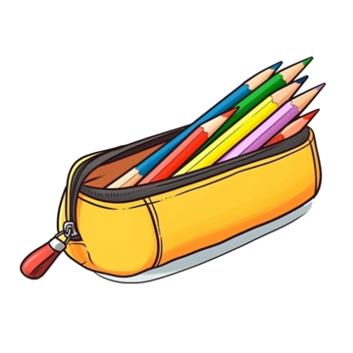
II. Answer the questions ( 1.5 point)

1. What’s your hobby ?


_________________.

2. What colour is it ?

_________________.

3. What do you do at breaktime ?

____________________.

______ The end ______
KEYS
PART A: LISTENING
I. Listen and tick
1. B | 2. A | 3. A | 4. B
II. Listen and number.
1. C | 2. A | 3. D | 4. B
III. Listen and write
1. running 2. Pencil case 3. football 4. orange
PART B: READING
I. Look, read and match.
1. c | 2. d | 3. a | 4. b
II. Read and circle a or b
1. a | 2.b | 3. a | 4. b
III. Look, read and complete
1. playground | 2.sit down | 3. school bag | 4. that
PART C: WRITING
I. Look and write
1. running | 2. touch | 3. notebook | 4. playground
II. Reorder the words
1. What colour are they ?
2. Do you have a pencil ?
PART D: SPEAKING
I. Interview
II. Answer the questions
1. Drawing./ I like drawing. 2. Yellow./ It’s yellow.
3. I play basketball.

