ĐỀ 1 | ĐỀ ÔN TẬP CUỐI HỌC KỲ I  NĂM HỌC 2025-2026  MÔN: TIẾNG ANH 3
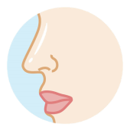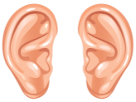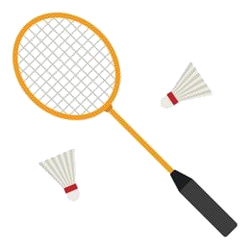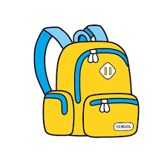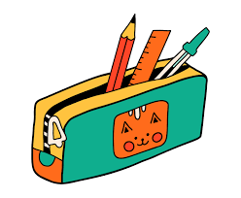
PART A: LISTENING
I. Listen and tick ( ) . There is 1 example .(1 point)
0
.
A
B
.
4
3
.
.
1
A
B
2
.
A
B
A B A B

II. Listen and number . There is 1 example .(1 point)
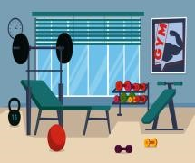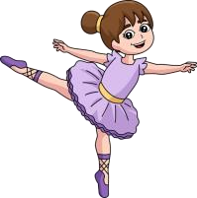
0
A B C D E

III. Listen and write . There is 1 example .(1 point)
- ________ your books, please.Open
- A : How old are you? 2. A : What’s your hobby?
B: I’m _________ years old. B : I like ___________ .
3. A : Let’s go to the _______ room. 4. I play __________ at breaktime.
B : Ok, let’s go.

PART B: READING

I. Look, read and draw the lines. There is one example. (1pt)
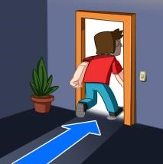
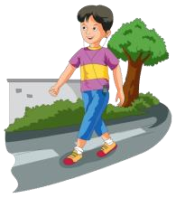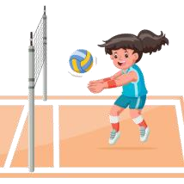0. I’m nine years old.
0.
1.
2.
3.
4.
a. eyes
b. walking
c. pencil
d. volleyball
e. Go out
II. Read and tick ( ) or cross ( ) . There are examples. ( 1 points)
1. A: May I go out ? B: Yes, you can. | 2. A: What do you do at break time? B: I play word puzzles.
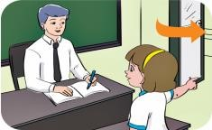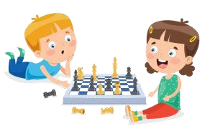
3. A: What’s your hobby ? B: I like running. | 4. A: What’s this ? B: It’s a mouth.
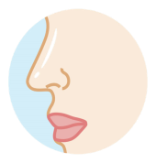

III. Look, read and complete. There are examples. ( 2 point)
Come in
playground
eraser
drawing
nine
- A: How old are you ? B: I ‘m (0) ________ .nine
- A: May I __________ ? 2. A: What’s your hobby ?
B: Yes, you can. B: It’s _____________ .
3. Let’s go to the ___________ . 4. A: Do you have an __________ ?
B: Yes, I do.

PART C: WRITING

I. Reorder the letters. There are examples. (1 point)
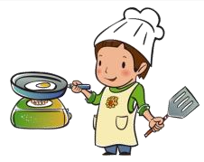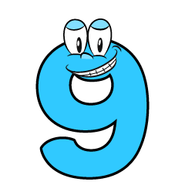
0. inen 1. gnicoko 2. arlriyb 3. lalsektbab 4. okobteno
→ _______nine → _________ → _________ → _________ → _________

II. Reorder the words. There are examples. ( 1 point)
0.
you?
are
How
__________________________________ .How are you?
1.
chess
time.
at
play
break
I
__________________________________ .
2.
eraser?
Do
you
an
have
__________________________________ .

PART D: SPEAKING

I. Interview. ( 0.5 point)
1. What’s your name ? 2. What is your hobby ?
____________________ . ____________________ .

II. Answer the questions ( 1.5 point)
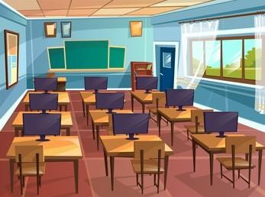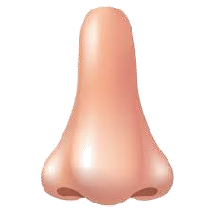
1. Is this the library ? 2. What is this ?
_________________. _________________.
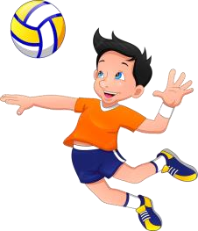
3. What do you do at break time ?
_________________.

______ The end ______

KEYS
PART A: LISTENING
I. Listen and tick
1. B | 2. A | 3. A | 4. B
II. Listen and number.
1. C | 2. D | 3. B | 4. A
III. Listen and write
1. eight 2. Drawing 3. Musci 4. volleyball
PART B: READING
I. Look, read and match.
1. D | 2. B | 3. A | 4. E
II. Read and tick or cross

1. V | 2.X | 3. X | 4. E
III. Look, read and complete.
1. come in | 2.drawing | 3. playground | 4. eraser
PART C: WRITING
I. Reorder the letters
1. cooking | 2.library | 3. basketball | 4. notebook
II. Reorder the words
1. I play chess at break time.
2. Do you have an eraser?
PART D: SPEAKING
I. Interview
II. Answer the questions.
1. No. /No, it isn’t. 2. A nose./ It’s a nose.
3. I play volleyball.

