ĐỀ KIỂM TRA CUỐI KÌ 2 – ĐỀ 14
MÔN: TIẾNG ANH 3 GLOBAL SUCCESS

Skill | Listening | Reading | Writing | Speaking | Total
Mark
LISTENING
PART 1:Listen and tick. There is one example.(1pt)

0. | 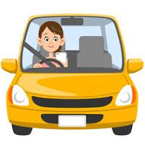 |  | 
  A.
  B.
  C.
1. |  | 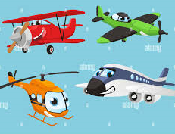 | 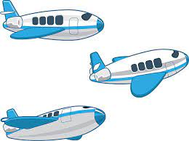
  A.
  B.
  C.
2. |  |  | 
  A.
  B.
  C.
3. | 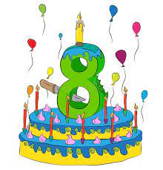 | 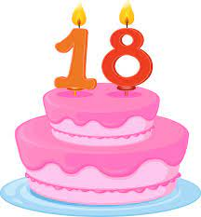 | 
  A.
  B.
  C.
4. | 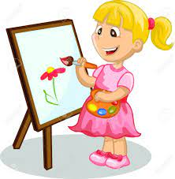 |  | 
  A.
  B.
  C.

PART 2:Listen and match. There is one example. (1pt)

 | A   | B  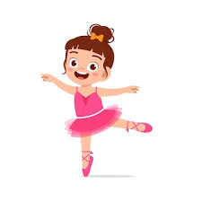 | C  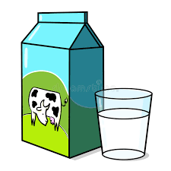 | D   | E  
4
3
2
1
0

PART 3: Listen and number. There is one example. (1pt)
A   | B   | C  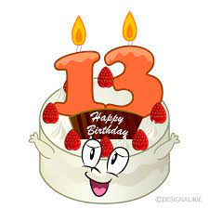 | D   | E  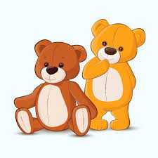
0

PART 4: Listen and choose the best answer. There is one example.(1pt)
0.I ……………. to music at break time.
A. speak | B. listen | C.read
1.Is she a …………….? –> Yes, she is.
A.farmer | B.doctor | C.teacher
2. I’m ……………………
A.cooking | B.skating | C.dancing
3.My mother is a………………….
A.driver | B. nurse | C.singer
4.She has a ……………….…
A. car | B.plane | C.train

READING
PART 1: Read and match the words with pictures. There is one example. (1pt)

0) bean | A 
1. father | B 
2. twenty | C 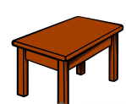
3. bedroom | D 
4. table | E 
PART 2. Read and choose A, B or C to complete text. There is one example. (1 pt)
This is my (0) school bag. That is my (1) ……………….. It is blue. These (2) ………………. my pencil cases. They’re yellow (3) ………………. brown. My books are on the (4) ………………… I love my school things very much.
0.a. school bag b.pens c.desks
1. a. ruler b.pencils c.erasers
2. a. is b.am c. are
3. a. in b.and c.with
4. a. new b.small c.table

WRITING
PART 1.Look at the pictures and the letters. Write the words. (1 pt)

 |  |  | 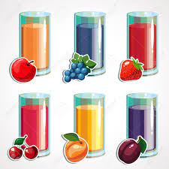 | 
(0). sihf  -> fish | 1.pingpski  ->__________ | 2.lodl  ->__________ | 3.cuije  ->_________ | 4. therom  ->_________
PART 2. Rearrange the words to make the sentences. There is one example. (1 pt)

(0). My/ is/ This/ brother/./

→ This is my brother

1. is/ Where/ bathroom/ your/?/

………………………………………………………………………………………

2. rice/ you/ like/ Would/some/?/

………………………………………………………………………………………

3. any/ you/ Do/ birds/ have/?/

………………………………………………………………………………………

4. flying/ They/ kites/ are/./

………………………………………………………………………………………

SPEAKING . (2pts)
Greeting & test taker’s name check.
The examiner says “My name is…It’s nice to talk to you today.”
Part 1: Getting to know each other
The examiner asks 3 questions below:
1.What’s your name?
2.What would you like to eat/ drink?
3.How old is your father/ mother/ brother/ sister?
Part 2: Point at the picture and say the words / sentences
The examiner point to the pictures and ask ss some questions.

1.Who is this?
2.What’s his/ her job?
3.Do you have any bird/ cat/ dog/ goldfish/ rabbit?
4.What can you see?

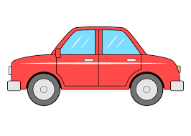 | 
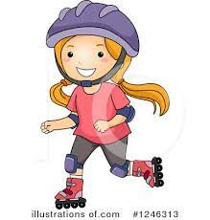 | 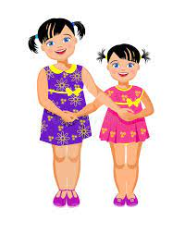 |  | 
 | 

Part 3: Answer the questions:
The examiner asks 3 questions below:
1.How many…….do you have?
2.Would you like some………?
3. Do you have any bus/ car/ plane/ kite/ train/ truck?
That’s the end of the speaking test. You did a great job. Thank you.

ĐÁP ÁN VÀ BIỂU ĐIỂM BÀI KIỂM TRA ĐỊNH KỲ HỌC KÌ II
MÔN TIẾNG ANH LỚP 3
LISTENING
PART 1. (0,25*4 =1pt)
1.C 2.A 3.B 4.C
PART 2. (0,25*4 =1pt)
1.A 2.E 3.D 4.B
PART 3.(0,25*4 =1pt)
1.C 2.E 3.B 4.D
PART 4. (0,25*4 =1pt)
1.A 2.C 3.B 4.A
READING
PART 1(0,25*4 =1pt)
1.D 2.A 3. E 4.C
PART 2 (0,25*4 = 1 pt )
1.A 2. C 3. B 4. C
WRITING
PART 1 (0,25*4 = 1 pt )
1. skipping 2.doll 3. juice 4. mother
PART 2 (0,25*4 = 1 pt )

1.Where is your bathroom?

2.Would you like some rice?

3.Do you have any birds?

4.They are flying kites.
SPEAKING
Greeting & test taker’s name check.
The examiner says “My name is…It’s nice to talk to you today.”
Part 1: Getting to know each other
The examiner asks 3 questions below:
1.What’s your name?
2.What would you like to eat/ drink?
3.How old is your father/ mother/ brother/ sister?
Part 2: Point at the picture and say the words / sentences
The examiner point to the pictures and ask ss some questions.

1.Who is this?
2.What’s his/ her job?
3.Do you have any bird/ cat/ dog/ goldfish/ rabbit?
4.What can you see?

Part 3: Answer the questions:
The examiner asks 3 questions below:
1.How many…….do you have?
2.Would you like some………?
3. Do you have any bus/ car/ plane/ kite/ train/ truck?
That’s the end of the speaking test. You did a great job. Thank you.

