ĐỀ KIỂM TRA CUỐI KÌ 2 – ĐỀ 13
MÔN: TIẾNG ANH 3 GLOBAL SUCCESS
LISTENING
PART 1:Listen and tick. There is one example.(1pt)

0. |  |  | 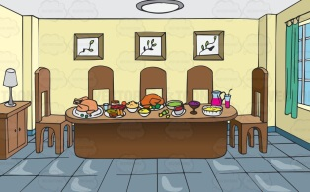
  A.
  B.
  C.
1. |  |  | 
  A.
  B.
  C.
2. |  |  | 
  A.
  B.
  C.
3. |  |  | 
  A.
  B.
  C.
4. |  |  | 
  A.
  B.
  C.

PART 2:Listen and match. There is one example. (1pt)

 | A   | B   | C   | D   | E  
4
3
2
1
0

PART 3: Listen and number. There is one example. (1pt)
A  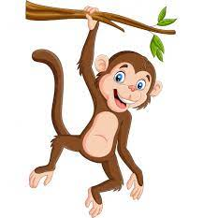 | B   | C   | D   | E  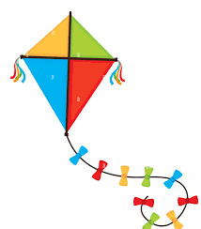
0

PART 4: Listen and choose the best answer. There is one example.(1pt)
0.My mother is a …………….
A. driver | B. teacher | C.doctor
1 ……………… many rabbits do you have? –> I have many.
A.How | B.What | C.Where
2. Would you like some …………………..? -> Yes, please!
A.chicken | B.meat | C.fish
3.What’s she doing ? -> She’s ………………….
A.cooking | B. skating | C. cycling
4.She has a ……………….….
A.car | B.kite | C.plane

READING
PART 1: Read and match the words with pictures. There is one example. (1pt)
(0) Example  0) bed | A 
1. trucks | B 
2. dancing | C 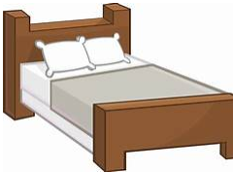
3. father | D 
4. house | E 

PART 2.Read and tick (√) True or False. There is an example .(1pt)
My name is Lucy. Today I am in the park with my friends. We like sports and games. Linh is flying a kite. Mary is playing badminton with Hoa. Ben is cycling. I am drawing a picture. We have a lot of fun in the park.

 |  | TRUE | FALSE
0. | Lucy is in the park with her friends. | √
1. | Lucy and her friends like sports and game.
2. | Linh and Ben is cycling.
3 | Mary and Hoa are playing badminton.
4 | Lucy is flying a kite.

WRITING
PART 1.Look at the pictures and the letters. Write the words. (1 pt)

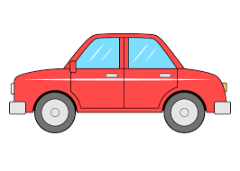 |  |  |  | 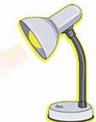
(0). rac  -> car | 1.singkat  ->__________ | 2. sogd  ->__________ | 3.gesg  ->_________ | 4. paml  ->_________

PART 2. Rearrange the words to make the sentences. There is one example. (1 pt)

(0). can/ What/ see/ you/ ?/

→ What can you see ?

1. have/ a/ They/ teddy bear/./

………………………………………………………………………………………

2. skipping/ and/ Lan/ are/ Linh/./

………………………………………………………………………………………

3. do/ many/ have/ How/ you/parrots/?/

………………………………………………………………………………………

4. nurse/ My/ a/ mother/ is/./

………………………………………………………………………………………

SPEAKING . (2pts)
Part 1: Getting to know each other
The examiner asks 3 questions below:
- What’s your name?
- How old is your mother/ father/ sister/ brother?
- Would you like some……?
Part 2: Point at the picture and say the words / sentences
The examiner point to the pictures and ask ss some questions.

- Who is this/ that?
- What is his/ her job?
- Where is the……?
- What would you like to eat?

 |  |  | 
 | 
 | 

Part 3: Answer the questions:
The examiner asks 3 questions below:
- Do you have any…….?
- How many……do you have?
- What can you see?

The end
ĐÁP ÁN VÀ BIỂU ĐIỂM BÀI KIỂM TRA ĐỊNH KỲ HỌC KÌ II
MÔN TIẾNG ANH LỚP 3
LISTENING
PART 1. (0,25*4 =1pt)
1.C 2.B 3.A 4.B
PART 2. (0,25*4 =1pt)
1.C 2.A 3.E 4.D
PART 3.(0,25*4 =1pt)
1.E 2.C 3.D 4.A
PART 4. (0,25*4 =1pt)
1.A 2.B 3.C 4.A
READING
PART 1(0,25*4 =1pt)
1.E 2. D 3. A 4. B
PART 2 (0,25*4 = 1 pt )
1.T 2.F 3. T 4.F
1E 2D 3A 4B
WRITING
PART 1 (0,25*4 = 1 pt )
1. skating 2.dogs 3. eggs 4. lamp
PART 2 (0,25*4 = 1 pt )
- They have a teddy bear.
- Linh and Lan are skipping.
- How many parrots do you have?
- My mother is a nurse.
SPEAKING
Greeting & test taker’s name check.
The examiner says “My name is…It’s nice to talk to you today.”
Part 1: Getting to know each other
The examiner asks 3 questions below:
1.What’s your name?
2.How old is your mother/ father/ sister/ brother?
3.Would you like some……?
Part 2: Point at the picture and say the words / sentences
The examiner point to the pictures and ask ss some questions.
1.Who is this/ that?
2.What is his/ her job?
3.Where is the……?
4.What would you like to eat?

Part 3: Answer the questions:
The examiner asks 3 questions below:
1.Do you have any…….?
2.How many……do you have?
3.What can you see?

