ĐỀ KIỂM TRA CUỐI KÌ 2 – ĐỀ 11
MÔN: TIẾNG ANH 3 GLOBAL SUCCESS

PART A. LISTENING
Question 1. Listen and tick. There is one example.
Example |  | 
1 |  | 
2 |  | 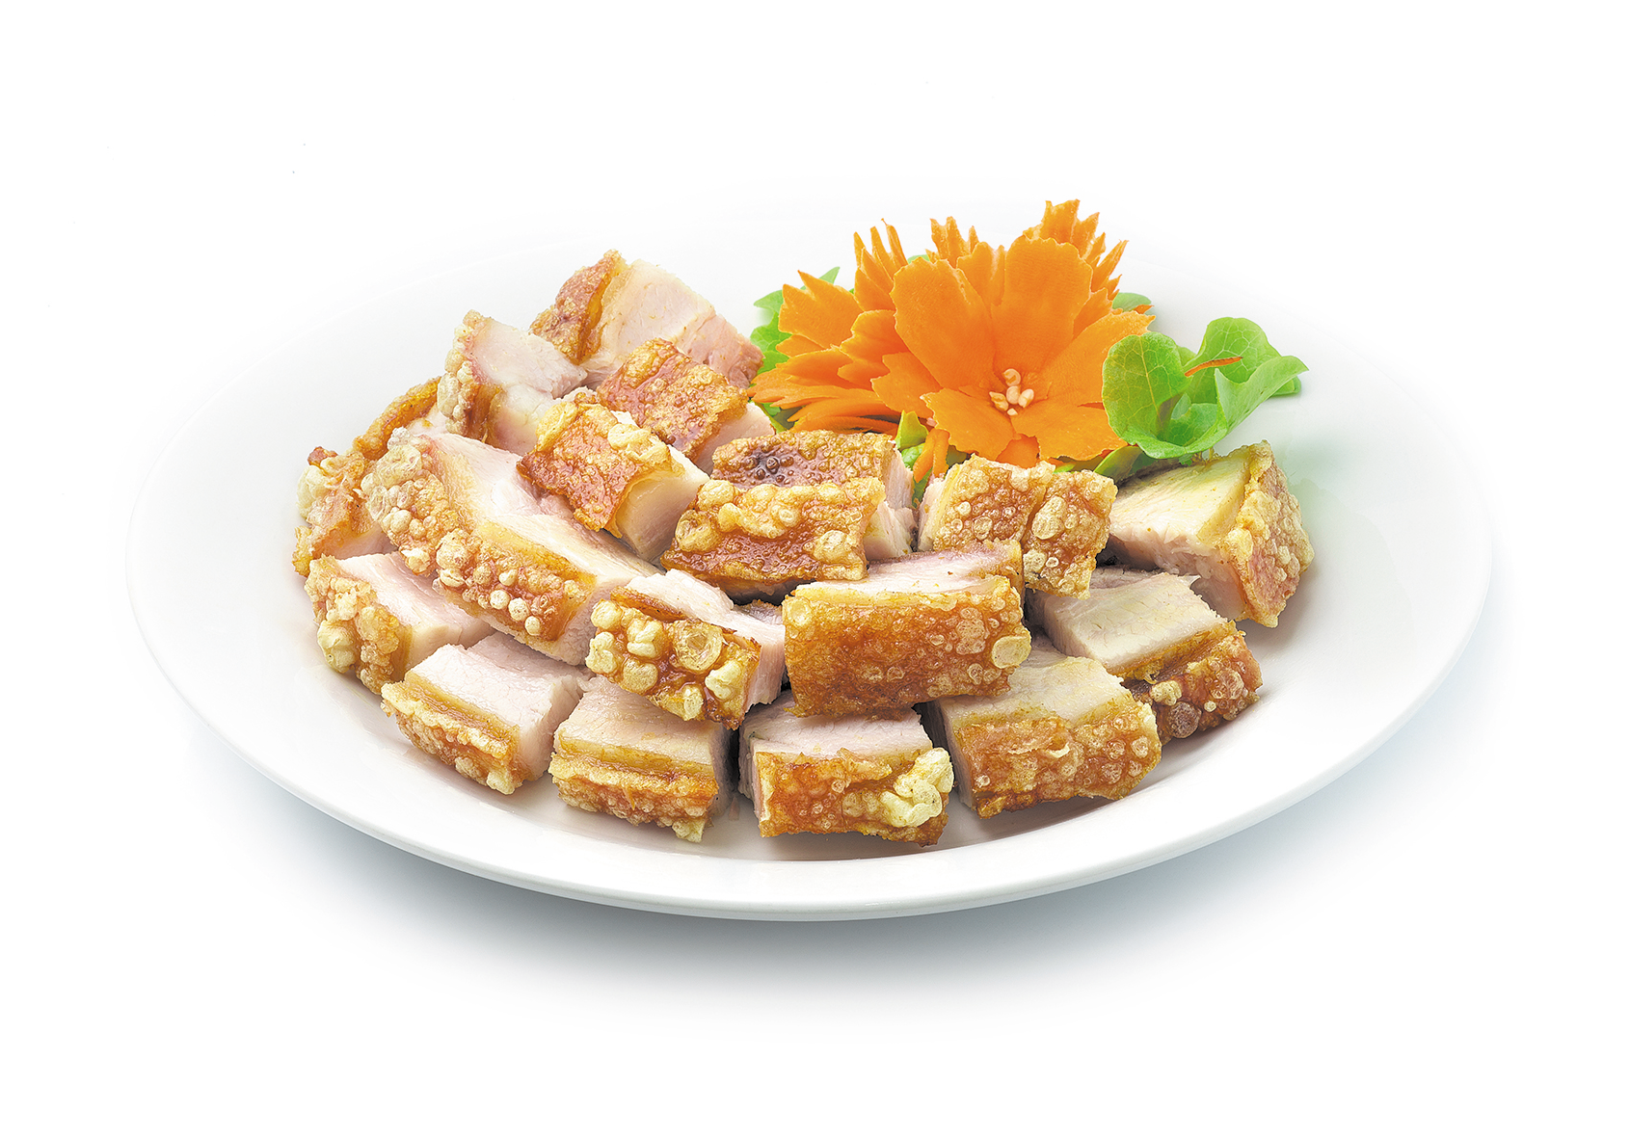
3 |  | 
4 |  | 

Question 2. Listen and circle .There is one example.
Example:

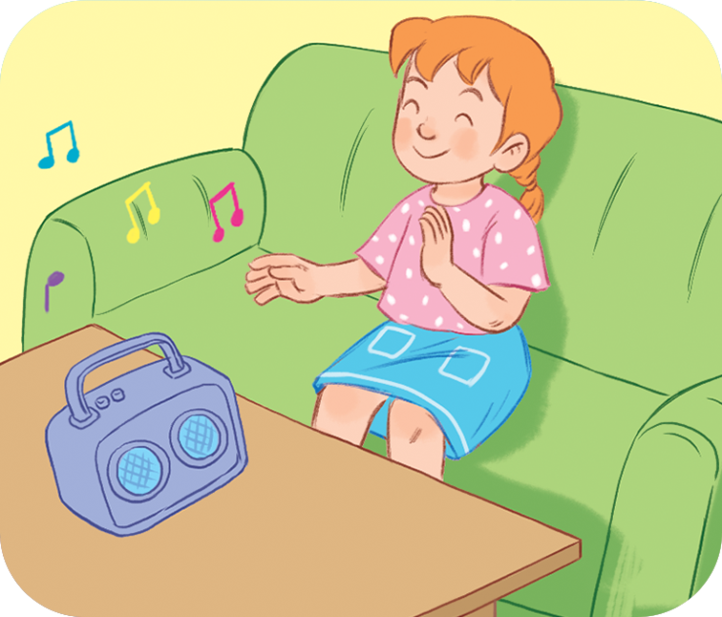





1. 2.

b
a
b
a






3. 4.

b
a
b
a

Question 3. Listen and match. There is one example.






1
4
3
2
0

Question 4. Listen and write. There is one example.
0. Do you have any parrots? – No, I don’t.
1. Where’re the lamps? They’re in the …………………….
2. What are you doing?- I’m ………………………….
3. Is she a …………………? Yes, she is.
4. Would you like some ………………………….? No, thanks.

PART B. READING AND WRITING
Question 5. Read and odd one out.
1. A. father B. brother C. family D. sister
2. A. door B. window C. bed D. small
3. A. tiger B. elephant C. animal D. peacock
Question 6. Read and choose the best answer.
1. ……………….. is the monkey doing? It’s swinging.
A. How B. When C. What D. Who
2. How many………………...do you have? I have five.
A. cats B. parrot C. dog D. bird
3. There is a lamp………………..the desk.
A. on B. for C. from D. of
Question 7. Read and write YES OR NO. There are two examples.
Hello. My name's Phong. Here is a photo of my family. My father is a taxi driver. My mother is a nurse. My sister is teacher. She works in a school. I’m a pupil. We are a happy family.
0. His name's Phong. Yes
1. Phong’s father is a teacher. No
2. Phong’s mother is a driver. ……..
3. Phong’s sister works in a school. ……..
Question 8. Look and unscramble the letters. There is one example.

0. | Example : g d r a w i n  drawing
1. | r/r/p/a/o/t/s  ………………………
2.   | o/l/g/d/s/f/i/h  ………………………
3.   | h/c/i/r/s/a  ………………………

Question 9. Look and write the words. There is one example.
0. | Example :  This is my horse.
1.   | What is she doing?  She is…………………………
2.   | There is a …………………..
3.   | I have one ………………….
Question 10. Put the words in order.
1. many/ birds /How/ have/ do/ you/?
=> __________________________________
2. elephant/ dancing /The/ is/.
=> __________________________________

PART C. SPEAKING . ( 2 pt)

Question 1

Question 2

Question 3

ĐÁP ÁN BÀI KIỂM TRA ĐỊNH KỲ HỌC KÌ II
MÔN TIẾNG ANH LỚP 3
LISTENING
Question 1.
1.A 2.B 3.A 4.B
Question 2.
1.A 2.B 3.B 4.A
Question 3
1.C. 2.A 3.D 4.B
Question 4.
A.bathroom B.watching tv C.worker D.juice

READING
Question 5
- C 2. D 3. C
Question 6
1.C 2. A 3. A
Question 7
1. NO 2 NO 3. YES
Question 8
- Parrots 2. Goldfish 3. Chairs
Question 9
- reading 2. desk 3.dog
Question 10
- how many birds do you have?
- The elephant is dancing.

PART C SPEAKING
Part 1: Interview(0.75pt)
Teacher gives students three questions related to personal information.
1. What’s your name?
2. What is your brother’s job?
3. How many cats do you have?
Part 2: Point and say.(0.75pt)
Teacher shows two pictures for each question. Student listen and points then say aloud. (There are three questions)
Flashcard 1 | Flashcard 2
 | 
Teacher: What is she doing?
- Student points to flashcard …………………………………….
 | 
Teacher: What would you like to drink?
Student points to flashcard …………………………………………..
 | 
Teacher: Where are the chairs?
Student points to flashcard …………………………………………..
Part 3: Let’s talk.(0.5pt)
Teacher show a picture and some cues. Student uses the cues to talk about the picture.
- Teacher says: Now you have 30 seconds to look at the picture and say aloud.
I’m Mai. I have a kite. This is my friend. …
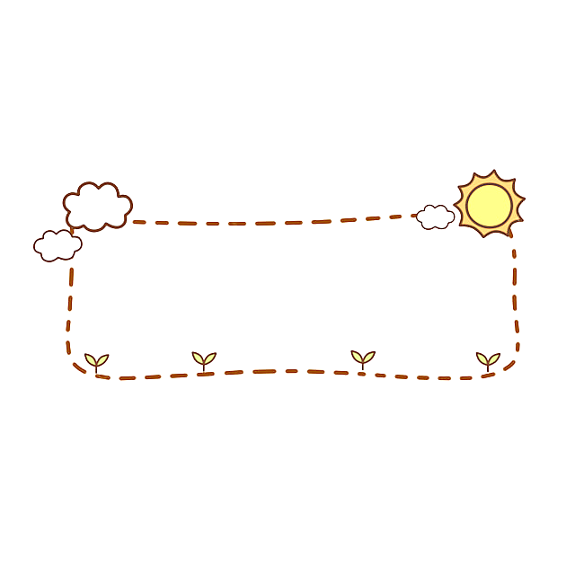
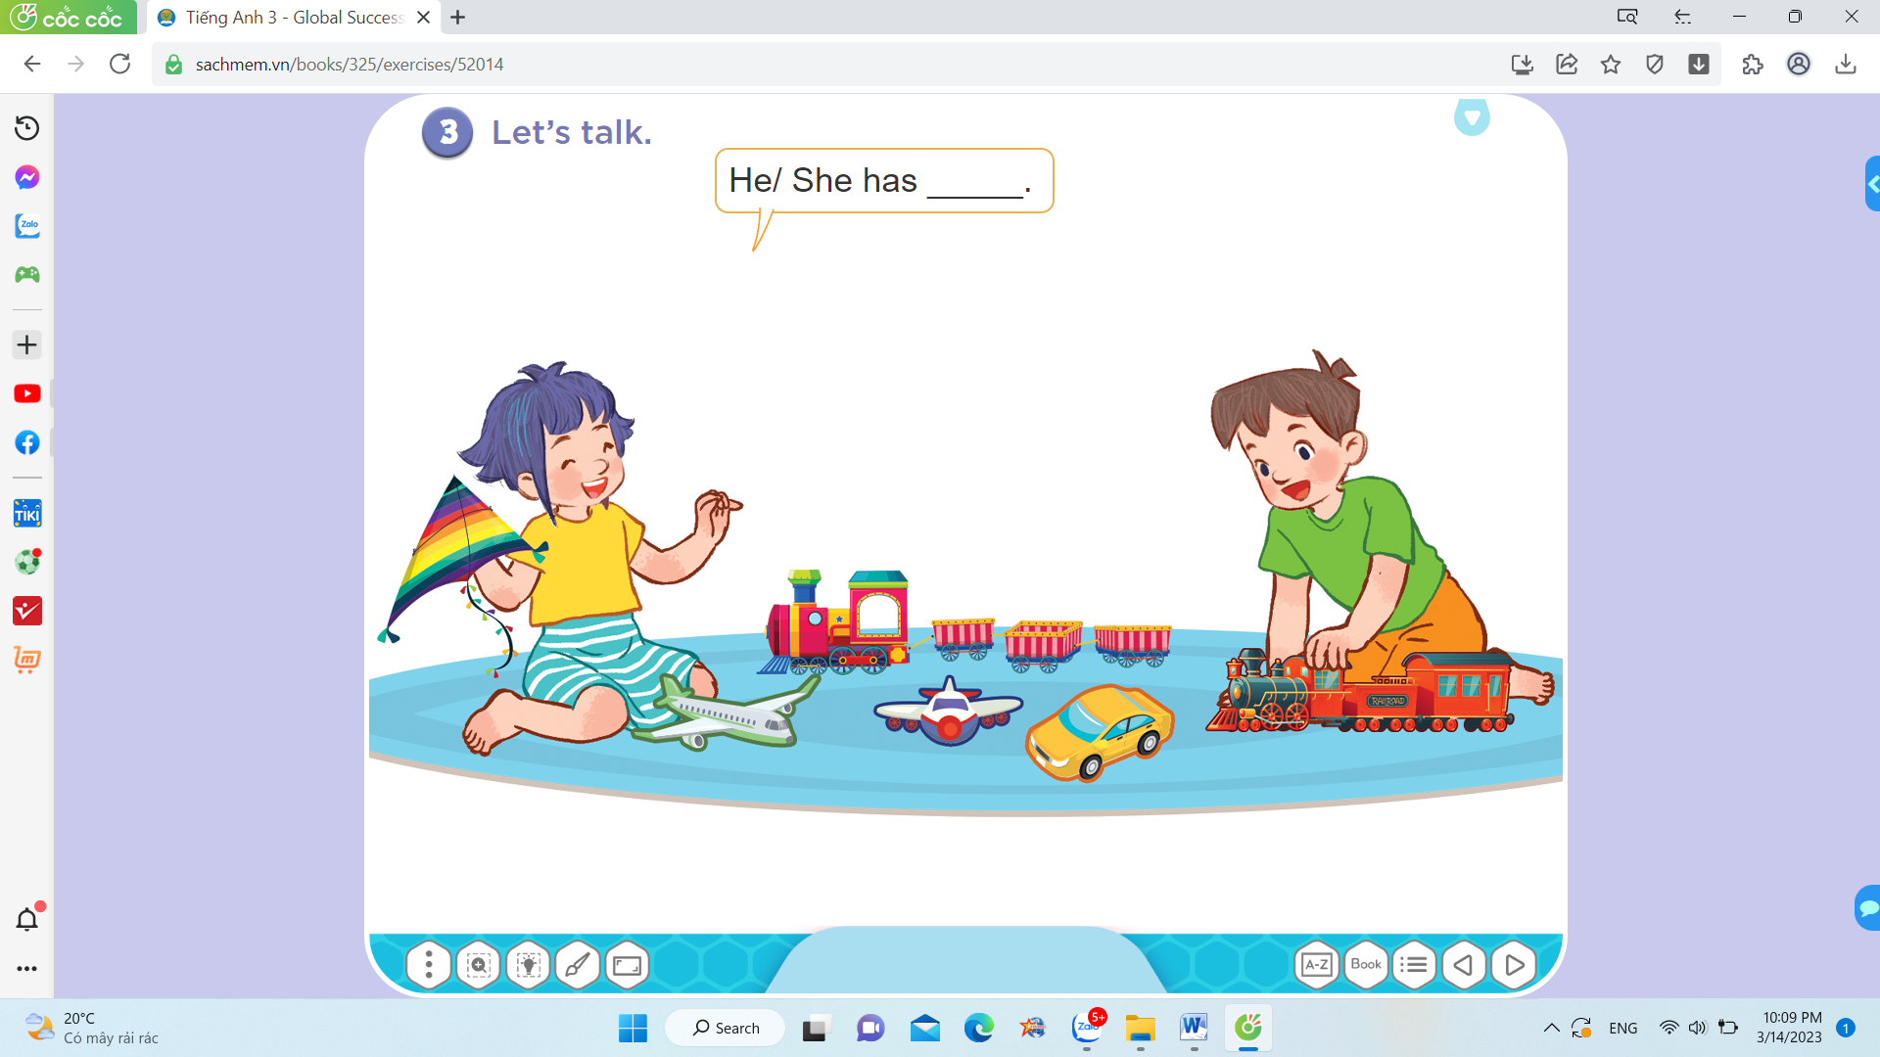

- Mai:
+ kite
+ plane
Her friend:
+ car
+ trains…..

