ĐỀ KIỂM TRA CUỐI KÌ 2 – ĐỀ 10
MÔN: TIẾNG ANH 3 GLOBAL SUCCESS

PART A. LISTENING
Question 1. Listen and tick. There is one example.
Example |  | 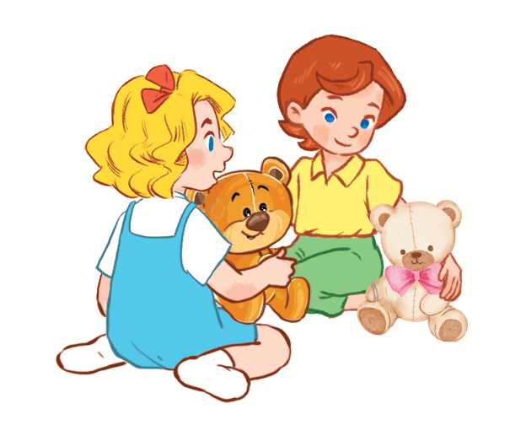
1 | 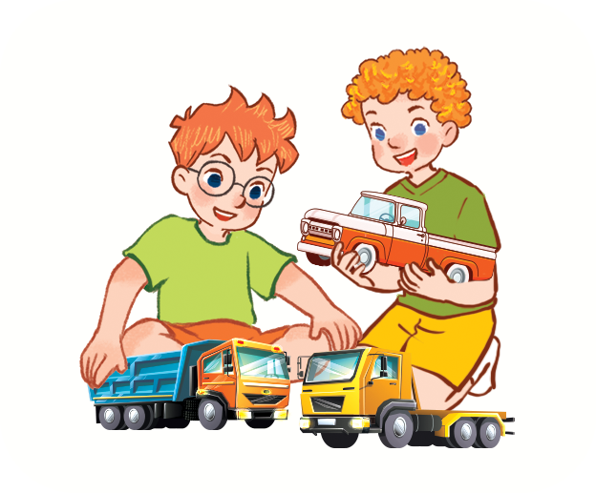 | 
2 | 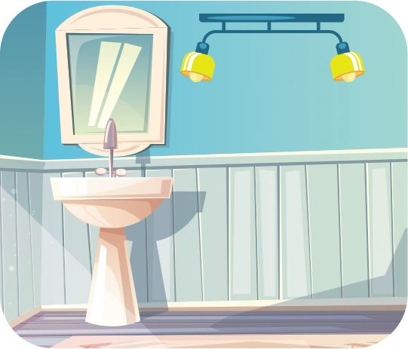 | 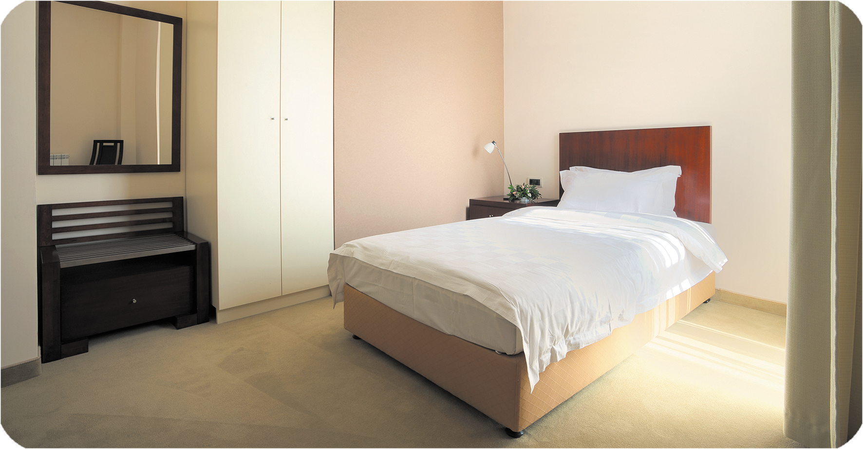
3 |  | 
4 |  | 

Question 2. Listen and tick or cross .There is one example.
Example:
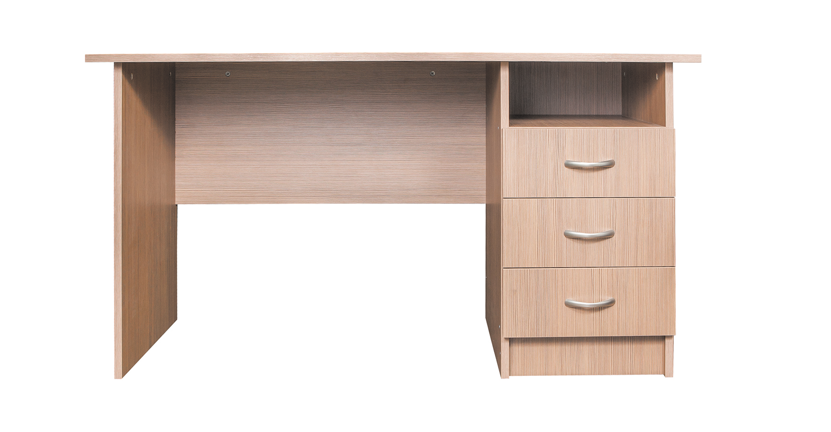





1. 2. 3. 4.

Question 3. Listen and draw lines. There is one example.

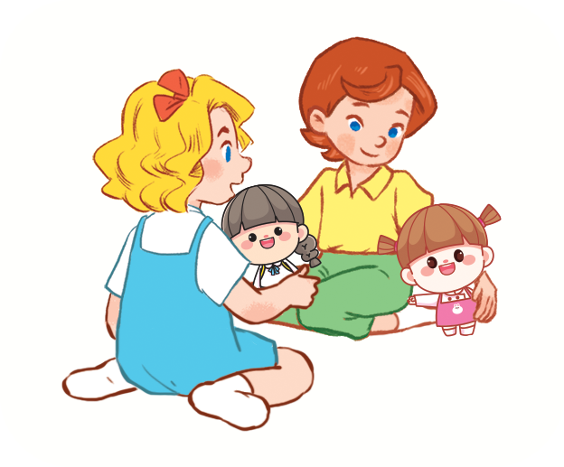




4

3

1
2
2
0

Question 4. Listen and write. There is one example.
0. How old is your sister? She’s eighteen.
1. Would you like some ………………………….? Yes, please.
2. I have two ……………………………..
3. What are you doing? – I’m …………………………..
4. They have ………………………… cars.
PART B. READING AND WRITING
Question 5. Look and read. Put a tick ( ) or cross (X) in the box.
 | 0. There is a bed in my bedroom.
 | 0.0. I have two planes. | X
 | 1. I’d like some eggs, please.
 | 2. Is he a doctor?  Yes, he is.
 | 3. She has a rabbit.

Question 6. Read and match.
0. How many dogs do you have? | 0.a | a. I have many dogs.
1. Do you have any birds? | 1…. | b. They are on the desk.
2. What are you doing? | 2…. | c. No, I don’t.
3. Where are the lamps? | 3…. | d. I’m reading.

Question 7. Read and complete. There are two examples.
Linh and her mother are at the zoo. They can see many animals. There is a monkey. It’s swinging. A tiger is climbing a tree. An elephant is dancing. Linh and her mother love the animals at the zoo.
0. Linh and her mother can see many animals.
1. The monkey is ………………………..
2. A ………………………….. is climbing a tree.
Question 8. Look and unscramble the letters. There is one example.

0.   | Example : k i t e n c h  kitchen
1. | s/d/e/k  ………………………
2.   | j/c/u/i/e  ………………………
3.   | t/i/e/k/s  ………………………
Question 9. Look and write the words. There is one example.
0.   | Example :  Who is this?  It’s my mother.
1. | How many ………..…….. do you have?  I have four.
2.   | Would you like some …………………?  Yes, please.
3. | What is he doing?  He’s ………………...
Question 10. Put the words in order.
1. can /What /see /you/?
=> __________________________________
2. drawing/ He/ is/ the/ in /art room/.
=> __________________________________

PART C. SPEAKING . ( 2 pt)

Question 1

Question 2

Question 3

ĐÁP ÁN BÀI KIỂM TRA ĐỊNH KỲ HỌC KÌ II
MÔN TIẾNG ANH LỚP 3
LISTENING
Question 1.
1.A 2.B 3.A 4.A
Question 2.
1.V 2.X 3.V 4.X
Question 3
1.D 2.A 3...B .4.C
Question 4.
A.beans B.cats C.singing D.three

READING
Question 5
- V 2. x 3. x
Question 6
1.C 2. D 3. B
Question 7
1. animals 2 YES 3. NO
Question 8
- skipping 2. Swinging 3. tiger
Question 9
- cats 2. bread 3.running
Question 10
- what can you see?
- He is drawing in the art room

PART C SPEAKING
Part 1: Interview (0.75pt)
Teacher gives students three questions related to personal information.
1. What’s your name?
2. How old are you?
3. What would you like to drink?
Part 2: Point and say.(0.75pt)
Teacher shows two pictures for each question. Student listen and points then say aloud. (There are three questions)
Flashcard 1 | Flashcard 2
 | 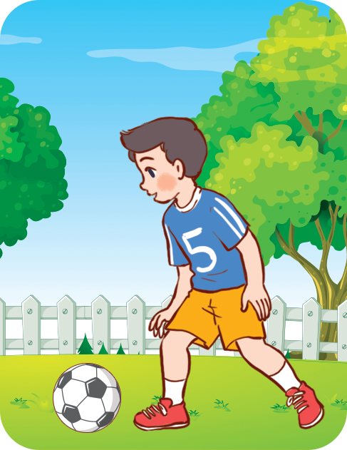
Teacher: What’s he doing
- Student points to flashcard …………………………………………….
 | 
Teacher: What is her job?
Student points to flashcard ……………………………………………………
 | 
Teacher: Where’s the bed?
Student points to flashcard …………………………………………………….
Part 3: Let’s talk. (0.5pt)
Teacher show a picture and some cues. Student uses the cues to talk about the picture.
- Teacher says: Now you have 30 seconds to look at the picture and say aloud.
This is my house.
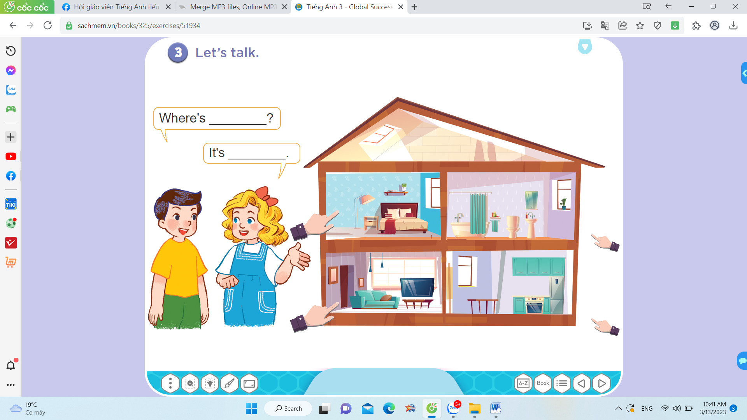


There are…

- four/ rooms
- bedroom
- bathroom
- kitchen
………

