ĐỀ KIỂM TRA CUỐI KÌ 2 – ĐỀ 9
MÔN: TIẾNG ANH 3 GLOBAL SUCCESS

PART A. LISTENING

Question 1. Listen and tick. There is one example.
Example |  | 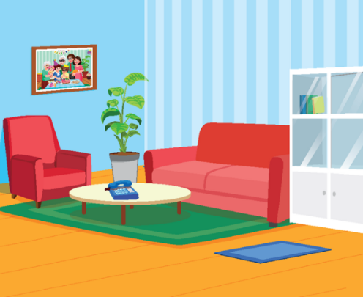
1 | 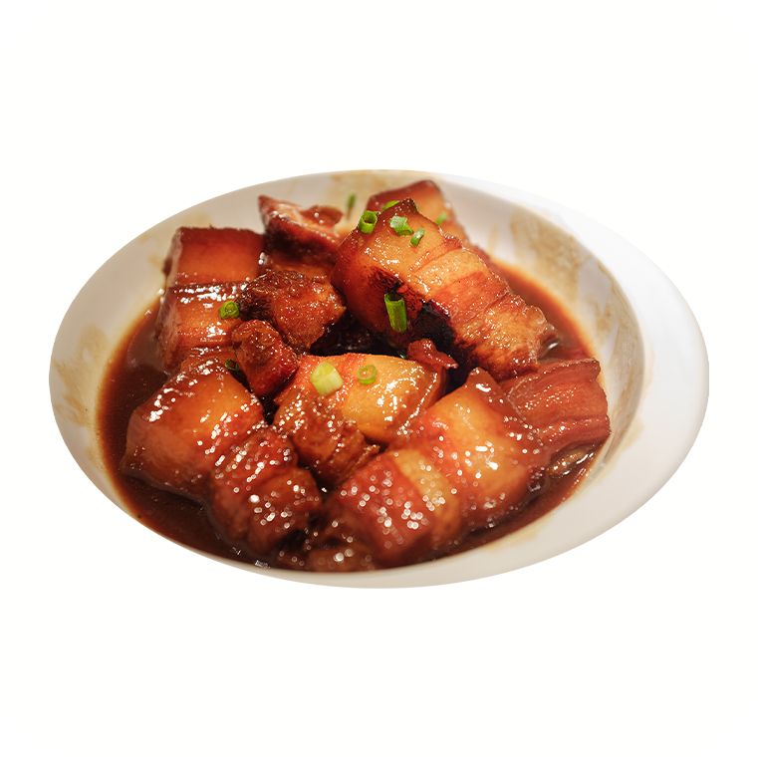 | 
2 |  | 
3 |  | 
4 |  | 

Question 2. Listen and circle .There is one example.
Example:





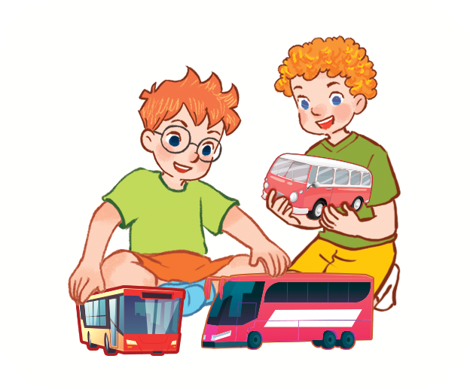

1. 2.

b
a
b
a


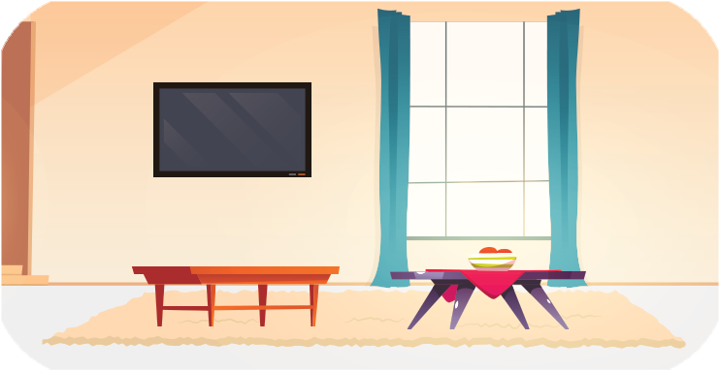

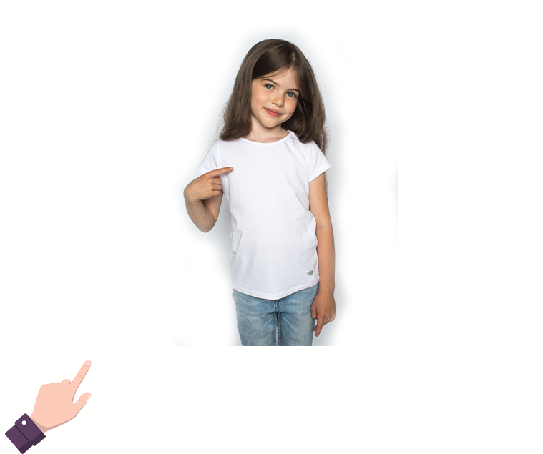

3. 4.

b
a
b
a

Question 3. Listen and number. There is one example.







0

Question 4. Listen and write. There is one example.
0. There are two chairs in my bedroom. They’re small.
1. What are you doing?- I’m playing ……………………….
2. This is my mother.
What’s her job?- She’s a …………………………..
3. Who’s this? It’s my ……………………….
4. What would you like to eat? I’d like some ………………………, please.

PART B. READING AND WRITING
Question 5. Read and odd one out.
1. A. milk B. chicken C. bean D. rice
2. A. parrot B. plane C. dog D. cat
3. A. cycling B. walking C. painting D. badminton
Question 6. Read and choose the best answer.
1. ……………….. is she? It’s my brother.
A. How old B. When C. What D. Who
2. Would you like some fish? No,………………...
A. thanks B. thanks you C. please D. thanks
3. What are you doing? I’m………………..
A. watch B. watching C. watches D. watched
Question 7. Read and decide the statements True (T) or false( F). There is one example.
Hi, my name is Lucy. Here is my bedroom. It is very beautiful. There is a blue window near the desk. There are three chairs and a bed. There is a lamp on the desk. I love my bedroom very much.
 |  | T | F
0 | Lucy’s bedroom is beautiful.
1 | The window is pink.
2 | There are three chairs and a bed in the bedroom.

Question 8. Look and unscramble the letters. There is one example.

0.  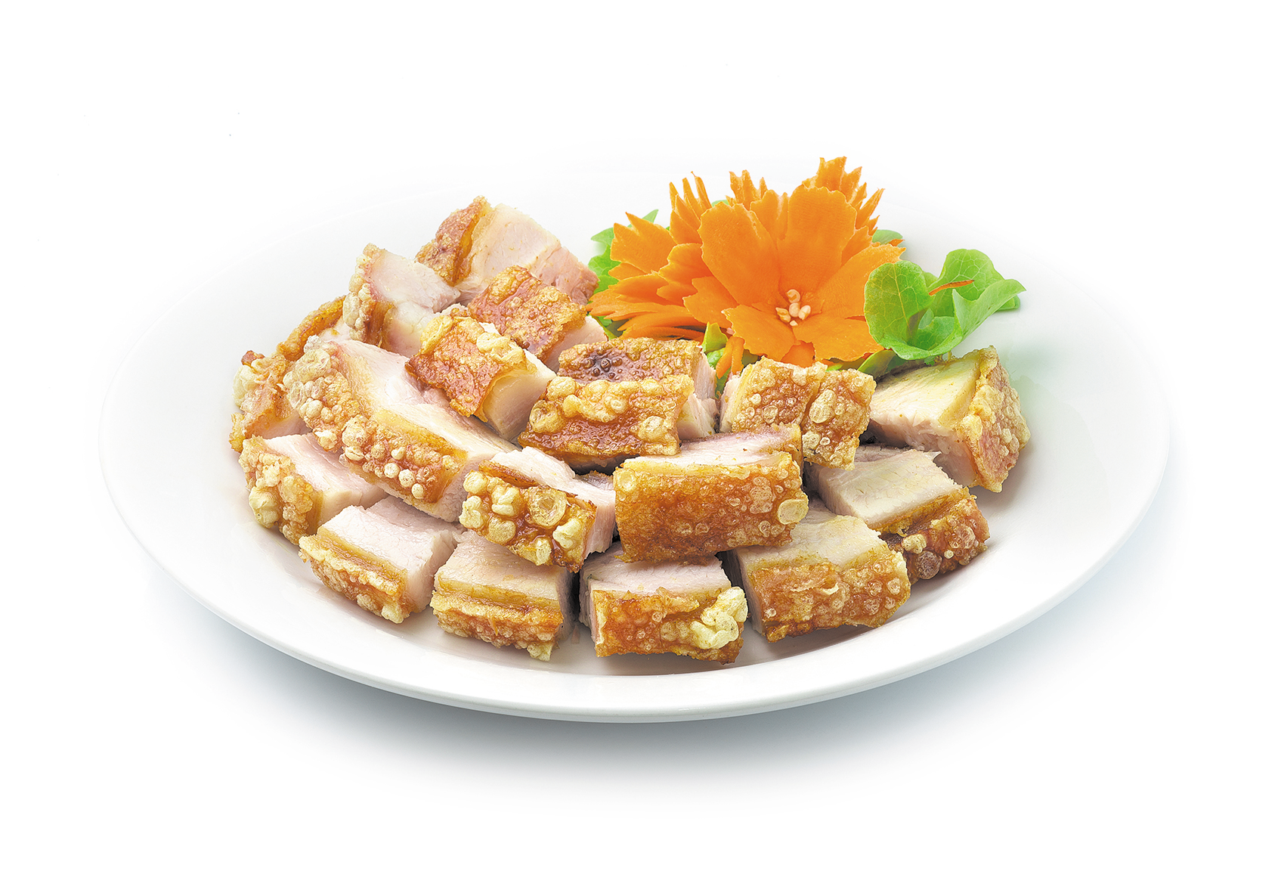 | Example : e a m t  meat
1.  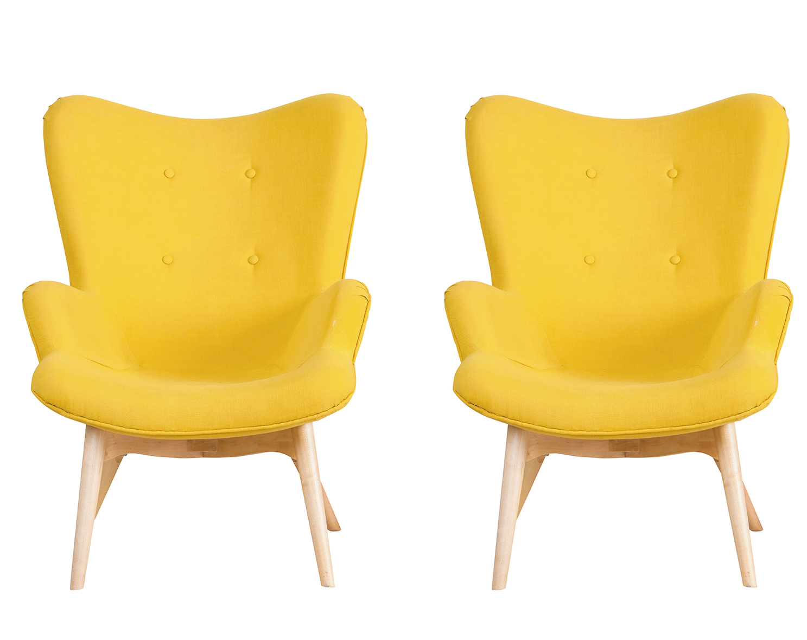 | e/w/n  ………………………
2. | b/r/o/e/d/o/m  ………………………
3.   | r/s/a/b/i/b/t  ………………………

Question 9. Look and write the words. There is one example.
0.   | Example :  This is my house.
1.  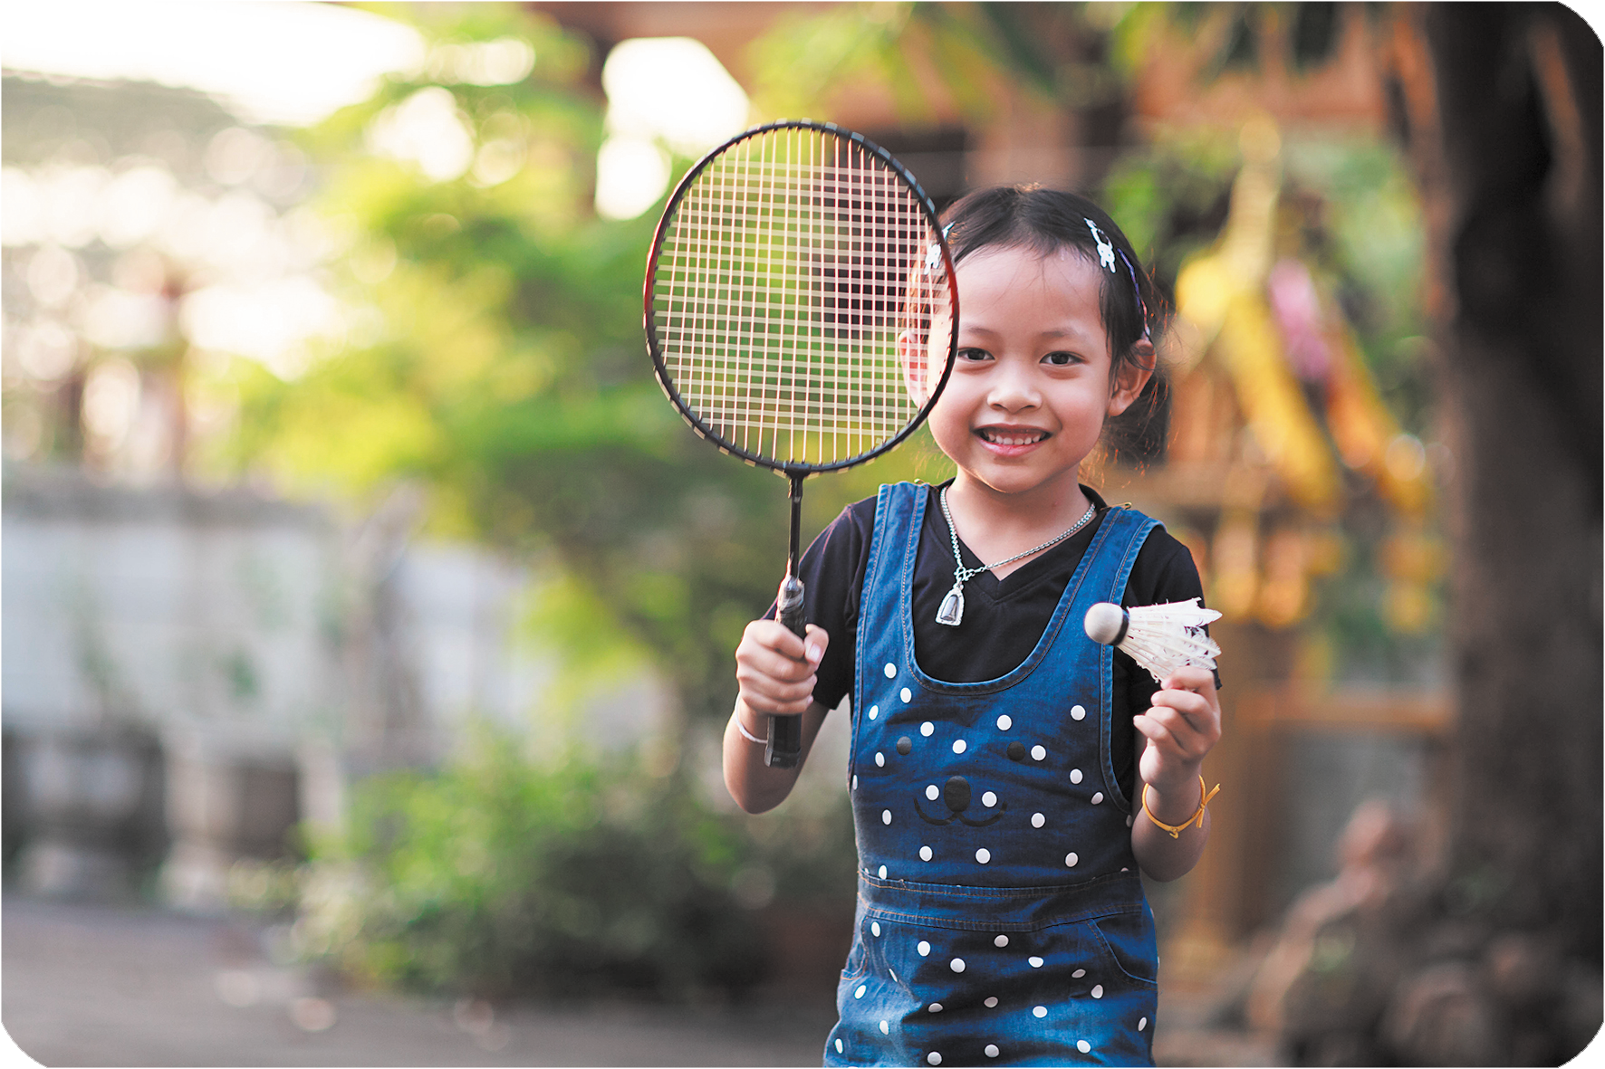 | What is she doing?  She is playing badminton.
2.   | Where are the tables?  They are in the kitchen.
3.  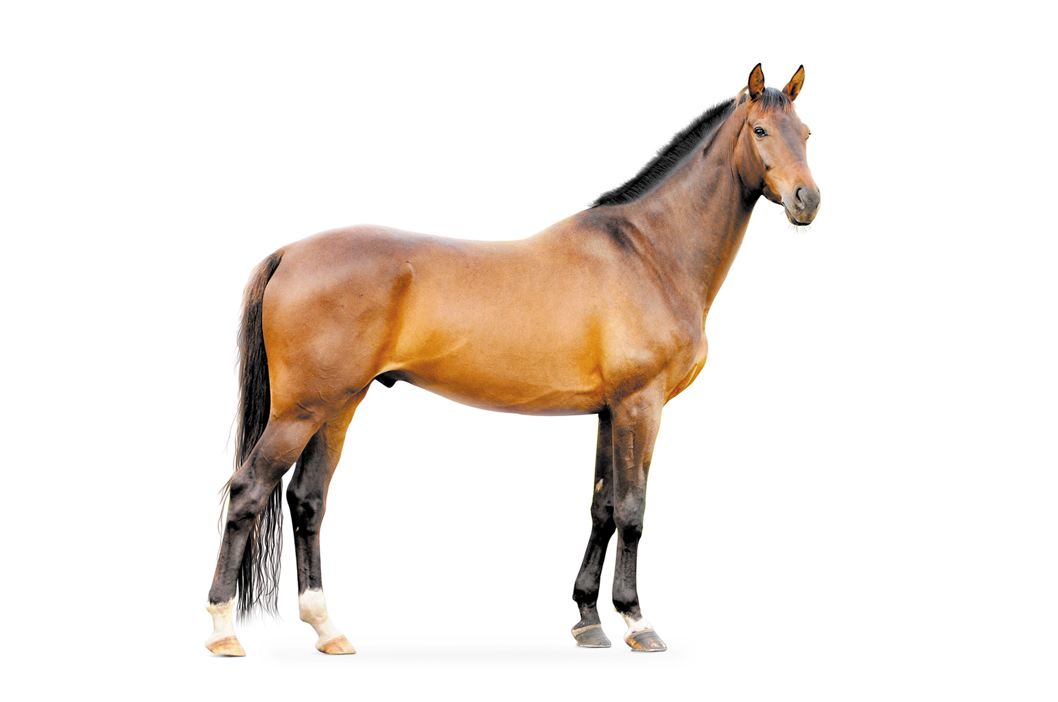 | What can you see?  I can see a horse.
Question 10. Put the words in order.
1. is/ the/ What /doing /elephant/?
=> __________________________________
2. have/ I/ parrots/ many/.
=> __________________________________

PART C. SPEAKING . ( 2 pt)

Question 1

Question 2

Question 3

ĐÁP ÁN BÀI KIỂM TRA ĐỊNH KỲ HỌC KÌ II
MÔN TIẾNG ANH LỚP 3
LISTENING
Question 1.
1.B 2.A 3.B 4.A
Question 2.
1.A 2.B 3.B 4.A
Question 3
A1. B.3 C..0 D.4. E.2.
Question 4.
A.basketball B.doctor C.father D.bread

READING
Question 5
- A 2. B 3. D
Question 6
1.D 2. A 3. B
Question 7
1. T 2 F 3. T
Question 8
- New 2. bedroom 3. rabbits
Question 9
- badminton 2. table 3.horse
Question 10
- what is the elephant doing?
- I have many parrot

PART C SPEAKING
Part 1: Interview (0.75pt)
Teacher gives students three questions related to personal information.
1. What’s your name?
2. How old are you?
3. Is the chair in the room new?
Part 2: Point and say.(0.75pt)
Teacher shows two pictures for each question. Student listen and points then say aloud. (There are three questions)
Flashcard 1 | Flashcard 2
 | 
Teacher: Who is this?
- Student points to flashcard ………………………………….

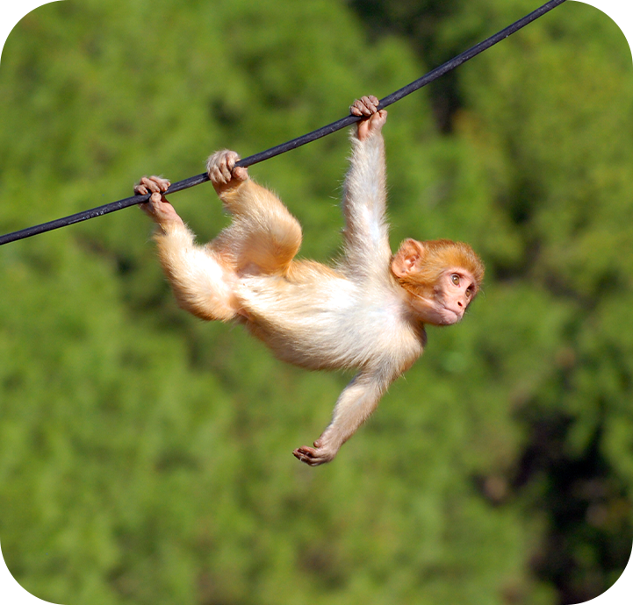 | 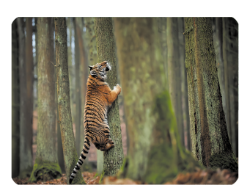
Teacher: What is the monkey doing?
Student points to flashcard …………………………………………
 | 
Teacher: I have a new…………………….
Student points to flashcard ……………………………………….
Part 3: Let’s talk.(0.5pt)
Teacher show a picture and some cues. Student uses the cues to talk about the picture.
- Teacher says: Now you have 30 seconds to look at the picture and say aloud.
Father
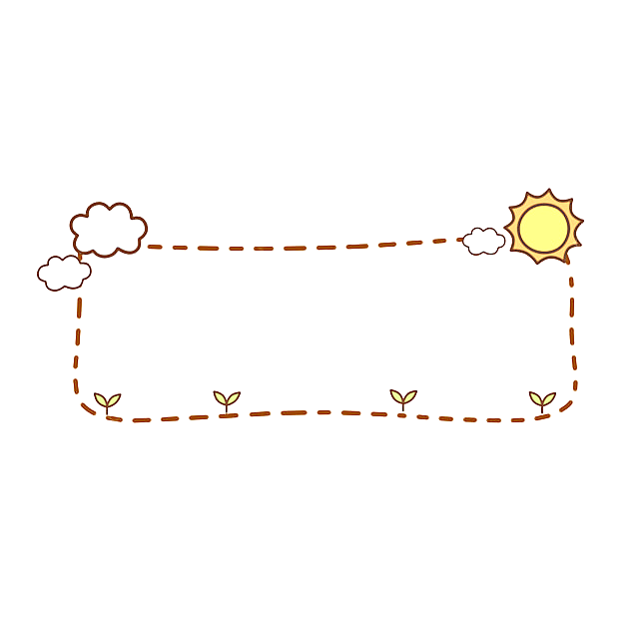
Mother
brother
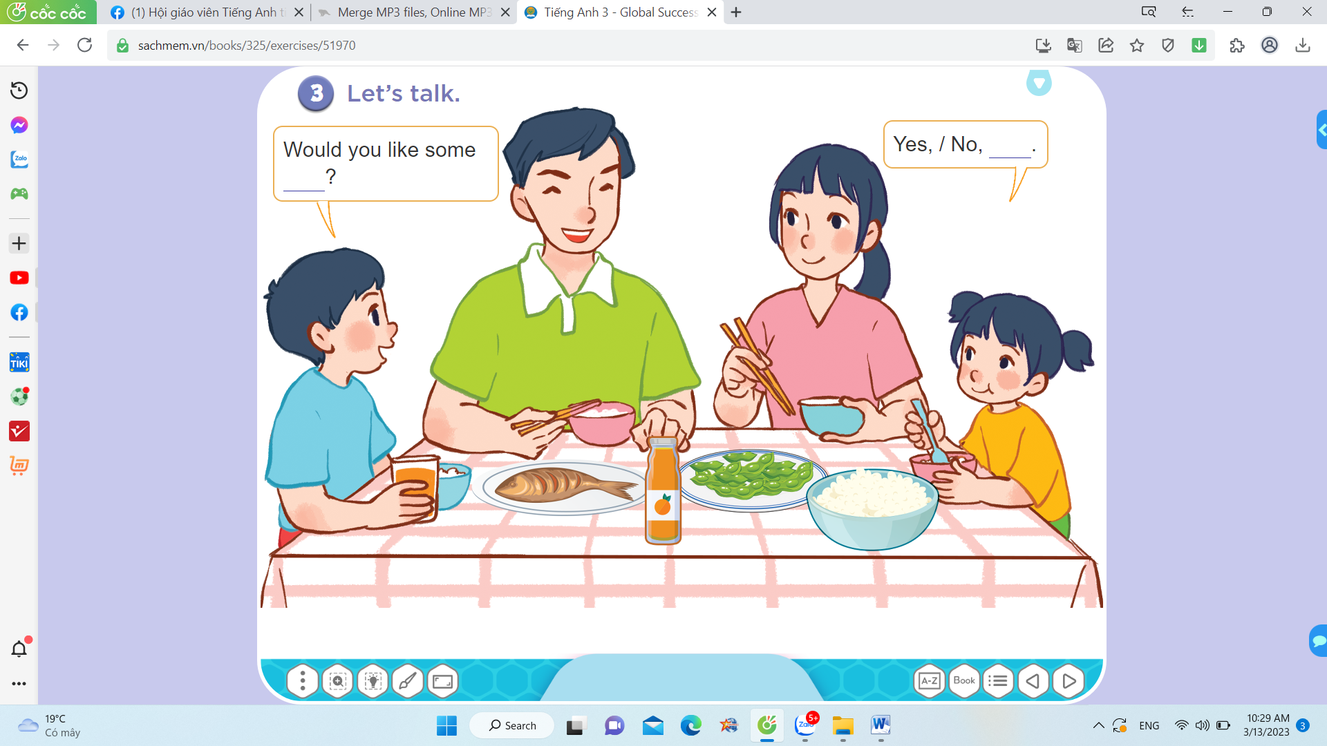

- I’d like some rice.
- Father
- Mother
- Brother
………

I

We are in the dining room.

