ĐỀ KIỂM TRA CUỐI KÌ 2 – ĐỀ 8
MÔN: TIẾNG ANH 3 GLOBAL SUCCESS

PART A. LISTENING

Question 1. Listen and tick. There is one example.
Example | 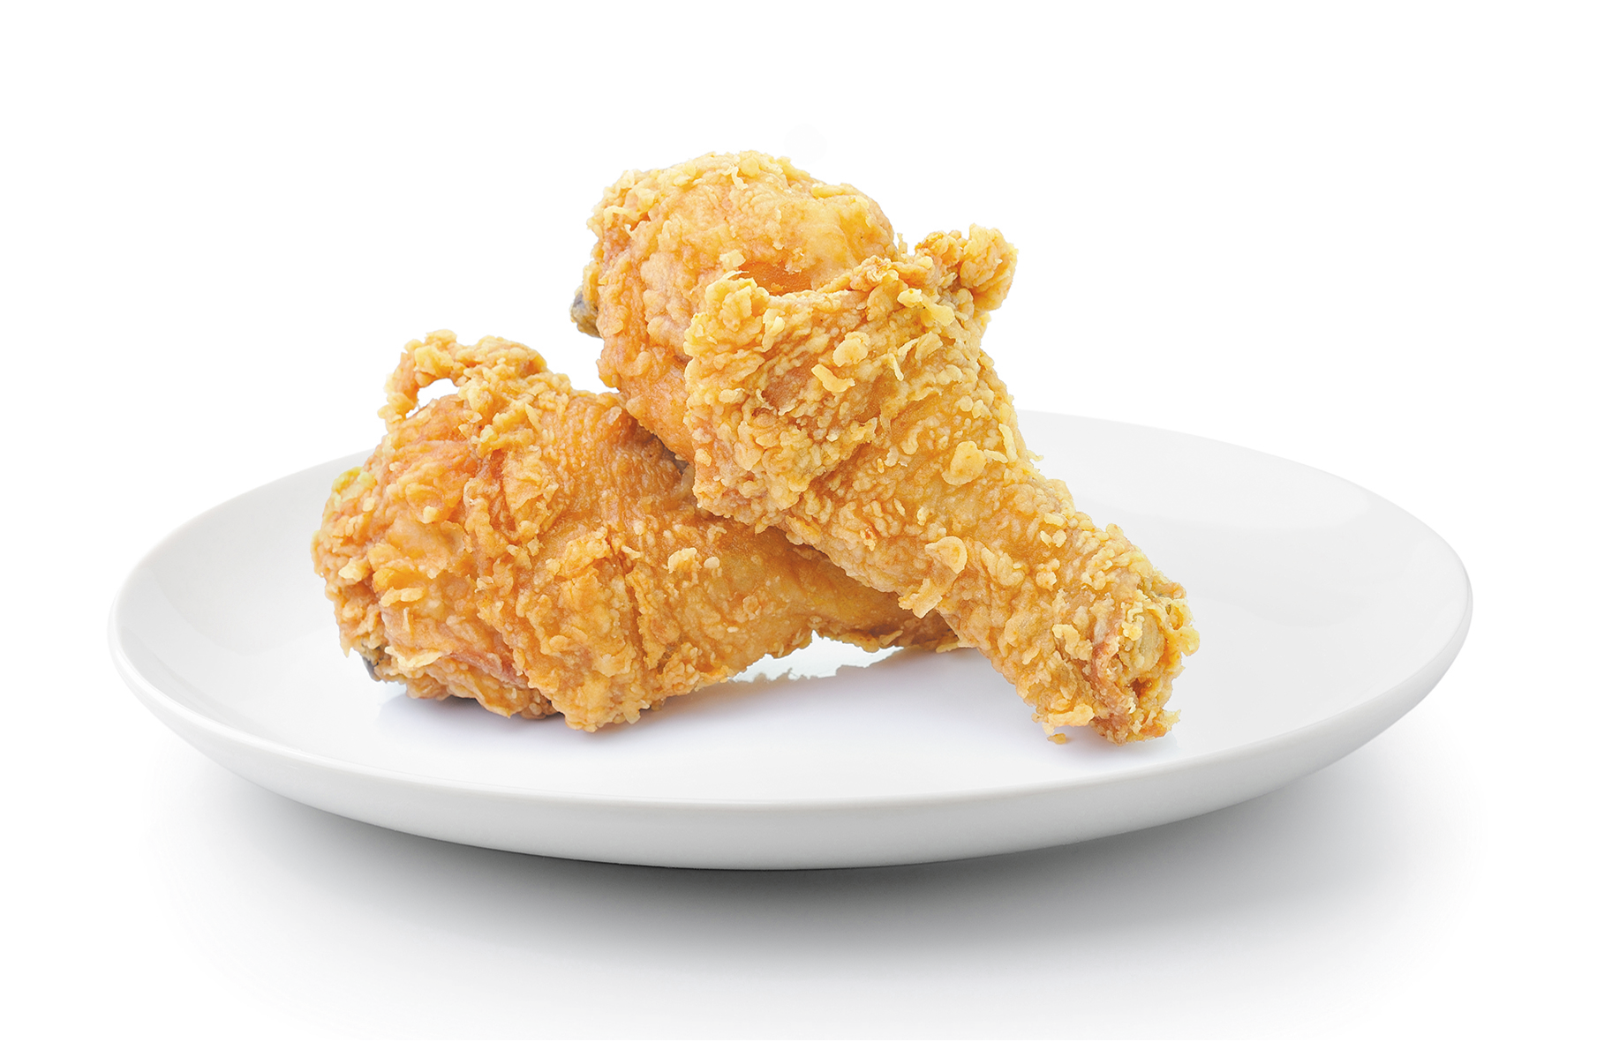 | 
1 | 
2 |  | 
3 | 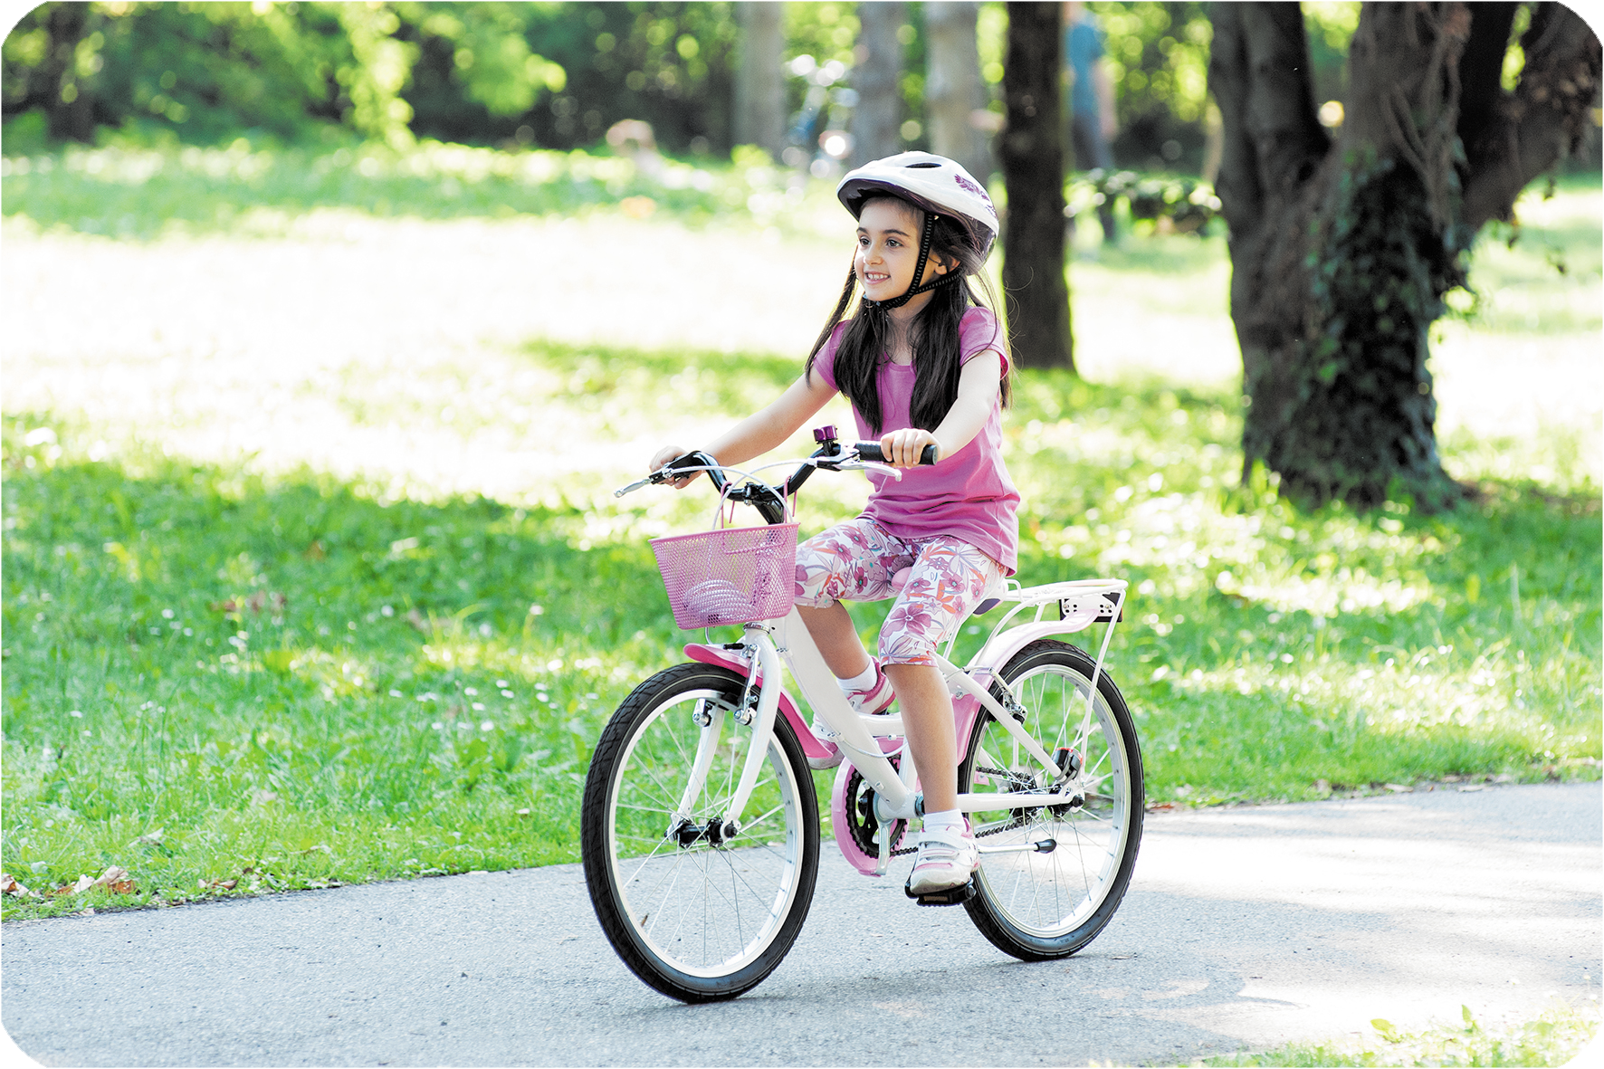 | 
4 | 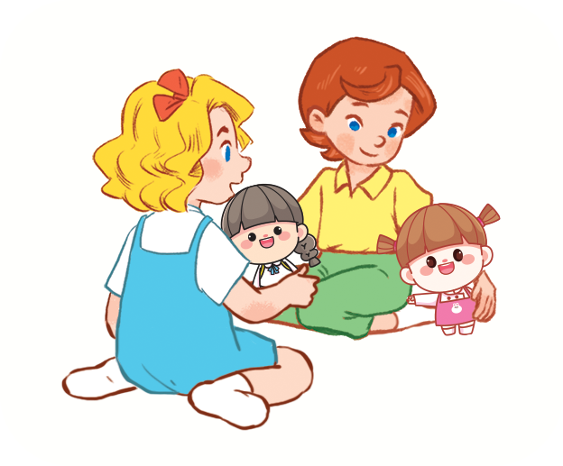 | 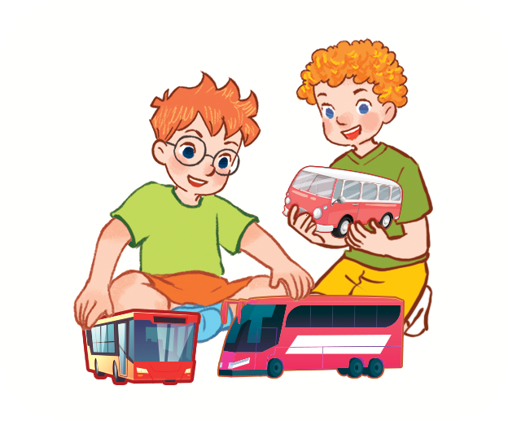

Question 2. Listen and circle .There is one example.
Example:






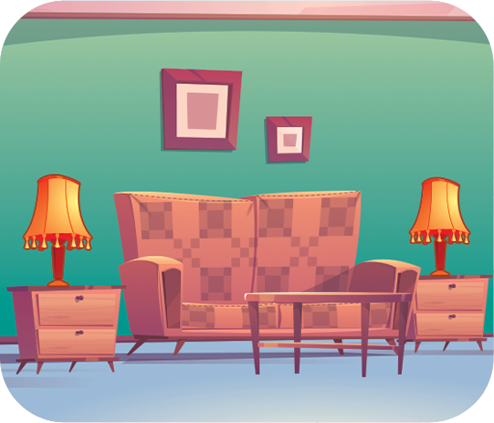
1. 2.

b
a
b
a

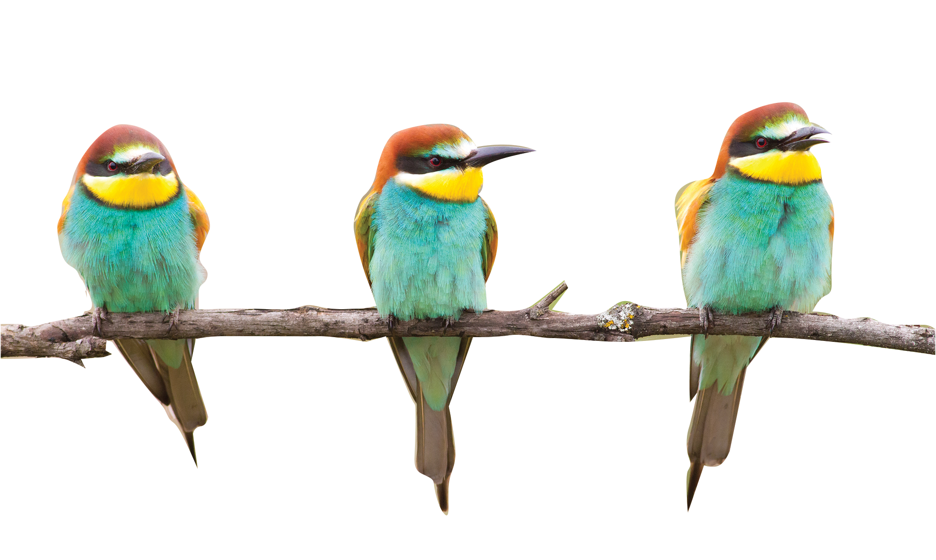

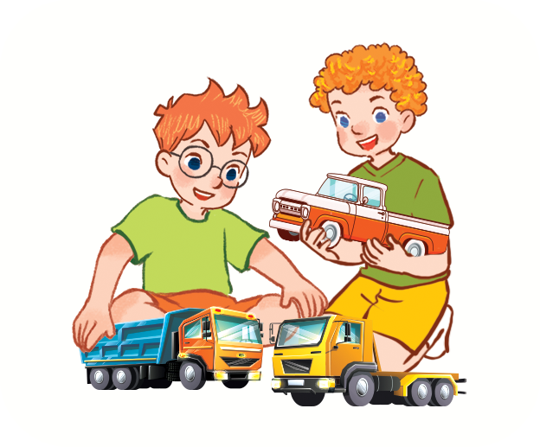
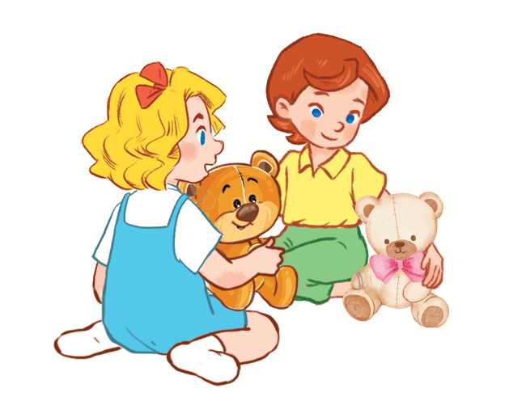

3. 4.

b
a
b
a

Question 3. Listen and number. There is one example.



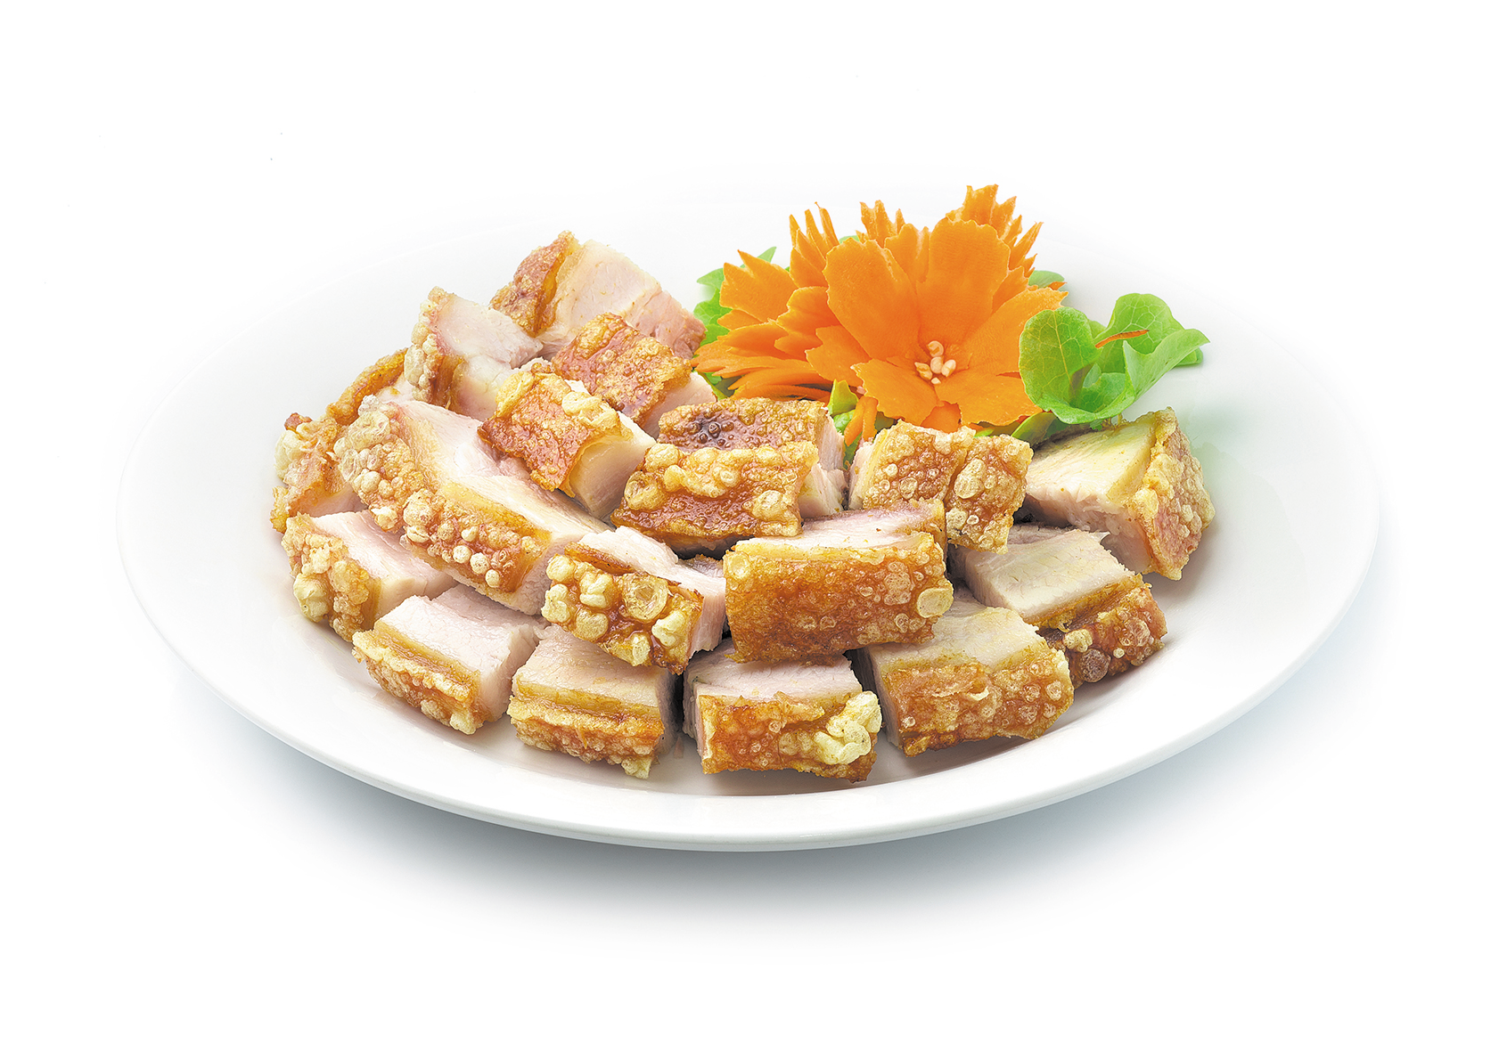



0

Question 4. Listen and write. There is one example.

0. Would you like some juice? - Yes, please.
1. How old is your brother? – He’s ………………….. years old.
2. Do you have any ………………….? – Yes, I do.
3. He has a ……………………..
4. This is my father.
What’s his job? – He’s a ………………………….

PART B. READING AND WRITING
Question 5. Look and read. Put a tick ( ) or cross (X) in the box. There are two examples.
 | 0. The lamps are on the table.
 | 0.0. I’d like some juice, please. | X
 | 1. What can you see?  I can see a tiger.
 | 2. They have two trains.
 | 3. Would you like some eggs?  No, thanks.
Question 6. Read and match. There is one example.

0. Do you have any birds? | 0.c | a. I have some dogs.
1. What is she doing? | 1… | b. Yes, she is.
2. How many dogs do you have? | 2… | c. No, I don’t.
3. Is she a nurse? | 3… | d. She is listening to music.
Question 7. Read and complete. There is one example.
Hi, I’m Nhung. My family is having dinner together. We are in the kitchen. There are lots of food and drink on the table. My father would like rice with chicken and water. My brother would like bread and water. My brother and I would like beans and milk. We all have nice food and drink.
0. Nhung’s family is in the kitchen.
1. Her father would like rice with ……………………. and water.
2. Tuan would like ………………………………. and milk.
Question 8. Look and write the missing letters. There is one example.

0.  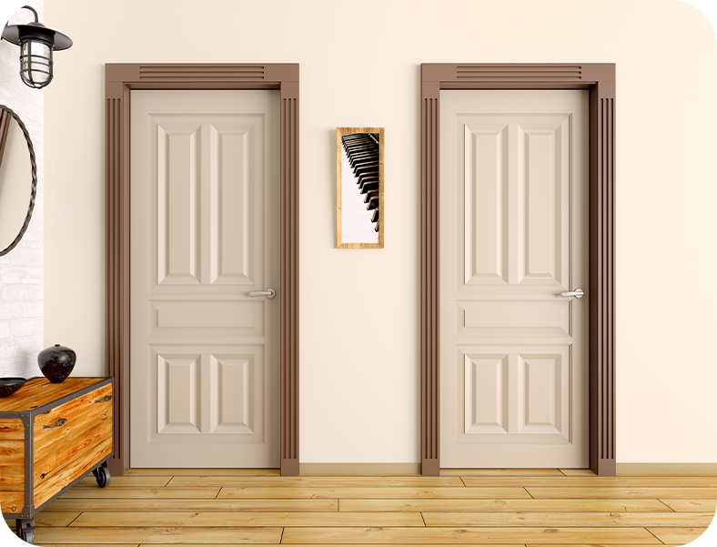 | Example : doors
1.   | brea…………
2. | dri…………..er
3.   | …………….ite

Question 9. Look and write. There is one example.
0.   | Example :  What would you like to drink?  I’d like some water, please.
1.  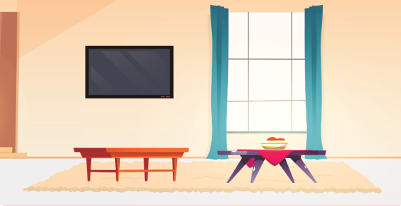 | Where’s the living room?  It’s ……………………
2.   | I have three ……………….
3.  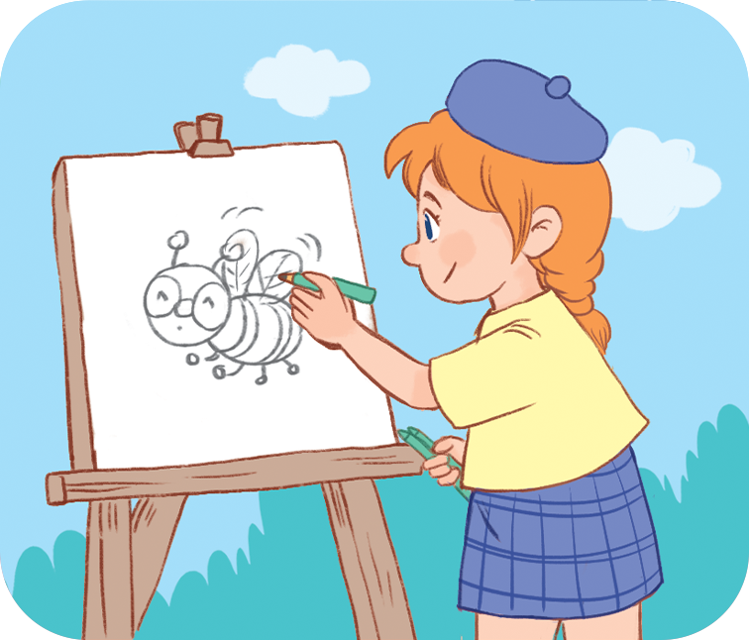 | What is she doing?  She is …………………...
Question 10. Put the words in order.
1. is/ She/ to/ listening/ music/.
=> __________________________________
2. you/ goldfish /How/ many/ do/ have/?
=> __________________________________

PART C. SPEAKING . ( 2 pt)

Question 1

Question 2

Question 3
ĐÁP ÁN BÀI KIỂM TRA ĐỊNH KỲ HỌC KÌ II
MÔN TIẾNG ANH LỚP 3
LISTENING
Question 1.
1.A 2.B 3.A 4.A
Question 2.
1.A 2.A 3.B 4.B
Question 3
A2. B.4 C..3 D.0. E.1.
Question 4.
1..twenty 2.cat 3.car 4. teacher

READING
Question 5
- v 2. x 3. v
Question 6
1.D 2A 3. B
Question 7
1. chicken 2 beans
Question 8
- bread 2. driver 3. kite
Question 9
- there 2. planes 3.drawing
Question 10
- she is listening to music
- how many goldfish do you have?

PART C SPEAKING

Part 1: Interview (0.75pt)
Teacher gives students three questions related to personal information.
1. What’s your name?
2. Do you have a train?
3. What is Hoa doing?
Part 2: Point and say.(0.75pt)
Teacher shows two pictures for each question. Student listen and points then say aloud. (There are three questions)
Flashcard 1 | Flashcard 2
 | 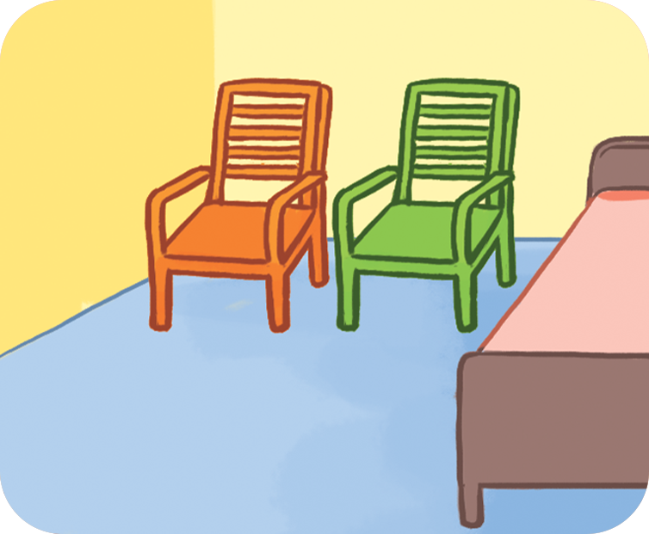
Teacher: Where are the books?
- Student points to flashcard :…………………………………..

Teacher: What is her job?
Student points to flashcard …………………………………………
 | 
Teacher: She has a…………………..
Student points to flashcard …………………………………………
Part 3: Let’s talk.(0.5pt)

Teacher show a picture and some cues. Student uses the cues to talk about the picture.
- Teacher says: Now you have 30 seconds to look at the picture and say aloud.
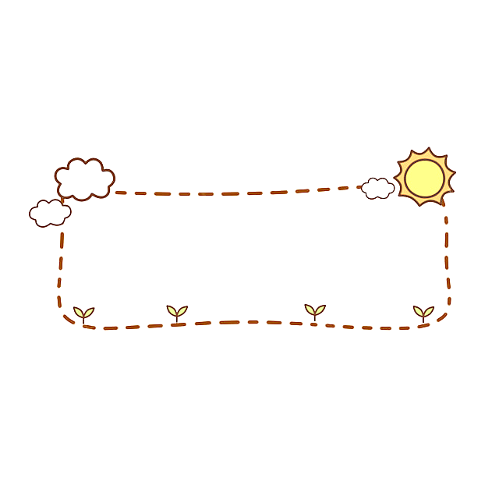

These are my pets.

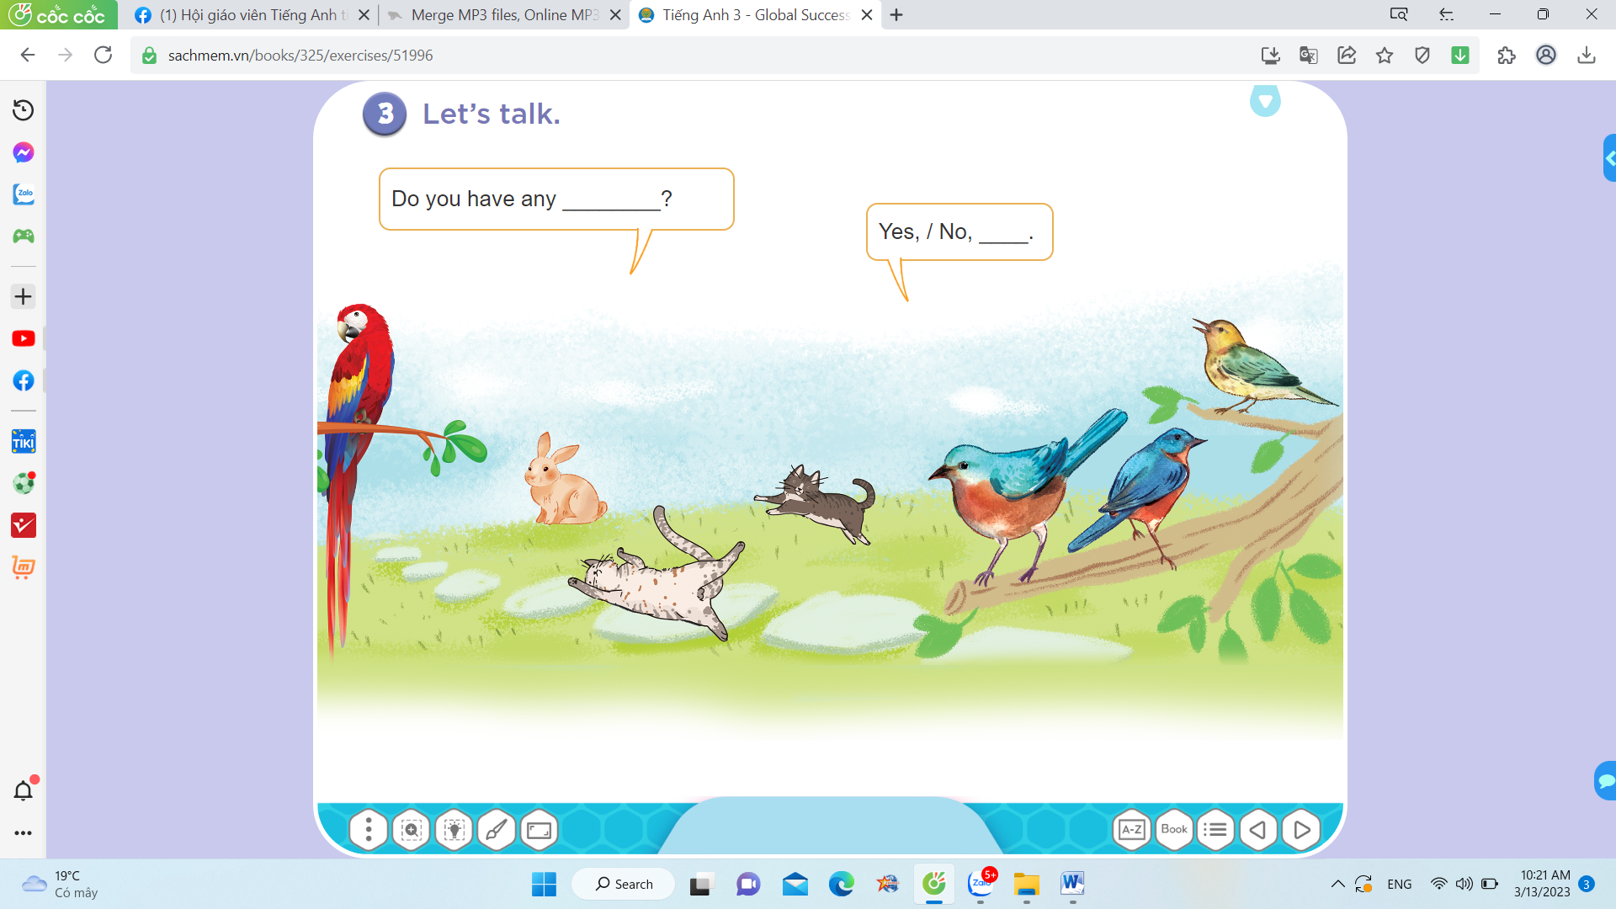

- These/ pets
- rabbit
- bird
- cats
………

