ĐỀ KIỂM TRA CUỐI KÌ 2 – ĐỀ 7
MÔN: TIẾNG ANH 3 GLOBAL SUCCESS

PART A. LISTENING
Question 1. Listen and tick. There is one example.
Example |  | 
1 | 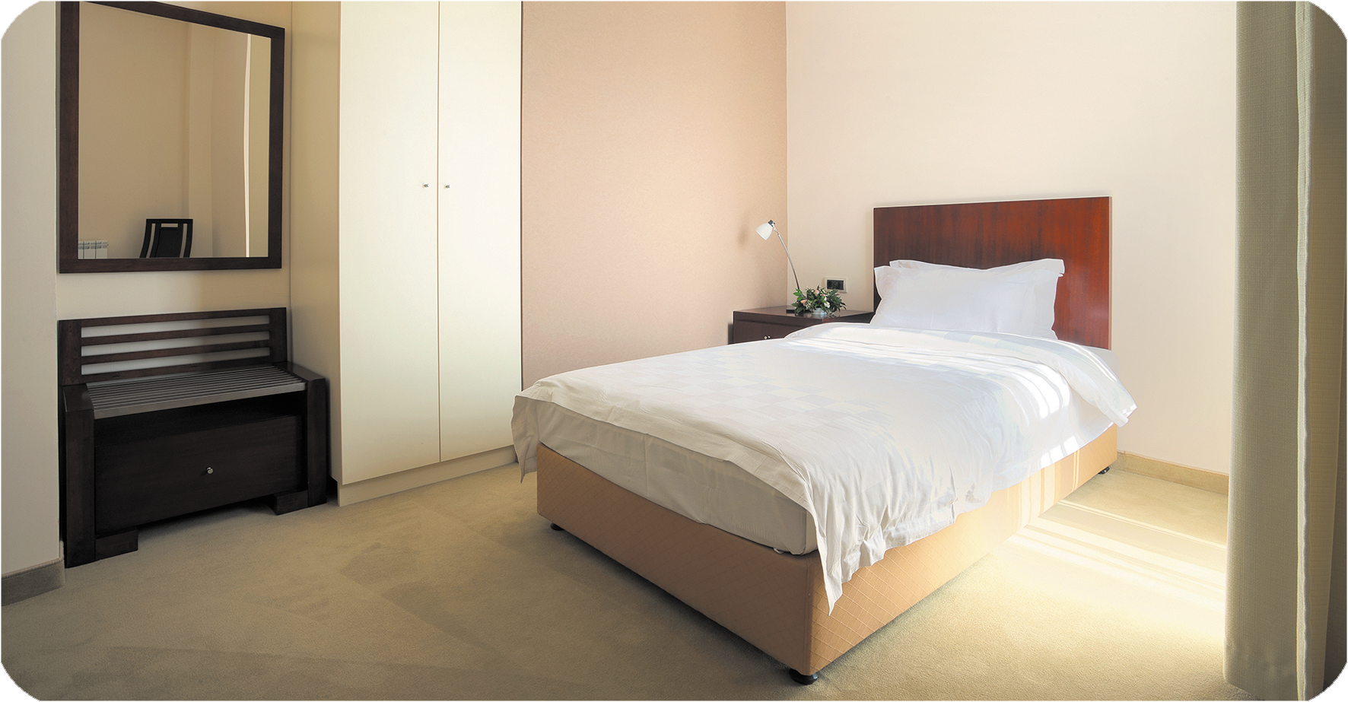 | 
2 |  | 
3 |  | 
4 |  | 

Question 2. Listen and circle .There is one example.
Example:







1. 2.

b
a
b
a



3. 4.

b
a
b
a

Question 3. Listen and number. There is one example.





0

Question 4. Listen and write. There is one example.

0. Is she a worker? Yes, she is.
1. Ben and Bill are my friends. They have three …………………..
2. Mom! I’m ………………………….
- Have fun!
3. Where’s the bedroom?
- It’s …………………….
4. This is my bedroom. There are two ………………… in the room.

PART B. READING AND WRITING
Question 5. Read and odd one out.
1. A. brother B. sister C. doctor D. mother
2. A. pet B. bird C. cat D. dog
3. A. train B. truck C. car D. kite
Question 6. Read and choose the best answer.
1. What is ………………..job? He is a nurse.
A. she B. her C. his D. your
2. What are you doing? I’m………………..basketball.
A. singing B. writing C. play D. playing
3. She ………………..a ship.
A. has B. have C. cycle D. fly
Question 7. Read and decide the statements True (T) or False( F). There is one example.
I’m Ben. I’m at school with my friends. Quan is in the classroom. He’s writing. Thao is in the music room. She is listening to music. Lucy is drawing a goldfish in the art room. Nam is in the playground. He is playing basketball with Phong. I’m in the library. I’m reading a book. We love all activities at school.
0. Quan is writing. | T
1. Nam is playing basketball with Phong in the playground.
2. Ben drawing a goldfish in the art room.

Question 8. Look and unscramble the letters. There is one example.

0. | Example : e r o w k r  Worker
1.   | i/b/g  ………………………
2. | n/a/t/s/k/i/g  ………………………
3.   | e/a/m/t  ………………………

Question 9. Look and write the words. There is one example.
0.   | Example :  There is a table
1. | The …………………. is here.
2.   | What is her job?  She is a …………………….
3.   | She has a …………………..
Question 10. Put the words in order.
1. There/ the/ living room/ windows/ are/ two/ in/.
=> __________________________________
2. He / is / a / flying/ kite/.
=> __________________________________

PART C. SPEAKING . ( 2 pt)

Question 1

Question 2

Question 3

ĐÁP ÁN BÀI KIỂM TRA ĐỊNH KỲ HỌC KÌ II

LISTENING
Question 1.
1.A 2.B 3.B 4.A
Question 2.
1.B 2.B 3.B 4.A
Question 3
A2. B.0 C..4 D.3. E.1.
Question 4.
A.dancing B.here C.windows

READING
Question 5
- C 2. A 3. D
Question 6
1.C 2. D 3. A
Question 7
1. F 2 T
Question 8
- big 2. skating 3. meat
Question 9
- bedroom 2. Nurse 3.car
Question 10
- there are two windows in the living room
- he is flying a kite

PART C SPEAKING

Part 1: Interview (0.75pt)
Teacher gives students three questions related to personal information.
1. What’s your name?
2. How old are you?
3. What would you like to drink?

Part 2: Point and say.(0.75pt)
Teacher shows two pictures for each question. Student listen and points then say aloud. (There are three questions)
Flashcard 1   | Flashcard 2  
Teacher: What would you like to eat?
- Student points to flashcard ………………………………….
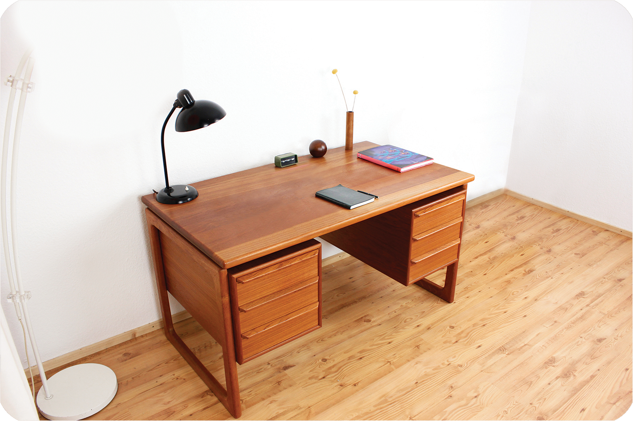 | 
Teacher: Where are the lamps?
Student points to flashcard ………………………………………..
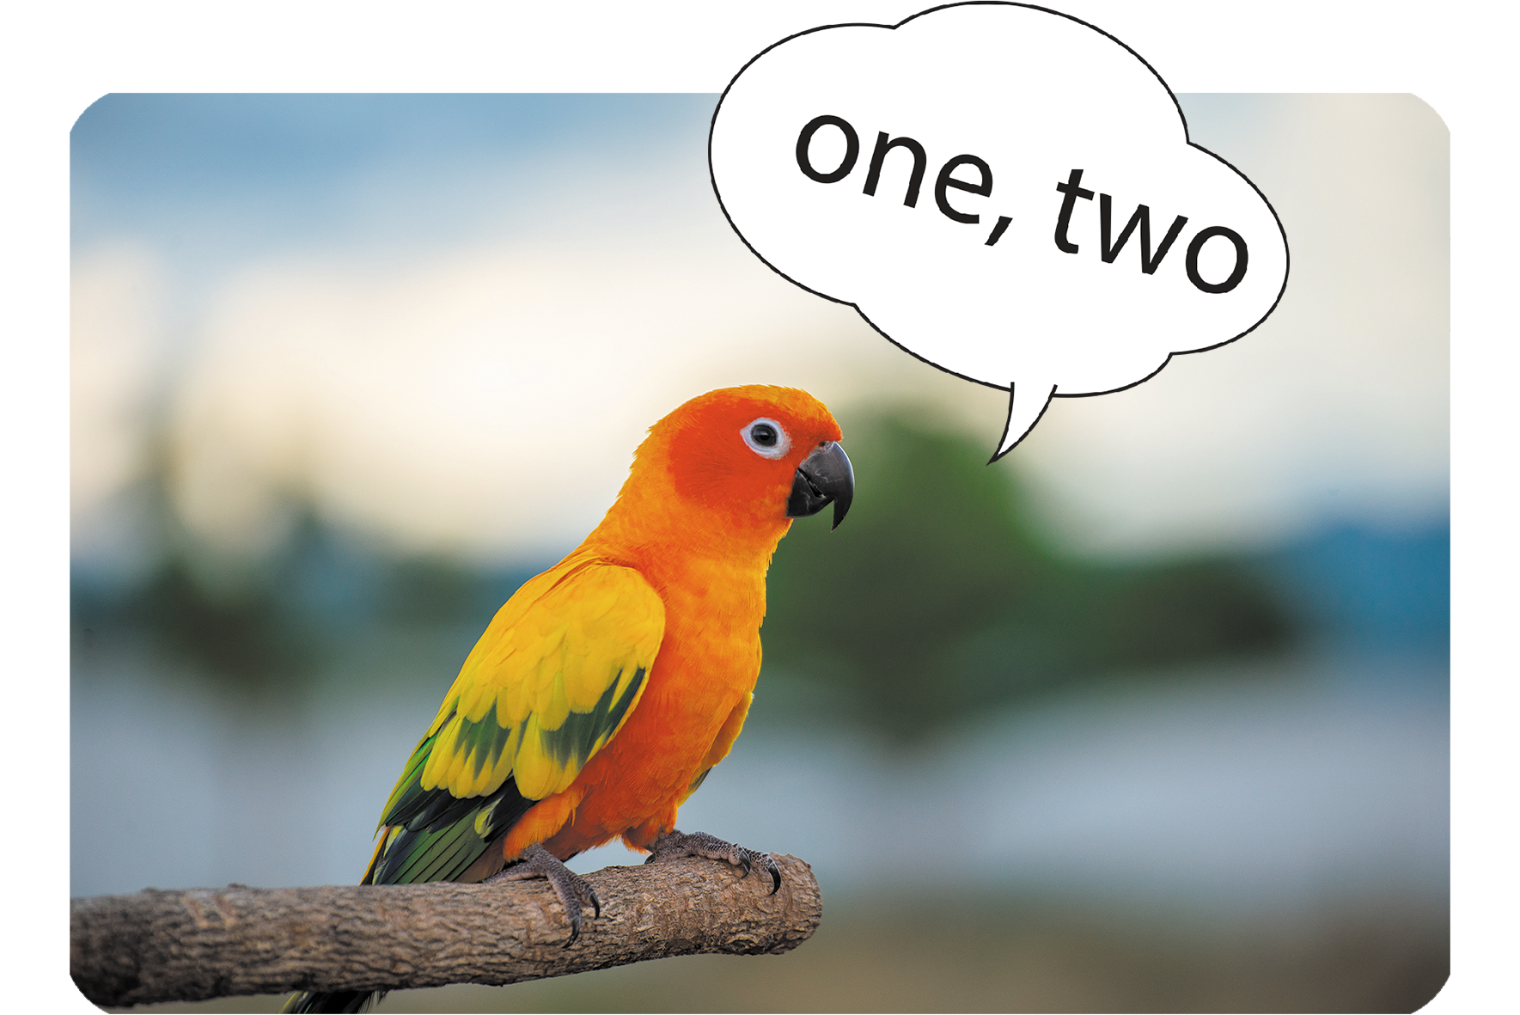


Teacher: What is the elephant doing?
Student points to flashcard ……………………………………….
Part 3: Let’s talk.(0.5pt)
Teacher show a picture and some cues. Student uses the cues to talk about the picture.
- Teacher says: Now you have 30 seconds to look at the picture and say aloud.
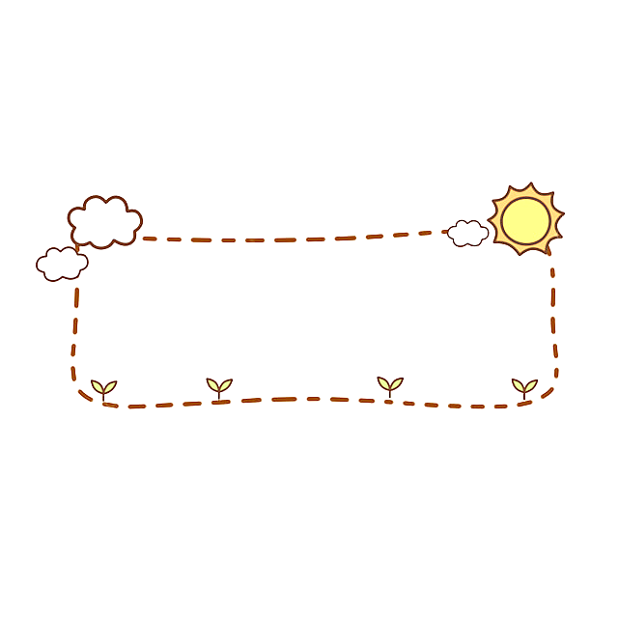
Where’re you?
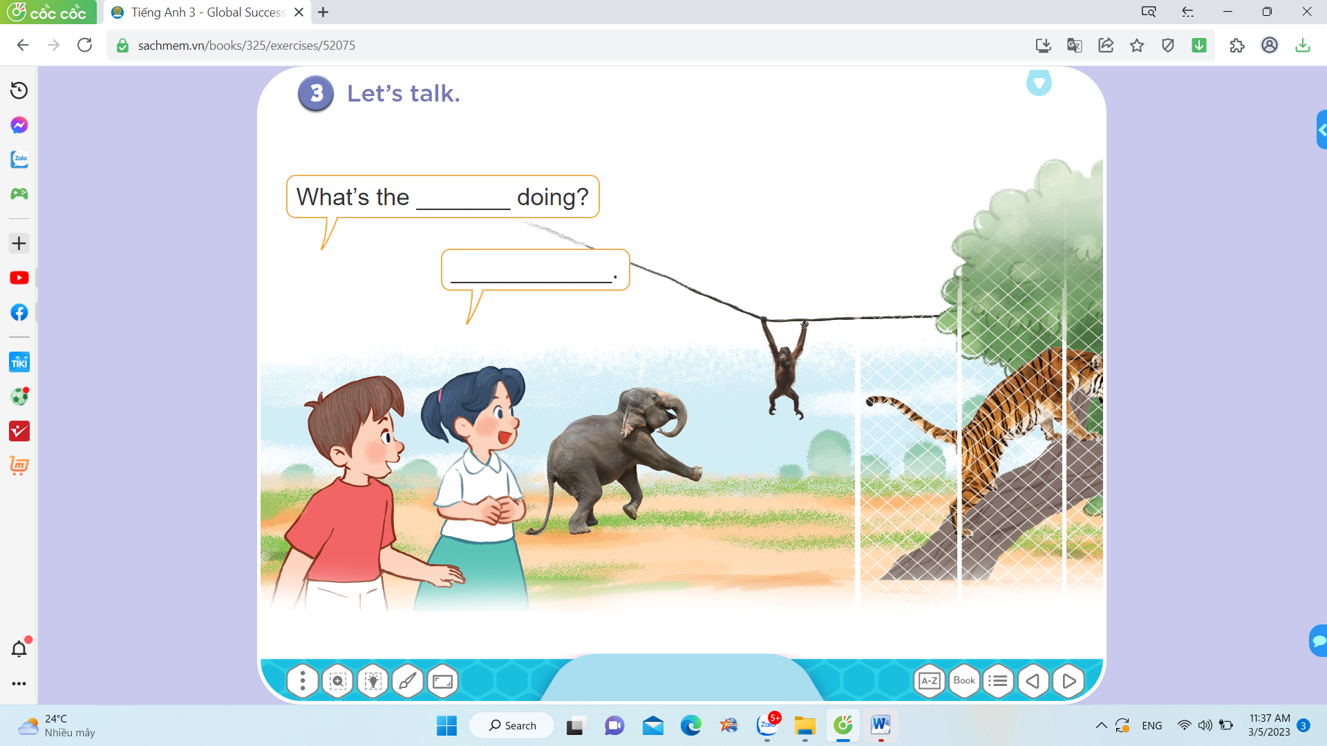

I’m in the zoo.

- Elephant/dancing
- Monkey/swinging
- Tiger/climbing
………

