ĐỀ KIỂM TRA CUỐI KÌ 2 – ĐỀ 6
MÔN: TIẾNG ANH 3 GLOBAL SUCCESS

PART A. LISTENING

Question 1. Listen and tick. There is one example.
Example
1 |  | 
2 |  | 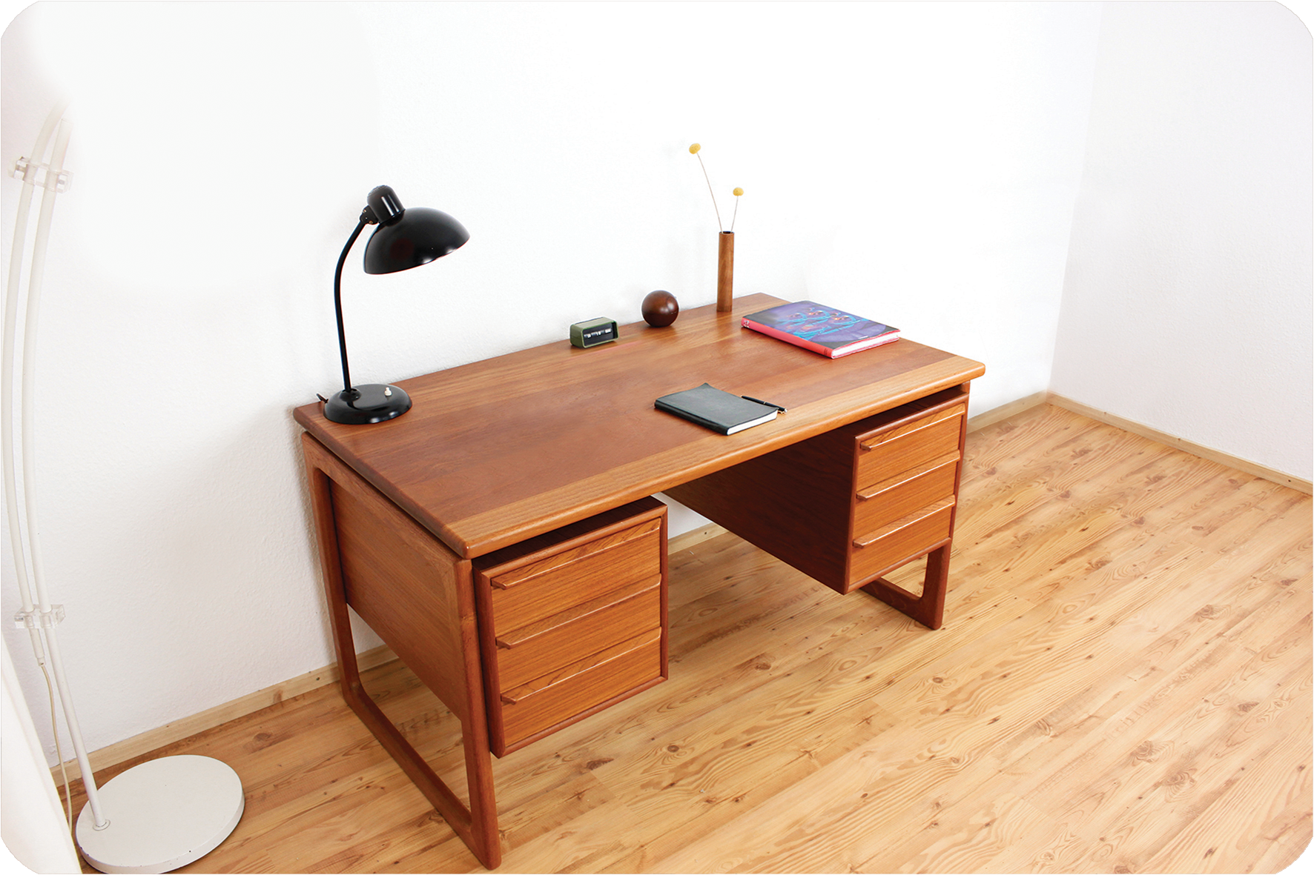
3 |  | 
4 | 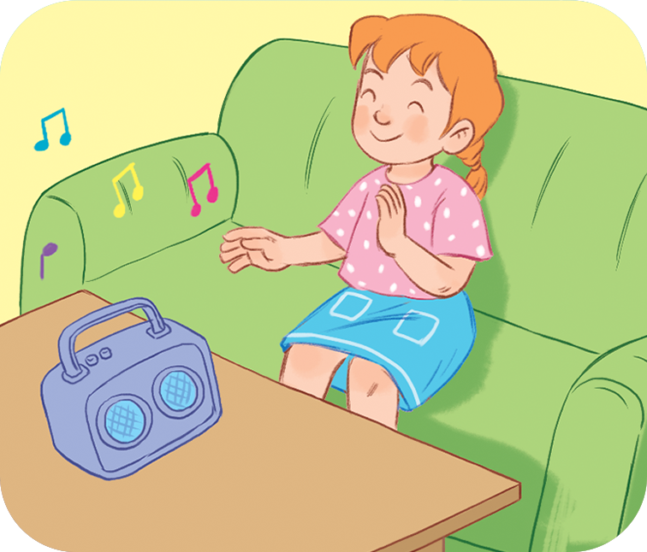 | 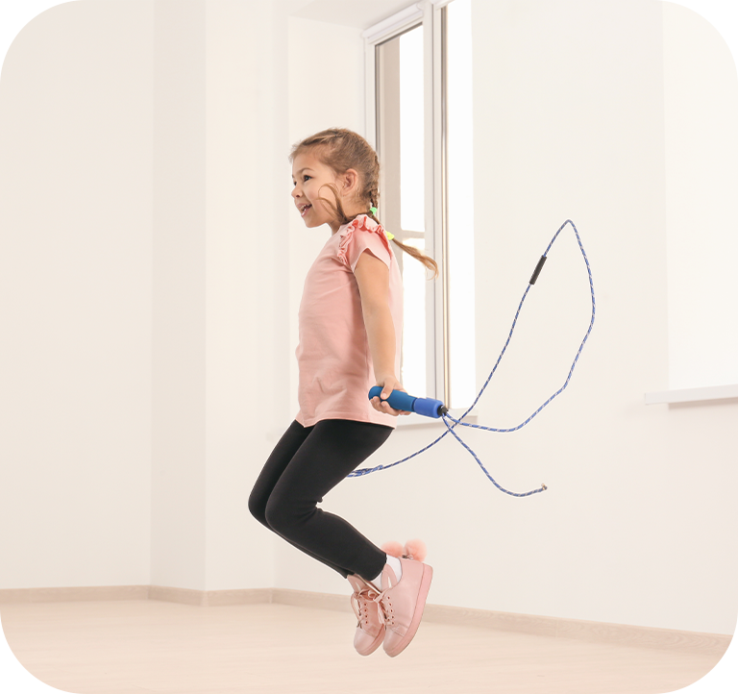

Question 2. Listen and circle .There is one example.
Example:



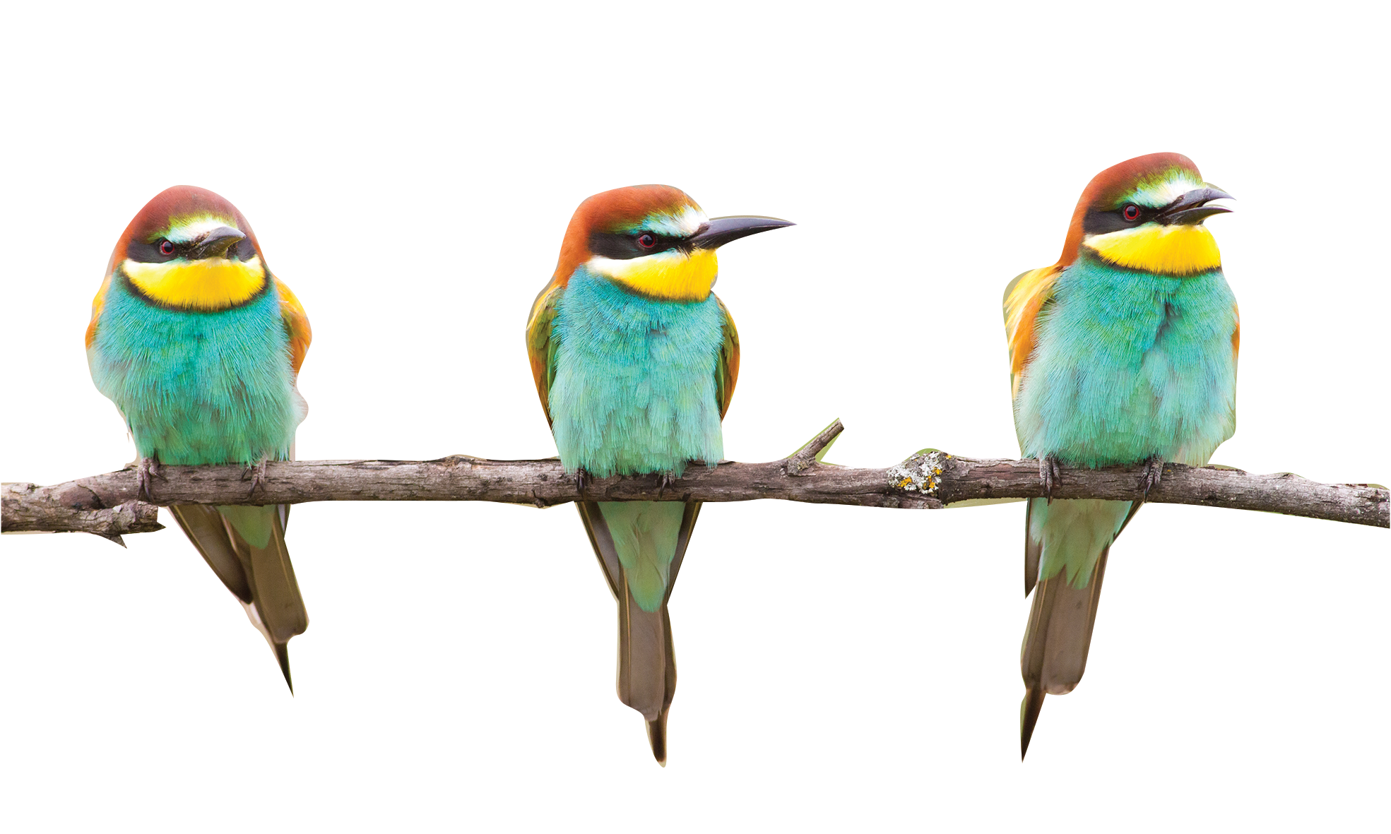



1. 2.

a
b
a
b

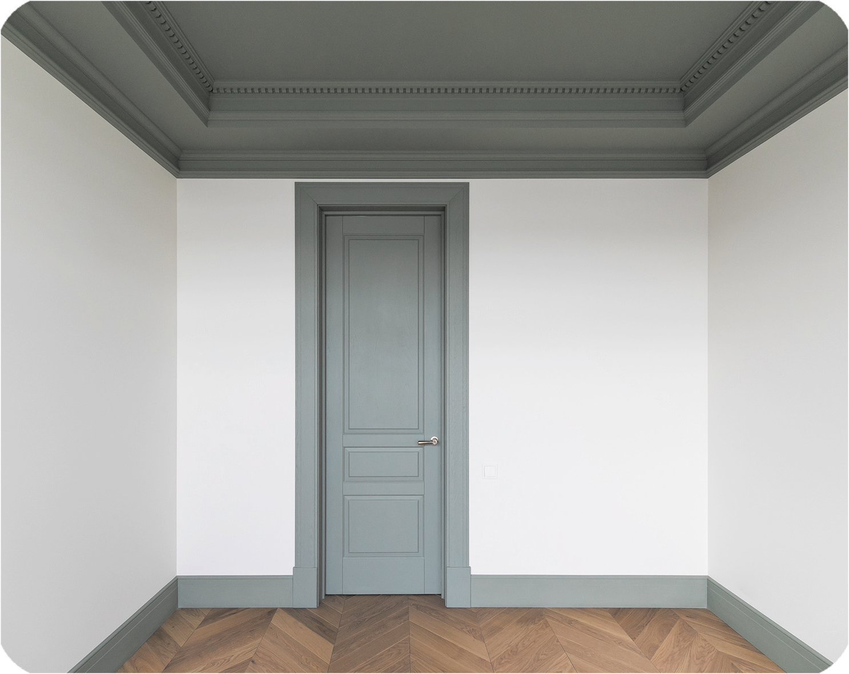
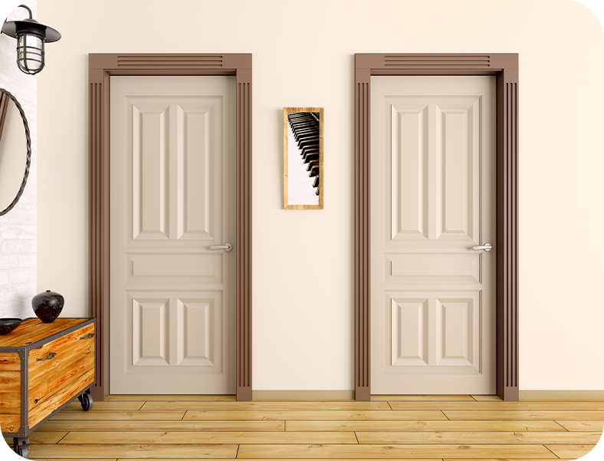


3. 4.

b
a
b
a

Question 3. Listen and number. There is one example.


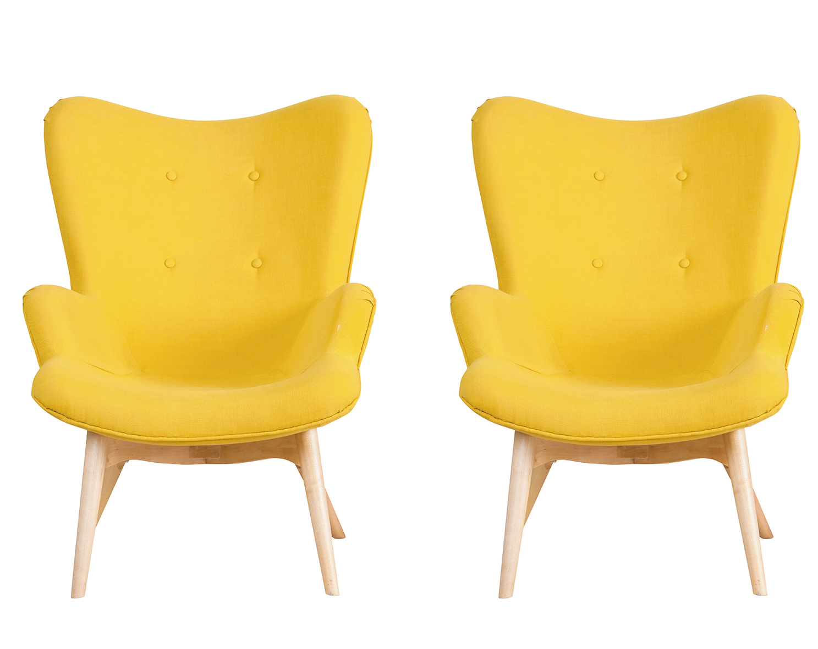



0

Question 4. Listen and write. There is one example.
0. There is a bed in my bedroom. It’s small.
1. She has a ……………………..
2. Do you have any ………………….? No, I don’t.
3. What’s he doing? He’s ……………………...
4. What would you like to drink? I’d like some …………………., please.

PART B. READING AND WRITING
Question 5. Look and read. Put a tick ( ) or cross (X) in the box. There are two examples.
 | 0. Would you like some juice?
 | 0.0. The books are on the chairs. | X
1. Do you have any birds?
Yes, I do.
 | 2. She has two planes.
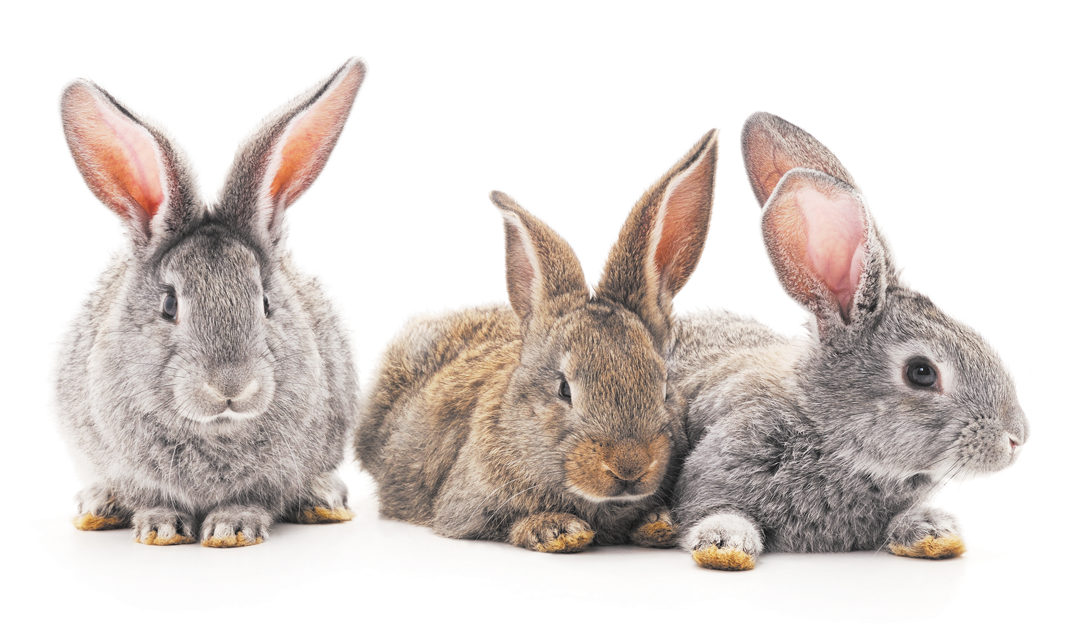 | 3. I have many rabbits.
Question 6. Read and match. There is one example.
0. Is he a teacher? | 0.b | a. It’s there.
1. What are you doing? | 1…. | b. I’d like some rice, please.
2. What would you like to eat? | 2…. | c. I’m drawing.
3. Where’s the kitchen? | 3…. | d. I’d like some beans.
Question 7. Read and tick Yes (Y) or No (N). There is one example.
Hello, my name is Bill. These are my friends. We have many pets. Ben has seven dogs. Lucy has two cats and one parrot. Mai doesn’t have any parrots, but she has many birds. And I have six dogs and some cats. We love pets very much.
 | Yes | No
0. They have many pets.
1. Ben has many dogs.
2. Bill has six dogs and one parrot.
Question 8. Look and unscramble the letters. There is one example.

0.  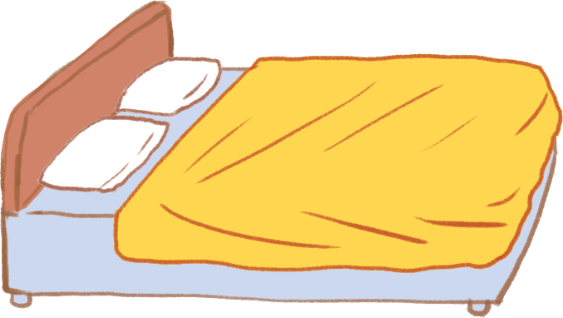 | Example : e d b  bed
1.   | i/i/n/p/s/k/p/g  ………………………
2.  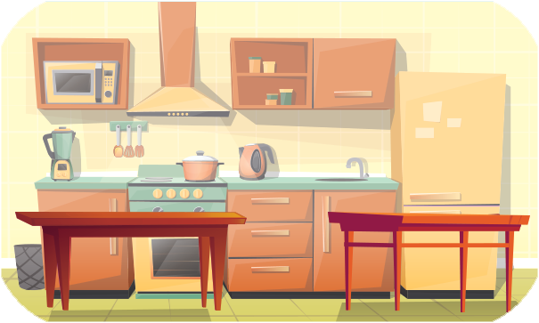 | i/t/k/c/n/h/e  ………………………
3.  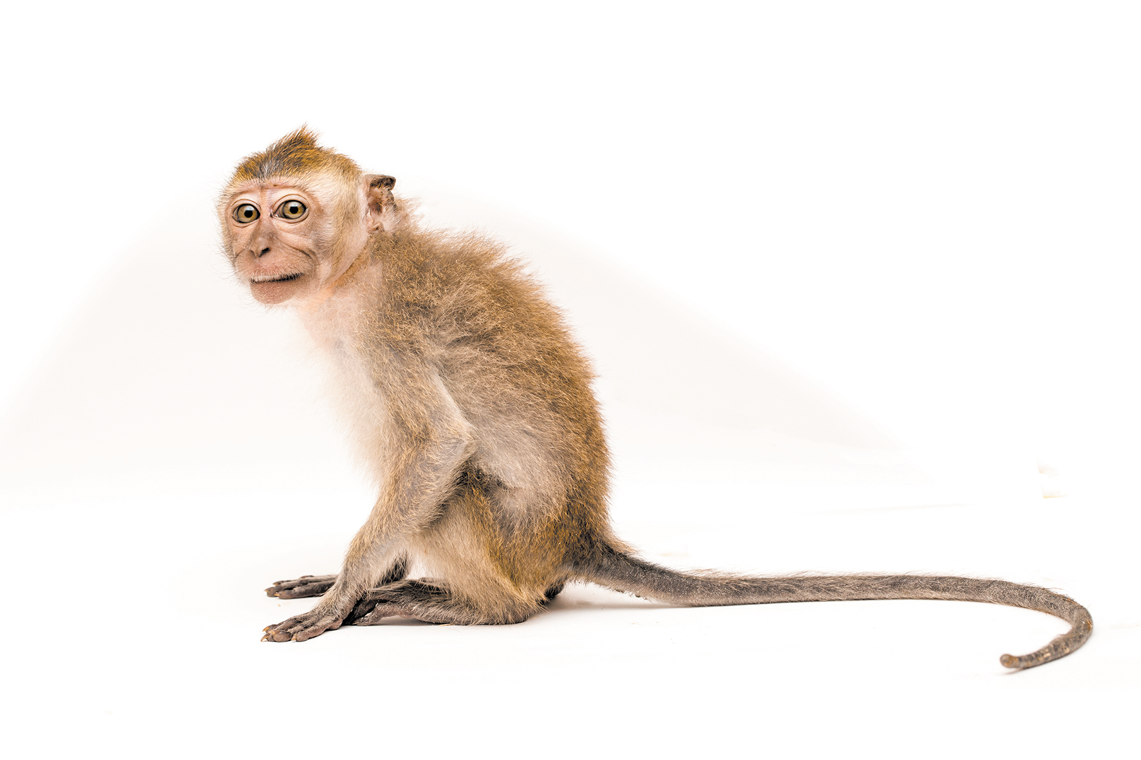 | n/k/e/y/m/o  ………………………

Question 9. Look and write the words. There is one example.
0.   | Example :  I’d like some chicken, please.
1.   | Is she a ……………………?  Yes, she is.
2.  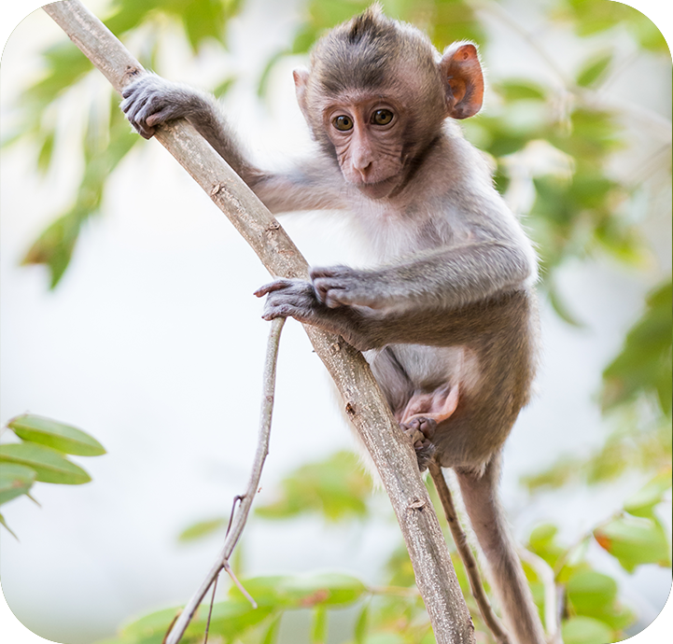  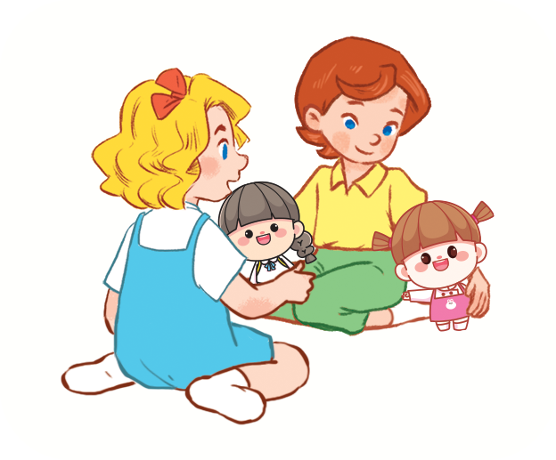 | The monkey is ………………...
3. | Do they have any …………..?  Yes, they do.

Question 10. Put the words in order.
1. chairs/ The/ are/ kitchen/ in /the/.
=> __________________________________
2. you /parrots/ have/ Do/ any/?
=> __________________________________

PART C. SPEAKING . ( 2 pt)

Question 1

Question 2

Question 3

ĐÁP ÁN BÀI KIỂM TRA
LISTENING
Question 1.
1.A 2.A 3.B 4.A
Question 2.
1.B 2.B 3.B 4.A
Question 3
A1. B.3 C..0 D.4. E.2.
Question 4.
A.car B.parrots C.skating D.milk

READING
Question 5
- V 2. V 3. x
Question 6
1.C 2. B 3. A
Question 7
1. YES 2 YES 3. NO
Question 8
- skipping 2. kitchen 3. monkey
Question 9
- farmer 2. Climbing 3.doll
Question 10
- the chairs are in the kitchen
- do you have any parrot?

PART III. SPEAKING
Task 1: Interview(0.75pt)
Teacher gives students three questions related to personal information.
1. Is your father a worker?
2. How many dogs do you have?
3. What are you doing?
Task 2: Point and say.(0.75pt)
Teacher shows two pictures for each question. Student listen and points then say aloud. (There are three questions)
Flashcard 1 | Flashcard 2
 | 
Teacher: She is a singer.
- Student points to flashcard : …………………………..
 | 
Teacher: How many parrots do you have?
Student points to flashcard : …………………………..
Teacher: What’s she doing?
Student points to flashcard : …………………………..
Task 3: Let’s talk.(0.5pt)

Teacher show a picture and some cues. Student uses the cues to talk about the picture.
- Teacher says: Now you have 30 seconds to look at the picture and say aloud.
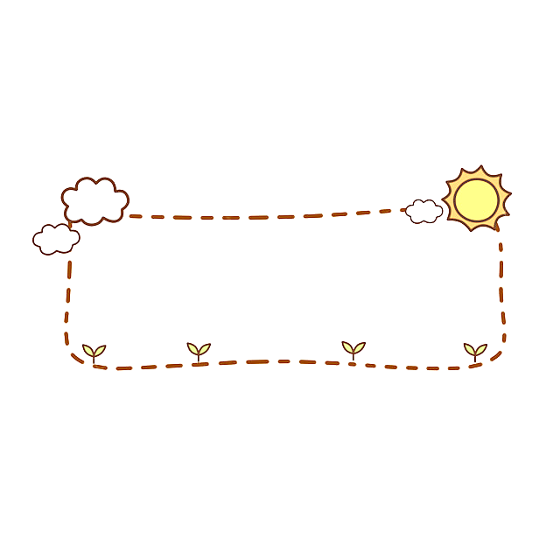

This is my bedroom

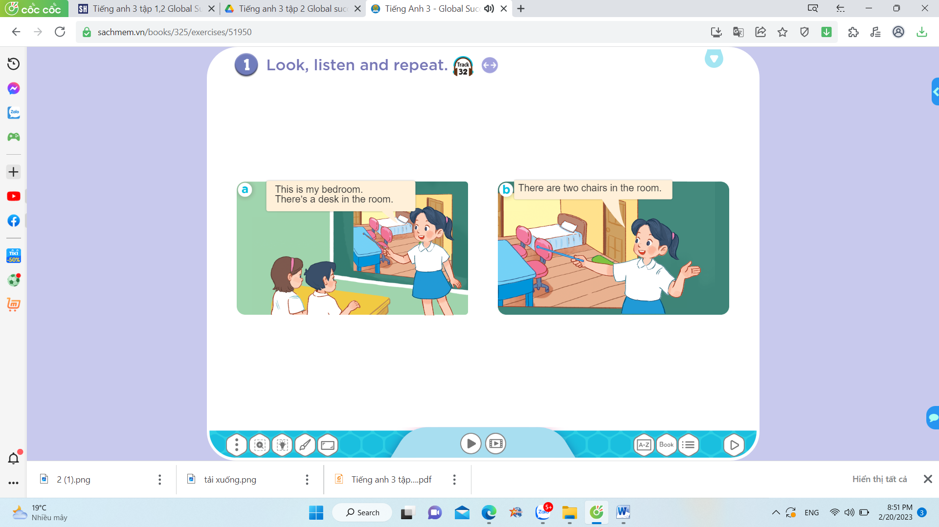

- This/ bedroom
- a bed
- a desk
- two chairs
………

