ĐỀ KIỂM TRA CUỐI KÌ 2 – ĐỀ 5
MÔN: TIẾNG ANH 3 GLOBAL SUCCESS
PART I. LISTENING
1. Listen and tick. (1pt)
1.    a. ❑ |   b. ❑ | 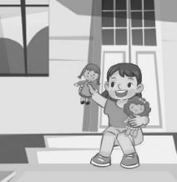  c. ❑
2.    a. ❑ |   b. ❑ |   c. ❑
3.  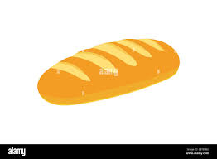  a. ❑ |   b. ❑ |   c. ❑
4.    a. ❑ |   b. ❑ |   c. ❑
Task 2 Listen and number. (1pt)
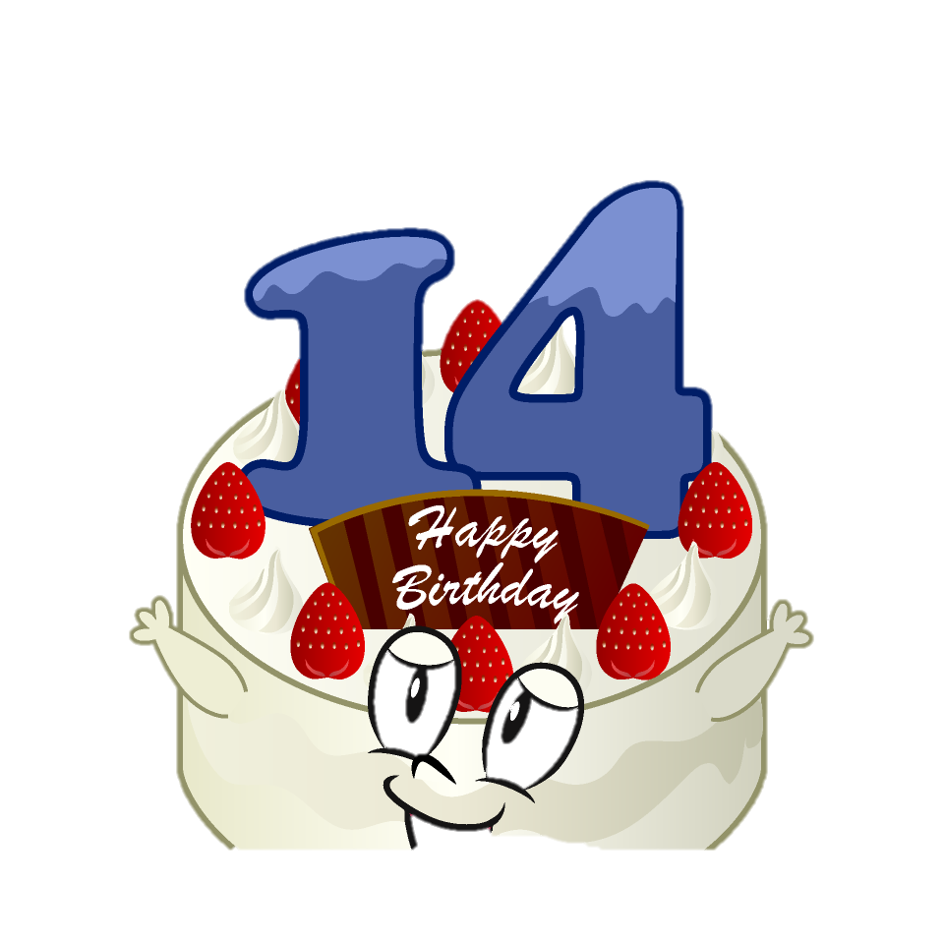




Task 3 Listen and draw lines. (1pt)

1 |  |   a.
2 |  |   b.
3 |  |   c.
4 |  |   d.
Task 4. Listen and tick or cross. (1pt)
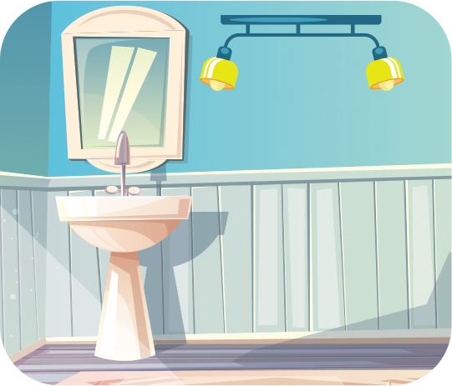
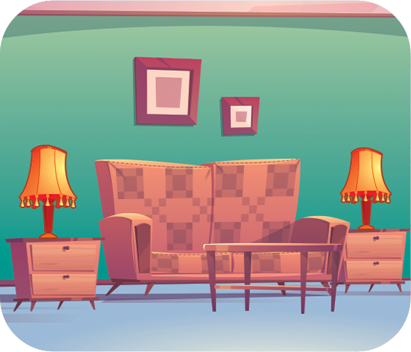

A. B. C. D.

PART II. READING
Task 1: Read and complete the sentences using the words in the box.

My name is Nancy. Here is my (1) ……………….. It is very beautiful. There are two pink(2)……………….near the table. There are three (3)………………………on the desk. I (4)……………..……….. my bedroom very much.

books
lamps
love
bedroom

Task 2. Read and match. (1pt)
1. She has a kite.

a. b. c.

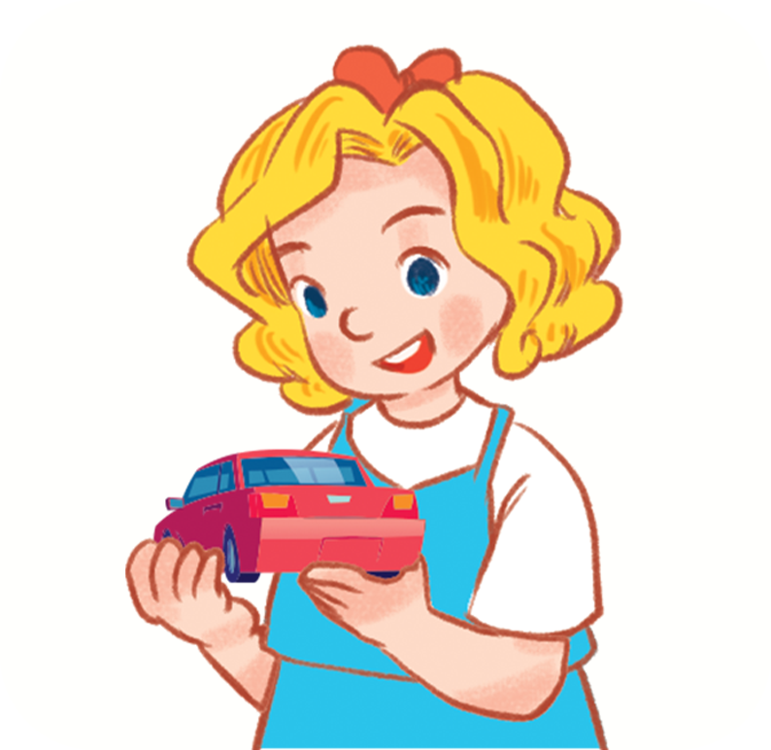
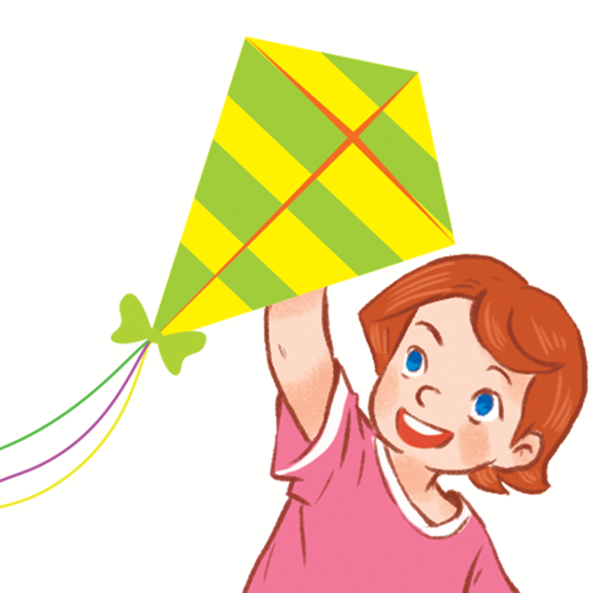

2. I have two parrots.
a. b. c.

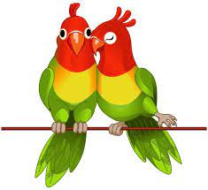


3. She has two planes.
a. b. c.



4. He has two dogs.
a. b. c.
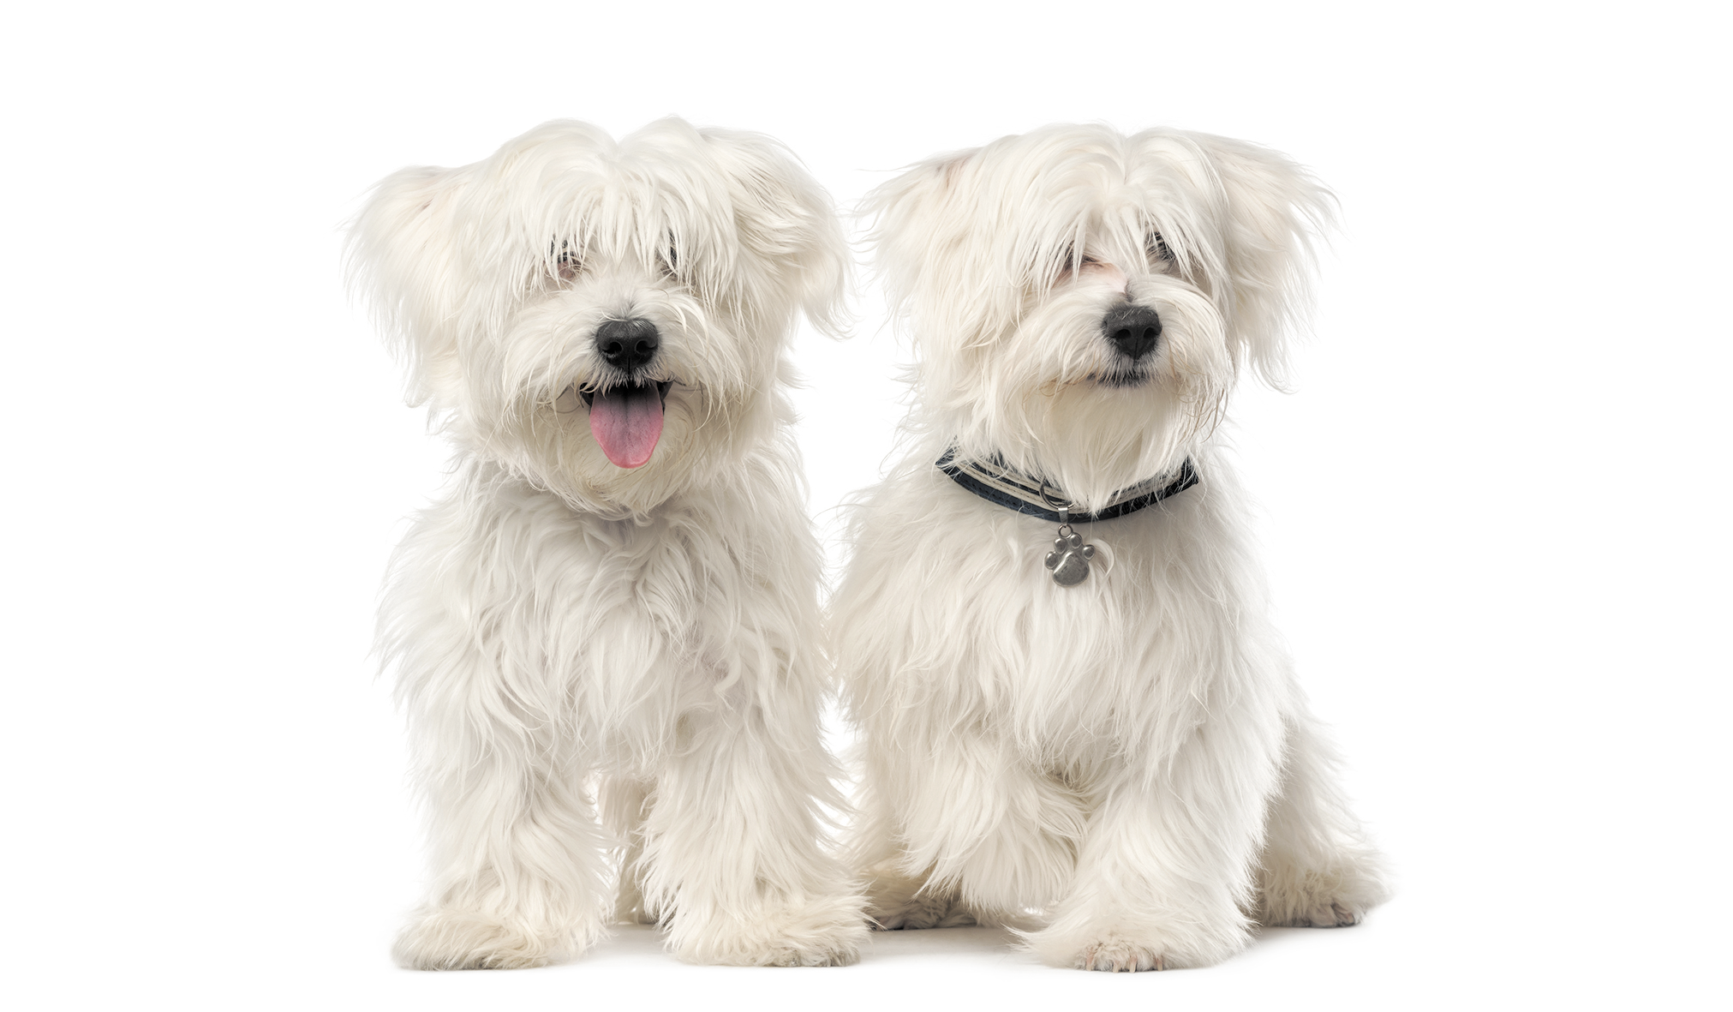
PART III. WRITING

Task 1. Reorder the words to make sentences (1pt)
0. He/ brother/ is with/ playing/ basketball /his/.
=>He is playing basketball with his brother

1. reading/. /I /am/
……………………..…………………………………..……………………..
2. writing/./ I’m /
……………………..…………………………………..……………………..
3. singing /brother/ My/ is/.
……………………..…………………………………..……………………..
4. drawing/ picture/ She/ is /a/.
……………………..…………………………………..……………………..

Task 2. Fill in the blank with the correct answer.(1pt)
 | 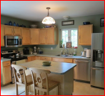
  0.Where’s the kitchen? – It’s here.
1.There __________ two lamps on the table. | 
2. There is a ____________ and a book on the desk. | 
3. There are six____________ near the table. | 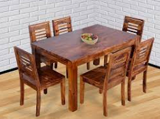
4. There are four ___________ on the table  PART III. SPEAKING . ( 2 pt)  Task 1.  Task 2.  Task 3.  ĐÁP ÁN VÀ BIỂU ĐIỂM  LISTENING  Task 1. (0,25*4 =1pt)  1.a 2.b 3.c 4.b  Task 2. (0,25*4 =1pt)  1.4 2.3 3.1 4.2  Task 3.(0,25*4 =1pt)  1.d 2. a 3. b 4. c  Task 4. (0,25*4 =1pt)  A.bed B.big C.chairs D.small  READING  Task 1 (0,25*4 =1pt)  - Bedroom 2. lamps 3. book 4.are  Task 2 (0,25*4 =1 pts )  a.1 b.4 c.3 d.2  WRITING  Task 1 (0,25*4 =1pts )  1. I’m reading 2. I’m writing 3. My brother is singing  4 . she is drawing picture  Task 2 (0,25*4 =1 pts )  - are  - lamps  - chairs  - books  SPEAKING  Greeting & test taker’s name check.  The examiner says “My name is…It’s nice to talk to you today.”  Task 1: Getting to know each other (0.5 pt)  The examiner asks 3 questions below:  - What’s your name?  - How are you ?  - How old are you?  Task 2: Point at the picture and say the words / sentences(0.5 pt)  The examiner point to the pictures and ask ss some questions.  - What’s he/she doing?  - - Do you have any …?  - Yes, I do. / No, I don’t.What her/his job?  3. - Where’s the …?  - It’s here / there.  4. - What would you like to eat / drink?  - I’d like some …, please.  Task 3: Answer the questions: ( 1pt)  The examiner asks 2 questions below:  - Is your father a farmer?  - Do you have any dogs? | 
  - 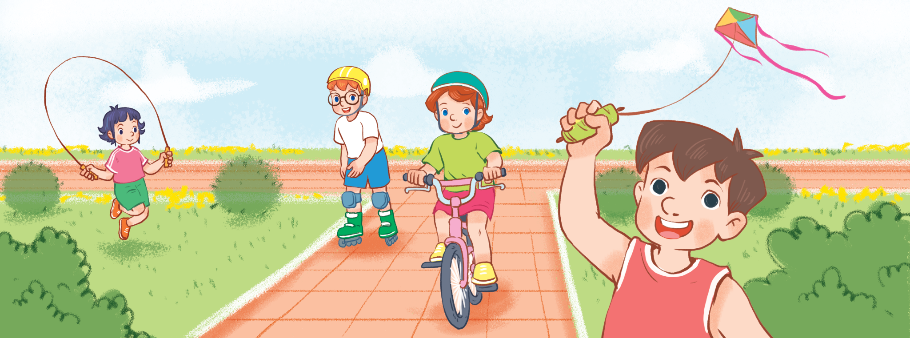 | 2.
  3. 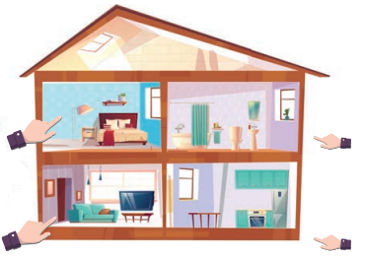 | 4.