ĐỀ KIỂM TRA CUỐI KÌ 2 – ĐỀ 4
MÔN: TIẾNG ANH 3 GLOBAL SUCCESS

PART I. LISTENING
Task 1. Listen and write Y (Yes) or N (No). There is one example.( 1pt)
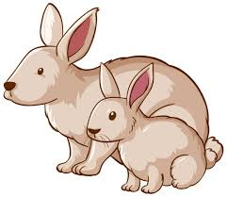  0. |   1.❑ |   2.❑ |   3.❑ |   4.❑

Task 2. Listen and tick. There is one example. ( 1pt)
0. |   a.❑ |   b. |   c.❑
1. |   a.❑ |   b.❑ |   c.❑
2. |   a.❑ |   b.❑ |   c.❑
3. |   a.❑ |   b.❑ |   c.❑
4. |   a.❑ |   b.❑ |   c.❑

Task 4. Listen and circle. There is one example. ( 1pt)

-  B. C.
A
0
C
A 
B
1

A
C

B
2

C
B
A
3

A
C
B
4

Task 4. Listen and write. There is one example. ( 1pt)

- There are two lamps in my bathroom
a. There a…………………………..in my bedroom.
b. The bed in the bedroom is…………….
c. There are two………………. in the bedroom. They are big.
d. The chairs in the bedroom is …………………..
PART II. READING

Task 1: Look, read and put a tick (✔) or cross (🗶). There is one example.
( 1pt)

 0. There are two windows in the room


 | 1. A: Who’s this?   B: It’s my brother
   | 2. A: Where’s the living room?  B: It’s there.
 | 3. There are two windows in the room.
 | 4. A:How many monkeys do you have?  B: I have three monkeys.
Task 2. Look and complete. There is one example. ( 1pt)
parrots
many
and
some
have

0. I have some dogs.
1. How _____________ cats do you have?- I have four.
2. Do you have any _________________? – No, I don’t. I have three birds.
3. I _________ some pets.
4. My brother has a bird ___________ a rabbit.

PART III. WRITING

Task 1. Fill the missing letters. There is one example.(1pt)

- Pl_ying foob_ll
Playing football





- Sk…t…ng
Cy…..l…ng
…..ki….ping
Fl….ing a k…t….

…………………………
…………………………
…………………………
…………………………

Task 2. Put the words in order. There is one example.(1pt)
0. is /A/ monkey/ swinging/.
=>A monkey is swinging

1. elephant /drawing /An /is/.
…………………………………………..
2. at/ the/ her /mother/ Linh /and /are /zoo/.
…………………………………………..
3. see/. /I /can /a/ parrot/
…………………………………………..
4. brother/ my/ has/ a/ car.

PART III. SPEAKING . ( 2 pt)

Task 1.

Task 2.

Task 3.

ĐÁP ÁN VÀ BIỂU ĐIỂM
LISTENING
Task 1. (0,25*4 =1pt)
1.x 2.x 3.v 4.x
Task 2. (0,25*4 =1pt)
1.C 2.C 3.A 4.A
Task 3.(0,25*4 =1pt)
1.B 2. A 3. C 4. A
Task 4. (0,25*4 =1pt)
A.bed B.big C.chairs D.small
READING
Task 1 (0,25*4 =1pt)
- X 2. V 3. V 4.X
Task 2 (0,25*3 =0.75 pts )
1.many 2. Parrots 3. have 4. and
WRITING
Task 1 (0,25*3 =0.75 pts )
1. skating 2 flying a kite 3. skipping 4 . cycling
Task 2 (0,25*3 =0.75 pts )
- An is drawing elephant
- Linh and her mother are at the zoo
- I can see a parrot
- My brother has a car
SPEAKING
Greeting & test taker’s name check.
The examiner says “My name is…It’s nice to talk to you today.”
Task 1: Getting to know each other (0.5 pt)
The examiner asks 3 questions below:
- What’s your name?
- How are you ?
- How old are you?
Task 2: Point at the picture and say the words / sentences(0.5 pt)
The examiner point to the pictures and ask ss some questions.

- How many……. does he/she have?
- What’s he/she doing?
- What can you see?
- What her/his job?
- 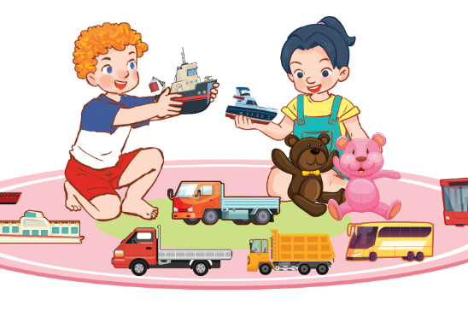 | 2.
3.  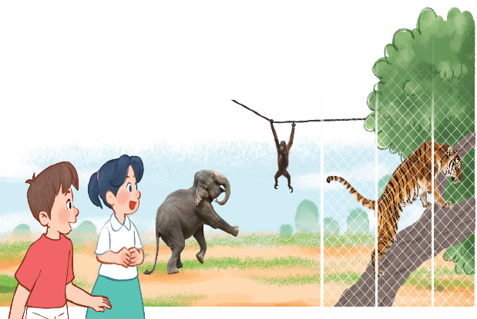 | 4.

Task 3: Answer the questions: ( 1pt)
The examiner asks 2 questions below:
- Is your father a farmer?
- Do you have any cats?

