ĐỀ KIỂM TRA CUỐI KÌ 2 – ĐỀ 3
MÔN: TIẾNG ANH 3 GLOBAL SUCCESS

PART I. LISTENING

Task 1. Listen and tick. There is one example.(1pt)
0. |  |  | 
  A.
  B.
  C.
1. |  |  | 
  A.
  B.
  C.
2. |  |  | 
  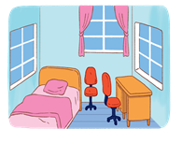
  A. 
  B.
  C.
3. |  |  | 
  
  A .
  B.
  C.
4. |  |  | 
  A.
  
  B.
  C.
Task 2. Listen tick Y (Yes) or N (No). There is one example.(1pt)
0.   | 1   | 2   | 3   | 4  
Y

Task 3. Listen and write. There is one example.(1pt)
1. A: Is…………………….Mary?
B: Yes, it is.
2. A: Look! she is playing ………………………
B: Yes, she is.
3. A: Who’s that?
B: It’s …………………………………
4. A: Look! He is ………………………
B: Yes, he is.
Task 4. Listen and number. There is one example.(1pt)
0.   | A   | B   | C  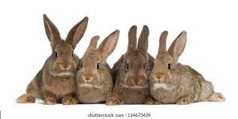 | D  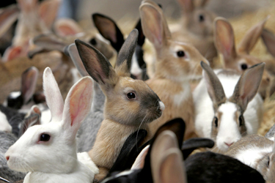
0

PART II. READING

Task 1: Read and complete. There is one example.(1pt)

Phong: (0) Do you have any toys?
Quan: Yes, I do. I have (1)…………cars.
Phong: (2)…………..cars do you have?
Quan: I have five cars. And you?
Phong: I (3)………… have any cars. But I have (4)………………planes.
Quan: Oh! It sounds great.

How many
open

Do
don’t

some
two

Task 2: Look and read. Put a tick or cross in the box. There is one example.(1pt)
  0. My mother is thirty- five.  V |   0. She is twenty years old.  X
  1. Who is this?  It’s my father. |   2. How are you , Mai?  I’m five years old.
  3. This is my family. |   4. He is nineteen years old.

PART III. WRITING

Task 1. Fill in the blank with the correct answer. There is one example.(1pt)
 | 
  - Is he a worker?
  -No, he isn’t
- This is my mother.  She is a_________________. | 
2. What’s her ______________ ?  She is a teacher. | 
3.My mother is a doctor and my father is a ______________. | 
4. Is he a driver?  No, he isn’t. He’s a ________________. | 
Task 2. Fill in the blank with the correct letter. There is one example.(1pt)

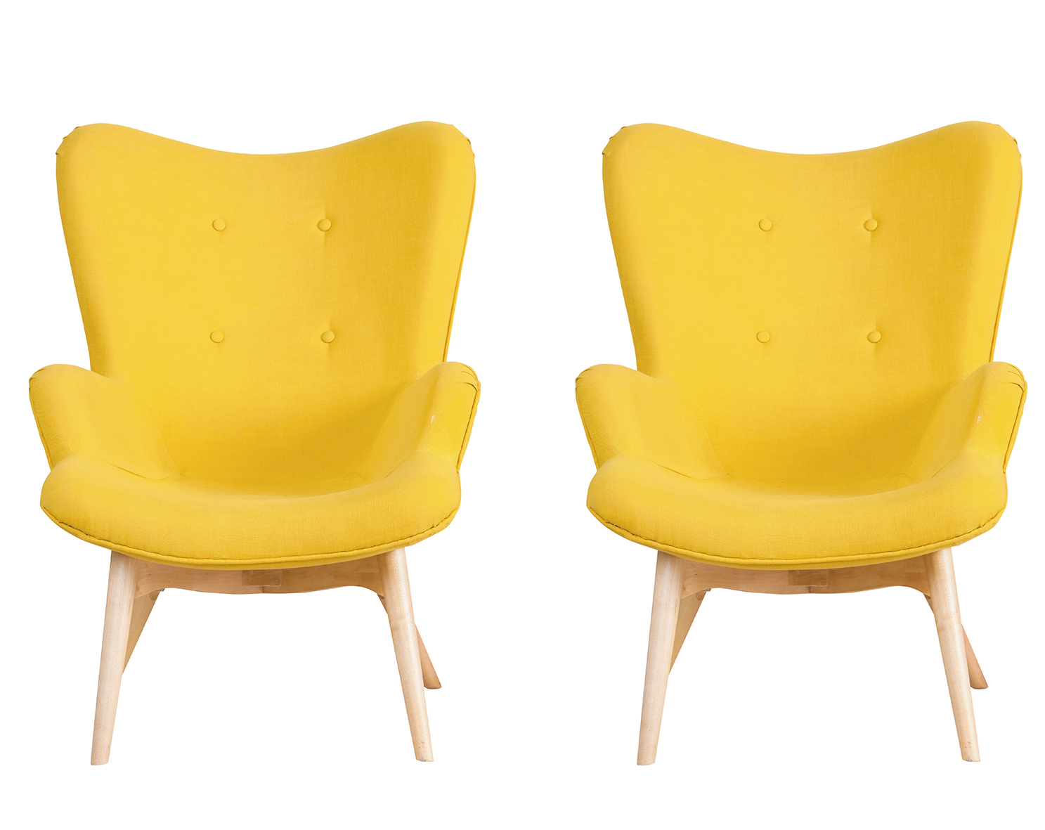
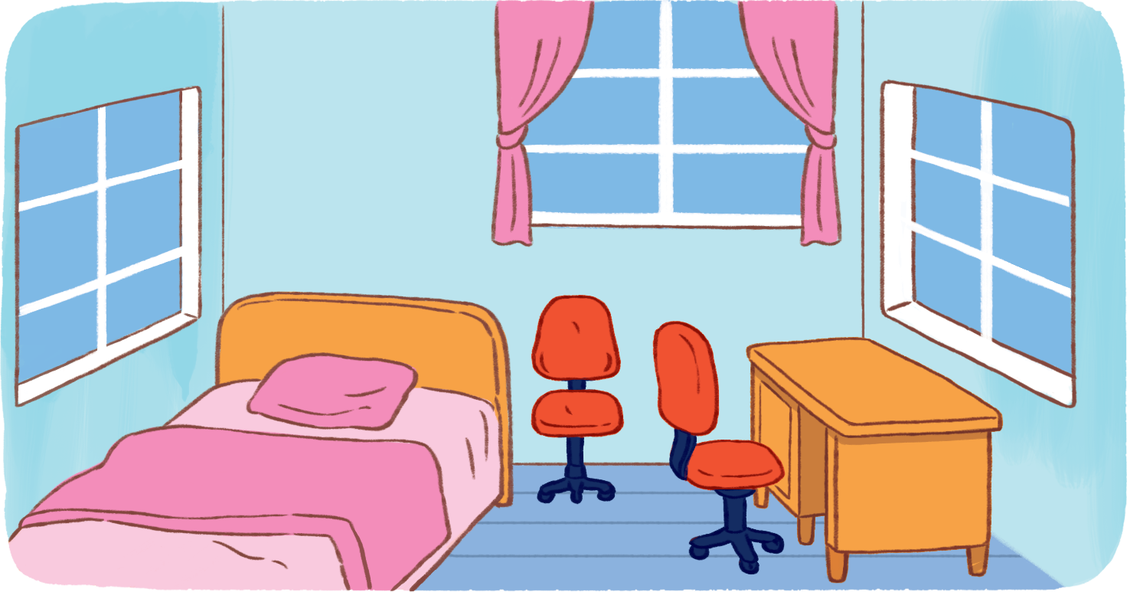


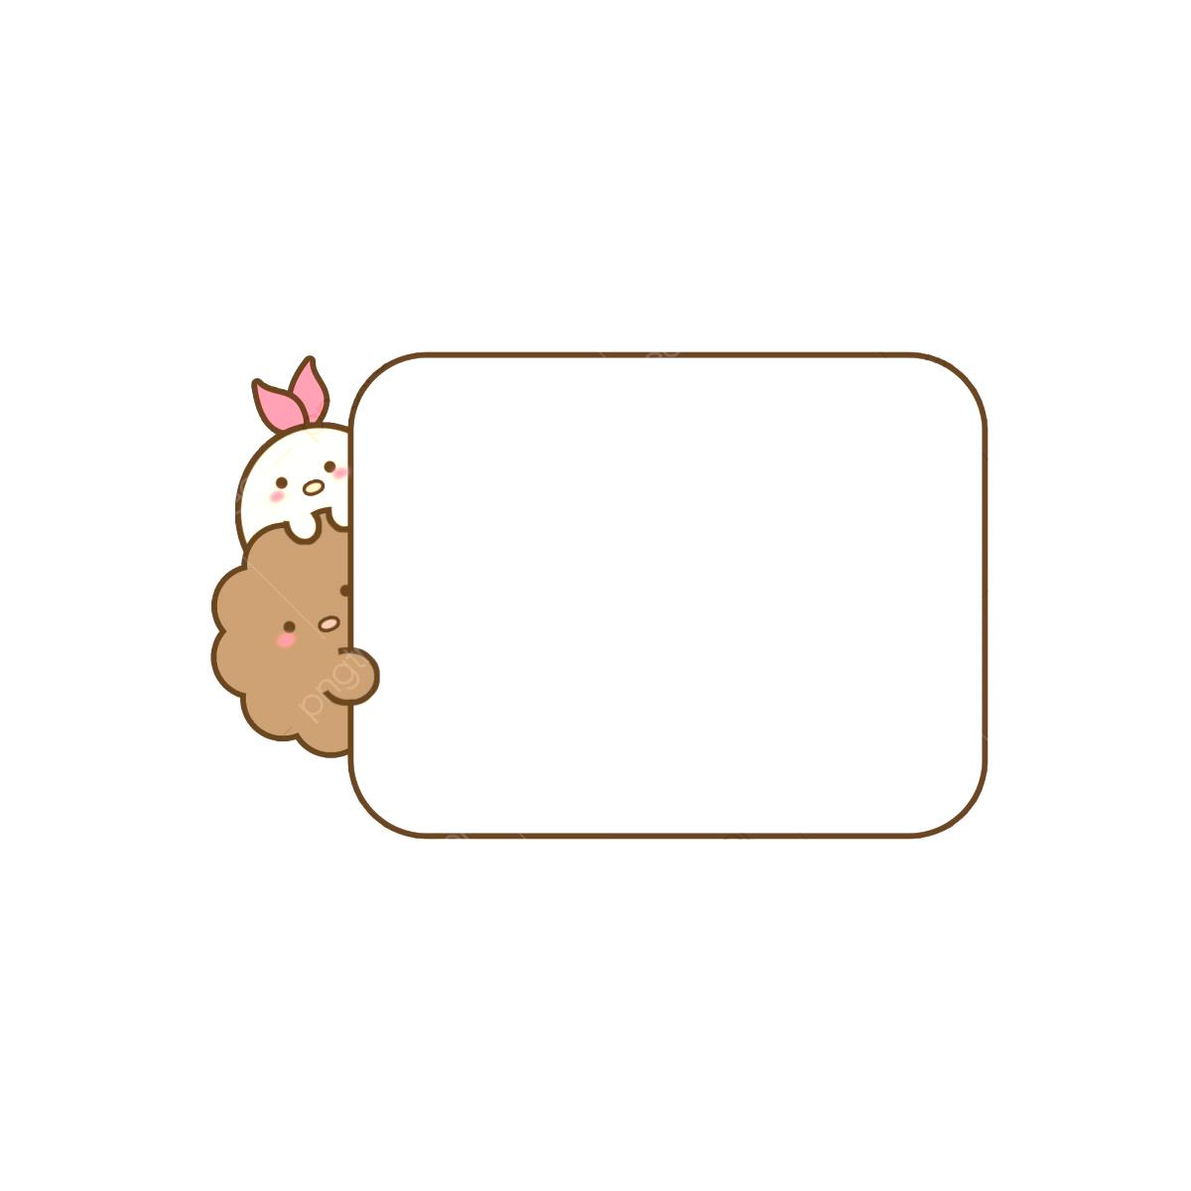
4. b _ _
3. ch_ i _ s
2. _o_ rs
1. ro_ m

PART III. SPEAKING . ( 2 pt)

Task 1.

Task 2.

Task 3.

ĐÁP ÁN VÀ BIỂU ĐIỂM
LISTENING
Task 1. (0,25*4 =1pt)
1.A 2.A 3.B 4.C
Task 2. (0,25*4 =1pt)
1.Y 2.Y 3.N 4.Y
Task 3.(0,25*4 =1pt)
1.That 2.badminton 3.Nam 4.running
Task 4. (0,25*4 =1pt)
A.4 B.3 C.2 D.1
READING
Task 1 (0,25*4 =1pt)
- Two 2. How many 3. Don’t 4.some
Task 2 (0,25*3 =0.75 pts )
1.v 2. X 3. V 4. X
WRITING
Task 1 (0,25*3 =0.75 pts )
1. singer 2 job 3. Farmer 4 . cook
Task 2 (0,25*3 =0.75 pts )
- Room 2. Doors 3. Chairs 4. bed
SPEAKING
Greeting & test taker’s name check.
The examiner says “My name is…It’s nice to talk to you today.”
Task 1: Getting to know each other (0.5 pt)
The examiner asks 3 questions below:
- What’s your name?
- How are you ?
- How old are you?
Task 2: Point at the picture and say the words / sentences(0.5 pt)
The examiner point to the pictures and ask ss some qu estions.

- Where is the table?
- How old is your father?
- What’s he doing?
- What would you like to eat / drink?
- 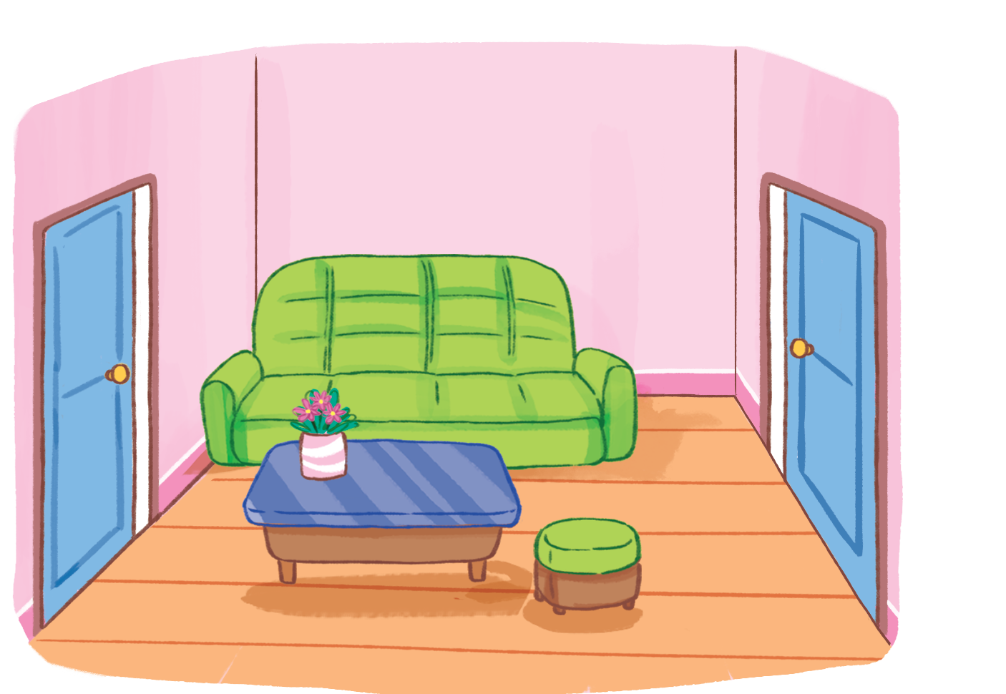 | 2.
3.  | 4.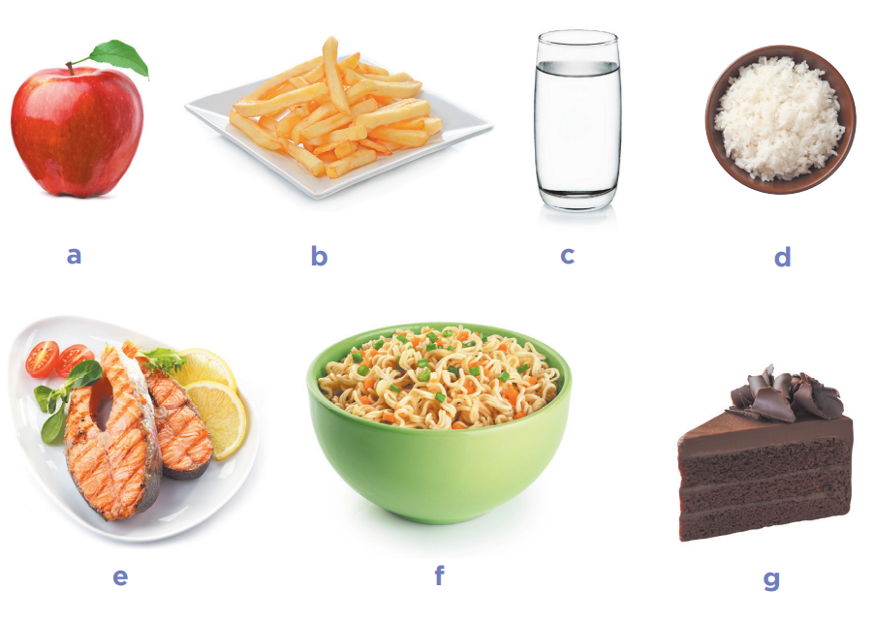

Task 3: Answer the questions: ( 1pt)
The examiner asks 2 questions below:
- Do you have a…….?
- Would you like some …?

