Week 17 Preparing date: December …..,
Period 65 Teaching date: December …..,

Unit 10: Break time activities
Lesson 2 (4, 5, 6)
A. OBJECTIVES:
By the end of the lesson, Ss will be able to:
1. Knowledge:
- listen to and understand four comunicative context in which Ss ask and answer question about school break time activities
- read and match four target sentences with four pictures
- practice the target language by playing Miming game.
- Vocabulary: Review
- Skills: speaking, listening, reading and writing.
2. Competences:
- Critical Thinking: look, complete and read
- Co-operation: ready to help friends in pair work/ group work.
- Self-control and independent learning: perform listening tasks.
3. Attitude/ Qualities:
- Kindness: Help partners to complete learning tasks.
- Honesty: tell the truth about feelings and emotions.
- Diligence: complete learning tasks.
B. TEACHING AIDS:
- Teacher: Teacher’s guide Pages 128, 129; audio Tracks 103; website sachmem.vn, posters, laptop, pictures, textbook, lesson plan, TV or projector.
- Students: Pupil’s book Page 71, notebooks, workbooks, school things.
C. PROCEDURES:
Stages/Time | Teacher’s activities | Students’ activities
1.Warm- up:  (5’)  2.Practice: (27’)  3. Homework. (3’) | Game: Who says fast?  *Aims: to create a friendly and active atmosphere in the class to beginning the lesson.  *Procedure:  - Hold a school break time activities card, then reveal it slowly.  - Ask What do you do at break time?  - Ask the Ss guess the answer as fast as possible.  - Then have Ss do the same with the rest.  - This can be played in groups to make it more interesting.  - Say “Open your book page 72” and look at “Unit 10, Lesson 2 (4,5,6)”.  Activity 1. Listen and number:  *Aims: Ss will be able to listen to and understand four comunicative context in which Ss ask and answer question about school break time activities.  *Procedure:  - Elicit the action of the character in each picture.  + Who are they?  + What are they doing?  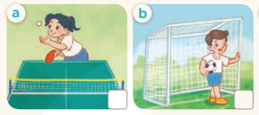  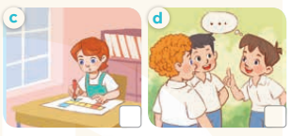  - T ask Ss to guess the answers.  + T writes Ss’guessing on the board.  - Listen to the tape:  + Play the recording  + Play the recording again and get Ss to swap books with their partners.  + Play the recording again to check answers together as a class.  + Write the answers on the board for Ss to correct their answers. Then checks Ss’ guessing.  - Play the recording, sentence by sentence, for the class to listen and repeat in chorus.  Key: 1. b 2. a 3. d 4. c  Activity 2. Read and match  *Aims: Ss will be able to read and match four target sentences with four pictures  *Procedure:  - Get Ss to look at the pictures and elicit the characteres’ actions.  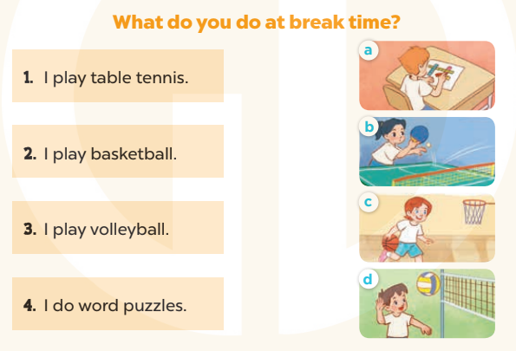  - Have Ss look at the first sentence and the pictures. Elicit and model with number 1: I play table tennis  + Ask Ss read and find the correct picture on the right to match.  + When Ss answer picture b, tell Ss draw a line to match the sentence and the picture  -Have Ss work in pairs and match the sentences 2, 3, 4.  - Ask a few Ss to stand up and read the sentences aloud.  -T gives feedbacks.  Key:  1. b 2. c 3. d 4. a  Activity 3. Let’s play  *Aims: Ss will be able to practice the target language by playing Miming game.  *Procedure:  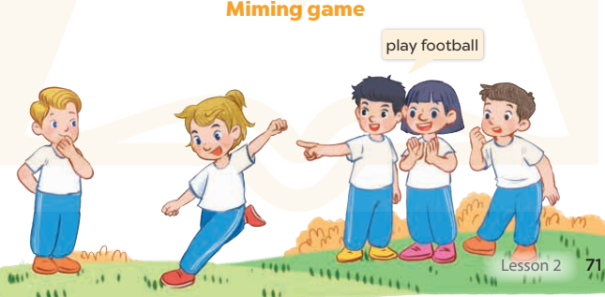  -Elicit the language that Ss need to talk about break time activities (play football, play chess, play volleyball, do word puzzles, chat with friends, play tble tennis…)  -Explain how the game is played:  +One Ss mimes the action of doing an activity.  +Other Ss look at him/ her, guess the action and what it is, ex: play football.  -Model the game with two Ss  -Divide class into four groups, each group, choose a pupil to do the actions while the resr guesses the words.  +Ss get one point for each correct answer.  -The group with most point wins  *Consolidation  *Aims: Ss will be able consolidate and wrap up the content of the lesson.  *Procedure:  - T asks ss to answer the following questions:  + What have you learnt from the lesson today?  +What are the core values of the lesson? (if the teacher can take from the lesson).  - T praises some Ss who are hardworking / active/ good…. as well as encourage others to try more.  - Practice part 5 again.  - Prepare the new lesson: Unit 10, Lesson 3 (1,2,3). | - Ss listen  - Ss play game  -Ss play game  - Ss open their books  -Look at the pictures and say:  + Picture a: a girl play table tennis  + Picture b: a boy playing football  + Picture c: a girl doing word puzzle  + Picture d: a boy chatting with his friends  -Ss guess the answers  - Ss listen to the tape and write  - Ss listen again, write and swap books with their partners.  - Ss check their answers and guessing  -Ss listen and repeat.  -Ss look at the picture and say  -Ss look and answer  -Ss read  -Ss answer and match  -Ss work in pairs and match  -Ss read aloud  -Ss listen and answer  -Ss listen  - Ss look and guess  -Ss model with the teacher  - Ss play game  -Ss answer the questions  -Ss listen and clap their hands  -Ss listen and take note
D. ADJUSTMENTS (if necessary):
………………………………………………………………………………………….…..……………………………………………………………………………...………………………………………….…..……………………………………………………………………………….……………………………………………………………………...

Week 17 Preparing date: December …..,
Period 66 Teaching date: December …..,

Unit 10: Break time activities
Lesson 3 (1, 2, 3)
A. OBJECTIVES:
By the end of the lesson, Ss will be able to:
1. Knowledge:
- correctly repeat the sounds of the letter f and letter v in isolation, in the words football and volleyball, and in the sentences I play football at break time. and I play volleyball at break time. with correct pronunciation and intonation.
- identify the target words football and volleyball while listening.
- say the chant with the correct rhythm and pronunciation.
- Vocabulary: Review
- Skills: speaking, listening, reading and writing.
2. Competences:
- Co-operation: ready to help friends in pair work/ group work.
- Sociability: Talk to each other, say good words to others.
3. Attitude/ Qualities:
- Kindness: Help partners to complete learning tasks.
- Honesty: tell the truth about feelings and emotions
B. TEACHING AIDS:
- Teacher: Teacher’s guide Pages 130, 131; audio Tracks 104, 105, 106; website sachmem.vn, posters, laptop, pictures, textbook, lesson plan, TV or projector.
- Students: Pupil’s book Page 72, notebooks, workbooks, school things.
C. PROCEDURES:
Stages/Time | Teacher’s activities | Students’ activities
1.Warm- up:  (5’)  2. Presentation  (9’)  3.Practice: (19’)  4. Homework. (2’) | Game: Find and circle the words  *Aims: to create a friendly and active atmosphere in the class to beginning the lesson.  *Procedure:  *Procedure:  - Divide class into 2 groups  - Ask Ss to find and circle the words that they learnt.  - Which groups find the best correct words is winner.  - Give Ss time to play the game.  Rows: foot  Columns: football, volleyball, chess  -T checks who’s winner?  - Say “Open your book page 72” and look at “Unit 10, Lesson 3 (1,2,3)”.  Activity 1. Listen and repeat:  *Aims: Ss will be able to correctly repeat the sounds of the letter f and letter v in isolation, in the words football and volleyball, and in the sentences I play football at break time. and I play volleyball at break time. with correct pronunciation and intonation.  *Procedure:  - T gives instruction to the letter f and v, football and volleyball, and in the sentences I play football at break time. and I play volleyball at break time.  - Play the recording for the letter f, v.  - Encourage Ss to point at the letter/ word/ sentence while listening.  - Play the recording again and encourage Ss to listen and repeat.  - Do this several times until Ss feel confident.  - T calls some Ss to practice.  - T gives feedbacks.  Activity 2. Listen and circle.  *Aims: Ss will be able to identify the target words football and volleyball while listening.  *Procedure:  - Elicit the sentences and the gap-fill options.  - T ask Ss to guess the answers.  + T writes Ss’guessing on the board.  - Listen to the tape:  + Play the recording  + Play the recording again and get Ss to swap books with their partners.  + Play the recording again to check answers together as a class.  + Write the answers on the board for Ss to correct their answers. Then checks Ss’ guessing.  - Play the recording, sentence by sentence, for the class to listen and repeat in chorus.  - Invite one or two Ss to stand up and read the completed sentences.  Key: 1.a 2.b  Activity 3. Let’s chant  *Aims: Ss will be able to say the chant with the correct rhythm and pronunciation  *Procedure:  - Introduce the title and lyrics of the chant.  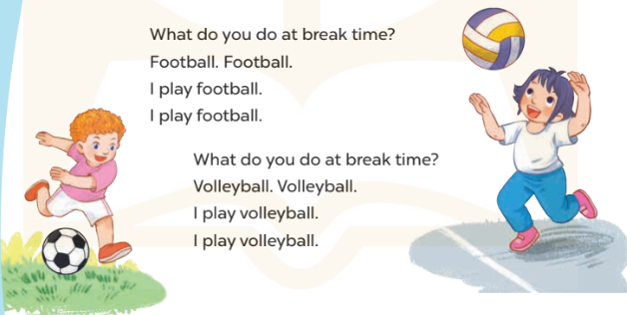  - Play the recording for Ss to listen to the whole chant.  + Have them repeat the title and lyrics line by line.  + Ask Ss to attend to the sounds of the letters f and v and the words football and volleyball.  - Play the recording all the way through for Ss to listen to pronunciation and melody.  - Play the recording line by line for Ss to listen and repeat  - Play the recording for Ss to chant and clap along.  - Ask Ss to practice chant and clap along in pairs or groups.  - Invite groups to the front of the classroom to perform the chant  -T gives feedback.  *Consolidation  *Aims: Ss will be able consolidate and wrap up the content of the lesson.  *Procedure:  - T asks ss to answer the following questions:  + What have you learnt from the lesson today?  +What are the core values of the lesson? (if the teacher can take from the lesson).  - T praises some Ss who are hardworking / active/ good…. as well as encourage others to try more.  - Practice the chant more.  - Prepare the new lesson: Unit 10, Lesson 3 (4, 5, 6). | - Ss listen  -Ss play game  - Ss open their books  - Ss recognize the differences about color of letter  - - Ss listen  - Ss listen and point  - Ss listen again and repeat  -Ss listen again and repeat  -Ss practice  -Ss listen  -Ss listen and say:  + Number 1: I play .…….  + Number 2: I play……  -Ss guess the answers  - Ss listen to the tape and circle  - Ss listen again, circle and swap books with their partners.  - Ss check their answers and guessing  -Ss listen and repeat.  -Ss read the sentences  - Ss look and listen.  -Ss listen to the chant  - Ss listen and repeat line by line without clap their hands  -Ss note the sounds, words  -Ss listen to melody of the chant  - Ss listen and chant line by line.  - Ss chant and clap along.  - Ss work in groups (two groups) to chant  -Ss perform in front of the class.  -Ss listen  -Ss listen.  -Ss answer the questions  -Ss listen and clap their hands  -Ss listen and take note
  F | M | V | C | E | P | S | V | B | T
  O | C | T | H | N | E | B | O | B | H
  O | L | U | E | A | V | X | L | O | I
  T | E | L | S | N | N | T | L | X | N
  B | B | S | S | M | K | K | E | V | K
  A | C | D | K | O | K | K | Y | E | B
  L | R | O | E | E | C | V | B | A | H
  L | H | B | B | W | W | N | A | A | Y
  D | F | O | O | T | S | O | L | S | M
  V | O | B | L | Y | Y | Z | L | W

D. ADJUSTMENTS (if necessary):
………………………………………………………………………………………….…..……………………………………………………………………………...………………………………………….…..……………………………………………………………………………….……………………………………………………………………...

Week 17 Preparing date: December …..,
Period 67 Teaching date: December …..,

Unit 10: Break time activities
Lesson 3 (4, 5, 6)
A. OBJECTIVES:
By the end of the lesson, Ss will be able to:
1. Knowledge:
- read the exchange and tick the correct boxes in the table bout Mary’s, Lucy’s, Bill’s and Minh’s break time activities
- use the target language in a real context by completing a gapped text about their school break time activities
- revise the target by asking and answering questions about school break time activities and talking about them to the class.
- Vocabulary: Review
- Skills: speaking, listening, reading and writing.
2. Competences:
- Written communication: write about the colours of school things
- Critical thinking: complete a task in reading a text.
- Co-operation: ready to help friends in pair work/ group work.
- Self-control and independent learning: perform listening tasks.
3. Attitude/ Qualities:
- Kindness: Help partners to complete learning tasks.
- Honesty: tell the truth about feelings and emotions.
- Diligence: complete learning tasks.
B. TEACHING AIDS:
- Teacher: Teacher’s guide Pages 132 133; website sachmem.vn, posters, laptop, pictures, textbook, lesson plan, TV or projector.
- Students: Pupil’s book Page 73, notebooks, workbooks, school things.
C. PROCEDURES:
Stages/Time | Teacher’s activities | Students’ activities
1.Warm- up:  (5’)  2.Practice: (8’)  3.Production: (19’)  4. Homework. (3’) | Game: “Chant”  *Aims: to review the vocabulary and structure about greet and respond to greetings.  *Procedure:  - Ask Ss chant and do the actions in Unit 10 , Lesson 3 page 66 in groups.  - Give point for the groups and encourage them.  - Say “Open your book page 67” and look at “Unit 10, Lesson 3 (4, 5, 6)”.  Activity 1. Read and tick:  *Aims: Ss will be able to read the exchange and tick the correct boxes in the table bout Mary’s, Lucy’s, Bill’s and Minh’s break time activities  *Procedure:  - Explain how to complete the task: read the dialogue and tick the correct break time activities in the table.  - Ask Ss to read the list of the break time activities in the first column of the table.  - Ask Ss look at the name on the right side of the table.  - Ask Ss read the text and tick the correct activities  - Let Ss swap and check answers.  - Check the answers  - Ask some Ss to read the text aloud.  Key:  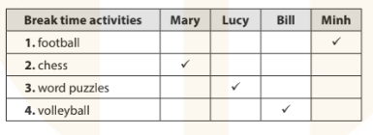  Activity 2. Let’s write  *Aims: Ss will be able to use the target language in a real context by completing a gapped text about their school break time activities  *Procedure:  - Check comprehension and elicit to Ss read the gapped text and fill in the gaps.  - Let Ss read the gapped text and fill in the gaps.  - Have Ss complete the first gap together as an example: I am in the school …….  - Ask Ss to look at the gap and ask them what is missing. Then let them identify the playground. After that, let them write down the suitable word in the gap.  - Give Ss time to complete the text independently.  - In pairs or groups, ask Ss to swap their complete texts before checking as a class.  - Invite some Ss to come to the board and read the answer.  Key: Pupils’ answer  Activity 3. Project.  *Aims: Ss will be able to revise the target by asking and answering questions about school break time activities and talking about them to the class.  *Procedure:  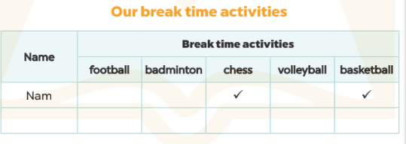  - Elicit the language needed to do the task: What do yo do at break time? –I…………..Write it on the board.  - Model with one Ss, asking: What do you do at break time? And the Ss answer: I play football. Put a tick in the column football in the table.  - Ask Ss to work in groups of six.  - Invite some Ss to report on their work using the language leanrt.  - Have Ss tick their notes on the walls of the classroom as a display.  *Consolidation  *Aims: Ss will be able consolidate and wrap up the content of the lesson.  *Procedure:  - T asks ss to answer the following questions:  + What have you learnt from the lesson today?  +What are the core values of the lesson? (if the teacher can take from the lesson).  - T praises some Ss who are hardworking / active/ good…. as well as encourage others to try more.  - Prepare the new lesson: Review 2 (1, 2, 3). | - Ss listen and chant  - Ss open their books  -Ss read and answer  -Ss listen and read  -Ss listen  -Ss read and tick  -Ss swap their answers  -Ss check their answer  -Ss read aloud  -Ss listen and read  -Ss read in chorus  -Ss write  -Ss do the task  It’s break time. I am in the school……..…I play……….…..  I like playing………….  -Ss swap the book and check  -Ss listen and repeat  - Ss listen and answer  -Ss answer  -Ss work in groups  -Ss report  -Ss tick on the wall  -Ss answer the questions  -Ss listen and clap their hands  -Ss listen and take note
D. ADJUSTMENTS (if necessary):
………………………………………………………………………………………….…..……………………………………………………………………………...…………

Week 17 Preparing date: December …..,
Period 68 Teaching date: December …..,
Review 2
Parts 1, 2
A. OBJECTIVES:
By the end of the lesson, Ss will be able to:
1. Knowledge:
- correctly use the following sentence patterns:
correctly use the following sentence patterns:
+ Is this our ………..? – Yes, it is. / No, it isn’t.
+ Let’s go to the………….. – OK, let’s go.
+…………. , please.
+ May I…………..? − Yes, you can. / No, you can’t.
+ I have………..
+ Do you have………….? − Yes, I do. / No, I don’t.
+ What colour is it? − It’s……………..
+ What colour are they? − They’re ……………..
+ I………….. at break time.
+ What do you do at break t time? − I ………….
- Vocabulary: Review
- Skills: speaking, listening, reading and writing.
2. Competences:
- Critical Thinking: self-introduce
- Co-operation: ready to help friends in pair work/ group work.
- Self-control and independent learning: perform listening tasks.
3. Attitude/ Qualities:
- Kindness: Help partners to complete learning tasks.
- Honesty: tell the truth about feelings and emotions.
- Diligence: complete learning tasks.
B. TEACHING AIDS:
- Teacher: Teacher’s guide Pages 134, 135; Track 107, 108; website sachmem.vn, posters, laptop, pictures, textbook, lesson plan, TV or projector.
- Students: Pupil’s book Page 74, notebooks, workbooks, school things.
C. PROCEDURES:
Stages/Time | Teacher’s activities | Students’ activities
1.Warm- up:  (5’)  2.Practice: (27’)  3. Homework. (3’) | Game: Whispering  *Aims: to review the vocabulary and structure about greet and respond to greetings.  *Procedure:  - Divide class into 2 groups.  -Ask 5 Ss in each group stand in a straight line.  - T says a word or phrase to the first pupil in this line.  - Then, the first pupil whispers what she/ he hear to the second person in line; the second one whispers what he/ she hears to the third one and so on until the last pupil in group hears the word or phrase.  - The last pupil says the word or phrase out loud.  - The faster group has correct word or phrase is the winner.  - Say “Open your book page 74” and look at Review 2.  Activity 1. Listen and tick:  *Aims: Ss will be able to listen to and understand five communicative contexts  *Procedure:  - Elicit the context in each picture and what they do.  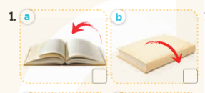  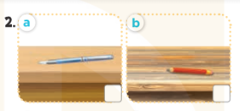  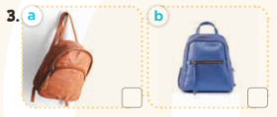  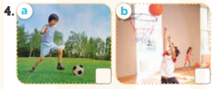  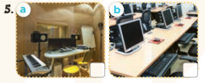  - T ask Ss to guess the answers.  + T writes Ss’guessing on the board.  - Listen to the tape:  + Play the recording  + Play the recording again and get Ss to swap books with their partners.  + Play the recording again to check answers together as a class.  + Write the answers on the board for Ss to correct their answers. Then checks Ss’ guessing.  - Play the recording, sentence by sentence, for the class to listen and repeat in chorus.  Key: 1. b 2. a 3. b 4. b 5. b  Activity 2. Listen and number  *Aims: Ss will be able to listen to and understand four communicative contexts  *Procedure:  - Elicit the content and context of each picture.  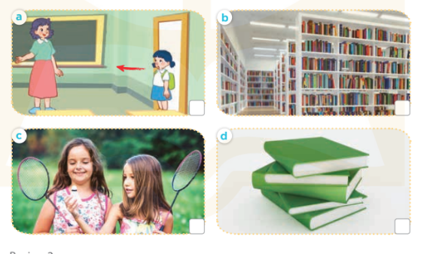  - T ask Ss to guess the answers.  + T writes Ss’guessing on the board.  - Listen to the tape:  + Play the recording  + Play the recording again and get Ss to swap books with their partners.  + Play the recording again to check answers together as a class.  + Write the answers on the board for Ss to correct their answers. Then checks Ss’ guessing.  - Play the recording, sentence by sentence, for the class to listen and repeat in chorus.  Key: 1. b 2. d 3. a 4. c  * Game: Chain game  - Play the game “chain game”.  + Divide the class into a lot of groups. There are four or five Ss in each group.  + T says a sentence. Then, the first S repeats T’s sentence and adds to it. Next, the second S repeats what the first S has said and adds to it, ect.  - T gives feedback by a game  *Consolidation  *Aims: Ss will be able consolidate and wrap up the content of the lesson.  *Procedure:  - T asks ss to answer the following questions:  + What have you learnt from the lesson today?  +What are the core values of the lesson?  - T praises some Ss who are hardworking / active/ good…. as well as encourage others to try more.  - Prepare the new lesson: review 2 (3,4,5) | - Ss listen  -Ss play game  - Ss open their books  -Look at the pictures and say:  + Picture 1a. a book being closed  + Picture 1b. a book being opened  + Picture 2a. a pen  + Picture 2b. a pencil  + Picture 3a. a brown school bag  + Picture 3b. a blue school bag  + Picture 4a. a boy playing football  + Picture 4b. a boy playing basketball  + Picture 5a. a music room  + Picture 5b. a computer room  -Ss guess the answers  - Ss listen to the tape and tick  - Ss listen again, tick and swap books with their partners.  - Ss check their answers and guessing  -Ss listen and repeat.  -Look at the pictures and say:  + Picture a: Mai is asking permission to enter the classroom.  + Picture b: A library  + Picture c: Two girls are playing badminton.  + Picture d: five green books  -Ss guess the answers  - Ss listen to the tape and write the number  - Ss listen again, write number and swap books with their partners.  - Ss check their answers and guessing  -Ss listen and repeat.  -Ss listen and play game  -Ss listen and answer  -Ss listen and clap their hands  -Ss listen and take note
D. ADJUSTMENTS (if necessary):
………………………………………………………………………………………….…..……………………………………………………………………………...…………

