Week 12 Preparing date: November …..,
Period 45 Teaching date: November …..,

Unit 7: Classroom instructions
Lesson 1(4, 5, 6)
A. OBJECTIVES:
By the end of the lesson, Ss will be able to:
1. Knowledge:
- listen to and understand two communicative contexts in which pupils introduce someone and respond to the introduction.
- read and complete the sentences correctly.
- recognise target words while listening and acting out the classroom instructions by playing the game Sit down, please!
- Vocabulary: Review
- Skills: speaking, listening, reading and writing.
2. Competences:
- Critical Thinking: self-introduce
- Co-operation: ready to help friends in pair work/ group work.
- Self-control and independent learning: perform listening tasks.
3. Attitude/ Qualities:
- Kindness: Help partners to complete learning tasks.
- Honesty: tell the truth about feelings and emotions.
- Diligence: complete learning tasks.
B. TEACHING AIDS:
- Teacher: Teacher’s guide Pages 92; audio Tracks 69; website sachmem.vn, posters, laptop, pictures, textbook, lesson plan, TV or projector.
- Students: Pupil’s book Page 51, notebooks, workbooks, school things.
C. PROCEDURES:
Stages/Time | Teacher’s activities | Students’ activities
1.Warm- up:  (5’)  2.Practice: (27’)  3. Homework. (3’) | Game: Simon says  *Aims: to create a friendly and active atmosphere in the class to beginning the lesson.  *Procedure:  - T is the “Simon” and calls out the actions. Every student must follow and do the action, but only when they hear “Simon says ...”.  - If teacher leaves out “Simon says” before giving instruction, anyone who does the action is out.  - Then, teacher can choose one or more students as the leader to continue a game.  - Say “Open your book page 51” and look at “Unit 7, Lesson 1 (4,5,6)”.  Activity 1. Listen and tick:  *Aims: Ss will be able to listen to and understand two communicative contexts in which Ms Hoa gives pupils two instructions.  *Procedure:  - Elicit the instruction used in each picture.  - Point at the pictures respectively to explain the context.  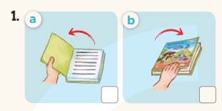  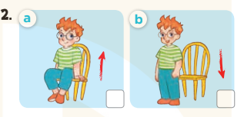  - T ask Ss to guess the answers.  + T writes Ss’guessing on the board.  - Listen to the tape:  + Play the recording  + Play the recording again and get Ss to swap books with their partners.  + Play the recording again to check answers together as a class.  + Write the answers on the board for Ss to correct their answers. Then checks Ss’ guessing.  - Play the recording, sentence by sentence, for the class to listen and repeat in chorus.  Key: 1. a 2. a  Activity 2. Look, complete and read  *Aims: Ss will be able to complete the four target sentence patterns with the help of the picture cues.  *Procedure:  - Get Ss to look at the pictures and identify the instruction used in each picture.  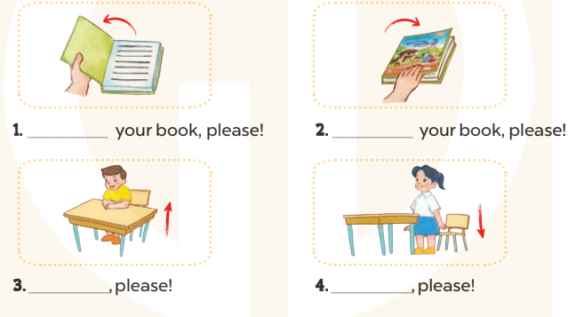  - Have Ss look at the four incomplete sentences. Elicit and model with picture 1  + Ask Ss to read the sentence 1 in chorus.  + Ask Ss what word is missing in the gap (Open). Then have them complete the sentence (Open your book, please!).  -Have Ss work in pairs and complete the sentences 2, 3, 4.  - Ask a few Ss to stand up and read the sentences aloud.  -T gives feedbacks.  Key:  - Open 2. Close  - 3. Stand up 4. Sit down  Activity 3. Let’s play  *Aims: Ss will be able to recognise target words while listening and acting out the classroom instructions by playing the game Sit down, please!  *Procedure:  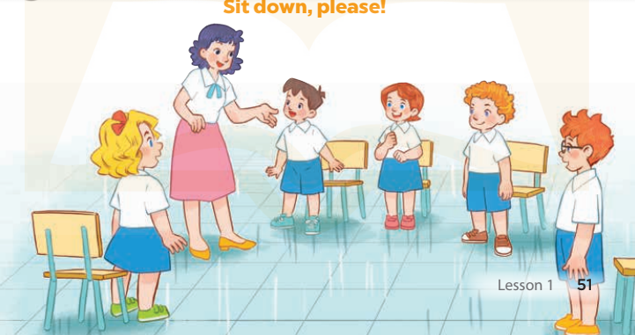  - Put Ss into groups of 5 or 6. Choose one pupil from each group as aperson who gives instructions for the rest of the group to act out.  - Model by saying: Stand up, please! Ss respond to this instruction by  standing up.  - Have groups play the game. One pupil in each group gives instructions for his / her group to act out.  + Ss perform the wrong action are out of the game.  - The winning group is the one that has the highest number of members left at the end of the game.  *Consolidation  *Aims: Ss will be able consolidate and wrap up the content of the lesson.  *Procedure:  - T asks ss to answer the following questions:  + What have you learnt from the lesson today?  +What are the core values of the lesson? (if the teacher can take from the lesson).  - T praises some Ss who are hardworking / active/ good…. as well as encourage others to try more.  - Practice part 5 again.  - Prepare the new lesson: Unit 7, Lesson 2 (1,2,3). | - Ss listen  -Ss play game  - Ss play game  -Ss play game  - Ss open their books  -Look at the pictures and say:  + Picture 1a: a book opening  + Picture1 b: a book closing  + Picture 2a: a boy about to stand up  + Picture 2b: a boy about to sit down  -Ss guess the answers  - Ss listen to the tape and tick  - Ss listen again, tick and swap books with their partners.  - Ss check their answers and guessing  -Ss listen and repeat.  -Ss look at the picture and say  -Ss look and answer  -Ss read  -Ss say and write  -Ss work in pairs and complete  -Ss read aloud  - Ss listen  -Ss play game  -Ss play game  -Ss answer the questions  -Ss listen and clap their hands  -Ss listen and take note
D. ADJUSTMENTS (if necessary):
………………………………………………………………………………………….…..……………………………………………………………………………...………………………………………….…..……………………………………………………………………………….……………………………………………………………………...

Week 12 Preparing date: November …..,
Period 46 Teaching date: November …..,

Unit 7: Classroom instructions
Lesson 2 (1, 2, 3)
A. OBJECTIVES:
By the end of the lesson, Ss will be able to:
1. Knowledge:
- use the words go out, come in, speak, English, Vietnamese in relation to the topic “Classroom instructions”
- use May I …………? – Yes, you can. / No, you can’t. to ask for and give permission
- Vocabulary: open, close, stand up, sit down, please
- Skills: speaking and listening
2. Competences:
- Critical Thinking: self-introduce
- Co-operation: ready to help friends in pair work/ group work.
- Sociability: Talk to each other, say good words to others.
3. Attitude/ Qualities:
- Kindness: Help partners to complete learning tasks.
- Honesty: tell the truth about feelings and emotions
B. TEACHING AIDS:
- Teacher: Teacher’s guide Pages 93, audio Tracks 70, 71, website sachmem.vn, posters, laptop, pictures, textbook, lesson plan, TV or projector.
- Students: Pupil’s book Page 52, notebooks, workbooks, school things.
C. PROCEDURES:
Stages/Time | Teacher’s activities | Students’ activities
1.Warm- up:  (3’)  2. Presentation  (16’)  3.Practice: (7’)  4.Production: (7’)  5. Homework. (2’) | Matching game  *Aims: to create a friendly and active atmosphere in the class to beginning the lesson.  *Procedure:  - Using pictures and flashcards, get 3 pupils hold the pictures and 3 more hold the sentences.  - Ask them to find and match. Praise the ones who finish the matching.  - Then ask the class to look and say aloud.  - Say “Open your book page 52” and look at “Unit 7, Lesson 2 (1,2,3)”.  Activity 1. Vocabulary.  *Aims: Ss will be able to know the vocabulary in front of starting the new lesson.  *Procedure:  -T elicits the new words  + go out : đi ra (mime)  + come in : đi vào (mime)  + speak :nói (situation)  + Vietnamese: tiếng Việt (explain)  + English : tiếng Anh (translation)  - T models (3 times).  - T writes the words on the board.  - Checking: Rub out and remember  Activity 2. Look, listen and repeat:  *Aims: Ss will be able to correctly say the words and use May I ………? and Yes, you can. / No, you can’t. to ask for and give permission.  *Procedure:  - Have Ss look at Pictures a and b and identify names of the speakers in the pictures.  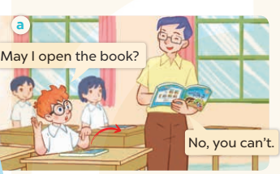  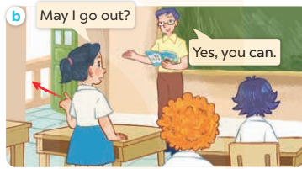  - Play the audio twice (sentence by sentence). Correct their pronunciation where necessary.  - Have Ss to practice the dialogue  - T invites a few pairs to the front of the class to practice.  - T checks pronunciation for ss.  Activity 3 2. Listen, point and say.  *Aims: Ss will be able to correctly say the words and use May I ……. ? and Yes, you can. / No, you can’t. to  ask for and give permission. *Procedure:  * Model sentences:  - T asks Ss look at picture b and helps Ss know the structure from the dialogue.  - T introduces new structure for Ss.  - T explains, models and gives meaning.  -Have Ss repeat the model sentences.  A: May I go out?  B: Yes, you can. / No, you can’t  *Drill pictures  - Have Ss look at the pictures and identify the characters.  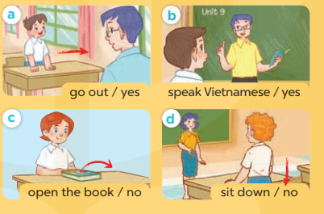  - Run through all the pictures.  - Run through model sentences.  - Have Ss to practise:  + T asks, Ss answer picture a  + Ss ask, T answers picture b  + Group A ask, group B answer picture c  + Group B ask, group A answer picture d  - Ask Ss to work in pairs.  - T controls and corrects.  - Invite a few pairs to come to the front of the classroom and point at the pictures and say the questions and answers in front of the class.  - T gives feedbacks.  Activity 4. Let’s talk.  *Aims: Ss will be able to enhance the correct use of May I …….? and Yes, you can. / No, you can’t. to ask for and give permission.  *Procedure:  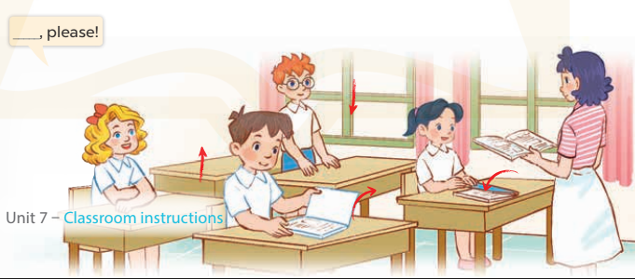  - Have Ss look at the picture and elicit the question and the answer in context.  + Who are they?  + Where are they?  + What are they talking about?  - Put Ss work in pairs to give and respond to instructions.  - Invite some pairs of Ss to the front of the class to act out the instructions.  *Consolidation  *Aims: Ss will be able consolidate and wrap up the content of the lesson.  *Procedure:  - T asks ss to answer the following questions:  + What have you learnt from the lesson today?  +What are the core values of the lesson? (if the teacher can take from the lesson).  - T review the vocabulary and model sentences.  - T praises some Ss who are hardworking / active/ good…. as well as encourage others to try more.  - Learn the vocabulary and model sentences by heart  - Prepare the new lesson: Unit 7, Lesson 2 (4,5,6). | - Ss sing and matching  - Ss open their books  -Ss listen and answer  - - Ss listen and repeat  + Choral repetition (3 times).  + Individual repetition (3 ss)  - Ss take note  - Ss look, remember and write  -Look at the pictures and say  + In picture a: Ben asks: May I open the book? Mr Long says: No, you can’t.  + In picture b: Mai asks: May I go out? Mr Long says: Yes, you can  -Ss listen and repeat in chorus (twice)  -Ss work in pairs to practice  -Ss practice the dialogue  -Ss listen  -Ss look at the picture and answer.  -Ss listen  -Ss listen and repeat  -Ss repeat to the place  - Ss look, listen and answer  + Picture a: A boy asks Mr Long for his permission to leave the classroom.  + Picture b: A boy asks Mr Long for his permission to speak Vietnamese.  + Picture c: A girl asks the teacher for her permission to open her book.  + Picture d: A boy asks Ms Hoa for her permission to sit down.  -Ss listen and repeat  -Ss practice in chorus  -Ss work in pairs to practice  -Ss point and say  -Ss listen.  -Ss look at the picture and answer  + A picture of a classroom in which pupils are asking the teacher for her permission to  (open the book / close the book / stand up / sit down)  -Ss work in pairs  -Ss act out the instructions.  -Ss answer the questions  - Ss listen  -Ss listen and clap their hands  -Ss listen and take note
D. ADJUSTMENTS (if necessary):
………………………………………………………………………………………….…..……………………………………………………………………………...………………………………………….…..……………………………………………………………………………….……………………………………………………………………...
Week 12 Preparing date: November …..,
Period 47 Teaching date: November …..,

Unit 7: Classroom instructions
Lesson 2 (4, 5, 6)
A. OBJECTIVES:
By the end of the lesson, Ss will be able to:
1. Knowledge:
- listen to and understand four communicative contexts and number the correct pictures.
- complete six gapped sentences with the help of picture cues.
- sing the song May I come in and sit down? with the correct pronunciation, rhythm and melody.
- Vocabulary: Review
- Skills: speaking, listening, reading and writing.
2. Competences:
- Critical Thinking: self-introduce
- Co-operation: ready to help friends in pair work/ group work.
- Self-control and independent learning: perform listening tasks.
3. Attitude/ Qualities:
- Kindness: Help partners to complete learning tasks.
- Honesty: tell the truth about feelings and emotions.
- Diligence: complete learning tasks.
B. TEACHING AIDS:
- Teacher: Teacher’s guide Pages 95; audio Tracks 72; website sachmem.vn, posters, laptop, pictures, textbook, lesson plan, TV or projector.
- Students: Pupil’s book Page 53, notebooks, workbooks, school things.
C. PROCEDURES:
Stages/Time | Teacher’s activities | Students’ activities
1.Warm- up:  (5’)  2.Practice: (27’)  3. Homework. (3’) | Game: Slap the board  *Aims: to create a friendly and active atmosphere in the class to beginning the lesson.  *Procedure:  - Divide class into 2 groups  - How to play:  + Each group chooses five Ss to play.  + Class will read aloud.  + Look at the picture, listen and slap the picture you heard.  + Who faster will get 1 mark.  + Which group with higher mark is the winner.  - T gives feedback.  - Say “Open your book page 53” and look at “Unit 7, Lesson 2 (4,5,6)”.  Activity 1. Listen and number:  *Aims: Ss will be able to listen to and understand four communicative contexts in which pupils ask their teachers for permission.  *Procedure:  - Elicit the questions to ask for permission used in the pictures.  - Point at the pictures respectively to explain the context.  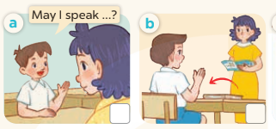  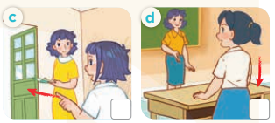  - T ask Ss to guess the answers.  + T writes Ss’guessing on the board.  - Listen to the tape:  + Play the recording  + Play the recording again and get Ss to swap books with their partners.  + Play the recording again to check answers together as a class.  + Write the answers on the board for Ss to correct their answers. Then checks Ss’ guessing.  - Play the recording, sentence by sentence, for the class to listen and repeat in chorus.  Key: 1. b 2. a 3. d 4. c  Activity 2. Look, complete and read  *Aims: Ss will be able to complete the six target sentence patterns in the dialogues with the help of the picture cues.  *Procedure:  - Get Ss to look at the pictures and identify what the characters in the pictures are asking for.  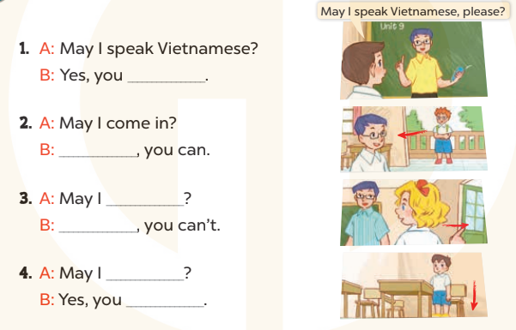  - Have Ss look at the four dialogues and the pictures. Elicit and model with picture 1  + Ask Ss to read the sentence 1 in chorus.  + Ask them what word is missing in the answer (can’t). Then have them complete the answer (No, you can’t.).  -Have Ss work in pairs and complete the sentences 2, 3, 4.  - Ask a few Ss to stand up and read the sentences aloud.  -T gives feedbacks.  Key:  1.can’t 2. Yes  3. go out; No 4. sit down; can  - Activity 3. Let’s sing  *Aims: Ss will be able to sing the song May I come in and sit down? with the correct pronunciation and melody  *Procedure:  - Introduce the title and lyrics of the song: “May I come in and sit down?”  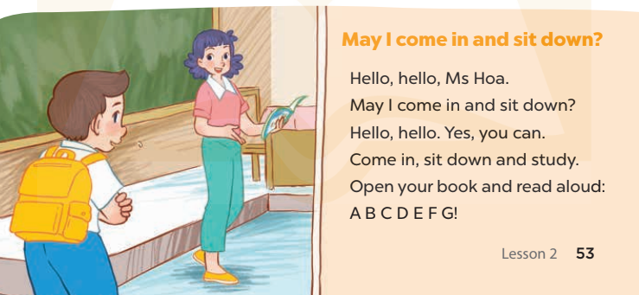  - Play the recording for Ss to listen to the whole song.  + Have them repeat the title and lyrics line by line.  + Tell Ss to point at the pictures while singing.  - Play the recording all the way through for Ss to listen to pronunciation and melody of the song.  - Play the recording line by line for Ss to listen, repeat and point to the pictures  - Play the recording for Ss to sing and do actions.  - Ask Ss to practice singing and doing actions in pairs or groups.  - Invite groups to the front of the classroom to perform the song  -T gives feedback.  *Consolidation  *Aims: Ss will be able consolidate and wrap up the content of the lesson.  *Procedure:  - T asks ss to answer the following questions:  + What have you learnt from the lesson today?  +What are the core values of the lesson? (if the teacher can take from the lesson).  - T praises some Ss who are hardworking / active/ good…. as well as encourage others to try more.  - Practice part 5 again.  - Prepare the new lesson: Unit 7, Lesson 3 (1,2,3). | - Ss read the words  - Ss play game  -Ss play game  - Ss open their books  -Look at the pictures and say:  + Picture a: Minh asks Ms Hoa’s permission to speak Vietnamese.  + Picture b: Nam asks Ms Hoa’s permission to open a book.  + Picture c: Linh asks Ms Hoa’s permission to leave the classroom.  + Picture d: Bill asks Ms Hoa’s permission to sit down.  -Ss guess the answers  - Ss listen to the tape and write  - Ss listen again, write and swap books with their partners.  - Ss check their answers and guessing  -Ss listen and repeat.  -Ss look at the picture and say  -Ss look and answer  -Ss read  -Ss say and complete  -Ss work in pairs and complete  -Ss read aloud  - Ss listen  -Ss listen to the song  - Ss listen and repeat line by line without the action.  -Ss point to the pictures while singing  -Ss listen to melody of the song  - Ss listen and sing line by line.  - Ss sing and do actions.  + Ss work in groups (two groups) to sing.  -Ss perform in front of the class.  -Ss listen  -Ss answer the questions  -Ss listen and clap their hands  -Ss listen and take note
D. ADJUSTMENTS (if necessary):
………………………………………………………………………………………….…..……………………………………………………………………………...………………………………………….…..……………………………………………………………………………….……………………………………………………………………...

Week 12 Preparing date: November …..,
Period 48 Teaching date: November …..,

Unit 7: Classroom instructions
Lesson 3 (1, 2, 3)
A. OBJECTIVES:
By the end of the lesson, Ss will be able to:
1. Knowledge:
-repeat and pronounce the sounds of the consonant clusters sp and st in isolation, in the words speak and stand and in the sentences Speak English, please! and May I stand up? with the correct pronunciation and intonation;
-identify the target words speak and stand and the sentences Speak English, please! and May I stand up? while listening.
- Vocabulary: Review
- Skills: speaking, listening, reading and writing.
2. Competences:
- Co-operation: ready to help friends in pair work/ group work.
- Sociability: Talk to each other, say good words to others.
3. Attitude/ Qualities:
- Kindness: Help partners to complete learning tasks.
- Honesty: tell the truth about feelings and emotions
B. TEACHING AIDS:
- Teacher: Teacher’s guide Pages 97; audio Tracks 74, 75, 76; website sachmem.vn, posters, laptop, pictures, textbook, lesson plan, TV or projector.
- Students: Pupil’s book Page 54, notebooks, workbooks, school things.
C. PROCEDURES:
Stages/Time | Teacher’s activities | Students’ activities
1.Warm- up:  (5’)  2. Presentation  (9’)  3.Practice: (19’)  4. Homework. (2’) | Game: Pass the ball  *Aims: to create a friendly and active atmosphere in the class to beginning the lesson.  *Procedure:  - Divide the class into 3 teams.  - Each team has 1 sticky ball.  - Play the music, Ss in each team take turns to pass the ball.  + After the music ends, 3 Ss have the ball – stand up and say the name, using the sentence model.  - Say “Open your book page 54” and look at “Unit 7, Lesson 3 (1,2,3)”.  Activity 1. Listen and repeat:  *Aims: Ss will be able to correctly repeat the sounds of the consonant clusters sp and st in isolation, in the words speak and stand and in the sentences Speak English, please! and May I stand up? with the correct pronunciation and intonation  *Procedure:  - T gives instruction to the letter sp and st, speak and stand, and in the sentences Speak English, please! and May I stand up?  - Play the recording for the letter sp, st.  - Encourage Ss to point at the letter/ word/ sentence while listening.  - Play the recording again and encourage Ss to listen and repeat. - Do this several times until Ss feel confident.  - T calls some Ss to practice.  - T gives feedbacks.  Activity 2. Listen and tick.  *Aims: Ss will be able to identify the target words speak and stand while listening.  *Procedure:  - Elicit the sentences and the gap-fill options.  - T ask Ss to guess the answers.  + T writes Ss’guessing on the board.  - Listen to the tape:  + Play the recording  + Play the recording again and get Ss to swap books with their partners.  + Play the recording again to check answers together as a class.  + Write the answers on the board for Ss to correct their answers. Then checks Ss’ guessing.  - Play the recording, sentence by sentence, for the class to listen and repeat in chorus.  - Invite one or two Ss to stand up and read the completed sentences.  Key: 1.b 2.a  Activity 3. Let’s chant  *Aims: Ss will be able to say the chant with the correct rhythm and pronunciation  *Procedure:  - Introduce the title and lyrics of the chant.  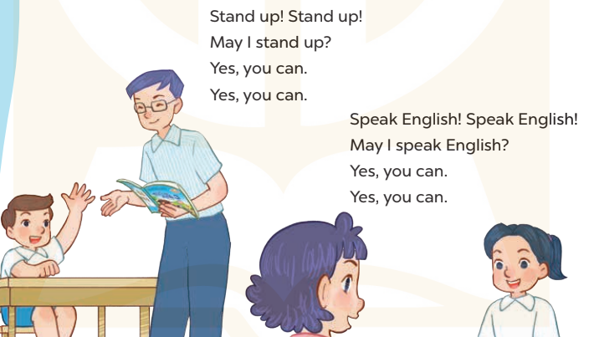  - Play the recording for Ss to listen to the whole chant.  + Have them repeat the title and lyrics line by line.  + Ask Ss to attend to the sounds of the letters sp and st and the words speak and stand.  - Play the recording all the way through for Ss to listen to pronunciation and melody.  - Play the recording line by line for Ss to listen and repeat  - Play the recording for Ss to chant and clap along.  - Ask Ss to practice chant and clap along in pairs or groups.  - Invite groups to the front of the classroom to perform the chant  -T gives feedback.  *Consolidation  *Aims: Ss will be able consolidate and wrap up the content of the lesson.  *Procedure:  - T asks ss to answer the following questions:  + What have you learnt from the lesson today?  +What are the core values of the lesson? (if the teacher can take from the lesson).  - T praises some Ss who are hardworking / active/ good…. as well as encourage others to try more.  - Practice the chant more.  - Prepare the new lesson: Unit 7, Lesson 3 (4,5,6). | - Ss listen  -Ss play game  - Ss open their books  - Ss recognize the differences about color of letter  - - Ss listen  - Ss listen and point  - Ss listen again and repeat  -Ss listen again and repeat  -Ss practice  -Ss listen  -Ss listen and say:  + Number 1: …..., please.  + Number 2: May I stand up ……?  -Ss guess the answers  - Ss listen to the tape and tick  - Ss listen again, tick and swap books with their partners.  - Ss check their answers and guessing  -Ss listen and repeat.  -Ss read the sentences  - Ss look and listen.  -Ss listen to the chant  - Ss listen and repeat line by line without clap their hands  -Ss note the sounds, words  -Ss listen to melody of the chant  - Ss listen and chant line by line.  - Ss chant and clap along.  - Ss work in groups (two groups) to chant  -Ss perform in front of the class.  -Ss listen  -Ss listen.  -Ss answer the questions  -Ss listen and clap their hands  -Ss listen and take note

D. ADJUSTMENTS (if necessary):
………………………………………………………………………………………….…..……………………………………………………………………………...………………………………………….…..……………………………………………………………………………….……………………………………………………………………...

