Week 9 Preparing date: November …….
Period 33 Teaching date: November ……,

Unit 5: My hobbies
Lesson 3 (1, 2, 3)
A. OBJECTIVES:
By the end of the lesson, Ss will be able to:
1. Knowledge:
- correctly repeat the sounds of the letters p and r in isolation, the words painting and running, and the sentences I like painting. and I like running. with the correct pronunciation and intonation.
- identify the target words painting and running while listening.
- say the chant with the correct rhythm and pronunciation.
- Vocabulary: Review
- Skills: speaking, listening, reading and writing.
2. Competences:
- Co-operation: ready to help friends in pair work/ group work.
- Sociability: Talk to each other, say good words to others.
3. Attitude/ Qualities:
- Kindness: Help partners to complete learning tasks.
- Honesty: tell the truth about feelings and emotions
B. TEACHING AIDS:
- Teacher: Teacher’s guide Pages 69, 70; audio Tracks 52, 53, 54; website sachmem.vn, posters, laptop, pictures, textbook, lesson plan, TV or projector.
- Students: Pupil’s book Page 38, notebooks, workbooks, school things.
C. PROCEDURES:
Stages/Time | Teacher’s activities | Students’ activities
1.Warm- up:  (5’)  2. Presentation  (9’)  3.Practice: (19’)  4. Homework. (2’) | Game: What is missing?  *Aims: to create a friendly and active atmosphere in the class to beginning the lesson.  *Procedure:  - Divide the class into teams.  - Place some flashcards on the board (cooking, running, singing and some flashcards of hobby).  - Have Ss from the teams close their eyes.  + Remove one of the pictures.  + Ss have to remember and say the missing pictures.  +Give the first team to guess correctly one point.  +The team that gets the most points wins.  - Say “Open your book page 38” and look at “Unit 5, Lesson 3 (1,2,3)”.  Activity 1. Listen and repeat:  *Aims: Ss will be able to correctly pronounce the sounds of the letters p and r in isolation, in the words painting and running, and in the sentences I like painting. and I like running with correct pronunciation and intonation.  *Procedure:  - T gives instruction to the letter p and r, painting and running, and in the sentences I like painting. and I like running  - Play the recording for the letter p, r.  - Encourage Ss to point at the letter/ word/ sentence while listening.  - Play the recording again and encourage Ss to listen and repeat.  - Do this several times until Ss feel confident.  - T calls some Ss to practice.  - T gives feedbacks.  Activity 2. Listen and circle.  *Aims: Ss will be able to identify the target words painting and running while listening.  *Procedure:  - Elicit the sentences and the gap-fill options.  - T ask Ss to guess the answers.  + T writes Ss’guessing on the board.  - Listen to the tape:  + Play the recording  + Play the recording again and get Ss to swap books with their partners.  + Play the recording again to check answers together as a class.  + Write the answers on the board for Ss to correct their answers. Then checks Ss’ guessing.  - Play the recording, sentence by sentence, for the class to listen and repeat in chorus.  - Invite one or two Ss to stand up and read the completed sentences.  Key: 1.b 2.a  Activity 3. Let’s chant  *Aims: Ss will be able to say the chant with the correct rhythm and pronunciation.  *Procedure:  - Introduce the title and lyrics of the chant.  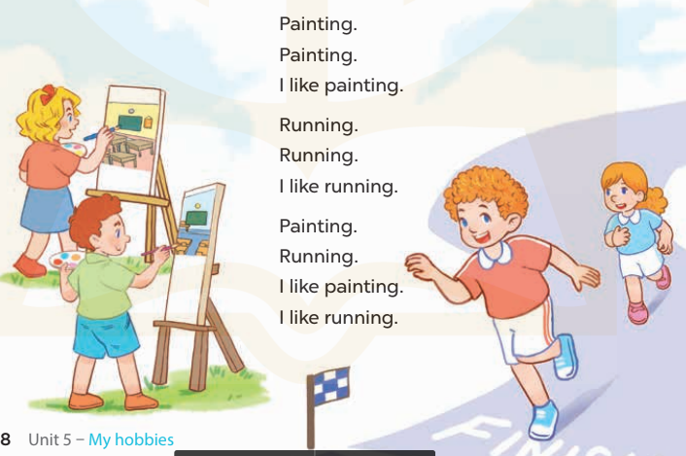  - Play the recording for Ss to listen to the whole chant.  + Have them repeat the title and lyrics line by line.  + Ask Ss to attend to the sounds of the letters p and r and the words painting and running.  - Play the recording all the way through for Ss to listen to pronunciation and melody.  - Play the recording line by line for Ss to listen and repeat  - Play the recording for Ss to chant and clap along.  - Ask Ss to practice chant and clap along in pairs or groups.  - Invite groups to the front of the classroom to perform the chant  -T gives feedback.  *Consolidation  *Aims: Ss will be able consolidate and wrap up the content of the lesson.  *Procedure:  - T asks ss to answer the following questions:  + What have you learnt from the lesson today?  +What are the core values of the lesson? (if the teacher can take from the lesson).  - T praises some Ss who are hardworking / active/ good…. as well as encourage others to try more.  - Practice the chant more.  - Prepare the new lesson: Unit 5, Lesson 3 (4,5,6). | - Ss listen  -Ss play game  - Ss open their books  - Ss recognize the differences about color of letter  - - Ss listen  - Ss listen and point  - Ss listen again and repeat  -Ss listen again and repeat  -Ss practice  -Ss listen  -Ss listen and say:  + Number 1: It’s….!  + Number 2: I like…..!  -Ss guess the answers  - Ss listen to the tape and circle  - Ss listen again, circle and swap books with their partners.  - Ss check their answers and guessing  -Ss listen and repeat.  -Ss read the sentences  - Ss look and listen.  -Ss listen to the chant  - Ss listen and repeat line by line without clap their hands  -Ss note the sounds, words  -Ss listen to melody of the chant  - Ss listen and chant line by line.  - Ss chant and clap along.  - Ss work in groups (two groups) to chant  -Ss perform in front of the class.  -Ss listen  -Ss listen.  -Ss answer the questions  -Ss listen and clap their hands  -Ss listen and take note

D. ADJUSTMENTS (if necessary):
………………………………………………………………………………………….…..……………………………………………………………………………...………………………………………….…..……………………………………………………………………………….……………………………………………………………………...
Week 9 Preparing date: November …….
Period 34 Teaching date: November ……,

Unit 5: My hobbies
Lesson 3 (4, 5, 6)
A. OBJECTIVES:
By the end of the lesson, Ss will be able to:
1. Knowledge:
- read a communicative context and complete a table about hobbies.
- read and complete gapped sentences with personal information.
- reinforce and extend pupils’ language knowledge and competences by making a hobby show.
- Vocabulary: Review
- Skills: speaking, listening, reading and writing.
2. Competences:
- Critical Thinking: self-introduce
- Co-operation: ready to help friends in pair work/ group work.
- Self-control and independent learning: perform listening tasks.
3. Attitude/ Qualities:
- Kindness: Help partners to complete learning tasks.
- Honesty: tell the truth about feelings and emotions.
- Diligence: complete learning tasks.
B. TEACHING AIDS:
- Teacher: Teacher’s guide Pages 71, 72; website sachmem.vn, posters, laptop, pictures, textbook, lesson plan, TV or projector.
- Students: Pupil’s book Page 39, notebooks, workbooks, school things.
C. PROCEDURES:
Stages/Time | Teacher’s activities | Students’ activities
1.Warm- up:  (5’)  2.Practice: (8’)  3.Production: (19’)  4. Homework. (3’) | Game: Matching  *Aims: to review the vocabulary and structure about greet and respond to greetings.  *Procedure:  -T divides class into 2 teams  - Ss in 2 teams take turn to open the boxes to match the questions and answers to their pictures (open: click the numbers -close: click the red signs).  - Ss of each team will get points if their matching is correct.  - Review hobbies: painting, cooking, running, walking, singing, swimming.  - Say “Open your book page 39” and look at “Unit 5, Lesson 3 (4, 5, 6)”.  Activity 1. Read and tick:  *Aims: Ss will be able to read a communicative context and complete a table about hobbies.  *Procedure:  - T models with Ben.  + Get Ss to read the dialogue  + Ask Ss to read the first sentence and tick the correct hobby  -Have Ss work in pairs and complete the table by ticking the correct boxes.  - Tell Ss to swap books with a partner, then check answers together as a class.  - Write the correct answers on the board for pupils to correct their answers.  - Invite pairs of Ss to stand up and say the characters’ hobby.  -T gives feedbacks.  Key:  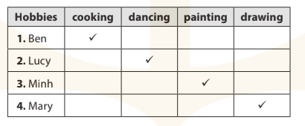  Activity 2. Let’s write  *Aims: Ss will be able to read and complete gapped sentences with personal information.  *Procedure:  - Explain to the class the goal of this activity.  - Ask Ss to read each gapped sentence, guess the missing information and complete the sentence with their own personal information.  - Give Ss time to write their answers. - Ask Ss to swap and correct their answers in pairs.  - Check the answers as a class.  Key: Pupils’ answer.  Activity 3. Project.  *Aims: Ss will be able to reinforce and extend pupils’ language knowledge and competences by making a hobby show.  *Procedure:  - Explain the goal of this activity to Ss.  - Point at the picture and explain what they should do to complete the project.  - Tell Ss to work in groups.  - Give the class time to complete the project by drawing three pictures showing their hobbies  - Invite some Ss go to the board and perform their hobbies.  - Have a class display of Ss’ projects and have them vote for the most interesting.  *Consolidation  *Aims: Ss will be able consolidate and wrap up the content of the lesson.  *Procedure:  - T asks ss to answer the following questions:  + What have you learnt from the lesson today?  +What are the core values of the lesson?  - T praises some Ss who are hardworking / active/ good…. as well as encourage others to try more.  - Prepare the new lesson: Review 1 | - Ss listen  -Ss play game  - Ss open their books  - Ss read and answer  -Ss read and tick  -Ss swap books and check  -Ss check the correct their answers  -Ss say  -Ss listen  -Ss listen  -Ss read and answer  -Ss write  -Ss swap books and check their answers  -Ss check  -Ss listen  -Ss listen  -Ss work in groups  -Ss draw three pictures showing their hobbies.  -Ss perform in front of the class.  -Ss vote  -Ss answer the questions  -Ss listen and clap their hands  -Ss listen and take note
D. ADJUSTMENTS (if necessary):
………………………………………………………………………………………….…..……………………………………………………………………………...…………

Week 9 Preparing date: November …….
Period 35, 36 Teaching date: November ……,

Review 1
Parts 1, 2, 3, 4, 5
A. OBJECTIVES:
By the end of the lesson, Ss will be able to:
1. Knowledge:
- correctly use the following sentence patterns:
+ Hello. / Hi. I’m ………. – Hello , / Hi, I’m ……..
+ How are you? − …….., thank you.
+ What's your name? − My name's ……...
+ How old are you? – I’m ……..years old.
+ Is this / that ? − Yes, it is. / No, it isn't. It's ……...
+ What's your hobby? − It's ………...
+ What do you like? – I like …….
- Vocabulary: Review
- Skills: speaking, listening, reading and writing.
2. Competences:
- Critical Thinking: self-introduce
- Co-operation: ready to help friends in pair work/ group work.
- Self-control and independent learning: perform listening tasks.
3. Attitude/ Qualities:
- Kindness: Help partners to complete learning tasks.
- Honesty: tell the truth about feelings and emotions.
- Diligence: complete learning tasks.
B. TEACHING AIDS:
- Teacher: Teacher’s guide Pages 73, 74, 75; Track 55, 56; website sachmem.vn, posters, laptop, pictures, textbook, lesson plan, TV or projector.
- Students: Pupil’s book Page 40, 41, notebooks, workbooks, school things.
C. PROCEDURES:
Stages/Time | Teacher’s activities | Students’ activities
1.Warm- up:  (5’)  2.Practice: (52’)  3.Production: (10’)  4. Homework. (3’) | Game: Whispering  *Aims: to review the vocabulary and structure about greet and respond to greetings.  *Procedure:  - Divide class into 2 groups.  -Ask 5 Ss in each group stand in a straight line.  - T says a word or phrase to the first pupil in this line.  - Then, the first pupil whispers what she/ he hear to the second person in line; the second one whispers what he/ she hears to the third one and so on until the last pupil in group hears the word or phrase.  - The last pupil says the word or phrase out loud.  - The faster group has correct word or phrase is the winner.  - Say “Open your book page 40, 41” and look at Review 1.  Activity 1. Listen and tick:  *Aims: Ss will be able to listen to and understand five communicative contexts  *Procedure:  - Elicit the names of the characters in each picture and what they say.  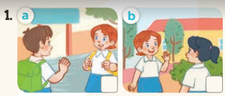    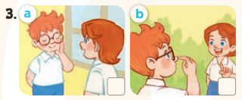  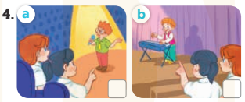  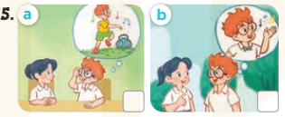  - T ask Ss to guess the answers.  + T writes Ss’guessing on the board.  - Listen to the tape:  + Play the recording  + Play the recording again and get Ss to swap books with their partners.  + Play the recording again to check answers together as a class.  + Write the answers on the board for Ss to correct their answers. Then checks Ss’ guessing.  - Play the recording, sentence by sentence, for the class to listen and repeat in chorus.  Key: 1. b 2. b 3. a 4. b 5. b  Activity 2. Listen and number  *Aims: Ss will be able to listen to and understand four communicative contexts  *Procedure:  - Elicit the names of the characters in each picture and what they say  - Point at the pictures respectively to explain the context.  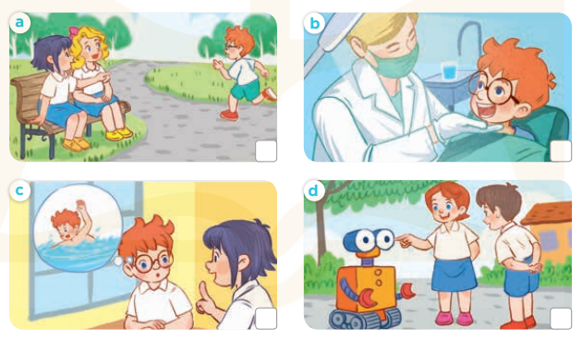  - T ask Ss to guess the answers.  + T writes Ss’guessing on the board.  - Listen to the tape:  + Play the recording  + Play the recording again and get Ss to swap books with their partners.  + Play the recording again to check answers together as a class.  + Write the answers on the board for Ss to correct their answers. Then checks Ss’ guessing.  - Play the recording, sentence by sentence, for the class to listen and repeat in chorus.  Key: 1. b 2. c 3. d 4. a  Activity 3. Read and match  *Aims: Ss will be able to read and match pairs of target sentence patterns  *Procedure:  - Tell Ss about this activity. Point at sentence 1, elicit the answer and models.  - Give Ss work in pairs to do the sentence 2,3,4,5.  - Tell Ss to swap their books with their partners, then check answers together as a class.  - Write the correct answers on the board for Ss to correct their answers.  - Invite some pairs to stand up and read the matched exchanges aloud.  Key:  1. e 2. a 3. b 4. c 5. d  Activity 4. Read and complete  *Aims: Ss will be able to read and complete a gapped conversation between two pupils.  *Procedure:  - Elicit the words in the box and the conversation.  - Tell Ss about this activity. Point at number1, elicit the answer and models.  - Give Ss work in pairs to do the task  - Tell Ss to swap their books with their partners, then check answers together as a class.  - Write the correct answers on the board for Ss to correct their answers.  - Invite some pairs to stand up and read the matched exchanges aloud.  Key:  1. name 2. Hello 3. eight  4. hobby 5. singing  * Mini game: Comprehension questions  - Ask Ss to read the conversation again  - Give Ss work in pairs and answer the questions:  + How many people in the conversation?  There are 2 people/ 2 people.  + What are their names?  Their names are Minh and Mary.  + How old is Mary?  She is eight years olds.  + What is Mary’s hobby?  She likes singing.  + What is Minh’s hobby?  He likes drawing.  Activity 5. Ask and answer  *Aims: Ss will be able to ask and answer questions using personal information.  *Procedure:  - Ask Ss to read the question and elicit the answer  - Get Ss to role-play the exchange with sentence 1  - Give Ss time to take it in turns to role-play the four exchanges.  - Invite some paris to stand up and role-play.  Key: Pupil’s answer  *Consolidation  *Aims: Ss will be able consolidate and wrap up the content of the lesson.  *Procedure:  - T asks ss to answer the following questions:  + What have you learnt from the lesson today?  +What are the core values of the lesson?  - T praises some Ss who are hardworking / active/ good…. as well as encourage others to try more.  - Prepare the new lesson: Fun time 1 | - Ss listen  -Ss play game  - Ss open their books  -Look at the pictures and say:  + Picture 1a. Minh and Lucy first meet each other  + Picture 1b. Lucy and Mai first meet each other.  + Picture 2a. a birthday cake with number 6 on it  + Picture 2b. a birthday cake with number 8 on it  + Picture 3a. Lucy tells Ben to touch his face.  + Picture 3b. Lucy tells Ben to touch his nose.  + Picture 4a. Ben is singing on the stage.  + Picture 4b. Bill is playing music on the stage.  + Picture 5a. Ben tells Mai he likes dancing.  + Picture 5b. Ben tells Mai he likes singing.  -Ss guess the answers  - Ss listen to the tape and tick  - Ss listen again, tick and swap books with their partners.  - Ss check their answers and guessing  -Ss listen and repeat.  -Look at the pictures and say:  + Picture a: Linh guesses that the running boy is Bill, but Mary says it is Ben.  + Picture b: The doctor tells Ben to open his mouth for him to check.  + Picture c: Linh wants to know what Ben likes. He says that he likes swimming.  + Picture d: Lucy points at the eye of the robot and asks Minh what it is. He answers that it is an eye.  -Ss guess the answers  - Ss listen to the tape and write the number  - Ss listen again, write number and swap books with their partners.  - Ss check their answers and guessing  -Ss listen and repeat.  -Ss look at the sentence 1 and say  -Ss work in pairs and match  -Ss swap their books and match  -Ss check  -Ss read aloud  -Ss listen and answer  -Ss look at the dialogue and say number 1  -Ss work in pairs and complete  -Ss swap their books and match  -Ss check  -Ss read aloud  -Ss read the dialogue again  -Ss work in pairs and answer  -Ss listen and answer  -Ss role play sentence 1  -Ss work in paris  -Ss role play  -Ss listen and answer  -Ss listen and clap their hands  -Ss listen and take note
D. ADJUSTMENTS (if necessary):
………………………………………………………………………………………….…..……………………………………………………………………………...…………

